Understanding Customer Behaviour Through POS Data Analysis
Tool: MySQL
Database: customer_behavior
Project Objective:
To analyze customer behavior using Point-of-Sale (POS) data by building a structured relational database in MySQL, preparing and cleaning the data, and generating meaningful business insights using SQL queries.
Project Overview
This project analyzes customer information, transaction details, and product category data collected from a retail company's POS systems. The analysis focuses on customer purchasing patterns, transaction behavior, revenue performance, return trends, and category-level performance.
Tools & Technologies
- Database: MySQL
- Tool: MySQL Workbench
- Data Source: CSV files
- Language: SQL
Dataset
The project consists of three CSV datasets:
- Customer
- Transactions
- Product Category

1. Database Setup

Create Database
CREATE DATABASE Customer_Behavior;

USE Customer_Behavior;

- import the three CSV files into MySQL Workbench
- Verify that data has been successfully imported
  - table structure
  - data types
  - primary keys
  - successful import

DESC customer_behavior.transactions;

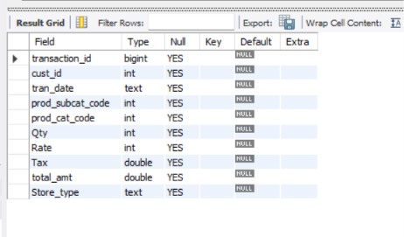
DESC
DESC customer_behavior.prod_cat_info;

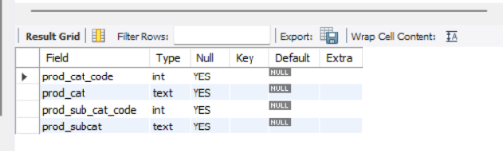

DESE customer_behavior.customer;

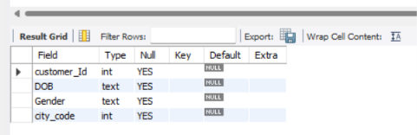

2. Data preparation and understanding
- Determine the total number of rows present in each of the three tables: Customer, Transactions, and Product Category

-- Customer Table
SELECT COUNT(*) AS total_rows
FROM Customer; # 5645

-- Product Category Table
SELECT COUNT(*) AS total_rows
FROM prod_cat_info; # 23

-- Transactions Table
SELECT COUNT(*) AS total_rows
FROM transactions; # 23053

/*
Combined Result:
Total number of rows in all three tables
*/
SELECT 'Customer' AS table_name, COUNT(*) AS total_rows FROM Customer
UNION ALL
SELECT 'Transactions', COUNT(*) FROM Transactions
UNION ALL
SELECT 'Product Category', COUNT(*) FROM Prod_Cat_info;
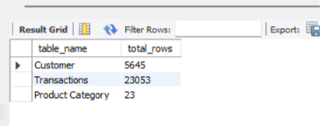

- Identify the total number of returned transactions
SELECT COUNT(*) AS total_returned_transactions
FROM Transactions
WHERE Qty < 0; #2177
- Convert all date fields into valid date formats before proceeding with analysis
SELECT STR_TO_DATE(tran_date, '%d-%m-%Y') AS valid_tran_date
FROM Transactions;

SELECT STR_TO_DATE(DOB, '%d-%m-%Y') AS valid_DOB
FROM customer;

- Establish the overall time range of the transaction dataset and display the output in terms of days, months, and years
SELECT
MIN(STR_TO_DATE(tran_date, '%d-%m-%Y')) AS start_date,
MAX(STR_TO_DATE(tran_date, '%d-%m-%Y')) AS end_date,

DATEDIFF(
MAX(STR_TO_DATE(tran_date, '%d-%m-%Y')),
MIN(STR_TO_DATE(tran_date, '%d-%m-%Y'))
) AS total_days,

TIMESTAMPDIFF(
MONTH,
MIN(STR_TO_DATE(tran_date, '%d-%m-%Y')),
MAX(STR_TO_DATE(tran_date, '%d-%m-%Y'))
) AS total_months,

TIMESTAMPDIFF(
YEAR,
MIN(STR_TO_DATE(tran_date, '%d-%m-%Y')),
MAX(STR_TO_DATE(tran_date, '%d-%m-%Y'))
) AS total_years

FROM Transactions;
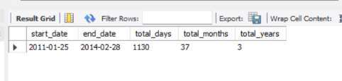
- Determine the product category to which the sub-category “DIY” belongs
select * from prod_cat_info where prod_subcat= 'DIY';
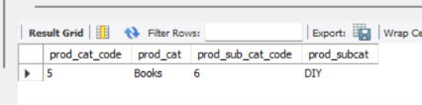

Core business analysis
- Identify the most frequently used transaction channel
select
Store_type,
count(Store_type) as 'total transaction channel'
from transactions
group by Store_type
order by 2 desc;
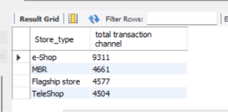

- Calculate the count of male and female customers
SELECT Gender, COUNT(*) AS total_customers
FROM Customer
WHERE Gender IN ('M', 'F')
GROUP BY Gender;
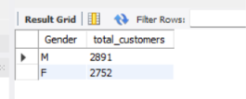

- Determine which city has the maximum number of customers and provide the count
SELECT
city_code, COUNT(city_code)
FROM
customer
GROUP BY city_code
ORDER BY 2 DESC
LIMIT 1;
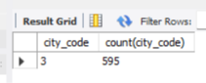

- Ascertain the number of sub-categories under the books category
SELECT COUNT(prod_subcat) AS total_subcategories
FROM prod_cat_info
WHERE prod_cat = 'Books'; #6

- Find the maximum quantity ordered in a single transaction
SELECT
MAX(Qty) 'maximum quantity ordered'
FROM
customer_behavior.transactions; #5

Revenue and profitability analysis
- Calculate the net total revenue generated in the electronics and books categories
SELECT pc.prod_cat, round(sum(t.total_amt),2) 'net total revenue'
FROM transactions t inner join prod_cat_info pc
on t.prod_cat_code= pc.prod_cat_code
WHERE pc.prod_cat in ('electronics','books') group by 1 with rollup; #130548482.42
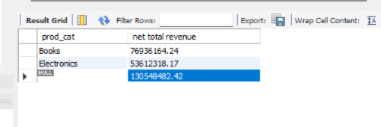

- Identify customers with more than 10 transactions, excluding returns
SELECT
cust_id,
COUNT(*) AS total_transactions
FROM Transactions
WHERE Qty > 0
GROUP BY cust_id
HAVING COUNT(*) > 10;
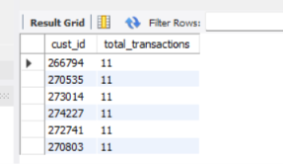

- Compute combined revenue from electronics and clothing categories in flagship stores
SELECT
pc.prod_cat, ROUND(SUM(t.total_amt), 2) 'net total revenue'
FROM
transactions t
INNER JOIN
prod_cat_info pc ON t.prod_cat_code = pc.prod_cat_code
WHERE
pc.prod_cat IN ('electronics' , 'clothing') AND t.Store_type = 'Flagship store'
GROUP BY 1 WITH ROLLUP;
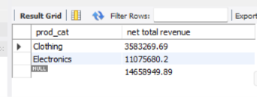

- Determine total revenue generated from male customers in the electronics category, grouped by sub-category
SELECT
pc.prod_subcat, ROUND(SUM(t.total_amt), 2) 'total revenue'
FROM
transactions t
JOIN
prod_cat_info pc
ON t.prod_cat_code = pc.prod_cat_code
join
customer c
on t.cust_id = c.customer_Id
WHERE
pc.prod_cat = 'electronics' AND c.Gender = 'M'
GROUP BY 1 ;
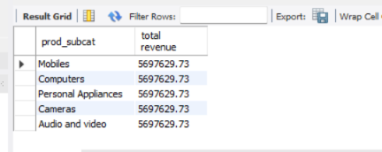

- Calculate sales and returns percentages by product sub-category, displaying the top five sub-categories by sales
SELECT
prod_subcat,
SUM(CASE
WHEN t.Qty > 0 THEN 1
ELSE 0
END) AS sales,
SUM(CASE
WHEN t.Qty < 0 THEN 1
ELSE 0
END) AS returns,
ROUND(SUM(CASE
WHEN t.Qty > 0 THEN 1
ELSE 0
END) * 100 / COUNT(*),
2) AS sales_percentage,
ROUND(SUM(CASE
WHEN t.Qty < 0 THEN 1
ELSE 0
END) * 100 / COUNT(*),
2) AS returns_percentage
FROM
transactions t
JOIN
prod_cat_info pc ON t.prod_cat_code = pc.prod_cat_code
GROUP BY pc.prod_subcat
ORDER BY sales DESC
LIMIT 5;
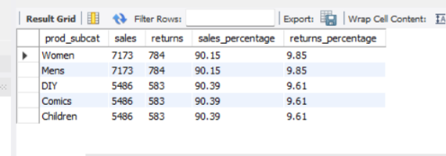

Time-based and demographic analysis
- Calculate revenue from customers aged 25-35 years during the last 30 days from the maximum transaction date
SELECT
TIMESTAMPDIFF(
YEAR,
STR_TO_DATE(c.dob, '%d-%m-%Y'),
CURDATE()
) AS age,
SUM(t.total_amt) AS revenue
FROM transactions t
JOIN customer c
ON t.cust_id = c.customer_Id
WHERE TIMESTAMPDIFF(
YEAR,
STR_TO_DATE(c.dob, '%d-%m-%Y'),
CURDATE()
) BETWEEN 25 AND 35
AND t.tran_date >= DATE_SUB(
(SELECT MAX(tran_date) FROM transactions),
INTERVAL 30 DAY
)
GROUP BY age
ORDER BY revenue DESC; #0
- Identify the product category with the highest return value in the last three months
SELECT
pc.prod_cat_code,
pc.prod_cat,
SUM(ABS(t.total_amt)) AS return_value
FROM transactions t
INNER JOIN prod_cat_info pc
ON t.prod_cat_code = pc.prod_cat_code
WHERE t.total_amt <= 0
AND t.tran_date >= DATE_SUB(
(SELECT MAX(tran_date) FROM transactions),
INTERVAL 90 DAY
)
GROUP BY pc.prod_cat_code, pc.prod_cat
ORDER BY return_value DESC; #0
- Determine which store type generates maximum sales by revenue and quantity
SELECT
Store_type,
SUM(Qty) AS total_quantity,
SUM(total_amt) AS total_revenue
FROM transactions
GROUP BY Store_type
ORDER BY total_revenue DESC;
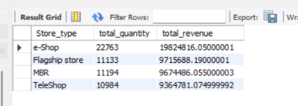

- Identify categories with average revenue above the overall average
SELECT
pc.prod_cat,
AVG(t.total_amt) AS category_avg_revenue
FROM transactions t
JOIN prod_cat_info pc
ON t.prod_cat_code = pc.prod_cat_code
GROUP BY pc.prod_cat
HAVING AVG(t.total_amt) > (
SELECT AVG(total_amt)
FROM transactions
);
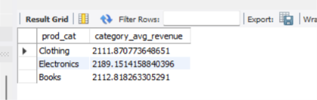

- Find average and total revenue by sub-category for the top five categories in terms of quantity sold
SELECT
pc.prod_cat,
SUM(t.Qty) AS total_quantity
FROM transactions t
JOIN prod_cat_info pc
ON t.prod_cat_code = pc.prod_cat_code
WHERE t.Qty > 0
GROUP BY pc.prod_cat
ORDER BY total_quantity DESC
LIMIT 5;
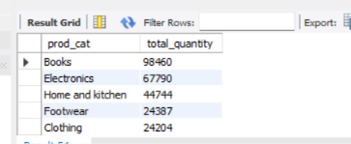

Report generation
Customer_Behavior_Complete_Project

