Game Design Document

Fill up the following document

1. Write the title of your project.

Mario Game

1. What is the goal of the game?

To collect points and escape from obstacle. It’s an infinite game.

1. Write a brief story of your game.

Mario is participated in a running race/ hurdle and the player have to

help Mario to escape the obstacle.

1. Which are the playing characters of this game?

* Playing characters are the ones who respond to the user based on the input from the user.
* Cars, monkeys, dinos, wizards, etc., are the playing characters in the game.

|  |  |  |
| --- | --- | --- |
| Number | Character Name | What can this character do? |
| 1 | Mario | This character can get the points with the help of controls. |

1. Which are the Non-Playing Characters of this game?

* Non-Playing characters are the ones that don't have an action or behavior when the user interacts with the game.
* Hurdles, stones, bananas, coins, etc., are non-playing characters in the game.

|  |  |  |
| --- | --- | --- |
| Number | Character Name | What can this character do? |
| 1 | Pipe | This character is obstacle for the Mario which stops it from collecting the points and if Mario touches it. Mario will lose |
| 2 | Coins | This character help the player to gain points |

Draw your imagination of this game. What does this game look like?

* Draw the game either on your computer or on paper.
* Add images of the game scenes to show each of the playing and non-playing characters at least once.

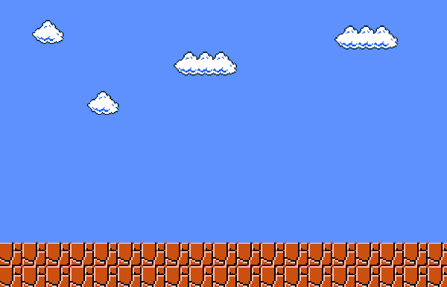 Background

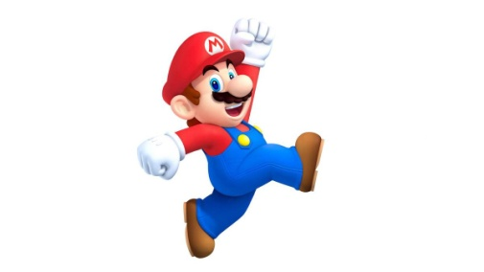 Mario (Playing Character)

 Coin (Non Playing Character, Point)

 Pipe (Obstacle, Non Playing Character)

How do you plan to make your game engaging?

If the score is incremented by 100 then the speed will increase. And try to add some sounds.