Audience Doubtless group data team, Doubtless entity data teams, Calandra infrastructure team, Technical Design Authority (TDA), Doubtless IT security team, Doubtless data protection office
Key message(s) This is a high-level technical design document for the proposed Doubtless Group Data Platform
Channel Architecture
Date of distribution Monday, 21 September 2026
Sign-off Tom Arnold (Doubtless Director of Data)
Subject/headline High-level design document

Doubtless Group Data Platform

High-level design and technical requirements

Version History:

Version | Date | Changes
0.1 | 5th August | Initial draft created
0.2 | 24th August | Architecture design decision (ADD) records completed
0.3 | 25th August | Added NFRs and Exec. Summary – ready to circulate
0.4 | 16th September | Amended NFRs post feedback.
0.5 | 17th September | Added in Data Toolkit
1.0 | 17th September | Signed-Off by Tom Arnold

Stakeholders:

Stakeholder | Organisation | Role
James Lupton | Account Manager, Cynozure | Review
Tom Wilson | Solution Architect, Cynozure | Author
Tom Arnold | Director of Data, Doubtless | Signatory
Roisin Bowen | Head of Data Engineering, Animal Friends | Review

Table of Contents
Version History: 2
Table of Contents 3
Overview 4
Project Brief 4
Functional Requirements 4
Non-Functional Requirements 7
Calandra Azure landing zone architecture 20
Tier 0 – Platform Landing Zone 20
Tier 1 – Application Landing Zone 20
Doubtless Europe and UK – Data Platform Design 23
Executive Summary 23
Architecture Design Decision Records 24
Platform Foundations 27
Integration Capabilities 30
Data Storage 37
Processing and Compute 44
Governance and Curation 49
Consuming Data 55
Platform Operations 56
Calandra Data Tool Kit Requirements – Deployment Best Practices 59
Services Required for Initial Doubtless UK and Europe Group Data Platform deployment 60
Services Required for Future Doubtless UK and Europe Group Data Platform capabilities 70

Table of Figures

Figure 1: High-level Calandra landing zone architecture, showing the new Doubtless Europe and UK data platform in an Application Landing Zone 21
Figure 2: High-level system context (C1) architecture design for the Doubtless Europe and UK Data Platform 26
Figure 3: Container (C2) level diagram depicting a number of integration capabilities supported by the data platform. 36
Figure 4: Component (C2) level diagram of the proposed storage structure for the Doubtless data platform 41
Figure 5: Component (C3) level diagram showing the indicative catalogue schema structure inside an indicative Production Catalogue 42
Figure 6: Container (C2) level diagram depicting the environment aligned catalogue structure for representative entities within Unity Catalogue 43
Figure 7: Container (C2) and Component (C3) level diagram illustrating the Azure Databricks compute private networking architecture 48

Overview

Project Brief
Doubtless UK and Europe has commissioned Cynozure to define the target architecture for a strategic enterprise group data platform that will provide become the advanced analytics platform across the Doubtless Group. The platform will support both business insight and operational reporting capabilities. This wider programme aims to consolidate the current as-is estate of multiple independently managed data platforms into a single to-be Azure-based group platform capable of supporting all relevant Doubtless entities across Europe and the UK.
The target group platform will be hosted within the German Azure region, Germany West Central, aligning with the wider Calandra and Skylark technology strategy. Where appropriate and possible the architectural patterns will also look to reflect those adopted by Doubtless Pet Insurance North America (formerly Independent Pet Holdings (IPH)).
Whilst providing a common technology foundation, the platform must preserve logical separation between operating entities, allowing each business to maintain ownership and governance of its data whilst enabling secure, governed sharing of curated information for group-wide reporting and analytics.
Cynozure has been engaged to produce the target architecture and design standards for the platform, with Hexaware responsible for implementation, operational management and ongoing support. With the platform established, entity data teams will onboard their own workloads following an agreed migration roadmap under the governance of the Doubtless Group Data function.
The programme seeks not only to centralise the underlying technology estate at a group level, placing modern cloud architecture best practices at its core, but also to establish a common operating model that improves governance, reduces engineering duplication, lowers operating costs and provides a scalable foundation for future analytics and AI capabilities across the Doubtless Group.

Functional Requirements
The Doubtless UK and Europe Group Data Platform will be designed to support a set of functional requirements. These requirements define the functional scope of the target platform. They describe the capabilities that must be enabled by the architecture but do not prescribe the detailed technologies or implementation approach. These will be covered under the section containing the Architecture Decision Records;

ID | Functional requirement
FR-001 | The platform shall provide a single, shared data platform aligning to Calandra standards and capable of supporting multiple Doubtless UK and Europe operating entities.
FR-002 | The platform shall maintain logical isolation of each entity’s data, processing workloads and consumption assets.
FR-003 | The platform shall support a hub-and-spoke operating model, providing centrally managed platform engineering capabilities while enabling analytics teams to operate within their respective entities.
FR-004 | The platform shall enable controlled sharing of data between entities through explicitly approved, curated and aggregated data products.
FR-005 | The platform shall provide a governed Group reporting layer that is logically separated from entity-level data domains.
FR-006 | The platform shall support the independent separation and extraction of an entity’s data, workloads and configuration where a legal or organisational carve-out is required.
FR-007 | The platform shall enable reusable assets across data engineering and analytics, including pipelines, models, notebooks, libraries and data products, to be shared across entities.
FR-008 | The platform shall enforce standard patterns for data ingestion, storage, transformation, data quality, publication and consumption.
FR-009 | The platform shall support a common data architecture across entities, including consistent data-layering, naming, metadata and control standards.
FR-010 | The platform shall provide role-based access control (RBAC) capabilities across infrastructure, data, engineering and consumption services.
FR-011 | The platform shall support the identification, classification, masking and controlled access of personal and sensitive data.
FR-012 | The platform shall provide distinct administrative and operating boundaries for infrastructure management, data governance, data engineering and data consumption.
FR-013 | The platform shall support repeatable onboarding of new entities, data domains, source systems and user groups using standardised configuration and deployment patterns.
FR-014 | The platform shall provide a core data observability capability supporting central metadata management, data discovery and end-to-end lineage across ingestion, transformation and consumption processes.
FR-015 | The platform shall provide operational monitoring, pipeline status, failure information and audit records for platform and data-processing activities.
FR-016 | The platform shall support the definition, execution and reporting of data quality controls across entity and Group data products.
FR-017 | The platform shall support defined data ownership and stewardship responsibilities for entity-level and Group-level data assets.
FR-018 | The platform shall provide usage and cost information that can be attributed to individual entities, workloads and platform services.
FR-019 | The platform shall support continuous integration and deployment (CI/CD) and promotion of infrastructure, platform configuration and data workloads through controlled delivery pipelines.
FR-020 | The platform shall support entities with differing levels of data maturity through a common set of platform capabilities and standard delivery patterns.
FR-021 | The platform shall provide core data ingestion capabilities supporting batch, event-driven and streaming data ingestion and processing, where required by individual use cases.
FR-022 | The platform shall support a range of governed data-consumption mechanisms, including reporting, analytical querying, data products and authorised data exchange.
FR-023 | The platform shall provide advanced data science and analytics capabilities for the development, deployment and governed operation of advanced analytics, machine-learning and generative AI workloads.
FR-024 | The platform shall be aligned with relevant Doubtless Pet Insurance North America (formerly IPH) architecture patterns and reusable technology standards where these are compatible with Doubtless UK and Europe regulatory, operational and data-residency requirements.
FR-025 | The platform shall be capable of supporting both Non-Critical (Tier 3) and Critical (Tier 1) workloads, with different recovery point, recovery time and service level objectives.

Non-Functional Requirements
The Doubtless Europe and UK Data Platform will be designed to achieve the following Non-Functional Requirements (NFR). Each NFR is linked to one, or many, of the FRs itemised in the previous section. This is designed to provide clear evidence and traceability for the each NFR, calling out its relevance in supporting the key platform goals.

Ref | Mapped FR IDs | Focus | response
NFR 1 | Service Description
NFR 1.1.1 | FR-001, FR-005, FR-022, FR-023 | Definition | The Tier 1 Doubtless UK and Europe Group Data Platform shall support governed analytics, reporting, innovation, data science, Machine Learning, Generative AI and near-real-time analytical data services.  In addition, the data platform shall be built to support operational services that are currently provided by the group entities (Claims Processing supported provided by Animal Friends). Any future operational application dependency shall be separately approved and assigned an appropriate service criticality profile (see NFR 1.2.1).
NFR 1.1.2 | FR-008, FR-009, FR-014, FR-019, FR-021, FR-022, FR-023 | Definition | For the purposes of these NFRs, the platform scope includes data ingestion using batch, intra-day, event-based and streaming patterns; data transformation and orchestration; data storage; DevOps and DataOps tooling; Azure platform services; data governance; query and visualisation; data science; Machine Learning; Generative AI; approved near-real-time analytical serving; and operational service support capabilities.
NFR 1.1.3 | FR-019, FR-013, FR-024 | Definition | The Group Data Platform capabilities described above are new at Group level.  Existing entity capabilities may be retained, integrated, extended or migrated where this is agreed through process of entity onboarding and architecture governance.
NFR 1.2.1 | FR-015, FR-005, FR-022, FR-025 | Criticality | The Group Data Platform shall have a default service criticality of Tier 3 (Non-Critical) for recovery planning. Approved workloads that provide support to critical operational services, including low latency operational reporting, shall have an elevated service criticality of Tier 1 (Critical).  A production workload or data service may be assigned a different criticality, RTO, RPO or support profile where an approved business dependency requires it.
NFR 1.2.2 | FR-005, FR-015, FR-022 | Criticality | Under the current scope, loss of the Group Data Platform shall not prevent the execution of core policy sales or claims transactions. An outage may disrupt supporting applications, reporting, analytics, data science and near-real-time analytical data services, with impact managed according to the relevant service profile.
NFR 1.2.3 | FR-015, FR-005, FR-022, FR-023 | Criticality | Service failure may result in data not being refreshed within agreed reporting or freshness targets; unavailability of Business Intelligence and reporting; unavailability of analytics, data science and innovation environments; and interruption of near-real-time analytical data services. Impacts shall be assessed against the applicable service profile.
NFR 1.2.4 | FR-002, FR-012, FR-018, FR-025, FR-015, FR-021, FR-022, FR-023 | Workload Isolation | Production ingestion, interactive analysis, reporting, data science (including AI/ML) and near-real-time workloads shall be isolated or resource-governed so that activity in one workload does not materially cause another workload to breach its approved performance, availability or cost controls.
NFR 2 | Usability
NFR 2.1.1 | FR-022, FR-003, FR-020, FR-023 | Accessibility | The platform shall support governed self-service for approved user groups, including report and dashboard consumption, governed data discovery, SQL analysis, approved analytical development and controlled sandbox or Labs access, subject to role-appropriate access and governance controls.
NFR 2.1.2 | FR-001, FR-003, FR-022 | Accessibility | The data platform shall be reachable from both Doubtless on-premises and cloud locations.
NFR 2.1.3 | FR-010, FR-012 | Accessibility | System shall support Doubtless IGA solution (Microsoft Azure Entra) RBAC access to include group-wide security policies for System administrators, developers, Analysts with Lab access and read only consumers.
NFR 2.1.4 | FR-010, FR-011, FR-012 | Accessibility | Access to platform functions and data shall be controlled through approved enterprise identity, group-based RBAC and platform-native permissions. This shall extend to row level security and column masking as required by business or security requirements.  Roles shall align to business responsibilities and least-privilege principles. Direct assignment to individual users shall be minimised and administrative access restricted to authorised roles.
NFR 2.1.5 | FR-010, FR-012 | Accessibility | The Tier 1 Data Platform shall support single sign-on through Microsoft Entra ID. Suppliers and other external users shall use approved Entra B2B guest or equivalent enterprise identity processes and shall not use platform-local username and password authentication unless explicitly approved by Group Security.
NFR 2.1.6 | FR-011, FR-002, FR-004, FR-010 | Accessibility | The Tier 1 Data Platform application shall ensure data encryption at rest (AES-256) and in transit (TLS 1.2+) by default.
NFR 2.1.7 | FR-002, FR-004, FR-010, FR-012 | Accessibility | The platform shall enforce default-deny logical isolation between entities so that an identity assigned to one entity cannot discover, query, modify or administer another entity's data, compute, metadata or consumption assets unless an approved sharing policy explicitly permits it.
NFR 2.1.8 | FR-010, FR-012, FR-013, FR-015, FR-019 | Accessibility | All production workloads shall use approved workload identities or service principals with least-privilege permissions and auditable ownership. Privileged platform access shall be restricted, auditable and subject to approved elevation controls where required.
NFR 2.2.1 | FR-022, FR-005 | Volumes - users / data / transactions | The platform shall be designed to support an indicative upper planning bound of 1,000 concurrent Power BI report consumers. The figure represents expected user concurrency rather than a fixed reserved capacity and shall be validated through representative reporting workloads before production use.
NFR 2.2.2 | FR-023, FR-003, FR-022 | Volumes - users / data / transactions | The platform shall be designed to support an indicative upper planning bound of 200 concurrent users performing interactive analytics using Databricks compute. Validation shall use a representative mix of the approved interactive workloads and user access patterns.
NFR 2.2.3 | FR-009, FR-001, FR-005, FR-022 | Volumes - users / data / transactions | The lakehouse data platform shall accommodate an indicative planning bound of 100 TB of curated logical data and shall scale beyond that bound without structural re-platforming. The figure is a capacity-planning assumption rather than a fixed allocation or maximum permitted volume.
NFR 2.2.4 | FR-009, FR-008, FR-011, FR-021 | Volumes - users / data / transactions | The Data Lake shall retain raw source data in accordance with Doubtless Group retention policies and shall be capable of scaling elastically to petabyte-scale volumes without structural re-platforming. Forecast volumes shall be refined as entities and source systems are onboarded.
NFR 2.2.5 | FR-001, FR-021, FR-022, FR-023 | Volumes - users / data / transactions | Platform shall be able to scale without requiring physical hardware upgrade.
NFR 2.2.6 | FR-021, FR-008 | Volumes - users / data / transactions | The data platform shall support transactional-data ingestion using batch, intra-day, event-driven pull and streaming push patterns.  The selected pattern, cadence, throughput and freshness target shall be defined for each onboarded data asset or service profile. Specific data ingestion frequency requirements are specified in NFR 9.1.2
NFR 2.3.1 | FR-001, FR-021, FR-022, FR-023 | Scalability | The data platform services shall be capable of auto scaling based on the demand placed on those services.
NFR 2.3.2 | FR-018, FR-021, FR-023 | Scalability | The platform shall support configurable scaling and consumption controls that balance workload performance with cost. Limits, alerts and the required behaviour when a control is reached shall be defined for each relevant workload or service class.
NFR 2.3.3 | FR-009, FR-001, FR-018 | Scalability | Storage shall be able to scale separately from compute.
NFR 2.3.4 | FR-021, FR-008 | Scalability | Data ingestion and transformation services shall scale to the indicative baseline, peak and growth volumes defined for each workload, while meeting the applicable processing-time or freshness target.
NFR 2.4.1 | FR-018 | Licensing | The platform shall provide Cost Management and FinOps visibility at the lowest technically practical level, including attribution by legal entity, environment and major workload or service. Shared platform costs shall be identifiable and allocated using appropriate tagging (as laid out in the design decision records).
NFR 2.4.2 | FR-018, FR-015 | Licensing | The Doubtless UK and Europe Data Team shall be able to monitor resource consumption and receive configurable alerts when agreed budgets, limits or anomalous usage thresholds are reached. Ownership and escalation routes shall be defined in the operating model.
NFR 2.4.3 | FR-018 | Licensing | The platform shall provide capabilities to identify and implement cost optimisation across chargeable services, including appropriate right-sizing, scheduling, scaling, usage analysis and optimisation recommendations where supported.
NFR 2.5.1 | FR-012, FR-019, FR-023 | Environments | The platform shall maintain segregation between Development, Test, Staging and Production environments. Non-critical (Tier 3) analytics and reporting workloads will use a separate set of environments to the Critical (Tier 1) operational supporting workloads.  Promotion into Production shall be controlled, and Production services shall not depend on Development or Testing assets.
NFR 2.6.1 | FR-011, FR-008, FR-009 | Data Retention & Archival | Data retention, archival and deletion shall comply with the Doubtless Group Data Retention Policy across relevant data, backups, logs and retained history. Any technical or business exception shall be documented, risk assessed and formally approved.
NFR 2.6.2 | FR-008, FR-009, FR-011, FR-014 | Data Retention & Archival | Retention, legal hold and deletion policies shall be applied consistently across raw, curated, serving, metadata, feature, vector and backup stores, with deletion propagated and evidenced within the policy-defined period.
NFR 3 | Reliability
NFR 3.1.1 | FR-015, FR-005, FR-021, FR-022 | Availability | The Group Data Platform shall target 99.9% availability, equivalent to no more than approximately 8 hours 46 minutes of unplanned downtime per year.  Measurement scope, reporting window and approved exclusions shall be documented. Workload-specific service profiles may define different targets where explicitly approved.
NFR 3.1.2 | FR-019, FR-015, FR-022 | Availability | Software deployments and upgrades shall be controlled and designed to minimise user disruption, with availability maintained within the applicable service target.  Vendor-managed services may apply releases according to their supported service model.
NFR 3.2.1 | FR-015, FR-021, FR-022 | Recoverability | The platform shall provide fault-tolerance and error-handling appropriate to each workload, including detection of failures, controlled retries where safe, failure isolation, preservation of diagnostic context and restart from an appropriate recovery point.
NFR 3.2.2 | FR-015, FR-005, FR-014 | Recoverability | The platform shall provide recoverability for critical data and platform state, including relevant databases, storage, infrastructure and platform configuration, catalogues and permissions, pipeline and job definitions, and model or application configuration where in scope.  The recovery mechanism may vary by component.
NFR 3.2.3 | FR-015, FR-005 | Recoverability | Recoverable backup copies shall be retained for a minimum Group-agreed baseline of seven days. Longer retention shall be applied where required by Group policy, the applicable service profile, detection timescales or regulatory obligations.
NFR 3.2.4 | FR-015, FR-005 | Recoverability | Backup-protected platform state shall be captured at least daily, providing a default backup RPO of no more than 24 hours.  A different RPO or recovery mechanism shall be defined where required by a workload service profile or native service capability.
NFR 3.2.5 | FR-015, FR-006, FR-024 | Recoverability | Backups and recoverable configuration shall use zone-redundant storage within the approved primary region where technically supported. Cross-region disaster recovery is not required under the current scope unless subsequently approved through architecture and risk governance.
NFR 3.2.6 | FR-015, FR-005, FR-022 | Recoverability | An active disaster-recovery environment is not required under the current platform scope and criticality. This decision shall be reviewed if an operational application dependency or higher-criticality workload is approved.
NFR 3.2.7 | FR-015, FR-005, FR-022 | Recoverability | Following a disaster or major service failure, the platform shall be restorable in accordance with the approved RTO and RPO for the affected service profile and the applicable Doubtless ITDR and BCP requirements. The approved RTO for the platform are;  - Non-Critical (Tier 3): Group Analytics Platform standard workloads – 24 hours  - Critical (Tier 1): Operational service support and low-latency reporting requirement – 8 hours
NFR 3.2.8 | FR-019, FR-007, FR-008 | Recoverability | Platform code, Infrastructure as Code, pipeline and job definitions, deployment artefacts, configuration and other recoverable software assets shall be stored in approved version-controlled repositories where technically applicable.
NFR 3.2.9 | FR-002, FR-004, FR-006, FR-011, FR-024 | Recoverability | Entity data, backups, metadata and diagnostic logs shall remain in approved geographic regions. Cross-border replication or sharing shall require a recorded legal basis, data-owner approval and technical enforcement.
NFR 3.2.10 | FR-021, FR-025, FR-008, FR-015, FR-016 | Recoverability | Pipelines classified as Critical (Tier 1), shall support controlled backfill or replay for defined periods without requiring a full platform reload. Streaming and event-driven services shall define checkpoint, replay and recovery behaviour consistent with the approved RPO and duplication tolerance.
NFR 3.2.11 | FR-008, FR-015, FR-025 | Recoverability | Recovery procedures for critical services shall be tested at an agreed frequency against the applicable RTO and RPO, with results and material remediation actions retained as evidence.
NFR 3.2.12 | FR-014, FR-017, FR-025, FR-012, FR-015 | Recoverability | Critical production data services shall maintain documented upstream and downstream dependencies, named support ownership and an escalation route aligned to their approved service profile and support hours.
NFR 4 | Performance
NFR 4.1.1 | FR-022, FR-005 | Response Time | For approved interactive workloads joining two to three modelled tables and returning data for the current business date, the platform shall target a response time of no more than two seconds against the designated Silver or Gold serving datasets under the representative data volume and concurrency profile.
NFR 4.1.2 | FR-022, FR-023 | Response Time | The platform shall support long-running analytical queries through configurable timeouts, workload and resource management, cancellation and monitoring controls.
NFR 4.1.3 | FR-005, FR-021, FR-022 | Response Time | The platform shall support governed access to Bronze-layer data for approved data engineering and data science use cases where unmodelled or source-aligned data is required. Bronze shall not be treated as an operational reporting layer and no interactive response-time target shall apply unless separately approved.
NFR 4.2.1 | FR-018, FR-015 | Shutdown Time | The platform shall support automated or scheduled shutdown of chargeable compute and services when they are not required, where shutdown can occur without breaching an availability, ingestion, processing or freshness target.
NFR 4.3.1 | FR-018, FR-015 | Start-up Time | The platform shall support automated, event-driven and scheduled startup of chargeable compute and services where required to meet workload availability, processing or freshness targets.
NFR 4.4 | FR-021, FR-008 | Throughput - speed of handling above volumes | Ingestion services shall be capable of processing an indicative upper planning bound of 10 million records in a batch. Performance validation shall use representative record sizes, formats and source characteristics for the workload without changing the agreed record-count bound.
NFR 4.4 | FR-021, FR-006, FR-013 | Throughput - speed of handling above volumes | The platform shall support controlled full refreshes and Day 0 loads that process the complete available historical dataset for an onboarded source, subject to the agreed onboarding or recovery window.
NFR 4.4 | FR-021, FR-008 | Throughput - speed of handling above volumes | The platform shall be capable of processing and transforming an indicative upper planning bound of 10 million incremental records per batch within the approved workload SLA. Validation shall use representative record sizes, transformation complexity and concurrency without changing the agreed record-count bound.
NFR 5 | Supportability
NFR 5.1.1 | FR-015, FR-014, FR-019 | System Management | All platform components shall generate structured operational logs covering informational events, warnings, errors and relevant audit events, with sufficient context to support troubleshooting and monitoring.
NFR 5.1.2 | FR-015, FR-011 | System Management | System logs shall support configurable retention, archival and deletion policies aligned to Calandra Group operational, security and compliance requirements.
NFR 5.1.3 | FR-015, FR-014, FR-018 | System Management | The platform shall provide monitoring and observability capabilities to assess system health, workload status, performance, failures and resource utilisation.
NFR 5.1.4 | FR-015, FR-010, FR-011 | System Management | The platform shall support forwarding agreed security, audit and operational log events to the strategic Calandra Tier 0 Microsoft Sentinel SIEM for SOC monitoring.
NFR 5.2.1 | FR-015, FR-019, FR-024 | System maintenance / maintainability / upgradability | Vendor-managed patching and upgrade capabilities shall be used where applicable.  Customer-managed components shall follow an approved Doubtless Group patching and maintenance process.
NFR 5.2.2 | FR-015, FR-019, FR-024 | System maintenance / maintainability / upgradability | Platform components shall remain on vendor-supported versions and receive security patches within timescales defined by vulnerability severity, vendor guidance, compatibility and Calandra Group security policy.  Any exception shall be risk assessed and approved.
NFR 5.3.1 | FR-011, FR-015, FR-024 | Antivirus and patching | Malware protection and endpoint security controls shall be applied in line with Calandra Group security policy where technically applicable. For managed cloud services, equivalent vendor-native security controls shall be relied upon where traditional antivirus is not applicable.
NFR 5.4.1 | FR-019, FR-015 | Releases | Releases shall support rollback or an equivalent documented recovery approach to restore the previous stable service state where technically feasible.
NFR 6 | Implementation
NFR 6.1.1 | FR-018 | Third-party / external components | The platform shall provide cost-management controls for chargeable services, including budgets, usage monitoring, alerts, tagging/attribution, auto-scaling controls and configurable resource limits to minimise unexpected spend.
NFR 6.2.1 | FR-008, FR-013, FR-015, FR-024 | Ease / approach | The platform shall be provided as a service using platform as a service (PaaS) components where possible to minimise deployment and installation steps
NFR 6.2.2 | FR-019, FR-006, FR-013 | Ease / approach | Customer-managed infrastructure and platform configuration shall be defined and deployed through version-controlled Infrastructure as Code (IaC) where technically supported.
NFR 6.3.1 | FR-024, FR-008, FR-009, FR-019 | Standards compliance | Development on the platform shall be delivered in line with Calandra development best practices.
NFR 6.4.1 | FR-023, FR-007, FR-020 | Data toolkit Implementation languages | The platform shall support industry-standard development languages and interfaces required for data engineering, analytics and data science workloads, including (but my no means limited to) SQL and Python, with additional languages supported where there is a defined use case.
NFR 7 | Interface
NFR 7.1.1 | FR-007, FR-008, FR-021, FR-022, FR-023, FR-024 | External Systems | The platform shall support integration with approved enterprise tools and services across data ingestion, transformation, reporting, governance, data science and operational use cases through open standards, APIs and supported connectors, without unnecessary dependency on a single consuming application.
NFR 7.1.2 | FR-022, FR-021 | External Systems | The platform shall support secure integration with external applications using appropriate industry-standard interfaces, including JDBC/ODBC, APIs, event/streaming interfaces and supported native or third-party connectors.
NFR 8 | Physical
NFR 8.1.1 | FR-002, FR-003, FR-012, FR-024 | Location | The data platform shall be deployed as a Tier 1 application within the approved Calandra landing zone structure with the Azure region Germany West Central. The platform shall comply with the associated security, networking, policy and governance controls set out by the Calandra Tier 0 platform landing zone.
NFR 9 | Data Extraction, Load and Transformation
NFR 9.1.1 | FR-021, FR-008, FR-013 | Ingestion | The platform shall support ingestion from approved source systems using batch, intra-day, event-driven and streaming patterns through supported interfaces and connectors.
NFR 9.1.2 | FR-021 | Ingestion | The platform shall be capable of supporting ingestion profiles ranging from;  - Batch within a 24-hour window  - Intra-day processing from six hours to 15 minutes  - Event-driven pull polling intervals of approximately 0.5 to 5 seconds  - Near-real-time streaming with sub-second event ingestion where supported  These are indicative platform capability bounds, not universal end-to-end data-freshness SLAs. Each onboarded entity shall define its required freshness targets per use case.
NFR 9.1.3 | FR-008, FR-016, FR-021 FR-009, FR-014, FR-015, FR-011 | Ingestion | Ingestion shall detect source-schema changes and prevent unapproved breaking changes from silently affecting consumers. Invalid or rejected records shall be captured, quarantined where appropriate and traceable without silent data loss.
NFR 9.2.1 | FR-008, FR-009, FR-021 | Transformation | The platform shall support transformation of data using batch, intra-day, event-driven and streaming processing patterns where required by the approved workload or data-service profile.
FR 9.3.1 | FR-008, FR-021, FR-025 | Testing | Production changes shall support automated testing appropriate to the workload, including unit tests, data-transformation tests, configuration validation and deployment verification, with failures preventing uncontrolled promotion.
NFR 9.4.1 | FR-016, FR-021, FR-008, FR-014, FR-015, FR-022 | Workload Management | Where workloads may be retried, replayed or restarted, processing shall avoid duplicate, lost or inconsistent data outcomes and shall preserve the integrity of downstream data products.
NFR 9.4.2 | FR-008, FR-015, FR-021, FR-014, FR-025 | Workload Management | Production workflows shall support dependency management, controlled retries, failure handling and restart from an appropriate recovery point, with status and diagnostic information available to support teams.
NFR 10 | Data Governance
NFR 10.1.1 | FR-014, FR-009, FR-017 | Data Dictionary, Lineage and Stewardship | The data platform solution shall integrate with or support an enterprise data catalogue and business glossary covering relevant data assets across the wider technology estate, including definitions, classifications, ownership, stewardship and links to technical metadata.  The capability shall support search, collaboration and controlled maintenance of these definitions.
NFR 10.1.2 | FR-014, FR-015, FR-017 | Data Dictionary, Lineage and Stewardship | The platform shall provide automated end-to-end lineage across supported data assets and transformations on the platform, and integrate with wider enterprise lineage/catalogue tooling where technically supported, sufficient to meet Doubtless audit and governance requirements.
NFR 10.1.3 | FR-017, FR-005, FR-016 | Data Dictionary, Lineage and Stewardship | The solution shall support assignment and visibility of accountable data owners and stewards for governed data assets, business definitions and KPIs, with ownership maintained through agreed governance processes.
NFR 10.2.1 | FR-011, FR-024 | Compliance | The data platform shall support Doubtless in meeting applicable regulatory and data protection obligations, including PRA, FCA and UK GDPR requirements, through appropriate security, access control, auditability, retention, data minimisation, data residency and governance capabilities.
NFR 10.3.1 | FR-004, FR-005, FR-009, FR-017 | Data Management | The platform shall support governed management and reuse of approved reference data across Tier 1 entities, including defined ownership, versioning, change control and appropriate entity-level access controls.
NFR 10.3.2 | FR-010, FR-012, FR-017, FR-019 | Data Management | Platform administration, security administration, data ownership, data stewardship, engineering deployment and production approval duties shall be separated, with conflicting assignments prevented or explicitly risk-accepted and reviewed.
NFR 10.3.3 | FR-011, FR-013, FR-022 | Data Management | Personal and sensitive data shall be classified before general consumption, protected by default-deny access, and masked, tokenised or redacted according to classification and user purpose.
NFR 10.3.4 | FR-011, FR-012, FR-019 | Data Management | The platform shall support data minimisation and approved deletion or anonymisation across relevant raw, transformed and derived datasets where legally required. Production personal data in non-production environments shall be restricted and masked, anonymised or explicitly approved where required and within the guidelines of GDPR.
NFR 10.4.1 | FR-004, FR-010, FR-011, FR-017 | Data Sharing | Every cross-entity data share shall record the data owner, purpose, consumer, classification, permitted fields, legal basis where required, approval, review date and expiry; access shall be revocable without rebuilding the source data product.
NFR 10.5.1 | FR-005, FR-016, FR-017, FR-022 | Data Quality | Data products and pipelines shall implement automated checks for agreed data-quality rules, with results, failures and exceptions recorded and visible to the accountable owner.
NFR 10.5.2 | FR-014, FR-015, FR-016, FR-017, FR-025 | Data Quality | All production datasets shall have an approved freshness target and shall expose monitoring and alerting when expected data is late, incomplete or stale.
NFR 11 | Source Control
NFR 11.1.1 | FR-019, FR-008, FR-013, FR-024 | Infrastructure as Code (IaC) | The data platform shall be deployed using IaC in accordance with approved Calandra IaC standards, including version control, peer review, environment parameterisation, secret management and controlled deployment.
NFR 11.1.2 | FR-007, FR-008, FR-013, FR-019 | Infrastructure as Code(IaC) | IaC modules shall be parameterised and reusable where this supports known Doubtless Group or entity deployment patterns, without requiring unnecessary abstraction for one-off components.
NFR 11.2.1 | FR-012, FR-019 | Continuous Integration and Continuous Deployment (CI/CD) | 11.2.1 Infrastructure, platform configuration, permissions, policies and data workloads shall be promoted through controlled pipelines using immutable versioned artefacts; direct production changes shall be blocked except through audited break-glass procedures.
NFR 11.2.2 | FR-008, FR-011, FR-016, FR-019 | Continuous Integration and Continuous Deployment (CI/CD) | 11.2.2 Production promotion shall be blocked when required unit, integration, security, policy, data-quality, compatibility or performance tests fail.
NFR 11.2.3 | FR-019, FR-009, FR-007, FR-013, FR-015 | Continuous Integration and Continuous Deployment (CI/CD) | Production workloads shall use controlled and traceable package dependencies on supported versions.
NFR 11.3.1 | FR-010, FR-019, FR-009, FR-012, FR-013 | Secret Management | Secrets, keys and service credentials shall be stored and accessed through approved secret-management mechanisms and shall not be embedded in code, notebooks or deployment artefacts.
NFR 12 | Analytics and AI
NFR 12.1.1 | FR-010, FR-011, FR-014, FR-015, FR-023 | AI Assisted Analytics | Natural-language and AI-assisted analytics shall enforce the same identity, data-access, classification, masking, lineage and audit controls as other approved platform access methods.
NFR 12.1.2 | FR-009, FR-014, FR-017, FR-019, FR-023 | AI Assisted Analytics | AI-assisted analytics shall use governed business definitions, approved metrics and trusted data context, with accountable ownership and controlled change, so that answers are consistent with agreed business meaning.
NFR 12.1.3 | FR-018, FR-019, FR-023 | AI Assisted Analytics | AI-assisted analytics shall support repeatable evaluation against agreed business questions and expected results before production release and after material changes, and shall expose usage and cost information sufficient for monitoring and attribution.
NFR 12.2.1 | FR-014, FR-019, FR-023 | ML and GenAI Lifecycle | Production models shall be versioned, reproducible, approved and promoted through controlled environments, with traceability to the training data, code, configuration and evaluation evidence used for the release.
NFR 12.2.2 | FR-010, FR-015, FR-018, FR-023, FR-025 | ML and GenAI Lifecycle | Where production model-serving endpoints are approved, they shall have service-profile targets for availability, latency, scaling, authentication and cost.  They shall be monitored for errors, usage and agreed model-quality or drift indicators.
NFR 12.2.3 | FR-010, FR-015, FR-019, FR-023 | ML and GenAI Lifecycle | Production prompts, agent instructions, tools and model configuration shall be version-controlled and promoted through an approved change process.  Deployed agents shall use identifiable least-privilege identity context and auditable access. Material business actions shall use risk-appropriate approval or control points.

Calandra Azure landing zone architecture

The Doubtless UK and Europe group data platform will form part of the wider Calandra Azure infrastructure model. Calandra is deployed via Azure Landing Zones as per Microsoft’s cloud adoption framework. A high-level architecture diagram illustrating this design is shown in Figure 1. A brief summary of the supported capabilities for each landing zone layer are described as follows;

Tier 0 – Platform Landing Zone
The Tier 0 platform landing zone is a shared enterprise layer, centrally managed by the Calandra infrastructure team. Its purpose is to establish a secure and scalable foundation for the Azure estate. It includes the following core capabilities;
- Azure Management Groups and Subscriptions Hierarchy: Used to apply consistent policy, access control, cost management and monitoring across the tenancy.
- Identity & Access Management (IAM): Centralised via Azure Entra ID to provide group-based user access, role-based access control (RBAC), Conditional Access, and PIM.
- Policy & Security Governance: Azure Policies, Security Centre, and Defender integrations are defined here. Azure Purview is also provisioned at tenancy level and is managed in the Tier 0 landing zone.
- Hub Network: A Tier 0 VWAN HUB provides shared routing, network inspection, firewall services, DNS services and Azure Bastion. All data ingress and egress is managed through the Tier 0 VWAN, including all user access from the internet.
- Centralised Platform services: Including logging, monitoring and infrastructure deployment through Azure DevOps.

Tier 1 – Application Landing Zone
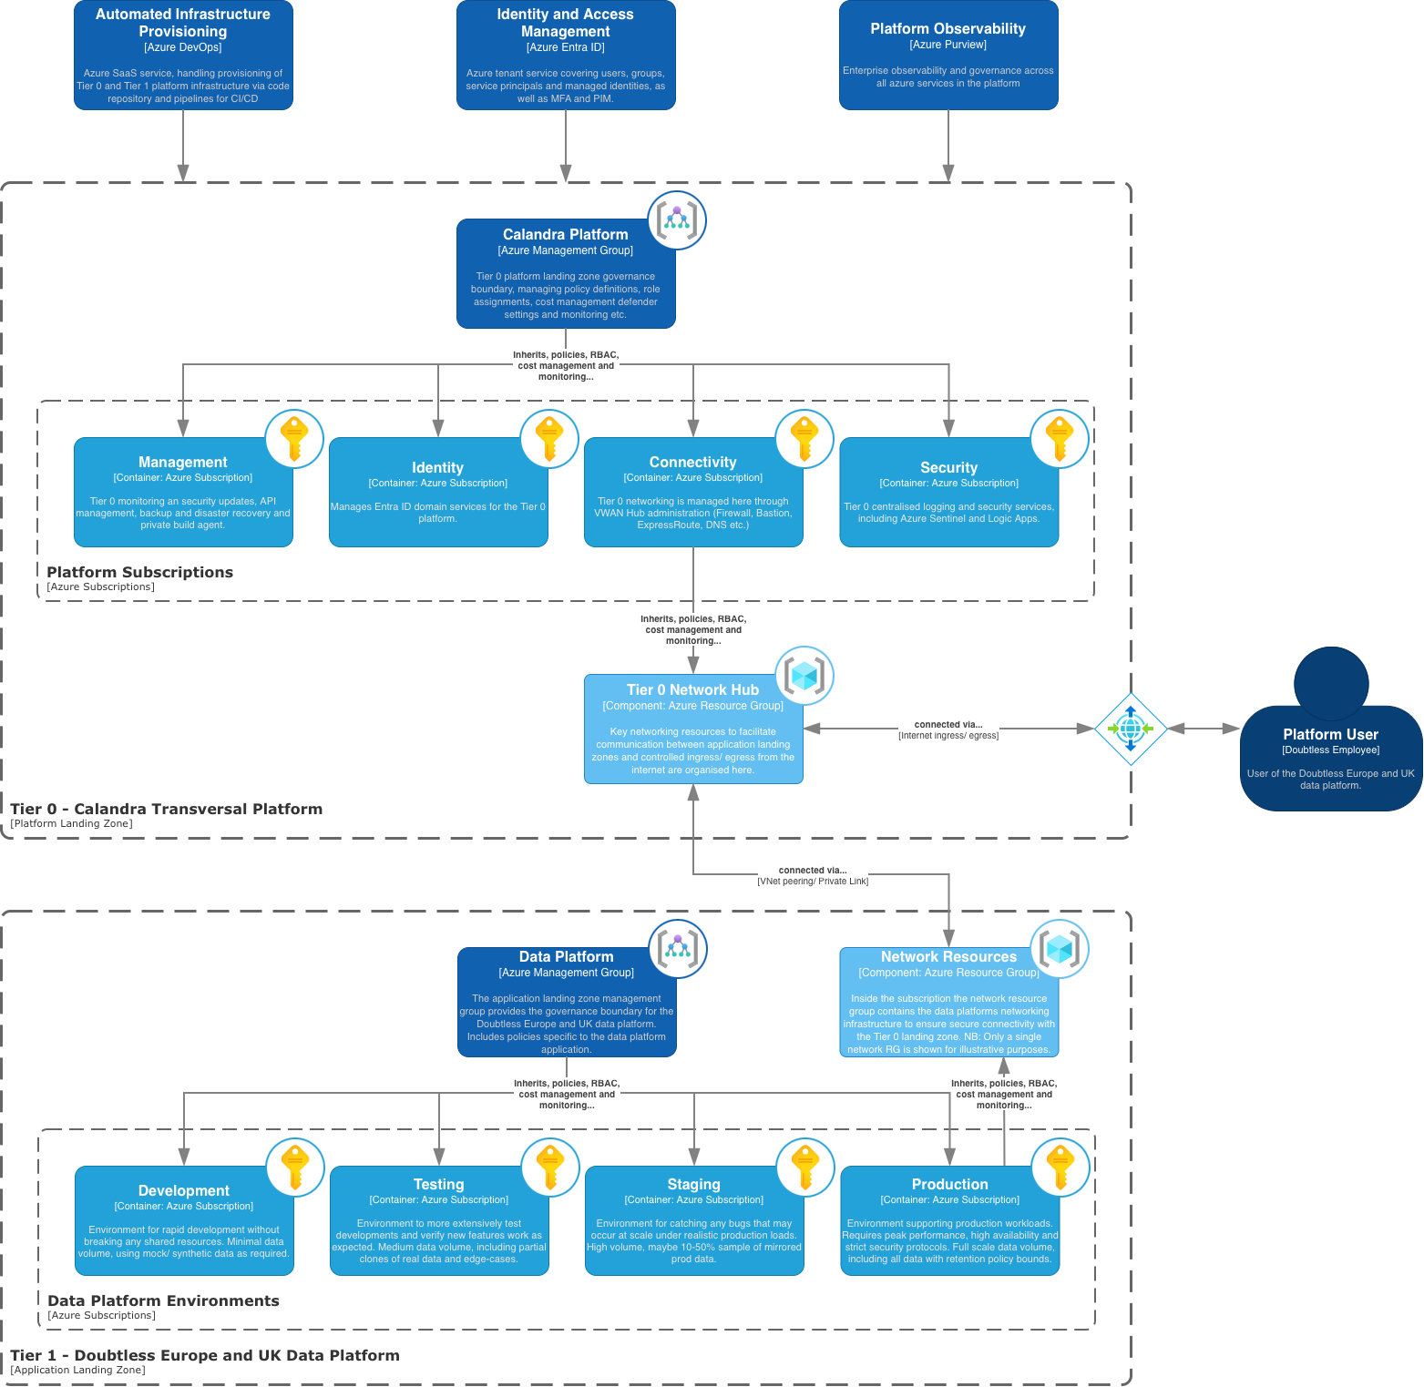
As per the landing zone cloud adoption framework, application workloads are deployed here. This includes the Doubtless Europe and UK Data Platform. The Tier 1 application landing zone is owned and operated by Doubtless Europe and UK, allowing for bespoke application delivery within the specified Calandra infrastructure guardrails.
Figure 1: High-level Calandra landing zone architecture, showing the new Doubtless Europe and UK data platform in an Application Landing Zone
The application landing zone has its own management group, which is designed to both inherit global policies from the Tier 0 landing zone as well as define its own policies specific to the application.
It is best practice to separate the data platform operating environments at the subscription level, which can inherit policies, RBAC cost controls etc. from the application management group.
Networking resources are contained in a resource group inside each subscription (only the resource group attached to production has been illustrated on the diagram as an example). These are connected to the Tier 0 VWAN hub, which securely manages all ingress and egress to the internet and services outside the platform.

Doubtless Europe and UK – Data Platform Design
A high-level system context (C1) architecture diagram for the Doubtless Europe and UK data platform is illustrated in Figure 2. The capabilities of this platform are carefully aligned to support the Functional Requirements, with specific elements and configurations put in place to satisfy all Non-Functional Requirements.

Executive Summary
The Doubtless UK and Europe Data Platform will provide a single, scalable foundation for governed reporting and analytics across the Group while preserving appropriate autonomy for each operating entity (PPUK, Agila, Figo etc.). It will be built natively on Microsoft Azure, using managed platform-as-a-service services (PaaS) wherever practical, with Azure Databricks as the core engine for data ingestion, processing and governed access. This aligns the platform with the Calandra Azure Landing Zone architecture and Azure’s Cloud Adoption Framework, reduces infrastructure overhead and establishes consistent security, resilience and operational standards.

The architecture adopts a shared, multi-entity model with logical isolation of each entity’s data and compute. A central platform engineering and governance team will own the common platform, security, standards and operations, while entity teams retain responsibility for their analytical use cases and business outcomes.
Development, Testing, Staging and Production environments will be separated, with sensitive and personally identifiable (PII) data restricted to Production only. Anonymised or representative datasets will be used elsewhere. In Production a dedicated Operational and Analytics workspaces will separate low-latency, sub-ten-second operational reporting from conventional analytical workloads and allow different service levels where required.

The platform will support batch, streaming and event-driven ingestion capabilities. Core Databricks capabilities will be preferred by default, supplemented by Azure services where source-specific patterns require them. Direct access to production source systems is not the default: Trusted data should be ingested to a controlled Group-owned RAW Storage boundary. Untrusted data will first enter isolated Azure Blob Landing Storage for security and vulnerability screening (see ADD-055 for full definition). Outbound third-party extracts will use the same controlled boundary to ensure tight security across the platform. Databricks Lakeflow Jobs and Pipelines will provide the principal orchestration capability.

Azure Data Lake Storage Gen2 will be the primary storage layer, with separate accounts by environment and entity-level separation by container. Delta Tables will be the standard structured data storage format on the platform. Structured data will be managed and curated using Databricks Unity Catalogue, with environment-aligned catalogues for each entity (i.e. each entity will have four catalogues). The data in each catalogue will progress through a medallion architecture, utilising Bronze, Silver and Gold schemas, moving from source-aligned records to validated, conformed and business-ready products. A dedicated Labs schema will be provisioned in production catalogues to provide a safe and governed space for platform users to experiment on production data. Unity Catalogue managed tables will be the default and external tables will be permitted only where interoperability, migration or lifecycle requirements justify the additional governance burden. Source-native RAW files will remain available through governed external volumes to support efficient ingestion, replay and auditability. Appropriate retention policies will apply to storage accounts in line with Calandra’s data etention policy.

Transformation will be SQL-first, using dbt Core on Databricks as the primary engine, with transformations in Lakeflow Pipelines used where better suited, particularly for low-latency ‘operational’ reporting use cases. Data quality rules and tests will be baked into dbt models, with re-usable logic used where possible. Compute will be serverless-first by default, selected according to workload and ephemeral for automated production processing. Classic compute will be an exception for technical or commercial reasons, such as predictable always-on operational reporting. Centrally defined policies, templates, identities and tags will enforce standards while enabling entity-level cost attribution. Reusable data products, pipelines and code will be version-controlled through Azure DevOps. All deployed infrastructure will be managed and controlled using Terraform.

Governance and security are identity-led and least-privilege by design. Microsoft Entra ID will be authoritative for users, groups and workload identities. Access will be group-based by default and separated into persona, entity-data and sensitive-data entitlements. Sensitive fields will be masked by default, with cleartext access separately approved for specific use-cases. Unity Catalogue will provide central permissions, metadata, lineage, auditing and fine-grained controls, while managed identities and service principals only will execute Production workloads. Power BI will be the strategic reporting tool, consuming Gold data by default, while Databricks ML, Genie, Apps and Azure AI Foundry support self-service, customised and more advanced data consumption use cases. Azure Private Link is the default method of facilitating secure network connectivity throughout the platform as per Calandra platform requirements. Azure Log Analytics Workspace will provide centrally governed logging, monitoring and alerting, with a Microsoft Sentinel enabled workspace used to collect all platform specific SIEM records and events at the platform landing zone level, whilst a dedicated workspace will be responsible for collecting data platform operational logs at the application landing zone level. Production will use zonal resilience by default, whilst other environments will default to local resilience. Geographic redundancy is explicitly out of scope for the platform.

Architecture Design Decision Records
The data platform high-level architecture design is underpinned by a number of key architecture design decision records (ADD). These will be unpacked in this section, and have been broken down under the following categories;

Category | Description
Platform foundations | Here we cover the decision records fundamental to establishing the data platform foundations
Ingestion capabilities | Here we cover the decision records that describe supporting three core ingestion capabilities, Streaming, Event Driven and Batch.
Data Storage | Here we cover the decision records that describe the approach for data storage
processing and compute | Here we cover the decision records that describe data processing, transformations and general compute policy
Governance and curation | Here we cover the decision records that describe governance of data on the platform, including data quality and curation
consuming data | Here we cover the decision records that describe the capabilities for consuming data from the platform
platform operations | Here we cover the decision records that describe the efficient operation and management of the platform, including logging, monitoring and infrastructure as code considerations

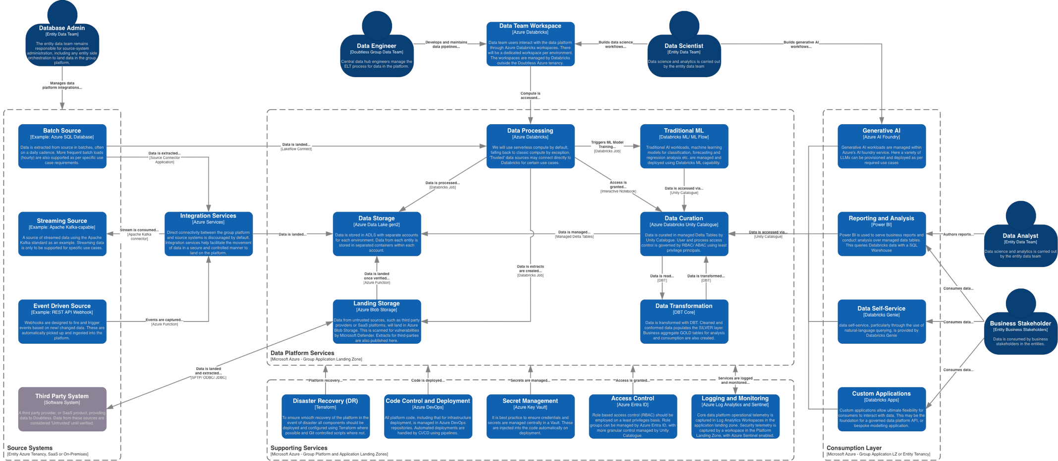
Figure 2: High-level system context (C1) architecture design for the Doubtless Europe and UK Data Platform

Platform Foundations
ADD ID | Mapped FR-IDs | Decision | Rationale
ADD-001 | FR-001, FR-008, FR-013, FR-020, FR-024 | Azure will be the strategic cloud platform | The Doubtless Group Data Platform will be built natively on Microsoft Azure using managed PaaS services wherever practical.  This approach aligns with the Calandra Azure Landing Zone architecture, reduces infrastructure management, improves scalability, resilience and security, and enables standardisation across the whole Doubtless estate.
ADD-002 | FR-001, FR-007, FR-008, FR-009, FR-014, FR-021, FR-022, FR-023 | Azure Databricks will be the core data platform | Azure Databricks will be the established central platform for data processing, engineering and governed data access. The use of Databricks will supports batch, event driven and streaming ingestion workloads, as well as future machine learning and AI workloads while providing data governance through Unity Catalogue.
ADD-003 | FR-002, FR-003, FR-012, FR-019 | Environment aligned Databricks Workspace strategy | The platform will leverage a Centralised Databricks Workspace strategy, with a single workspace aligned to the agreed environment structure (Development, Test, Staging, Production – see ADD-052) and not individual entities. All users of the platform will interact with Databricks services via the workspace, or using appropriate supported connectors and authentication methods to third party tools (e.g. VSCode, Cursor etc.). Workspaces are managed by Databricks and these sit outside the Calandra tenancy in the Databricks Control plane. Access to workspaces is governed with Azure Entra through identity federation. Granular access to features within the workspace is governed via RBAC granted at the Databricks account level.  This strategy will allow for clear governance by the central (hub) data team, and will reduce workspace admin overhead.
ADD-016 | FR-001, FR-002, FR-004, FR-005, FR-006, FR-010, FR-012 | The platform will support a multi-entity architecture with appropriate logical isolation | The platform will operate as a shared Azure and Databricks environment based around the Azure Landing Zone cloud adoption framework, with logical isolation of both compute and data storage for each of the operating entities.  This will be carried out using Unity Catalogue, appropriate RBAC aligned to Microsoft Entra Groups and segregated storage structures.
ADD-017 | FR-003, FR-012, FR-017, FR-020 | Platform governance will follow a central engineering, federated analytics operating model | A central platform engineering and governance team will own the shared Azure and Databricks platform, standards, security and operations, whilst individual operating entities retain ownership of their analytical use cases and business outcomes.  This balances standardisation with local autonomy and aligns with the new target operating model for Doubtless.
ADD-052 | FR-002, FR-006, FR-011, FR-012, FR-019, FR-024 | The platform will have Dev, Test, Staging and Prod Environments | This aligns with the environment structure in use by Doubtless Pet Insurance North America . Separate environments, following the same structure, will be used for Non-Critical (Tier 3) analytics and reporting workloads and Critical (Tier 1) operational service support.workloads. The environments are defined down as follows;  - Development - Used by developers to write and test new code for the platform (ingestion flows, integrations with external platforms etc.). This will contain minimal data by design, mainly using dummy/ small obfuscated samples where possible. Sensitive and PII data NOT allowed in development environments under current GDPR guidelines.  - Testing - Used for automated testing, integration testing and manual quality assurance (QA) validation. To contain standardised test datasets, including edge-case datasets at small to medium volume (GB scale). Sensitive and PII data NOT allowed in Testing environments under current GDPR guidelines  - Staging – Used for performance testing under near-production loads as well as user acceptance testing. This will contain a pre-defined period of anonymised data from prod. Volume of data is considered high, with perhaps 30% of the true production volume. Sensitive and PII data NOT allowed in Staging environments under current GDPR guidelines  - Production – To contain real, live and sensitive data in line with Doubtless retention policy. Very high data volume for all entities across the group, on the order of terabytes to petabytes.
ADD-053 | FR-001, FR-008, FR-009 | All services deployed across the platform will follow a standardised naming convention | Align to a standardised naming convention that can be used across all services to provide consistency and clarity across the group platform.  We recommend employing the service naming convention in-line with that used for the Calandra Azure Landing Zone design. The templated format is as follows;  doubtless-<service>-<asset>-<identifier>-dewc-<environment>-<count>  Where;  - <service> is replaced by shorthand notation of the azure service being deployed;  - e.g. for Azure Databricks this would be ‘adb’  - <asset> is replaced by shorthand notation of the asset where the service is deployed;  - e.g. for Doubtless Pet Insurance Partnerships – UK and Europe (formerly PPUK) this would be ‘dpetuk’  - e.g. for Agila this would be ‘agl’  - e.g. for Group services this would be ‘grp’  - <identifier> (optional) is replaced by shorthand notation describing a particular instance of the service;  - e.g. for example for SSIS integration runtime this might be ‘ssis’  - <region> is replaced by shorthand notation for the region where the service is deployed. As the Doubtless UK and Europe group platform will be deployed in the Germany West Central region this will always be ‘dewc’.  - <environment> is replaced by shorthand notation for the desired environment;  - e.g for production this would be ‘prod’  - <count> is replaced by the count of identical instances of a service;  - E.g. If Doubtless have two ADF instances with SSIS IR then the count on each will be 001 and 002.  Additional points on the naming convention template;  - Where possible it is desirable to keep the shorthand notation to three characters for brevity.  - Where possible use the hyphen ‘-‘ character to separate the terms in the name. Where this is not possible (notably in Azure storage accounts) use either the underscore character ‘_’ or have no space between each term.  - E.g. for the production Azure Data Lake Gen2 account, this would be named – doubtlessadlsgrpdewcprod001
ADD-054 | FR-005, FR-008, FR-012, FR-021, FR-022, FR-023, FR-025 | The platform shall support workloads supporting operational systems, analytics and reporting | Doubtless has been discussing the implementation of a separate 'Operational Data Store' (ODS) solution to provide analytics to operational systems through low-latency reporting use cases. That platform is also required to support solutions that are of high importance to operational services, such as claims processing.  Given the capability and flexibility of Azure Databricks it has been decided that this solution will be folded into the Doubtless Group Data Platform. The operational supporting capability will be referred to separately from traditional analytics and reporting, defined as follows;  - Operational Workloads - All workloads that are designated Critical (Tier 1) shall sit under the operational supporting side of the group data platform. This will have out of hours support and be governed by stricter data lifecycle, SLA, RTO and RPO standards - see NFR 3.2.7. Example workloads that would fall under Operational are;  - low-latency (less than 5 second serving) business reporting  - Solutions that directly support operational systems (e.g. AFI Databricks App workload to support claims processing)  - Analytical Workloads - The workloads that are designated as Non-Critical (Tier 3) shall sit under the traditional analytics and reporting side of the group data platform. This will operate under business hours support and be governed by Tier 3 data lifecycle, SLA, RTO and RPO standards. Example workloads that would fall under Analytical are;  - Business reporting solutions requiring daily data refresh  - Ad-hoc analysis that does not require real-time data capture

Integration Capabilities
ADD ID | Mapped FR IDs | Decision | Rationale
ADD-010 | FR-008, FR-013, FR-021, FR-025 | Support streaming, batch and event-driven ingestion capabilities | The platform will support a number of core data ingestion capabilities; scheduled batch ingestion, streaming ingestion and event-driven ingestion to accommodate differing source system requirements at Doubtless. Whilst use of Databricks services is preferred by default, the platform will make use of the wider range of Azure services where specific integration patterns are required. A number of example patterns aligning to each of the core ingestion capabilities are described below and shown in Figure 3.  - Direct Databricks Connectivity – Where a data source is ‘Trusted’ and the reporting requirement is low-latency, the platform will allow direct connectivity between source and Databricks. The example here shows direct connectivity between a SQL Read-Only Replica (an analytics replica of a trusted data source) and Databricks using the Lakeflow Connect SQL Server connector. This supports low-latency incremental data ingestion via Change Data Capture (CDC).  - Batch Ingestion Requiring Dedicated Integration Run-Time – Certain data sources require specific integration run-times to enable extraction of data e.g. Oracle databases require Oracle InstantClient. In this scenario the integration run-time is installed on an Azure Virtual Machine (VM) close to the source system (i.e. in the entity Tenancy). This VM will facilitate extract of data in batches, landing the data as structured parquet files in the RAW storage container.  - Streaming Data Integration – There are numerous streaming standards available, however Apache Kafka is one of the most common. In this example Azure Event Hubs is used to subscribe to the Kafka capable source, handling partitioning and data retention whilst also acting as a useful buffer as the data arrives. This is useful for use-cases that do not require low-latency real-time streaming, but can tolerate data being processed in micro-batches (e.g. every 10-15mins). Event Hubs Capture is used to write the streamed data into the RAW data container as .JSON files.  - Event Driven Data Integration – In this example a source system might push events (data created, updated or deleted) to the platform via a REST API Webhook. A dedicated Azure Function is used to respond to the webhook trigger and collect the metadata for the event. These light-weight functions can be run asynchronously and scale well horizontally to handle a wide range of event volumes. The metadata is passed to Azure Service Bus, which gracefully handles a queue of messages before passing each message on to a downstream consumer when ready. This is another Azure Function which extracts data from source as per the metadata description and is landed in the RAW storage container.  - Landing Untrusted Data – As mentioned I the previous section, data from untrusted sources is landed in a separate Azure Blob Storage account. Data here can be scanned for vulnerabilities by Microsoft Defender for Azure enabled on the account before it is moved downstream and landed in the RAW storage container for processing.  NB: These examples above are designed to demonstrate a number of different scenarios for data ingestion into the platform. They by no means constitute an exhaustive list, and individual solutions will need to be considered in detail at the point of low-level design.
ADD-011 | FR-007, FR-008, FR-015, FR-019, FR-021 | Databricks Lakeflow Jobs and Pipelines will act as the core platform orchestrator | Azure Databricks will orchestrate data movement throughout the platform from ingestion, transformation and output. This is achieved using Lakeflow Jobs and Lakeflow Pipelines depending on specific use-cases. These are detailed as follows;  - Lakeflow Jobs -This is primarily Databricks' orchestration service. It is used to schedule and coordinate data processing activities by executing notebooks, Python code, dbt projects, SQL, or Lakeflow Pipelines in a defined sequence, with support for dependencies, retries, conditional logic, and monitoring. It should be the primary orchestration engine for the platform.  - Lakeflow Pipelines - is Databricks' declarative data pipeline framework for building reliable batch and streaming data pipelines. It is used to ingest, transform, and incrementally process data into Delta tables, automatically managing dataset dependencies, incremental processing, and data quality expectations. It is best suited to implementing ingestion and processing pipelines, particularly when using the Auto Loader, Structure Streaming, and CDC workloads.
ADD-023 | FR-002, FR-010, FR-012, FR-021 | The Group data platform shall not require direct access to production source systems by default. | By default the platform should not require direct access to source systems. This reduces security risk, limits the blast radius of source system and platform credentials, preserves clear ownership boundaries with source systems and avoids introducing unnecessary dependencies between the central platform and operational systems.
ADD-024 | FR-010, FR-012, FR-021 | Direct connectivity from the Group platform to production operational databases shall be treated as an exception requiring explicit architectural approval. | Ensures higher-risk integrations are formally reviewed, documented and justified, preventing unnecessary long-term technical debt and security exposure to operational systems. Direct connectivity to a source system is only permissible if the following conditions are met;  - The data source must be considered to provide Trusted data under security guidelines.  - The source system must demonstrate that it can handle the additional load placed on it by the data platform.  - There is a clear and well defined business use-case for doing so.
ADD-025 | FR-002, FR-012, FR-013, FR-021 | Source-specific connectivity components shall be deployed within, or adjacent to, the source environment where required. | Some technologies (e.g. Oracle Instant Client, self-hosted integration runtimes or vendor connectors) require software to be installed close to the source system. Keeping these components within the entity environment minimises cross-boundary dependencies and aligns operational ownership with the source system.
ADD-026 | FR-002, FR-008, FR-013, FR-014, FR-015, FR-021 | The preferred integration pattern is for operating entities to publish trusted datasets to a controlled Group-owned ingestion boundary – RAW storage. | For trusted data sources the preferred pattern is to land data in the RAW storage container within the Doubtless group data platform.  This establishes a clear trust boundary, simplifies onboarding of data, standardises ingestion processes and enables consistent governance, validation and observability across all entities.
ADD-027 | FR-008, FR-021 | Where supported, operational databases should expose read-only reporting or integration replicas as the preferred extraction endpoint. | This is highlighted in the first of our example ingestion scenarios. Where the source system supports it, an exposed read-only replica that mirrors the production system is preferred as the extraction endpoint.  This protects production workloads by isolating analytical extraction activity from operational processing while providing a controlled integration endpoint.  NB: The costs of this approach should be analysed carefully – taking into consideration likely volumes and required frequency of extraction. Provisioning a read-only replica would be costly if the data ingestion from the production system is only required on a daily cadence and is of modest volume.
ADD-028 | FR-010, FR-012, FR-015, FR-021 | Source-side integration runtimes shall be hardened, single-purpose components used solely for secure data extraction and transfer. | This is highlighted in the second of our worked examples. Source-side integration run-times should only be used if they are required for secure and efficiently extraction of source data.  This will prevent integration infrastructure evolving into unmanaged application servers, reducing operational overhead, security exposure and support complexity.
ADD-055 | FR-008, FR-010, FR-012, FR-015, FR-021 | All 'Untrusted' data entering the platform must do so via Landing Storage, where it can be screened for vulnerabilities. | As highlighted in the fourth worked example. The platform will draw a clear distinction between ingesting 'Trusted' and 'Untrusted' data sources, and these are defined as follows;  - Trusted - Data sources that originate from within the current Calandra platform and have been verified not to contain vulnerbilities. Trusted sources may also include third-party SaaS products that have undergone the appropriate documentation and sign-off by the Doubtless security team.  - Untrusted - All data that originates from outside the Calandra platform and has not been signed off by the Doubtless security team is considered untrusted and must be screened for potential vulnerabilities.  The approach taken is to land this data in 'Landing Storage' using Azure Blob Storage. More detail on the storage accounts will be given under the storage sub-section.
ADD-056 | FR-008, FR-010, FR-012, FR-021, FR-022 | Data extracts that are provided for third-parties must be shared via the extracts container in the Landing Storage account by default | Any required data extracts for third parties are processed via Databricks Lakeflow Jobs or Pipelines and published to a dedicated ‘extracts’ container in Landing Storage. Extracts for each entity will be separated via sub-directories in the ‘extracts’ container.  This approach minimises security risk, as the Landing Storage Azure Blob Storage account is the only one that allows external third-party access. This significantly reduces the blast radius should their be any form of security or vulnerability exposure introduced by a third party.
ADD-058 | FR-008, FR-010, FR-012, NFR-020, FR-021, FR-022 | Data can be shared with third-parties using Databricks and Unity Catalogue via Delta Sharing technology | In addition to the above, for those third-parties who also use Databricks and Unity Catalogue we have the option to share data directly using the Delta Sharing technology.  This provides controlled and governed access to approved datasets within Unity Catalogue. Dedicated service principals and strict RBAC controls using least privileges access must facilitate the share to minimise risk of unwanted data exposure to third-parties.
ADD-059 | FR-008, FR-010, FR-012, FR-021, FR-022 | Data extracts provided for Doubtless use, including entities, must be shared via the extracts container within the Data Storage account | Data extracts required for Doubtless internal use, including individual entities, are processed via Databricks Lakeflow Jobs or Pipelines and published to a dedicated ‘extracts’ container in Data Storage. Extracts for each entity will be separated via sub-directories in the ‘_extracts’_ container.

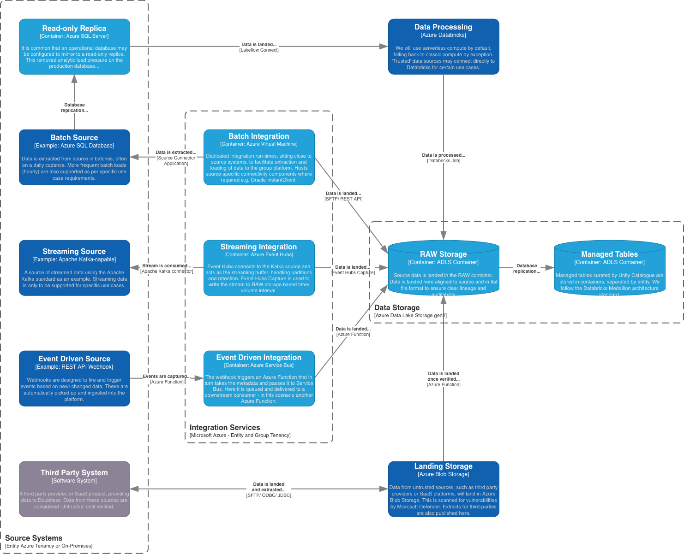
Figure 3: Container (C2) level diagram depicting a number of integration capabilities supported by the data platform.

Data Storage
ADD ID | Mapped FR IDs | Decision | Rationale
ADD-005 | FR-001, FR-002, FR-006, FR-008, FR-009, FR-013 | Azure Data Lake Storage gen2 (ADLS) will be the enterprise data lake with Azure Blob Storage used for landing third-party facing data. | Azure Data Lake Storage Gen2 will be the primary storage layer, providing scalable, low-cost storage with native Databricks integration and separation of storage from compute.  Separate storage accounts are to be used for each environment (Development, Testing, Staging and Production), with the data for each entity separated into dedicated containers. This structure will allow appropriate RBAC rules to be applied directly to storage as well as through Databricks Unity Catalogue to reinforce strong data governance principals.  Trusted data is landed in the platform in the RAW Storage container. A consistent file format is preferred, adopting one of the following;  - .parquet – for large volumes of low frequency (batch) loaded data. The schema must match the source extract as close as possible. Data should be partitioned on columns frequently used for filtering, a frequently used datestamp is a good default, with partitions separated by directory paths. Avoid partitioning on high cardinality columns (IDs or ETL timestamps etc.) to avoid sprawling directory structures of small files.  - .json – for small volume, high frequency, ‘message’ based data json format is favoured. The json should match the source message structure as closely as possible. Avoid excessing nesting of Json objects where possible. Ensure that well documented conventions are used for dates and timestamps (e.g. ISO 8601 in UTC – ‘YYYY-MM-DDTHH:MM:SS.Z’).  Untrusted data is landed in Landing Storage, allowing for specific security and data quality checks to be run against data arriving from untrusted third-party or SaaS sources. This will be done using Microsoft Defender for Azure by default. Landing storage will use separate accounts in Azure Blob Storage, which not only provides maximum compatibility for landing data from source where hierarchical namespace storage (ADLS) is not compatible, but also allows for a strict logical separation of data. This provides strong security and data governance, a key requirement of the Calandra platform.  The indicative storage structure, at account and container level, is shown in Figure 4
ADD-006 | FR-008, FR-009 | Delta Tables will be the standard storage format | Structured data will use the Delta Tables format by default. This format is well suited for storing data in a Data Lake environment, whilst also delivering ACID transactions, schema evolution, time travel and high-performance analytics.  NB: ACID ensures that data remains reliable and consistent when moved through a data platform, with the acronym defined as follows;  - Atomicity: A transaction completes entirely or not at all.  - Consistency: A transaction moves data from one valid state to another, preserving constraints, schemas, and business rules during the process.  - Isolation: Concurrent operations on the transaction do not improperly interfere with one another. Queries should also not see partially completed loads or updates to tables.  - Durability: Once committed, changes remain stored even after a crash or system restart.
ADD-007 | FR-008, FR-009, FR-016, FR-022 | A managed data storage architecture, closely inspired by the Databricks Medallion Architecture, will be adopted | Data will be processed from Landing Storage (if the source is considered Untrusted), deposited in RAW Storage in a consistent format before being loaded into managed tables. This will closely follow the Databricks Medallion Architecture. These layers are defined by Databricks as follows;  - Bronze - Raw: Stores data as it arrives from source systems, with minimal or no cleaning and validation. It preserves the original data for auditing and reprocessing.  - Silver - Validated: Contains cleaned, validated, and conformed data. Records may be filtered, deduplicated, joined, and enriched while retaining detail for analysis at this stage.  - Gold - Enriched: Contains business-ready data that is optimised for analytics and reporting. Data is typically aggregated and organised into dimensional models (or Data Marts – if preferred) with core metrics defined in one place to suit specific business requirements.  Whilst not an official medallion layer, it is recommended that a staging layer be used between bronze and silver where required. This will offer maximum flexibility for Doubtless and enable the group platform to pre-prepare and clean large volumes of data before it is confirmed into the enterprise model held in the Silver layer.  The recommended medallion inspired architecture to be adopted by Doubtless is depicted in Figure 5.
ADD-031 | FR-008, FR-009, FR-014, FR-016 | Use Unity Catalogue managed Delta tables as the default storage model for all platform-owned Bronze, Silver and Gold datasets. | Untity Catalogue Managed tables will be used by default for all data that is stored in the medallion architecture layers. This aligns with Databricks best practice and provide the highest level of platform automation, governance and operational simplicity.  Managed tables enable Unity Catalogue to manage table lifecycle, performance optimisation (OPTIMISE, VACUUM and ANALYSE) and metadata. This provides a consistent foundation across all medallion layers for security, lineage and data governance.  The data stored in managed tables for each entity will be separated into individual catalogues per entity and environment as depicted in Figure 6. The medallion architecture layers will then be separated by schemas inside each catalogue.
ADD-032 | FR-006, FR-008, FR-009, FR-014 | Use Unity Catalogue external tables only where a documented technical or business requirement prevents the use of managed tables. | Tables materialised as External tables have an accessible directory structure within ADLS. Whilst this may be useful for data that is intended to be accessed by shared workloads it does introduce additional operational overhead and a dual governance model split between Unity Catalogue and ADLS.  They should therefore be treated as an exception for interoperability, migration or independent data lifecycle requirements and should be used when required by a specific use case.
ADD-033 | FR-008, FR-009, FR-014, FR-015, FR-021 | Land source-native data into Unity Catalogue external volumes before ingestion into managed Bronze tables. | External volumes will be used for managing and accessing the trusted data that lands in RAW Storage from within Databricks for downstream processing.  External volumes provide a governed mechanism for accessing stored source files while maintaining stable storage paths, replay capability and independent retention, that is governed by the storage service.  This creates a clear separation between source-native files and platform-managed datasets, which by default use Unity catalogue Managed Tables.
ADD-057 | FR-002, FR-008, FR-009, FR-023 | Production catalogues will include a Labs schema as a dedicated space for data team experimentation, | Providing a dedicated Labs schema for members of the Doubtless data team ensures a safe and well governed space for experimentation and proof of concept work. It is the only space on the platform where users are granted WRITE access in production.  Without this space, users will often resort to back-door methods to access production data, including copying data to the dev environment or, worse still, off the platform entirely and on to local machines.  Workflows developed in Labs are not classed as production ready. Once proved they must go through the correct development and promotion process as per the platforms standards.
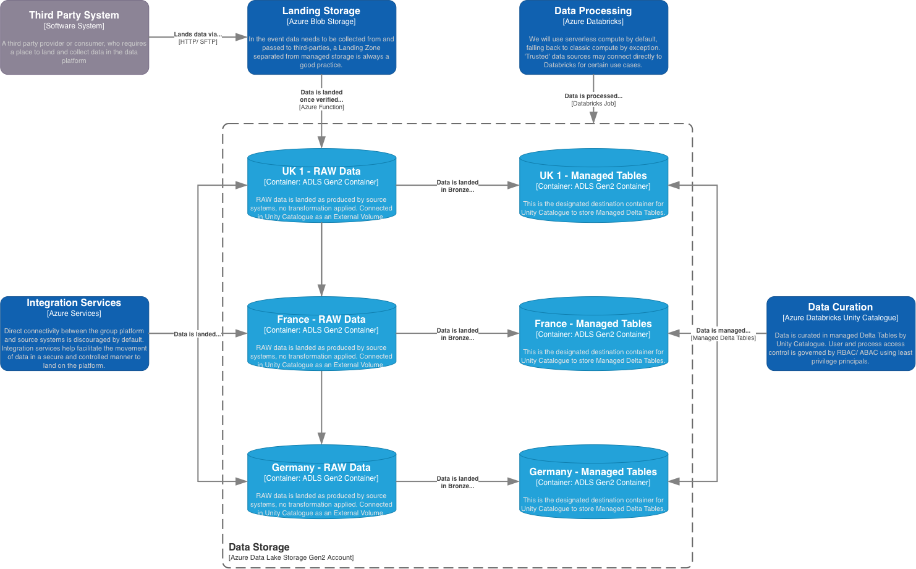
Figure 4: Component (C2) level diagram of the proposed storage structure for the Doubtless data platform

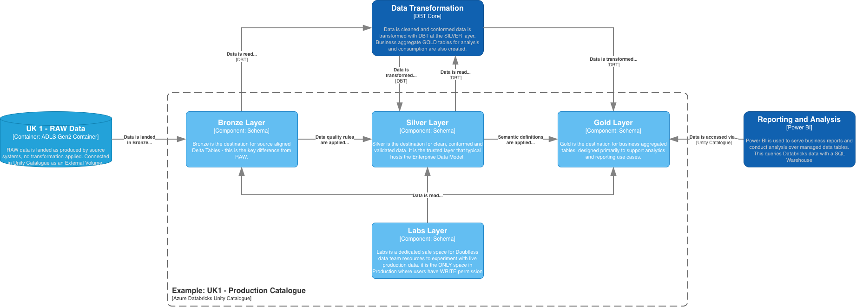
Figure 5: Component (C3) level diagram showing the indicative catalogue schema structure inside an indicative Production Catalogue

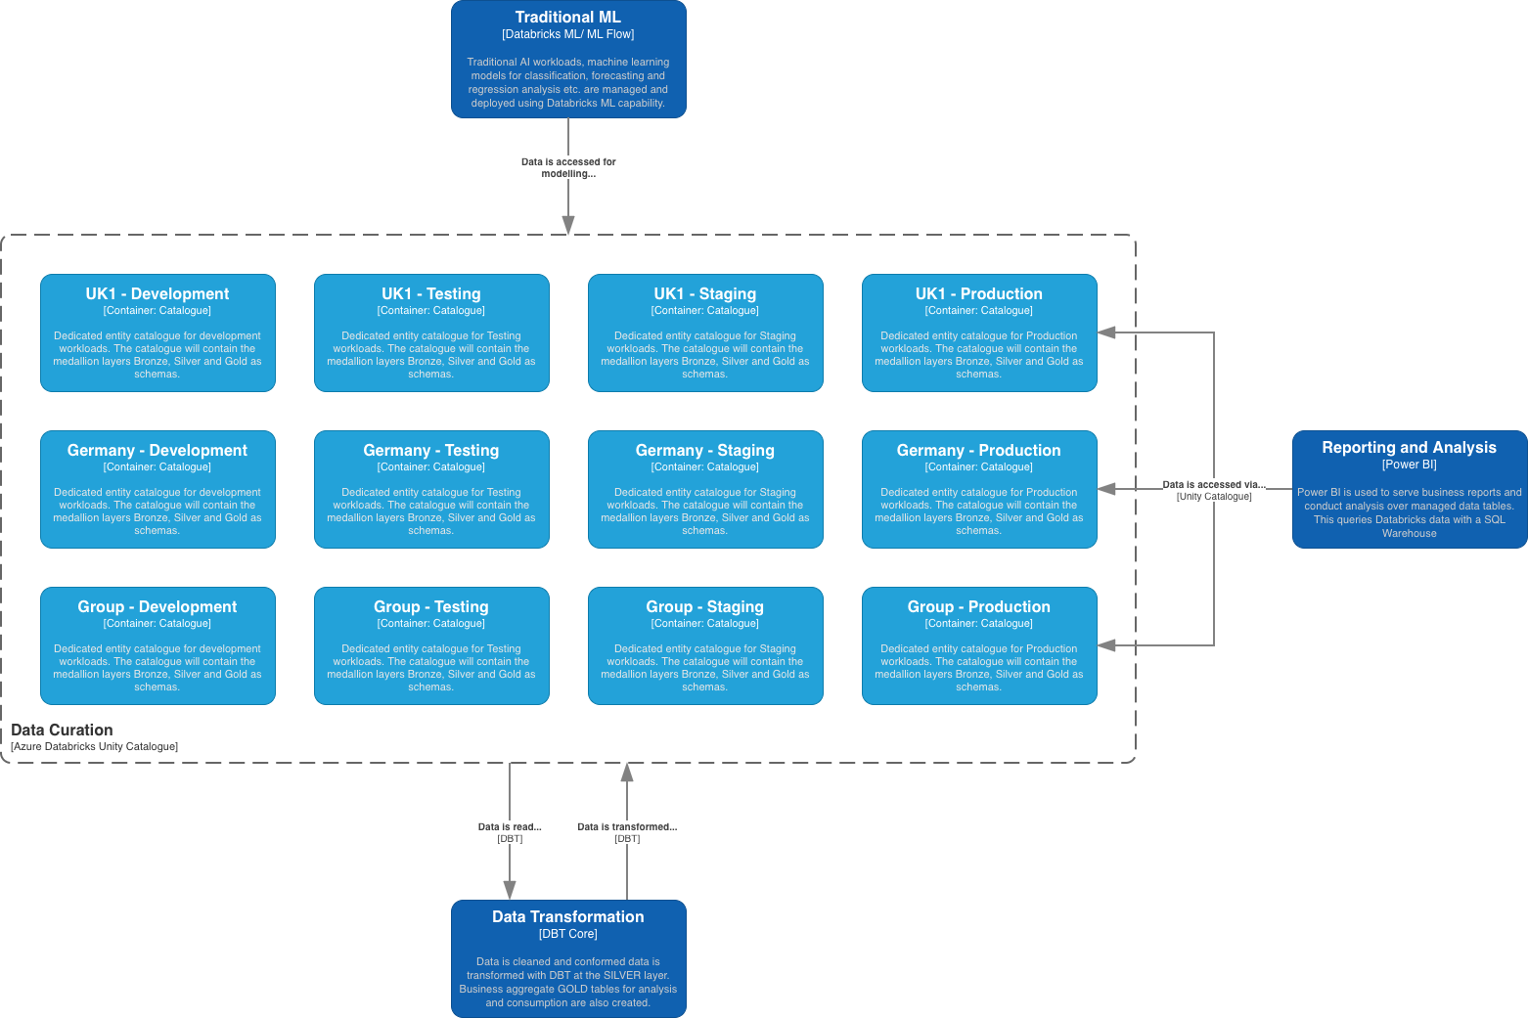
Figure 6: Container (C2) level diagram depicting the environment aligned catalogue structure for representative entities within Unity Catalogue

Processing and Compute
ADD ID | Mapped FR IDs | Decision | Rationale
ADD-004 | FR-002, FR-010, FR-012, FR-018 | Compute governance aligned to entities and role groups | Compute governance will be aligned closely to individual entities and/ or role groups. This will provide tightly governed compute usage across the two core types of compute workload (serverless and classic) as per Databricks best practice.
ADD-012 | FR-007, FR-008, FR-009, FR-014, FR-016, FR-019 | DBT to be the Transformation engine of choice, running on Azure Databricks | A market leading transformation engine, Data Build Tools (DBT) provides a SQL first, cross platform, environment to handle data transformation through the medallion architecture layers.  DBT Allows us to track lineage, automate unit tests, define metrics and curate documentation (which we link to Unity Catalogue) and work across target environments (CI/CD first development)  It is recommended that Doubtless make use of the open-source DBT Core service, which can be run on Databricks compute directly. Core DBT commands to build and run the models should be executed by Databricks Job compute, whilst a Databricks SQL Warehouse should be used to execute the compiled DBT model SQL. This follows DBT and Databricks best practice, allowing for DBT to make best use of the more efficient SQL engine provided by the SQL Warehouse.  Whilst it is recommended that DBT become the primary transformation engine for Doubtless, transformations executed as part of Databricks Jobs or Lakeflow Pipelines should also be used where it is deemed suitable for a particular use case. For example, transformations required to deliver the low-latency ‘Operational Reporting’ workloads may be more efficiently delivered as part of the Lakeflow Pipeline, or a particularly complex set of transforms may perform better when executed in PySpark.
ADD-019 | FR-007, FR-013, FR-020 | Reusable data products and engineering assets will be developed once and shared across operating companies | Common data models, transformation logic, pipelines, notebooks and reusable components will be designed for reuse wherever practical to minimise duplicated engineering effort and accelerate onboarding of future entities.  All code should be managed and version controlled via the Git framework. Azure DevOps is the git provider of choice for Doubtless.
ADD-034 | FR-008, FR-013, FR-018, FR-020 | Use serverless compute as the default execution model for supported Databricks workloads | Doubtless will adopt a serverless-first approach for Databricks workloads by default. This simplifies platform operations, improves elasticity and reduces infrastructure management, while aligning with the wider Doubtless platform strategy.  Classic compute remains available by exception where justified.  A diagram depicting an example serverless workload, ad-hoc data querying by an analyst, is shown in Figure 6. This depicts secure networking routes via Azure Private Link, as per the Calandra platform requirements.
ADD-035 | FR-002, FR-008, FR-015, FR-018, FR-019 | Use ephemeral job or pipeline compute for all automated production workloads. | Scheduled ingestion, transformation and orchestration workloads should execute on ephemeral compute (dedicated Databricks Lakeflow Job Pipeline compute) to improve isolation, reproducibility and cost efficiency.  Interactive clusters must not be used for production processing workloads. These should be reserved for specific analytic workloads where the Spark engine, and particularly PySpark, is required (large data volumes, parallel computing etc.).
ADD-036 | FR-002, FR-012, FR-018, FR-022, FR-023 | Select compute based on workload type rather than adopting a single compute model. | The type of compute should primarily be selected based on the required workload. For example;  - SQL workloads should use SQL Warehouses by default  - Development engineering workloads, making use of PySpark and SparkSQL should use interactive compute.  - Repeated Jobs and Pipelines in production should use ephemeral Job or Pipeline compute.  - Specialist workloads, for example compute intensive data science and pricing analysis, should use dedicated compute capacity only where required by a particular use-case.  This will provide better performance, tight compute governance and workload isolation.
ADD-037 | FR-008, FR-018 | Use classic compute only where technical or commercial justification exists. | Classic compute should be used only where serverless capabilities are unsuitable or where benchmarking demonstrates a lower total cost of ownership for predictable, long-running workloads.  For example, in the scenario where we require always-on compute to deliver low-latency ‘Operational Reporting’, a reserved classic compute cluster would be more cost effective than a serverless cluster.  A diagram depicting an example classic compute workload, regular job execution by a service principal, is shown in Figure 7. This depicts secure networking routes via Azure Private Link, as per the Calandra platform requirements.
ADD-038 | FR-002, FR-008, FR-013, FR-018 | Standardise compute policies centrally while attributing consumption at entity level. | Doubtless will standardise classic compute configurations using Databricks Compute Policies and applying serverless compute controls using Serverless Usage Policies;  - Classic Compute Policies: These govern the configuration of user-managed Databricks compute by enforcing approved settings such as runtime version, node types, autoscaling and auto-termination. Policies can be assigned to entity teams or enterprise role groups to ensure consistent, secure and cost-controlled deployment.  - Serverless Usage Policies: These govern the use of serverless compute by applying standardised tags for cost attribution and reporting. As Databricks manages all infrastructure deployment and scaling for serverless compute, this level of infrastructure control is not required. Policies can be aligned to individual entities or enterprise role groups to provide consistent financial governance across the platform.  All compute should be deployed from these common templates, with entity-level identities, tags and usage policies providing cost transparency without unnecessary duplication of platform standards.

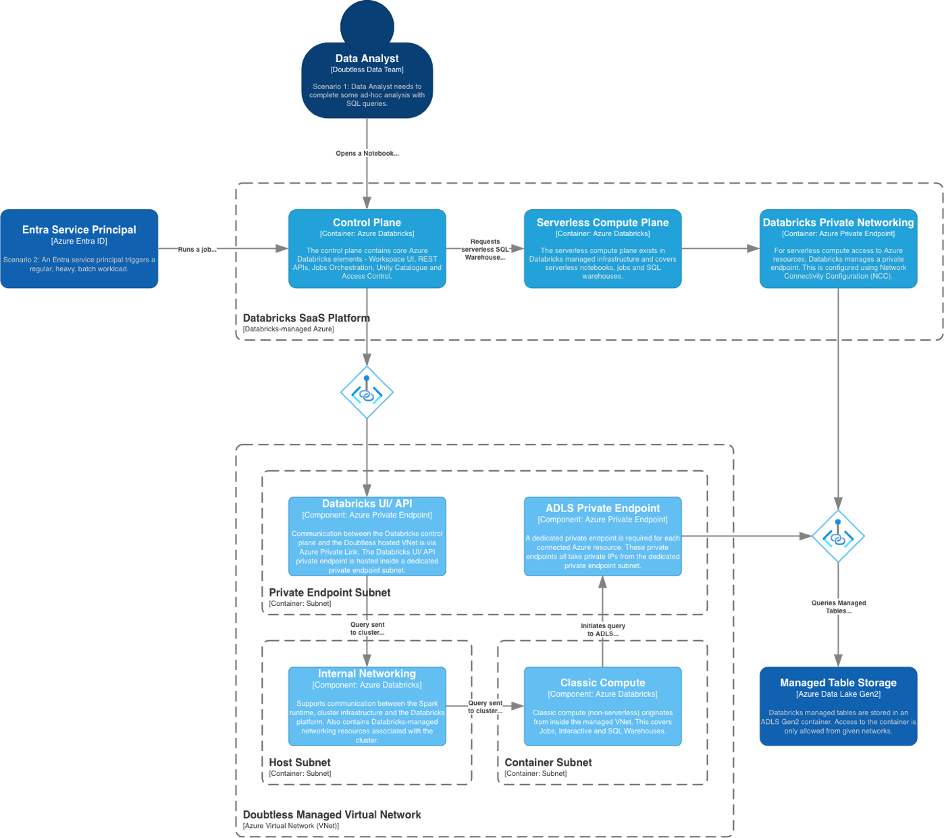
Figure 7: Container (C2) and Component (C3) level diagram illustrating the Azure Databricks compute private networking architecture

Governance and Curation
ADD ID | Mapped FR IDs | Decision | Rationale
ADD-008 | FR-002, FR-003, FR-004, FR-010, FR-011, FR-014, FR-015, FR-017, FR-022 | Unity Catalogue will provide central governance | Central Doubtless data platform data governance is provided by Databricks Unity Catalogue. This service will provide centralised permissions, metadata management, object lineage, auditing and fine-grained access control, including row level security (RLS).  Unity Catalogue allows us to adopt a least privileges role based access control (RBAC) model, a key requirement of the Calandra platform.
ADD-009 | FR-010, FR-011, FR-012 | Platform access will be identity-driven through Microsoft Entra ID | Platform authentication and authorisation will be managed through Microsoft Entra ID. This is integrated with Azure Databricks through identity federation to provide platform single sign on (SSO) and to enforce least-privilege access through Unity Catalogue.
ADD-021 | FR-009, FR-014, FR-017 | Enterprise metadata, lineage and data discovery will be managed centrally | Technical metadata, business metadata, lineage and data discovery capabilities will be managed centrally using Unity Catalogue and supporting governance tooling (e.g. Microsoft Purview) where required.  This will help improve discoverability, impact analysis, regulatory compliance and data trust across the Doubtless platform.
ADD-022 | FR-008, FR-014, FR-015, FR-016 | Data quality will be implemented as an automated platform capability | Data quality validation, monitoring and exception management will be embedded throughout ingestion and transformation pipelines rather than relying on manual validation.  Data quality rules will become part of the platform’s standard engineering patterns and implemented in Databricks and through DBT.
ADD-039 | FR-010, FR-012, FR-013 | Microsoft Entra ID will be the authoritative source for Databricks users, groups, managed identities and service principals. | All users, groups, managed identities and service principals will be governed through Microsoft Entra ID, with these being inherited by Databricks through identity federation.  Identity lifecycle, group membership and access approvals should be managed centrally in Entra rather than through workspace-local identities. This reduces duplication, supports joiner/mover/leaver controls and provides a consistent enterprise identity model across Azure and Databricks.  For automated workloads between Azure Services Managed Identities should be used by default. Azure manages all credentials associated with the managed identity, including storage, rotation and authentication.  For automated workloads that must communicate with services outside of Azure (SaaS platforms such as Salesforce or third-party BI tools) then Entra backed Service Principals should by used. Azure Key Vault should be used by default for the management of credential storage, secret rotation and certificate renewal and is the responsibility of the Doubtless data platform team.
ADD-040 | FR-010, FR-012, FR-013 | Access will be granted to Entra-backed groups and service principals rather than directly to individual users. | Group-based access is more scalable, auditable and supportable than user-level grants. Direct user assignments should be treated as controlled exceptions because they create hidden entitlements and complicate recertification.
ADD-041 | FR-002, FR-010, FR-011, FR-012 | Databricks access will be separated into persona, data-entitlement and sensitive-data dimensions. | A single group should not attempt to describe the user’s role, legal entity, data scope and sensitivity clearance simultaneously.  Separating these concerns enables controlled composition while avoiding excessive persona-specific group variants.
ADD-042 | FR-002, FR-010, FR-012 | Persona groups will govern workspace capabilities and compute-service access, but will not grant broad Unity Catalogue data access. | Persona groups such as Agila-Analysts or Doubtless-Data-Engineers should answer what a user can do within Databricks. This includes for example;  - Use SQL Warehouse  - Create and edit notebooks  - Denied ability to run Jobs and/or Pipelines.  Granting broad data privileges (e.g. access to individual schemas) through persona groups would risk exposing multiple entity catalogues because Unity Catalogue privileges are additive.
ADD-043 | FR-002, FR-010, FR-012 | Unity Catalogue data access will be granted through entity-scoped entitlement groups containing complete usable access paths. | An entity-scoped group should provide the following example privileges as required;  - USE CATALOG  - USE SCHEMA  - SELECT  This is clearer and safer than relying on separate persona and entity groups to assemble a usable privilege path indirectly.
ADD-044 | FR-002, FR-010, FR-013 | Entity entitlement groups will be aligned to meaningful access packages rather than every individual securable. | Entity entitlement groups such as UC-Agila-Analytics-Readers can cover an approved set of Silver and Gold schemas, avoiding a proliferation of groups for every schema or table.  More granular groups should be introduced only where business access requirements differ materially for that defined at entity entitlement level.
ADD-045 | FR-002, FR-010 | Unity Catalogue privileges will be treated as additive - group membership will not be assumed to create a logical permission intersection or explicit deny. | In Unity Catalogue an individual user receives the union of privileges granted directly and through all relevant groups assignments.  An entity group does not constrain privileges from another group, and a missing privilege should not be treated as a robust deny boundary where accidental grants could later complete the access path.
ADD-046 | FR-010, FR-011 | Sensitive data will be masked or filtered by default, with cleartext access granted through separate elevation groups. | Sensitive-data (personally identifiable information (PII) or financial details) access is treated as an additional privilege, not a standard part of persona or entity membership.  Users with base data access should see masked values by default unless they are explicitly approved for a sensitive-data exemption. Masking rules can be applied through Unity Catalogue.
ADD-047 | FR-010, FR-013, FR-019 | Unity Catalogue securables, ownership and baseline grants will be managed through Terraform. | Where possible, all Unity Catalogue securables, baseline grants and ownership should be defined through Terraform, the Calandra platform’s Infrastructure-as-code (IaC) service of choice.  IaC provides repeatability, clear peer review, audit history and consistency across all environments. It also reduces configuration drift and makes access changes part of the controlled delivery process.
ADD-049 | FR-010, FR-012, FR-015, FR-019 | Production writes will be performed through managed identities and service principals rather than interactive user identities. | Production ingestion, transformation and publication workloads should run under controlled workload identities, managed identities for Azure Services and service principals for third-party SaaS products.  Workloads in production should never be run by individual users.  This provides predictable ownership, stronger audibility and removes dependency on individual user accounts. Human users should not receive routine production write permissions.

The following table provides a summary of the proposed access group categories, example groups and typical permissions. NB: This is not meant to be an exhaustive list;

Access Group Category | Purpose | Example Groups | Typical Permissions
Persona Groups | These groups define what a user can do within the Databricks platform. Specifically, they govern workspace capabilities, compute usage and general platform permissions, but do not grant business data access. | Doubtless-ADB-Analysts  Doubtless-ADB-DataEngineers  Doubtless-ADB-DataScientists  Doubtless-ADB-PlatformEngineers | - Workspace access  - Databricks SQL access  - Notebook authoring  - CAN USE approved SQL Warehouses  - CAN USE approved Compute Policies (if required)  - Job authoring (engineering only)  - No Unity Catalogue business data permissions
Entity Data Entitlement Groups | These groups define which business data a user may access within Unity Catalogue. Each group represents a complete, usable data entitlement for an entity or domain. | Doubtless-UC-Agila-Analytics-Readers  Doubtless-UC-PPUK-Analytics-Readers  Doubtless-UC-Figo-Analytics-Readers  Doubtless-UC-Group-Reporting-Readers | - USE CATALOG  - USE SCHEMA on approved Silver/Gold schemas  - SELECT on approved tables/views  - Read-only production access  - No workspace or compute permissions
Sensitive Data Entitlement Groups | These groups grant exception-based access to sensitive information. Sensitive data is masked by default and only revealed to authorised users through explicit membership. Membership should be tightly controlled and time-bound through privileged identity management (PIM). | Doubtless-UC-Agila-PII-Cleartext-Readers  Doubtless-UC-PPUK-PII-Cleartext-Readers  Doubtless-UC-Group-Audit-Readers | - Exemption from PII masking  - Access to protected columns where authorised  - No additional table or schema permissions  - No workspace permissions
Operational & Administrative Groups | These groups support platform administration and operational support activities. Membership should be tightly controlled and time-bound through privileged identity management (PIM). | Doubtless-ADB-Workspace-Admins  Doubtless-ADB-UnityCatalogue-Admins  Doubtless-ADB-Production-Support  Doubtless-ADB-SQL-Warehouse-Admins | - Workspace administration  - Unity Catalogue administration  - Compute Policy administration  - SQL Warehouse management  - Production troubleshooting  - No automatic business data access beyond operational need
Workload Identity Groups | These groups define permissions for non-human identities, used by production workloads. These groups contain Service Principals or Managed Identities rather than users. | Doubtless-SP-dbt-AFI-Prod  Doubtless-SP-PowerBI-Prod  Doubtless-SP-PolicyIntegration-Prod  Doubtless-SP-Lakeflow-Agila-Prod | - Production execution permissions  - Unity Catalogue read/write required by workload  - SQL Warehouse access  - Job execution  - Storage credentials where required  - No interactive workspace access
For added clarity, below are two specific worked examples;
Example 1 – A Data Analyst who is part of the Agila data team
A typical analyst would simply be a member of three groups:
- Doubtless-ADB-Analysts: Granted access to use Databricks SQL, notebooks and approved serverless SQL warehouses
- Doubtless-UC-Agila-Analytics-Readers: Granted access to query Silver and Gold schemas within the Agila Unity Catalogues.
- Doubtless-UC-Agila-PII-Cleartext-Readers (optional): May view unmasked PII where business approval has been granted for a specific use case.
NB: Without the third group, the analyst can still query the data in the required catalogues, but sensitive columns remain masked.

Example 2: Production Semantic Model Refreh in Power BI
As Power BI is an Azure service we would use a Managed Identity, which would instead belong to the following groups:
- Doubtless-SP-PowerBI-Prod: May use the Production SQL Warehouse and refresh semantic models.
- Doubtless-UC-Group-Reporting-Readers: Read access to approved Gold reporting views ONLY in the requisite Unity Catalogues.
NB: Notice it doesn't need a persona group because it isn't an interactive user.

Consuming Data
ADD ID | Mapped FR IDs | Decision | Rationale
ADD-013 | FR-005, FR-022 | Power BI will be the strategic business intelligence reporting tool for the Doubtless data platform | Microsoft Power BI will consume curated Databricks data to deliver governed enterprise reporting and analytics. This will be the core reporting and consumption tool used by Doubtless.  By design production load Power BI refreshes will be carried out by Managed Identities, not individual users. Power BI reports will have READ ONLY access to Gold layer tables and views by default, with access granted to the Silver layer only where specific use cases require it.
ADD-014 | FR-004, FR-005, FR-022, FR-023 | Support multiple data consumption patterns | Curated data will be consumable by a number of consumption tools and services including the following;  - Power BI for regular BI and MI reporting: see ADD-013  - Azure Databricks Machine Leaning: Traditional AI workflows, such as the use of machine learning models for predictive (classification and regression) use cases will make use of Databricks ML by default. This has provision for serving model endpoints, governing deployed models through a model registry and feature store and providing a gated experimentation environment for advanced AI workloads.  - Self-service through natural language querying: Databricks Genie is chosen as the natural language data self-service tool of choice. Genie is able to make the most of it’s tight integration with Unity Catalogue to harness business logic and relevant context to provide solid foundations for generative AI driven analytics. Genie is accessible through the business-friendly Databricks One workspace.  - Custom application support: Where the consumption of data requires more than a simple user dashboard Databricks Apps offer a flexible solution to delivering a wide range of use cases. Apps on Databricks make use of dedicated compute so as not to interrupt regular workloads and support a variety of native libraries including Streamlit (Python), Node.js and Next.js (JavaScript).  - Dedicated Generative AI workloads: Whilst Databricks does support a variety of hosted generative AI models, Azure AI Foundry is the preferred solution for hosting and interacting with large language models at scale.  NB: This list of consumption tools and use cases is by no means exhaustive. Through the use of Unity Catalogue, SQL Warehouses and Service Principal access control the Doubtless UK and Europe data platform seeks to support an ever expanding range of data consumption tools.
ADD-018 | FR-004, FR-005, FR-017, FR-022 | Group reporting will consume curated, governed data products separate from entity reporting | Enterprise reporting at the Doubtless group level will be delivered from governed, curated Group-Level datasets rather than directly accessing operational entity data. Group data will be published to a dedicated catalogue, and will include both Silver (where relevant) and Gold layer tables and views. Bronze layer data will be omitted from the Group level catalogue, except under exceptional circumstances and driven by a specific use case.  By having a central Group data catalogue, we ensure consistent business definitions, embed trust in Group reporting and place a limit on unnecessary cross-entity data access.

Platform Operations
ADD ID | Mapped FR IDs | Decision | Rationale
ADD-015 | FR-010, FR-015, FR-019 | Doubtless Platform supporting services will use Azure-native operations | The Doubtless UK and Europe data platform shall use core Azure services to support its day-to-day operation. This is backed by the Calandra group strategy for an Azure Landing Zone based architecture. Key supporting services are as follows;  - Azure DevOps: Tenant wide shared service with Tier 0 landing zone, supports automated deployment pipelines and code management.  - Microsoft Entra ID: Tenant wide shared service with Tier 0 landing zone, Entra ID is used to centrally managed all platform RBAC operating on a least privileges principal.  - Azure Sentinel: A shared Tier 0 service, Sentinel is the cloud-native security information and event management system for the Calandra platform. Security-relevant logs and audit events from platform services will be forwarded to the central security Log Analytics Workspace in accordance with Calandra enterprise security policy.  - Azure Log Analytics Workspace (LAW): As above, security relevant logs will be forwarded to a centrally shared LAW however the data platform application landing zone will have a separate LAW to provide core operational logging, monitoring (with Azure Monitor) and alerting for data platform services.  - Azure Key Vault: All platform secrets are to be managed centrally within environment aligned key vaults within the application landing zone.
ADD-020 | FR-006, FR-013, FR-019, FR-024 | Platform infrastructure will be provisioned and managed using Infrastructure as Code | All Azure infrastructure, Databricks resources and configuration will be deployed and maintained through Infrastructure as Code (IaC) using Terraform.  All IaC code will be stored in a dedicated repository as part of the Doubtless UK and Europe data platform project in Azure DevOps. CI/CD pipelines in Azure DevOps will leverage consistency, repeatability, governance and controlled change management across all environments.
ADD-029 | FR-008, FR-009, FR-013, FR-014, FR-015, FR-016, FR-021 | The Doubtless UK and Europe platform shall standardise core operational flows regardless of the source extraction pattern. | The platform will standardise operational data flows where possible across key areas;  - Ingestion: Metadata-driven configuration will be the default control mechanism for loading data into the platform. Metadata will be contained within static .json config files and loaded at the point of Declarative Automation Bundle (DAB) deployment (the best practice approach for deploying Lakeflow Jobs or Pipelines. If an evolving configuration view is also required, for example to register watermarks during an incremental load of data, this will be stored in an appropriate Delta Table within the ‘operations’ schema.  - Error handling: All DAB should employ appropriate error handling mechanisms, designed not to fail quietly. Errors should raise appropriate exceptions that are passed to Job/ Pipeline output. Warnings should be designed to not fail the pipeline but be written to a dedicated observability table within the ‘operations’ schema, where they can be views via an appropriate dashboard (Databricks or Power BI).  - Validation: Data validation tests shall be performed as part of the ingestion routine, with simple routine tests run against loaded data and the results stored within the ‘operations’ schema. Some example unit tests employed for data validation might be;  - Source-target record reconciliation: Check to ensure the expected count of records between source and target are present  - Target schema conformance: Ensure that the incoming data schema aligns with the expected target schema  - Data-type and format validity: Ensure that all incoming data conform to the expected data-types and formats for the target schema  - Mandatory field completeness/ No NULLs: Ensure all mandatory fields are completed and that No NULL values are present.  - Observability: Data platform operational logs, including the state of Lakeflow Pipelines and Jobs, will be written to the data platform LAW by default. However, if additional detail is required to support the smooth operation of jobs and pipelines, logging at individual steps should be written to a dedicated delta table within the ‘operations’ schema. This table should capture step status, error messages, start and end timestamps as well as the ID of the managed identity/ service principal executing the process.  These standardised flows allow source systems to use different extraction mechanisms while maintaining consistent governance, monitoring, lineage, error handling and operational support within the central platform.
ADD-030 | FR-002, FR-010, FR-012, FR-021 | Cross-tenant connectivity shall use tightly scoped, service-specific network access leveraging Azure Private Link wherever practical. | Aligns with Calandra platform security and Zero Trust principles by exposing only the required services and endpoints, reducing lateral movement risk and simplifying security governance.  Azure Private Link is the preferred approach for secure networking across the Calandra platform and will be used by default between Azure services. All network traffic must be routed via the Tier 0 networking HUB as per Azure Landing Zone best practice.
ADD-048 | FR-010, FR-011, FR-015, FR-019 | Terraform will manage the stable access-control baseline, while exceptional access will follow a governed process. | Attempting to manage every short-lived or user-specific exception in central Terraform may become operationally cumbersome. The baseline access control should remain codified, while exceptional access should be time-bound, approved, auditable and subsequently reconciled.
ADD-050 | No direct FR – resilience and availability are non-functional requirements | Platform service redundancy will follow existing Calandra best practice. | Production services to use Zonal redundancy by default, with Dev and Test to use local redundancy. Geographic redundancy is out of scope for the platform under Calandra requirements.
ADD-051 | FR-006, FR-013, FR-019, FR-024 | All platform services to be defined, deployed and managed via Terraform where possible | Terraform is the agreed infrastructure as code (IaC) provider for Doubtless. With all platform component defined and managed as IaC.  This will enable environments to be recovered in the event of disaster quickly and efficiently. All changes must be managed through Terraform states to ensure good governance.  Operations that are performed outside Terraform scripts, i.e. through the Azure Portal (ClickOps) are permitted during development and testing. Once the developed changes have been approved they must be included in the terraform scripts, torn down and re-built via terraform deployment. Not only does this provide additional validation and testing of the deployed solution, it ensures that the Terraform state is kept up to date.

Calandra Data Tool Kit Requirements – Deployment Best Practices

Services Required for Initial Doubtless UK and Europe Group Data Platform deployment

Services required for the initial Doubtless UK and Europe Data Platform deployment should be taken from those agreed as part of the Calandra Data Toolkit. These are listed, along with requirement appropriate deployment best practices, below;

Microsoft Entra | NB: Microsoft Entra is a Tier 0 managed by the Calandra Platform team. It does not require creating as a service, however as all user access is required via groups that are centrally governed by Entra. To deploy the initial group data platform the following Entra groups are required;  Entra groups should be created with the following settings;  - Group Type: Security  - Membership Type: Assigned  - Mail_enabled: False
  Group Name | Group Description
  doubtless-admin-databricks-account | Group containing Databricks Account administrators
  doubtless-admin-databricks-workspace | Group containing Databricks Workspace administrators
  doubtless-admin-databricks-unity-catalogue | Group containing Databricks Unity Catalogue administrators
  doubtless-admin-databricks-compute | Group containing Databricks Compute policy, including serverless and SQL Warehouse administrators
  doubtless-persona-analysts | Data analysts persona, defines what a data analyst is allowed to access within the Databricks platform
  doubtless-persona-engineers | Data engineer persona, defines what a data engineer is allowed to access within the Databricks platform
  doubtless-group-data-analytics | Data access entitlement group for data analysis users
  doubtless-group-data-engineering | Data access entitlement group for data engineering users
  doubtless-group-data-reporting | Data access entitlement group for data reporting users
  doubtless-sp-platform-dev | Group containing service principals and managed identities for platform deployment
  doubtless-sp-workload-dev | Group containing service principals and managed identities for workload execution
  doubtless-sp-reporting-dev | Group containing service principals and managed identities for reporting workload execution
Azure Key Vault | - Name: doubtless-akv-grp-dewc-<environment>-001  - Region: Germany West Central  - SKU: Standard (or Premium for HSM-backed keys)  - Environments: Separate vaults should be configured for the following environments;  - Development – abbreviated to ‘dev’  - Testing – abbreviated to ‘tst’  - Staging – abbreviated to ‘stg’  - Production – abbreviated to ‘prd’  - Security & Compliance:  - Use RBAC, Governed by Microsoft Entra, for access management.  - Restrict access by enabling VNet integration, Azure PrivateLink and firewall rules.  - Monitoring:  - Enable Diagnostic Settings and Application Insights.  - Best Practices:  - Maintain separate Key Vault for different environments.  - Enable soft delete to allow recovery of deleted vaults and vault objects.  - Use private endpoints to connect securely from VNet to vault  - Principles of least privilege and limit who has access to azure resources.  - Managed identities for Azure resources shall be used as preference for authentication to Key Vault.  - Key Vault keys & secrets shall have an expiration date as per Calandra Landing Zone standards.  - Certificates shall have the specified maximum validity period as per Calandra Landing Zone standards.
Azure Databricks | - Name: doubtless-adb-grp-dewc-<environment>-001  - Region: Germany West Central  - Workspace Configuration:  - Workspaces are aligned to the following environments;  - Development – environment abbreviated to ‘dev’  - Testing – environment abbreviated to ‘tst’  - Staging – environment abbreviated to ‘stg’  - Production – Analytics Reporting – environment abbreviated to ‘prd’, with identifier ‘analytics’.  - Production – Operational Reporting - environment abbreviated to ‘prd’, with identifier ‘analytics’  - Use Premium Workspaces  - Workspace entitlements shall be granted as per the following baselines;  - Compute Policies Configuration:  - Usage Policy Configuration  - One serverless usage policy per environment  - Policy explicitly bound to its corresponding workspace  - Apply the following tags; * denotes mandatory  - Business Entity*: Group  - Cost Centre*: Group Data Platform  - Environment*: <as per deployed environment>  - Data Product: Group Data Platform  - Service Owner: Group Data Platform  - Managed*: Terraform  - Serverless SQL Warehouse Policy: Separate from engineering and BI workloads  - Unity Catalogue Configuration  - Unity Catalogue regional metastore created automatically on creation of first workspace. This will be in Germany West Central (DEWC).  - Create catalogues per entity + environment pairing. As an initial group baseline we deploy four catalogues;  - doubtless-uc-grp-dewc-dev  - doubtless-uc-grp-dewc-tst  - doubtless-uc-grp-dewc-stg  - doubtless-uc-grp-dewc-prd  - Each catalogue should contain the following schemas;  - bronze  - silver  - gold  - operations  - labs  - Isolation mode set to ISOLATED  - Force Destroy set to False  - The following baseline data entitlements should be applied;  - Networking & Security:  - Deploy with VNET Injection.  - Use Azure Private Link to connect to storage.  - Monitoring:  - Enable Diagnostic Settings and Application Insights.  - Best Practices:  - Databricks Premium plan shall be used for role-based access control & enhanced security.  - Deploy Azure Databricks in custom VNet.  - Azure AD be used for authentication and built in Databricks RBAC assignments for platform management and access.  - RBAC shall be used with least privilege model.  - Access tokens shall be stored in Azure Key Vault.  - Automated deployment through IaC.  - Cluster policies shall be implemented to limit the ability to create clusters based on a set of rules.  - Diagnostic logging must be enabled and configured as per Calandra Landing zone standards.  - Resource Tagging for costing and billing must be applied in advance as per Calandra Landing zone policies.
   | doubtless-admin-databricks-workspace | doubtless-sp-platform-dev | doubtless-persona-engineers | doubtless-persona-analysts
  workspace_access | - Auto | - Workspace admin | - Yes | - Yes
  databricks_sql_access | - Auto | - Auto | - Yes | - Yes
  workspace_consume | - N/A | - N/A | - No | - Yes
  allow_cluster_create | - Auto | - Auto | - No | - No
  Allow_instance_pool_create | - Auto | - Auto | - No | - No
  Shared Interactive | Automated Jobs
  - Cluster-type: all-purpose  - Access Model: STANDARD (with USER_ISOLATION)  - Runtime: Fixed to auto:latest-lts  - Photon: disabled  - Scaling: Auto, minimum 1 worker  - Non-Prod: Maximum: 2 workers 10DBU/hr  - Prod: Maximum: 4 workers 20DBU/hr  - Fixed size clusters: prohibited  - Interactive Termination: 15minutes  - Azure availability: On demand  - Node Types: Approved regional D/E allowlist  - Non-Prod: 2-8 vCPU  - Prod: 4-16 vCPU  - Driver Type: General Purpose  - Elastic disk: enabled  - Local disk encryption enabled  - Instance pools: Prohibited by default  - Custom containers: Prohibited by default  - Init scripts: Prohibited by default  - Credential passthrough: Prohibited  - Cluster Logs: Written to designated UC volume  - Libraries: Specified in workspace files or UC Volumes  - Max. Resources per Identity: One per identified user  - Permissions:  - CAN_USE: doubtless-persona-engineers, doubtless-persona-analysts  - CAN_MANAGE: doubtless-admin-databricks-compute | - Cluster-type: all-purpose  - Access Model: STANDARD (with USER_ISOLATION)  - Runtime: Fixed to auto:latest-lts  - Photon: disabled  - Scaling: Auto, minimum 1 worker  - Non-Prod: Maximum: 2 workers 10DBU/hr  - Prod: Maximum: 8 workers 40DBU/hr  - Fixed size clusters: prohibited  - Interactive Termination: N/A (job compute terminates when run concludes)  - Azure availability: Spot with fallback, Driver on demand  - Node Types: Approved regional D/E allowlist  - Non-Prod: 2-16 vCPU  - Prod: 4-32 vCPU  - Driver Type: General Purpose – larger driver available when workload justifies  - Elastic disk: enabled  - Local disk encryption enabled  - Instance pools: Prohibited by default  - Custom containers: Prohibited by default  - Init scripts: Must come from a declarative automation bundle (DAB)  - Credential passthrough: Prohibited  - Cluster Logs: Written to designated UC volume  - Libraries: Specified in DAB  - Max. Resources per Identity: Default 2. Set per workload based on expected concurrency  - Permissions: CAN_USE for;  - CAN_USE: doubtless-sp-workload-dev  - CAN_MANAGE: doubtless-admin-databricks-compute
  Engineering | Business Intelligence (BI)
  - Warehouse Type: PRO  - Size: XSmall  - Minimum Clusters: 1  - Maximum Clusters: 2  - Auto-stop: 15mins  - Photon: disabled unless explicitly required  - Release Channel: Latest  - Permissions:  - CAN_USE: doubtless-persona-engineers, doubtless-sp-workload-dev  - CAN_MANAGE: doubtless-admin-databricks-compute | - Warehouse Type:  - Size: Small  - Minimum Clusters: 1  - Maximum Clusters: 4  - Auto-stop: 15mins  - Photon: disabled unless explicitly required  - Release Channel: Latest  - Permissions:  - CAN_USE: doubtless-sp-reporting-dev, doubtless-persona-analysts  - CAN_MANAGE: doubtless-admin-databricks-compute  - Management: Workspace administrators
  Entra security group | Catalogue Permission | Schema Permission | Data Permission
  doubtless-group-data-analytics | - doubtless-uc-grp-dewc-dev: N/A  - doubtless-uc-grp-dewc-tst: USE_CATALOG  - doubtless-uc-grp-dewc-stg: USE_CATALOG  - doubtless-uc-grp-dewc-prd: USE_CATALOG | - bronze: N/A  - silver: USE_SCHEMA  - gold: USE_SCHEMA  - operations: N/A  - labs: USE_SCHEMA | Prod and Non-Prod Catalogues  - SELECT on all allowed schemas  - MODIFY on labs schema
  doubtless-group-data-engineers | - doubtless-uc-grp-dewc-dev: USE_CATALOG  - doubtless-uc-grp-dewc-tst: USE_CATALOG  - doubtless-uc-grp-dewc-stg: USE_CATALOG  - doubtless-uc-grp-dewc-prd: USE_CATALOG | - bronze: USE_SCHEMA  - silver: USE_SCHEMA  - gold: USE_SCHEMA  - operations: USE_SCHEMA  - labs: USE_SCHEMA | Prod Catalogue  - SELECT on all allowed schemas  - MODIFY on labs schema  Non-Prod Catalogues  - SELECT, MODIFY on all allowed schemas
  doubtless-group-data-reporting | - doubtless-uc-grp-dewc-dev: N/A  - doubtless-uc-grp-dewc-tst: USE_CATALOG  - doubtless-uc-grp-dewc-stg: USE_CATALOG  - doubtless-uc-grp-dewc-prd: USE_CATALOG | - bronze: N/A  - silver: N/A  - gold: USE_SCHEMA  - operations: N/A  - labs: N/A | Prod and Non-Prod Catalogues  - SELECT on all allowed schemas
  doubtless-sp-workload-dev | - doubtless-uc-grp-dewc-dev: USE_CATALOG  - doubtless-uc-grp-dewc-tst: USE_CATALOG  - doubtless-uc-grp-dewc-stg: USE_CATALOG  - doubtless-uc-grp-dewc-prd: N/A | - bronze: USE_SCHEMA  - silver: US_SCHEMA  - gold: USE_SCHEMA  - operations: USE_SCHEMA  - labs: USE_SCHEMA | Non-Prod Catalogues  SELECT, MODIFY on all allowed schemas
  doubtless-sp-reporting-dev | - doubtless-uc-grp-dewc-dev: N/A  - doubtless-uc-grp-dewc-tst: USE_CATALOG  - doubtless-uc-grp-dewc-stg: USE_CATALOG  - doubtless-uc-grp-dewc-prd: USE_CATALOG | - bronze: N/A  - silver: N/A  - gold: USE_SCHEMA  - operations: N/A  - labs: N/A | Prod and Non-Prod Catalogues  SELECT on all allowed schemas
Azure Storage Accounts | - Security & Compliance:  - Enable Private Endpoints for secure access.  - Enable Storage Firewall to allow only trusted networks.  - Disable storage account key access so that access is only through Managed Identity.  - Use Customer-Managed Keys (CMK) for encryption if required.  - Monitoring:  - Enable Diagnostic Settings and Application insights.  - Create following container structure for Prod and Non-Prod environments:  - ADLS gen 2 Account  - raw  - archive  - group – Databricks Unity Catalogue Managed Tables are stored here  - Azure Blob Storage  - landing  - quarantine  - archive
  Managed Data Storage | Landing Storage
  Name: doubtlessadlsgrpmanageddewc<environment>001  Region: Germany West Central (DEWC)  Account Type: StorageV2  Hierachical namespace: true  Account tier: Standard  Access tier: Hot  Replication:  - Production: ZRS  - Non-Prod: LRS  HTTPS only: true  Minimum TLS: TLS1_2  Public blob access: Disabled  Shared-key auth: Disabled  Default Auth: OAuth  Public network access: Disabled  Cross-tenant replication: Disabled  SFTP: Disabled  NFSv3: Disabled  Local storage users: Disabled  Infrastructure encryption: Conditional  Customer-managed keys: Conditional | Name: doubtlessabsgrplandingdewc<environment>001  Region: Germany West Central (DEWC)  Account Type: StorageV2  Hierachical namespace: true  Account tier: Standard  Access tier: Hot  Replication:  - Production: ZRS  - Non-Prod: LRS  HTTPS only: true  Minimum TLS: TLS1_2  Public blob access: Disabled  Shared-key auth: Disabled by default  Default Auth: OAuth  Public network access: Enabled from select networks  Cross-tenant replication: Disabled  SFTP: Enabled  NFSv3: Disabled  Local storage users: Disabled  Infrastructure encryption: Conditional  Customer-managed keys: Conditional
Azure DevOps | As an Azure SaaS service, Azure DevOps is available tenancy wide. The recommended configurations are as follows;  - Organisation Name: doubtless-ado-grp-org-dewc-001  - Project Name: doubtless-ado-grp-dp-dewc-001  - Region: Germany West Central (DEWC)  - License & Access Control:  - Assign at least two controlled organisation owners  - Access managed though MS Entra and users added to an ADO project contributor group  - Use PIM-managed groups for privileged administration where possible  - Enable the "Basic" License for all users in the ADO project.  - Enable audit-log monitoring  - Establish an approval process for installing marketplace extensions  - Security & Compliance:  - Enforce Microsoft Entra and conditional access  - Enable RBAC and Azure DevOps Policies.  - Use Service Connections with Managed Identities where possible, and use service principals by exception.  - Prohibit use of PAT token access, unless explicitly required, in which case limit full-scope and long lived tokens  - Disable unused legacy authentication methods if not required (SSH, legacy OAuth)  - Review inactive users, credentials, service connections and extensions regularly.  - Repositories & CI/CD Pipelines:  - Use Git repositories for managing all code, favouring separate repositories per workload within the project (e.g. doubtless-ado-grp-infra for infrastructure, doubtless-ado-grp-dbt for dbt models etc.)  - Use standard ‘Trunking’ branch model  - Dedicated ‘production’ branch for approved and validated releases to run production code  - Dedicated ‘development’ branch for hosting developed features  - Development merged into production on a regular ‘release cycle’ cadence  - No direct pushes to Production or Development branches  - Pull Request approval required for all features  - Require successful build and validation  - Restricted policy bypass permissions (no force push)  - Automate deployments using YAML pipelines.  - All secrets should be inherited from Azure Key Vault where appropriate, and if not stored in the Azure DevOps secrets repository  - Separate service connections should be used for Prod and Non-Prod environments. Individual connections per environment to be used only if required  - Service connections should be scoped to the lowest practical azure boundary for pipeline  - Do not use user identities for pipeline deployment  - Keep deployment and runtime identities separate  - Build Agents  - Prefer MS Managed Build agents where possible (not private connectivity restrictions)  - Use Managed DevOps Pools over deploying a dedicated IaaS VM  - Agents can be attached to delegated subnets within the VNet  - Services exposed and accessed through private endpoints  - Agents scale to manage demand  - Use stateless agents that are discarded after job completion  - Use Microsoft-mainted or controlled images by default  - Separate production agent poolsfrom non-production environment agent pools
Azure Log Analytics Workspace | - Name: doubtless-law-grp-dewc-<environment>-001  - Region: Germany West Central  - Service Configuration  - Deploy the law workspace within the application landing-zone, separate from the Calandra Tier 0 workspaces.  - Use the minimum number of workspaces required. Create additional workspaces only for environment isolation.  - Do not enable Microsoft Sentinel on the application workspace unless explicitly approved.  - Use workspace-based Application Insights for application telemetry.  - Apply mandatory reosurce tags covering;  - Application  - Owner  - Environment  - Cost centre  - Data classification.  - Data Collection and Retention  - Use diagnostic settings to collect required Azure resource logs.  - Use Azure Monitor Agent and Data Collection Rules for virtual machines and supported compute services.  - Use the Logs Ingestion API for custom application logs. Do not use legacy agents or ingestion APIs for new implementations.  - Collect only telemetry required for monitoring, troubleshooting, audit or agreed service objectives.  - Use ingestion-time transformations to filter unnecessary data and remove sensitive values before storage.  - Configure retention deliberately at workspace or table level according to Calandra group retention requirements  - Use Analytics tables for data required by alerts and frequent investigation.  - Consider Basic or Auxiliary plans for high-volume, infrequently queried data.  - Continue to send security, audit and other centrally mandated logs to the Tier 0 workspace.  - Networking and Security  - Use Microsoft Entra ID and least-privilege Azure RBAC through group membership.  - Prefer resource-context access or granular RBAC where teams should only see telemetry for resources they manage.  - Do not record credentials, access tokens, personal data or other unnecessary sensitive information in logs.  - Connect the workspace through the approved Azure Monitor Private Link Scope and disable public ingestion and query access.  - Use customer-managed keys only where required by data classification, contractual or regulatory requirements.  - Monitoring and Cost Management  - Configure alerts for:  - Data collection or ingestion failures.  - Unexpected gaps in telemetry.  - Alert-rule failures.  - Abnormal ingestion growth - volumes too low or two high.  - Retention or workspace configuration changes.  - Approaching budget thresholds.  - Review log ingestion volume, table usage and retention costs regularly.  - Use source filtering and Data Collection Rules as the primary cost controls.  - Use availability-zone resilience for Production environments and local resilience for non-production environments.  - Provide the central platform and security teams with the agreed read, audit or cross-workspace query access.

Services Required for Future Doubtless UK and Europe Group Data Platform capabilities

These services have been identified and called out in the high-level design to ensure that the Doubtless UK and Europe Data Platform can support all capabilities as per requirement. These are also taken from those agreed as part of the Calandra Data Toolkit. These are listed, along with requirement appropriate deployment best practices, below;

Azure Data Factory (ADF) | - Name: doubtless-adf-grp-dewc-<environment>-001  - Region: Germany West Central.  - Compute Type: General-purpose  - Networking & Security:  - Use VNET Integration for secure network access.  - Enable Managed Identity for Data Factory.  - Monitoring:  - Enable Diagnostic Settings and Application Insights.  - Best practices:  - Credentials shall be stored in Key Vault  - A Data Factory Managed Identity must be created for the Data Factory.  - Managed Virtual Networks and Private links must be utilized for Azure Integration Runtime connecting to linked services.  - Separate Data Factory created for each environment.  - Managed identities for Azure resources shall be used as a preference for authentication to the Key Vault  - Resource Tagging for costing and billing must be applied according to Calandra Tagging policies.
Azure Function App | - Name: doubtless-afa-grp-<identifier>-dewc-<environment>-001  - Region: Germany West Central  - Hosting Plan:  - Premium Plan for production workloads.  - Standard Plan for non-production workloads.  - Configuration:  - Use a reference to Azure Key Vault for retrieving secrets (e.g., database connection strings) in the Environment Variables section.  - Use the App Configuration Service for non-secret configurations.  - Enable Managed Identity.  - Networking & Security:  - Use VNET Integration.  - Enable Access Restrictions to limit inbound traffic.  - Monitoring:  - Enable Diagnostic Settings and Application Insights.
Azure Databricks – Machine Learning and AI | Azure Databricks infrastructure will be deployed as art of the initial phase, including all environments, catalogues and associated metastore. This section is specifically related to setting up good practice and standards for delivering traditional ML workloads through Azure Databricks;  - Compute  - Prefer serverless compute where it meets workload, networking and compliance requirements.  - Classic compute should only be used where there is a specific requirement, or demonstrated cost-saving, for using reserved capacity.  - Use job compute for automated training, feature engineering and batch inference.  - Restrict interactive compute to development and investigation.  - Apply compute policies to control runtime versions, node types, autoscaling, auto-termination, tags and permitted libraries.  - Use standard access mode and Unity Catalogue-compatible compute.  - Enable Photon where supported and cost-effective.  - Use GPU compute only where justified by measured workload requirements.  - Data, Features and Models  - Store governed data in Delta tables using Unity Catalogue.  - Access ADLS Gen2 through Unity Catalogue storage credentials and external locations using an Azure Databricks Access Connector with managed identity. Avoid direct access to ADLS Gen2 locations.  - Do not store application data in DBFS root or use legacy DBFS mounts for new solutions.  - Use Unity Catalogue volumes for governed non-tabular files and model-related artifacts where appropriate.  - Use Databricks Feature Store and Unity Catalogue feature tables where features need to be reused consistently across training and inference.  - Use MLflow to track experiments, parameters, metrics, code versions and model artifacts.  - Register production models using Models in Unity Catalogue.  - Do not use the legacy workspace model registry for new implementations.  - Record training data, feature, code and model lineage through Unity Catalogue and MLflow.  - Model Deployment  - Use Databricks Model Serving for real-time inference.  - Use Lakeflow Jobs or governed batch inference patterns for scheduled or high-volume asynchronous scoring.  - Select real-time, streaming or batch inference according to latency, throughput and cost requirements driven by individual business use cases.  - Use model aliases and controlled traffic splitting to promote approved versions gradually.  - Configure serving capacity and autoscaling according to measured throughput and latency requirements.  - Use scale-to-zero only for development or workloads that can tolerate cold-start latency.  - Authenticate production applications using OAuth and service principals. Avoid the personal access tokens anywhere accept for the development environment.  - MLOps and Monitoring  - Store notebooks, Python packages, configuration and tests in approved source control using Databricks Git folders where appropriate.  - Use Declarative Automation Bundles (DAB) and Azure DevOps pipelines to deploy jobs, models and serving endpoints consistently across environments.  - Automate testing and promotion, with approval gates for material production changes.  - Monitor data quality, feature drift, prediction drift and model performance using Databricks data profiling and agreed quality thresholds.  - Configure alerts for:  - Failed training or inference jobs.  - Serving endpoint errors, throttling and latency.  - Data-quality or model-drift thresholds.  - Pipeline failures and missed schedules.  - Unexpected compute or serving consumption.  - Send Azure Databricks diagnostic logs to the application Log Analytics workspace and centrally mandated security logs to the Tier 0 Log Analytics Workspace (Sentinel enabled).  - Use Databricks system tables for audit, lineage, compute, job and billing analysis.  - Networking and Security  - Use Microsoft Entra ID groups for user access and service principals for automation.  - Apply least privilege across Azure RBAC, Databricks workspace permissions and Unity Catalog privileges.  - Enable Secure Cluster Connectivity so classic compute nodes have no public IP addresses.  - Use Azure Private Link and centralised egress controls as required by the Calandra landing-zone security design.  - For serverless compute, use Network Connectivity Configurations and private endpoints where private access to Azure resources is required.  - Use managed identities through Azure Databricks Access Connectors for Azure Storage access.  - Store secrets in the appropriate Azure Key Vault and avoid embedding credentials in notebooks or configuration.  - Use customer-managed keys only where required by data classification, contractual or regulatory requirements.  - Cost Management  - Apply mandatory workload, owner, environment and cost-centre tags to compute and serving resources.  - Use autoscaling and auto-termination and remove idle or unused compute.  - Prefer ephemeral job compute over continuously running interactive compute for production workloads.  - Right-size CPU, memory, GPU and serving concurrency using measured utilisation.  - Configure Databricks budgets and monitor system.billing.usage for cost allocation and abnormal consumption.  - Use commitment or reserved-capacity options only where sustained utilisation justifies them.  - Review the cost of training, feature computation, batch inference and online serving as part of model approval.
Microsoft Foundry | - Foundry resource name: doubtless-fdy-grp-dewc-<environment>-001  - Project name: doubtless-fdy-grp-<workload>-<environment>-001  - Region: Germany West Central  - Service Configuration  - Use Microsoft Foundry resource with child projects as the default platform for new generative AI solutions.  - Consider separate resources where workloads have different residency, security or administrative requirements.  - Use a separate project for each independently governed workload or data product.  - Use generally available models and capabilities in Production. Preview features require documented risk acceptance.  - Use the smallest available model that meets the agreed requirements.  - Use zonal redundant deployment for production environments and local redundant deployment for non-production environments. Always consider data-processing and residency requirements.  - Deploy only the models and tools required by the solution.  - Record model versions and upgrade policies, and monitor model retirement notices.  - Networking and Security  - Disable public network access by default and use private endpoints.  - All data is encrypted in transit (TLS 1.2+) and at rest (AES-256) by default.  - Use Microsoft Entra ID and managed identities for authentication. Disable key-based authentication wherever supported.  - Store any unavoidable secrets or keys in Azure Key Vault.  - Apply least-privilege RBAC through Entra ID groups at the narrowest appropriate resource or project scope.  - Use customer-managed encryption keys only where required by data classification, regulatory or contractual requirements.  - Configure content guardrails for prompts and responses.  - Test for harmful content, prompt injection and sensitive-data disclosure.  - Require human approval before AI can perform high-impact, regulated or irreversible actions.  - Monitoring  - Enable diagnostic settings and send logs and metrics to the central Log Analytics workspace.  - Use Application Insights for application and agent tracing where appropriate.  - Avoid capturing prompts, responses or sensitive grounding data in telemetry unless explicitly approved.  - Monitor and alert on:  - Errors, latency and availability.  - Authentication failures and anomalous activity.  - Quota usage and API throttling.  - Token consumption and cost.  - Content-filtering and safety events.  - Configure Azure budgets and cost alerts.  - Best Practices  - Prefer the stable /openai/v1/ API and Responses API for new generative AI development where supported.  - Store prompts, agent instructions, tool definitions and evaluation criteria in version control.  - Test model quality, groundedness, safety, latency and cost before production deployment.  - Validate all tool inputs and outputs, and give agents only the permissions required for their approved purpose.  - Use controlled deployment pipelines, staged releases and tested rollback procedures.  - Design for rate limiting, retries, time-outs and graceful degradation.  - Review every implementation against the group’s AI governance, security, privacy and responsible-AI policies before production release.
Azure Event Hub | - Name: doubtless-aeh-group-<identifier>-dewc-<environment>-001  - Region: Germany West Central  - Configuration:  - Enable Auto Inflate.  - Define Scale Units based on workload requirements.  - If using the Standard SKU, data retention is 7 days. If using the Premium SKU, data retention is 30 days.  - Security & Compliance:  - Use VNET Integration.  - Monitoring:  - Enable Diagnostic Settings and Application Insights.  - Identity Management:  - Enable Managed Identity.
Azure Event Grid | - Name: doubtless-aeg-grp-<identifier>-dewc-<environment>-001  - Region: Germany West Central  - Monitoring:  - Enable Diagnostic Settings.  - Identity Management:  - Enable Managed Identity.
Azure Service Bus | - Name: doubtless-asb-grp-<identifier>-dewc-<environment>-001  - Region: Germany West Central.  - Configuration:  - Enable Premium Tier  - Enable partitioning on queues or topics to increase throughput and resilience.  - Configure Time To Live (TTL) at the entity or message level.  - Use dead-letter queues for failed or expired messages.  - Enable duplicate detection using a defined time window to prevent message reprocessing.  - Enable sessions if message ordering or correlation is required (e.g. per customer, transaction).  - Use auto-forwarding between queues or topics to support chaining or layering of processing stages.  - Networking & Security:  - Use Private Endpoints to enforce private access via VNets.  - Restrict access via IP ranges or specific VNet rules.  - Enforce TLS 1.2+ for all transit communications.  - Data is encrypted at rest by default using Microsoft-managed keys. Use customer-managed keys (CMK) with Azure Key Vault for enhanced compliance control as per asset requirements.  - Use Azure Entra ID for RBAC and Managed Identities where possible to avoid key-based access.  - Role based access should be on a least privileges basis by default  - If key-based access is required rotate shared access keys regularly.  - Monitoring:  - Enable Diagnostic Settings and Application Insights  - Create alerts for:  - Queue length thresholds  - Active/Dead-letter message count  - Delivery failures  - Server errors or exceptions  - Best Practices:  - Make use of Dead-Letter Queues to handle message processing failures and prevent data loss.  - Message receivers should handle duplicate messages gracefully.  - Use short lock duration and renewal for long-running operations.  - Use metrics/alerts on queue length to scale out consumers and avoid bottlenecks.  - Implement automated Retry Policies, such as exponential back-off or circuit breaker patterns, in downstream consumers.  - Use separate namespaces per environment to enforce isolation and simplify lifecycle management.  - Resource Tagging for costing and billing must be applied in advance as per Calandra Landing zone policies.

