Submitted by- DISHA GUPTA email- [guptadisha036@gmail.com](mailto:guptadisha036@gmail.com)

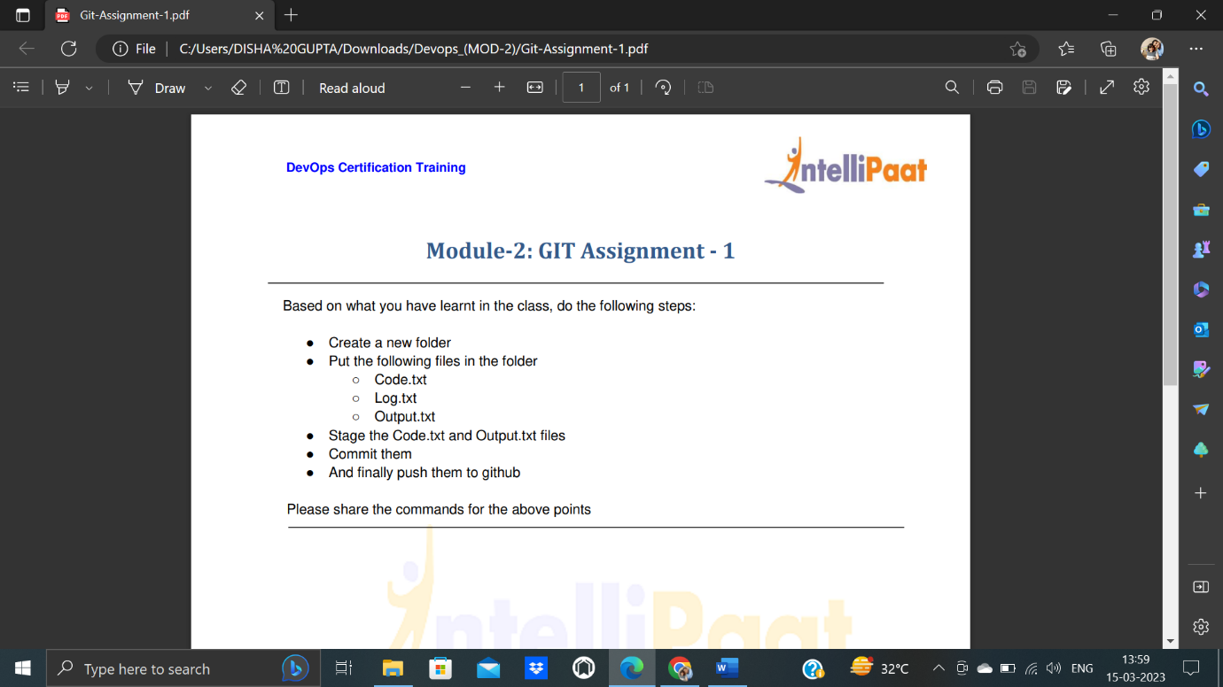

1)Creating central repository

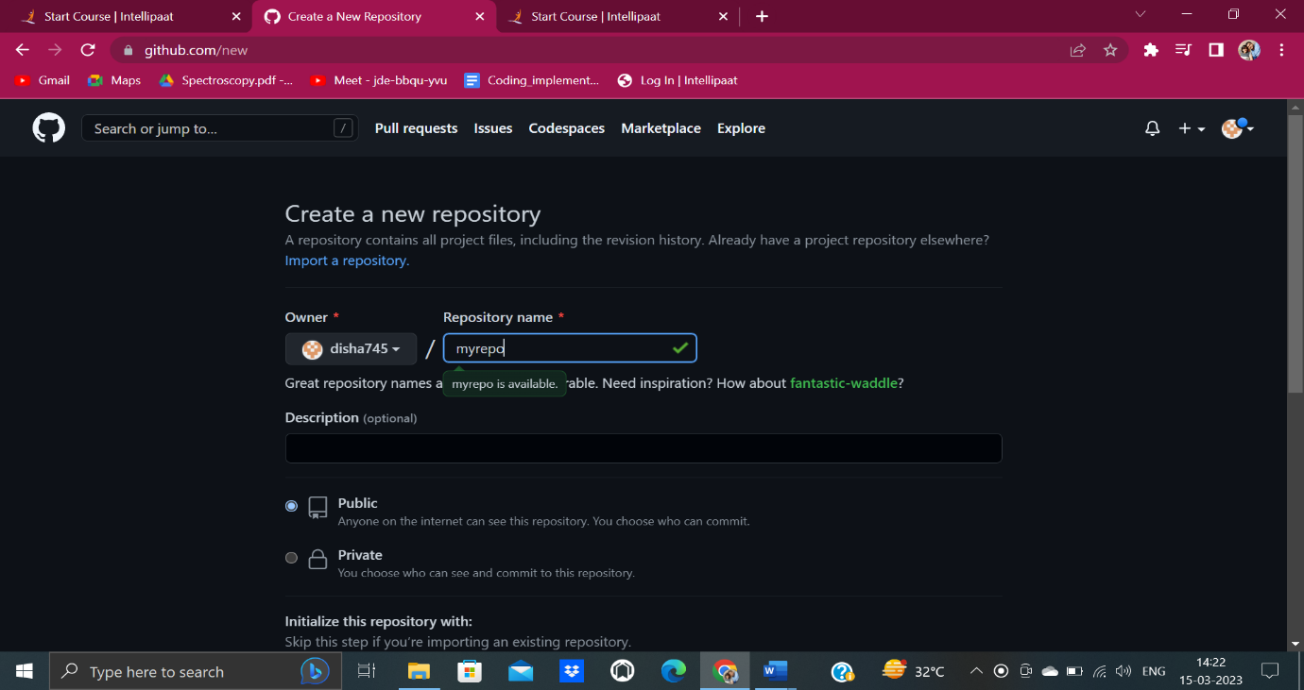

2)Make one folder and add the files output.txt and code.txt

And stage it then commit then push it to github

