Submitted by- DISHA GUPTA (phone no.- 9993786031 , email- guptadisha036@gmail.com)

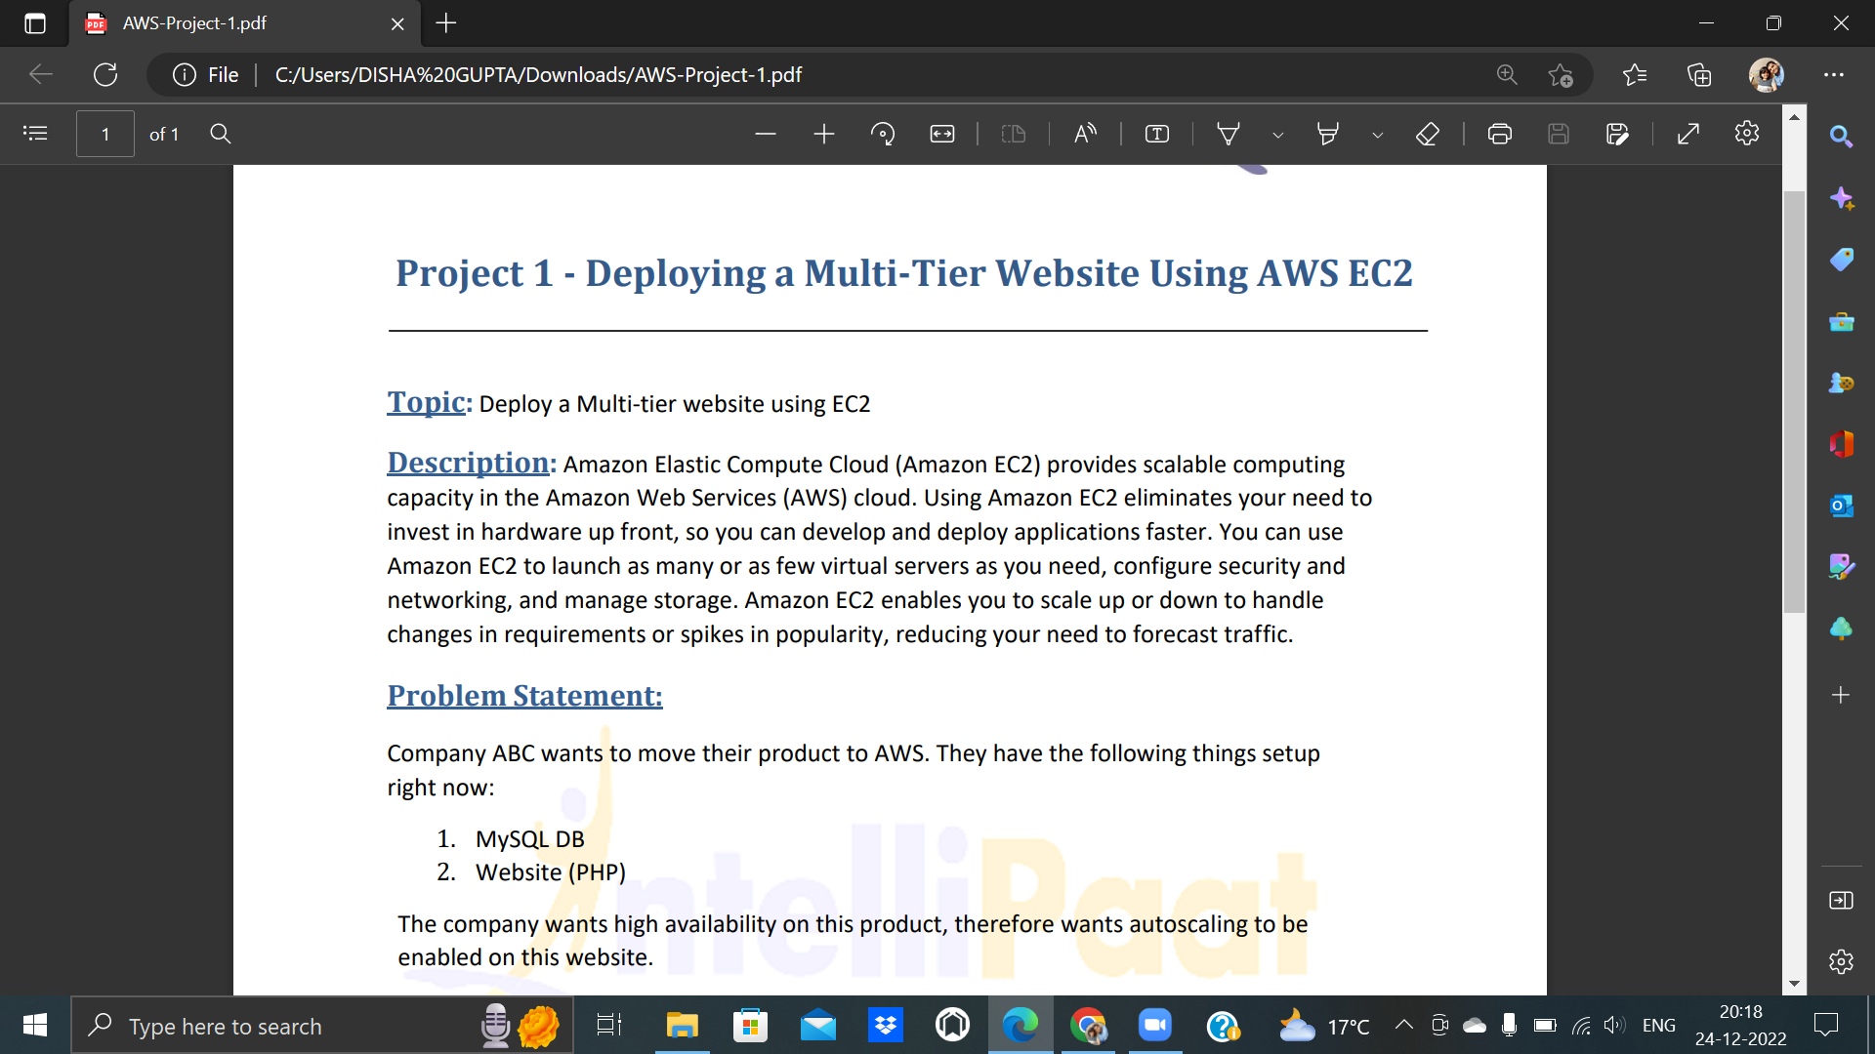

1)Launching the EC2 instance

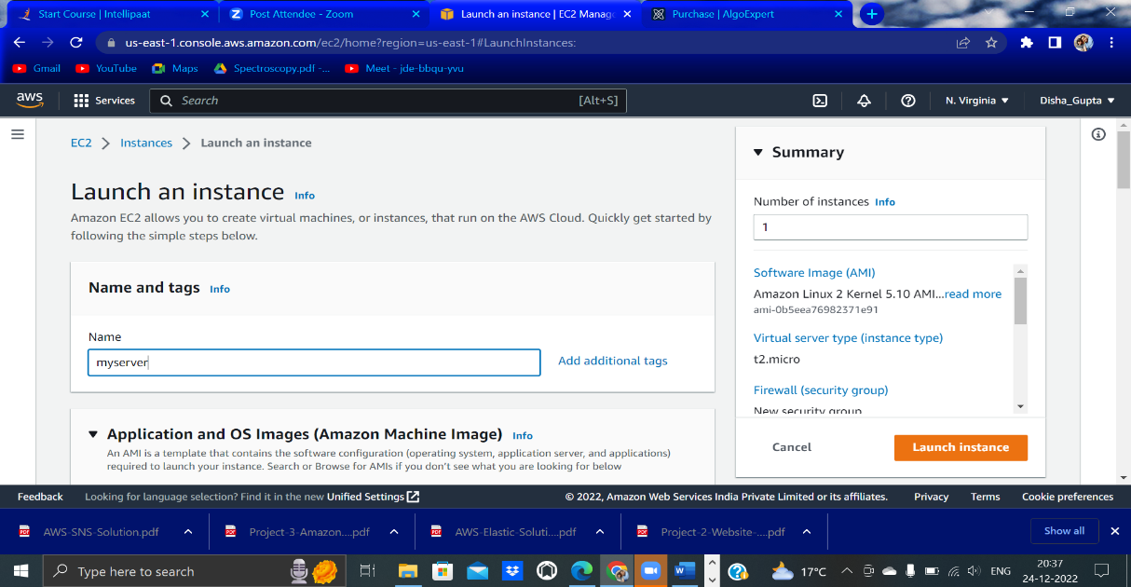

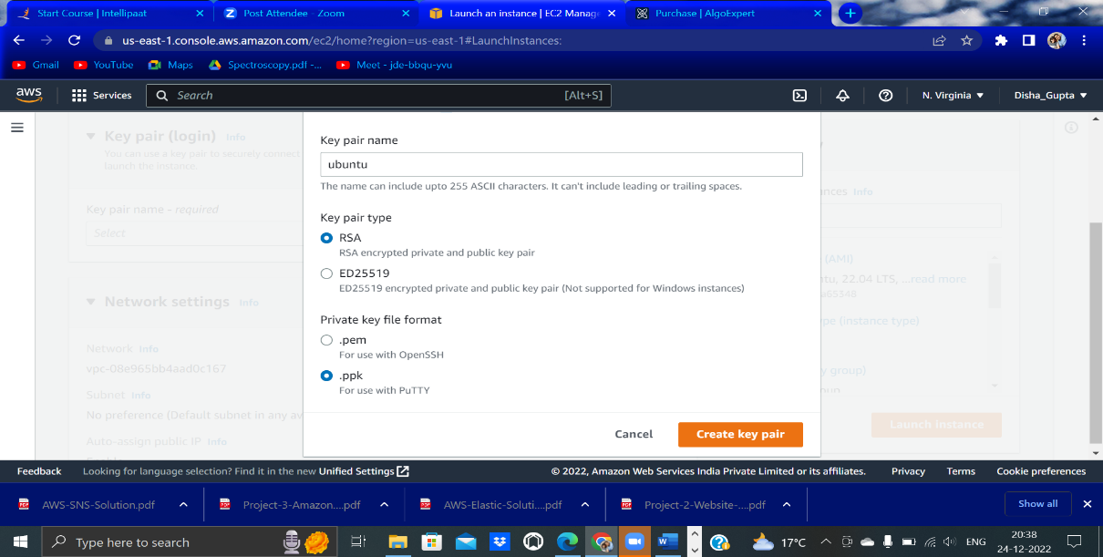

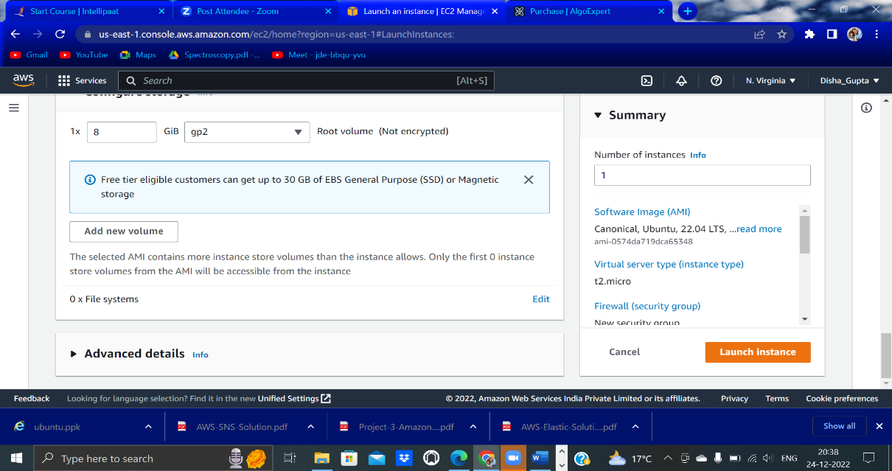

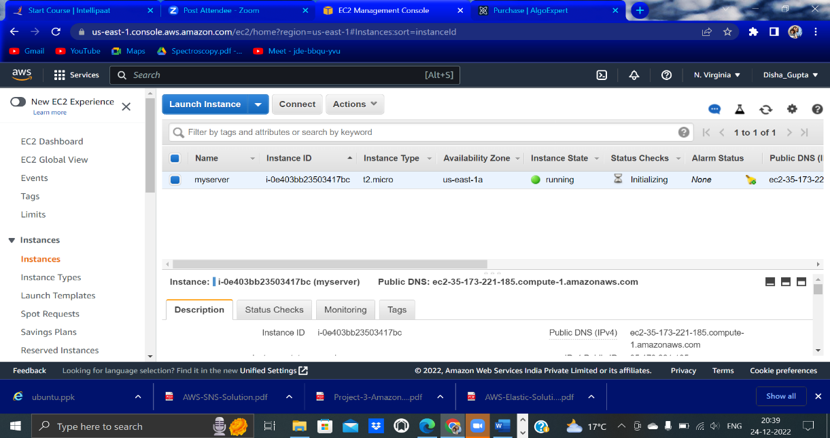

2)Connecting the EC2 instance through putty

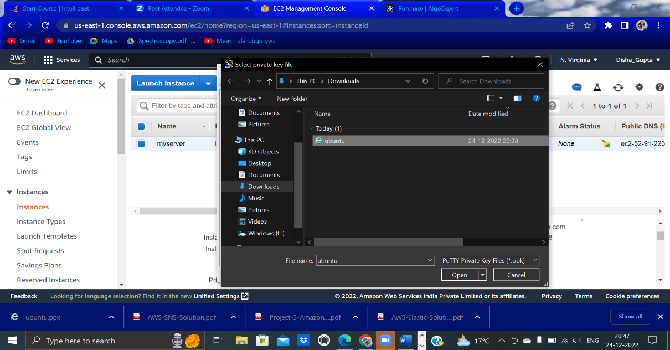

3)Run the following commands-

sudo apt-get update

sudo apt-get install apache2

*Then install php-mysql using the following command*

sudo add-apt-repository -y ppa:ondrej/php

sudo apt install php5.6 mysql-client php5.6-mysqli

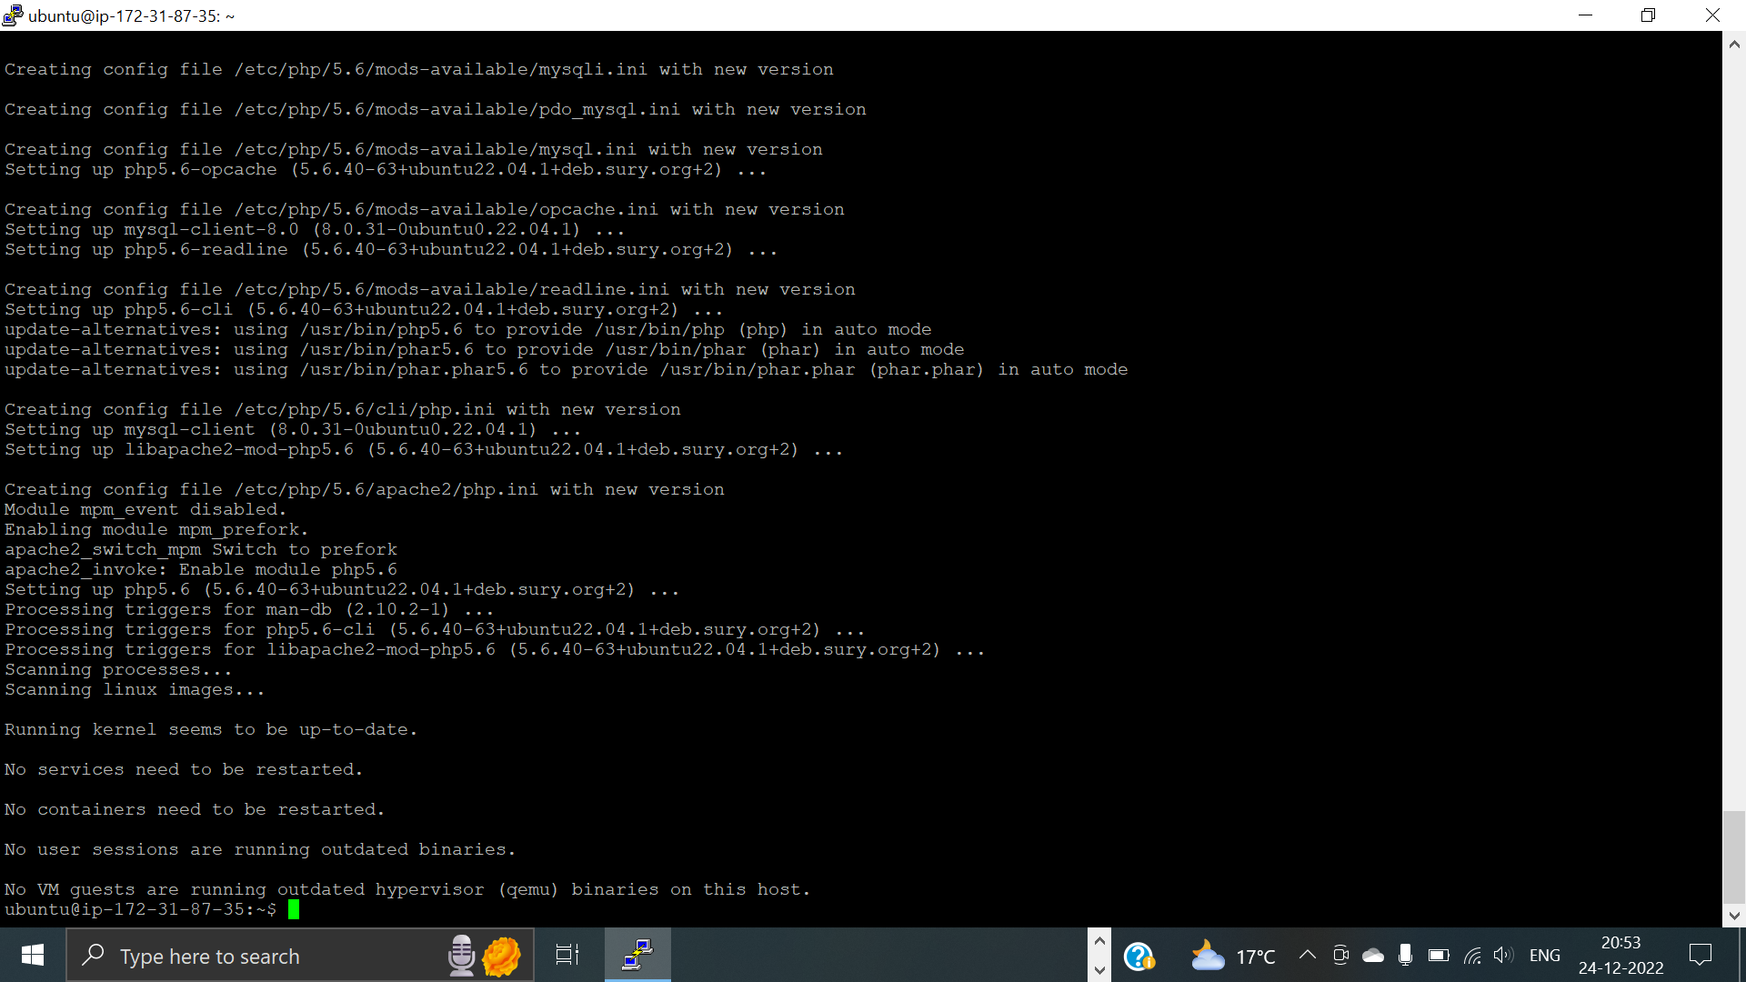

4)Creating RDS database

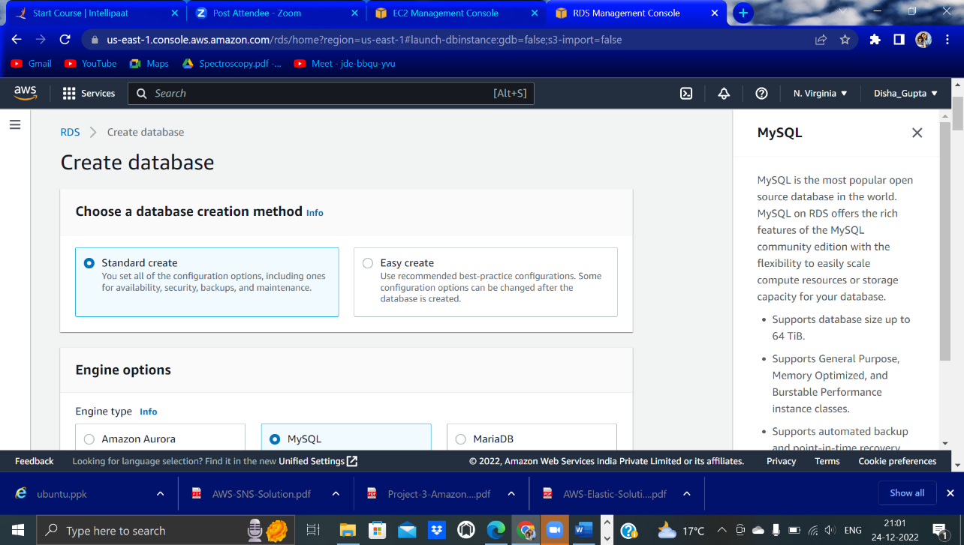

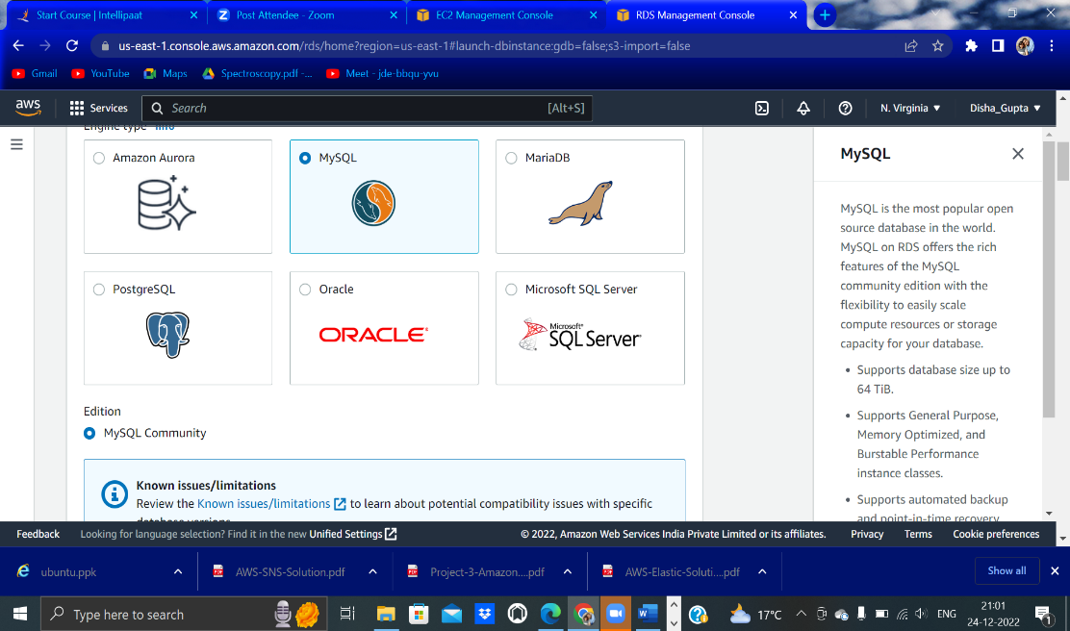

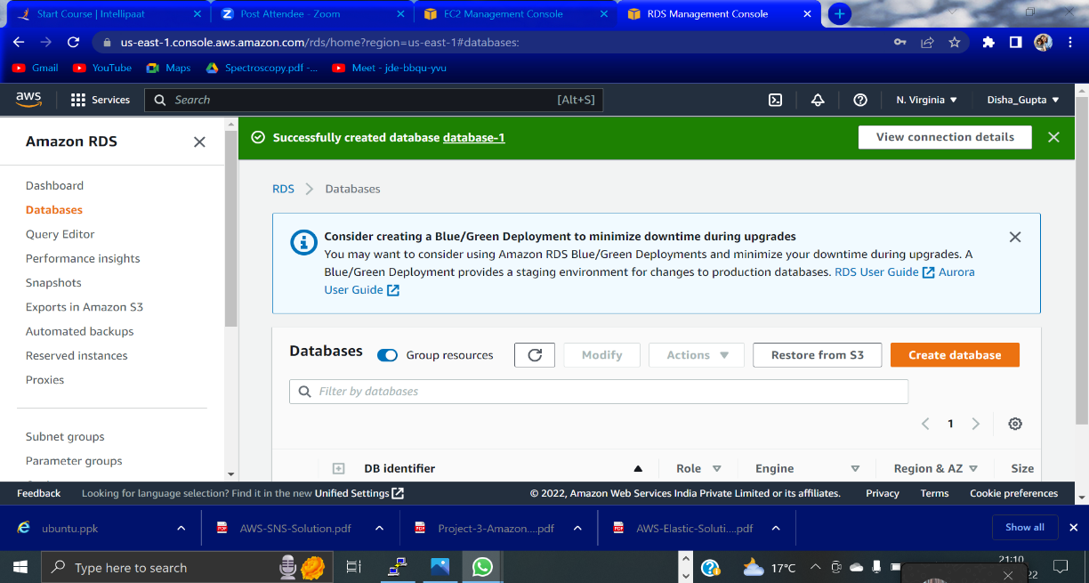

5) mysql -h hostname -u username -p

Hostname== Endpoint from RDS

Username which you created

6) Now install Filezilla

In order to connect it, enter hostname as the Endpoint of EC2 and Username as Ubuntu and no need to keep the password, then quickconnect.

7) Create a ‘New Folder’ of your website in your Desktop

And copy paste it in your Filezilla Remote Site path: /home/ubuntu

Remove the ‘index.html’ file and add ‘index.php’ in its place

Before running this website, you need to create a table in it (its database)

8) Copying public IP to your browser, you will observe that your website is working on it