Submitted by- DISHA GUPTA (phone no.- 9993786031 , email- guptadisha036@gmail.com)

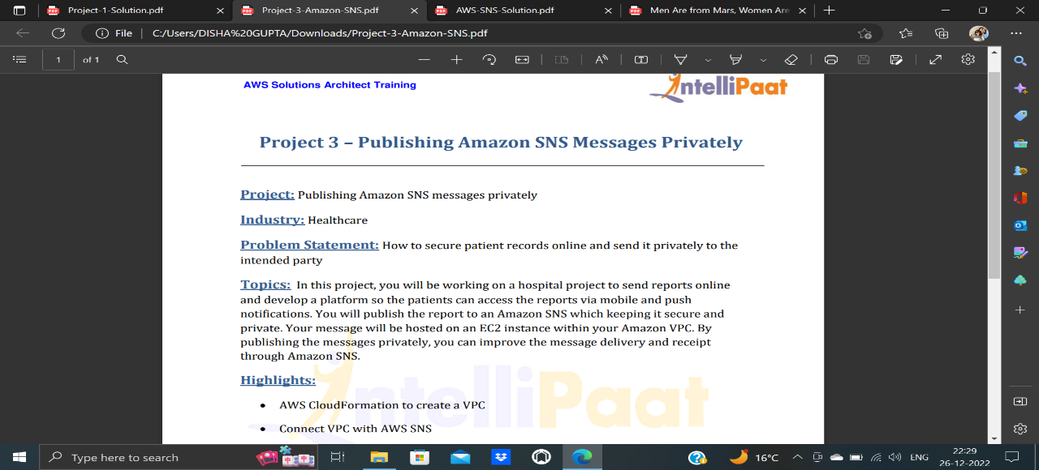

1. Create an Amazon EC2 Key Pair

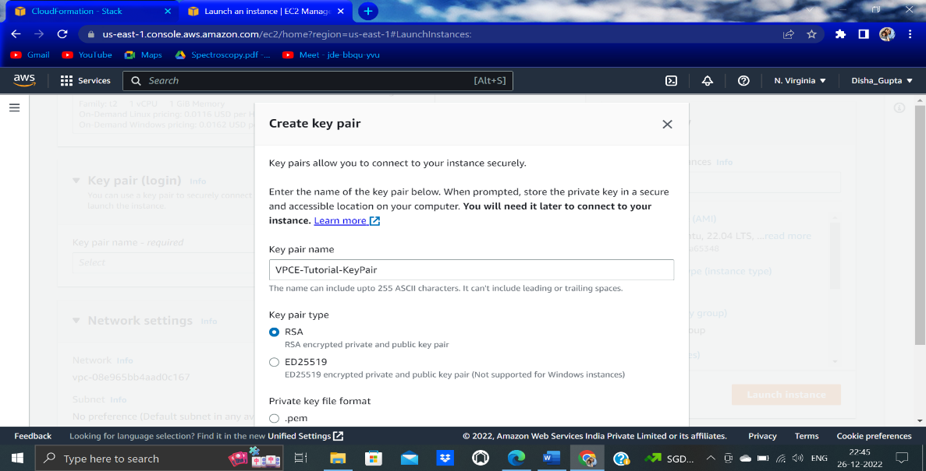

2)Create AWS resources using stack

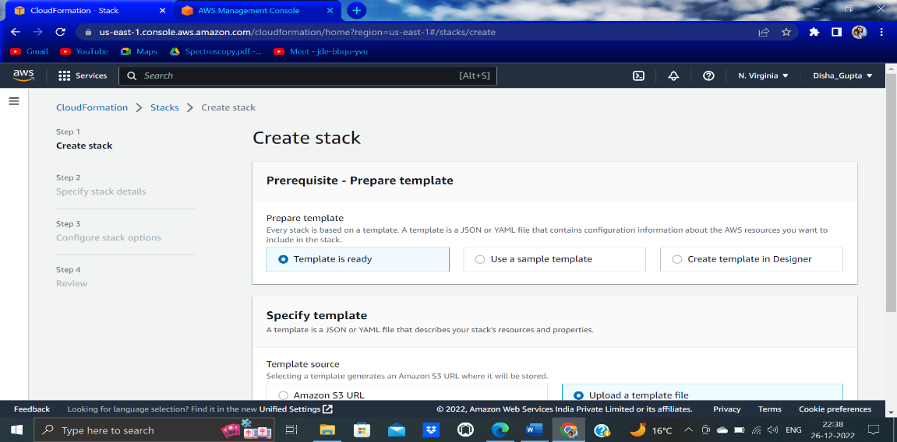

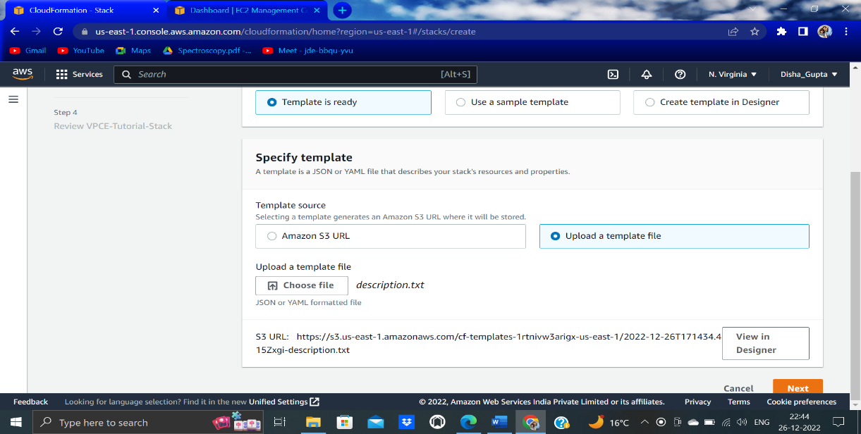

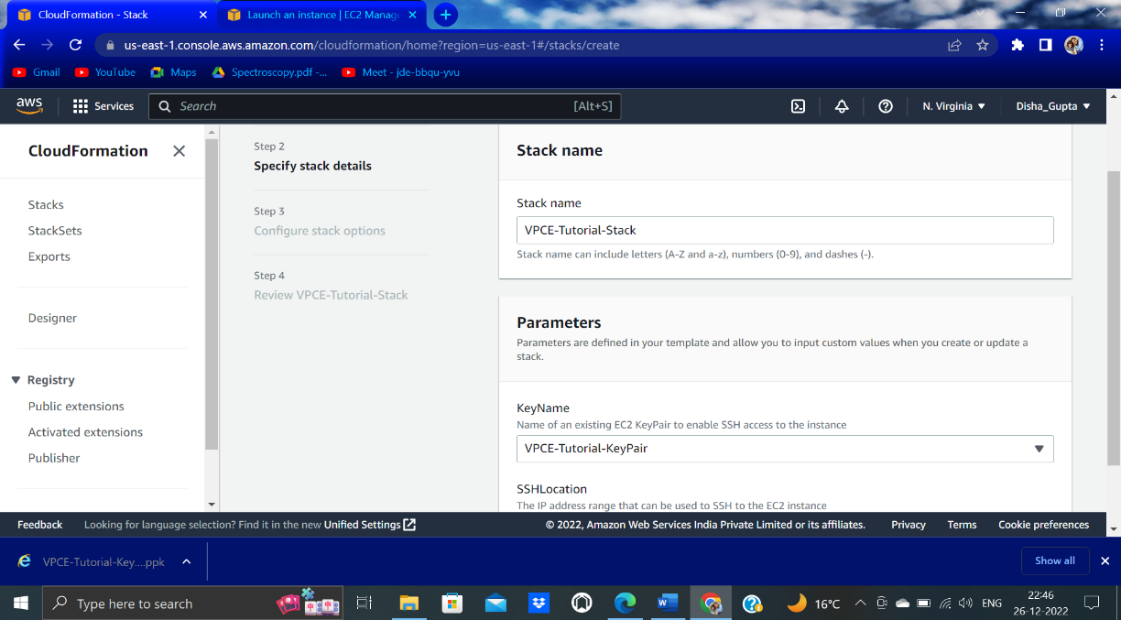

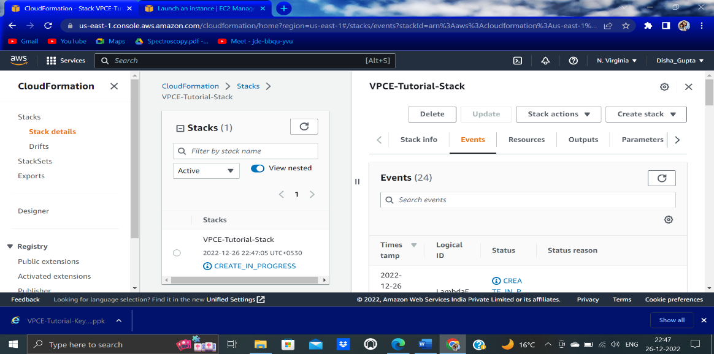

3)Confirm That Your Amazon EC2 Instance Lacks Internet Access

Using the following command To connect to your Amazon EC2 instance-

$ ssh -i VPCE-Tutorial-KeyPair.pem ec2-user@instance-hostname

To verify that the instance lacks internet connectivity-

$ ping amazon.com

4)Creating VPC endpoint

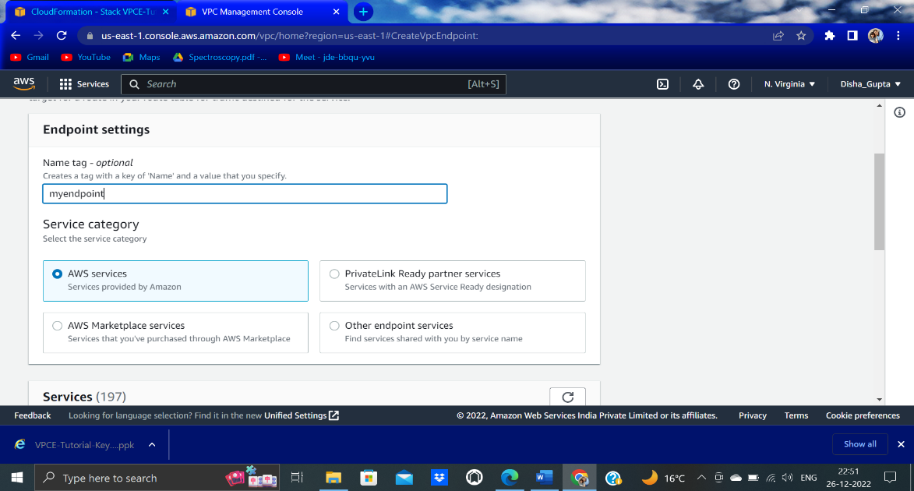

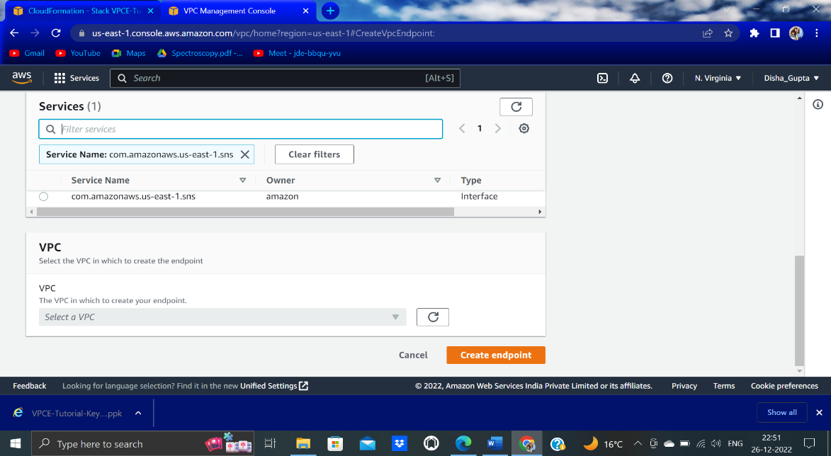

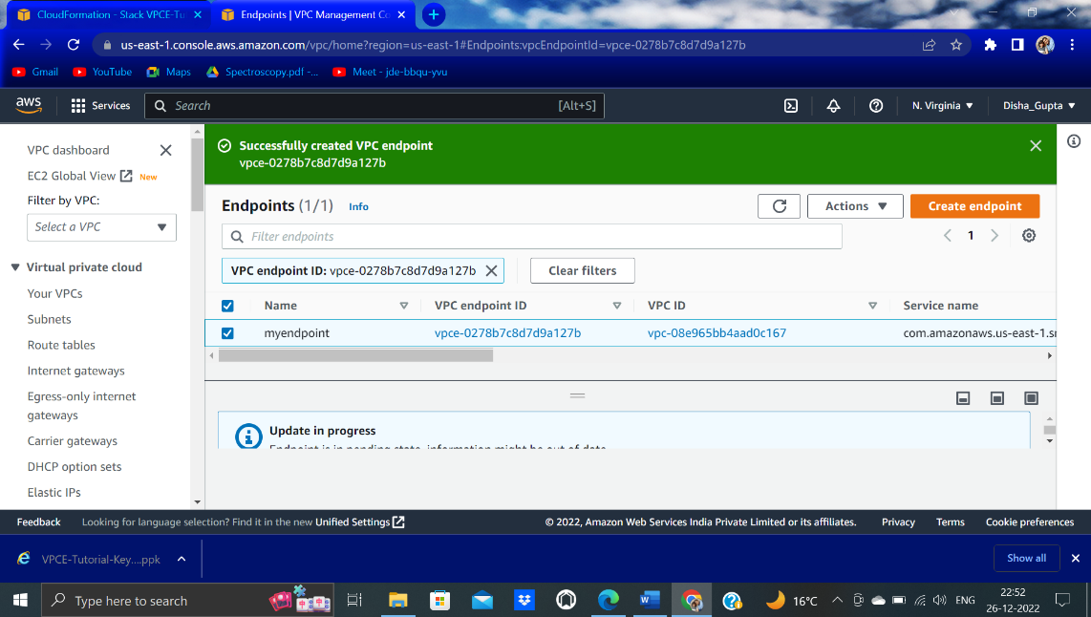

5) Publish a Message to Your Amazon SNS Topic

$ ssh -i VPCE-Tutorial-KeyPair.pem ec2-user@instance-hostname