Enterprise ERP Development Plan
React + NestJs + PostgreSQL
Tenant Application and Separate Super Admin Platform

Prepared for | Opsedge Ai Pvt. Ltd.
Prepared by | Aakash Vaidya
Delivery scope | Architecture, phased execution, database chart, standards, governance
Primary stack | React, NestJs (Node.js), PostgreSQL, Redis
Reference basis | ERP-Application-Playbook-v2.pdf

This document provides a practical industry-standard implementation plan for building a multi-tenant ERP platform using React, Express, and PostgreSQL. It includes the tenant-facing product, the separate super admin application, the proposed data model, platform standards, security controls, delivery phases, and engineering governance needed to ship and scale the system responsibly.

1. Executive summary
The recommended solution is a modular SaaS ERP platform with a shared application core, strict tenant isolation, and a separate super admin project for platform governance. The tenant application handles business operations such as identity, CRM, sales, projects, invoices, subscriptions, payments, finance, support, and reporting. The super admin platform is intentionally isolated to reduce risk and to keep cross-tenant operations, provisioning, subscription management, support tooling, and platform analytics outside the tenant runtime.
Key architectural decisions
Frontend: React with feature-based modules, React Query, form validation, route guards, and reusable design system components.
Backend: NestJs + TypeScript with a clean layered architecture (route → controller → service → repository), integrated OpenAPI (Swagger) documentation, request validation, and centralized exception handling.
Database: PostgreSQL as the source of truth for transactional data, with per-record tenant_id, audit fields, optimized indexes, and row-level isolation patterns.
Platform split: tenant product and super admin product run as separate web projects, separate API surface, separate RBAC model, and separate deployment pipeline.
Operations: CI/CD, structured logging, monitoring, alerting, migration discipline, backups, and disaster recovery drills.

2. Business and technical objectives
- Support multiple tenants on a shared SaaS platform without cross-tenant data exposure.
- Enable rapid delivery of core ERP modules while preserving maintainability and auditability.
- Provide a foundation for subscriptions, invoicing, payments, workflows, reporting, and integrations.
- Make the platform easy to test, deploy, scale, monitor, and extend with additional modules later.
- Keep super admin capability operationally powerful but logically isolated from tenant operations.

3. Recommended solution overview
The preferred implementation model is a modular monolith for phase 1 and phase 2, designed with clear domain boundaries and event-ready contracts so that high-load modules can be extracted into separate services later if the product and team scale justify it. This is the most practical path for a new ERP because it lowers operational complexity while still following the discipline required for long-term enterprise growth.
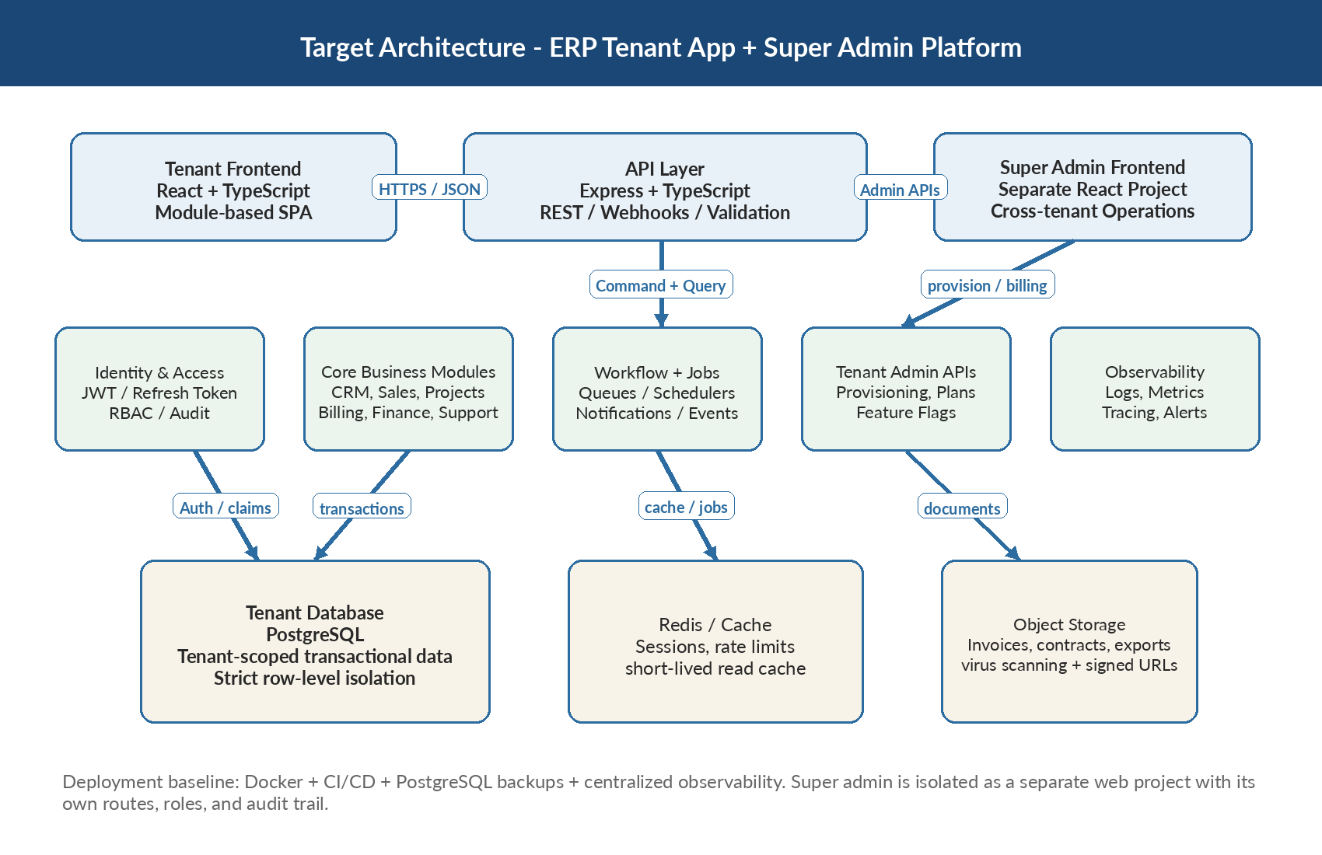
Figure 1. Recommended target architecture for the tenant ERP application and separate super admin platform.

4. Technology stack and standards
Layer | Recommendation | Rationale | Notes
Frontend | React + TypeScript | Large talent pool, reusable components, SPA ergonomics | Prefer Vite, React Router, React Query, Zod, Zustand or Redux Toolkit only where needed
Backend | Node.js + NestJS (TypeScript) | Highly scalable and maintainable architecture with built-in modular design, strong TypeScript support, and an ecosystem well-suited for complex enterprise systems like ERP. | Use strict TypeScript configuration, class-validator (or Zod) for DTO validation, structured logging (Pino), Swagger (OpenAPI) for API documentation, rate limiting, and NestJS guards for authentication and RBAC authorization.
Database | PostgreSQL | Reliable ACID transactions, indexing, JSONB, reporting capability | Prefer UUID PKs, migration-based schema changes, partition audit logs if needed
Caching / jobs | Redis | Fast cache, queues, throttling | Use for BullMQ job queues, sessions, token blocklist, short-lived projections
Storage | Object storage | Document and report storage | Signed URLs, malware scanning, retention rules
Authentication | JWT access + refresh token flow | Scalable and API friendly | Short TTL access token, rotation, device/session tracking
DevOps | Docker + CI/CD + IaC | Consistent delivery and recoverability | Separate dev, QA, staging, production environments

5. Application architecture

5.1 Frontend architecture
The React application should use a feature-first folder structure so each business domain owns its pages, components, hooks, API client adapters, validation schema, and tests. Cross-cutting concerns such as design tokens, layout shells, route guards, tables, modals, and notifications should live in shared UI packages or app-level libraries rather than inside feature folders.
- Use TypeScript strict mode, path aliases, ESLint, Prettier, and import boundaries.
- Keep business rules out of UI components; move them into domain services or shared client-side mappers only when necessary for display logic.
- Use React Query for server state, request caching, retry control, optimistic updates, and invalidation.
- Use form libraries with schema validation for complex workflows such as invoice creation, subscription changes, and approval forms.
- Build accessibility, localization readiness, and responsive behavior from the start instead of treating them as later fixes.

5.2 Backend architecture
The Express backend should be organized by domain modules. Each module exposes routes, controllers, services, repositories, DTOs, validators, and tests. Controllers stay thin. Services hold application rules. Repositories encapsulate SQL or query builder logic. Transactions should be coordinated at the service layer. Cross-module calls should happen through service contracts, emitted domain events, or internal command interfaces rather than direct table access.
- Middleware chain: request ID -> auth -> tenant context -> validation -> controller -> service -> structured response.
- Standard error model with domain errors, validation errors, forbidden errors, not-found errors, and safe user-facing messages.
- Idempotency keys for financial endpoints such as payment initiation, webhook handling, invoice issue/post actions, and exports.
- Version APIs from day one, even if v1 is the only version at launch.
- Use OpenAPI generation and publish internal API documentation continuously.

5.3 Suggested domain modules
Module | Primary responsibility | Owns key entities | Integration notes
Identity & RBAC | Authentication, sessions, tenant-aware authorization | users, roles, permissions, sessions | Shared by tenant app and admin app through separate API policies
Tenant setup | Tenant profile, plan, settings, feature flags | tenants, tenant_settings, plan_assignments | Provisioned from super admin
CRM | Customers, contacts, addresses | customers, contacts, customer_addresses | Feeds projects, invoices, subscriptions, support
Sales | Leads, opportunities, quotations | leads, opportunities, quotations | Converts into customers/projects/invoices
Projects | Delivery planning and billable work | projects, milestones, project_members | Can trigger billing events
Billing | Invoices, credit notes, tax snapshots | invoices, invoice_items, credit_notes | Consumes customer and subscription data
Subscriptions | Recurring plans and renewals | subscription_plans, subscriptions, subscription_changes | Generates billing schedules
Payments | Payment intent, reconciliation, refunds | payments, payment_attempts, refunds | Integrates with gateway via webhooks
Finance | Ledger, journal entries, fiscal periods | journals, ledger_entries, accounts | Consumes billing and payment events
Workflow | Approvals, policies, SLA/rules | workflow_definitions, approvals | Cross-cutting orchestration
Support | Tickets, comments, SLA handling | tickets, ticket_comments | Customer-facing service module
Reporting | Aggregated analytics and exports | materialized views, snapshots, exports | Read optimized, no ownership of transactional truth
Audit | Immutable activity and security logging | audit_logs, login_events | Appends from all domains

6. Separate super admin project
The super admin capability should not be merged into the tenant application UI. It should be delivered as a separate React project with its own routes, permissions, navigation, branding treatment, deployment pipeline, and audit policy. It may reuse a shared component library and selected backend packages, but its runtime boundary should remain separate.
Why it should be separate
Reduces the blast radius of privileged features and lowers the chance of accidental cross-tenant exposure.
Makes RBAC cleaner: platform administrators, support operations, finance operations, and compliance roles are not mixed with tenant roles.
Allows independent release cadence, stronger audit logging, and separate MFA or network controls for highly privileged users.
Keeps tenant UX focused on operational work instead of platform-management concerns.

Area | Responsibilities | Guardrails
Tenant lifecycle | Create tenant, suspend, reactivate, archive, assign plan, seed defaults | Every action logged with justification and actor identity
Platform subscriptions | Global pricing plans, billing oversight, invoice disputes | No direct edits to tenant transactional records without approved override flow
Feature governance | Enable/disable modules, beta flags, regional controls | Use configuration records, not code edits in production
Support tooling | Safe impersonation or support session approval | Time-boxed, approved, visible to audit, masked where required
Compliance & risk | Access reviews, export approvals, retention policy triggers | Restricted to dedicated admin roles and dual control for sensitive actions
Operations dashboard | Health, alerts, queue depth, tenant usage trends | Read-only operational dashboards separate from write actions

7. Data architecture and database chart
PostgreSQL is the transactional system of record. The recommended starting point is one PostgreSQL cluster with clearly separated schemas or bounded domain tables, enforced tenant scoping, migration-based schema management, and a documented path for extracting heavy modules later. Every tenant-owned table must include tenant_id, created_at, updated_at, created_by, updated_by, and a soft-delete status when business retention rules require it.
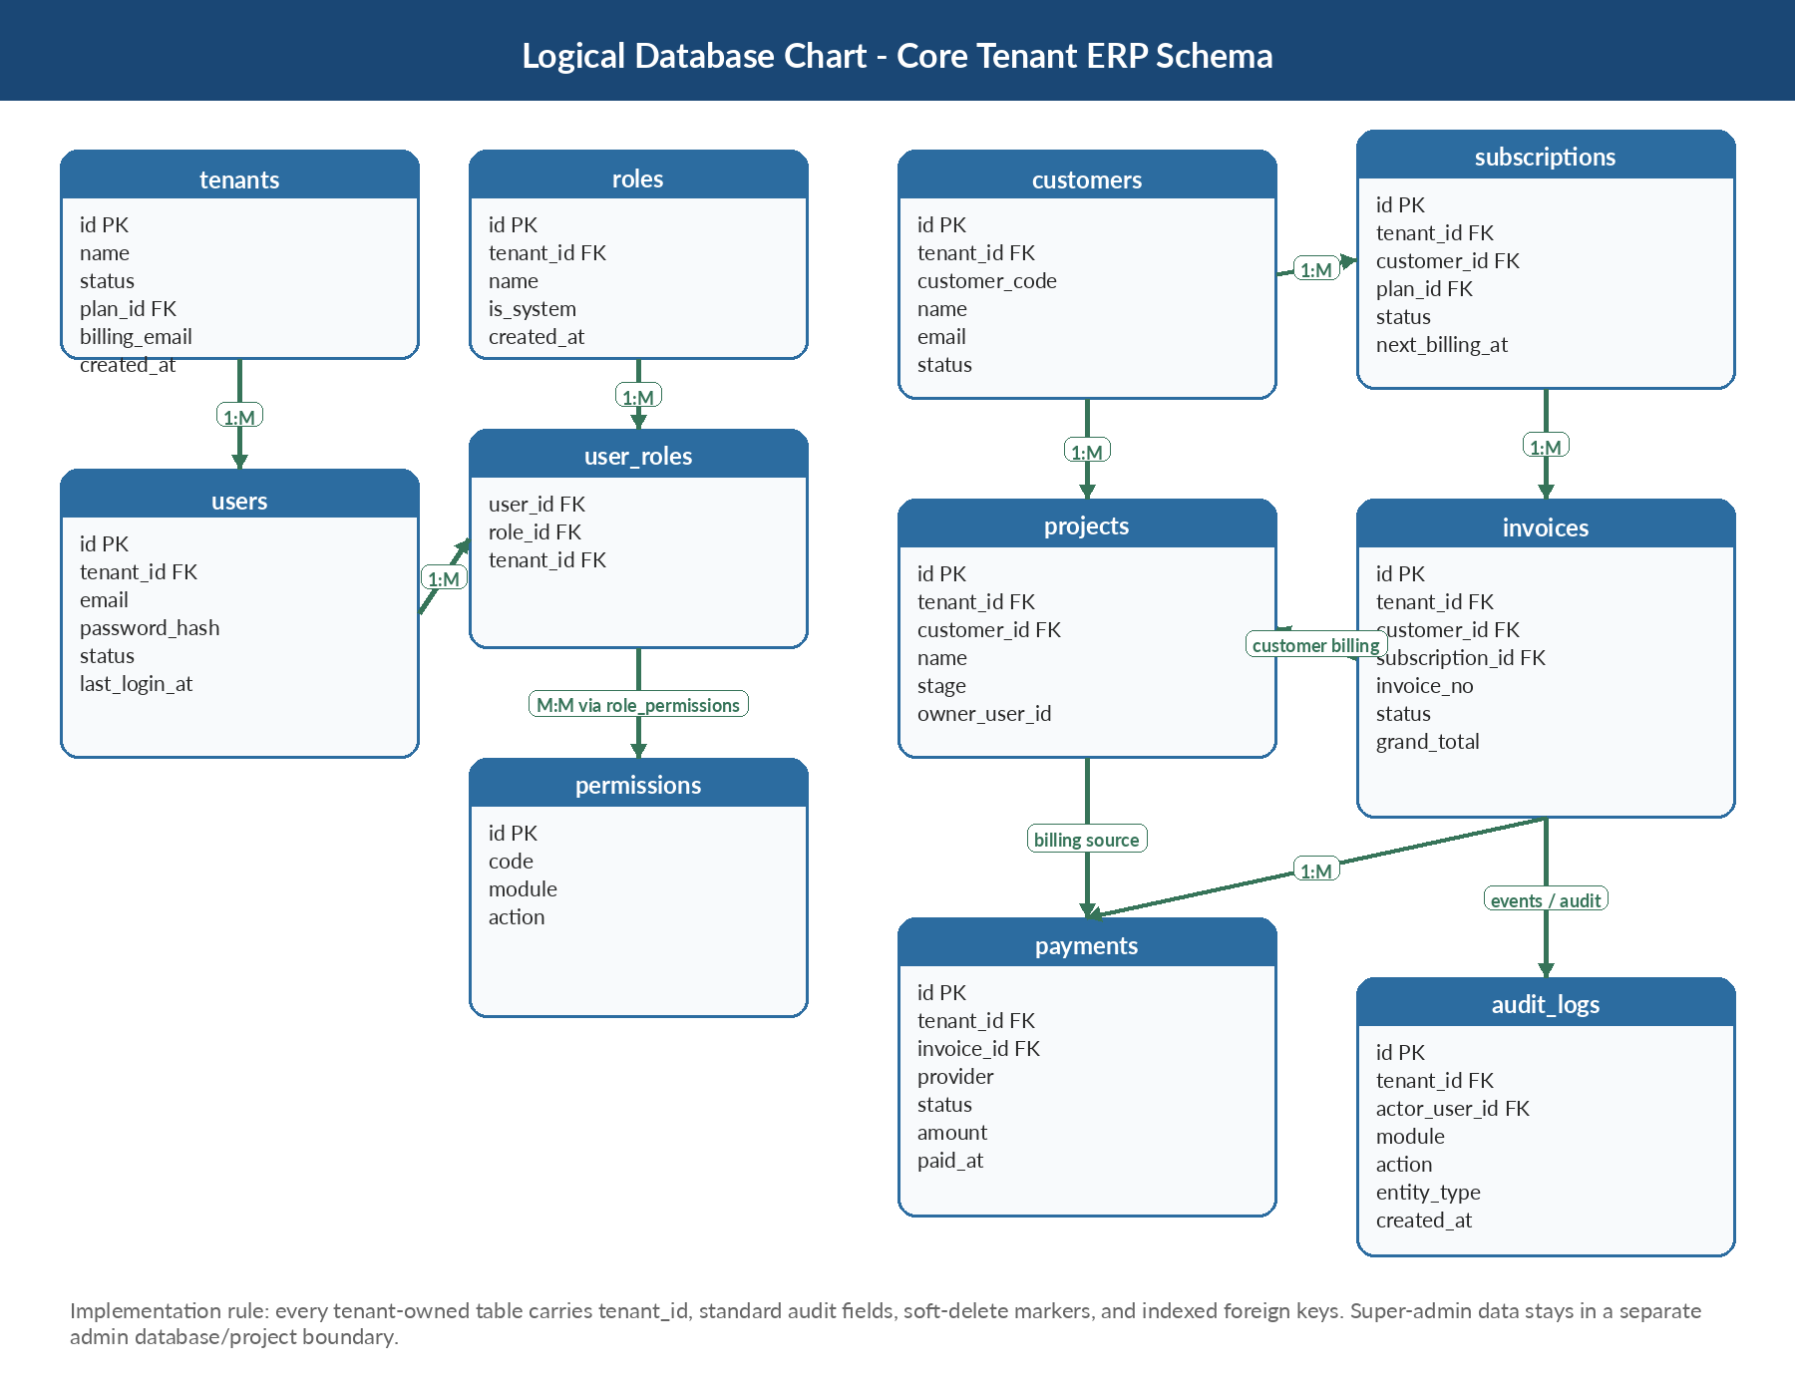
Figure 2. Core logical database chart for the tenant ERP schema. This is a planning baseline, not the final exhaustive schema.

7.1 Core schema standards
- Use UUID primary keys for internal identity and separate human-friendly codes for invoice numbers, customer codes, ticket codes, and project numbers.
- Apply NOT NULL constraints intentionally, use check constraints for enum-like status values where appropriate, and keep reference data normalized.
- Create compound indexes around tenant_id plus the main filter columns, for example (tenant_id, status), (tenant_id, created_at), and unique (tenant_id, invoice_no).
- Prefer append-only records for financial history and audit events; do not overwrite material financial facts after posting.
- Use migration tooling for all schema changes, including backfill scripts, rollbacks, and release notes.

7.2 Proposed key tables and fields
Platform / identity
Table | Key fields
tenants | id, name, slug, status, plan_id, default_currency, timezone, billing_email, created_at
tenant_settings | id, tenant_id, key, value_json, updated_at
users | id, tenant_id, email, password_hash, full_name, status, last_login_at, created_at
roles | id, tenant_id, name, description, is_system, created_at
permissions | id, code, module, action, description
user_roles | tenant_id, user_id, role_id, assigned_at, assigned_by
sessions | id, user_id, tenant_id, refresh_token_hash, ip_address, user_agent, expires_at

CRM / sales / project
Table | Key fields
customers | id, tenant_id, customer_code, name, email, phone, status, tax_id, created_at
contacts | id, tenant_id, customer_id, name, email, phone, role, is_primary
leads | id, tenant_id, source, owner_user_id, stage, expected_value, created_at
opportunities | id, tenant_id, customer_id, stage, amount, close_date, owner_user_id
projects | id, tenant_id, customer_id, name, stage, start_date, end_date, owner_user_id
project_milestones | id, tenant_id, project_id, name, due_date, billing_status, amount

Billing / subscription / payment
Table | Key fields
subscription_plans | id, code, name, billing_cycle, price, currency, active
subscriptions | id, tenant_id, customer_id, plan_id, status, start_at, next_billing_at, cancel_at
invoices | id, tenant_id, customer_id, subscription_id, invoice_no, status, subtotal, tax_total, grand_total, issued_at, due_at
invoice_items | id, tenant_id, invoice_id, line_no, item_type, description, qty, unit_price, tax_rate, line_total
payments | id, tenant_id, invoice_id, provider, provider_ref, status, amount, currency, paid_at
refunds | id, tenant_id, payment_id, amount, reason, status, approved_by, created_at

Finance / workflow / support / audit
Table | Key fields
accounts | id, tenant_id, account_code, account_name, account_type, status
ledger_entries | id, tenant_id, journal_id, account_id, debit, credit, reference_type, reference_id, posted_at
workflow_definitions | id, tenant_id, code, name, trigger_event, status, definition_json
approvals | id, tenant_id, workflow_instance_id, approver_user_id, decision, comments, decided_at
tickets | id, tenant_id, customer_id, subject, priority, status, assigned_user_id, opened_at
audit_logs | id, tenant_id, actor_user_id, module, action, entity_type, entity_id, metadata_json, created_at

7.3 Data isolation rules
- Tenant data queries always filter by tenant_id in application code and database access abstractions.
- Super admin reads across tenants only through a separate admin path with explicit audit logging and approval where required.
- Direct cross-module database access is prohibited; modules communicate through services or events.
- Sensitive fields such as tax identifiers, secrets, and payment provider references should be encrypted or tokenized according to risk level.
- Soft delete is the default unless legal or financial retention rules require immutable archival instead.

8. Security, compliance, and operational best practices
Area | Minimum standard | Implementation notes
Authentication | JWT access token + rotating refresh token + MFA for privileged users | Store refresh token hashes only, track device/session, revoke on logout or compromise
Authorization | Role-based access control with explicit permissions | Permission naming pattern module.action; audit all privilege changes
API security | TLS everywhere, rate limiting, input validation, safe serialization | Apply helmet, CORS policy, request size limits, and webhook signature verification
Data protection | Encryption in transit and at rest for sensitive records | Use secret manager, backup encryption, signed URLs for documents
Auditability | Immutable security and business audit logs | Log actor, tenant, action, entity, before/after summary, timestamp, IP when relevant
Operational resilience | Automated backups, restore tests, health checks, alerting | Define RPO/RTO targets and test them quarterly
Release control | CI/CD with mandatory review and automated gates | No manual database edits in production outside approved break-glass process

9. DevOps and deployment model
- Repository strategy: either one mono-repo with apps/tenant-web, apps/admin-web, apps/api, packages/shared-ui, packages/config, packages/types; or two repos if organizational controls require stricter separation.
- Environment strategy: local, development, QA, staging, production. Keep infrastructure, secrets, and environment variables separate.
- Deployment baseline: Docker images, reverse proxy / ingress, PostgreSQL managed service or HA setup, Redis, object storage, centralized logs, metrics, and tracing.
- CI pipeline: install, lint, type-check, unit tests, integration tests, build, security scans, migration check, artifact publish.
- CD pipeline: deploy to staging automatically, run smoke tests, require approval for production, enable rollback and previous image redeploy.

10. Testing and quality strategy
Test type | Scope | Tools | Release rule
Unit tests | Core services, validators, utility functions | Vitest/Jest | Required on changed modules
API integration tests | Routes, auth, tenant isolation, posting rules | Supertest + test DB | Must pass before merge
UI tests | Critical user journeys | Playwright | Run on staging and before production release
Contract tests | Gateway webhooks, admin APIs, exports | Mock servers / pact style tests | Required for third-party integrations
Performance tests | Invoice posting, payment webhook burst, exports | k6 / Artillery | Baseline before go-live and each major release
Security tests | Dependency scans, SAST, auth checks, penetration testing | CI scanners + external review | Critical findings block release

Phase | Target outcome | Major deliverables | Suggested duration | Exit criteria
0. Discovery & blueprint | Freeze scope and operating model | BRD refinement, domain map, wireframes, backlog, ADRs, solution blueprint | 2-4 weeks | Signed architecture, module priority, non-functional requirements
1. Platform foundation | Make the product runnable end-to-end | Repo setup, auth, tenant context, design system, CI/CD, migrations, audit baseline | 3-5 weeks | Users can log in, create tenant-scoped records, deploy safely
2. Core operations | Deliver initial business value | Customers, roles, dashboard, projects, leads/opportunities, document storage | 4-8 weeks | Tenant admins can operate day-to-day workflows
3. Billing & finance | Revenue operations online | Plans, subscriptions, invoices, payments, refunds, ledger foundation, reports | 5-9 weeks | Financial workflow tested, auditable, reconciliation baseline ready
4. Super admin project | Platform controls online | Admin web, tenant lifecycle tools, global plans, support controls, ops dashboard | 3-6 weeks | Privileged workflows isolated, MFA and audit policies enforced
5. Hardening & go-live | Production readiness | Load tests, security testing, DR drill, runbooks, training, launch checklist | 2-4 weeks | Go-live checklist signed, monitored production release completed

11. Team structure and ownership
- Product owner / business analyst: requirement definition, prioritization, UAT sign-off, change control.
- Solution architect / technical lead: architecture governance, domain boundaries, API contracts, database review, security design.
- Frontend engineers: tenant app and admin app delivery, design system, accessibility, test automation.
- Backend engineers: domain modules, APIs, migrations, integrations, events, performance tuning.
- QA engineer: test strategy, automated regression, non-functional validation, release gate support.
- DevOps engineer: environments, CI/CD, infrastructure, observability, backup and recovery.
- Security/compliance reviewer: privileged access policy, audit, vulnerability management, release risk review.

12. Risks and mitigation plan
Risk | Impact | Mitigation
Unclear ERP scope or frequent requirement changes | Delays, rework, unstable delivery plan | Freeze MVP per phase, maintain change log, use ADRs and backlog prioritization discipline
Cross-tenant leakage through poorly designed queries | Critical security incident | Mandatory tenant context middleware, repository patterns, integration tests for isolation, admin-path segregation
Billing logic changes late in project | Financial defects and audit pain | Domain modeling workshops early, invoice lifecycle locked, idempotent integration design
Over-engineering into microservices too early | Slower delivery and ops burden | Start with modular monolith and extract only proven hotspots
Privileged admin features mixed with tenant app | Governance confusion and higher breach risk | Separate super admin project with distinct auth policy and audit logs
Weak migration and release discipline | Production instability and data drift | Migration reviews, staging rehearsal, rollback plans, tested restores

13. Recommended coding and engineering standards
- Adopt trunk-based or short-lived branch workflow with pull requests, code review, and conventional commits or release tags.
- Protect main branch with required checks: lint, type-check, tests, secret scan, dependency scan, and migration validation.
- Define naming conventions for modules, APIs, events, permissions, DB tables, columns, and job queues early and document them.
- Use DTO validation on every external input, sanitize outputs, and never trust client-supplied tenant identifiers.
- Implement structured logging from the beginning with correlation ID, actor ID, tenant ID, module, and request latency.
- Track architecture decisions in ADRs and review any changes to auth, tenancy, billing, integration, or data retention design.
- Write documentation alongside code: setup guide, API docs, runbooks, migration notes, and troubleshooting guides.

14. Suggested initial backlog
- Set up repositories, package management, linting, formatting, TypeScript config, commit hooks, and CI pipeline.
- Create database migration framework, base schema, audit columns, tenant context, and seed data pipeline.
- Implement auth module with login, refresh, logout, password reset, RBAC, session tracking, and permission middleware.
- Build tenant app shell, navigation, dashboard, generic data table, form primitives, and notification patterns.
- Build super admin shell, tenant list, tenant detail, plan assignment, suspend/reactivate flow, and audit view.
- Deliver customers, contacts, projects, and document upload foundations before complex finance workflows.
- Implement subscription plans, invoice generation, payment webhooks, posting rules, and financial reports in controlled order.

15. Final recommendation
Proceed with React, Express, and PostgreSQL as the approved stack, but execute the solution with TypeScript, modular architecture, disciplined schema design, and strong operational controls. Build the tenant ERP and super admin as separate web projects from the start. Use a modular monolith first, not a premature microservice landscape. Lock down tenant isolation and billing lifecycle rules early. Treat auditability, backups, migrations, and testing as release-blocking concerns rather than optional cleanup.
Go-live readiness checklist
Tenant isolation tested across API, UI, exports, reports, and admin paths.
Invoice, payment, refund, and subscription lifecycles validated with real edge cases.
Backups restored successfully in a rehearsal environment.
Monitoring, alerts, runbooks, and escalation matrix reviewed by the team.
Super admin MFA, privileged action logging, and support access controls verified.

