**Online Quiz Portal**

**Software Design Description**

-TANNIKA AGGARWAL (12BCE0209)

-DISHA AGARWAL (12BCE0460)

-JASPREET SINGH (12BCE0305)

**CONTENT**

1. Overview.....................................................................................................................................................

1.1 Purpose .................................................................................................................................................3

1.2 Scope .....................................................................................................................................................3

2. System Architecture .................................................................................................................................4

3. Class Diagram ...........................................................................................................................................5

4. Sequence Diagrams and Descriptions .......................................................................................................

4.1 Sequence Diagram for User ...................................................................................................................6

4.2 Sequence Diagram Admin.......................................................................................................................7

5. Activity Diagram .......................................................................................................................................

5.1 Activity Diagram for User .......................................................................................................................8

5.2 Activity Diagram for Admin ....................................................................................................................9

6. ER Diagram ............................................................................................................................................10

7. Data Flow Diagrams ..................................................................................................................................

7.1 Level 0 DFD ..........................................................................................................................................11

7.2 Level 1 DFD ..........................................................................................................................................11

7.3 Level 2 DFD………………………………..........................................................................................................12

8. User Interface Design ................................................................................................................................

8.1 User Interface Screen for User Login...................................................................................................13

8.2 User Interface Screen for User Registration .......................................................................................14

1. **Overview**

**1.1 Purpose**

Design is the abstraction of a solution; it is a general description of the solution to a problem without the details. Design is view patterns seen in the analysis phase to be a pattern in a design phase. After design phase we can reduce the time required to create the implementation.

In this document we introduce context diagram, models, system architecture, principal system object, design model and object interface.

**1.2 Scope**

Scope of this project is very broad in terms of other manually checking yourself.

Few of them are:

* This can be used in educational institutions as well as in corporate world.
* Can be used anywhere any time as it is a web based application (user Location doesn’t matter).
* No restriction that examiner has to be present when the candidate takes the test.
* The user can choose any category and then take the quiz. Users will be given with maple options for selection.
* The user will be given a time limit in which he has to complete the quiz.
* The user will be shown all the correct answers instantly after taking the quiz.
* The questions will be randomized giving users a number of question to choose from.

1. **Architecture**

System refers to both hardware and software. The system architecture describes the collection of inter-connected hardware nodes on which the software will eventually run. System architecture consists of Hardware nodes, the connectivity among nodes, the location of users, inputs and outputs; Software Architecture We use Three-tier architectures to design our system. Because 3-tier Architecture increases performance, flexibility, maintainability, reusability, and scalability while hiding the complexity of distributed processing from the users/clients.

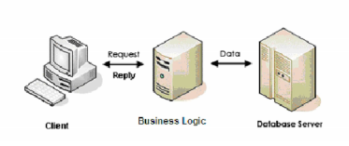

**System Architecture**

**CLIENT TIER**: Here client-tier is the first tier of our System/Software that the end-users (students, teachers and admin) will use.

**BUSINESS LOGIC TIER:** System/Software that Client-tier use to get data from the Database Server. Client-tier cannot access Database Server directly. It must request the Business Logic Server first. Upon authorization, the Business Logic Server will get the required data from Database Server and reply to the Client appropriately.

**DATABASE SERVER:** Central and persistent storage of all data from where Business Logic access data.

1. **CLASS DIGRAM**

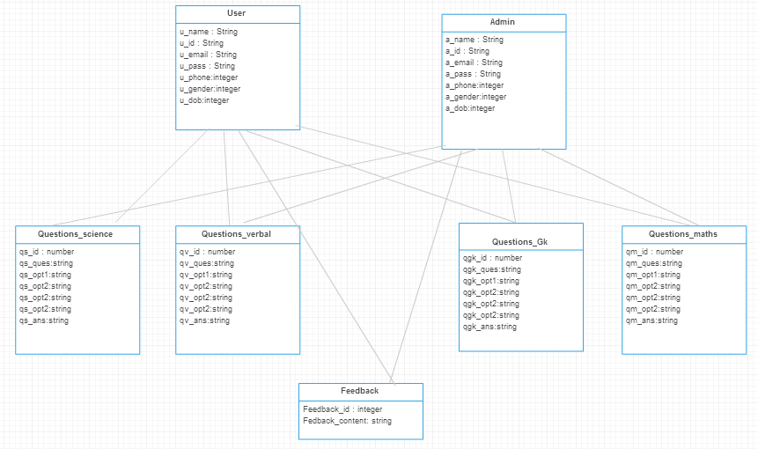

1. **SEQUENCE DIAGRAM**

Show Result:

Enter user name and password

User

Login:

Select subject:

Subject DB:

Start Test:

Verify

Request subject

Question DB:

DB:

Invalid subject

Inactive subject

Verify

Verify

If Accept

Unavailable question

Unavailable question

Take test:

If Accept

If Accept

Return result and finish the exam

4.1 Sequence Diagram - USER

Receive registration request from student

Administrator

New registration:

Registration process:

Registration DB:

Subject DB:

If new

Insert

Question DB:

Randomize Questions

Accept/ reject

Insert

Insert

Insert

4.2 Sequence Diagram - Admin

1. **Activity diagram**

5.1 Activity Diagram for USER

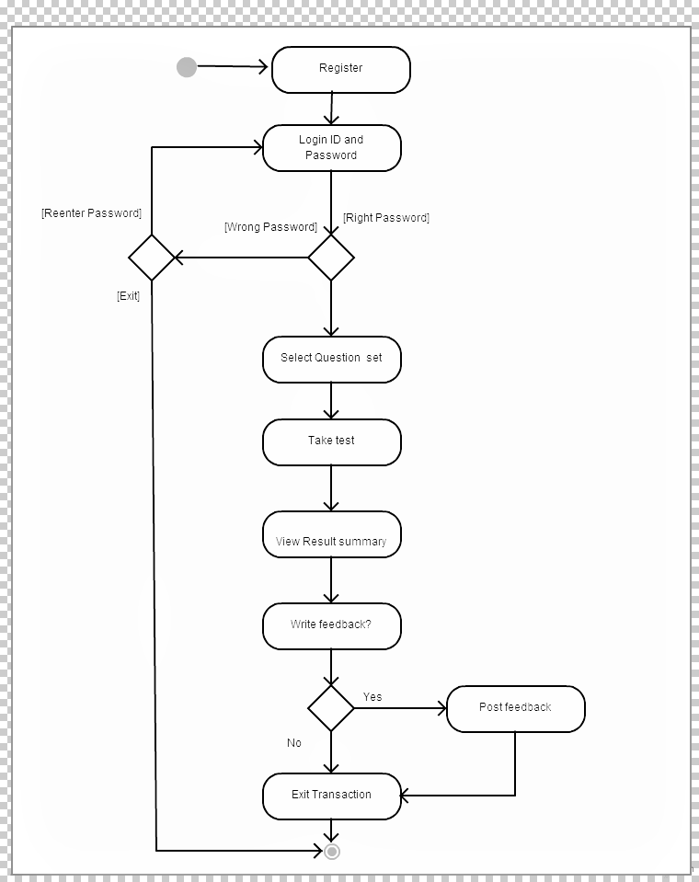

5.2 Activity diagram for Admin

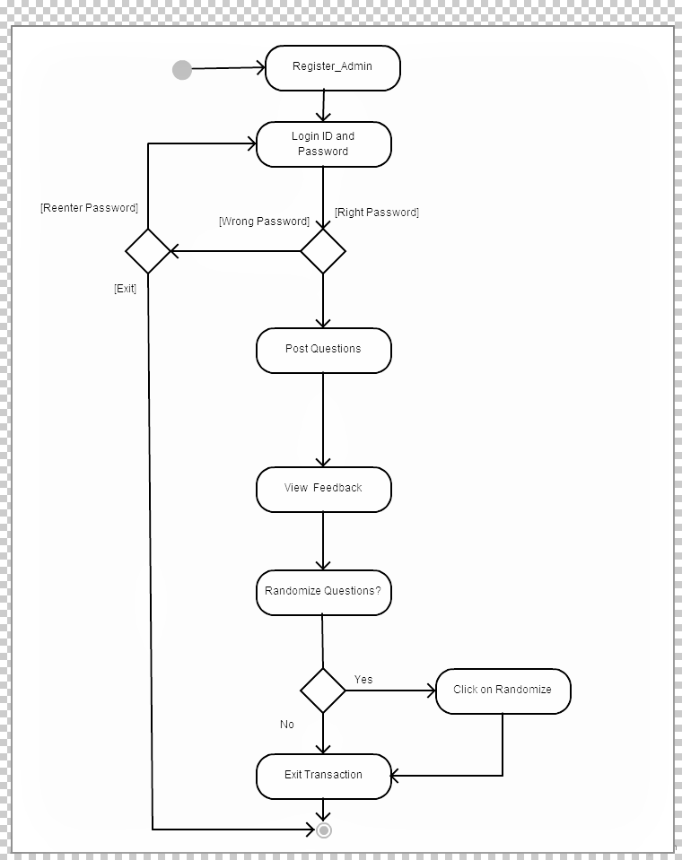

1. **ER diagram**

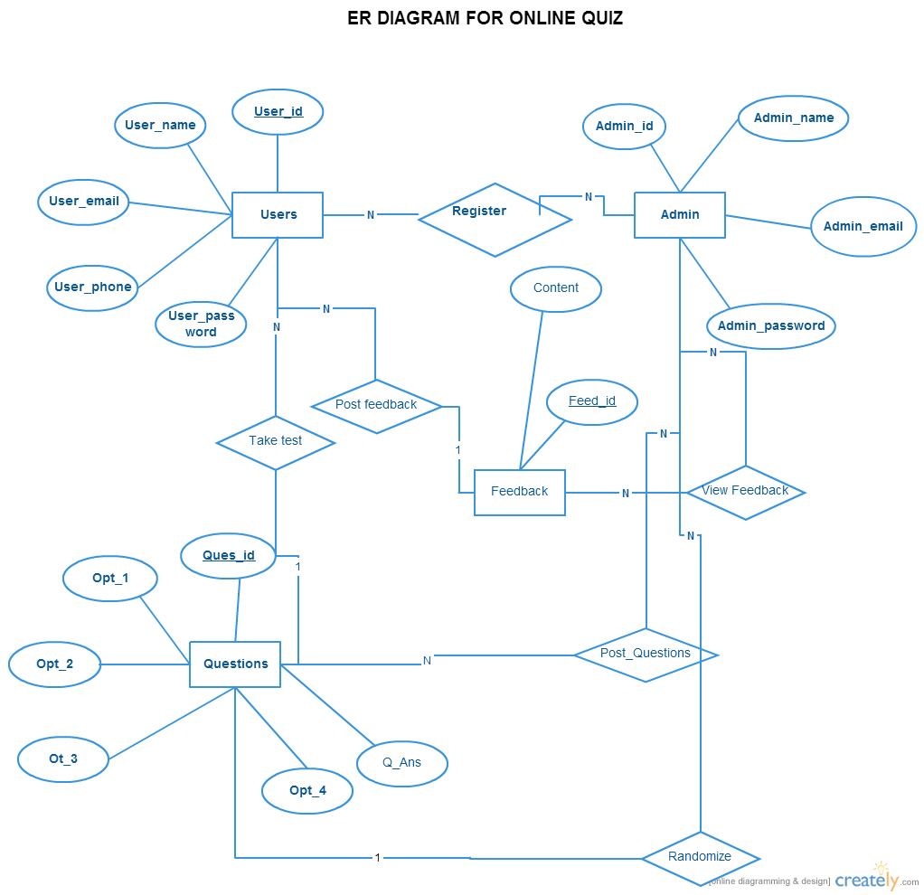

1. **Data Flow Diagram**

**Level 0**

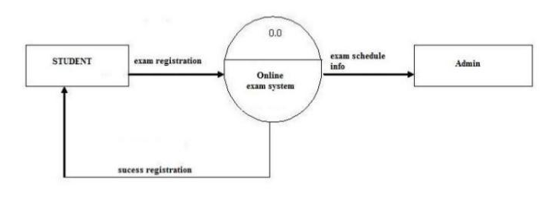

**Level 1**

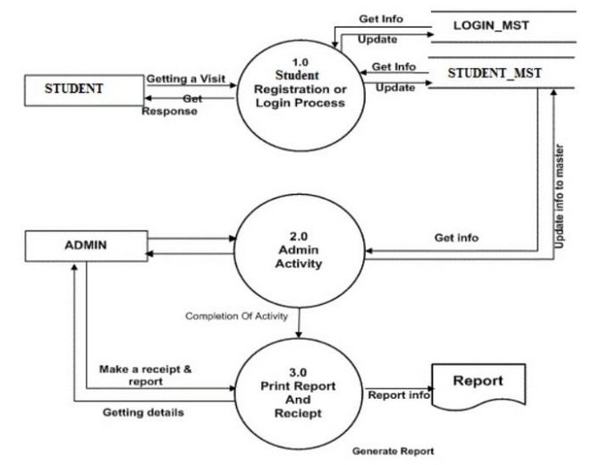

**Level 3**

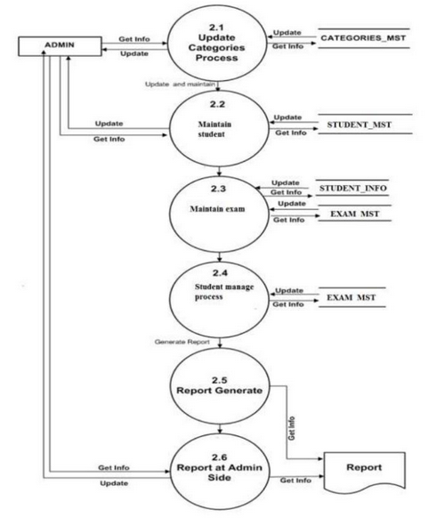

1. **User Interface Design**

**8.1 User Interface for Login** –

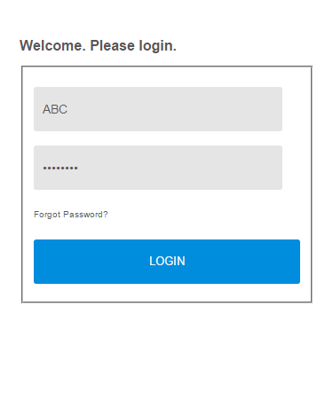

**8.2 User Interface for Registration**

