LAB-06 Date- 07/08/2025

1.The echo command can be used simply to display a piece of text (useful in programs).
Use echo to create a sentence. Pipe the output of this command to count the number of
words in the sentence. How do I use the wc to count the number of lines in this sentence?

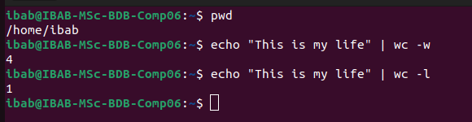

2. Execute the following command, and explain the meaning of the output. This concerns
the appearance of the command prompt, and you should be able to dissect the output
completely and explain it part by part. Make a list of the parts of the output and write
your explanations against each part. The command is cat .bashrc | grep ’PS1’

.bashrc file finds lines contailing PS1 which defines my shell prompt

\u Username
\h Hostname
\w Full working directory
\$ for normal user
\s Shell name
\v shell version
debian_chroot : font name

3.In the above exercise, filter the output based on ’HIST’ pattern. You will see a list
of environment variables. Figure out what they stand for and what the current values
mean.

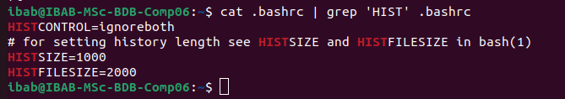
HISTFILESIZE- maximum number of commands written to the history file
HISTFILE- specifies the file path
HISTCONTROL- commands are excluded from history
HISTIGNORE- allows specifying patterns of commands to ignore

4.The whereis command searches for a program in a predefined set of standard binary
directories such as /bin, /usr/bin and /usr/sbin. Type whereis ls and study the
output. What is the difference between which and whereis commands?

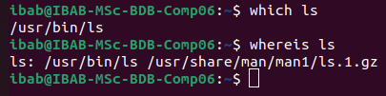

which ls – shows where the executable ls is located (usr/bin/ls)
whereis ls – returns a broader results: binary, man pages, even source locations
(/bin/ls /usr/share/man/man1/la.1.gz

5.The command dirname is used to retrieve the directory name in a given file path. Nav-
igate to a previous lab folder such as Lab4 and list the files. Then type the command

dirname <filename> where give some existing filename in this command. What is the
output?

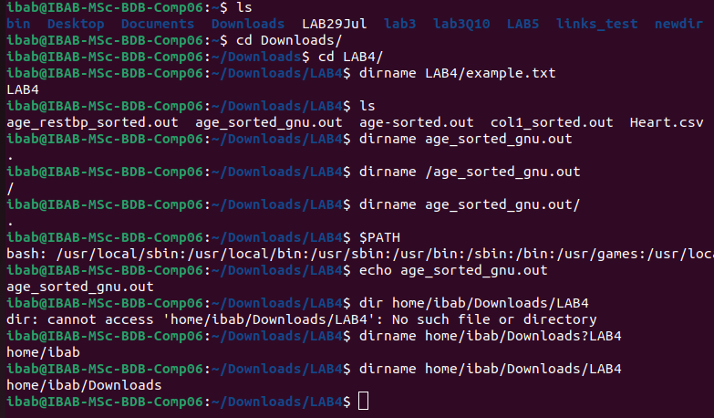

6.Create a local variable called mylabdir, and set it to the following value: /home/ibab/Lab6
(which means that if you have not created a Lab6 folder you should do so). Print the
value of this variable using the echo command, and then the dirname command output
with a file you are working with, under the Lab6 directory.

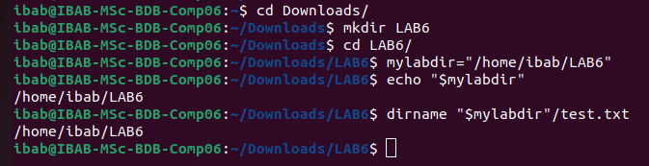

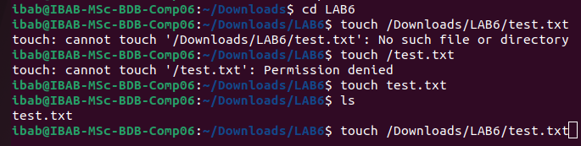

(7) Create a new bash subshell in this terminal. Prove that you have created a subshell
using the ps command with the appropriate options. Inside this subshell print the value
of the variable mylabdir. What is the value? If it is empty, how do you convert it to a
global variable? Do the conversion and show that mylabdir is indeed a global variable.

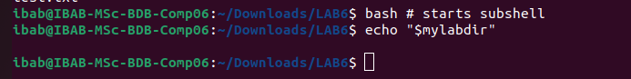
its empty beacuse local vbariables are not passed to subshells unless it is exported. To make it a environment (global) variable:

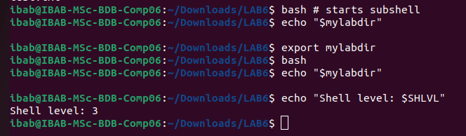
It now shows the Shell Level which proves its in Sub shell

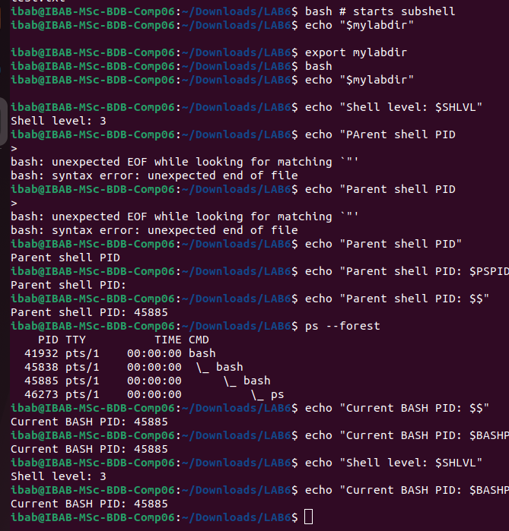

(8) Display the output of the command echo $PATH. Is PATH local or global variable? De-
scribe two ways of finding this out.

It is a GLOBAL (Environmental) variable

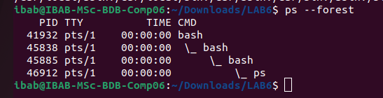

2 ways
a. using /etc/profile etcprofile.d
b. I acan modify using /.profile, /.bashrc, or /.bash_profile

(9) The concept of a directory stack. Learning about this will allow you to know the powerful
navigation mechanisms in Linux. The key commands in this exercise are dirs,cd -,
pushd and popd. The directory stack operates like a stack of plates – the last plate on
top is the first to be taken out. Try the following exercises to understand this.
(i) Execute dirs -v -l. What is the output? Learn more about the command
and the options by looking up the man pages of what these options did. For
each command below execute dirs -v -l to understand what happened to the
directory stack.
(ii) By default the directory stack contains only one entry – the path to your $HOME.
Let’s add some entries to this stack using the following commands:
(a) pushd /var/log
(b) pushd /tmp
(c) pushd /etc
(d) pushd ~/Downloads
(e) pushd ~/Documents

