1. (iii)


Pre-Installed software
1. Archive
2. Backups
3. Brave
4. calender
5. cheese- to click pictures
6. DB Browzer for SQLite
7. Disks
8. Disk usage Analyser
9. Document Scanner
10. Firefox- to browse the net
11. gedit
12. Gnome-3-38-2004
13. gnome-42-2204
14. GNOME Calculator
15. GNOME Characters
16. GNOME Fonts
17. GNOME Power Statistics
18. Google Chrome
19. Gparted
20. Image Viewer
21. LibreOffice Calc
22. LibreOffice Draw
23. LibreOffice Impress
24. LibreOffice Writer
25. terminal
26. System Monitor
27. Terminal-parrot
28. pycharm-professional
29. Remmina
30. Shotwell

3. (i)
Hostname- IBAB-Msc-BDB-Comp06
buildname- 6.8.60-generic
SMP- PREEMPT_DYNAMIC
build_time- Tue Apr 22 19:00:15
machine hardware name- UTC 2 x86_64 x86_64
Operating system- GNU/Linux

3. (ii)
Ouput for the commands- uname -r= 6.8.60-generic (Kernel)
Output for the Commands- IBAB-Msc-BDB-Comp06

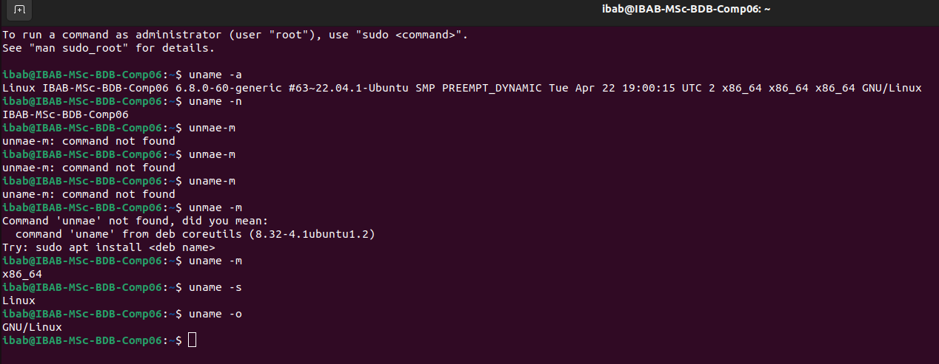

terminal added to favourites 1 (vi)


Network Settings
