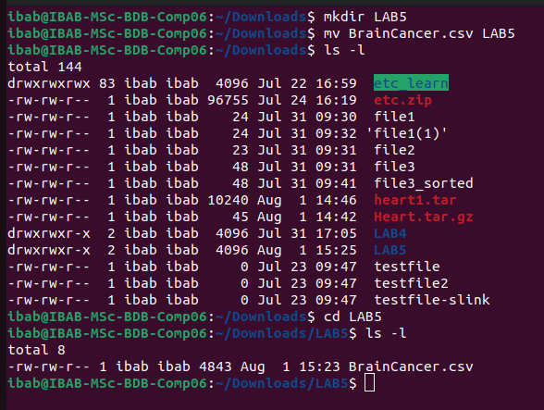
For this lab, download ’BrainCancer.csv’ to a folder called ‘Lab5’. If the file download to the
”Downloads” folder by default, move the file to the folder ’Lab5’.
The data file contains the following columns for the survival times of patients diagnosed with
brain cancer.

1. Look for the pattern ‘Meningoma’ in the data file. Redirect the output to a new file
called ’LinesWithMeningoma.out’. Show the command used and the contents of this
new file in your screenshot.
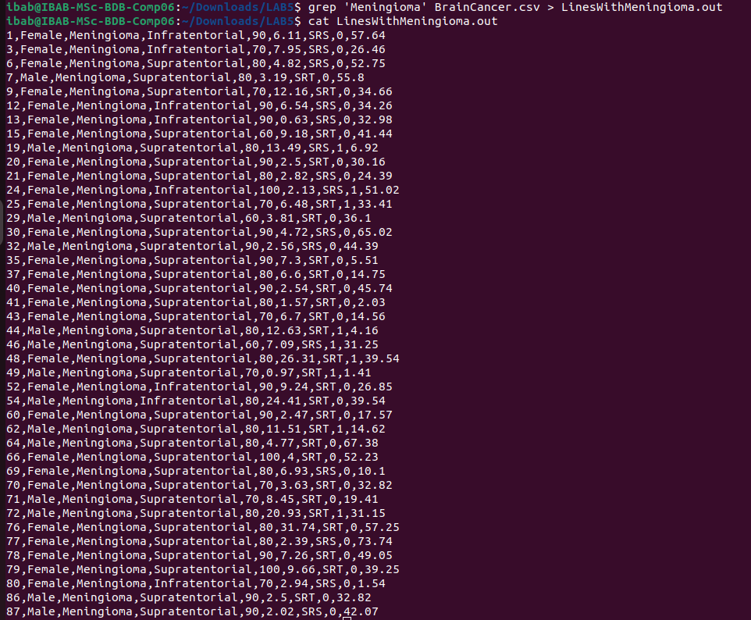

2. How many males and females were present in this study? How will you create a grep
filter to find this out?

