

MEDIMINDER

Title of the project

Mediminder: Reminder App
Names of the Students
DISHA DEEPAK NAIK
JANHAVI SAMEER NAIK
KANISHKA MAHESH NAIK
RIANOSHKA CARVALHO
VELIP SANJEET SHRIKANT
SANIKA RAMDAS NAIK

Course
Bachelor of Science Honours (Computer Science)

Year
2024-2025

Name of the Project Supervisor
Dr Kissan Gauns Dessai

Name of the College
Government College of Arts, Science and Commerce Quepem Goa
GOA UNIVERSITY

i
Declaration
We declare that this project report titled “Mediminder: Reminder App” has been prepared by us and to the best of our knowledge it has not previously formed the basis for the award of any diploma or degree by this or any other University.

Roll No. | Name | Signature
S22-428 | DISHA DEEPAK NAIK
S22-410 | JANHAVISAMEER NAIK
S22-610 | KANISHKA MAHESH NAIK
S22-419 | RIANOSHKA CARVALHO
S20-741 | VELIP SANJEET SHRIKANT
S22-406 | SANIKA RAMDAS NAIK

ii

Certificate
Certified that the project report titled :
MEDIMINDER: REMINDER APP
Is a record of work done by:
DISHA DEEPAK NAIK
JANHAVI SAMEER NAIK
KANISHKA MAHESH NAIK
RIANOSHKA CARVALHO
SANJEET SHRIKANT VELIP
SANIKA RAMDAS NAIK

Under my guidance during academic year 2024-2025 in the partial fulfillment for the award of degree of Bachelor of Science Honors (Computer Science) and to the best of my knowledge it has not previously formed the basis for the award of any degree or diploma by this or any other University.

_____________ ___ _________ ___________
Name and Signature Head of Dept External
Project Supervisor Computer Science Examiner
iii
Acknowledgement
If word is considered as symbol of approval and token of appreciation then let the words play the heralding role expressing our gratitude.
This project would not have been successfully completed without the active support and help given to us by our teachers, library, friend and staff. So, we take this opportunity to express our sincere gratitude and thank them all.
We would like to take the opportunity to express our humble gratitude to our guide Dr. Kissan Gauns Dessai, Assistant Professor, faculty of computer science department, under whom we undertook our project. His constant guidance and willingness to share his vast knowledge made us enhance our knowledge and helped us to complete the assigned task to perfection. Without his effort and support and an astonishing testing ability this project may not have succeeded. Our special thanks to Mr. Philip Rodrigues, the H.O.D. of Computer science department.
We would also like to thank our principal Dr. Pravina Kerkar for their kind encouragement.
For love, understanding and patience we are indebted to our family members who maintained us throughout and thus gave a boost to our project.
Last but not the least, we would like to thank "God" the driving force behind us without whose support, this project would remain a dream.

iv
Content

Sr. No | Title | Page No
1. | Introduction | 1
2. | Benefits of using reminder system | 2
3. | Core Functionalities | 3
4. | Technologies Used | 5
5. | Flow Chart | 13
6. | User Manual | 14
7. | Limitations | 31
8. | Enhancement | 32
9. | Bibliography | 33

V
- Introduction
Project Overview:
- In today’s busy world people may forget to take their medications at their prescribed time. This can lead to decreased effectiveness of the medication and potential health complications.
- Taking medication at irregular intervals can disrupt their efficiency.
- Some people have multiple medications with different dosing schedule which they might forget and can mix up their medicine intake.
- People can also forget to fill their medicine once they got over.
- People also might forget to store their previous medical history as it can be important in future.

Solutions:-
- Developing an app which will give people a reminder of taking their medicines at regular intervals, so that patients do not miss their dosage at their regular time.
- This app will also have a space to store the previous history of the patients.

1
2.Benefits of using Reminder System

- Improved Medication Adherence: Health tips can educate users on the importance of taking their medication as prescribed, which can lead to better adherence and improved health outcomes.

- Enhanced Patient Engagement: Providing health tips can help users become more engaged in their own health care, making them more likely to follow their treatment plans and take an active role in managing their health.

- Increased Health Literacy: Health tips can provide valuable information about medications, such as potential side effects, interactions, and the importance of adherence. This can help users make informed decisions about their health.

- Support for Chronic Conditions: For users with chronic conditions, health tips can offer guidance on managing their condition, lifestyle changes, and other relevant information that can improve their quality of life.
- Prevention of Medication Errors: By providing clear and concise health tips, users can better understand their medication regimen, reducing the risk of medication errors and potential complications.

2
3.Core Functionalities

- Medication Schedule Tracking – Allows users to set reminders for their medications, ensuring they take them on time. It can include scheduling options like daily, weekly, or as prescribed by a doctor.

- Water Intake Reminder – Encourages healthy habits by reminding users to drink water to maintain overall well-being.

- Dosage and Prescription Details – Stores important details about medications, including dosage, frequency, and any special instructions from the doctor. This helps users keep track of their prescriptions easily.

- Emergency Contacts – Enables users to save emergency contacts, such as family members, caregivers, or doctors, for quick access in case of a medical emergency.

- Pill Count and Refill Tracking – Helps users monitor their pill stock and notifies them when it’s time to refill their medications, preventing missed doses.

3
- Health Tips and Information – Provides daily health tips and useful medical information to educate users about wellness, lifestyle, and disease prevention.

- Patients Previous History – Keeps a record of past medications, doctor visits, allergies, and medical history to help users and healthcare providers track health progress and make informed decisions.

- Reviews – Allows users to leave feedback about the app, their experience with certain medications, or share health-related insights with the community.

4
4.TECHNOLOGIES USED
i) Firebase
Firebase is a mobile and web application development platform development by Firebase, Inc. In 2011, then acquired my Google in 2014.
Firebase evolved from Envolve, a prior start-up founded by James Tamplin and Andrew Lee in 2011. Envolve provided developers an API that enables the integration of online chat functionality into their websites. After releasing the chat service, Tamplin and Lee found that it was being used to pass application data that were not chat messages.
Developers were using Envolve to sync application data such as game state in real time across their users. Tamplin and Lee decided to separate the chat system and the realtime architecture that powered it. They founded Firebase as a separate company in September 2011 and it launched to the public in April 2012.
Firebase's first product was the Firebase Real-time Database, an API that synchronizes application data across iOS, Android, and Web devices, and stores it on Firebase's cloud. The product assists software developers in building real-time, collaborative applications.

5

- Authentication:
Firebase Authentication is a service that can authenticate users using only client-side code. It supports social login providers Facebook, GitHub, Twitter and Google.
Additionally, it includes a user management system whereby developers can enable user authentication with email and password login stored with Firebase.
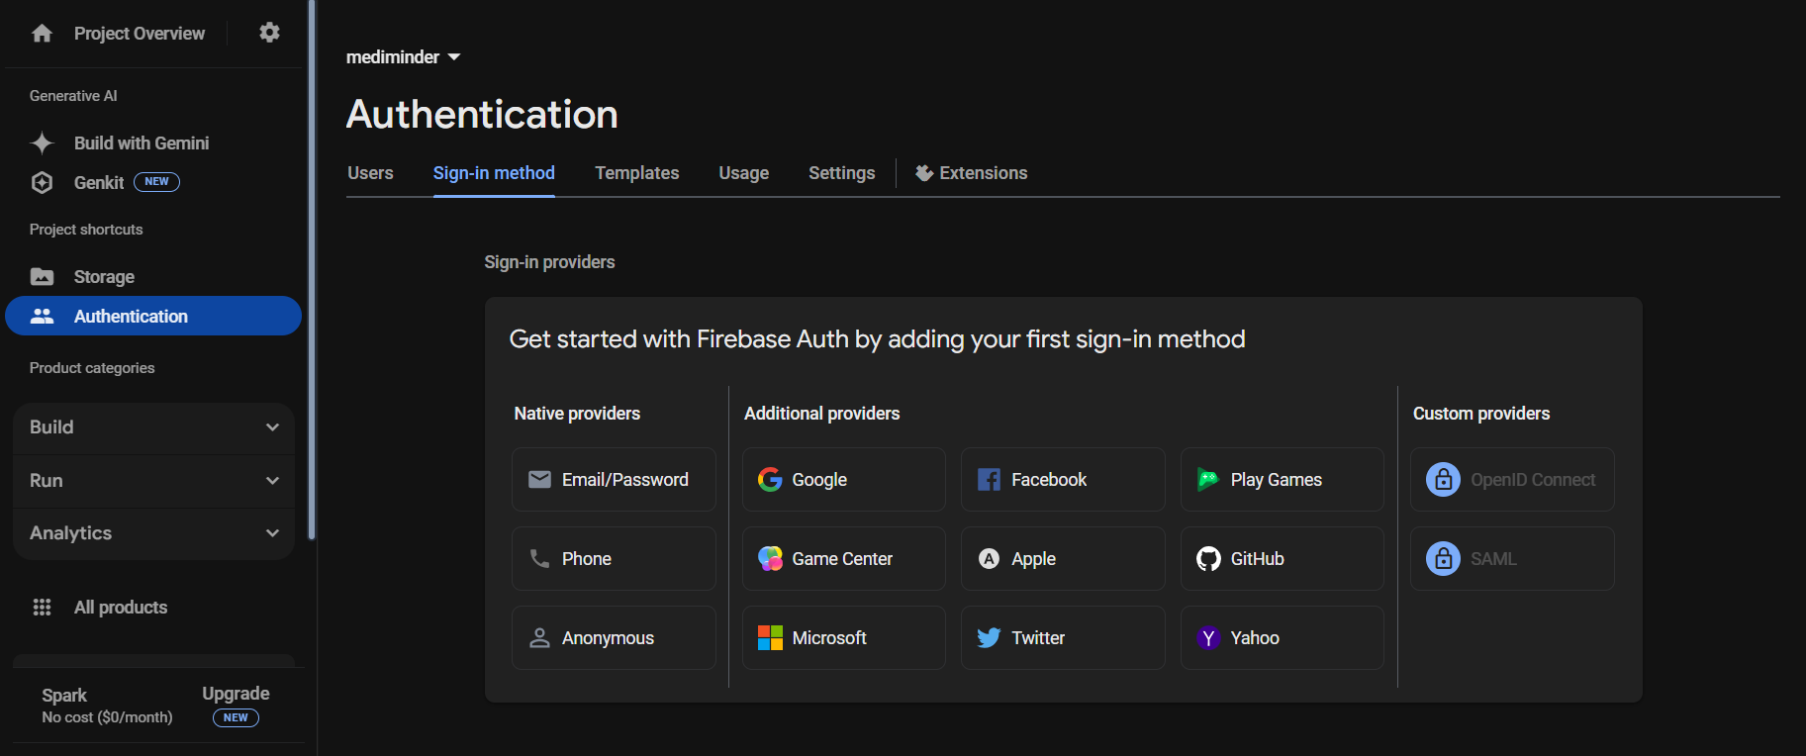
Figure: - 4.1
6
- Storage:
Firebase Storage provides secure file uploads and downloads for Firebase apps, regardless of network quality.
The developer can use it to store images, audio, video, or other user-generated content. Firebase Storage is backed by Google Cloud Storage.
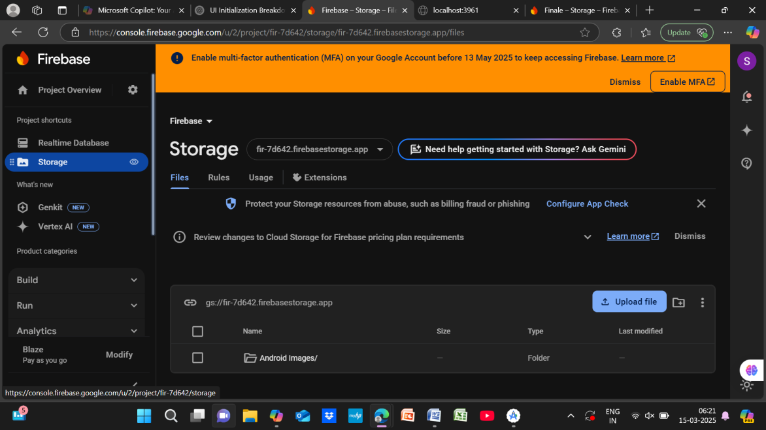
Figure: - 4.2
- Notification:
Firebase notification is a service that enables targeted user notification for mobile app developers at no cost.

7

- Realtime database:
Firebase provides a Realtime database and backend as a service. The service provides application developers an API that allows application data to be synchronized across clients and stored on Firebase's cloud. The company provides client libraries that enable integration with Android, iOS, JavaScript, Java, Objective-C, swift and Node.js application. The database is also accessible through a REST API and bindings for several JavaScript frameworks such as Angular JS, React, Ember.js and Backcone.js. The REST API uses the server-Sent Events protocol, which is an API for creating HTTP connections for receiving push notifications form a server. Developers using the Realtime database can secure their data by using the company's server-side-enforced security rules.
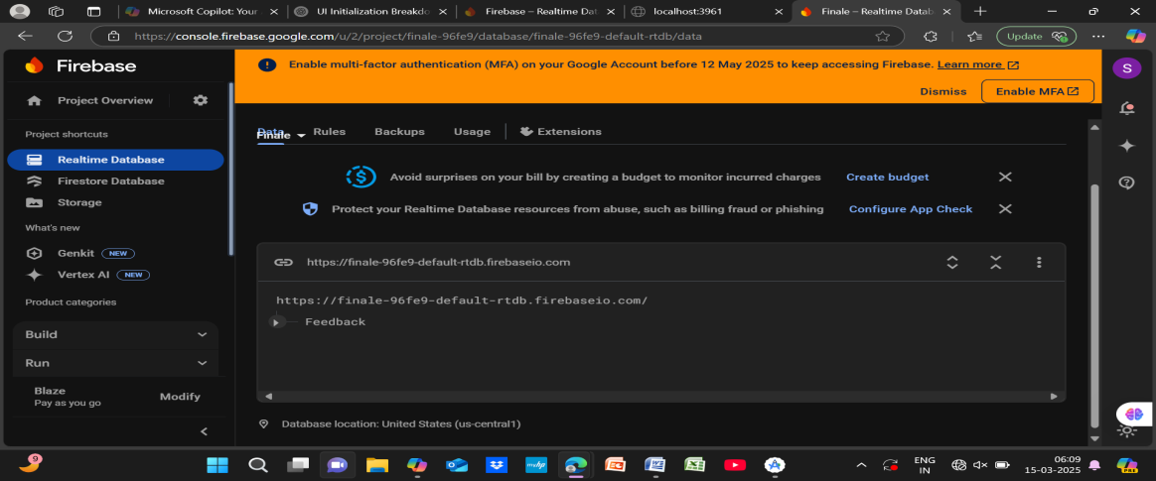
Figure:- 4.3

8
ii). Android Studio
Android Studio is the official integrated develop environment (IDE) for Google's Android operating system, built on JetBrains` IntelliJ IDEA software and designed specifically for Android development.
In Android Studio, Grade is custom build tool used to build android packages (apk files) by managing dependencies and providing custom build logic. APK file (Android Application package) is a specially formatted zip file which contains. Byte code. Resources (image, Ul, xml etc).

Android Studio Features
- Gradle-based build support.
2. Android-specific refactoring and quick fixes
3. Lint tools to catch performance, usability, version compatibility and other problems.
4. Pro Guard and app-signing capabilities.
5. Template based wizards to create common Android designs and components.
6. A rich layout editor: it allows you to drag-and-drop Ul components, preview layouts on multiple screen configurations. Preview appears instantly as you change in the layout editor.
9
7. Rich Color Preview editor: while adding colors as a resource, we can see the color preview at the left-hand side of the editor.
8. Deep Code Analysis: if you point to a line, it gives detailed explanation about an exception based on the annotation added and you can also know which contents are allowed for which API. It also has a powerful code completion. You can also inspect code in whole project, IntelliJ lists all Lint errors during code inspection.

10
iii) JSON
JavaScript Object Notation or JSON is an open-standard file format that uses human-readable text to transmit data objects consisting of attribute-value pairs and array data types (or any other serializable value). It is a very common data format used for asynchronous browser-server communication, including as a replacement for XML in some AJAX-style systems.
JSON is a language-independent data format. It was derived from JavaScript, but as of 2017 many programming languages include code to generate and parse JSON-format data. JSON filenames use the extension ". json".
Why is JSON more popular than XML?
The more lightweight JSON (JavaScript object notation) has become a popular alternative XML for various reasons. A couple obvious ones are: Less verbose-XML uses more words than necessary. JSON is faster-Parsing XML software is slow and cumbersome.
The JSON format is often used for serializing and transmitting structured data over a network connection. It is used primarily to transmit data between a server and web application, serving as on alternative to XML.

11
JSON Syntax Rules
JSON syntax is derived from JavaScript object notation syntax:
• Data is in name/value pairs.
• Data is separated by commas.
• Curly braces hold objects.
• Square brackets hold arrays.

12
5.FLOW CHART
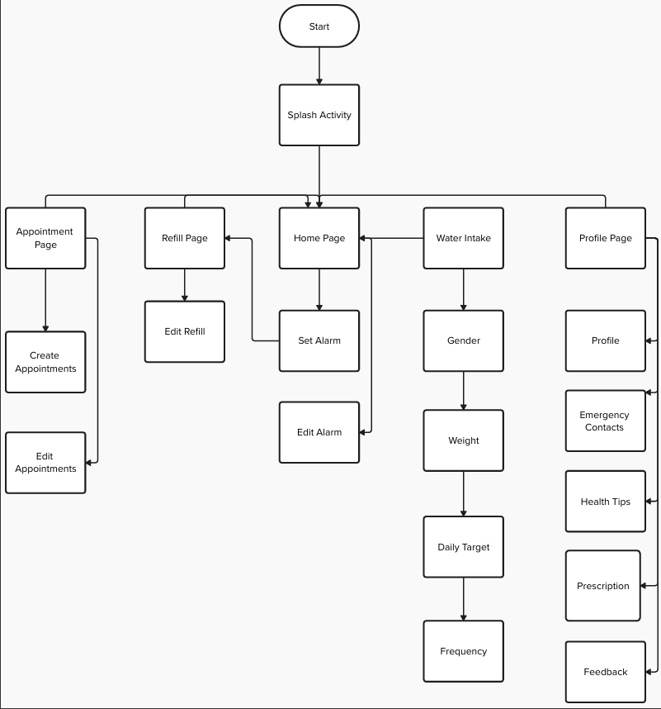

Figure 5.1 – User Flow Chart

13

6.USER MANUAL
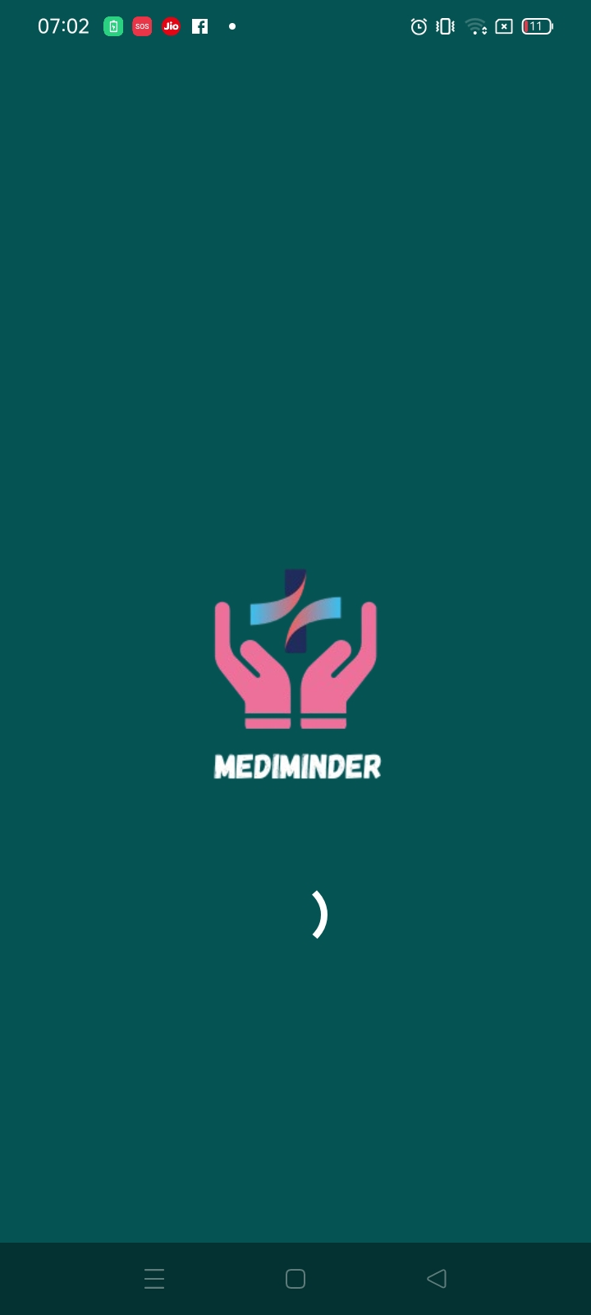
Figure 6.1- Splash Screen
Figure 6.1 is a splash screen that will be displayed on the screen once you open the Mediminder App. This is the first screen that will appear after clicking on the app.

14

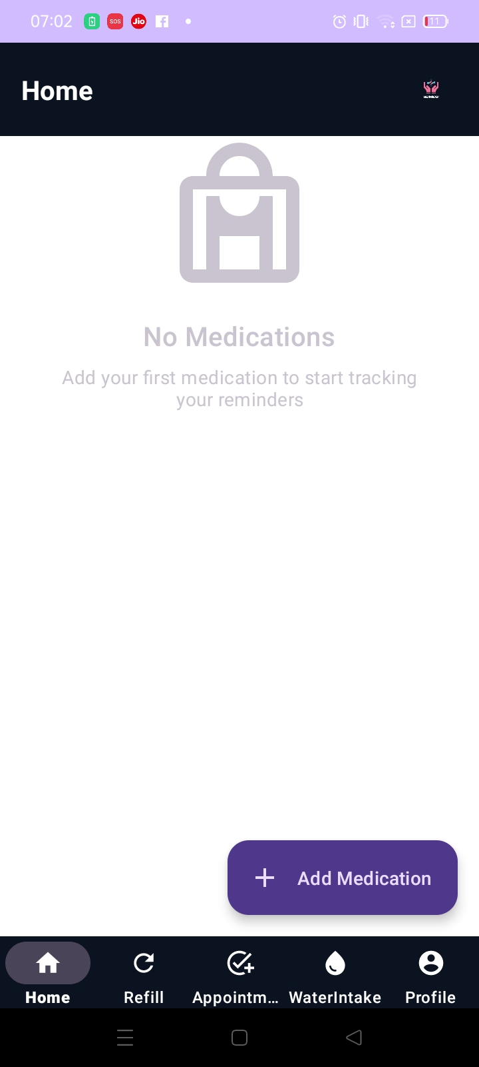
Figure 6.2 – Home Screen
Figure 6.2 is a home screen page that displays all the features such as add medication, refill, appointment, Water Intake and profile, through which we can navigate into different screens. Upon clicking on “+ Add Medication” the user will reach to the screen shown in figure: - 6.3.

15

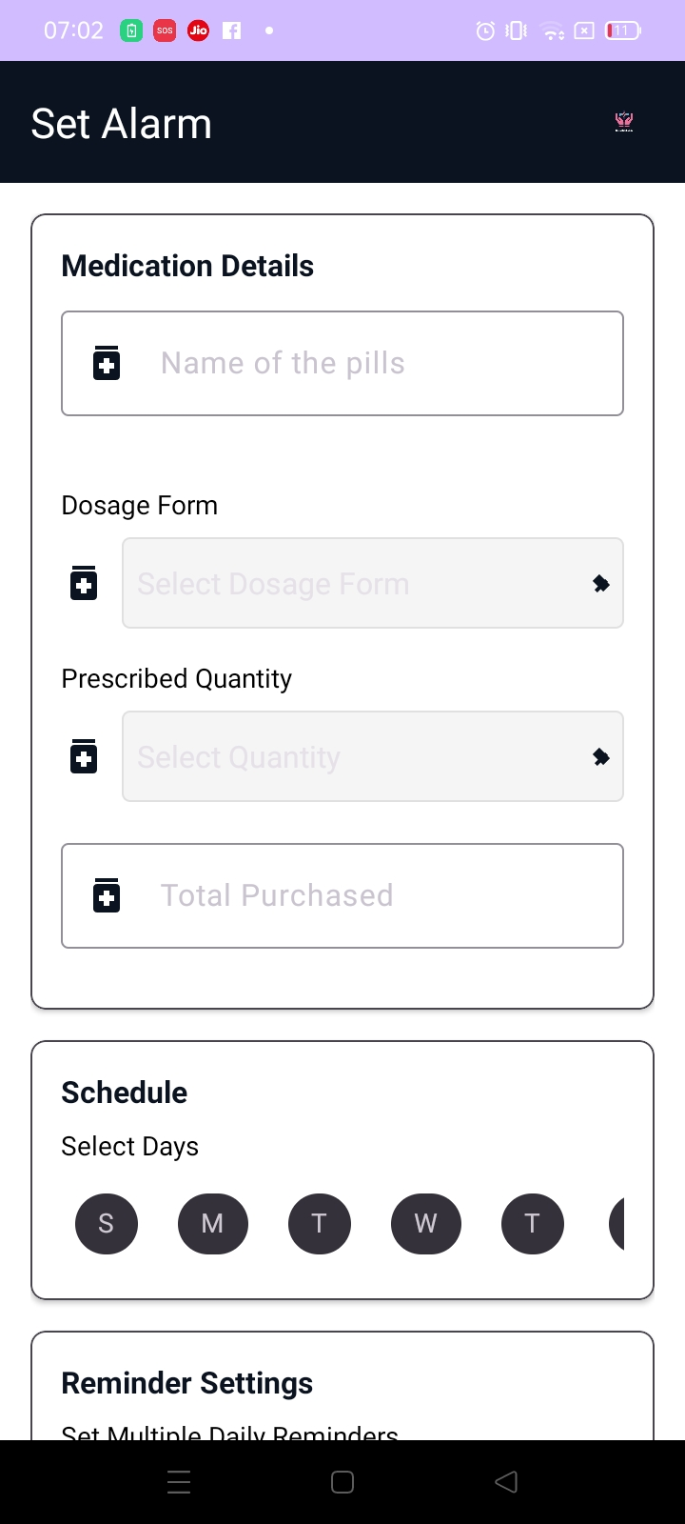
Figure-6.3-Set Alarm Screen
Figure-6.3 shows how user will be able to enter all the details of the medicine like name, type, quantity etc. The User must fill all the details or the alarm will not be set.

16

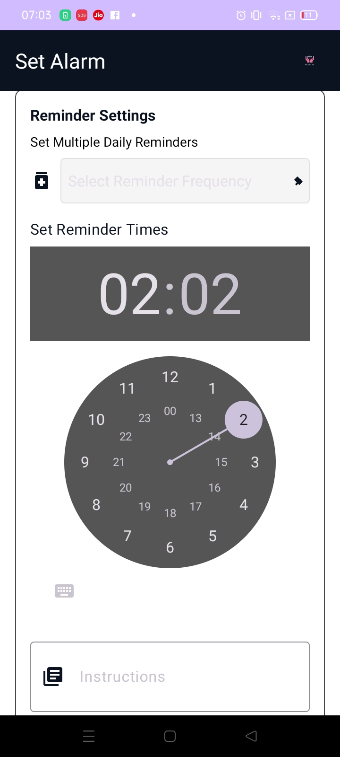
Figure 6.4-Time Setting
Figure 6.4 shows the alarm clock wherein we will be able to set the time for medicine selected/entered. Also the user will be able put the Instruction given by the doctor.

17

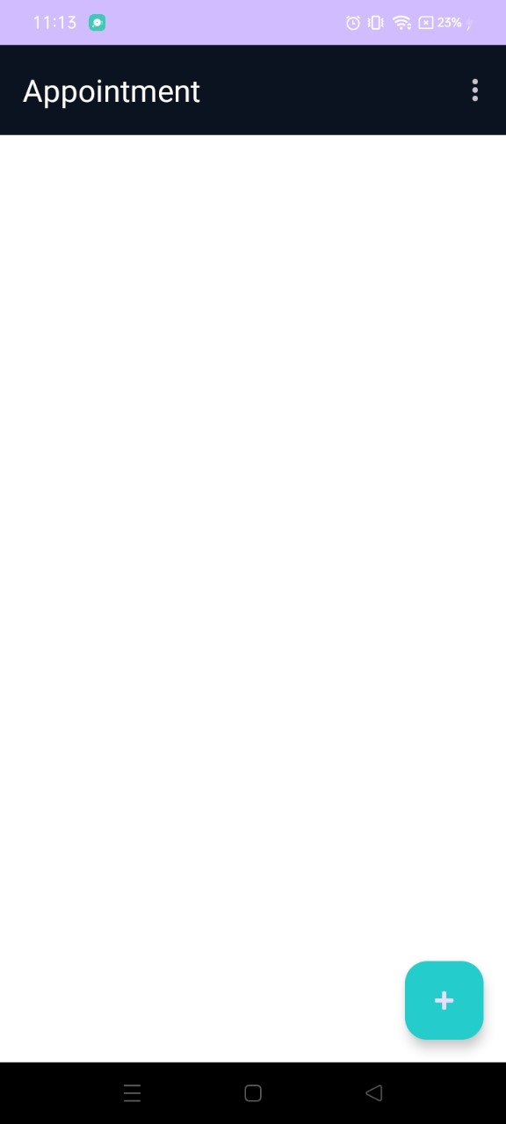

Figure: - 6.5 –Appointment Screen
Figure: - 6.5 shows a “+” button, on clicking that button we will be able to create an appointment with a Doctor.

18
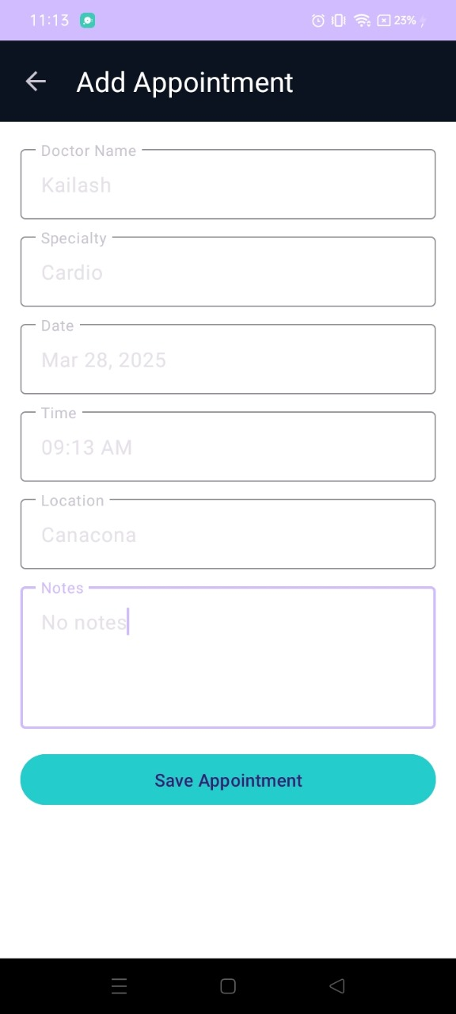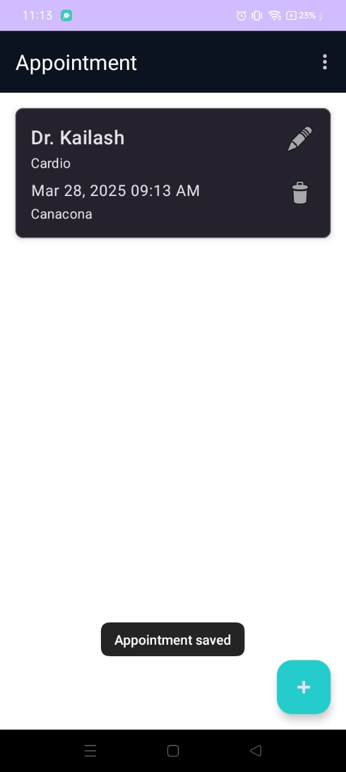

Figure: - 6.7 Appointment saved
Figure: - 6.7, shows how Toast message appears after clicking on save appointment button if all fields have valid inputs and are not empty. Finally it displays the list of all appointments.

Figure: - 6.6 Appointment Creation
Figure: - 6.6 Allows the user to enter the information such as Doctors name, Speciality, Date, Location and Notes.
The user will basically enter the timer when he is called by the Doctor also enter notes, location and date to meet the doctor. On clicking Save Appointment button screen shown in Figure: - 6.7 appears.

19

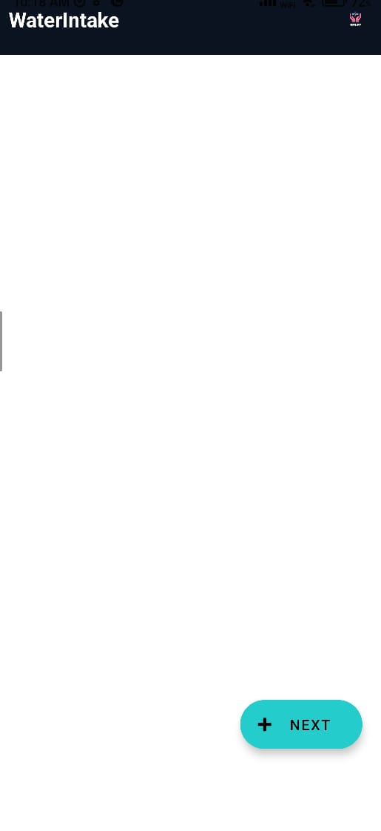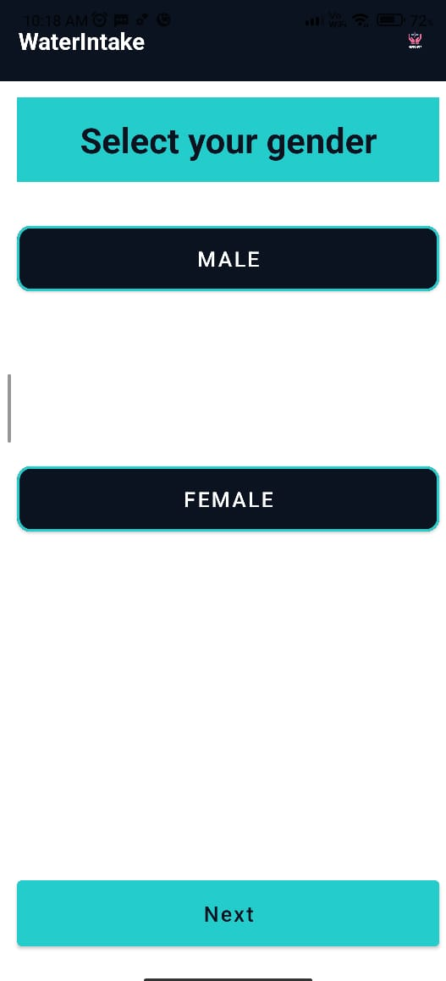

Figure: - 6.9 Gender Selection
In Figure: - 6.9, user should click on his/her Gender which will help to calculate the amount of the water the user needs to drink per day.

Figure: - 6.8 Water Intake Creation
In Figure: - 6.8, the user need to click on the create “+ NEXT” button and then the user will reach to screen shown in figure:- 6.9. After setting all the details, at last the alarm for water intake will be displayed here.

20
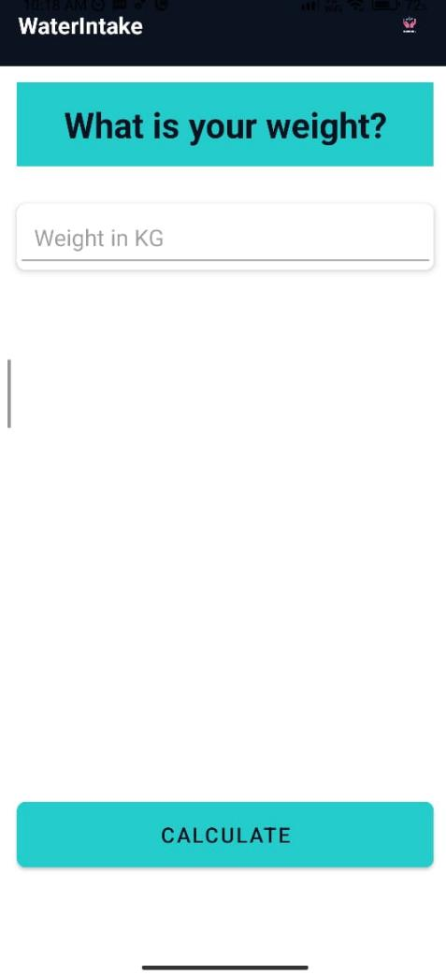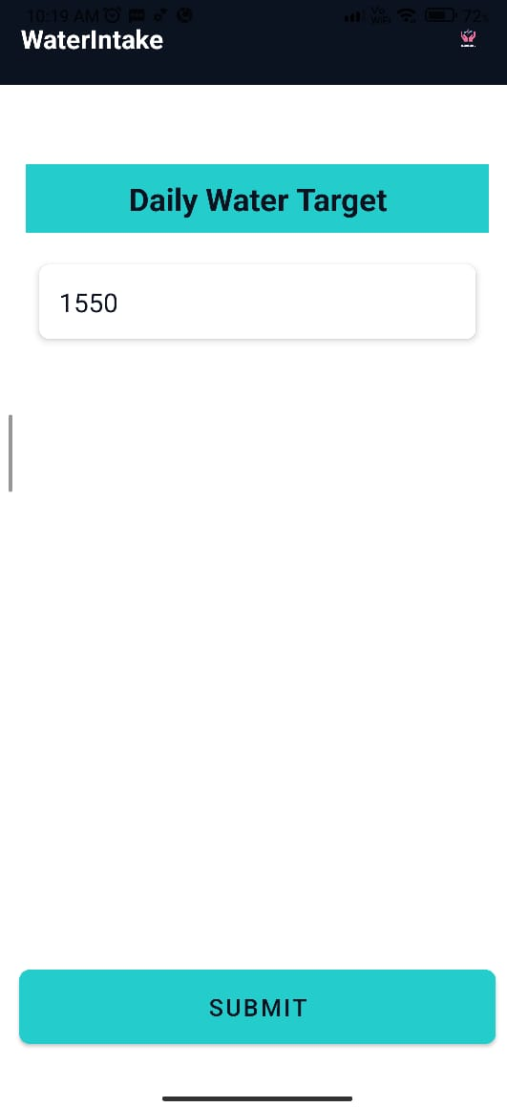
Figure: - 6.10 – Weight Input
Figure: - 6.10 shows that the user can give input for weight and then click on calculate, Which will calculate the daily water target.
Figure: - 6.11 – Daily Water Target
Figure: - 6.11 shows the total Water Intake the user should take in a day, the output is in ML.
After clicking on the submit button the user will reach on the screen shown in Figure: - 6.12.
We get this result after taking the User Gender and its weight.
If female the weight is multiplied by 31ml and for male the weight is multiplied by 35ml.

21
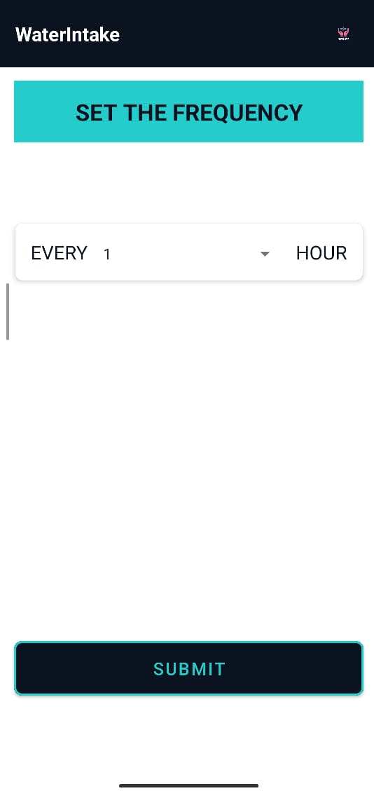
Figure: - 6.12 –Water Intake Interval
Figure: - 6.12, screen gives us access to set daily water intake frequency and then we can later submit it.

22

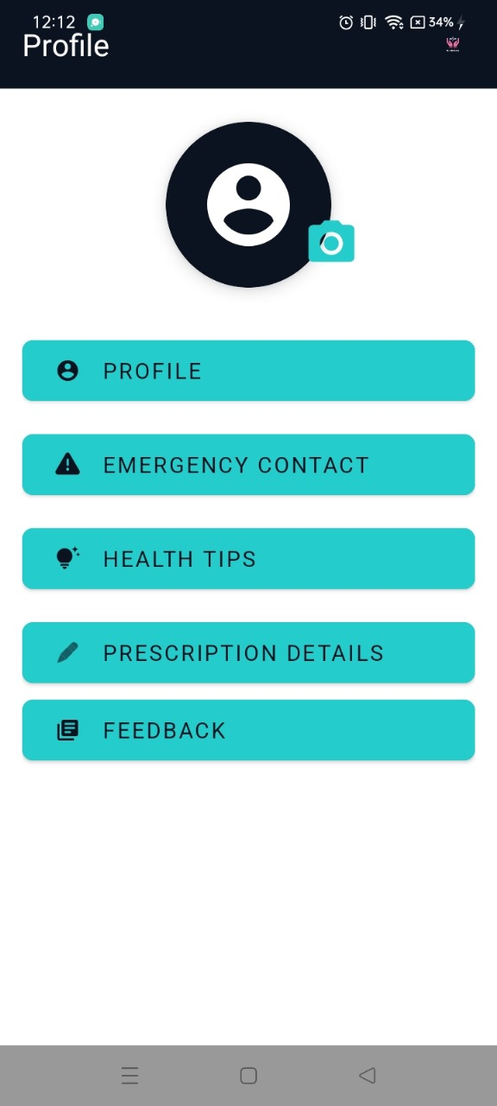
Figure: - 6.13 – Profile Section
When on home screen we click on profile, screen (Figure: - 6.13) appears. From which we can navigate to different screens such as emergency contact, health tips, prescription details and feedback.

23
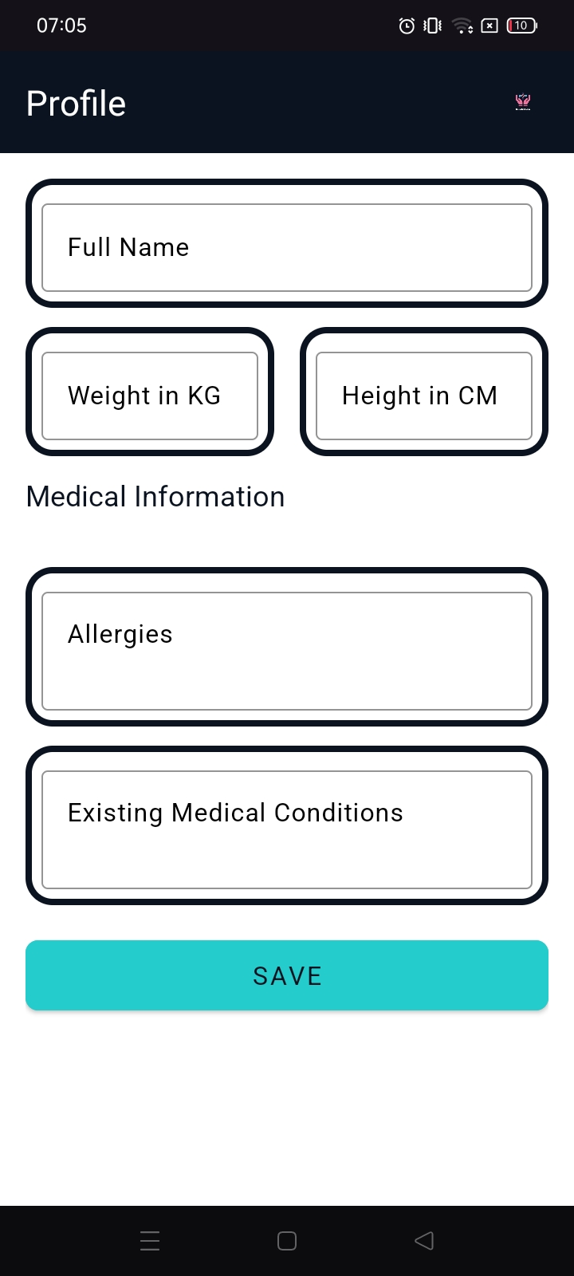
Figure: -6.14 – Profile Screen
Figure: -6.14 is profile screen where we will be able to enter all the details of the user, such as Full name, Weight, Height, Allergies and Existing Medical Condition.

24
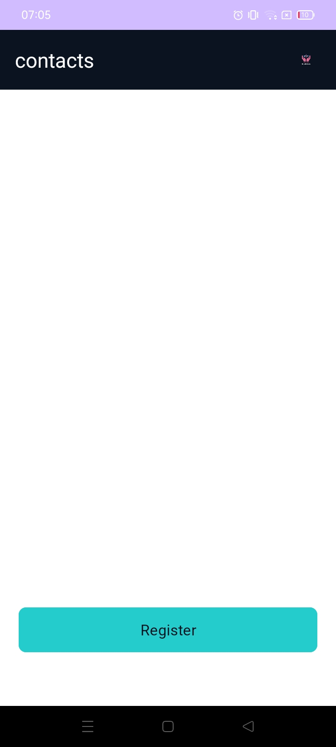
Figure: -6.15 – Emergency Contact
Figure: -6.15, shows the screen where the user will be able to register contacts after clicking register button.

25
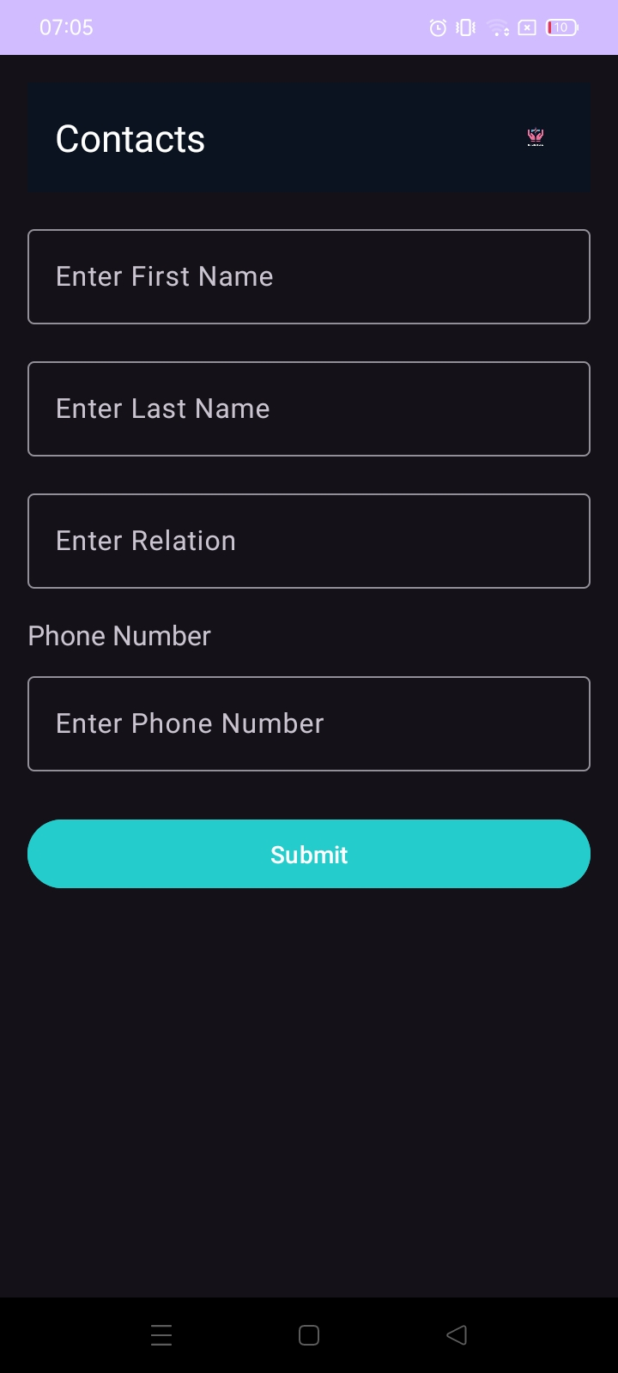

Figure: -6.16 – Emergency Contact Details
Figure: -6.16 displays adding of a contact number and its details such as first name, last name, relation and contact number. If the user did not put any field in on the screen it will show an error.

26

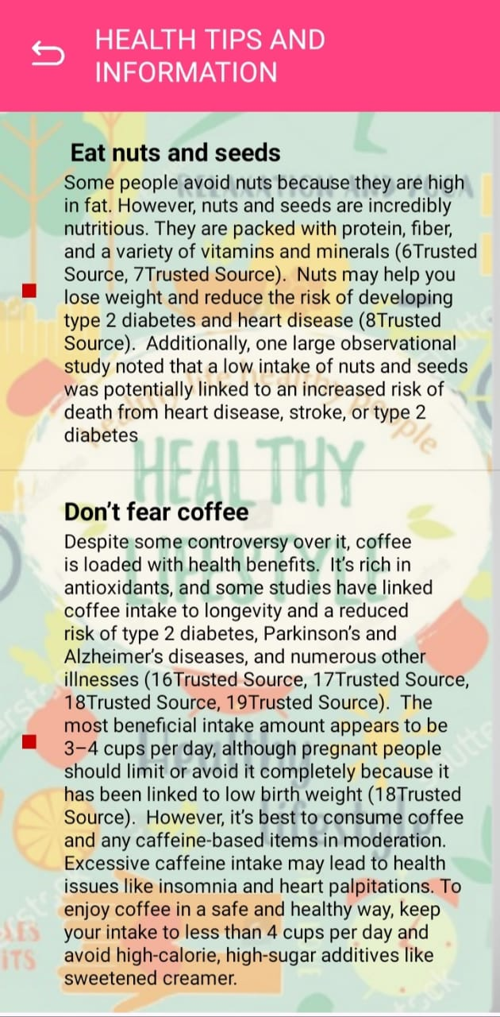
Figure: -6.17 – Health Tips Screen
Figure: -6.17 – shows the daily health tips list

27

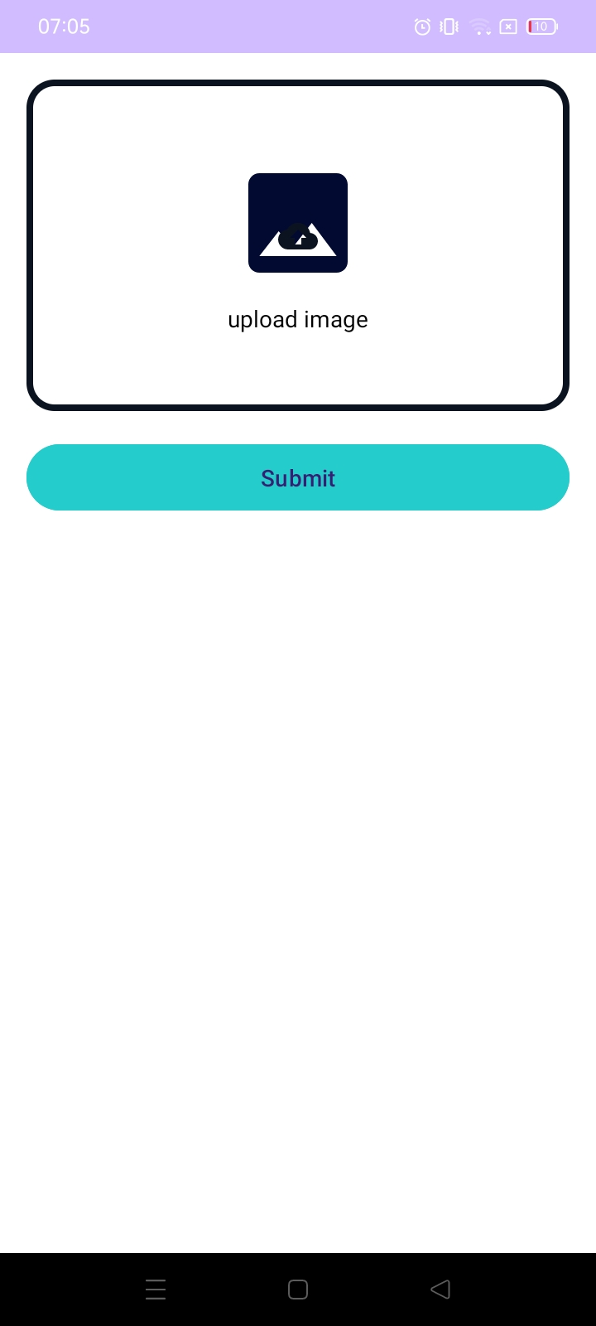
Figure: -6.18 – Prescription Details

Figure: - 6.18 shows that the user can insert an image by clicking on the upload image after clicking on the upload button user will reach to the screen shown in figure:- 6.19 and then later submit it.

28

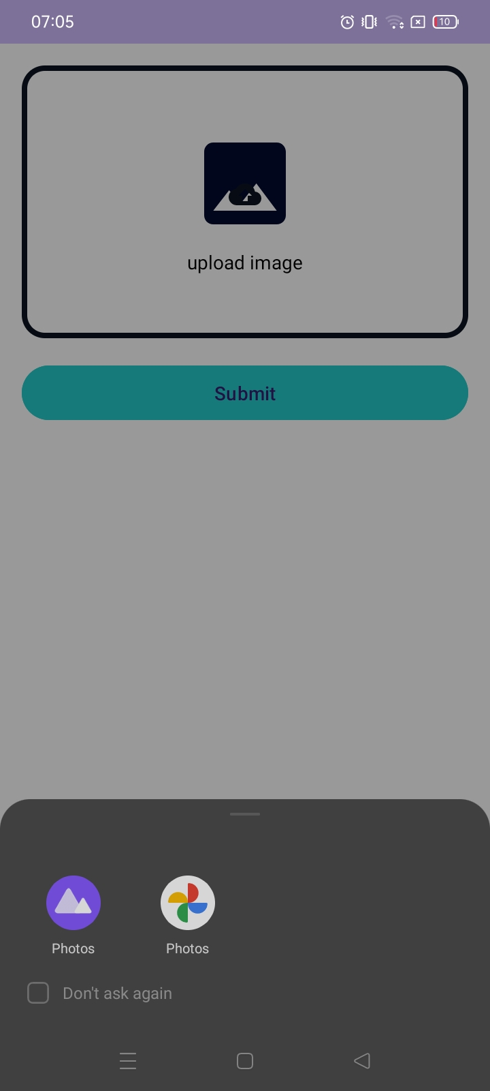
Figure: -6.19 - Prescription Details page

Figure:- 6.19 shows that we can access the images from gallery, Google photos. Here the user can click from where he wants to access the image and put the image in on the empty area

29
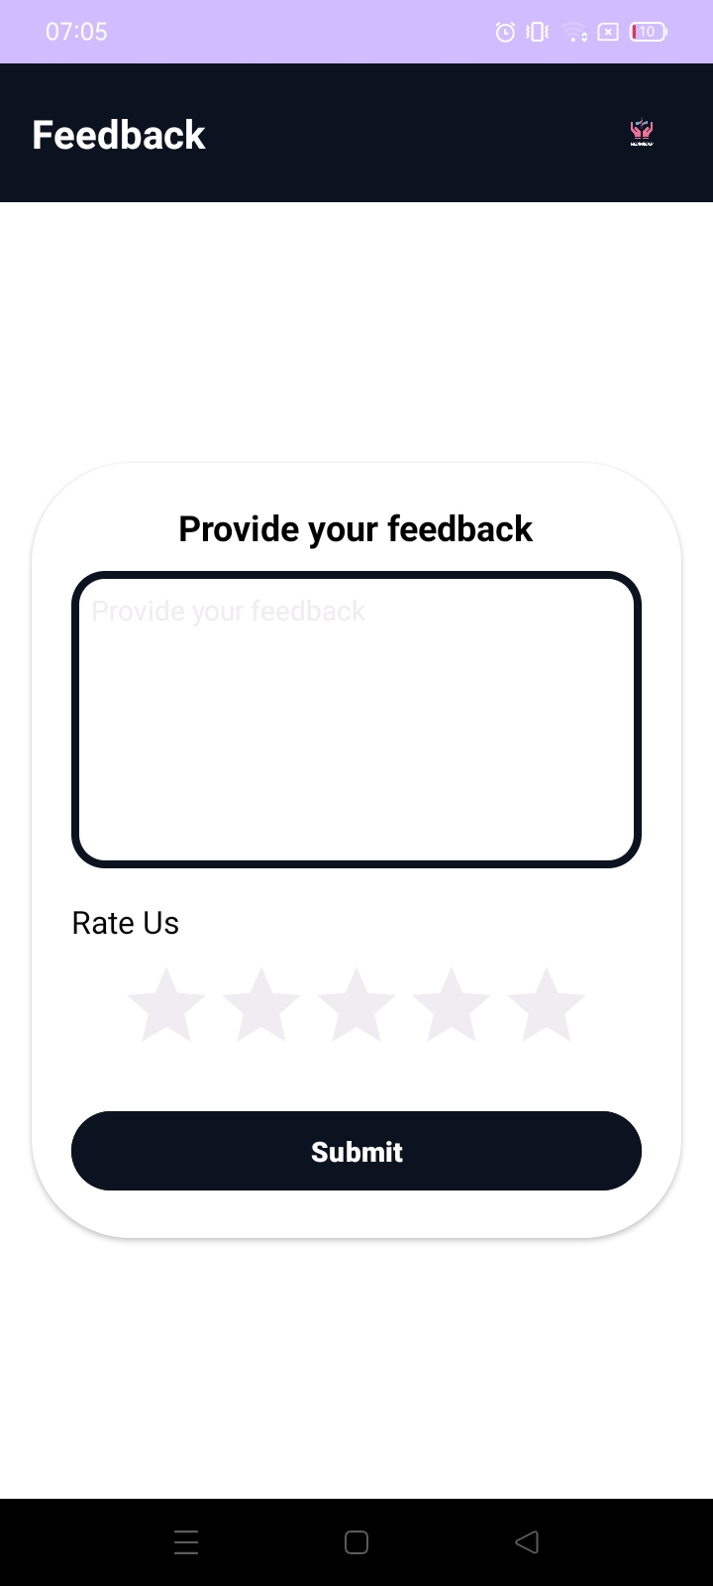
Figure: -6.20 – Feedback Form Page

Figure: - 6.20 is a feedback page where the user can put his feedback. If the user do not enter his feedback and gives rating than the screen will show an error.

30

7.Limitations

- Accuracy and Reliability of Reminders:
- User Input Errors: The app's effectiveness relies heavily on users accurately inputting their medication schedules, dosage information, and refill details. Incorrect data entry can lead to missed doses or incorrect refills.
- Device Reliability: Reminder delivery depends on the user's device being functional (battery, internet connectivity if cloud-based, notification settings). If the device is off, has a poor connection, or notifications are disabled, reminders won't be delivered.
- User Engagement and Adherence:

- User Fatigue: Too many notifications (medication, water, health tips) can lead to "notification fatigue," where users start ignoring or disabling notifications altogether.
- Motivation: The app can remind, but it can't force users to take their medication or follow healthy habits. Maintaining user motivation is a challenge.

- Technical Limitations:
- Platform Dependence: it is available only on Android Operating System.
31
8.Enhancements

Future enhancements planned for Mediminder include:

- Integration with voice assistants for hands-free operation.
- Smart suggestions based on medication patterns.

- Support for smartwatches and fitness bands for more accessible reminders.

- Direct connection to healthcare providers for consultations.

- Partnership with pharmacies for automatic prescription refills.

- More detailed insights into medication adherence patterns.

- Enhanced family monitoring and management capabilities.

32
9.Bibliography

1. Android Developers. (2024). Android Studio. Retrieved from https://developer.android.com/studio

2. Firebase Documentation. (2024). Firebase Realtime Database. Retrieved from https://firebase.google.com/docs/database

3. Firebase Documentation. (2024). Cloud Messaging. Retrieved from https://firebase.google.com/docs/cloud-messaging

4. Google Developers. (2024). Google Maps Platform. Retrieved from https://developers.google.com/maps

5. Square,Inc. (2024).Retrofit. Retrieved from https://square.github.io/retrofit/

6. World Health Organization. (2023). Adherence to Long-Term Therapies: Evidence for Action. WHO Technical Report.

7. Journal of Medical Internet Research. (2024). "Effectiveness of Mobile Phone-Based Interventions for Medication Adherence: A Systematic Review."

8. Healthcare Informatics Research. (2023). "Design and Implementation of Medication Reminder Applications: Best Practices and Guidelines."

33

