LAB 10

Name: Disha Agarwal Registration number: 210905412 Branch: CSE A

DESIGN 1

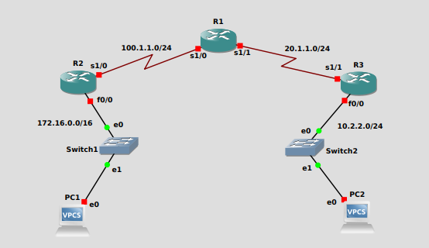

Configuration for R1:
conf t
int s1/0
ip add 100.1.1.2 255.255.255.0
no shut

int s1/1
ip address 20.1.1.1 255.255.255.0
no shut
exit

router rip
version 2
network 20.1.1.0
network 100.1.1.0
exit

do wr
exit

Configuration for R2:
conf t
int f0/0
ip address 172.16.2.1 255.255.0.0
no shut

int s1/0
ip address 100.1.1.1 255.255.255.0
no shut
exit

router rip
version 2
network 172.16.0.0
network 100.1.1.0
exit
do wr
exit

Configuration for R3:
conf t
int s1/1
ip add 20.1.1.2 255.255.255.0
no shut

int f0/0
ip add 10.2.2.1 255.255.255.0
no shut
exit

router rip
ver 2
network 10.2.2.0
network 20.1.1.0
exit
do wr
exit

PC1> ip 172.16.0.1/16
PC2> ip 10.2.2.1/24

RIP Verification:
1. show ip route command should display all RIP networks and end to end ping
should be successful.
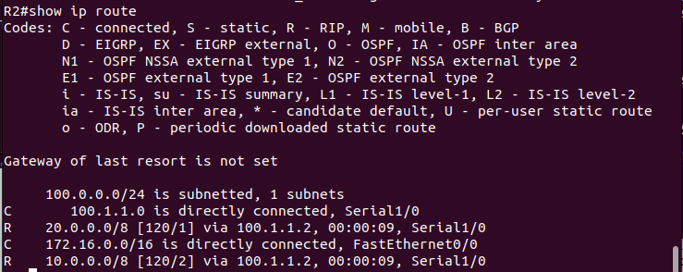
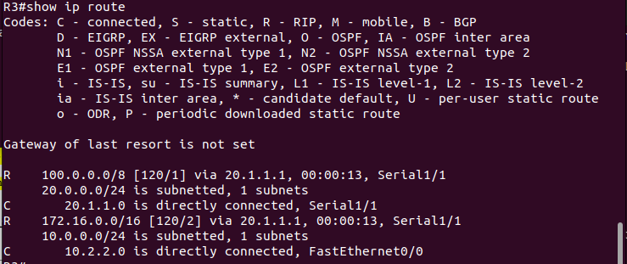

2. show ip protocol command should display if necessary, ports are active.
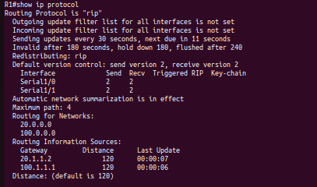

3. show ip rip database command should displays the contents of RIP database
inside the router.
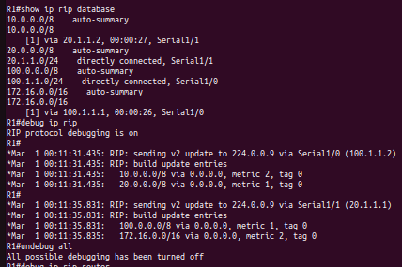

4. debug ip rip command shows RIP updates occurring in the system undebug all
Once you turn on. debug ip rip router will keep showing RIP updates. The command undebug all
will stop such RIP updates.

5. show run command is used to get the current configuration from the
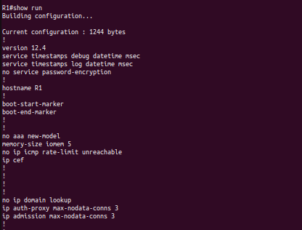
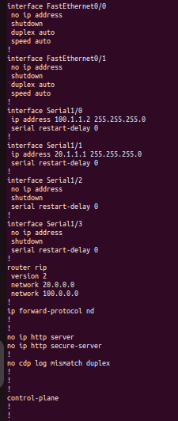
Router.

DESIGN 2

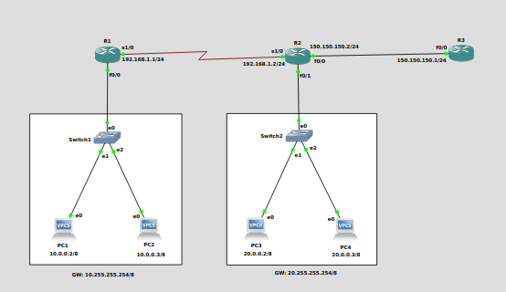

PC1> ip 10.0.0.2/8 10.255.255.254
PC2> ip 10.0.0.3/8 10.255.255.254
PC3> ip 20.0.0.2/8 20.255.255.254
PC4> ip 20.0.0.3/8 20.255.255.254

Configuration for R1:
conf t
int s1/0
ip add 192.168.1.1 255.255.255.0
no shut
int f0/0
ip address 10.255.255.254 255.0.0.0
no shut
exit
router ospf 200
network 10.0.0.0 0.255.255.255 area 0
network 192.168.1.0 0.0.0.255 area 0.0.0.0
exit
do wr
exit

Configuration for R2:
conf t
int f0/0
ip address 150.150.150.2 255.255.255.0
no shut
int f0/1
ip address 20.255.255.254 255.0.0.0

no shut
int s1/0
ip address 192.168.1.2 255.255.255.0
no shut
exit
router ospf 200
network 20.0.0.0 0.255.255.255 area 0
network 192.168.1.0 0.0.0.255 area 0
network 150.150.150.0 0.0.0.255 area 1
exit
do wr
exit

Configuration for R3:
conf t
int f0/0
ip add 150.150.150.1 255.255.255.0
no shut
exit
router ospf 200
network 150.150.150.0 0.0.0.255 area 1
exit
do wr
exit

OSPF Verification:

1. Ping from PC1 to PC2, PC3, PC4
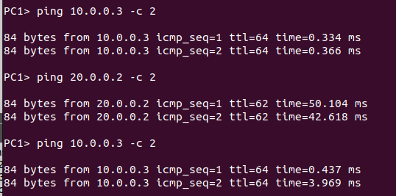

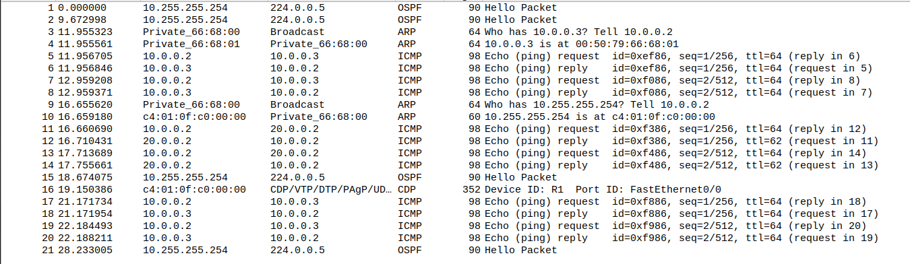

2. show ip route
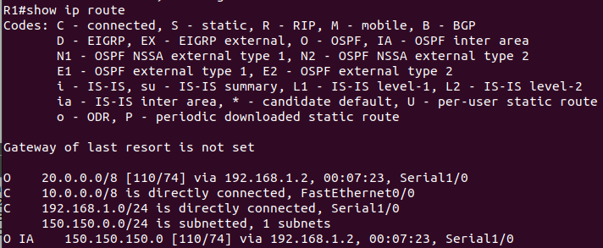
3. show ip ospf neighbor
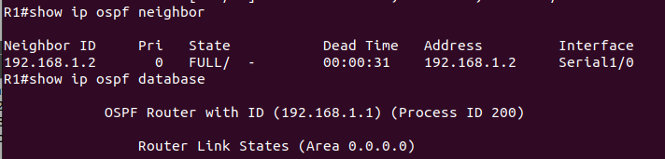
4. show ip ospf database
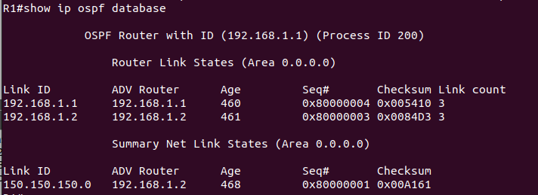

Notes:
Interior gateway protocol: OSPF (inside airtel, inside bsnl)
Exterior: BGP (airtel to bsnl)

DESIGN 3

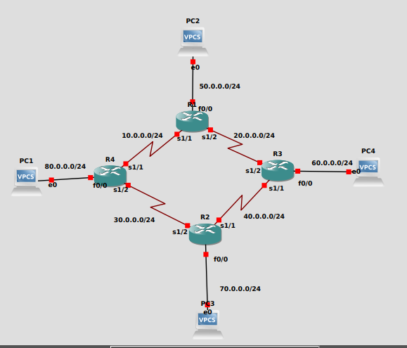
Configuring R1
conf t
int f0/0
ip address 50.0.0.1 255.255.255.0
no shut
int s1/1
ip address 10.0.0.1 255.255.255.0
no shut
int s1/2
ip address 20.0.0.1 255.255.255.0
no shut
exit
router ospf 200
network 10.0.0.0 0.0.0.255 area 0
network 20.0.0.0 0.0.0.255 area 0
network 50.0.0.0 0.0.0.255 area 0
exit
do wr

Configuring R2
conf t
int f0/0
ip address 70.0.0.1 255.255.255.0
no shut
int s1/1
ip address 40.0.0.1 255.255.255.0
no shut
int s1/2
ip address 30.0.0.1 255.255.255.0
no shut
exit
router ospf 200
network 30.0.0.0 0.0.0.255 area 0
network 40.0.0.0 0.0.0.255 area 0
network 70.0.0.0 0.0.0.255 area 0
exit
do wr

Configuring R3
conf t
int f0/0
ip address 60.0.0.1 255.255.255.0
no shut
int s1/1
ip address 40.0.0.1 255.255.255.0
no shut
int s1/2
ip address 20.0.0.1 255.255.255.0
no shut
exit
router ospf 200
network 20.0.0.0 0.0.0.255 area 0
network 40.0.0.0 0.0.0.255 area 0
network 60.0.0.0 0.0.0.255 area 0
exit
do wr

Configuring R4
conf t
int f0/0
ip address 80.0.0.1 255.255.255.0
no shut
int s1/1
ip address 10.0.0.1 255.255.255.0
no shut
int s1/2
ip address 30.0.0.1 255.255.255.0
no shut
exit
router ospf 200
network 10.0.0.0 0.0.0.255 area 0
network 30.0.0.0 0.0.0.255 area 0
network 80.0.0.0 0.0.0.255 area 0
exit
do wr

