LAB 5

1

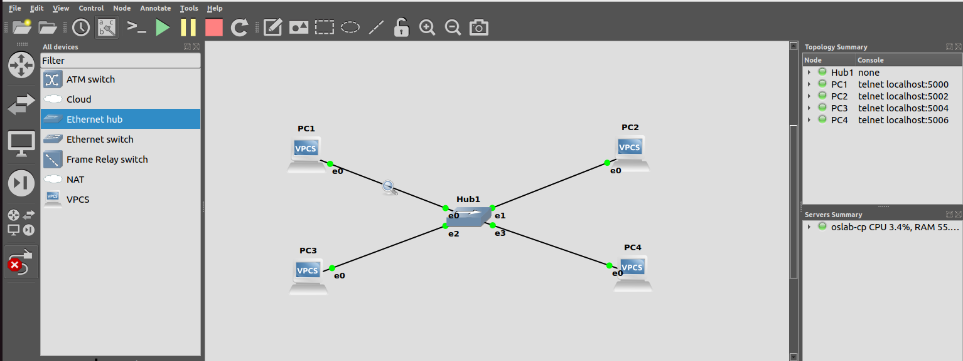

a. On PC1, view the ARP cache with show arp b. Start Wireshark on PC1-Hub1 link with a capture filter set to the IP address of PC2.
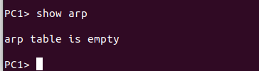
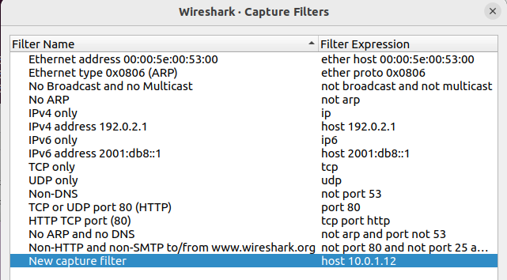

c. Issue a ping command from PC1 to PC2: ping 10.0.1.12 –c 3

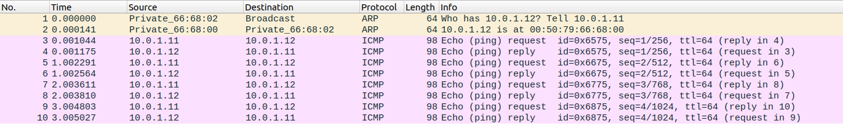

Observe the ARP packets in the Wireshark window. Explore the MAC addresses in the
Ethernet headers of the captured packets. (left: request packet, right: reply packet)
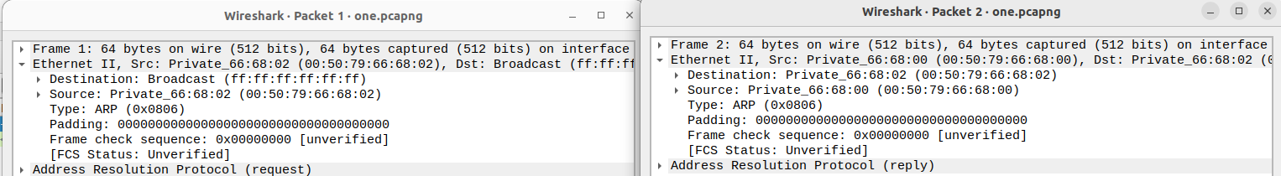
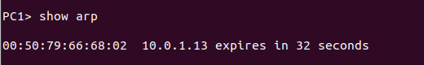
d. View the ARP cache again
(arp -a shows invalid ID)

QUESTIONS:

• What is the destination MAC address of an ARP Request packet?
=> The destination MAC address is typically a broadcast address, which is represented by a string of "ff:ff:ff:ff:ff:ff". It is the IP address used to send a message to all devices connected to a specific network. It is a special address where all devices on the network are listening.

• What are the different Type Field values in the Ethernet headers that you observed?

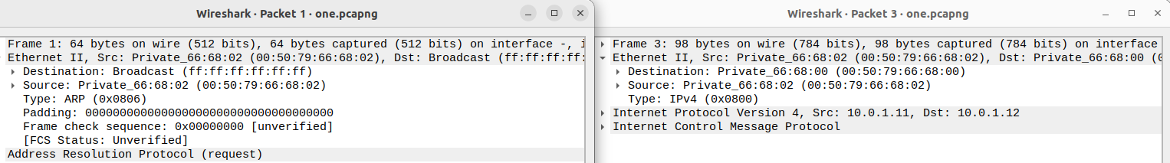
=> The different Type Field valuesin the Ethernet headers are ARP and Ipv4

• Use the captured data to analyze the process in which ARP acquires the MAC address for IP
address 10.0.1.12.
=> The Address Resolution Protocol (ARP) uses a process called ARP request and ARP reply to acquire the MAC address for the IP address 10.0.1.12. ARP first sends an ARP request broadcast message to all devices in the network, asking which device has the MAC address associated with the IP address. The device with the IP address 10.0.1.12 responds with an ARP reply message, providing its MAC address. ARP then updates its local ARP table with the IP-to-MAC address mapping it received in the reply.

------------------------------------------------------------------------------------------------------------------------

2
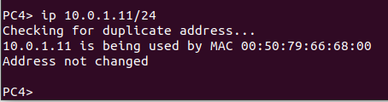

IP adresses over the same network cannot be the same. They need to be unique over the same network.

------------------------------------------------------------------------------------------------------------------------

3

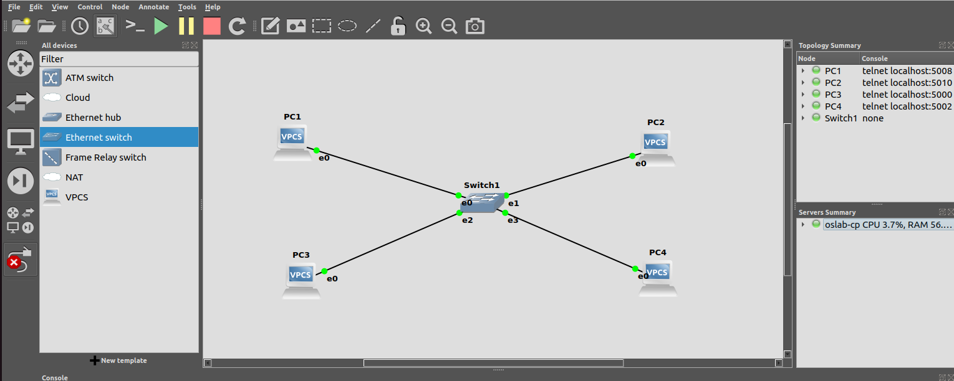
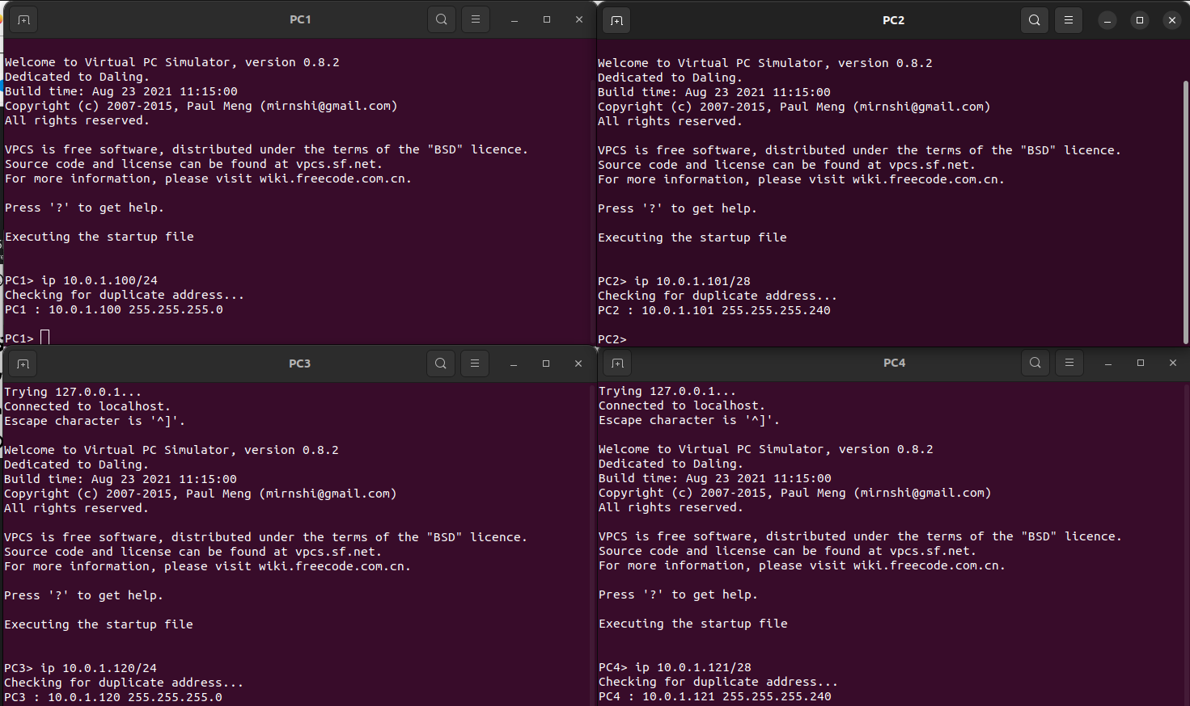
Run Wireshark on PC1-Hub1 link and capture the packets for the following scenarios. Use your output data and ping results to explain what happened in each of the ping commands. Which ping operations were successful and which were unsuccessful? Why?

i. From PC1 ping PC3 – ping successful since same network id.
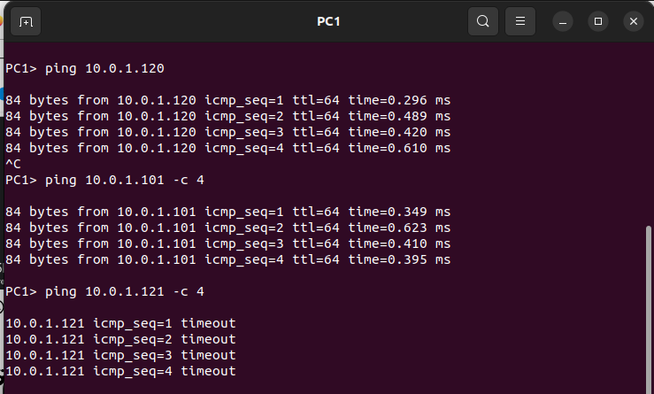
ii. From PC1 ping PC2 – ping successful even though different network ids since the first 4 bits of host id of PC1 matches the last 4 bits of network id of PC2 i.e the first 28 bits of both the ip addresses are the same.

iii. From PC1 ping PC4 – ping unsuccessful since network
ids are different. Timeout: There is no reponse.

iv. From PC4 ping PC1 v. From PC2 ping PC4.
vi. From PC2 ping PC3

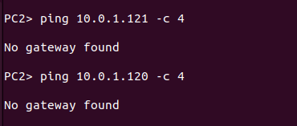

iv, v, vi – ping unsuccessful since no gateway configured

