LAB 6

Name: Disha Agarwal Branch: CSE A Registration Number: 210905412

Design 1

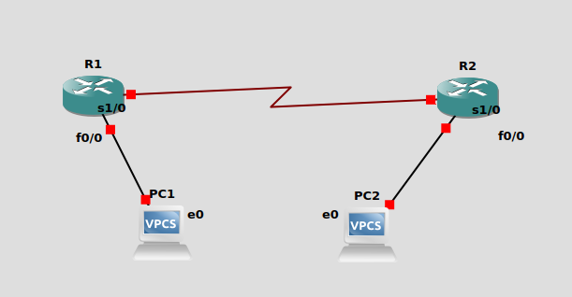

PC1 | 10.0.0.10/8
PC2 | 30.0.0.10/8
R1 | s1/0: 20.0.0.1  f0/0: 10.0.0.1
R2 | s1/0: 20.0.0.2  f0/0: 30.0.0.1

PC1
ip 10.0.0.10/8 10.0.0.1

PC2
ip 30.0.0.10/8 30.0.0.1

R1
conf t
int f0/0
ip address 10.0.0.1 255.0.0.0
no shutdown
exit

int s1/0
ip address 20.0.0.1 255.0.0.0
no shut
exit
exit
ping 20.0.0.2

conf t
ip route 30.0.0.0 255.0.0.0 20.0.0.2
exit

ping 30.0.0.1

R2
conf t
int f0/0
ip address 30.0.0.1 255.0.0.0
no shut
exit

int s1/0
ip address 20.0.0.2 255.0.0.0
no shut
exit

ip route 10.0.0.0 255.0.0.0 20.0.0.1
exit

ping 10.0.0.10

Design 2
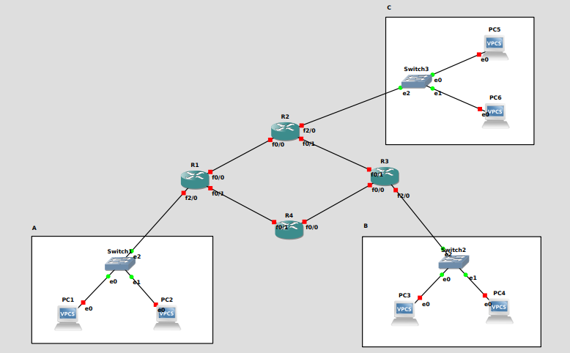
PC1 | 30.0.0.1/8
PC2 | 30.0.0.2/8
PC3 | 176.16.0.1/16
PC4 | 176.16.0.2/16
PC5 | 197.168.1.1/24
PC6 | 197.168.1.2/24
R1 | f0/0: 20.0.0.1/8  f0/1: 40.0.0.1/8  f2/0: 30.255.255.254/8
R2 | f0/0: 20.0.0.2/8  f0/1: 60.0.0.2/8  f2/0: 197.168.1.254/24
R3 | f0/0: 80.0.0.1/8  f0/1: 60.0.0.1/8  f2/0: 172.16.255.254/16
R4 | f0/0: 80.0.0.2/8  f0/1: 40.0.0.2/8

PC1> ip 30.0.0.1/8 30.255.255.254/8
PC2> ip 30.0.0.2/8 30.255.255.254/8
PC3> ip 172.16.0.1/16 172.16.255.254/16
PC4> ip 172.16.0.2/16 172.16.255.254/16
PC5> ip 197.168.1.1/24 197.168.1.254/24
PC6> ip 197.168.1.2/24 197.168.1.254/24
R1:
conf t
inter f2/0
ip address 30.255.255.254 255.0.0.0
no shut
exit
inter f0/0
ip address 20.0.0.1 255.0.0.0
no shut
exit
inter f0/1
ip address 40.0.0.1 255.0.0.0
no shut
exit
do wr
end

R2:
conf t
inter f2/0
ip address 197.168.1.254 255.255.255.0
no shut
exit
inter f0/1
ip address 60.0.0.2 255.0.0.0
no shut
exit
inter f0/0
ip address 20.0.0.2 255.0.0.0
no shut
exit
do wr
end

R3:
conf t
inter f2/0
ip address 172.16.255.254 255.255.0.0
no shut
exit
inter f0/0
ip address 80.0.0.1 255.0.0.0
no shut
exit

inter f0/1
ip address 60.0.0.1 255.0.0.0
no shut
exit
do wr
end

R4:
conf t
inter f0/1
ip address 40.0.0.2 255.0.0.0
no shut
exit
inter f0/0
ip address 80.0.0.2 255.0.0.0
no shut
exit
do wr
end

Configuring Routing paths:
R4:
ip route 172.16.0.0 255.255.0.0 80.0.0.1
ip route 30.0.0.0 255.0.0.0 40.0.0.1
R3:
ip route 30.0.0.0 255.0.0.0 80.0.0.2
ip route 197.168.1.0 255.255.255.0 60.0.0.2
R2:
ip route 30.0.0.0 255.0.0.0 20.0.0.1
ip route 172.16.0.0 255.255.0.0 60.0.0.1
R1:
ip route 197.168.1.0 255.255.255.0 20.0.0.2
ip route 172.16.0.0 255.255.0.0 40.0.0.2

Pinging:
ping 30.0.0.1
ping 30.0.0.2
ping 172.16.0.1
ping 172.16.0.2
ping 197.168.1.1
ping 197.168.1.2

