LAB – 03 DISHA AGARWAL
210905412 CSE A

numpyarr.py:

import numpy as np

# 1. Array creation
A = np.array ([2,5,10])
print(A.dtype)
B=np.array ([2.4,10.6,5.2])
print(B.dtype)

# Creating sequence of sequence will create 2-dimensional array.
A=np.array([(3,4,5),(12,6,1)])
Z=np.zeros((2,4)) # will create zero matrix of dimension 2x4
print(A,'\n',B)
print(np.ones((3,3))) # will create one’s matrix of dimension 3x3

# To create a sequence of data,
S=np.arange(10,30,5)
print(S)
print(np.arange( 0, 2, 0.3 )) # it accepts float arguments

#lnstead of step-size, we can specify total number of elements in the array using
S1=np.linspace(0,2,9) # produce 9 numbers starting 0 & ends with 2
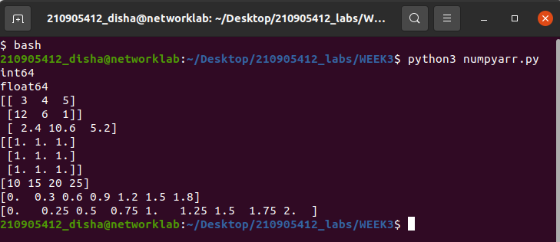
print(S)

randomex.py

import random
print(random.choice([1,2,3,4,5])) # this will pick one number from the list randomly
print(random.choice('python')) # will pick one character from the string randomly
print(random.randrange(25,50)) # will pick one integer between 25 to 50

print(random.randrange(25,50,2)) # pick one integer between 25 to 50 with step size of 2
print(random.random()) # will pick a random number between 0 to 1
print(random.uniform(5,10)) # will pick a floating point number between 5 to 10
l = [1,2,3,4,5]
random.shuffle(l) # will shuffle the list elements
print(l)
random.seed(10) # to get same random value during every execution
print(random.random())
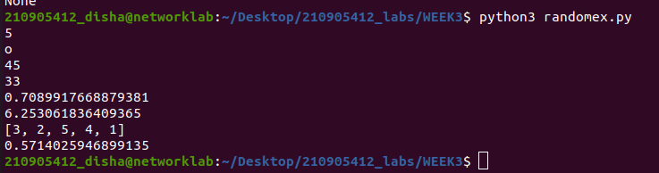
2D_3D.py

import numpy as np
# 2- Dimensional array (Matrix)
a = np.arange(15).reshape(3, 5)
#to check the dimension
print(a.shape)
print(a.size) # will return total elements in matrix
# to transpose a matrix
print(a.T)

# 3- Dimensional array
c = np.arange(24).reshape(2,3,4) # 1st value indicates (no of planes) (3,4) is the dimension
print(c)
print(c.shape)
print(c[1,...]) # equal to c[1,:,:] # will fetch all elements of 2nd plane
print(c[...,2]) # equal to c[:,:,2]
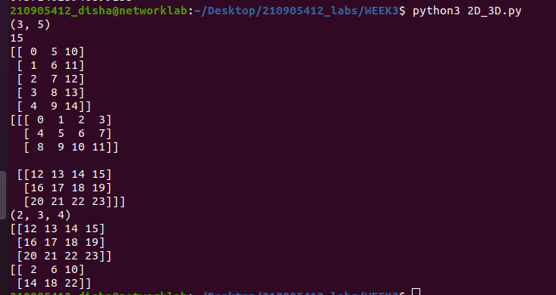

stacking.py

import numpy as np

# Stacking together different arrays
A1=np.array([(3,4,5),(12,6,1)])
A2=np.array([(1,2,6),(-4,3,8)])
D1=np.vstack((A1,A2))
print(D1)
D2=np.hstack((A1,A2))
print(D2)

# Stacking 1-D array into 2-D array (column wise)
a = np.array([4.,2.])
b = np.array([3.,8.])
print(np.column_stack((a,b))) # returns a 2D array
print(np.hstack((a,b)))
# print(np.hstack((a[:,newaxis],b[:,newaxis]))) # the result is the same
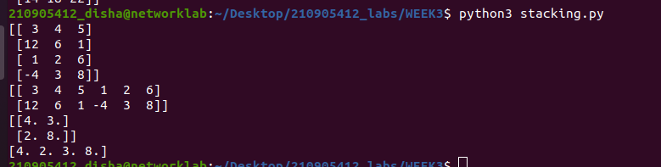

loop.py

import numpy as np
# Usage of for-loop (Mapping by Value)
# Calculate sum of all the elements in a 2D Numpy Array
a=np.array([(3,2,9),(1,6,7)])
s1=0
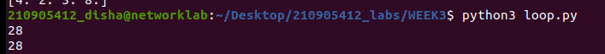
for row in a:
for col in row:
s1+=col
print(s1)

# Usage of for-loop (Mapping by Index)
# Calculate sum of all the elements in a 2D Numpy Array
a=np.array([(3,2,9),(1,6,7)])
s=0
for i in range(a.shape[0]):
for j in range(a.shape[1]):
s+=a[i,j]
print(s)

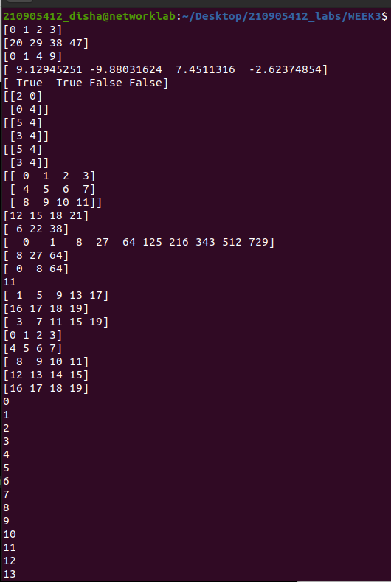
operations.py

import numpy as np
# Array operations
a = np.array( [20,30,40,50] )
b = np.arange( 4 )
c = a-b
print(b)
print(c)
print(b**2)
print(10*np.sin(a))
print(a<35)

# Matrix operations
A = np.array( [[1,1],[0,1]] )
B = np.array( [[2,0],[3,4]] )
print(A*B) # elementwise product
print(A.dot(B)) # matrix product
# (OR)
print(np.dot(A, B))
b = np.arange(12).reshape(3,4)
# another matrix product
print(b)
print(b.sum(axis=0)) # sum of each column
print(b.sum(axis=1)) # sum of each row

# Indexing, Slicing & Iterating Array
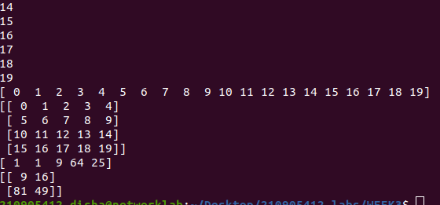
a = np.arange(10)**3
print(a)
print(a[2:5])
print(a[0:6:2])
b=np.arange(20).reshape(5, 4)
print(b[2,3])
print(b[0:5,1]) # or b[:5,1] or b[:,1]
print(b[-1,:]) # will fetch last row
print(b[:,-1]) # will fetch last col
for row in b:
print (row) # will print every row
for element in b.flat:
print (element) # will show all elements of b in 1-D array
# Changing the shape of a matrix
print(b.ravel()) # returns the array flattened to (1x20)
# Later, we can convert 5x4 matrix into 4x 5 matrix using
B1=b.reshape(4,5)
print(B1)

# Indexing with array of indices
a = np.arange(12)**2
i = np.array( [ 1,1,3,8,5 ] )
print(a[i])
# the first 12 square numbers
# an array of indices
# the elements of a at the positions i
j = np.array( [ [ 3, 4], [ 9, 7 ] ] ) # a bidimensional array of indices
print(a[j])
# the same shape as j

