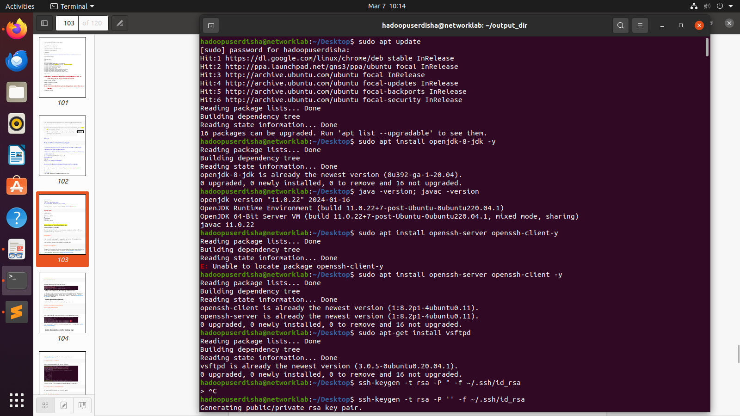
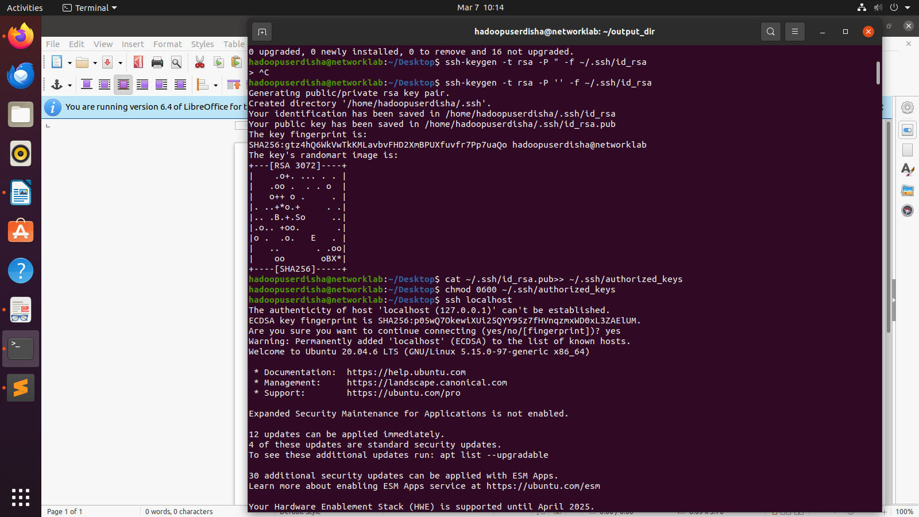

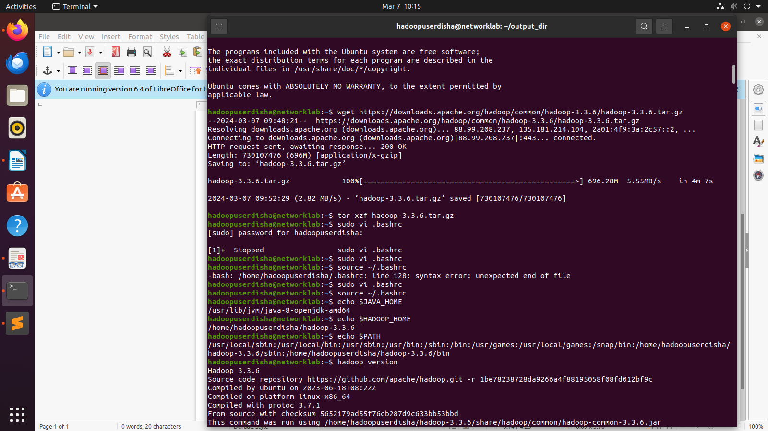
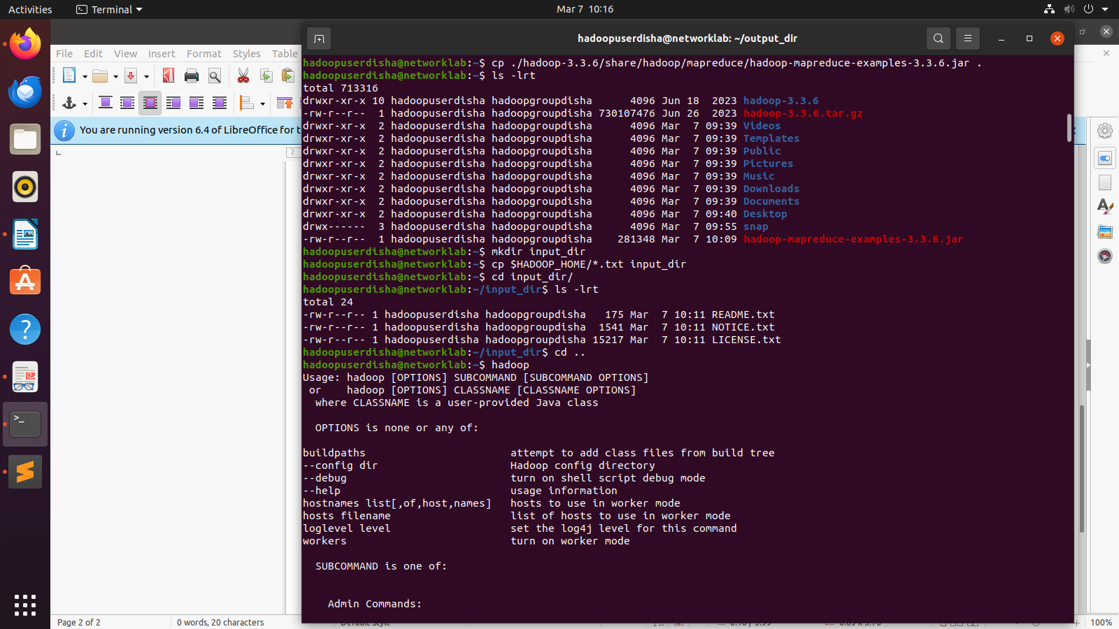

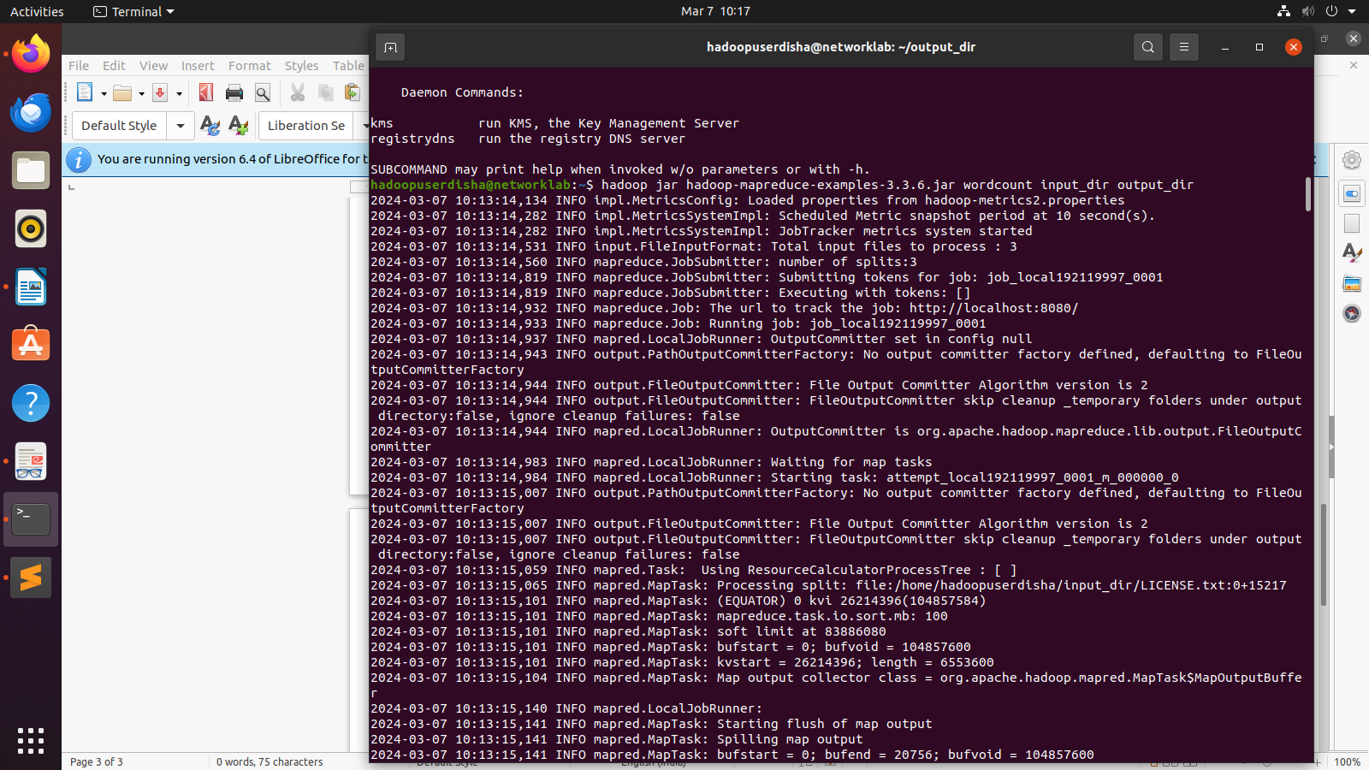
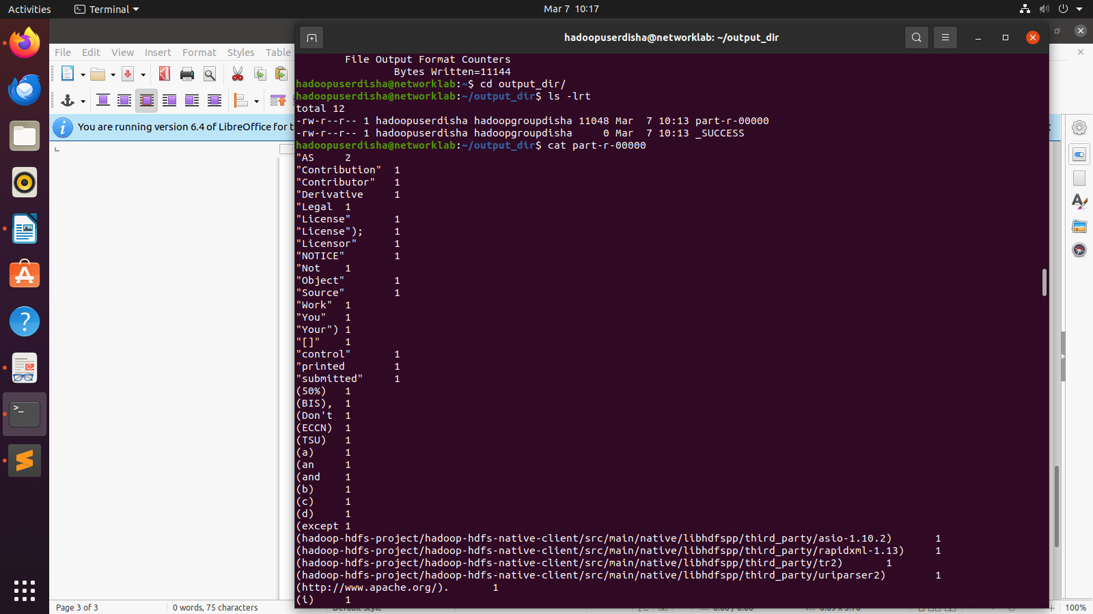

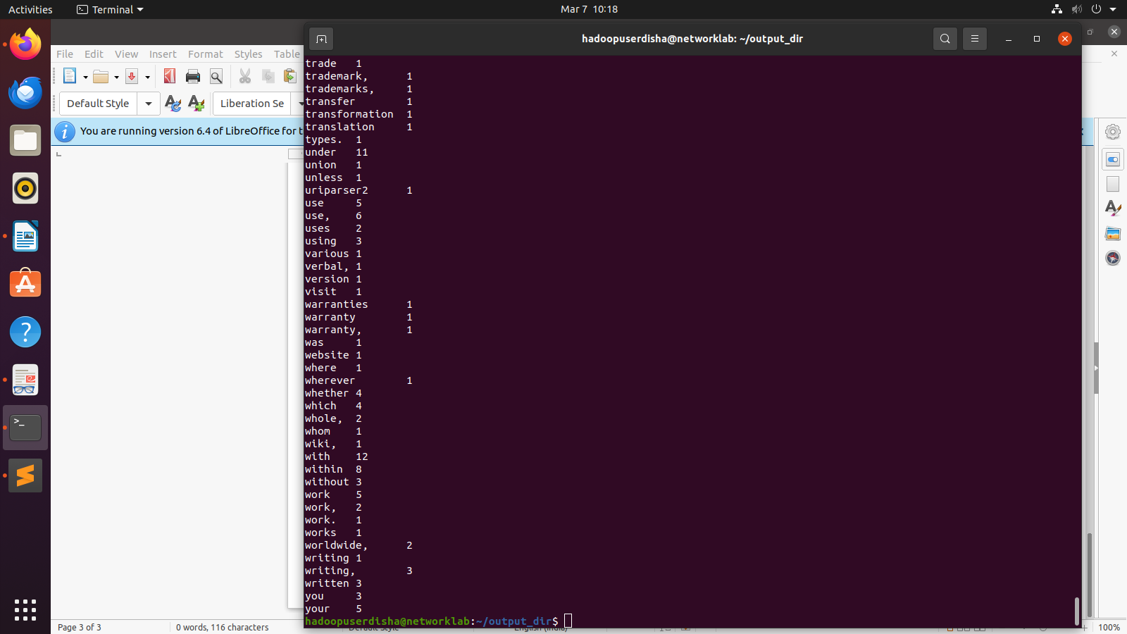

after getting the bashrc file -> press i to enter insert mode -> press enter to go to the next line -> paste the following:

export JAVA_HOME=/usr/lib/jvm/java-8-openjdk-amd64
export HADOOP_HOME=/home/hadoopuserdisha/hadoop-3.3.6
export HADOOP_INSTALL=$HADOOP_HOME
export HADOOP_MAPRED_HOME=$HADOOP_HOME
export HADOOP_COMMON_HOME=$HADOOP_HOME
export HADOOP_HDFS_HOME=$HADOOP_HOME
export YARN_HOME=$HADOOP_HOME
export HADOOP_COMMON_LIB_NATIVE_DIR=$HADOOP_HOME/lib/native
export PATH=$PATH:$HADOOP_HOME/sbin:$HADOOP_HOME/bin
export HADOOP_OPTS="-Djava.library.path=$HADOOP_HOME/lib/native"
then press enter -> then esc -> then type :wq

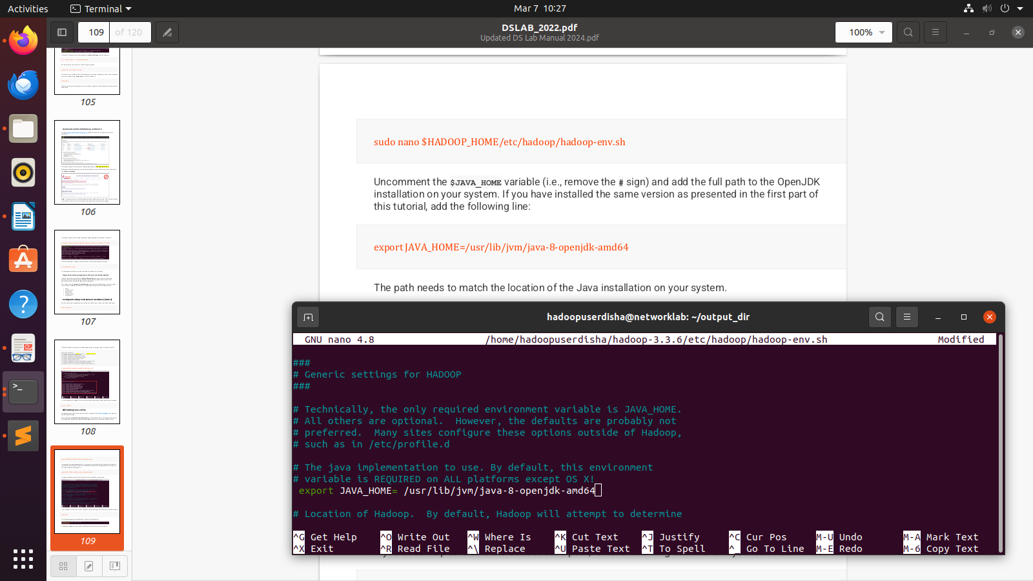
for distributed hadoop:
uncomment this line not the above line::::: REMEMBER NO SPACE AFTER EXPORT=

