LAB – 06 DISHA AGARWAL
210905412 CSE A

1. Write a mapper and reducer program for word count by defining separator instead of
using “\t”.

sepmap.py

# A more advanced Mapper, using Python iterators and generators
import sys
def read_input(file):
for line in file:
# split the line into words
yield line.split()
def main(separator='\t'):
# input comes from STDIN (standard input)
data = read_input(sys.stdin)
for words in data:
# write the results to STDOUT (standard output);
# what we output here will be the input for the
# Reduce step, i.e. the input for reducer.py
# tab-delimited; the trivial word count is 1
for word in words:
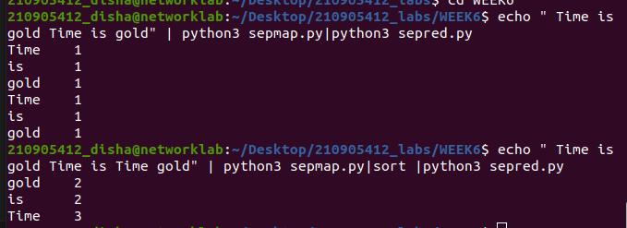
print('%s%s%d' % (word, separator, 1))
if __name__=="__main__":
main()

sepred.py

from itertools import groupby
from operator import itemgetter
import sys
def read_mapper_output(file, separator='\t'):
for line in file:
yield line.rstrip().split(separator, 1)
def main(separator='\t'):
# input comes from STDIN (standard input)
data = read_mapper_output(sys.stdin, separator=separator)
# groupby groups multiple word-count pairs by word,
# and creates an iterator that returns consecutive keys and their group:
# current_word - string containing a word (the key)
# group - iterator yielding all ["&lt;current_word&gt;", "&lt;count&gt;"] items
for current_word, group in groupby(data, itemgetter(0)):
try:
total_count = sum(int(count) for current_word, count in group)
print ("%s%s%d" % (current_word, separator, total_count))
except ValueError:

# count was not a number, so silently discard this item
pass
if __name__=="__main__":
main()

2. Write a map reduce program that returns the cost of the item that is most expensive, for each location in the dataset example.txt

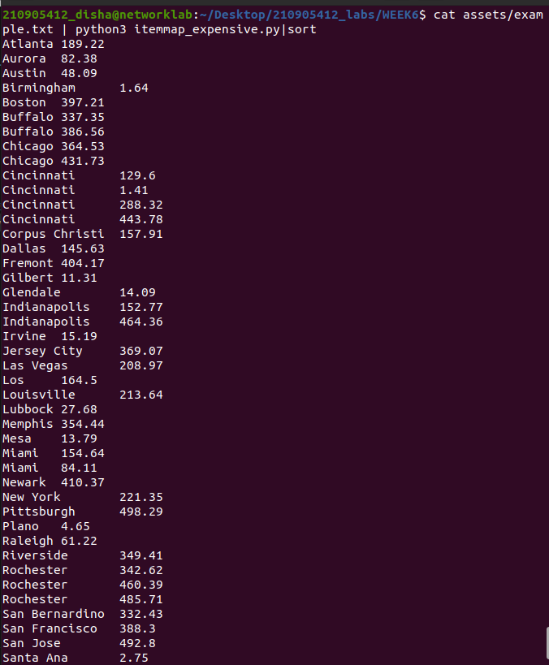
itemmap_expensive.py

import fileinput
for line in fileinput.input():
data = line.strip().split("\t")
if len(data)==6:
date, time, location, item, cost, payment = data
print("{0}\t{1}".format(location, cost))

itemred_expensive.py

import fileinput
max_value = 0
old_key = None
for line in fileinput.input():
data = line.strip().split("\t")
if len(data) != 2:
# Something has gone wrong. Skip this line.
continue
current_key, current_value = data
# print(current_key, current_value)
# Refresh for new keys (i.e. locations in the example context)
if old_key and old_key != current_key:
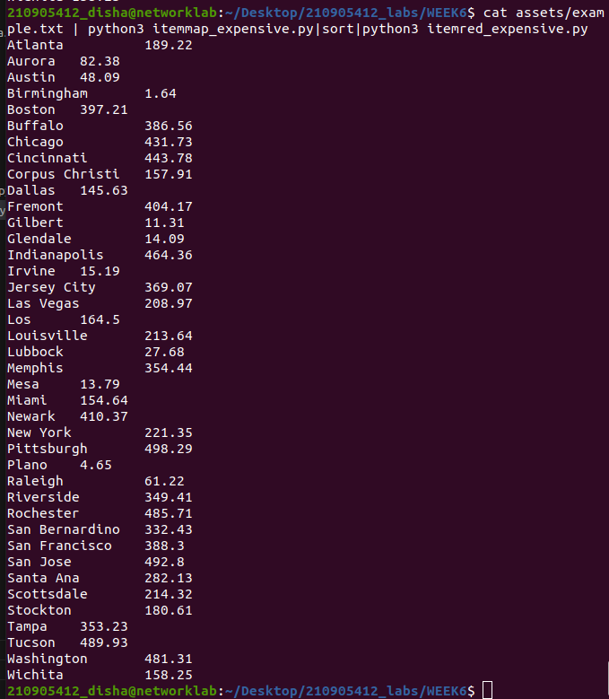
print(old_key,"\t", max_value)
max_value = 0
if float(current_value) > float(max_value):
max_value = float(current_value)
old_key = current_key
if old_key != None:
print (old_key, "\t", max_value)

