DISHA AGARWAL
210905412
CSE A

assignment.py:

# 1. Assigning Values to Variables
counter = 100 # An integer assignment
miles = 1000.0 # A floating point
name = "John" # A string
print (counter)
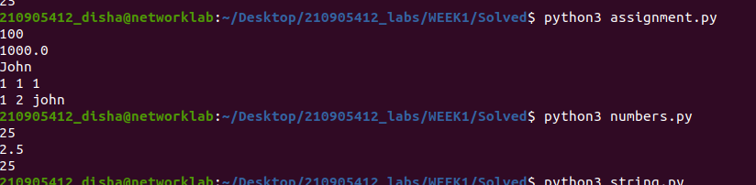
print (miles)
print (name)

# 2. Multiple Assignment
a = b = c = 1
print(a,b,c)
a, b, c = 1, 2, "john"
print(a,b,c)

numbers.py:

a = 5 # integer assignment
b= 4.56 #floating point assignment
#mathematical operations with scalar variables
print (5*a)
print (a/2)
print(a**2)

string.py

str = 'Hello World!'
print (str) # Prints complete string
print (str[0]) # Prints first character of the string
print (str[2:5]) # Prints characters starting from 3rd to 5th
print (str[2:]) # Prints string starting from 3rd character
print (str * 2) # Prints string two times
print (str + "TEST") # Prints concatenated string

# Updating a string
var1 = 'Hello World!'
print ("Updated String :", var1[:6] + 'Python')

# String formatting operator
print( "String formatting: My name is %s and weight is %d kg!" % ('Abay', 55))

# Built−in String methods
str = "this is STRING example wow!!!"

print ("Capitalize: ", str.capitalize())
print("Count: ", str.count('s'))
print("Find: ", str.find('example'))
print ("Lower: ", str.lower())
print ("Replace: ", str.replace("is", "was"))
print ("Swapcase: ", str.swapcase())
print ("Title: ", str.title())

list.py

list = [ 'abcd', 786 , 2.23, 'john', 70.2 ]
tinylist = [123, 'john']
print (list) # Prints complete list
print (list[0]) # Prints first element of the list
print (list[1:3]) # Prints elements starting from 2nd till 3rd
print (list[2:]) # Prints elements starting from 3rd element
print (tinylist * 2) # Prints list two times
print (list + tinylist) # Prints concatenated lists

# Functions & Methods in LIST

# add an element
list = ['physics', 'chemistry', 1997, 2000]
list.append('maths')
print(list)

# To delete an element in a list
del list[2]
print(list)

# To check a data in a list,
print("in operator: ", 'physics' in list)
print("in operator: ", 'english' in list)
print("length: ", len(list))
print("count: ", list.count('physics'))

# modifying lists
list = ['physics', 'chemistry', 1997, 2000]
list.pop()
print("pop: ",list)
list.insert (2, 'maths')
print("insert: ", list)
list.remove('chemistry')
print("remove: ", list)
list.reverse()
print("reverse: ", list)

tuple.py

tuple = ( 'abcd', 786 , 2.23, 'john', 70.2 )
list = [ 'abcd', 786 , 2.23, 'john', 70.2 ]
# tuple[2] = 1000 # Invalid syntax with tuple
list[2] = 1000 # Valid syntax with list
print(list)
print(tuple)

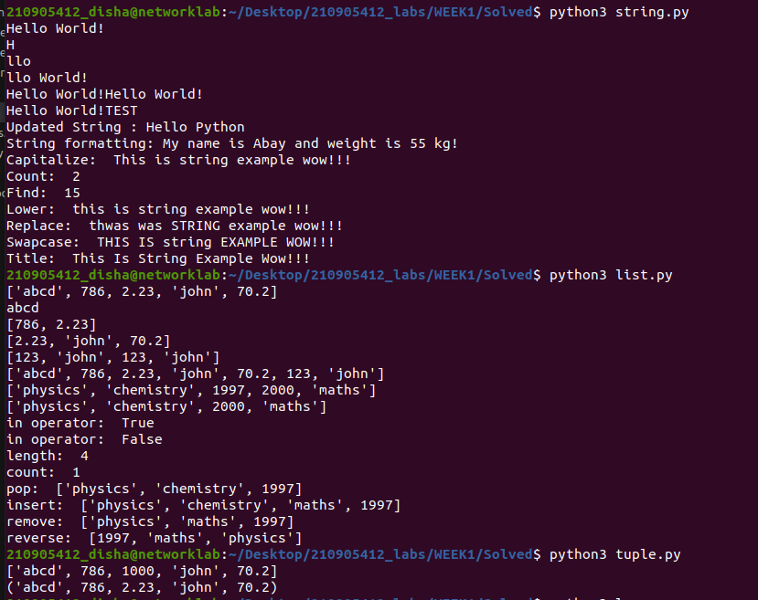

loop.py:

# Eg.1
for val in [5,4,3,2,1]:
print(val)
print("------------------------")

# Eg.2
stud=['Ram','Vijay','Nithya','Anu','Ramesh','suja']
for k in stud:
print('Hello:', k)

print("------------------------")

# Eg.3
for i in range(5):
print(i)
if i>2:
print('Bigger than 2')
print("------------------------")

# Eg.4: Calculate factors of a number
x=int(input('Enter a number:'))
for i in range(1,x+1):
if x%i ==0:
print(i)
print("------------------------")

# Eg.5: Calculate largest number in an array
from math import *
x= [9, 41, 12, 3, 74, 15]
Largest=-inf
for i in x:
if i>Largest:
Largest=i
print(Largest)
print("------------------------")

# Eg.6: Calculate smallest number in an array
from math import *
x= [9, 41, 12, 3, 74, 15]
smallest=inf
for i in x:
if i<smallest:
smallest=i
print(smallest)
print("------------------------")

# Eg.7: Calculate the count, sum and average of numerical array
x= [9, 41, 12, 3, 74, 15]
count=sum=avg=0
for i in x:
count=count+1
sum=sum+i
avg=sum/count
print(count)
print(sum)
print(avg)
print("------------------------")

# Eg.8: Filtering in a loop (print all numbers >20)
x= [9, 41, 12, 3, 74, 15]

for i in x:
if i>20:
print (i)
print("------------------------")

# Eg.9: For the above problem, instead of printing the result, store the elements in a
# variable (object)
x= [9, 41, 12, 3, 74, 15]
res=[]
for i in x:
if i>20:
res.append(i)
print(res)
print("------------------------")

# # Eg.10: For the above x, replace all elements <20 into zero. Store the result in different
# # variable (object)
y=[0] * len(x)
for i in range(len(x)):
if x[i]>20:
x[i] = 0
y[i]=x[i]
print(y)
print("------------------------")

# Eg. 11: Program using elif to check more than one condition.
price = 100
if price > 100:
print("price is greater than 100")
elif price == 100:
print("price is 100")
elif price < 100:
print("price is less than 100")
print("------------------------")

# Eg. 12: Program using while loop -
# program to display numbers from 1 to 5

# initialize the variable
i = 1
n = 5
# while loop from i = 1 to 5
while i <= n:
print(i)
i = i + 1
print("------------------------")

# Eg. 13:Take input from user , until user enters zero and calculate the sum of entered numbers.
total = 0
number = int(input('Enter a number: '))
# add numbers until number is zero
while number != 0:
total += number # total = total + number
# take integer input again
number = int(input('Enter a number: '))
print('total =', total)
print("------------------------")

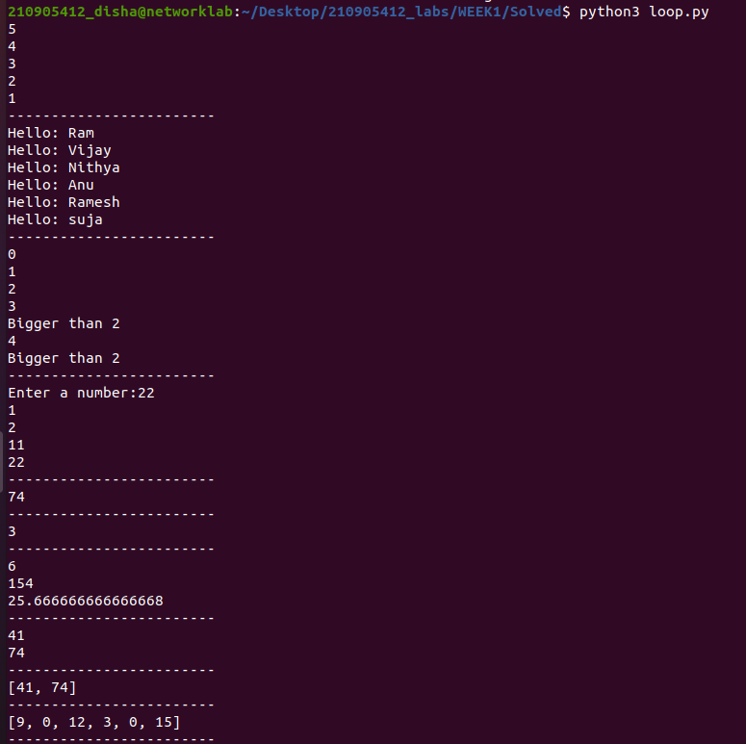

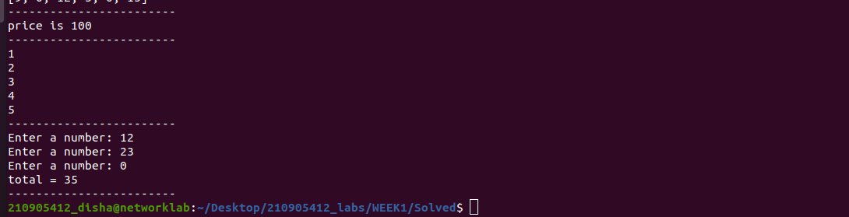

conditional.py:

# Eg.1
num=float(input('Enter a number:'))
if num>0:
print('pos number')
elif num==0:
print('zero')
else:
print('Neg number')
print("-------------------------------------")

# Eg.2
x=float(input('Enter a number:'))
if x<10:
print('smaller')
if x>20:
print('bigger')
print('Finished')
print("-------------------------------------")

# Eg.3
x=5
print('Before 5')
if x==5:
print ('this is 5')
print('still 5')
print('After 5')
print('Before 6')
if x==6:
print('this is 6')
print ('After 6')
print("-------------------------------------")

# Eg.4: which will never print?
x=float(input('Enter a number:'))
if x<20:
print('Below 20')
elif x<10:
print('Below 10')
else:
print('something else')
print("-------------------------------------")

# Eg.5: Nested Decisions
x=42
if x>1:
print('above one')
if x<100:
print('less than 100')
print('All done')
print("-------------------------------------")

# Eg.6: Ternary operator
age=15
b=('kid' if age<18 else 'adult')
print(b)
#this will print 'kid'
print("-------------------------------------")

