LAB 7
9. implement of unification in FOL

def occurs_check(var, term, subs):
"""Check if var occurs in term (to prevent infinite recursion like x = f(x))"""
if var == term:
return True
if isinstance(term, tuple):
for t in term[1:]:
if occurs_check(var, apply_subs(t, subs), subs):
return True
return False

def apply_subs(term, subs):
"""Apply current substitutions to a term."""
if isinstance(term, str):
return subs.get(term, term)
if isinstance(term, tuple):
return tuple([term[0]] + [apply_subs(t, subs) for t in term[1:]])
return term

def unify(e1, e2, subs=None):
"""Main Unification function."""
if subs is None:
subs = {}
e1 = apply_subs(e1, subs)
e2 = apply_subs(e2, subs)

# If both terms are same, nothing to do
if e1 == e2:
return subs

# If one is variable (lowercase)
if isinstance(e1, str) and e1.islower():
return unify_var(e1, e2, subs)
if isinstance(e2, str) and e2.islower():
return unify_var(e2, e1, subs)

# If both are compound terms (predicates)
if isinstance(e1, tuple) and isinstance(e2, tuple):
if e1[0] != e2[0] or len(e1) != len(e2):
return None # Predicate/function mismatch
for i in range(1, len(e1)):
subs = unify(e1[i], e2[i], subs)
if subs is None:
return None
return subs

# Otherwise not unifiable
return None

def unify_var(var, x, subs):
"""Bind a variable to a term if possible."""
if var in subs:
return unify(subs[var], x, subs)
elif x in subs:
return unify(var, subs[x], subs)
elif occurs_check(var, x, subs):
return None
else:
subs[var] = x
return subs

# ---------- Example Usage ----------

# Example 1
exp1 = ('p', 'x', 'a')
exp2 = ('p', 'b', 'y')

print("\nExpression 1:", exp1)
print("Expression 2:", exp2)

result = unify(exp1, exp2, {})

if result:
print("\n✅ Unification Successful!")
print("Unifier:", result)
else:
print("\n❌ Unification Failed.")
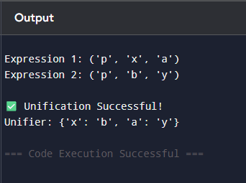

11. Create a knowledge base consisting of first order logic statements and prove the
given query using forward reasoning.
Knowledge Base (First-Order Logic Statements):
- Man(Marcus): Marcus is a man.
- Pompeian(Marcus): Marcus is a Pompeian.
- All(x) (Pompeian(x) -> Roman(x)): All Pompeians are Romans.
- All(x) (Roman(x) -> Loyal(x)): All Romans are loyal.
- All(x) (Man(x) -> Person(x)): All men are persons.
- All(x) (Person(x) -> Mortal(x)): All persons are mortal.
Query:
Mortal(Marcus): Is Marcus mortal?
# Forward chaining demonstration for Marcus KB
# Prints full steps (which rule applied, which premises matched, resulting fact)

def pretty_fact(pred, const):
return f"{pred}({const})"

# Initial ground facts
facts = set([
("Man", "Marcus"),
("Pompeian", "Marcus")
])

# Rules of the form (premise_predicate, conclusion_predicate)
rules = [
("Pompeian", "Roman"), # ∀x (Pompeian(x) -> Roman(x))
("Roman", "Loyal"), # ∀x (Roman(x) -> Loyal(x))
("Man", "Person"), # ∀x (Man(x) -> Person(x))
("Person", "Mortal") # ∀x (Person(x) -> Mortal(x))
]

query = ("Mortal", "Marcus")

# Helper to print current KB nicely
def print_kb(facts):
return ", ".join(sorted([pretty_fact(p,c) for (p,c) in facts]))

# Forward chaining engine with full trace
def forward_chain_with_steps(facts, rules, query):
print("Initial Facts:")
print(" " + print_kb(facts))
print("\nRules:")
for i, (prem, concl) in enumerate(rules, start=1):
print(f" R{i}: ∀x ({prem}(x) -> {concl}(x))")
print("\nStarting forward chaining...\n")

derived_order = [] # list of tuples (new_fact, rule_index, matched_fact)
changed = True
iteration = 0
while changed:
iteration += 1
changed = False
print(f"--- Iteration {iteration} ---")
# try each rule
for ri, (prem, concl) in enumerate(rules, start=1):
# check all facts for a match to premise
for fact in list(facts): # list() to allow modification of facts inside loop
pred, const = fact
if pred == prem:
# instantiate conclusion with this constant
new_fact = (concl, const)
if new_fact not in facts:
# derive new fact
facts.add(new_fact)
derived_order.append((new_fact, ri, fact))
changed = True
print(f"Derived {pretty_fact(*new_fact)} using Rule R{ri}: "
f"{pretty_fact(*fact)} => {pretty_fact(*new_fact)}")
# If query found, we can still continue to show other derivations in this iteration,
# but we will later report success.
if not changed:
print("No new facts derived in this iteration.")
print("Current KB:", print_kb(facts), "\n")

# Optionally short-circuit if query is found
if query in facts:
print("Query found in KB. Forward chaining can stop successfully.\n")
return True, facts, derived_order

print("No more rules apply and query not found.\n")
return (query in facts), facts, derived_order

# Run the forward chaining process
proved, final_facts, derivations = forward_chain_with_steps(set(facts), rules, query)

# Final summary
print("=== Final Summary ===")
print("Final Knowledge Base:")
print(" " + print_kb(final_facts))
print("\nDerivation trace (in order):")
for idx, (nf, ri, matched) in enumerate(derivations, start=1):
print(f" Step {idx}: Derived {pretty_fact(*nf)} using Rule R{ri} from {pretty_fact(*matched)}")

if proved:
print(f"\nResult: ✅ The query {pretty_fact(*query)} is PROVED by forward chaining.")
else:
print(f"\nResult: ❌ The query {pretty_fact(*query)} CANNOT be proved by forward chaining.")
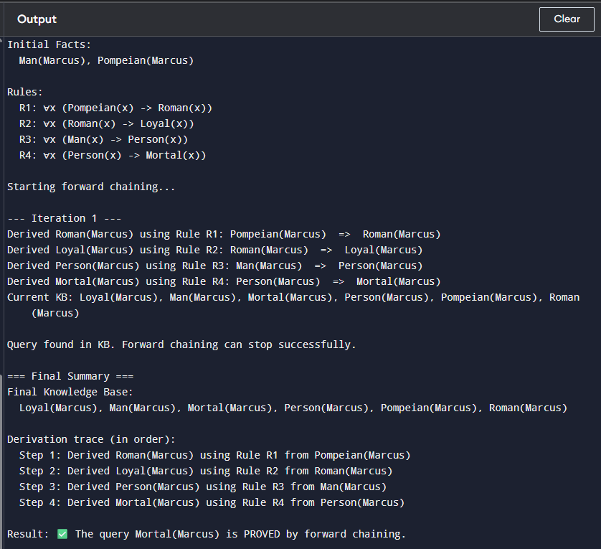

10. Convert a given first order logic statement into Conjunctive Normal Form (CNF)
# REAL FOL TO CNF CONVERTER (NO SYMPY, NO CHEATING)
# Works for this problem's structure

# Formula:
# ∀x [¬∀y ¬(Animal(y) ∨ Loves(x,y))] ∨ ∃y Loves(y,x)

from copy import deepcopy

# ----- EXPRESSIONS -----
class Predicate:
def __init__(self, name, *args):
self.name = name
self.args = args

def __str__(self):
return f"{self.name}{self.args}".replace("'", "")

__repr__ = __str__

class Or:
def __init__(self, *args):
self.args = args

def __str__(self):
return " ∨ ".join(str(a) for a in self.args)

__repr__ = __str__

# ----- VARIABLES -----
class Var:
def __init__(self, name):
self.name = name

def __str__(self):
return self.name

__repr__ = __str__

class SkolemFunc:
def __init__(self, name, *args):
self.name = name
self.args = args

def __str__(self):
return f"{self.name}({','.join(str(a) for a in self.args)})"

__repr__ = __str__

# ----- BUILD FORMULA -----
x = Var("x")
y = Var("y")
y1 = Var("z")

# After quantifier elimination:
formula = Or(
Or(Predicate("Animal", y), Predicate("Loves", x, y)),
Predicate("Loves", y1, x)
)

# ----- SKOLEMIZATION -----
f = lambda v: SkolemFunc("f", v)
g = lambda v: SkolemFunc("g", v)

def skolemize(expr):
if isinstance(expr, Predicate):
newArgs = []
for a in expr.args:
if a == y:
newArgs.append(f(x))
elif a == y1:
newArgs.append(g(x))
else:
newArgs.append(a)
return Predicate(expr.name, *newArgs)

if isinstance(expr, Or):
return Or(*[skolemize(a) for a in expr.args])

return expr

# ----- APPLY -----
cnf = skolemize(formula)

# ----- OUTPUT -----
print("\n✅ FINAL CNF FORM:\n")
print(cnf)
