**📄 Project Report**

**🧠 Project Title:**

**Dr.ShethBot – Chatbot for E-Commerce (Skin Care)**

**🎯 Objective / Problem Statement:**

To develop a GUI-based chatbot that can assist customers in placing skincare orders from Dr.Sheth’s product range. This chatbot aims to help small businesses offer easy ordering, bill generation, and order tracking through a user-friendly interface.

**🧩 Tech Stack Used:**

* Python
* Tkinter (GUI)
* Custom logic for cart, billing, and order ID tracking

**👨‍💻 Features Implemented:**

✅ Add products to cart  
✅ View cart contents  
✅ Remove specific items  
✅ Clear entire cart  
✅ Billing summary with auto-calculated totals  
✅ Order ID tracking  
✅ Friendly chatbot flow (yes/no responses)

**👩‍🏫 Team Members:**

* **Disha Girase** (Roll No: 14099)
* **Jahnavi Goyal** (Roll No: 14045)

**B.Tech Computer Engineering – Section A**  
**Semester 4**

**🖼️ Screenshots of the Chatbot (GUI + Output)**

📌 *Insert the following screenshots as images in your PDF:*

* Chatbot welcome screen

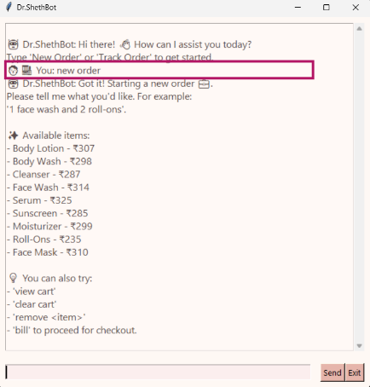

* Product selection flow

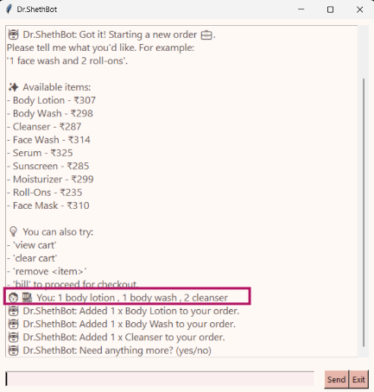

* Cart summary

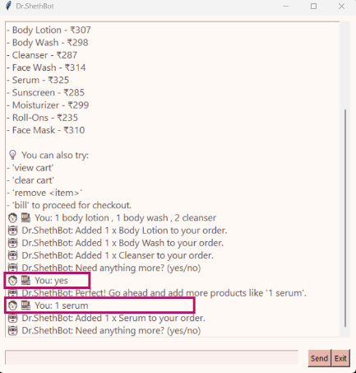

**🧾 Final Output Screenshot**

📌 *Insert a screenshot of the chatbot generating the final bill and Order ID*

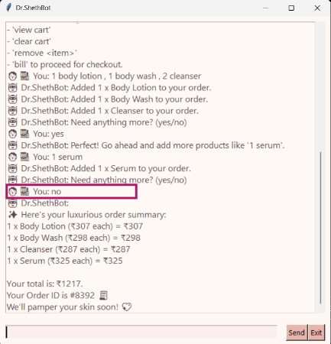

**📎 Notes:**

* This chatbot is specifically customized for selected products of **Dr.Sheth** brand.
* Made as part of a practical assignment submission.