Case Study 3: Fraud Detection in Online Banking
Dataset Source: Kaggle – Credit Card Fraud Detection Dataset
- Background
A bank is experiencing an increase in fraudulent online transactions. Fraud transactions lead to financial losses, reduced customer trust, and legal risks.
The bank collects transaction data including:
- Transaction Amount
- Time of Transaction
- Device / Transaction behaviour
- Customer Spending History
- Merchant Type (conceptual in real banking systems)
Using this data, the goal is to detect fraudulent transactions using machine learning techniques.
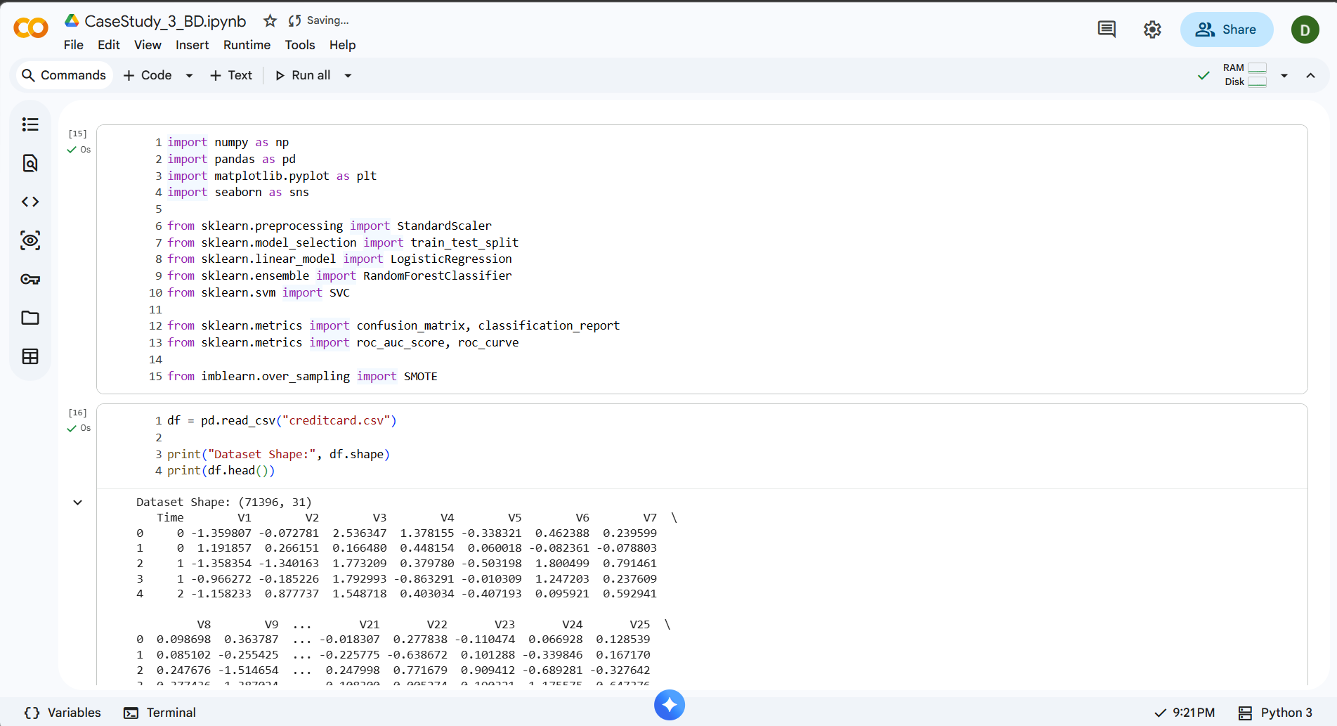
- Problem Statement
Fraud detection is defined as a binary classification problem:
- Class 0 → Legitimate Transaction
- Class 1 → Fraudulent Transaction
Goal:
- Detect maximum fraud cases
- Minimize false alarms
- Maintain high model accuracy
- Class Imbalance Issue
In real banking systems, fraud transactions are extremely rare.
From the dataset:
- Total transactions = 71396
- Fraud transactions = 31
- Fraud Percentage ≈ 0.25%
- Genuine transactions = 99.75%
This creates a high class imbalance problem.
Why is this dangerous?
If 99% transactions are genuine:
A model predicting everything as genuine will show:
99% Accuracy
0% Fraud Detection
Therefore, accuracy alone is misleading.
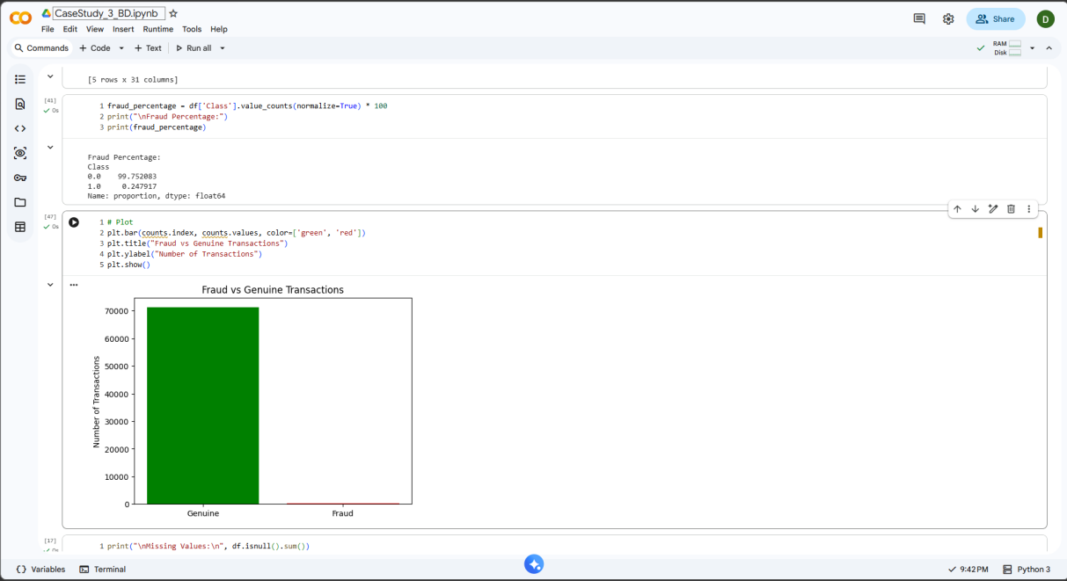
- Data Processing
- Handling Imbalanced Data (SMOTE)
We use SMOTE (Synthetic Minority Over-sampling Technique).
Concept:
- Generates synthetic fraud samples
- Balances minority class
- Applied only on training data
Why? To prevent model bias toward majority class.
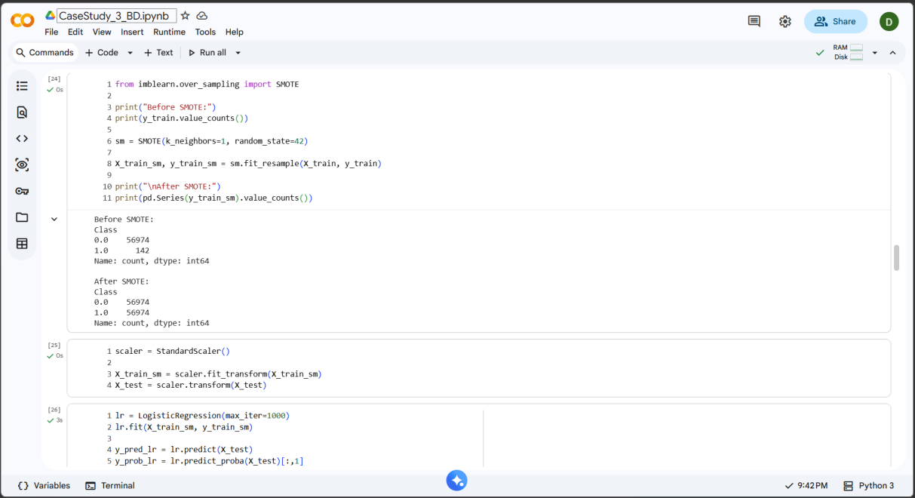
- Feature Engineering
Feature engineering improves fraud detection performance.
Since Kaggle dataset contains:
Time ,Amount ,PCA features (V1–V28) ,Class
Engineered features:
- Transaction Hour - Fraud often occurs at unusual hours
- Night Transaction Flag - 12 AM–6 AM flagged as suspicious
- Log Amount - Reduces skew in transaction amounts
- High Amount Flag - Transactions above 95th percentile marked high risk.

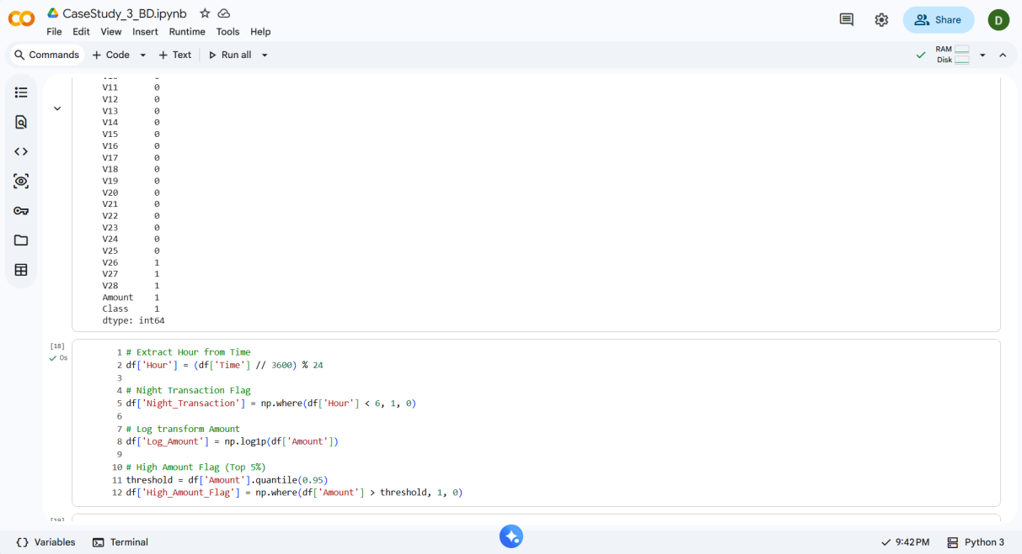
- Descriptive Analytics
Before modeling, fraud patterns were analyzed.
Fraud by Time of Day - Night transactions showed higher fraud probability.
Visualization: Bar Plot
Fraud by Transaction Amount - Fraud occurs in Very small test transactions or Very large suspicious transfers
Visualization: Boxplot
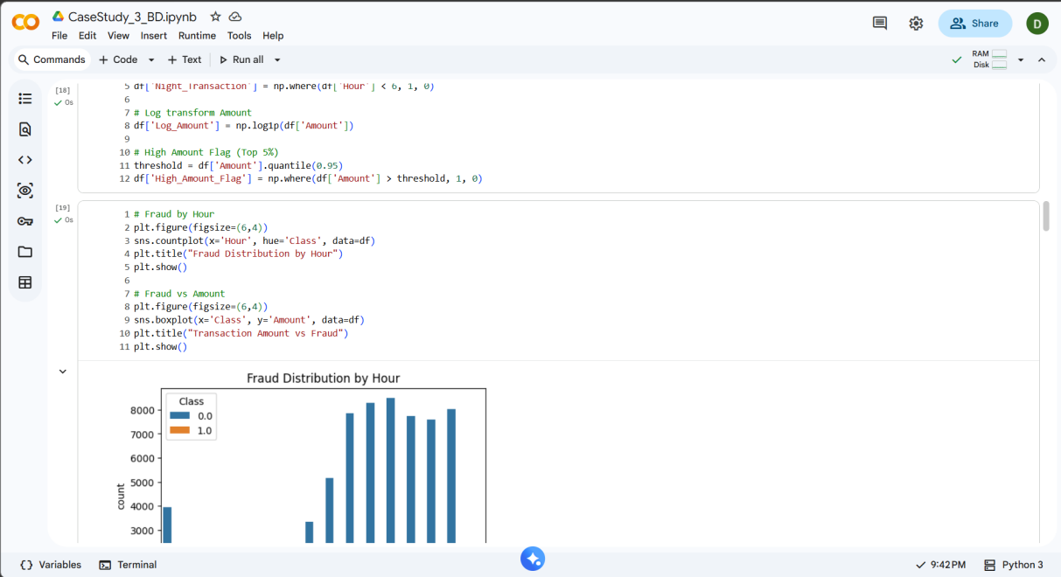

- Evaluation Metrics
- Confusion Matrix
Shows: True Positive (TP) ,False Positive (FP) ,False Negative (FN) ,True Negative (TN)
- Precision
Precision = TP / (TP + FP)
Out of predicted fraud, how many were actually fraud? Important to reduce false alarms.
- Recall (Most Important)
Recall = TP / (TP + FN)
Out of actual fraud, how many did we detect?
In fraud detection: False Negative is more dangerous than False Positive.
If fraud is predicted as genuine:
- Bank loses money
- Customer trust reduces
- Legal risks increase
Therefore: High Recall is prioritized.
- F1 Score
Balances precision and recall.
- Predictive Models Used
Three classification algorithms were applied:
- Logistic Regression
- Baseline model
- Works well with linear separation
- Fast and interpretable
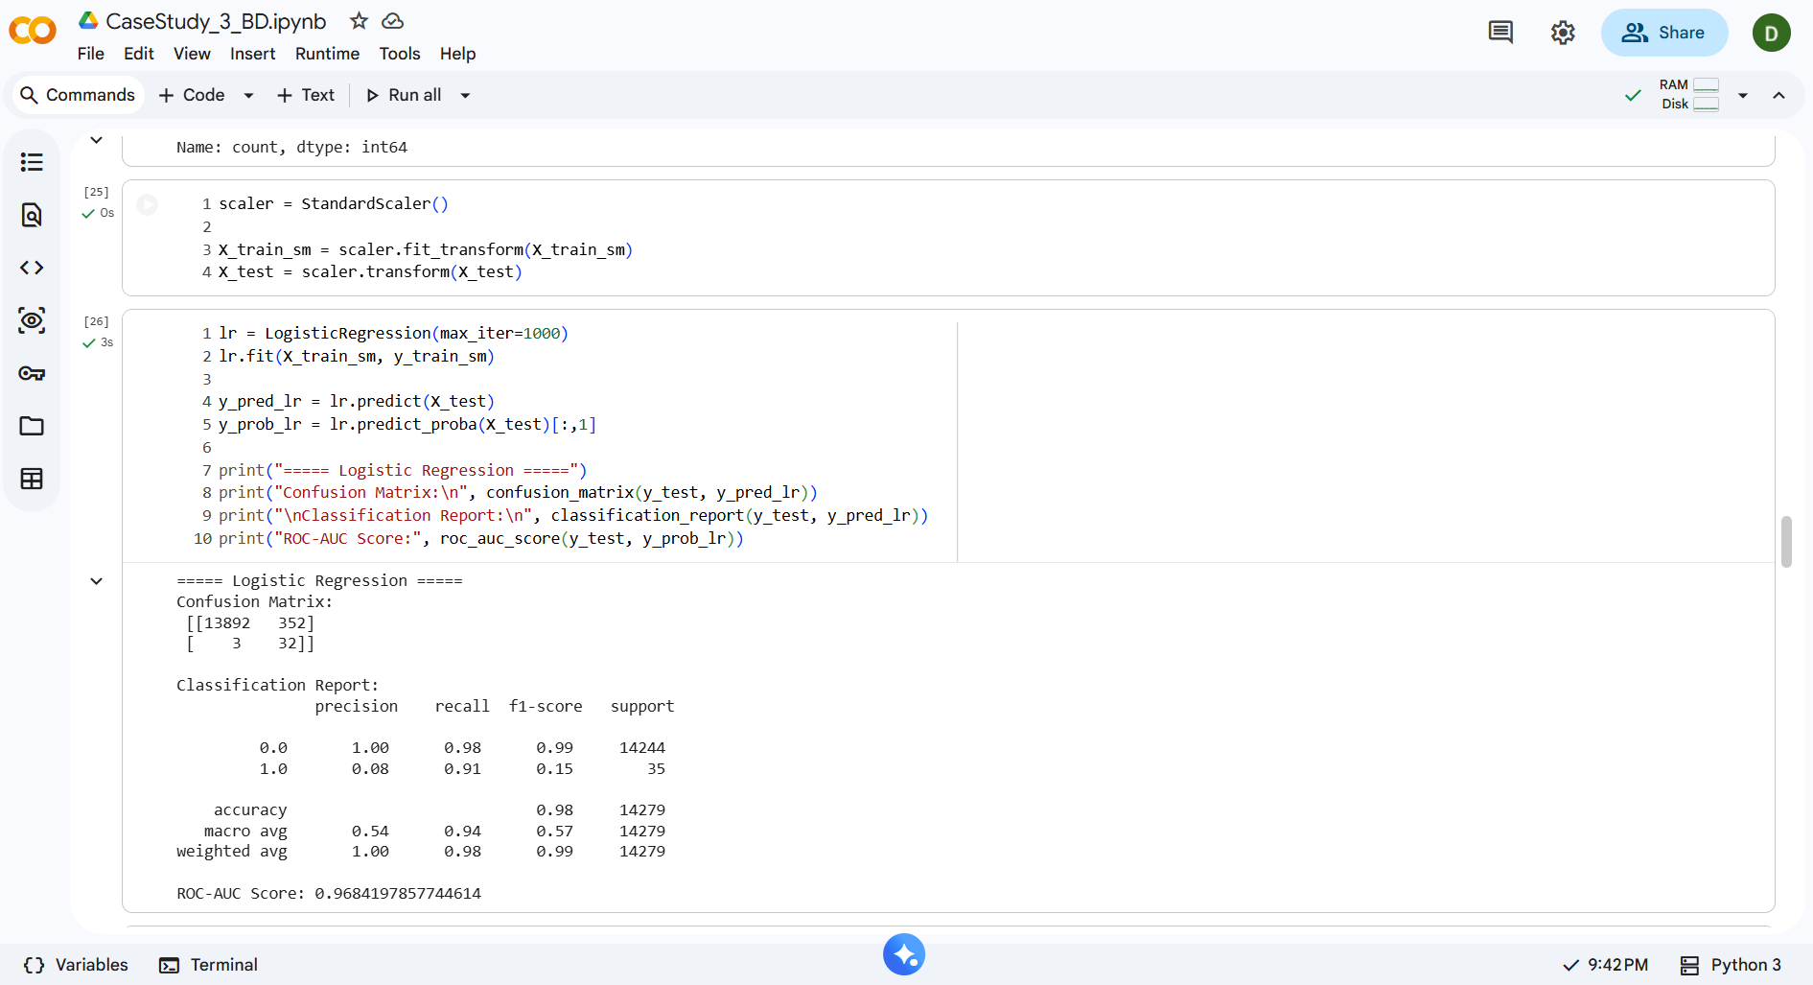
Logistic Regression Result Analysis:
- Confusion Matrix
 | Predicted Genuine | Predicted Fraud
Actual Genuine | 13892 | 352
Actual Fraud | 3 | 32

Metric | Value
Fraud Detected | 32 / 35
Missed Fraud | 3
Recall | 0.91
Precision | 0.08
Accuracy | 0.98
ROC-AUC | 0.968
Is This Model Good?
High recall – most fraud detected
Low precision – many false alarms due to rare fraud
Good overall for banking, prioritizes fraud detection

- Support Vector Machine (SVM)
- Works well in high-dimensional space
- Finds optimal separating hyperplane
- Handles complex fraud boundaries
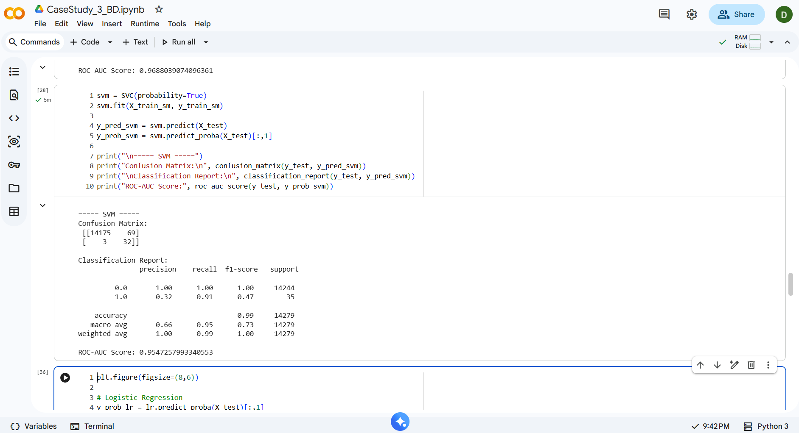

SVM Result Analysis:
- Confusion Matrix
 | Predicted Genuine | Predicted Fraud
Actual Genuine | 14175 | 69
Actual Fraud | 3 | 32

Metric | Value
Fraud Detected | 32 / 35
Missed Fraud | 3
Recall | 0.91
Precision | 0.32
Accuracy | 0.99
ROC-AUC | 0.955

Is This Model Good?
High recall, moderate precision
Some false alarms, less balanced than Random Forest

- Random Forest (Best Performer)
- Ensemble of decision trees
- Handles non-linearity
- Reduces overfitting
- Automatically detects feature importance
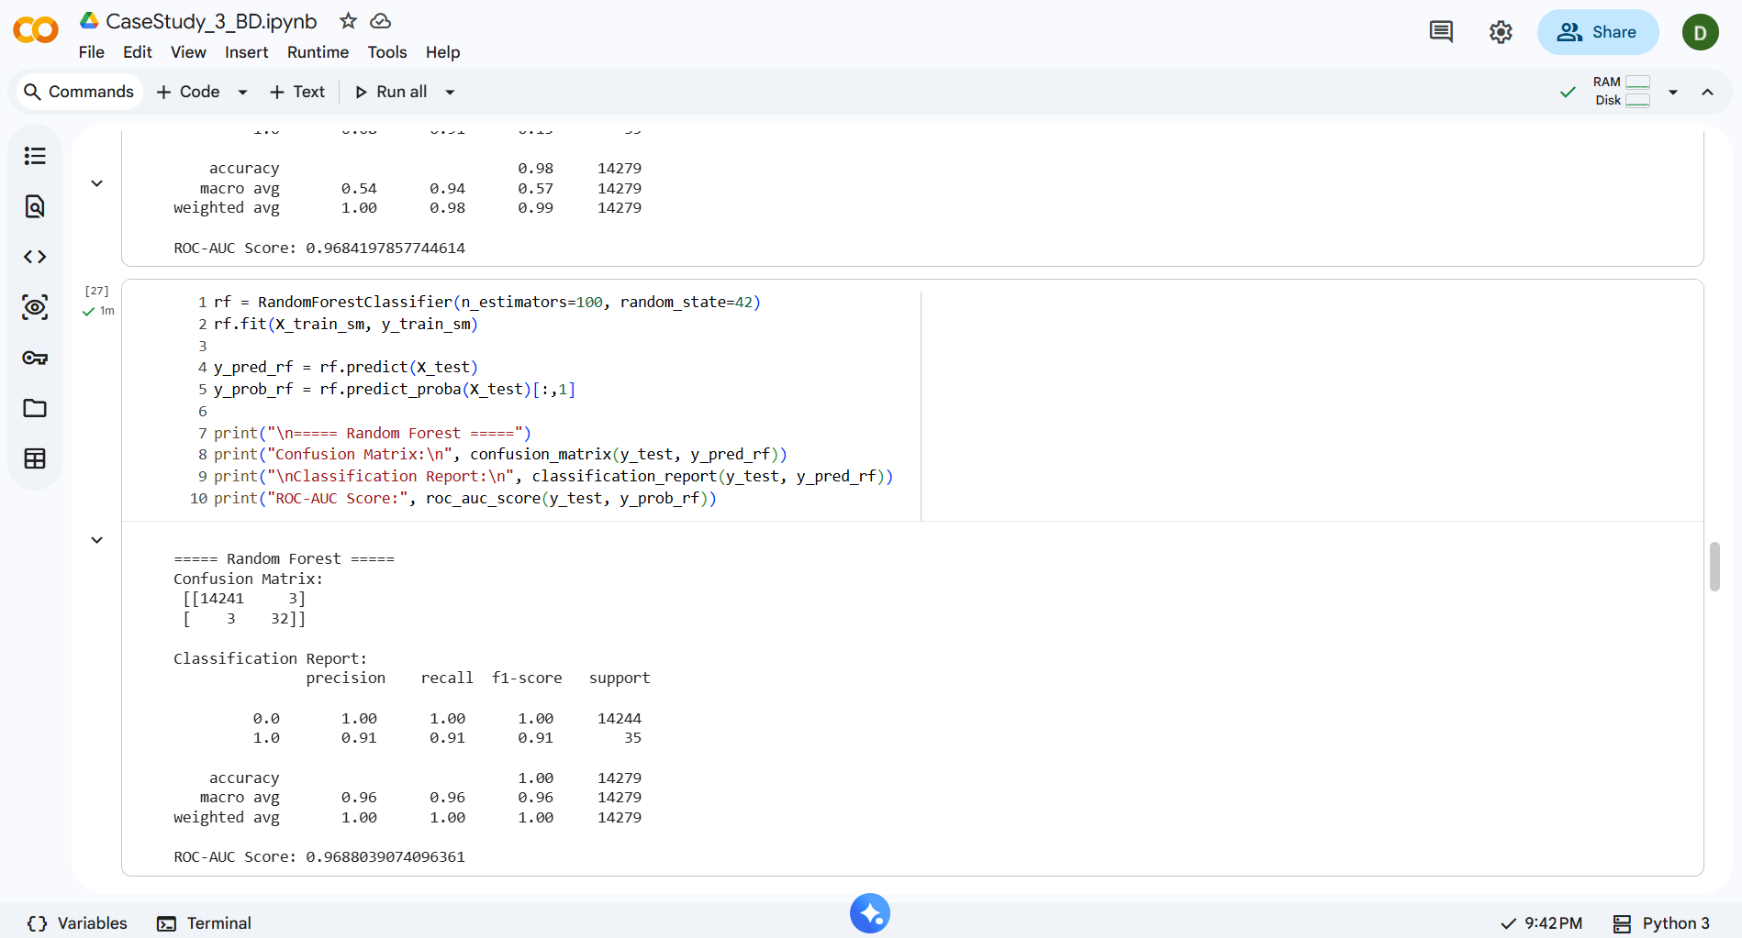

Random Forest Result Analysis (Best Performer):
- Confusion Matrix
 | Predicted Genuine | Predicted Fraud
Actual Genuine | 14241 | 3
Actual Fraud | 3 | 32

Metric | Value
Fraud Detected | 32 / 35
Missed Fraud | 3
Recall | 0.91
Precision | 0.91
Accuracy | 1.0
ROC-AUC | 0.9688

Is This Model Good?
High recall & precision
Minimal false alarms
Best balance, ideal for fraud detection

Model | Precision | Recall | F1-Score | Accuracy | ROC-AUC | Comments
Logistic Regression | 0.08 | 0.91 | 0.15 | 0.98 | 0.968 | High recall, low precision
SVM | 0.32 | 0.91 | 0.47 | 0.99 | 0.955 | Moderate precision, more false alarms
Random Forest | 0.91 | 0.91 | 0.91 | 1.00 | 0.969 | Best balance, ideal for fraud detection

- Why Ensemble Models Perform Better
Fraud patterns are:
Complex, Dynamic, Non-linear, Rare
Ensemble models like Random Forest:
- Combine multiple trees
- Reduce variance
- Capture complex patterns
- Generalize better
- More robust to noise
Therefore, Random Forest usually performs best.
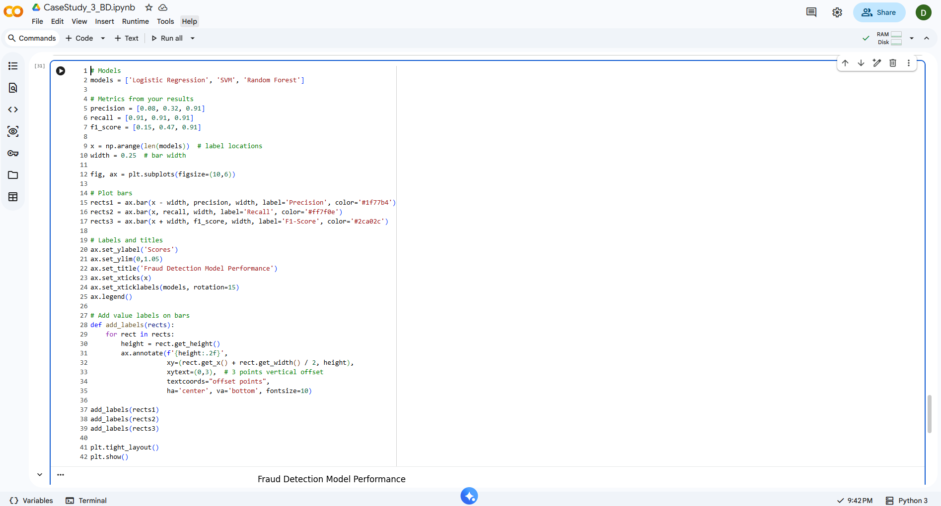
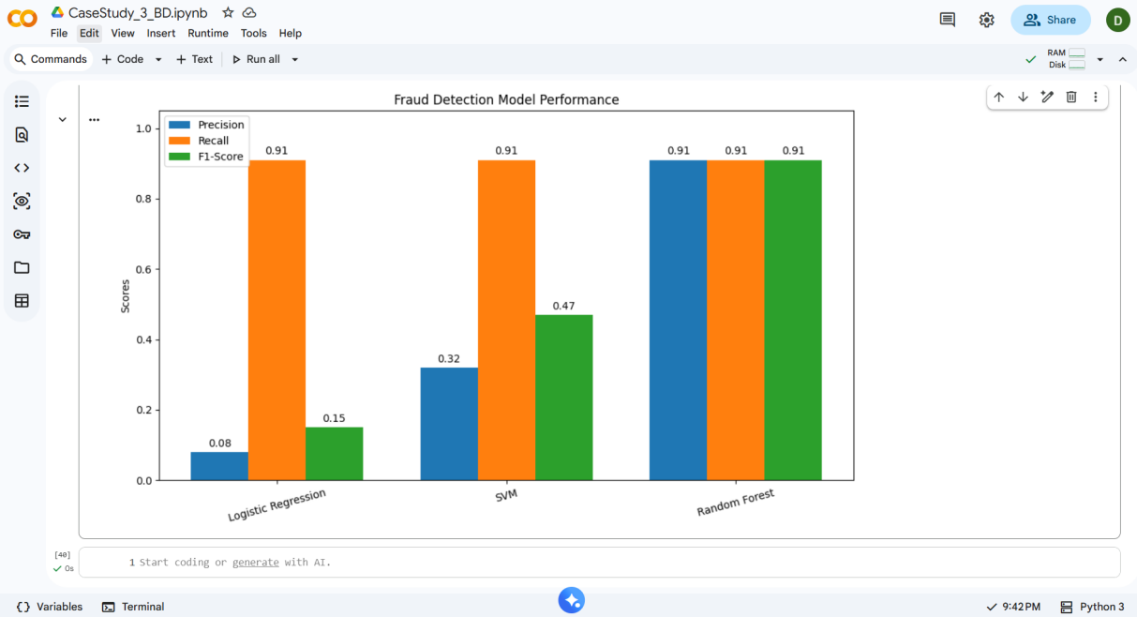
- ROC Curve & AUC
- Plots True Positive Rate vs False Positive Rate
- AUC close to 1 → strong model
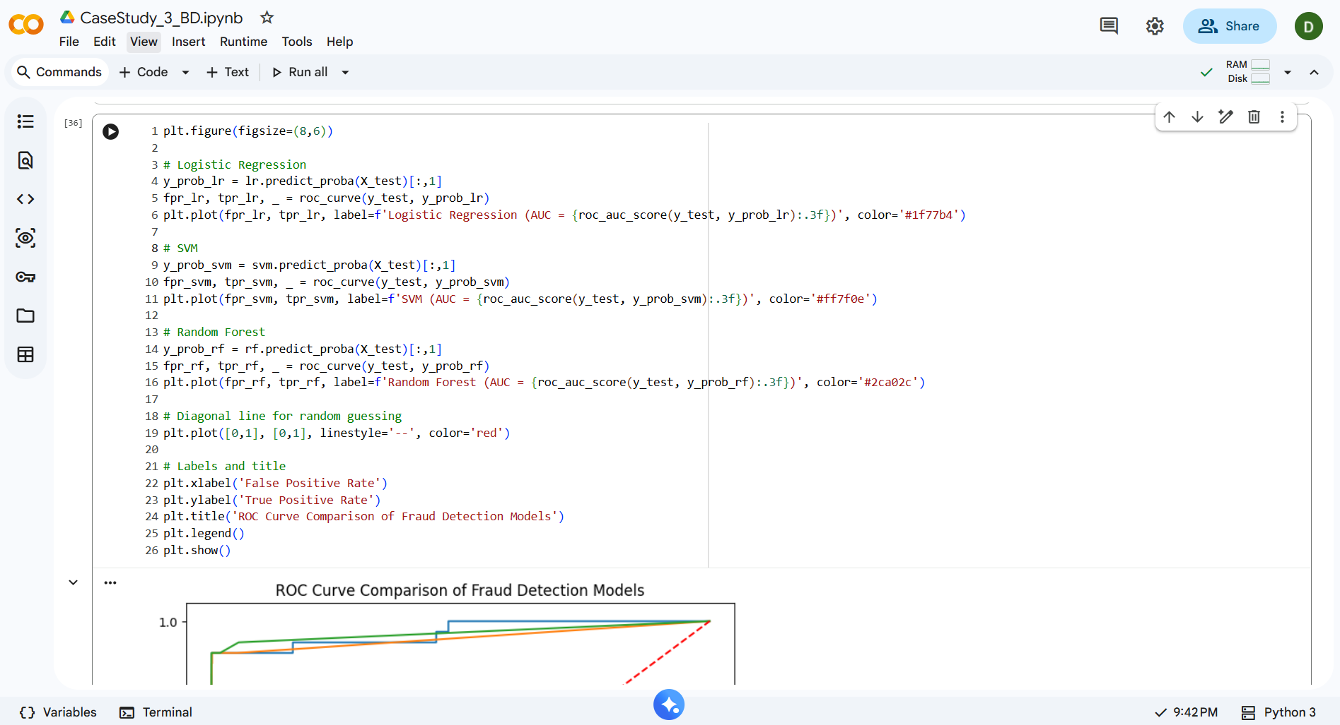
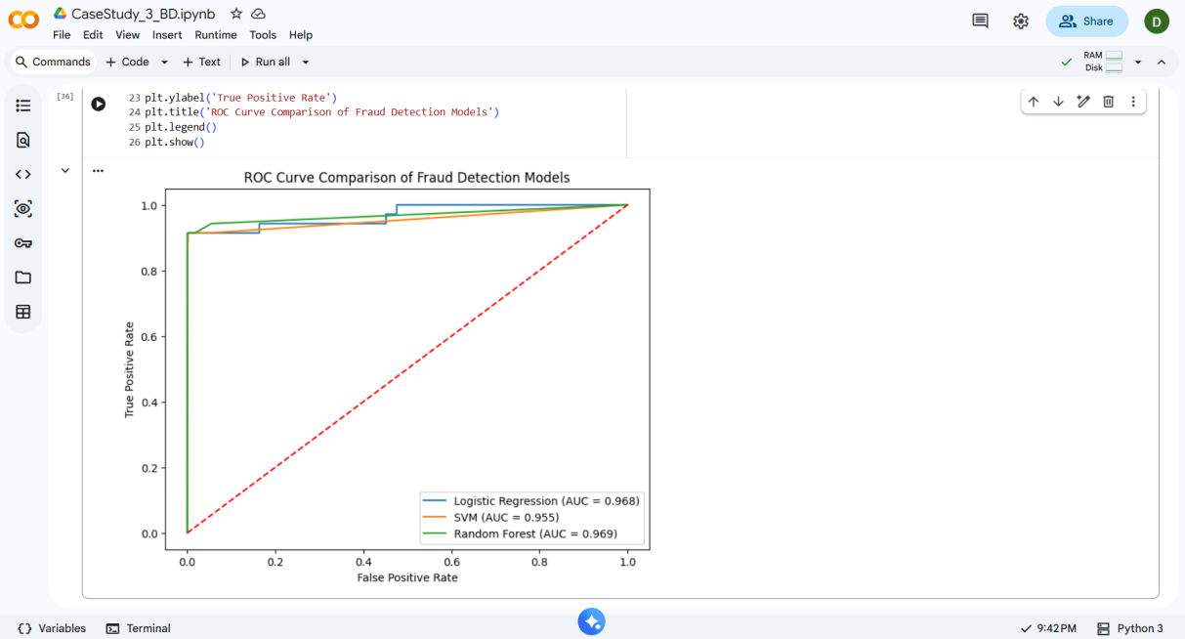

- Question:

Why is recall more important than accuracy in fraud detection?
- Fraud is rare (~0.25%), so high accuracy can be misleading.
- Recall tells us: “Out of all real frauds, how many did we catch?”
- Missing a fraud (False Negative) = Bank loses money, customer trust drops, legal risks rise.
- False alarms (False Positive) = Minor inconvenience, usually acceptable.
- In fraud detection, catching fraud matters more than overall accuracy.

