**QUESTION:1**

1. **A screenshot of a computer

   Description automatically generated**
2. A screenshot of a computer

   Description automatically generated
3. A screenshot of a computer

   Description automatically generated
4. 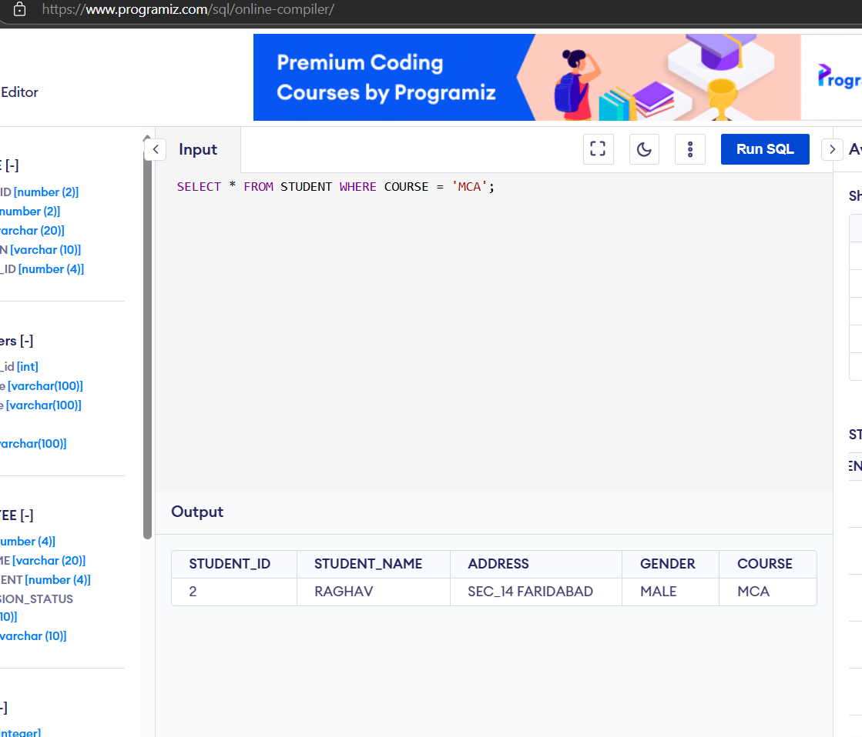
5. A screenshot of a computer program

   Description automatically generated

