**CS 514**

**Quiz 4 – Network Flow, Linear Programming, and NP Completeness**

**Q2. Solve the following linear program using SIMPLEX:**

**Maximize 120x + 100y**

**Subject to - 2x + 2y + u = 8**

**5x +3y + v = 15**

**x >=0, y>=o, u>=0 and v>=0**

Answer**-**

**Step 1.** Introduce slack variables s1 and s2 in the standard form and write everything on the RHS side.

Optimization function - z – 120x – 100y + 0u + 0v + 0s1 + 0s2 = 0

Constraints – 2x + 2y + u + 0v + s1 + 0s2 = 8

5x + 3y + 0u + v + 0s1 + s2 = 15

**Step 2.** Creating the initial tableau –

**Step 3.** Considering the most negative value in the row of z, that will be our key column – Here, 120 is the most negative value.

**Step 4.** We calculate the ratio column by dividing a row’s RHS entry with the value in the key column.

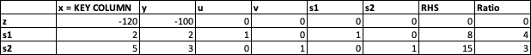

**Step 5.** The least positive ratio row will be considered as our key row – Here, 3 is the least positive ratio



**Step 6.** The intersection of the key column and the key row will be our key value – Here, it is 5.

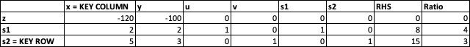

**Step 7.** We make the key value entry as 1 by doing row operation –

**R3 = R3/5.**

This changes the values of elements in the key row leading to the below table.

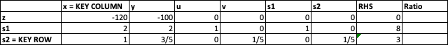

**Step 8.** We make the values of elements (other than key row) in key column equal to zero. To do this, we perform row operations

**R2 = R2 – 2R3**

**R1 = R1 + 120R3**

This leads us to a new table. In this table, the slack variable which is in the key row (here, s2) leaves and the basic variable in the key column (here, x) enters key row.

**Step 9.** Now, iteration 1 is over and iteration 2 starts. Here the most negative value in the row of basic variable z is -28, so that will be our key column.



**Step 10.** We calculate the ratios and the one with least positive ratio(Here, 5/2) will be our key row.



**Step 11.** We make the key value(here, 4/5) as 1 by performing the row operation

**R2 = (5/4)*R2.**



**Step 12.** We make the corresponding entries in the key column as 0, considering the key value. We do this by performing the below row operations –

**R3 = R3 – (3/5)R2**

**R1 = R1 + 28R2.**

This leads us to yet another new table. In this table, the slack variable which is in the key row (here, s1) leaves and the basic variable in the key column (here, y) enters key row.

As we have all positives and zeroes in the z row, we have got our final values. The optimal values of each basic variable will be in the RHS row

**So the optimal values are - Z = 430**

**X = 5/2**

**Y = 3/2**

**U = 0**

**V = 0**