**Industrial Internship Report on**

**”Project 5: Crop and Weed Detection”**

**Prepared by**

**Disha Panigrahy**

|  |
| --- |
| *Executive Summary* |
| This report provides details of the Industrial Internship provided by upskill Campus and The IoT Academy in collaboration with Industrial Partner UniConverge Technologies Pvt Ltd (UCT).  This internship was focused on a project/problem statement provided by UCT. We had to finish the project including the report in 6 weeks’ time.  My project was Project 5: Crop and Weed Detection. The dataset contained 1300 images of sesame crops and different types of weeds with each image labels. Each image was a 512 X 512 color image. Labels for images were in YOLO format. By using RCNN we can identify and differentiate the crops from the weeds.  This internship gave me a very good opportunity to get exposure to Industrial problems and design/implement solution for that. It was an overall great experience to have this internship. |

**TABLE OF CONTENTS**

1 Preface 3

2 Introduction 4

2.1 About UniConverge Technologies Pvt Ltd 4

2.2 About upskill Campus 8

2.3 Objective 9

3 Problem Statement 11

4 Existing and Proposed solution 12

5 Performance Test 17

5.1 Performance Outcome 17

6 My learnings 19

# Preface

In this, 6 weeks internship we had to perform certain tasks for each week. The first week was to learn more about UniConverge Technologies and explore all the given problem statements and choose one of them. In the next week we had to study the required material and start working on the solution of the problem we had chosen; for DSML interns we had to find the different algorithms that could be used . In the third week we had to start implementing our solution and continue implementation in the fourth week. In the fifth week we had to check the performance and see if we can improve it.

During these 6 weeks, we were given access to various study materials like soft copies of books on important topics and blogposts by The IOT Academy and we had to take a quiz every two weeks to test our understanding.

In this overcompetitive world we need to make sure that we have relevant industry experience for the development of our careers and this internship provided the opportunity to achieve exactly that.

Brief about Your project/problem statement. The dataset contained 1300 images of sesame crops and different types of weeds with each image labels. Each image was a 512 X 512 color image. Labels for images were in YOLO format. By using RCNN we can identify and differentiate the crops from the weeds.

Opportunity given by USC/UCT.

How Program was planned

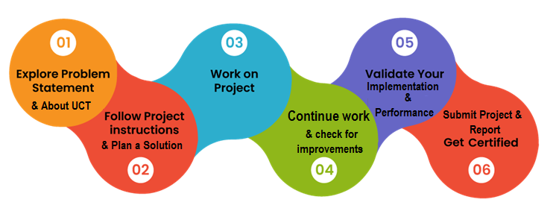

Your Learnings and overall experience.

Thank to all (with names), who have helped you directly or indirectly.

Your message to your juniors and peers.

# Introduction

## About UniConverge Technologies Pvt Ltd

A company established in 2013 and working in Digital Transformation domain and providing Industrial solutions with prime focus on sustainability and RoI.

For developing its products and solutions it is leveraging various**Cutting Edge Technologies e.g. Internet of Things (IoT), Cyber Security, Cloud computing (AWS, Azure), Machine Learning, Communication Technologies (4G/5G/LoRaWAN), Java Full Stack, Python, Front end**etc.



1. UCT IoT Platform **(****)**

**UCT Insight** is an IOT platform designed for quick deployment of IOT applications on the same time providing valuable “insight” for your process/business. It has been built in Java for backend and ReactJS for Front end. It has support for MySQL and various NoSql Databases.

* It enables device connectivity via industry standard IoT protocols - MQTT, CoAP, HTTP, Modbus TCP, OPC UA
* It supports both cloud and on-premises deployments.

It has features to  
• Build Your own dashboard  
• Analytics and Reporting  
• Alert and Notification  
• Integration with third party application(Power BI, SAP, ERP)  
• Rule Engine

 

1. **Smart Factory Platform (****)**

Factory watch is a platform for smart factory needs.

It provides Users/ Factory

* with a scalable solution for their Production and asset monitoring
* OEE and predictive maintenance solution scaling up to digital twin for your assets.
* to unleased the true potential of the data that their machines are generating and helps to identify the KPIs and also improve them.
* A modular architecture that allows users to choose the service that they what to start and then can scale to more complex solutions as per their demands.

Its unique SaaS model helps users to save time, cost and money.

 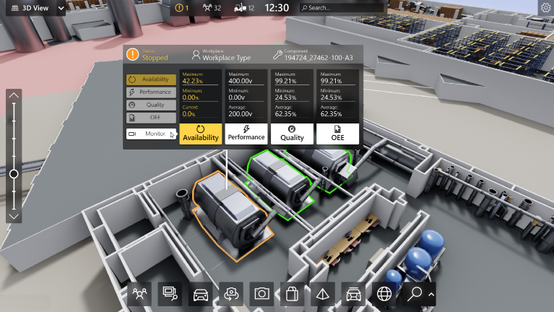

1.  based Solution

UCT is one of the early adopters of LoRAWAN teschnology and providing solution in Agritech, Smart cities, Industrial Monitoring, Smart Street Light, Smart Water/ Gas/ Electricity metering solutions etc.

1. Predictive Maintenance

UCT is providing Industrial Machine health monitoring and Predictive maintenance solution leveraging Embedded system, Industrial IoT and Machine Learning Technologies by finding Remaining useful life time of various Machines used in production process.



## About upskill Campus (USC)

upskill Campus along with The IoT Academy and in association with Uniconverge technologies has facilitated the smooth execution of the complete internship process.

USC is a career development platform that delivers **personalized executive coaching** in a more affordable, scalable and measurable way.



Seeing need of upskilling in self paced manner along-with additional support services e.g. Internship, projects, interaction with Industry experts, Career growth Services

<https://www.upskillcampus.com/>

upSkill Campus aiming to upskill 1 million learners in next 5 year

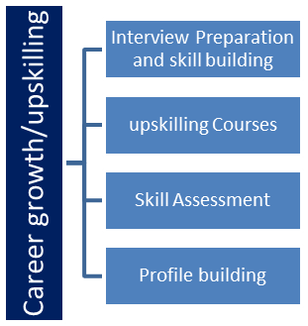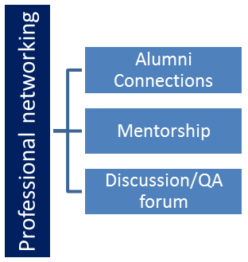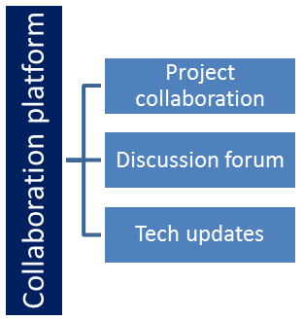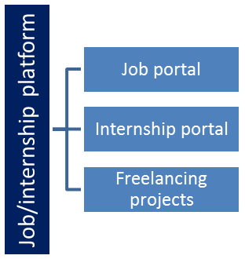

## The IoT Academy

The IoT academy is EdTech Division of UCT that is running long executive certification programs in collaboration with EICT Academy, IITK, IITR and IITG in multiple domains.

## Objectives of this Internship program

The objective for this internship program was to

 ☛ get practical experience of working in the industry.

 ☛ to solve real world problems.

 ☛ to have improved job prospects.

 ☛ to have Improved understanding of our field and its applications.

 ☛ to have Personal growth like better communication and problem solving.

# Problem Statement

In the assigned problem statement,

Weed is an unwanted thing in agriculture. Weed use the nutrients, water, land and many more things that might have gone to crops. This results in less production of the required crop. The farmer often uses pesticides to remove weed which is also effective but some pesticides may stick with crop and may causes problems for humans.

We aim to develop a system that only sprays pesticides on weed and not on the crop which will reduce the mixing problem with crops and also reduce the waste of pesticides.

The dataset contained 1300 images of sesame crops and different types of weeds with each image labels. Each image was a 512 X 512 color image. Labels for images were in YOLO format.

# Existing and Proposed solution

RCNN is Regions with CNN features. (CNN – Convolutional Neural Network) To bypass the problem of selecting a huge number of regions, Ross Girshick et al. proposed a method where we use selective search to extract just 2000 regions from the image and he called them region proposals. Therefore, now, instead of trying to classify a huge number of regions, you can just work with 2000 regions. These 2000 region proposals are generated using the selective search algorithm which is written below.

Selective Search:

1. Generate initial sub-segmentation, we generate many candidate regions

2. Use greedy algorithm to recursively combine similar regions into larger ones

3. Use the generated regions to produce the final candidate region proposals

These 2000 candidate region proposals are warped into a square and fed into a convolutional neural network that produces a 4096-dimensional feature vector as output. The CNN acts as a feature extractor and the output dense layer consists of the features extracted from the image and the extracted features are fed into an SVM to classify the presence of the object within that candidate region proposal. In addition to predicting the presence of an object within the region proposals, the algorithm also predicts four values which are offset values to increase the precision of the bounding box. For example, given a region proposal, the algorithm would have predicted the presence of a person but the face of that person within that region proposal could’ve been cut in half. Therefore, the offset values help in adjusting the bounding box of the region proposal.

Problems with R-CNN are:

It still takes a huge amount of time to train the network as you would have to classify 2000 region proposals per image.

It cannot be implemented real time as it takes around 47 seconds for each test image.

The selective search algorithm is a fixed algorithm. Therefore, no learning is happening at that stage. This could lead to the generation of bad candidate region proposals.

## Code submission (Github link)

<https://github.com/DishaPanigrahy/Upskill_Project>

# Proposed Design/ Model

Given more details about design flow of your solution. This is applicable for all domains. DS/ML Students can cover it after they have their algorithm implementation. There is always a start, intermediate stages and then final outcome.

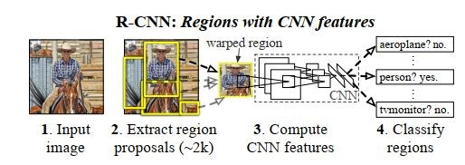

Author Ross Girshick, Jeff Donahue, Trevor Darrell, and Jitendra Malik of the paper Rich feature hierarchies for accurate object detection and semantic segmentation proposed this solution.

## Module design

**Region proposals.​** A variety of recent papers offer methods for generating category independent region proposals.

**Feature extraction.​** Authors extract a 4096-dimensional feature vector from each region proposal using the Caffe implementation of the CNN. Features are computed by forward propagating a mean-subtracted 227 × 227 RGB image through five convolutional layers and two fully connected layers. Regardless of the size or aspect ratio of the candidate region, authors warp all pixels in a tight bounding box around it to the required size. Prior to warping, they dilate the light bounding box so that at the warped size there are exactly p pixels of warped image context around the original box (p = 16). Figure​ ​shows a random sampling of warped training regions.

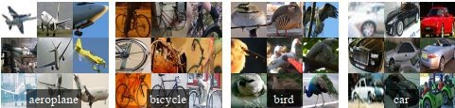

## Test-time detection

At test time, authors run selective search on the test image to extract around 2000 region proposals. they warp each proposal and forward propagate it through CNN in order to compute features. Then, for each class, score each extracted feature vector using the SVM trained for that class. Given all scored regions in an image, apply a greedy non-maximum suppression that rejects a region if it has an intersection-over union (IoU) overlap with a higher scoring selected region larger than a learned threshold.

**Run-time analysis.​** Two properties make detection efficient.

1. First, all CNN parameters are shared across all categories.
2. Second, the feature vectors computed by the CNN are low-dimensional when compared to other common approaches. **Advantage.**
3. The result of such sharing is that the time spent computing region proposals and features is amortized over all classes. The only class-specific computations are dot products between features and SVM weights and non-maximum suppression.
4. This analysis shows that R-CNN can scale to thousands of object classes without resorting to approximate techniques, such as hashing. Even if there were 100k classes, the resulting matrix multiplication takes only 10 seconds on a modern multi-core CPU. Training

**Supervised pre-training.​** Authors discriminatively pre-trained the CNN on a large auxiliary dataset (ILSVRC2012 classification) using image-level annotations only. Pre-training was performed using the open source Caffe CNN library. This discrepancy is due to simplifications in the training process.

**Domain-specific fine-tuning.​** Authors continue stochastic gradient descent (SGD) training of the CNN parameters using only warped region proposals. Aside from replacing the CNN’s ImageNetspecific 1000-way classification layer with a randomly initialized (N + 1)-way classification layer (where N is the number of object classes, plus 1 for background), the CNN architecture is unchanged. For VOC, N = 20 and for ILSVRC2013, N = 200. We treat all region proposals with ≥ 0:5 IoU overlap with a ground-truth box as positives for that box’s class and the rest as negatives. We start SGD at a learning rate of 0.001, which allows fine-tuning to make progress while not clobbering the initialization. In each SGD iteration, we uniformly sample 32 positive windows and 96 background windows to construct a mini-batch of size 128.

**Object category classifiers.​** Consider training a binary classifier to detect cars. It’s clear that an image region tightly enclosing a car should be a positive example. Similarly, it’s clear that a background region, which has nothing to do with cars, should be a negative example. **Less clear is how to label a region that partially overlaps a car​**. Authors resolve this issue with an IoU overlap threshold, below which regions are defined as negatives. The overlap threshold, 0.3, was selected by a grid search over (0, 0.1, … ,0.5) on a validation set.

Since the training data is too large to fit in memory, they adopt the standard hard negative mining method. Hard negative mining converges quickly and in practice mAP stops increasing after only a single pass over all images.

# Performance Test

Testing was done by passing images from the testing dataset to the model.

## Performance Outcome

This is the summary of the trained model:

Model: "model"

_________________________________________________________________

Layer (type) Output Shape Param #

=================================================================

input_1 (InputLayer) [(None, 224, 224, 3)] 0

_________________________________________________________________

block1_conv1 (Conv2D) (None, 224, 224, 64) 1792

_________________________________________________________________

block1_conv2 (Conv2D) (None, 224, 224, 64) 36928

_________________________________________________________________

block1_pool (MaxPooling2D) (None, 112, 112, 64) 0

_________________________________________________________________

block2_conv1 (Conv2D) (None, 112, 112, 128) 73856

_________________________________________________________________

block2_conv2 (Conv2D) (None, 112, 112, 128) 147584

_________________________________________________________________

block2_pool (MaxPooling2D) (None, 56, 56, 128) 0

_________________________________________________________________

block3_conv1 (Conv2D) (None, 56, 56, 256) 295168

_________________________________________________________________

block3_conv2 (Conv2D) (None, 56, 56, 256) 590080

_________________________________________________________________

block3_conv3 (Conv2D) (None, 56, 56, 256) 590080

_________________________________________________________________

block3_pool (MaxPooling2D) (None, 28, 28, 256) 0

_________________________________________________________________

block4_conv1 (Conv2D) (None, 28, 28, 512) 1180160

_________________________________________________________________

block4_conv2 (Conv2D) (None, 28, 28, 512) 2359808

_________________________________________________________________

block4_conv3 (Conv2D) (None, 28, 28, 512) 2359808

_________________________________________________________________

block4_pool (MaxPooling2D) (None, 14, 14, 512) 0

_________________________________________________________________

block5_conv1 (Conv2D) (None, 14, 14, 512) 2359808

_________________________________________________________________

block5_conv2 (Conv2D) (None, 14, 14, 512) 2359808

_________________________________________________________________

block5_conv3 (Conv2D) (None, 14, 14, 512) 2359808

_________________________________________________________________

block5_pool (MaxPooling2D) (None, 7, 7, 512) 0

_________________________________________________________________

flatten (Flatten) (None, 25088) 0

_________________________________________________________________

dense (Dense) (None, 4096) 102764544

_________________________________________________________________

dropout (Dropout) (None, 4096) 0

_________________________________________________________________

dense_1 (Dense) (None, 4096) 16781312

_________________________________________________________________

dropout_1 (Dropout) (None, 4096) 0

_________________________________________________________________

dense_2 (Dense) (None, 3) 12291

=================================================================

Total params: 134,272,835

Trainable params: 119,558,147

Non-trainable params: 14,714,688

This is the performance outcome of the model trained:

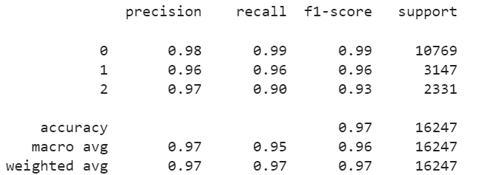

# My learnings

You should provide summary of your overall learning and how it would help you in your career growth. In this internship I learned the importance and the procedure to make weekly and project reports. The dataset of my choosing was based on images and their classification. I learned how to load data onto Colaboratory (Coding platform by Google), then preprocess the images to make the bounding boxes, then divide these images into training, testing and validation datasets, then apply CNN on the training dataset to make a model and validating it. We can use this model for detection of crops and weeds.