Bug Report

**Bug id: 01**

**Issue description**

Application crashes when trying to delete an already deleted entry or non-existing entry

**Environment Setup:**

Use Postman or any related tool to visualize the API calls with ease

**Steps to reproduce the issue**

1. Use the delete API
2. For the url , for the car_id use an already deleted entry or non-existing entry and observe the result

**What's the expected result?**

Appropriate error message should be seen

**What's the actual result?**

There is an application crashed error message

**Additional details / screenshot**

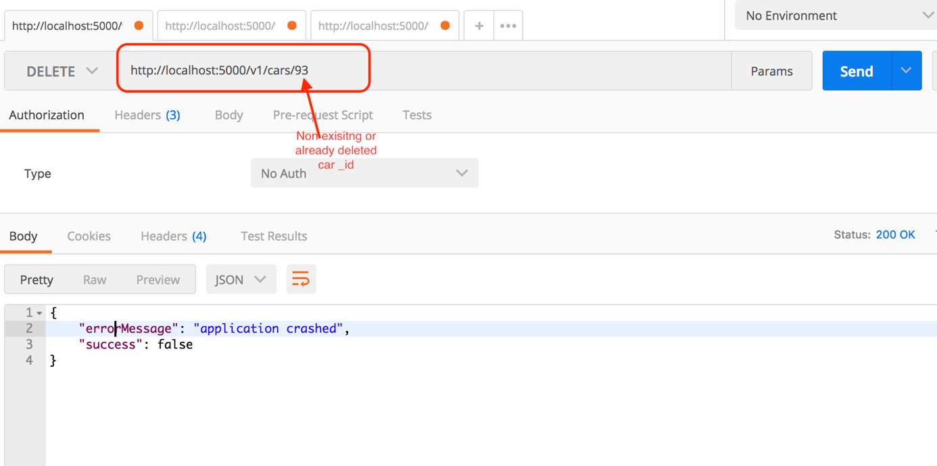

**Bug id: 02**

**Issue description**

Incorrect or missing specification

**Environment Setup:**

Use Postman or any related tool to visualize the API calls with ease

**Steps to reproduce the issue**

1. Open the Rent-A-Car Assignment specification document
2. Look at the specification document for delete a car API

**What's the expected result?**

The API call information should be accurate

**What's the actual result?**

The API call information has missing data for example the car_id is not specified

**Additional details / screenshot**



**Bug id: 03**

**Issue description**

No upper limit specified for Model and brand parameters

**Environment Setup:**

Use Postman or any related tool to visualize the API calls with ease

**Steps to reproduce the issue**

1. Use the add a car to the list API
2. For the parameters, brand specify the following value “whatisthelongestbrandnamethathisfieldcanactuallytakeissomethngthaIamtestingherebecauseIdonthaveanyspecificationforthat”
   1. For the other parameters use a correct value

**What's the expected result?**

Appropriate error message should be shown asking the user to enter an appropriate model name. It would help to specify

**What's the actual result?**

A new car gets added using this model name.

Same behavior is observed for brand parameter too

**Additional details / screenshot**

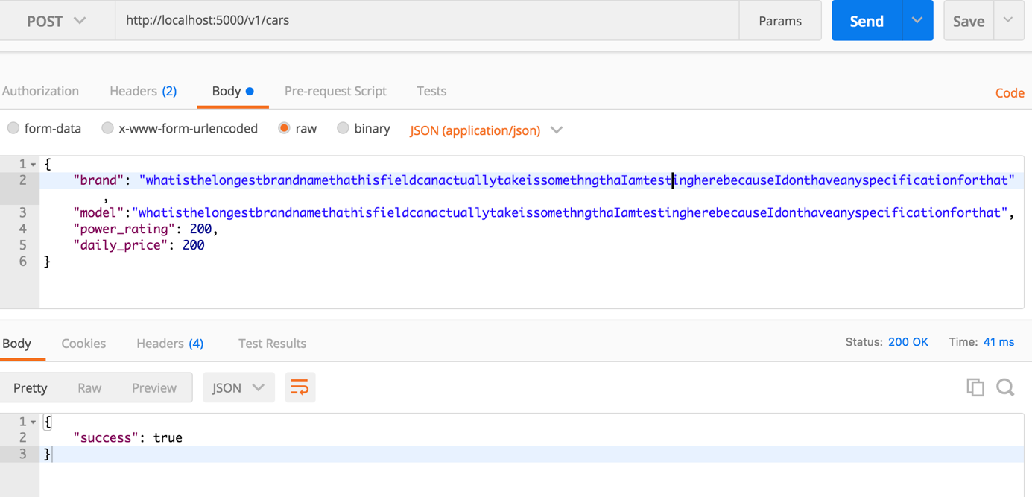

**Bug id: 04**

**Issue description**

Internal Server Error for daily_price =0

**Environment Setup:**

Use Postman or any related tool to visualize the API calls with ease

**Steps to reproduce the issue**

1. Use the add a car to the list API
2. For the parameters
   1. daily_price specify the following value 0
   2. power_rating = 200
   3. model = “model”
   4. Brand = “brand”

**What's the expected result?**

Appropriate error message should be shown asking the user to enter values between >= 0 and <= 500

**What's the actual result?**

500 Internal Server Error

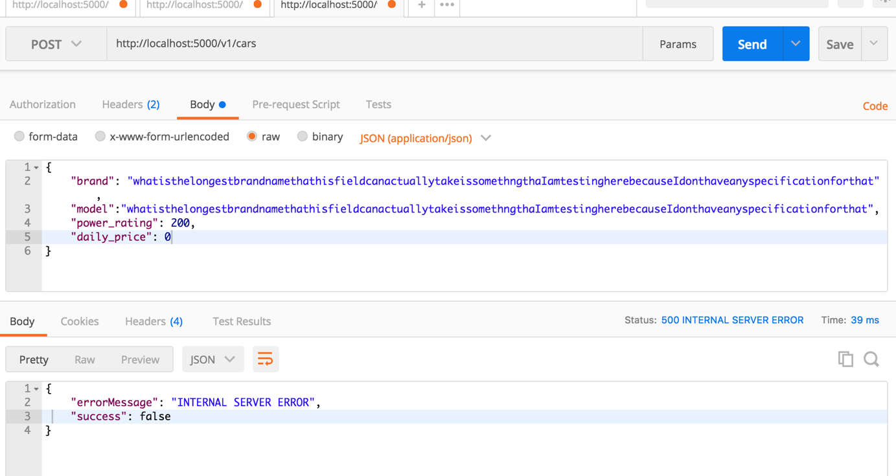

**Bug id: 05**

**Issue description**

Internal Server Error when daily_price and power_rating both have the same value and the value could be equal to or greater than 1000

**Environment Setup:**

Use Postman or any related tool to visualize the API calls with ease

**Steps to reproduce the issue**

1. Use the add a car to the list API
2. For the parameters,
   1. daily_price specify the following value 1000
   2. daily_power_rating specify the following value 1000
   3. For model specify: “model”
   4. brand = “brand”

**What's the expected result?**

Appropriate error message should be shown asking the user to enter values between >= 0 and <= 500

**What's the actual result?**

500 Internal Server Error

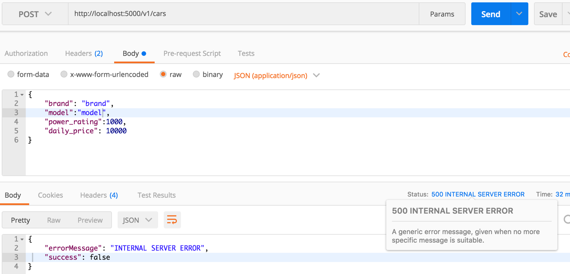

**Bug id: 06**

**Issue description**

Deletion of all the cars not possible. One always remains

**Environment Setup:**

Use Postman or any related tool to visualize the API calls with ease

**Steps to reproduce the issue**

1. Use the delete API
2. Try to delete all the entries one by one

**What's the expected result?**

Depending upon the system implementation: If we always want one entry to remain, we should specify an appropriate error message or if we allow all the entries to get deleted than all should get deleted

**What's the actual result?**

Even though the deletion is a success, the entry still remains

**Bug id: 07**

**Issue description**

Retreive Car API returns only 8 entries of the car even if there are more than 8 entries

**Environment Setup:**

Use Postman or any related tool to visualize the API calls with ease

**Steps to reproduce the issue**

1. Use the retrieve cars API
2. Observe the list of cars

**What's the expected result?**

All the cars present should be retreived

**What's the actual result?**

Only 8 cars are retrieved by the API. Only after you delete the first 8, the next 8 are seen

**Bug id: 08**

**Issue description**

Fetch Token API responds Bad Input response with response code 200

**Environment Setup:**

Use Postman or any related tool to visualize the API calls with ease

**Steps to reproduce the issue**

1. Use the Fetch Token API with empty clientId or clientsecret
2. Observe the response code and response message

**What's the expected result?**

Response code 400 should be returned for any Bad Request

**What's the actual result?**

Response code 200 is returned which corresponds to request being successful which is not the case.