Department of Computer Science and Engineering
Subject: Introduction to DevSecOps code: CSE641
Lab1: worksheet Topic: CI with GitHub Actions - Lab Exercises

Lab Overview
These hands-on exercises will teach you Continuous Integration (CI) using GitHub Actions. Each lab builds on previous concepts, helping you understand how CI automates testing, building, and validating code changes.

Exercise 1: The "Hello World" of Automation
Goal: Create your first "Robot Assistant" that greets you when you push code.
- Create a new public repository on GitHub.
- In the root directory, create the folder path: .github/workflows/
- Create a file inside that folder named hello-ci.yml.
- Task: Paste the following code and commit it:
name: Greeting Workflow
on: [push]

jobs:
say-hello:
runs-on: ubuntu-latest
steps:
- name: Run a greeting
run: echo "The CI pipeline has successfully started!"

Verification: Go to the Actions tab on GitHub. Click on the workflow run to see the output.
Checkpoint 1
- Q1: What is the "Trigger" in this workflow? (What makes the script start?)
workflow tiggered by push (on: [push])

- Q2: Where is the computer located that actually runs the echo command?
Cloud server managed by github
- Q3: If you create a new file called test.txt and push it, will this Action run again? Why?
Yes.because the workflow is triggered by push event.

Exercise 2: Building and Testing (The Core of CI)
Goal: Make the CI "fail" when you write bad code.
- Create a file named calc.py:
Python
def add(a, b):
return a + b
- Create a test file named test_calc.py:
Python
from calc import add

def test_add():
assert add(2, 3) == 5
- Update your .github/workflows/hello-ci.yml to include these steps:
YAML
- uses: actions/checkout@v4
- name: Run Python Tests
run: python3 test_calc.py
- The Challenge: Change the test to assert add(2, 3) == 6 and push it.

Checkpoint 2
- Q1: When the test failed, what color icon appeared in GitHub?
A red cross
- Q2: Why do we need the actions/checkout@v4 step? What happens to the code if we delete that line?
It downloads the repository code onto github runner.
The runner has no access to the code files created and workflow may fail with file not found
- Q3: In a real job, why is it better for the CI to find this error than a customer?
Bugs can be found immediately after the push.If bugs found after release then it may be difficult and expensive to get it fixed

Exercise 3: The Secure Weather App
Goal: Build a production-ready pipeline with Security and Compatibility.
- Create app.js:
JavaScript

const apiKey = process.env.WEATHER_API_KEY;
if (!apiKey) {
console.error("CRITICAL ERROR: No API Key found!");
process.exit(1);
}
console.log("App is running securely.");
- Requirements for your new Workflow:
  - Run on Node.js versions 18 and 20 (Matrix).
  - Use a GitHub Secret named WEATHER_API_KEY.
  - Upload the final code as a Build Artifact named weather-app-dist.
name: Weather App Production Check
on:
push:
branches: [ main ]
pull_request:
branches: [ main ]
jobs:
build-and-test:
runs-on: ubuntu-latest
# --- THIS IS THE MATRIX SECTION ---
strategy:
matrix:
node-version: [18.x, 20.x]
# ----------------------------------
steps:
- name: Checkout Code
uses: actions/checkout@v4
- name: Use Node.js ${{ matrix.node-version }}
uses: actions/setup-node@v4
with:
node-version: ${{ matrix.node-version }}

- name: Install Dependencies
run: npm install # Even if the folder is empty, this is good practice

- name: Run Unit Tests
run: node test.js

- name: Run Security Check
run: node app.js
env:
# This connects the GitHub Secret to the code's environment variable
WEATHER_API_KEY: ${{ secrets.WEATHER_API_KEY }}

package:
# This ensures packaging ONLY happens if BOTH Node versions pass
needs: build-and-test
runs-on: ubuntu-latest
steps:
- uses: actions/checkout@v4

- name: Create Build Artifact
run: zip -r weather-app-dist.zip . -x "*.git*"

- name: Upload Artifact
uses: actions/upload-artifact@v4
with:
name: weather-app-dist
path: weather-app-dist.zip

Checkpoint 3
- Q1: Why did we use a "Secret" instead of just typing the API Key into the app.js file?
To prevent secret leaks since it has a public visibility anyone can see the secret.
- Q2: What is the benefit of testing on two different Node.js versions (Matrix)?
To ensure compatibility between different versions.
- Q3: What is a "Build Artifact" and how would a Deployment team use it?
It is the final package of the application which is downloaded and moved to production server safely.

Exercise 4: Testing a Python Application

Goal :Learn how to run automated tests in CI.

Steps

1. Create a simple Python application

Create `calculator.py`:

```python
def add(a, b):
return a + b

def subtract(a, b):
return a - b

def multiply(a, b):
return a * b

def divide(a, b):
if b == 0:
raise ValueError("Cannot divide by zero")
return a / b
```

2. Create tests

Create `test_calculator.py`:

```python
import pytest
from calculator import add, subtract, multiply, divide

def test_add():
assert add(2, 3) == 5
assert add(-1, 1) == 0

def test_subtract():
assert subtract(5, 3) == 2
assert subtract(0, 5) == -5

def test_multiply():
assert multiply(3, 4) == 12
assert multiply(-2, 3) == -6

def test_divide():
assert divide(10, 2) == 5

def test_divide_by_zero():
with pytest.raises(ValueError):
divide(10, 0)
```
3. Create requirements file

Create `requirements.txt`:
```
pytest==7.4.3
```

4. **Create test workflow**

Create `.github/workflows/python-tests.yml`:

```yaml
name: Python Tests

on:
push:
branches: [ main ]
pull_request:
branches: [ main ]

jobs:
test:
runs-on: ubuntu-latest

steps:
- name: Checkout code
uses: actions/checkout@v4

- name: Set up Python
uses: actions/setup-python@v4
with:
python-version: '3.11'

- name: Install dependencies
run: |
python -m pip install --upgrade pip
pip install -r requirements.txt

- name: Run tests
run: pytest -v
```

5. Commit and observe

Checkpoint 4
- Make a test fail intentionally and observe the CI failure
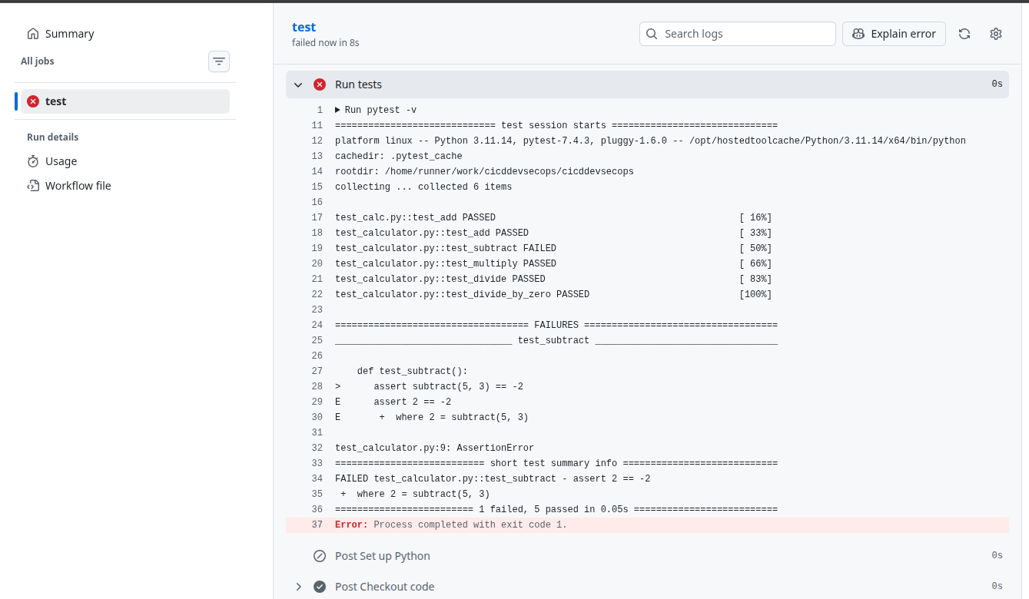

- Add a new function and test to the calculator

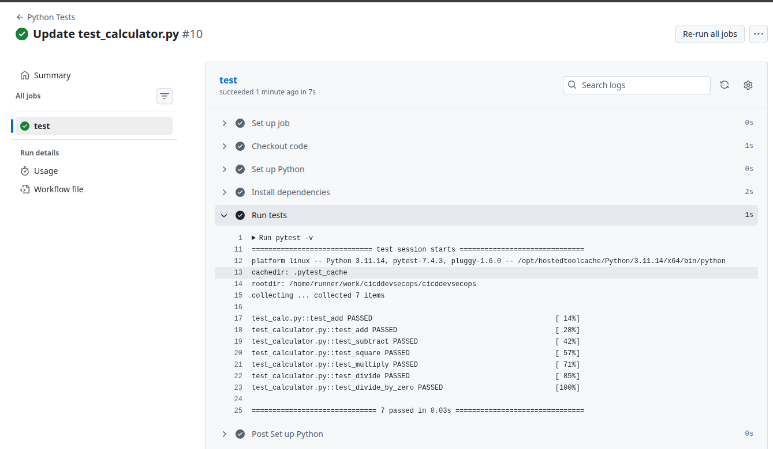
- Fix the failing test and see CI pass
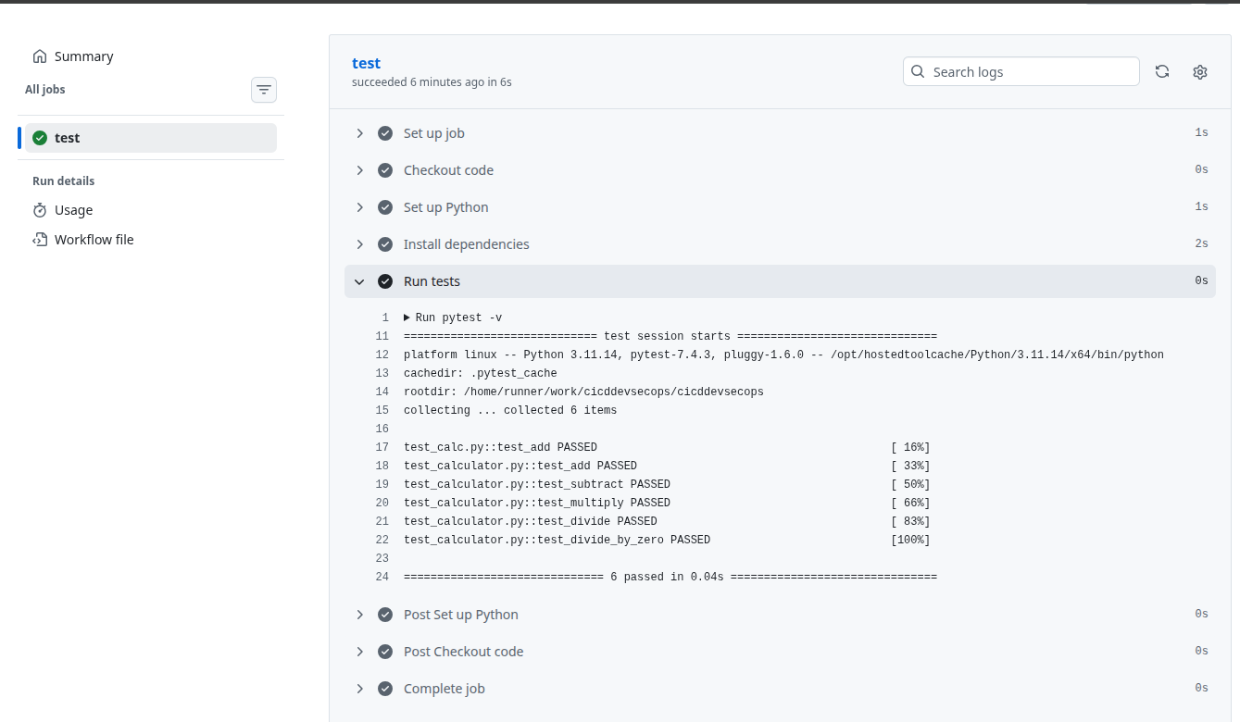
---

Exercise 5: Multi-Language Testing

Goal: Run tests for multiple programming languages in the same repository.

Steps

1. **Add a JavaScript application**

Create `stringUtils.js`:

```javascript
function capitalize(str) {
return str.charAt(0).toUpperCase() + str.slice(1);
}

function reverse(str) {
return str.split('').reverse().join('');
}

module.exports = { capitalize, reverse };
```

2. Add JavaScript tests

Create `stringUtils.test.js`:

```javascript
const { capitalize, reverse } = require('./stringUtils');

test('capitalize first letter', () => {
expect(capitalize('hello')).toBe('Hello');
});

test('reverse string', () => {
expect(reverse('hello')).toBe('olleh');
});
```

- Create package.json

```json
{
"name": "ci-lab",
"version": "1.0.0",
"scripts": {
"test": "jest"
},
"devDependencies": {
"jest": "^29.7.0"
}
}
```

4. Update workflow to test both languages

Create `.github/workflows/multi-language.yml`:

```yaml
name: Multi-Language CI

on:
push:
branches: [ main ]
pull_request:
branches: [ main ]

jobs:
python-tests:
runs-on: ubuntu-latest
steps:
- uses: actions/checkout@v4
- uses: actions/setup-python@v4
with:
python-version: '3.11'
- run: pip install -r requirements.txt
- run: pytest -v

javascript-tests:
runs-on: ubuntu-latest
steps:
- uses: actions/checkout@v4
- uses: actions/setup-node@v4
with:
node-version: '20'
- run: npm install
- run: npm test
```

Checkpoint 5
- Do the jobs run in parallel or sequentially?
parallel
- What happens if the Python tests pass but JavaScript tests fail?
Partial failure
red cross on java and green mark on python test

- How would you make JavaScript tests depend on Python tests passing?

---

Exercise 6: Testing Multiple Versions (Matrix Testing)

Goal: Test code across multiple versions of Python and Node.js.

##Steps

Create `.github/workflows/matrix-testing.yml`:

```yaml
name: Matrix Testing

on: [push, pull_request]

jobs:
python-matrix:
runs-on: ${{ matrix.os }}
strategy:
matrix:
os: [ubuntu-latest, windows-latest, macos-latest]
python-version: ['3.9', '3.10', '3.11', '3.12']

steps:
- uses: actions/checkout@v4
- name: Set up Python ${{ matrix.python-version }}
uses: actions/setup-python@v4
with:
python-version: ${{ matrix.python-version }}
- run: pip install -r requirements.txt
- run: pytest -v

node-matrix:
runs-on: ubuntu-latest
strategy:
matrix:
node-version: [18, 20, 21]

steps:
- uses: actions/checkout@v4
- name: Use Node.js ${{ matrix.node-version }}
uses: actions/setup-node@v4
with:
node-version: ${{ matrix.node-version }}
- run: npm install
- run: npm test
```

Checkpoint 6
- How many total jobs will run?
- Calculate: Python jobs + Node jobs
- Observe which combinations might fail

—

Create a file with name_USN.doc
Upload the All Checkpoint answers(1-6):
https://forms.gle/yZ3orxrGxaAk77aWA

