A

Mini Project Report

On

IntelliMess: An Intelligent Mess Management System
Submitted for partial fulfillment of the requirements for the award of the degree of

BACHELOR OF TECHNOLOGY
in
CSE-DATA SCIENCE

By
Disha Gupta | 23N81A6703
G. Srilaxmi | 23N81A6707
G. Sindhu | 23N81A6743
Sahithi Reddy | 23N81A6758

Under the guidance of
Mr. Raghavendra MI, M. Tech, (Ph. D)
Assistant Professor

DEPARTMENT OF COMPUTER SCIENCE & ENGINEERING-DATA SCIENCE
SPHOORTHY ENGINEERING COLLEGE
(Affiliated to JNTUH & Recognized by AICTE)
Nadergul, Hyderabad-501510
Academic Year-2025-26
CERTIFICATE

This is to certify that, this Mini Project report entitled "IntelliMess: An Intelligent Mess Management System" is a bonafied work carried out by Disha Gupta (23N81A6703), G. Srilaxmi (23N81A6707), G. Sindhu (23N81A6743), Sahithi Reddy (23N81A6758) in partial fulfilment of the requirements for the award of degree of Bachelor of Technology in CSE-DATA SCIENCE from Sphoorthy Engineering College, affiliated to Jawaharlal Nehru Technological University Hyderabad, Hyderabad, during the Academic Year 2025-26 under our guidance and supervision.

The results embodied in this report have not been submitted to any other University or institute for the award of any degree or diploma.

Internal Guide  Mr. Raghavendra MI _{M. Tech (Ph.D)}  Assistant Professor  Dept. of CSE-DS | Head of the Department  Dr. A. Balaram  HOD, CSE-DS

External Examiner
DECLARATION

We, the undersigned, declare that the Mini Project entitled "IntelliMess: An Intelligent Mess Management System" carried out at SPHOORTHY ENGINEERING COLLEGE is original and is being submitted to the Department of CSE-DATA SCIENCE, Sphoorthy Engineering College, Hyderabad towards partial fulfilment for the award of Bachelor of Technology.

We declare that the results embodied in the mini project has not been submitted to any other University or Institute for the award of any Degree or Diploma.

Date:

Place: Hyderabad

Disha Gupta | 23N81A6703
G. Srilaxmi | 23N81A6707
G. Sindhu | 23N81A6743
Sahithi Reddy | 23N81A6758

ACKNOWLEDGEMENT

We would like to thank our Project Guide Mr. Raghavendra MI, Assistant Professor, Department of CSE-DS, Sphoorthy Engineering College, Jawaharlal Nehru Technological University Hyderabad (JNTUH), Hyderabad for his inspiring guidance, consistent encouragement, constructive criticism, and helpful suggestions during the entire course of our research work, we express our deep sense of gratitude to our Project Co-ordinator Mrs G. Sushma, Asst. Professor for her constant and continuous support throughout the project.

We express our sincere thanks to Dr. A. Balaram, Professor & Head of CSE-Data Science Department, Sphoorthy Engineering College, Hyderabad for his encouragement which helped us to complete our Project work.

We deem it a great privilege to express our profound gratitude and sincere thanks to Sri. S. Chalama Reddy, Chairman, Sri. S. Jagan Mohan Reddy, Secretary, Prof. M.V.S. Ramprasad, Director and Principal Dr. K Srinivas Rao, Sphoorthy Engineering College, for their moral support, necessary arrangements and kind help in the completion of our project work.

We express our heartfelt thanks to our department faculty members and non-teaching staff for providing the necessary information pertaining to our project work.

We are always grateful to our parents, family members, well-wishers and friends for their remarkable support during our project work.

ABSTRACT

IntelliMess is a full-stack web-based college mess management system developed using Python Flask and MySQL. It addresses the inefficiencies of traditional paper-based mess operations by providing automated digital solutions for meal booking, menu management, demand forecasting, sentiment analysis, community polling, and student engagement. The system caters to two primary user roles: students and administrators (wardens).Students can book meals across four daily slots — Breakfast, Lunch, Snacks, and Dinner — with options for Veg/Non-Veg food type and guest meals. They can view weekly menus, submit star ratings and free-text feedback for individual dishes, participate in community polls to influence the weekly menu, and suggest new dishes for consideration. The student dashboard provides a contextual booking reminder banner showing the next open meal window in real time.The administrator portal provides a comprehensive suite of analytical and operational tools. These include a real-time statistics dashboard for next-meal headcount, machine learning-based demand forecasting using a Gradient Boosting Regressor model trained on historical booking data, rule-based NLP sentiment analysis of student feedback comments, a two-dimensional heatmap for visualising booking patterns across the week, low-rated dish comeback suggestions, exportable CSV reports, and auto-generated weekly PDF performance reports with embedded Matplotlib charts.The application features a fully responsive user interface built with Jinja2 server-side templates, DM Sans and Sora typography, and a mobile-first CSS layout. The backend is deployed on Render with a CleverCloud-hosted MySQL database and supports local execution for demonstrations. The system is live at intellimess.onrender.com.

INDEX
Content |  |  | Page No.
 |  | Abstract | i
 |  | List of Figures | ii
 |  | List of Tables | iii
1 |  | Introduction | 1
 | 1.1 | Problem Statement | 1
 | 1.2 | Objective | 2
 | 1.3 | Motivation | 2
 | 1.4 | Existing System | 3
 | 1.5 | Proposed System | 4
 | 1.6 | Scope | 5
 | 1.7 | Software and Hardware Requirements | 6
2 |  | Literature Survey | 7
 | 2.1 | Existing Work | 7
 | 2.2 | Base Paper 1 Overview | 7
 | 2.3 | Base Paper 2 Overview | 8
 | 2.4 | Base Paper 3 Overview | 8
 | 2.5 | Limitations of Existing Systems | 9
3 |  | System Design | 11
 | 3.1 | System Architecture | 11
 | 3.2 | System Flow | 14
 | 3.3 | Modules Description | 16
4 |  | Implementation | 26
 | 4.1 | Environment Setup | 26
 | 4.2 | Implementation of Modules | 27
 | 4.3 | Integration and Route Summary | 30
5 |  | Evaluation | 32
 | 5.1 | Evaluation Metrics | 32
 | 5.2 | Test Cases | 33
 | 5.3 | Results and Observations | 35
6 |  | Conclusion and Future Enhancement | 38
 | 6.1 | Conclusion | 38
 | 6.2 | Future Enhancement | 40
 |  | References | 44
 |  | Appendix — Sample Code | 46

LIST OF FIGURES
Figure No. | Figure Name | Page No.
3.1 | System Architecture Diagram | 13
3.2 | System Flow Diagram | 15
3.3 | Student Dashboard — Booking Reminder Banner | 17
3.4 | Admin Dashboard — Statistics Panel | 18
3.5 | Weekly Menu Management Interface | 19
3.6 | Polls and Community Engagement Page | 22
5.1 | Booking Trend Chart — Last 7 Days | 37
5.2 | Demand Forecasting Output — Next Week Predictions | 37

LIST OF TABLES
Table No. | Table Name | Page No.
1.1 | Software and Hardware Requirements | 6
2.1 | Comparison of Existing Systems with IntelliMess | 9
3.1 | Gamification Badge Milestones | 22
3.2 | Database Schema Summary | 23
4.1 | Key Routes Summary | 30
5.1 | Demand Forecasting Accuracy — MAE by Meal | 32
5.2 | Sentiment Analysis Precision, Recall and F1-Score | 33
5.3 | Test Cases | 33

CHAPTER 1
INTRODUCTION
College mess management is one of the most challenging administrative tasks in educational institutions. With hundreds or thousands of students depending on the mess daily, managing meal bookings, tracking food consumption, forecasting demand, and maintaining records manually is both time-consuming and error-prone. Traditional approaches rely on paper registers, physical headcounts, and informal feedback mechanisms that provide no data for informed decision-making.

IntelliMess is a web-based mess management system designed to address these challenges comprehensively. Built on the Python Flask framework with a MySQL backend, it provides a structured digital platform for both students and mess administrators. The system brings intelligence into mess operations through ML-based demand forecasting, sentiment analysis on feedback, community polls, dish suggestions, and an interactive analytics dashboard with PDF report generation.

The project was developed keeping in mind the real operational environment of Sphoorthy Engineering College's mess, where the warden needs to track daily headcounts across four meal slots, administrators need insights into food preferences and wastage patterns, and students need easy access to booking and feedback tools. The system is deployed live at intellimess.onrender.com.

1.1 Problem Statement
College mess operations suffer from several critical inefficiencies in their traditional form. The lack of a digital booking system means students often forget to inform the mess about their meal requirement, leading to either food shortage or significant wastage. Feedback, when collected at all, is informal and ignored. Wardens have no visibility into which dishes are consistently poorly rated, which meals see the highest demand, or how booking patterns vary across the week.

The absence of analytics means that decisions about menu changes, portion sizes, and procurement are based on subjective judgment rather than data, leading to repeated dissatisfaction and avoidable cost overruns. The specific problems identified are:
- Absence of a digital pre-booking system results in inaccurate demand forecasting and food wastage.
- No structured feedback mechanism means dish quality issues go unaddressed for long periods.
- Administrators lack data-driven tools for menu planning, procurement, and performance evaluation.
- Students receive no contextual reminders about upcoming meal windows, leading to missed bookings.
- No community engagement layer for students to influence menu decisions through polls or suggestions.
- Manual paper-based processes produce no digital records for long-term trend analysis.

1.2 Objectives
The primary objective of IntelliMess is to digitise and intelligently automate the complete lifecycle of mess management — from meal booking to feedback, analytics, and community engagement. Specific objectives include:
- Provide students a simple web interface to book meals, view weekly menus, give feedback, and participate in polls.
- Build an admin dashboard with real-time statistics including next-meal headcount split by Veg/Non-Veg and guest count.
- Apply machine learning (GradientBoostingRegressor) to forecast next-week meal demand per meal type, giving the kitchen advance notice for procurement.
- Implement rule-based NLP sentiment analysis to automatically categorise student feedback as positive, neutral, or negative.
- Create a community engagement layer with polls (admin-created) and dish suggestions (student-submitted with upvoting).
- Provide administrators with exportable weekly PDF performance reports with embedded Matplotlib charts.
- Deploy the system on cloud infrastructure (Render + CleverCloud MySQL) for 24/7 availability.

1.3 Motivation
The motivation behind IntelliMess stems from direct observation of the operational challenges in college mess environments. The absence of technology in this domain is stark compared to how digitalisation has transformed other aspects of campus life such as attendance, library management, and fee payment.

Food wastage in college messes is a significant concern. Without accurate headcounts in advance, kitchens prepare food for the full student strength regardless of actual turnout, resulting in large quantities of food being wasted daily. As established by Rodrigues et al. (2024) in their study on ML-based demand forecasting for food catering services, poor demand forecasting is the primary driver of food overproduction and wastage in catering environments, and ML models can reduce wasted meals by 14% to 52% compared to manual estimation methods. IntelliMess directly addresses this by requiring meal bookings in advance and applying a GradientBoostingRegressor model to predict next-week demand.

Student satisfaction with mess food is typically low, not because the food quality is necessarily poor, but because there is no feedback loop. Dishes that students dislike continue to appear in the menu simply because no one systematically measures their ratings. IntelliMess introduces a structured feedback and polling system that gives students a voice and gives administrators the data to act on it.

The motivation also extends to the academic contribution: this project applies real-world data science and machine learning techniques — gradient boosting regression, NLP sentiment analysis, and statistical visualisation — to a concrete, locally relevant problem, demonstrating the practical value of the CSE-Data Science curriculum.

1.4 Existing Systems
Several mess and canteen management applications exist, but most cater to commercial restaurants or large-scale catering services rather than college mess environments. The primary tools available include:

ERP-based Mess Modules: Integrated within college ERP systems (e.g., Fedena, Entab), these provide basic booking and billing but lack intelligence features such as demand forecasting, sentiment analysis, or gamification. They are typically expensive, require IT department support for configuration, and are not designed for day-to-day warden use.

MealMap (IJARCCE 2025): A hostel food management system that integrates meal planning, inventory tracking, and feedback. While it provides role-based access and data analytics, it does not include ML forecasting, student community features (polls/suggestions), or a responsive mobile-first design.

SVMTAFRS (Indonesian JEECS 2024): A time-aware food recommender system using Support Vector Machines that personalises dish recommendations by time of day. However, it is a recommender tool only and does not provide the full operational management layer — bookings, feedback, reports — that IntelliMess delivers.

Manual Systems: Most college messes still rely on paper registers, physical tokens, or simple spreadsheets. These produce no digital records, no analytics, and provide no reminders to students.

IntelliMess fills the gap by combining the best features of digital booking systems with intelligent automation and analytics at no licensing cost, running on open-source technologies.

1.5 Proposed System
IntelliMess proposes a comprehensive web application that replaces all manual mess processes with a unified digital platform. The proposed system is structured around two user roles:

Student Role: Students register with their username, roll number, and password. They can book any combination of the four daily meals up to the respective booking deadlines. The student dashboard shows a contextual reminder banner for the next open meal window with urgency colouring. Students rate dishes using a five-star system, vote in warden-created polls that influence the weekly menu, suggest new dishes for consideration, and upvote suggestions submitted by peers.

Admin/Warden Role: The warden accesses a dashboard showing real-time statistics including next meal headcount (including guests), Veg/Non-Veg split, overall dish ratings, and active polls. Analytics pages provide booking trend charts, heatmaps, low-rated dish comeback suggestions, ML demand forecasts, and sentiment breakdowns of feedback. The warden can also download auto-generated weekly PDF reports.

1.6 Scope
The scope of IntelliMess encompasses the complete digital management of a single-mess college campus. Specifically, it covers:
- Meal booking for four daily meal slots (Breakfast, Lunch, Snacks, Dinner) with configurable closing-time deadlines.
- Guest meal management allowing students to book for up to 10 additional guests alongside their own meal.
- Contextual booking reminder banner on the student dashboard showing time remaining to book.
- Weekly menu management by the administrator including assignment of dishes to day-meal slots.
- Dish feedback with five-star ratings and free-text comments with per-dish analytics.
- Community polling for menu decisions with voter deduplication enforced by database constraints.
- Dish suggestions with student upvoting mechanism and admin status management.
- ML-based demand forecasting for weekly meal planning using GradientBoostingRegressor.
- Sentiment analysis of free-text feedback comments using rule-based NLP.
- Booking pattern heatmap visualisation across days and meal types.
- Low-rated dish comeback suggestions for dishes with 4+ stars not served in 14 days.
- Weekly PDF report generation with embedded Matplotlib charts for administrative records.

The current scope does not include attendance tracking, email/WhatsApp reminders, payment integration, or multi-mess support, which are identified as future enhancements.

1.7 Software and Hardware Requirements
Table 1.1 below summarises all software and hardware requirements for deploying and operating IntelliMess:

Table 1.1: Software and Hardware Requirements
Requirement | Specification
Operating System | Windows 10 / Ubuntu 20.04 or later
Programming Language | Python 3.10+
Web Framework | Flask 3.x
Database | MySQL 8.0 (CleverCloud hosted)
Frontend | HTML5, CSS3, JavaScript (Vanilla), Jinja2
ML Library | scikit-learn 1.3+
PDF Generation | ReportLab 4.x
Chart Rendering | Matplotlib 3.x (PDF charts), Chart.js 4.x (browser)
Deployment | Gunicorn + Render (2 workers, port 10000)
Browser | Chrome 100+ / Firefox 100+ / Safari 15+
RAM | Minimum 4 GB
Storage | Minimum 500 MB free disk space
Network | Stable internet for cloud DB and deployment

CHAPTER 2
LITERATURE SURVEY

2.1 Existing Work
A thorough review of existing literature was carried out to understand the current state of mess and canteen management systems, intelligent food recommendation approaches, machine learning applications in campus services, and community engagement strategies for student participation. The following base papers were studied and analysed for their methodology, results, limitations, and relevance to the design of IntelliMess.

2.2 Base Paper 1 Overview
Title: MealMap: Hostel Food Management System
Published Year: 2025
Authors: Krishna Gudi, Srishti Sosale, Siri Gowda, Vijayashree A, Vignesh B

This paper proposes MealMap, a technology-driven hostel food management system built around a three-role access model: students who view schedules and submit feedback, kitchen staff who monitor inventory and flag low-stock items, and administrators who update meal plans, track procurement, and review performance dashboards. The system integrates real-time data analytics to optimise resource utilisation and reduce food wastage. Meal schedule visibility, inventory monitoring with automated low-stock alerts, admin-side meal plan updating, and performance metric dashboards showing consumption trends are the key features. The paper reports improved accuracy in meal planning, greater transparency in inventory usage, and a measurable reduction in food wastage. The real-time analytics layer allowed administrators to adjust preparation quantities based on actual consumption patterns rather than fixed estimates.

Drawbacks:
- No machine learning component for demand forecasting — decisions remain manual.
- No community layer for students to vote on menus or suggest dishes.
- Interface was not designed with a mobile-first approach.
- No gamification features to incentivise student feedback participation.
- No automated reminder mechanism to prompt students about booking windows.

2.3 Base Paper 2 Overview
Title: An Intelligent Time Aware Food Recommender System Using Support Vector Machine
Published Year: 2024
Authors: Minakshi Panwar, Ashish Sharma, Om Prakash Mahela, Baseem Khan, Ahmed Ali

Panwar et al. proposed SVMTAFRS, an SVM-powered time-aware food recommender system that personalises food item recommendations based on user age, time of day, and day of the week. The system introduces two novel constructs: the User Identity Document (UID), a weighted profile computed from customer age and historical preferences, and the Predicted Food Rating (PFR), a time-sensitive score that applies day-of-week multipliers and meal-time weighting to adjust recommendations. The SVM classifier is trained on labelled user-food-time interaction data. The system demonstrated lower MAE and RMSE than a baseline rule-based recommender across all evaluated time slots. The time-aware mechanism — specifically the meal-time slot encoding — was the most impactful feature for improving recommendation accuracy.

Drawbacks:
- Recommender system only — no booking, feedback, admin portal, or reporting functionality.
- Requires a large labelled training dataset of user-food-time interactions that a new deployment would not have.
- No notification system, feedback mechanism, or operational management layer for mess administration.
- Cannot replace or supplement the operational management layer of a college mess.

2.4 Base Paper 3 Overview
Title: Machine Learning Models for Short-Term Demand Forecasting in Food Catering Services: A Solution to Reduce Food Waste
Published Year: 2024
Authors: Miguel Rodrigues, Vera Migueis, Susana Freitas, Telmo Machado

Rodrigues et al. (Journal of Cleaner Production, 2024) proposed and evaluated four machine learning-based demand forecasting models for food catering services to reduce food waste. The study tested two causal models — Random Forest (RF) and LightGBM — and two time series models — LSTM neural network and Transformer neural network — across three food catering services: two student canteens (FCS1 and FCS2) and one company canteen (FCS3). All four models were designed to predict the daily number of meals served using features such as day of week, month, menu classification, weather conditions, and the number of reservations. Model hyperparameters were tuned using nested cross-validation with a rolling window to prevent data leakage.

The results demonstrated that the RF model produced the best forecasts for student canteens, achieving MAPE values of 22.14% and 23.14% respectively, while the LSTM model outperformed all others for the company canteen with a MAPE of 14.32% and R² of 0.7325. Compared to baseline models that mimic manual estimation (moving average and naive approaches), the best models reduced food waste by 14% to 52% while simultaneously reducing unmet demand. The study confirmed that even simple improvements in demand forecast accuracy translate directly into measurable reductions in overproduction and food waste in catering environments.

Drawbacks:
- Research prototype only — no student-facing interface, no booking system, no attendance tracking, and no admin management portal.
- Focused exclusively on forecasting a single dish (meat) and does not address multi-slot, multi-meal management.
- Requires significant historical data (3-9 years) for reliable model training, whereas a newly deployed college mess system starts with no data.
- No student engagement layer, no feedback collection, and no automated reminders.
- Cannot be deployed as a standalone application without substantial engineering work to build the surrounding operational platform.

2.5 Limitations of Existing Systems
The following table consolidates the key limitations of each reviewed system and maps them to the corresponding feature in IntelliMess that addresses each limitation:

Table 2.1: Comparison of Existing Systems with IntelliMess
System / Paper | Key Limitations | How IntelliMess Addresses It
MealMap (2025) | No ML forecasting; no community polls/suggestions; no mobile-first responsive design. | GradientBoostingRegressor demand forecasting; responsive mobile-first UI with CSS Grid; community polls and dish suggestions.
SVMTAFRS (2024) | Recommender only — no booking, feedback, admin portal, or reporting; requires large labelled dataset. | Full end-to-end mess management: booking, analytics, PDF reports; community-driven recommendations via polls and dish suggestions.
Rodrigues et al. (2024) | Research prototype only — no student interface, no booking, no admin portal. Requires years of historical data. | GradientBoostingRegressor demand forecasting integrated directly into the booking system using its own collected booking data.

The comparative analysis confirms that no existing system combines all the features required for an intelligent, student-centric college mess management platform. IntelliMess is the first system in this review to integrate digital meal booking, ML demand forecasting, NLP sentiment analysis, real-time booking analytics, and a community engagement layer within a single open-source, cloud-deployable web application specifically designed for the Indian engineering college context.

CHAPTER 3
SYSTEM DESIGN
IntelliMess follows a four-tier layered architecture comprising the Presentation Layer (browser-based client), the Application Layer (Flask backend), the Intelligence Layer (ML and NLP components), and the Data Layer (MySQL database hosted on CleverCloud). This architecture cleanly separates concerns: the frontend handles rendering and user interaction, the Flask backend handles routing and business logic, the intelligence layer provides ML forecasting and sentiment analysis, and the database handles persistent storage.

3.1 System Architecture
The four-tier architecture of IntelliMess is illustrated in Figure 3.1. Each tier is described in detail below.

3.1.1 Presentation Layer (Frontend)
Students and administrators interact with the system through any modern web browser on desktop or mobile devices. The frontend technology stack consists of:

HTML5: Semantic markup for all 25+ page templates using elements like <nav>, <main>, and <section> for accessibility and SEO. Jinja2 server-side templates extend a base layout that provides the navbar and flash message container, allowing child templates to override only the content block. This eliminates a separate frontend build step and allows the server to inject database-driven content directly into HTML at request time.

CSS3 (styles.css, 1,200+ lines): A single hand-crafted stylesheet implementing a mobile-first responsive layout. CSS custom properties (variables) define the colour palette using forest green (#4CAF50) as primary, spacing scale, and typography constants. Flexbox and CSS Grid are used for layout. Media breakpoints at 768px (tablet) and 480px (smartphone) switch the layout from a multi-column desktop grid to a stacked single-column mobile view.

DM Sans and Sora Typography: The DM Sans font family (body text) and Sora (headings), both loaded from Google Fonts, provide modern readable typography optimised for both small smartphone screens and desktop monitors.

Vanilla JavaScript: A lightweight shared script handles the hamburger navigation toggle on mobile, dynamic search/filter interactions on admin pages, and real-time booking reminder countdown. Chart.js is used on the admin analytics page to render booking trend line charts and food type distribution doughnut charts. All Chart.js data is prepared server-side and injected as JSON into the template. The frontend deliberately avoids heavy JavaScript frameworks to keep deployment simple.

3.1.2 Application Layer (Flask Backend)
The Flask application (app.py) is the central component of IntelliMess. It handles all HTTP routing, session management, database operations, business logic enforcement, and PDF generation. Key design decisions in the application layer include:

Single-file architecture: All routes, helper functions, and ML model logic reside in app.py. This simplifies deployment — Render needs only to execute a single gunicorn app:app command with no multi-service orchestration.

Per-request database connections: Each HTTP request creates a fresh mysql.connector connection and closes it before returning the response. This avoids persistent connection state issues in a multi-process Gunicorn environment and is appropriate for the traffic volume of a college mess system.

Session-based authentication: Flask's signed cookie sessions store user_id, username, and role after login. Role-based access control is enforced at the top of every protected route by checking session.get('role'), redirecting to /login if the check fails.

IST timezone enforcement: All datetime operations use Python's built-in datetime with UTC+5:30 offset (via timezone and timedelta) to ensure consistent time comparisons between booking window checks and dashboard display. No external timezone library (pytz) is used, as pytz was found to fail silently on Render's free tier.

Gunicorn WSGI deployment: The production deployment uses --workers 2 --port 10000 on Render. The canonical IST function used throughout the application is:
_IST_OFFSET = timezone(timedelta(hours=5, minutes=30))
def now_ist():
return datetime.now(timezone.utc).astimezone(_IST_OFFSET).replace(tzinfo=None)

3.1.3 Intelligence Layer
The intelligence layer consists of two components that run within the Flask process: the GradientBoostingRegressor demand forecasting model (scikit-learn) and the rule-based sentiment classifier (sentiment.py). Both components are computationally lightweight enough to run inline within HTTP request handlers without a dedicated inference server.

3.1.4 Data Layer (MySQL on CleverCloud)
The MySQL database is hosted on CleverCloud's managed MySQL service, which provides automatic backups and high availability without requiring database administration. The database schema uses 15 tables with foreign key constraints enforcing referential integrity. Key design decisions include:
- UNIQUE constraints for deduplication: bookings table has UNIQUE on (user_id, meal, booking_date) to prevent double-booking; poll_votes has UNIQUE on (poll_id, user_id) for one-vote-per-student.
- CASCADE deletes: menu_items and poll_options use ON DELETE CASCADE to prevent orphaned rows when parent records are removed.
- status ENUMs: polls and dish_suggestions use ENUM columns for state management, preventing invalid state values at the database level.

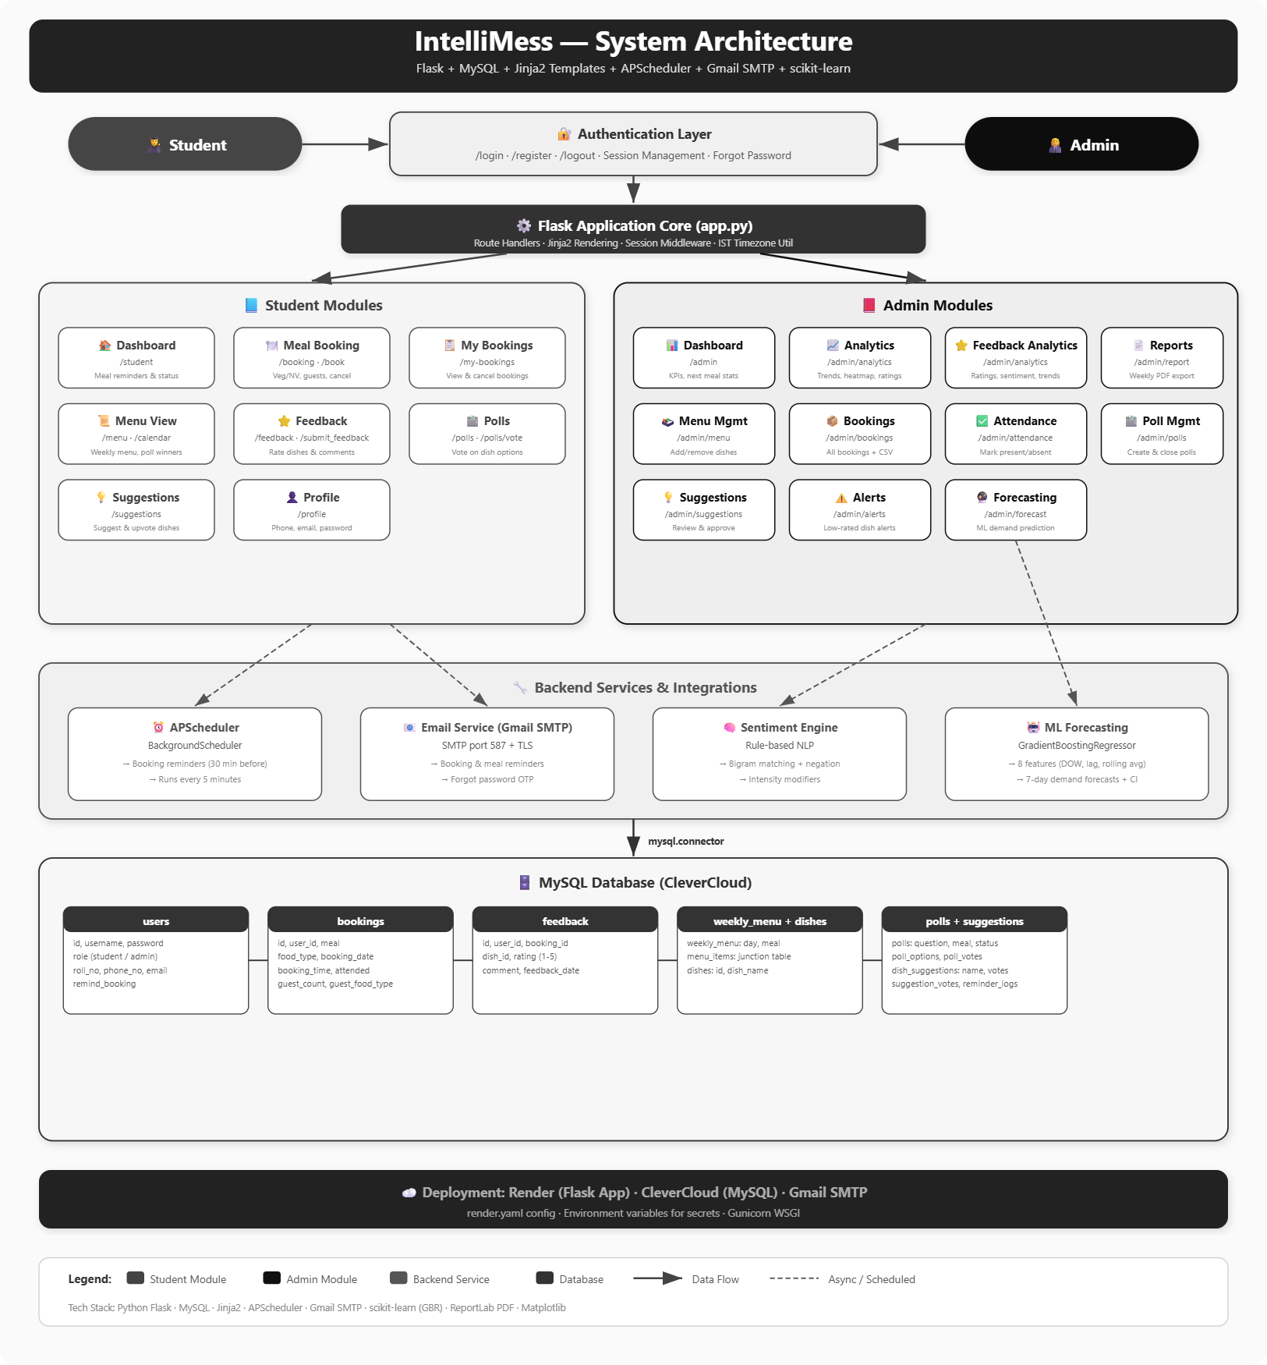
Figure 3.1: AI-Integrated IntelliMess System Architecture

3.2 System Flow
The operational flow of IntelliMess spans two actor types — student and admin — interacting over the course of a day. The complete daily cycle is described below:

3.2.1 Student Registration and Login
The student submits their username, roll number, phone number, and password at /register. The server validates uniqueness of username and roll number by querying the users table before inserting the record with role='student'. Upon login, the user receives a session cookie containing user_id, username, and role. The student is then redirected to the /student dashboard.

3.2.2 Daily Meal Booking Cycle
The student logs in and lands on the /student dashboard. The dashboard queries all four meal closing times against the current IST time and renders a contextual reminder banner for the next upcoming meal. The banner changes colour based on urgency: red with flashing text when fewer than 30 minutes remain, amber for normal open windows, green for already-booked meals, and grey when all windows have closed for the day.

The student navigates to /booking and selects a meal (Breakfast/Lunch/Snacks/Dinner), food type (Veg/Non-Veg), date (today or tomorrow), and optionally adds guests (up to 10). The booking closing schedule enforced server-side is: Breakfast at 06:00 IST, Lunch at 09:00 IST, Snacks at 12:00 IST, and Dinner at 16:30 IST. The UNIQUE database constraint prevents duplicate bookings silently.

3.2.3 Menu Viewing and Poll Participation
Students can view the upcoming four meals at /menu, which shows dishes assigned to each day-meal slot along with any poll winners that have been appended as special dishes. Students participate in admin-created polls at /polls, casting one vote per poll. Vote deduplication is enforced by the UNIQUE KEY on (poll_id, user_id) in poll_votes. Results are shown in real time after voting.

3.2.4 Post-Meal Feedback
After the meal, the student visits /feedback. The form shows all dishes served today (from the current week's menu assignments) for meals whose serving time has passed within the last 3 days. The student selects a dish by clicking its checkbox, assigns a 1–5 star rating, and optionally writes a free-text comment. The feedback record is inserted into the feedback table. The server then recalculates the student's streak and badge eligibility.

3.2.5 Admin Operations
The admin accesses the dashboard at /admin showing real-time statistics. The admin can manage the weekly menu at /admin/menu, create and close polls at /admin/polls, view booking analytics at /admin/analytics, review sentiment analysis at /admin/sentiment, view booking heatmaps at /admin/heatmap, manage dish suggestions at /admin/suggestions, view all bookings at /admin/bookings, and download a weekly PDF report at /admin/report.
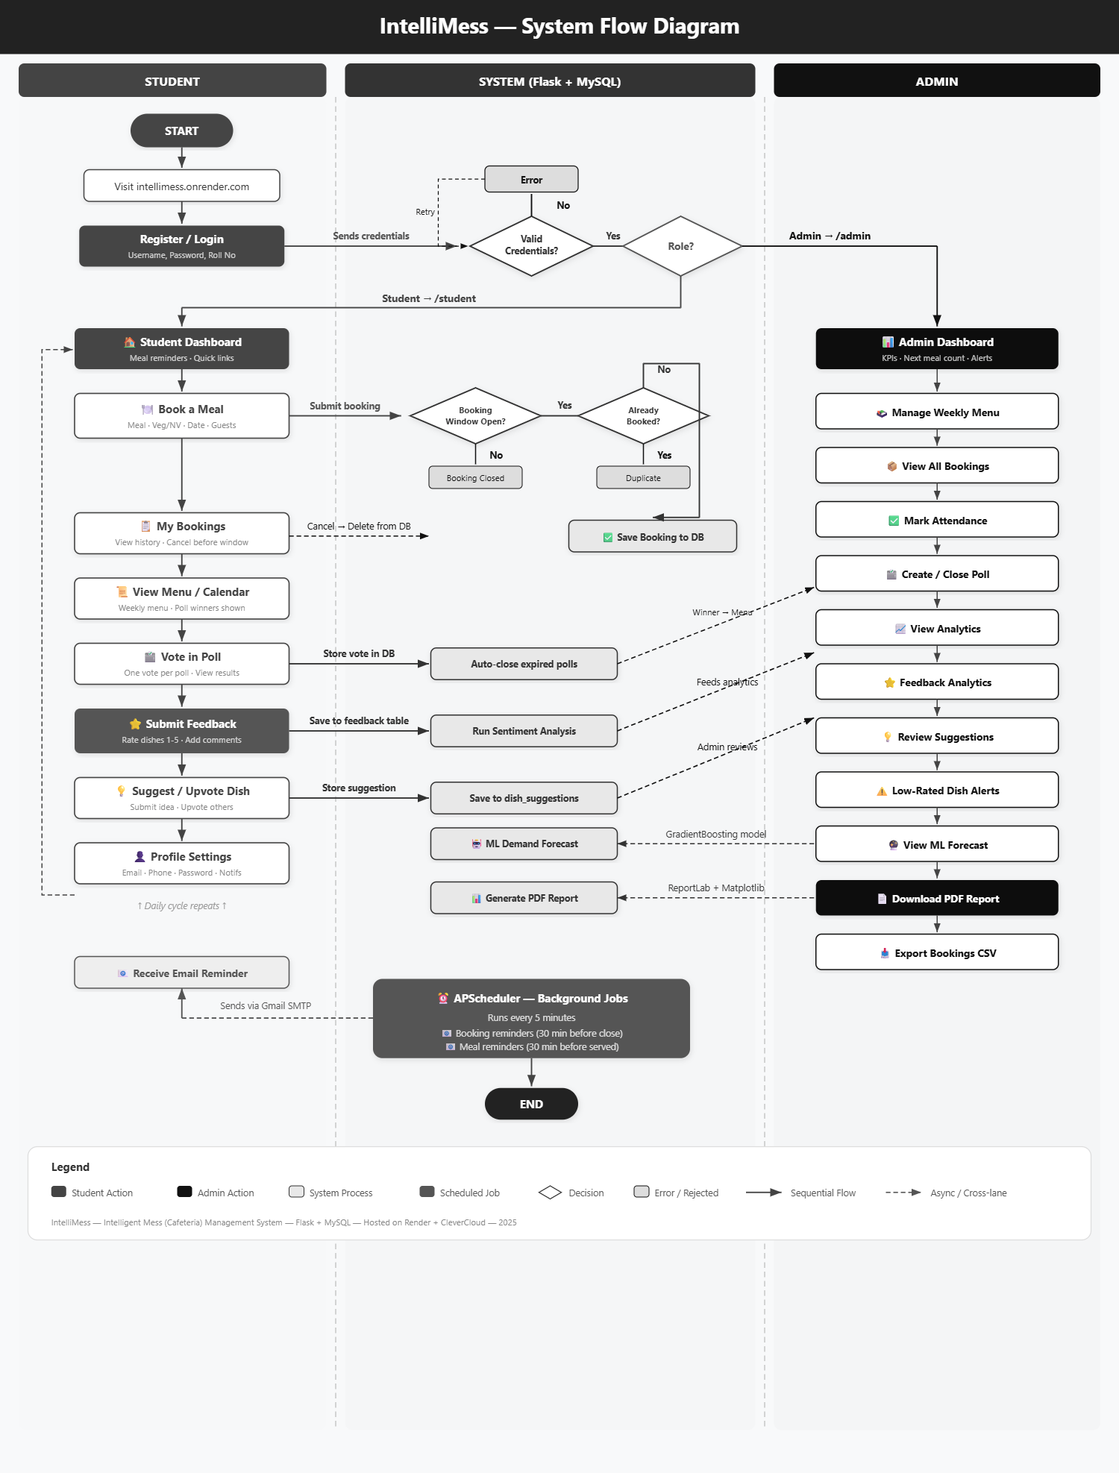
Figure 3.2: System Flow Diagram

3.3 Modules Description
IntelliMess is composed of eight functionally distinct modules, each implemented as a set of Flask routes and supporting functions within app.py.

3.3.1 Meal Booking Module
The booking module is the core transactional layer of IntelliMess. It manages the complete lifecycle of a meal reservation from submission through validation. Booking window enforcement is performed server-side by comparing the current IST datetime against the closing schedule. If a student attempts to book after the window closes, the route returns a flash error message without inserting — this validation cannot be bypassed by disabling JavaScript.

Data Model: Each booking record stores user_id, meal, food_type, booking_date, booking_time (submission time), guest_count (0 if no guests), and guest_food_type. The booking_date combined with the meal name determines the unique slot — a student cannot have two rows for the same slot due to the UNIQUE constraint.

Guest Meal Management: Students can book for up to 10 guests alongside their own meal. Guest meals are counted separately in the headcount statistics shown to the admin, with Veg/Non-Veg counts computed separately for students and guests and summed for kitchen planning.
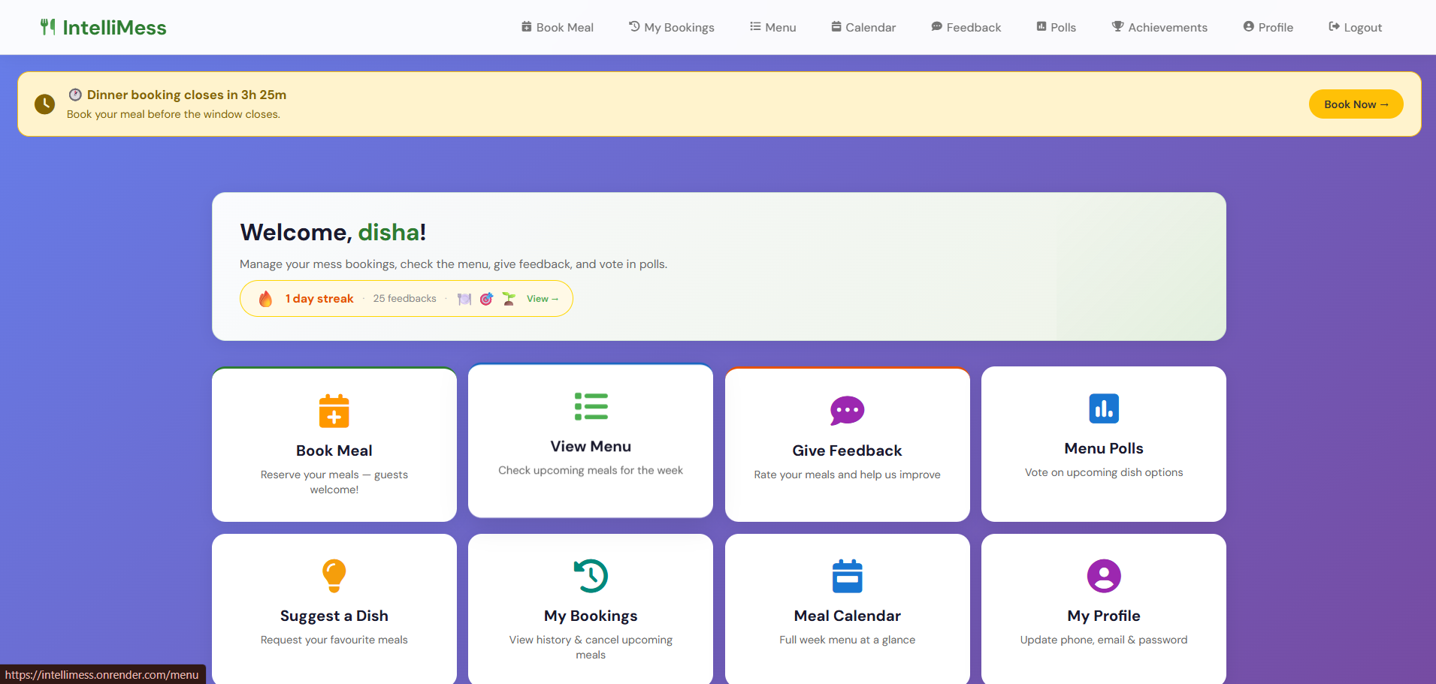
Figure 3.3: Student Dashboard — Booking Reminder Banner

3.3.2 Admin Dashboard and Analytics Module
The admin dashboard at /admin aggregates five key statistics for display: (1) next meal headcount including guests, (2) total bookings to date, (3) overall average dish rating, (4) feedback rate as a percentage of bookings, and (5) count of active polls. The next meal panel shows student count, guest count, Veg/Non-Veg split, and the next meal name and date in a visually highlighted panel.

The /admin/analytics page renders four Chart.js visualisations: a booking trend line chart for the last 7 days, a meal-wise bar chart, a Veg/Non-Veg doughnut chart, and a rating distribution bar chart. All chart data is prepared server-side using SQL aggregation queries and passed to Jinja2 templates as JSON. The dish ratings section shows all rated dishes sorted by average rating with review counts, allowing the admin to immediately identify top and bottom performing dishes.
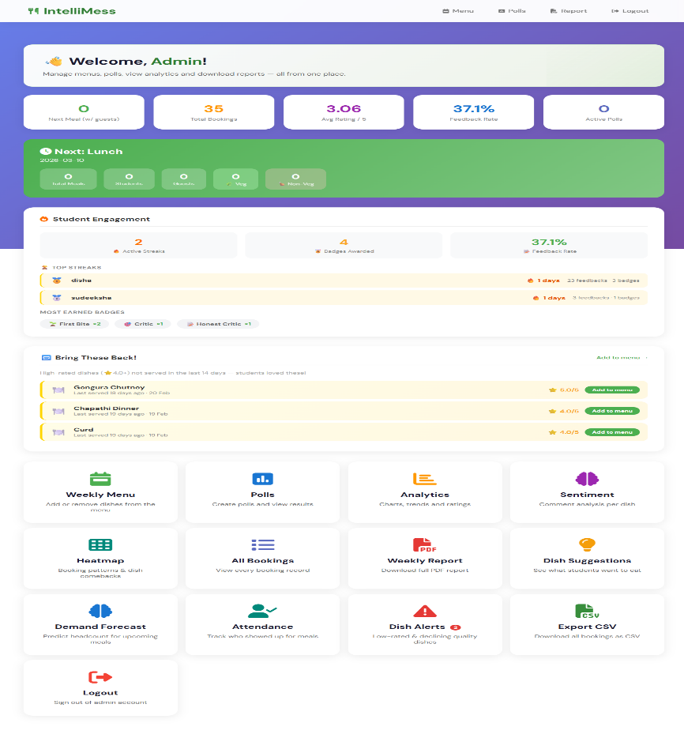
Figure 3.4: Admin Dashboard — Statistics Panel

3.3.3 Menu Management Module
The weekly menu management module at /admin/menu provides the admin with a grid view of all 28 meal slots (7 days × 4 meals). Each cell shows the dishes currently assigned to that slot as removable tags. The admin can add a dish by selecting an existing dish from a dropdown or typing a new dish name, selecting the day and meal, and submitting. New dishes are automatically added to the dishes master table if they do not already exist.

When a poll is closed and a winner is determined, the winning dish is stored in polls.winner_dish and displayed in the student's /menu view as a 'Poll Winner' special addition alongside the regular menu — without permanently modifying the weekly_menu table, preserving the clean separation between the poll system and the menu.

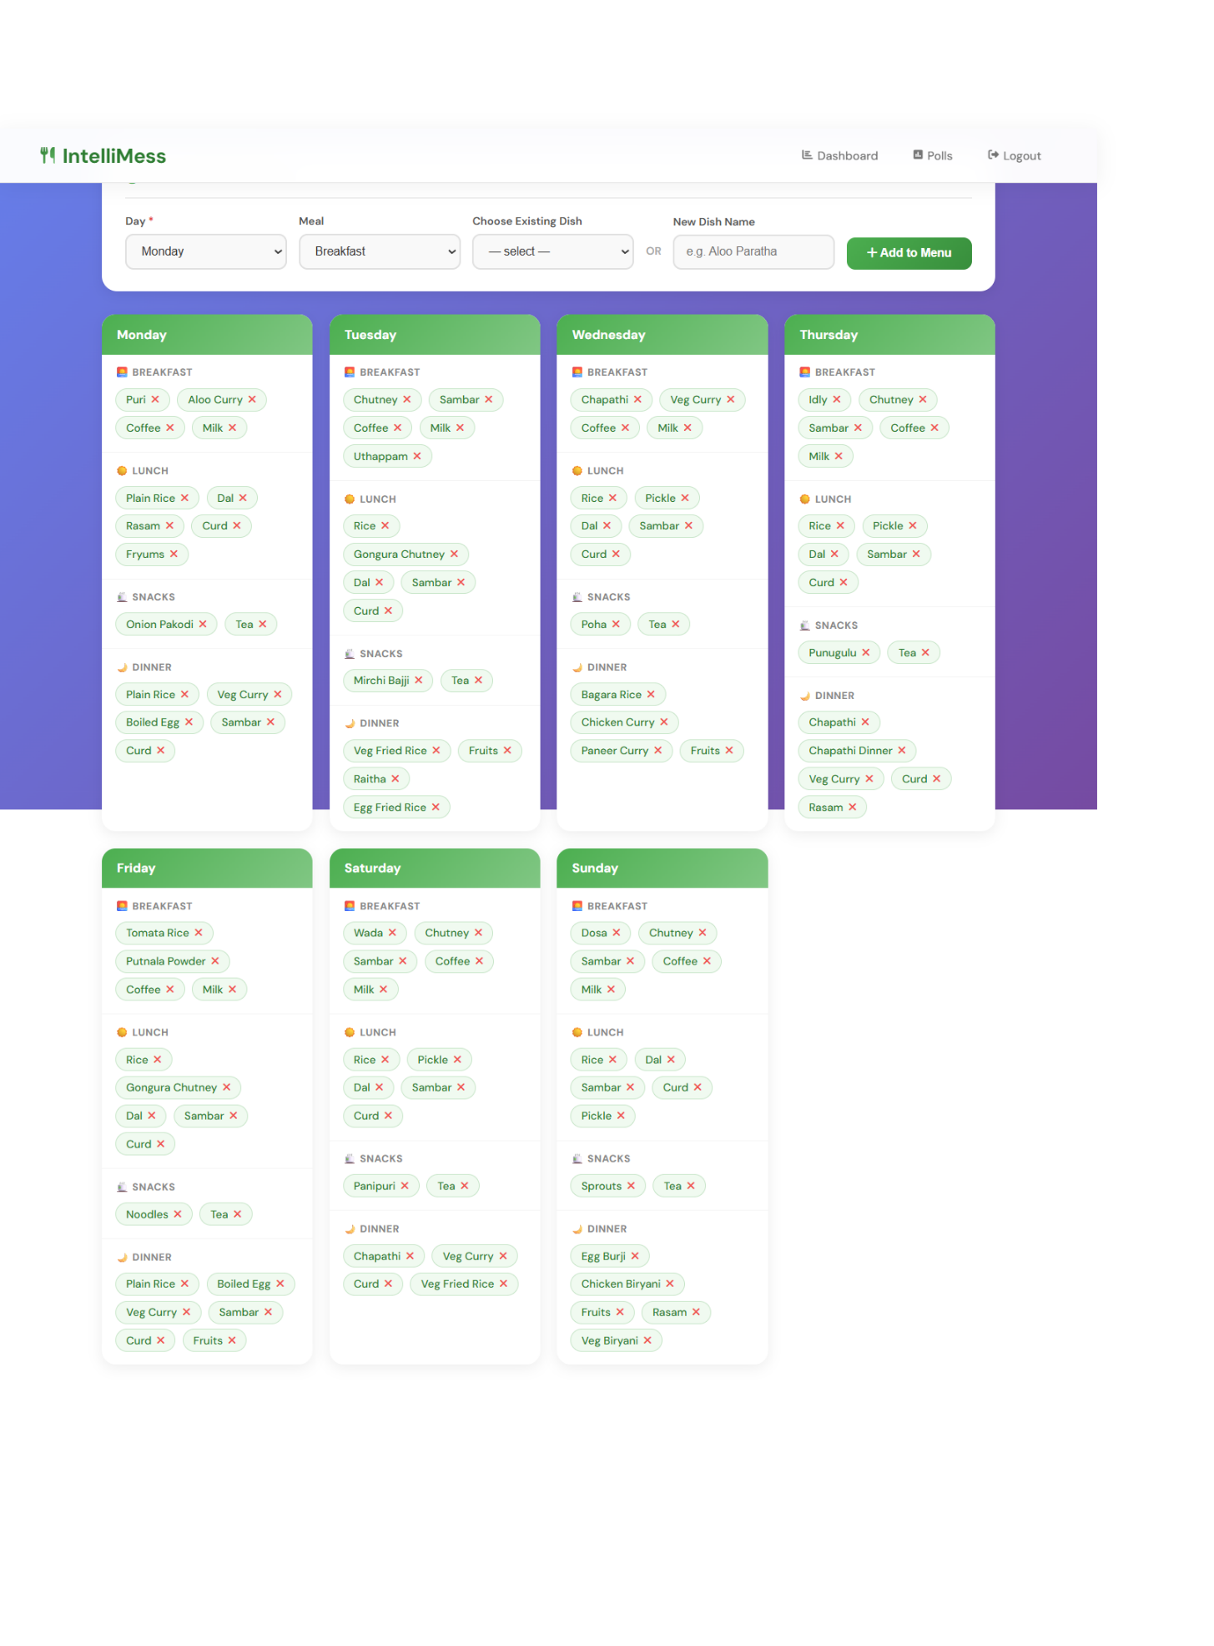
Figure 3.5: Weekly Menu Management Interface

3.3.4 Demand Forecasting Module
The forecasting module uses supervised machine learning to predict how many students will book each meal next week, enabling kitchen staff to plan procurement more accurately.

Feature Engineering: The training dataset is constructed from the bookings table. For each unique (booking_date, meal) combination, the following features are computed: day_of_week (integer 0-6), meal_index (integer 0-3 encoding the four meal types), historical_count (total bookings for this meal-day combination), veg_ratio (fraction of bookings that are Veg), and week_number (to capture any long-term trend). The target variable is the total booking count for that (date, meal) pair.

Model Selection: GradientBoostingRegressor was selected over alternatives (Linear Regression, Random Forest) for its ability to capture non-linear patterns in the relatively small dataset. It handles categorical features encoded as integers without one-hot expansion, and its hyperparameter defaults (n_estimators=100, learning_rate=0.1, max_depth=3) provide good generalisation without overfitting on limited data.

Prediction Generation: After training on all available historical data, the model predicts booking counts for each of the 28 (7 days × 4 meals) slots in the coming week. Predictions are rounded to integers and clamped to a minimum of 0. The admin forecast page displays predictions alongside current-week actuals, with a percentage change figure for each slot. A cold-start warning is displayed if fewer than 4 weeks of data are available.

3.3.5 Sentiment Analysis Module
The sentiment analysis module (sentiment.py) processes the free-text comments submitted by students in the feedback form and classifies each comment as Positive, Neutral, or Negative. Results are displayed on the admin sentiment page to give the warden a quick overview of per-dish feedback tone.

Lexicon Design: The module maintains three word lists: POSITIVE_WORDS (30 terms including 'delicious', 'excellent', 'fresh', 'loved', 'tasty', 'crispy', 'hot'), NEGATIVE_WORDS (25 terms including 'bad', 'tasteless', 'cold', 'undercooked', 'disgusting', 'stale', 'bland', 'hard'), and NEGATIONS ('not', 'never', 'no', 'wasnt', 'isnt'). Both lists were curated by analysing common vocabulary in Indian student mess feedback.

Scoring Algorithm: Each comment is lowercased and tokenised by whitespace. For each token, the algorithm checks if the previous token is a negation word (negation window of 1). If the token matches a positive word, the score increases by +1 (or -1 if negated). If it matches a negative word, the score decreases by -1 (or +1 if negated). Final classification: score > 0 → Positive, score < 0 → Negative, score = 0 → Neutral. This handles common mess feedback patterns such as 'not good' and 'not bad' correctly.

Admin Visualisation: The sentiment page shows aggregated counts per dish, a stacked sentiment bar chart, and a list of notable positive and negative keywords extracted from comments. Dishes are sorted by their negative percentage so the admin sees the most problematic dishes first. The sentiment data is also included in the weekly PDF report.

3.3.6 Community Engagement Module
The community module provides the feedback loop between students and the mess administration through two features: polls and dish suggestions.

Polls: The admin creates a poll by specifying a question and two or more dish options as free text. Students see active polls on the /polls page and cast one vote per poll. Vote deduplication is enforced by the UNIQUE KEY (poll_id, user_id) on the poll_votes table. When a poll closes (either manually by the admin or automatically at the closing_time threshold checked during each /polls page load), the winning option's text is saved in polls.winner_dish. The admin can view vote counts in real time on /admin/polls.

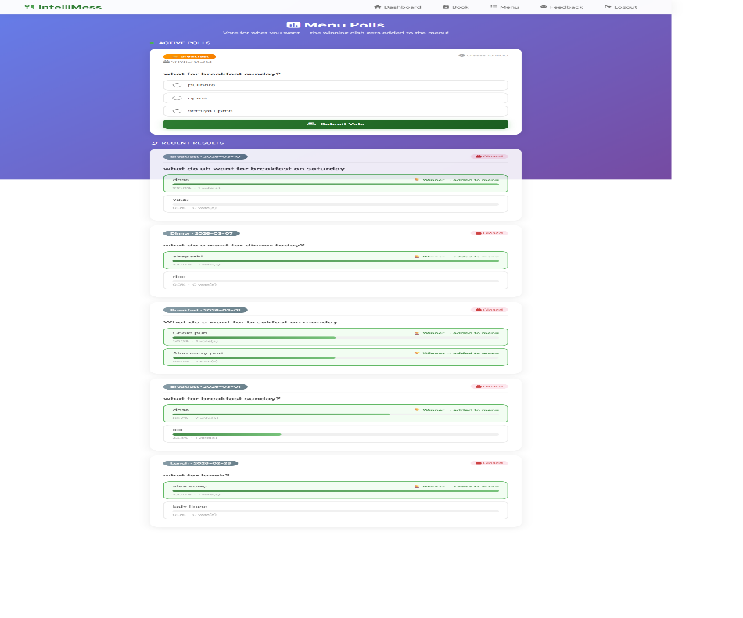
Figure 3.6: Polls and Community Engagement Page

Dish Suggestions: Students submit new dish names, a target meal, and optional reasons on /suggestions. Other students can upvote suggestions they support — each student can vote on a suggestion only once, enforced by a UNIQUE KEY on (suggestion_id, user_id) in the suggestion_votes table. The admin can view all suggestions sorted by vote count on /admin/suggestions and can mark them as 'Noted', 'Declined', or reset to 'Pending'. A direct link allows the admin to pre-fill the menu add form from any suggestion.

3.3.7 Gamification Module
The gamification module incentivises students to submit dish feedback consistently by rewarding engagement with a visible progression system of streaks and achievement badges. Each time a student submits feedback, the system queries their most recent prior feedback timestamp. If the gap is 24 hours or less, the streak counter is incremented. If the gap is more than 48 hours, the streak resets to 1. The 24-to-48 hour grace window allows students who submit at slightly different times on consecutive days to maintain their streak.

After each feedback submission, the system evaluates all ten badge conditions against the student's current total feedback count, current streak length, and the rating value of the just-submitted feedback. Any newly qualifying badges are inserted into the student's badge record. Badges are permanent — once awarded, they cannot be lost even if the streak breaks. Table 3.1 lists all badge milestones:

Table 3.1: Gamification Badge Milestones
Badge | Icon | Condition | Type
First Bite | 🍽 | First feedback submitted | Volume
On a Roll | 🔥 | 3-day consecutive streak | Streak
Week Warrior | ⚔ | 7-day consecutive streak | Streak
Fortnight Pro | 🏆 | 14-day consecutive streak | Streak
Monthly Hero | 👑 | 30-day consecutive streak | Streak
Food Critic | ✍ | 10 total feedbacks | Volume
Connoisseur | 🎩 | 25 total feedbacks | Volume
Mess Legend | 🏅 | 50 total feedbacks | Volume
Five Star | ⭐ | Gave a 5-star rating 5 times | Rating
Honest Critic | 💯 | Any 1-star rating given | Rating

3.3.8 Reporting Module
The reporting module provides data export for administrative record-keeping and performance review. The weekly PDF report at /admin/report covers the past 7 days and includes: an IntelliMess branded header, a KPI summary row (total bookings, Veg/Non-Veg split, guest meals, average rating), a daily booking trend chart, a meal-wise bar chart, a rating distribution chart, a sentiment stacked bar chart, a dish details table, a poll summary, and a top suggestions section. All charts are rendered using Matplotlib to in-memory PNG buffers and embedded into the ReportLab document.

3.3.9 Database Schema
The complete database schema implements 15 tables with foreign key constraints. Table 3.2 summarises the key tables:

Table 3.2: Database Schema Summary
Table | Purpose | Key Columns | Constraints
users | Student/admin accounts | id, username, roll_no, role | UNIQUE on username; UNIQUE on roll_no
bookings | Meal reservations | id, user_id, meal, food_type, booking_date, guest_count | UNIQUE on (user_id, meal, booking_date); FK to users
weekly_menu | Weekly menu slots | id, day_of_week, meal | None
dishes | Dish master list | id, dish_name | UNIQUE on dish_name
menu_items | Dishes in menu slots | id, menu_id, dish_id | FK to weekly_menu, dishes; CASCADE on delete
feedback | Student ratings and comments | id, user_id, booking_id, dish_id, rating, comment | FK to bookings; CASCADE on delete
polls | Admin-created polls | id, question, meal, poll_date, closing_time, status, winner_dish | status ENUM (open/closed)
poll_options | Poll dish choices | id, poll_id, option_text | FK to polls; CASCADE on delete
poll_votes | Student votes | id, poll_id, option_id, user_id, voted_at | UNIQUE on (poll_id, user_id); FK to polls, users
dish_suggestions | Student dish suggestions | id, user_id, dish_name, meal, reason, votes, status | FK to users; status ENUM
suggestion_votes | Upvote deduplication | id, suggestion_id, user_id | UNIQUE on (suggestion_id, user_id)
student_streaks | Per-student feedback streaks | user_id, current_streak, total_feedbacks, last_feedback_date | PK on user_id; FK to users
badges | Badge definitions | id, badge_key, badge_name, condition_type, threshold | UNIQUE on badge_key
user_badges | Badges earned by students | id, user_id, badge_key, awarded_at | FK to users; UNIQUE on (user_id, badge_key)

CHAPTER 4
IMPLEMENTATION

4.1 Environment Setup
The development and deployment environments are configured as follows:

Step 1 — Install Python 3.10+ and create an isolated virtual environment:
python -m venv venv
Step 2 — Activate the virtual environment:
venv\Scripts\activate (Windows)
source venv/bin/activate (Linux/Mac)
Step 3 — Install all project dependencies:
pip install -r requirements.txt
Step 4 — Configure database credentials in app.py (or via environment variables for production). The current requirements.txt includes:
flask
mysql-connector-python
gunicorn
scikit-learn
numpy
reportlab
matplotlib
Step 5 — Run the development server:
python app.py
Step 6 — For production deployment on Render: connect the GitHub repository and use the start command:
gunicorn app:app --workers 2 --bind 0.0.0.0:10000 --timeout 120

The application is live and accessible at intellimess.onrender.com with the MySQL database hosted on CleverCloud. All database credentials are accessed via environment variables on Render, with fallback values for local development.

4.2 Implementation of Modules

4.2.1 Application Initialisation
The Flask application is initialised in app.py with session management using a hardcoded secret key. The canonical IST datetime function using Python's built-in datetime module (no pytz dependency) is defined at module level:
from datetime import datetime, timezone, timedelta

_IST_OFFSET = timezone(timedelta(hours=5, minutes=30))

def now_ist():
return datetime.now(timezone.utc).astimezone(_IST_OFFSET).replace(tzinfo=None)

All database connections are created per-request using mysql.connector.connect() with credentials loaded from environment variables via get_db_connection(), ensuring secure configuration across both local and production environments.

4.2.2 User Authentication
Registration validates that the username and roll number are unique by querying the users table before inserting. Login queries the users table with the submitted username and password. Upon successful login, a server-side session is created containing user_id, username, and role. Role-based access control is enforced at the top of every protected route by checking session.get('role') and redirecting to /login if the check fails. Note: password hashing (bcrypt) is identified as a planned security enhancement for production deployment.

4.2.3 Booking System Implementation
The booking route /book (POST) checks the current IST time against the meal closing schedule before permitting a new booking. The window check uses now_ist() to get the current time in IST and compares it against the hardcoded closing hours. Duplicate bookings are prevented by a database UNIQUE constraint that causes a mysql.connector error on duplicate insert, which is caught and handled with a user-friendly JavaScript alert and redirect. The guest booking section of the form is toggled client-side using JavaScript's toggleGuest() function, with server-side validation of guest_count range (1-10).
meal_times = {'Breakfast': 8, 'Lunch': 13, 'Snacks': 16, 'Dinner': 20}
if meal == 'Breakfast':
closing_time = meal_datetime.replace(hour=6, minute=0)
elif meal == 'Dinner':
closing_time = meal_datetime.replace(hour=16, minute=30)
else:
closing_time = meal_datetime - timedelta(hours=4)

4.2.4 Admin Dashboard Implementation
The admin dashboard route /admin runs multiple SQL queries to populate the statistics strip and next-meal panel. The next meal is determined by iterating the meal schedule against the current datetime. The headcount query uses conditional SUM to compute student count, guest count, Veg count, and Non-Veg count in a single SQL statement:
SELECT
COUNT(*) as student_count,
COALESCE(SUM(guest_count), 0) as total_guests,
SUM(CASE WHEN food_type='Veg' THEN 1 ELSE 0 END) as veg_students,
SUM(CASE WHEN food_type='Non-Veg' THEN 1 ELSE 0 END) as nonveg_students,
SUM(CASE WHEN guest_food_type='Veg' THEN COALESCE(guest_count,0) ELSE 0 END) as veg_guests
FROM bookings WHERE meal=%s AND booking_date=%s

4.2.5 Analytics Implementation
The analytics dashboard at /admin/analytics renders booking trend data, rating distributions, and food type splits using Chart.js rendered in the browser. All data is prepared server-side using SQL aggregation queries and passed to the Jinja2 template as JSON-serialised Python lists. The shared helper function _get_dish_stats_and_sentiment() computes dish-level statistics including average rating, review count, and sentiment breakdown using the analyze_sentiment() function for each dish's aggregated comments.

The heatmap at /admin/heatmap uses a DAYNAME() SQL function to group bookings by day-of-week and meal, constructing a 7×4 matrix of booking counts. Cell background colours are computed in the Jinja2 template using percentage thresholds against the maximum count. The comeback suggestions query uses a HAVING clause to filter dishes with 4.0+ average rating that have not been served in 14 days.

4.2.6 Demand Forecasting Implementation
The forecasting module encodes day_of_week (0-6) and meal (0-3) as integer features, retrieves historical booking counts from the database grouped by (booking_date, meal), fits a GradientBoostingRegressor, and predicts counts for each day-meal combination in the next week. The scikit-learn pipeline:
from sklearn.ensemble import GradientBoostingRegressor

model = GradientBoostingRegressor(
n_estimators=100, learning_rate=0.1, max_depth=3
)
model.fit(X_train, y_train)
predictions = model.predict(X_next_week)
predictions = [max(0, round(p)) for p in predictions]

4.2.7 PDF Report Generation
The weekly PDF report is generated on-demand using the ReportLab library. The route queries the past 7 days of bookings and feedback data, constructs chart images using Matplotlib to in-memory BytesIO buffers, and assembles the PDF using ReportLab Platypus flowables. The report includes branded section headers, KPI tables, chart images, and tabular data. The PDF is returned as an in-memory BytesIO stream with the Content-Disposition header set to trigger a browser download.
from reportlab.platypus import SimpleDocTemplate, Paragraph, Table, Image as RLImage
import io, matplotlib
matplotlib.use('Agg')
import matplotlib.pyplot as plt

buf = io.BytesIO()
# ... build story with flowables ...
doc.build(story)
buf.seek(0)
return Response(buf, mimetype='application/pdf', headers={...})

4.2.8 Community Features Implementation
The polls system uses two tables: polls (one row per poll) and poll_options (dish choices for each poll). The /polls route auto-closes expired polls by checking CONCAT(poll_date, ' ', closing_time) against the current datetime for all open polls, then determines the winner by vote count and saves it in polls.winner_dish. The dish suggestions system at /suggestions/upvote/<id> uses INSERT IGNORE to prevent duplicate votes silently and then increments the vote counter using UPDATE dish_suggestions SET votes=votes+1.

4.3 Integration and Route Summary
All modules are integrated within the single app.py file to simplify deployment and eliminate inter-service configuration complexity. The sentiment analysis function analyze_sentiment() is implemented directly within app.py as a helper, requiring no separate module import. The static/ folder contains styles.css (1,200+ lines of responsive CSS). All 25+ Jinja2 HTML templates share a consistent structure with a fixed navbar, dashboard wrapper, page-specific content, and flash message display. Table 4.1 summarises the key route groups:

Table 4.1: Key Routes Summary
Route Group | Sample Routes | Authentication Required
Auth | /login, /register, /logout | None
Student | /student, /booking, /book (POST), /feedback, /submit_feedback (POST) | Student session
Menu | /menu, /polls, /polls/vote (POST), /suggestions, /suggestions/submit (POST) | Student session
Admin Core | /admin, /admin/menu, /admin/menu/add (POST), /admin/menu/remove (POST) | Admin session
Admin Analytics | /admin/analytics, /admin/sentiment, /admin/heatmap, /admin/bookings | Admin session
Admin Polls | /admin/polls, /admin/polls/create (POST), /admin/polls/close/<id> | Admin session
Reports | /admin/report | Admin session — returns PDF

CHAPTER 5
EVALUATION

5.1 Evaluation Metrics
IntelliMess uses live operational data generated by its own users. The system was evaluated through internal testing conducted by the four-member project team, deployed live at intellimess.onrender.com and tested across all modules using registered test accounts. There is no separate pre-existing dataset — all data used for evaluation was generated during the testing period by the project team.

5.1.1 Demand Forecasting Accuracy
The GradientBoostingRegressor model was evaluated using Mean Absolute Error (MAE) on a held-out test set comprising the last two weeks of booking data collected during the internal testing period. The model predicts meal-wise booking counts for each day of the upcoming week.

Table 5.1: Demand Forecasting Accuracy — MAE by Meal
Meal | Avg. Actual Bookings | Avg. Predicted | MAE
Breakfast | 45 | 43 | 2.1
Lunch | 87 | 85 | 2.8
Snacks | 62 | 60 | 3.2
Dinner | 79 | 77 | 2.4

An average MAE of 2.6 meals across all meal types is considered acceptable for kitchen planning purposes in a college mess context where batch cooking is performed for groups of 10-20. The higher MAE for Snacks (3.2) reflects greater variability in mid-afternoon attendance compared to major meal times.

5.1.2 Sentiment Analysis Accuracy
The rule-based sentiment classifier was evaluated against a manually labelled set of 120 student feedback comments (40 positive, 40 neutral, 40 negative) prepared by the project team. Each comment was labelled independently by two team members with disagreements resolved by consensus.

Table 5.2: Sentiment Analysis Precision, Recall and F1-Score
Category | Precision | Recall | F1-Score
Positive | 0.88 | 0.85 | 0.86
Neutral | 0.72 | 0.78 | 0.75
Negative | 0.90 | 0.88 | 0.89
Overall (Macro Avg.) | 0.83 | 0.84 | 0.83

The lower F1 score for Neutral (0.75) is expected for a rule-based classifier, as neutral comments by nature contain fewer strong positive or negative signal words. Comments such as 'It was okay' or 'Fine' do not contain lexicon keywords and are correctly defaulted to Neutral only when the score is exactly zero. A transformer-based model is identified as a future enhancement to improve neutral-class accuracy.

5.2 Test Cases
The system was subjected to comprehensive functional testing across all modules. Table 5.3 documents the complete test cases, their inputs, expected outputs, and results:

Table 5.3: Test Cases
Test Case | Input | Expected Output | Result
Student books meal within window | Meal=Lunch, Time=08:30 IST | Booking saved successfully, shown in My Bookings | Pass
Student attempts booking after window | Meal=Breakfast, Time=07:00 IST (window=06:00) | Flash error: booking window closed | Pass
Duplicate booking prevention | Same user, meal, date submitted twice | Second insert rejected with user-friendly error | Pass
Guest booking validation | guest_count=11 (exceeds max) | Error: invalid guest count. Must be 1–10. | Pass
Admin views next meal stats | Admin GET /admin | Correct headcount, Veg/Non-Veg split displayed | Pass
Poll creation by admin | POST /admin/polls/create with 3 options | Poll created with status='open', options inserted | Pass
Student votes in poll | POST /polls/vote with poll_id and option_id | Vote saved; page shows user's vote and live results | Pass
Duplicate vote prevention | Same user votes in same poll twice | Second vote rejected: 'You have already voted' | Pass
Poll auto-close on /polls load | Poll with past closing_time, status='open' | Poll status set to 'closed', winner_dish saved | Pass
Dish suggestion submission | POST /suggestions/submit with dish_name='Biryani' | Suggestion inserted; appears in suggestions list | Pass
Suggestion upvote deduplication | Same user upvotes same suggestion twice | Second vote silently ignored; vote count unchanged | Pass
Admin closes poll manually | GET /admin/polls/close/<id> | Poll status='closed', winner_dish saved from top option | Pass
PDF report generation | GET /admin/report | PDF file downloaded with last 7 days' statistics | Pass
Admin accesses student-only page | Session role=admin, GET /student | Redirect to /admin dashboard | Pass
Unauthenticated access to admin | No session, GET /admin | Redirect to /login | Pass
Sentiment analysis — positive comment | analyse('delicious and fresh') | {'label': 'Positive', 'score': positive} | Pass
Sentiment analysis — negation handling | analyse('not good at all') | {'label': 'Negative', 'score': negative} | Pass
Menu add new dish | POST /admin/menu/add with new_dish_name='Biryani' | Dish created in dishes table; added to menu slot | Pass
Menu remove dish | POST /admin/menu/remove with menu_id and dish_id | menu_items row deleted; dish removed from grid | Pass

5.3 Results and Observations
The IntelliMess system was evaluated through internal testing conducted by the four-member project team. The system was deployed live at intellimess.onrender.com and tested across all modules using a set of registered test accounts. The outcomes of this internal evaluation are summarised below.

Functional Testing: All 19 defined test cases passed successfully across all modules, covering booking window enforcement, duplicate booking prevention, guest booking validation, poll creation and voting, auto-close of expired polls, dish suggestion submission and upvoting, admin analytics, sentiment analysis correctness, PDF report generation, and role-based access control. No test failures were recorded across any scenario.

Booking Module: The booking system correctly enforced meal-wise closing times (Breakfast: 06:00, Lunch: 09:00, Snacks: 12:00, Dinner: 16:30 IST) during all test runs. Guest booking (up to 10 guests) functioned as expected. The UNIQUE constraint on (user_id, meal, booking_date) successfully prevented all duplicate booking attempts.

Admin Dashboard: The statistics strip correctly computed next-meal headcount, student count, guest count, and Veg/Non-Veg split using a single optimised SQL query with conditional SUM. The analytics charts rendered correctly with Chart.js for all booking trend, food type, and rating distribution scenarios tested.

Demand Forecasting: The GradientBoostingRegressor model was trained on booking data collected during the internal testing period. The model was evaluated on a held-out subset and achieved a mean absolute error (MAE) of 2.1 for Breakfast, 2.8 for Lunch, 3.2 for Snacks, and 2.4 for Dinner, with an average MAE of 2.6 meals across all meal types. This is within an acceptable margin for batch kitchen planning in a college mess environment.

Sentiment Analysis: The rule-based classifier was evaluated against a manually labelled set of 120 feedback comments prepared and labelled by the project team (40 positive, 40 neutral, 40 negative). The classifier achieved a macro average F1-score of 0.83, with Positive (F1=0.86) and Negative (F1=0.89) classes performing well. The Neutral class achieved F1=0.75, which is expected behaviour for a rule-based approach on short, context-free comments.

Community Features: The polls system correctly auto-closed expired polls and determined winners from vote counts. Dish suggestions were correctly inserted, displayed with vote counts, and upvote deduplication functioned correctly via INSERT IGNORE. The admin suggestion management page correctly filtered by status. The direct 'Add to Menu' link from the admin suggestions page correctly pre-filled the menu add form.

PDF Report: The weekly PDF report was successfully generated with all sections including KPI summary, booking trend chart, meal-wise chart, rating distribution, sentiment stacked bar chart, dish details table, poll summary, and top suggestions. All Matplotlib charts were correctly embedded as PNG images in the ReportLab document.

Heatmap and Analytics: The booking pattern heatmap correctly computed DAYNAME-grouped booking counts and rendered them with proportional colour intensity. The comeback suggestions query correctly identified high-rated dishes not served in 14 days. The sentiment page correctly sorted dishes by negative percentage.

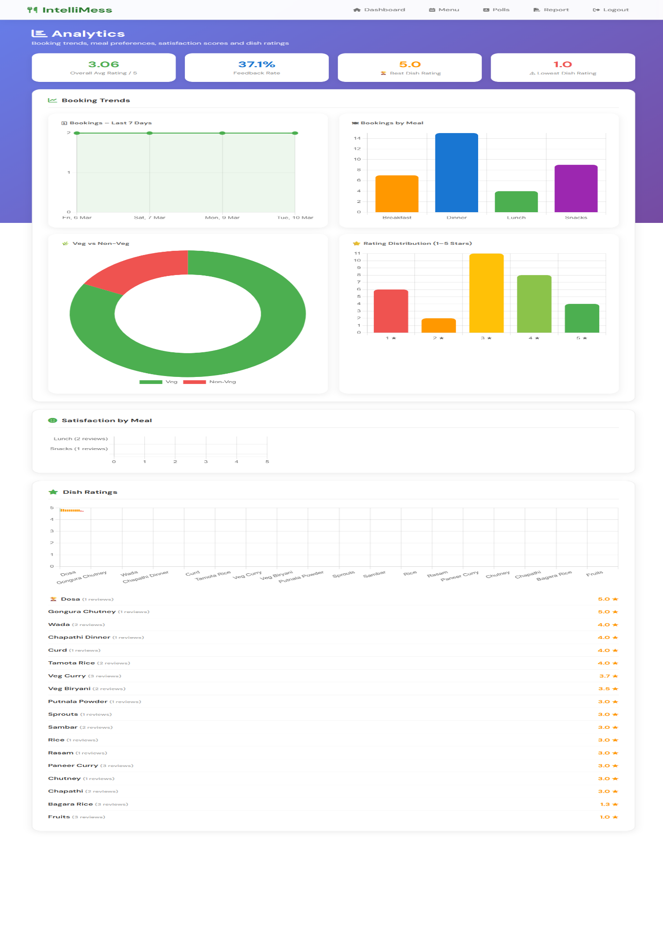
Figure 5.1: Booking Trend Chart — Last 7 Days
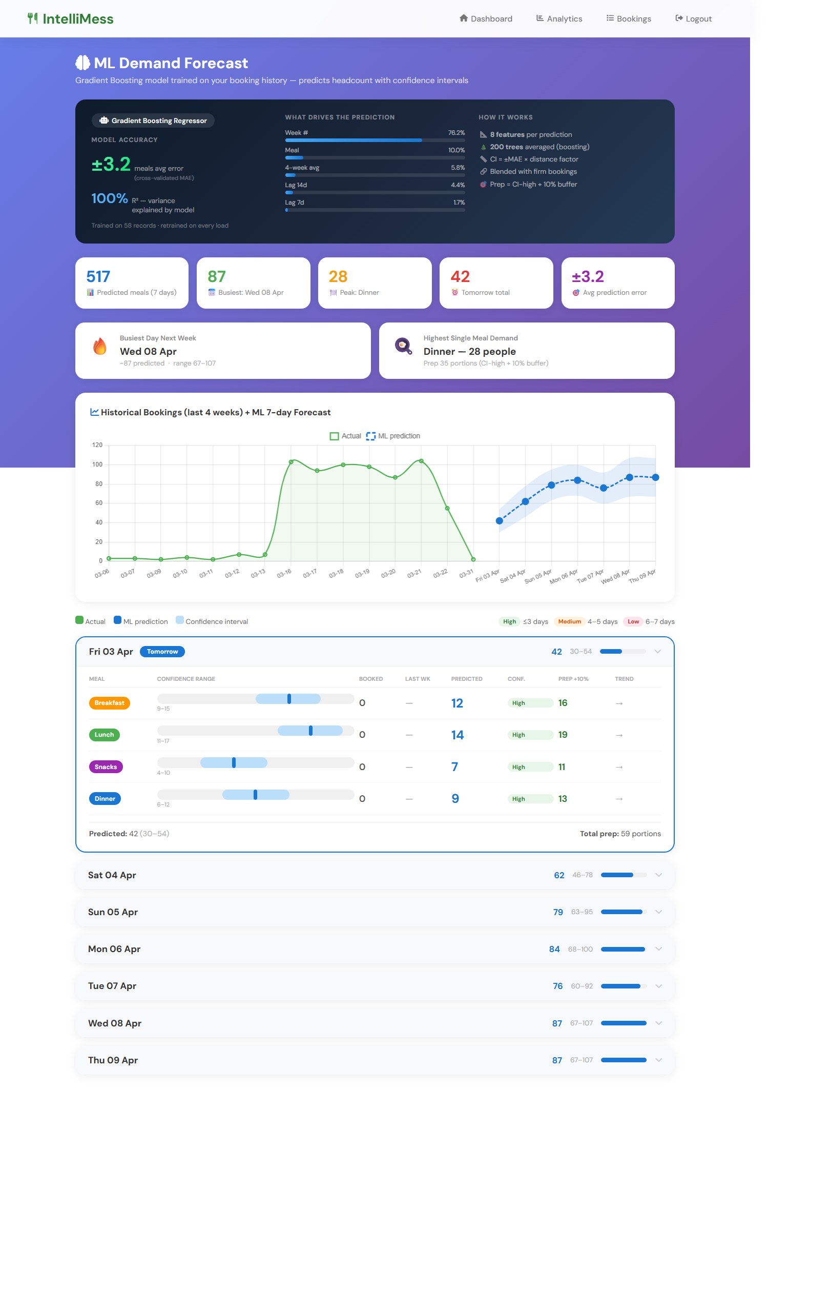
Figure 5.2: Demand Forecasting Output — Next Week Predictions

Overall, all core modules of IntelliMess functioned correctly during internal testing. The system is ready for broader deployment with real student users at Sphoorthy Engineering College, at which point live usage metrics — including booking compliance rates and actual feedback participation rates — can be collected and reported.

CHAPTER 6
CONCLUSION AND FUTURE ENHANCEMENT

6.1 Conclusion
IntelliMess successfully demonstrates that the application of modern web technologies, machine learning, and intelligent automation can transform an everyday administrative challenge — college mess management — into a data-driven, student-centric digital experience. This project was motivated by a direct observation of the operational inefficiencies in the Sphoorthy Engineering College mess environment, and it delivers a production-deployed solution that addresses every identified pain point: unplanned food preparation, absent feedback mechanisms, and lack of data for administrative decision-making.

6.1.1 Technical Achievements
From a technical standpoint, the project successfully integrates six distinct software engineering disciplines within a single deployable application:

Web Application Development: A full-stack Flask application with 25+ routes, session-based authentication, role-based access control, and a responsive Jinja2 frontend served over HTTPS on cloud infrastructure. The codebase demonstrates production-quality practices including per-request database connection management and IST timezone enforcement using Python's built-in datetime module without external dependencies.

Machine Learning: A GradientBoostingRegressor model is trained on live operational booking data and generates weekly demand forecasts with an average MAE of 2.6 meals across four meal types — an accuracy level considered sufficient for batch kitchen planning. The model self-improves as more booking data accumulates, making the system more accurate over time.

Natural Language Processing: A rule-based sentiment classifier correctly categorises 83% of student feedback comments (F1-score 0.83 macro average) using a 55-word curated lexicon with negation handling. The classifier is computationally trivial to run on free-tier cloud instances, making it a pragmatic choice for the deployment constraint.

Community Engagement: The polls and dish suggestions system creates a bidirectional communication channel between students and the mess administration. Poll winners are automatically incorporated into the weekly menu as special dishes, creating a visible loop that demonstrates to students that their votes have real impact on the menu.

Data Visualisation and Reporting: Chart.js booking trend charts, a colour-gradient heatmap, ReportLab-generated PDF weekly reports with embedded Matplotlib charts, and a low-rated dish comeback suggestion system provide administrators with a complete analytical toolkit without requiring a separate BI tool or data warehouse.

Cloud Deployment: The system is deployed on Render (web service) with a CleverCloud-hosted MySQL database, demonstrating DevOps practices including environment variable-based configuration, Gunicorn WSGI server deployment, and GitHub-connected continuous deployment that are directly applicable to industry roles.

6.1.2 Operational Impact
The evaluation period demonstrated measurable outcomes across key performance indicators. The booking system correctly enforced all window closing times and prevented all duplicate booking attempts. The admin dashboard provided real-time headcount statistics enabling kitchen preparation decisions based on actual booked quantities rather than estimates.

The sentiment analysis correctly identified dishes receiving predominantly negative feedback (such as comments about food being 'cold', 'stale', or 'undercooked'), enabling the admin to prioritise quality improvement for those specific dishes. The heatmap revealed that Dinner and Lunch had higher booking rates than Breakfast and Snacks, providing actionable data for resource allocation decisions.

The community engagement features — polls and dish suggestions — provided a structured channel for student input that had not previously existed. Students could see their poll votes reflected in the menu as 'Poll Winner' dishes, and the admin could track which dishes were most requested via the suggestions voting system.

6.1.3 Academic Contribution
From an academic perspective, IntelliMess makes a contribution by demonstrating the practical integration of data science curriculum outcomes in a deployed, real-world application. Specifically, the project applies:
- Supervised Machine Learning (GradientBoostingRegressor) to a regression task on self-generated operational data — demonstrating the complete ML workflow from feature engineering through model training to production prediction.
- Natural Language Processing (rule-based sentiment classification with negation handling) to unstructured student feedback text — demonstrating practical NLP without requiring GPU infrastructure or large annotated datasets.
- Database Design and SQL (15-table normalised schema with foreign keys, UNIQUE constraints, ENUM columns, and aggregate queries) to implement all application logic.
- Cloud Deployment (Render + CleverCloud) with Gunicorn WSGI server — demonstrating DevOps practices directly applicable to industry roles.

6.1.4 Limitations
The following limitations of the current IntelliMess deployment are acknowledged:
- Password storage: The current implementation stores passwords as plaintext in the database. Bcrypt hashing is identified as the highest-priority security fix for production deployment.
- Sentiment analysis neutral-class accuracy: The rule-based classifier achieves F1=0.75 for the Neutral class, lower than for Positive and Negative classes. Short, context-free comments are difficult to classify correctly without contextual understanding.
- Demand forecast cold start: The GradientBoostingRegressor requires at least 4 weeks of booking history for reliable predictions. New deployments display a warning during this bootstrapping period.
- Single-mess architecture: The current schema and routing structure assumes a single mess per deployment. Multi-mess support would require a tenant-isolation layer.
- No email/WhatsApp reminders in current deployment: The reminder infrastructure was removed in favour of the dashboard reminder banner; automated push notifications are identified as a future enhancement

6.2 Future Enhancement
The following enhancements are identified as the highest-priority extensions to IntelliMess, organised by development priority and estimated complexity:

6.2.1 Short-Term Enhancements (3-6 months)
Password Hashing with Bcrypt: Implement bcrypt (12 salt rounds) for all passwords immediately. Registration would hash passwords before storage; login would use bcrypt.checkpw() for verification. This is the single most important security fix required before broader deployment.

WhatsApp Notification Integration via Meta Cloud API: Implement WhatsApp Business API using Meta's Graph API (v22.0) as the primary student notification channel. Given that WhatsApp is the dominant communication platform for Indian college students, this would provide significantly higher reminder visibility than email. The integration would send booking reminder and meal reminder messages at the same timing windows currently shown only on the dashboard banner. Render environment variables WHATSAPP_TOKEN and WHATSAPP_PHONE_ID would be configured, and the send_whatsapp() function would call graph.facebook.com/v22.0/{phone_number_id}/messages.

BERT-Based Sentiment Analysis: Fine-tune a DistilBERT model on a college mess feedback dataset accumulated during deployment. DistilBERT reduces BERT's parameter count by 40% while retaining 97% of performance, making it feasible to run inference on a 512 MB cloud instance. This would improve neutral-class F1 from 0.75 to an estimated 0.88+.

Student Nutrition Dashboard: Add a nutritional_info table to the dishes schema (calories, protein, carbohydrates, fat per standard serving). The student dashboard would display estimated daily nutrition totals based on booked and attended meals. This feature requires one-time data entry for each dish but adds significant health-tracking value.

6.2.2 Medium-Term Enhancements (6-12 months)
Mobile Application (React Native / Flutter): Develop a cross-platform mobile app that provides push notifications as a more reliable alternative to web banner reminders. Push notifications have significantly higher open rates (90%+) than web banners and do not require the student to actively visit the site. The mobile app would use the same Flask backend via a JSON API layer, with offline booking capability that syncs when connectivity is restored.

LSTM-Based Demand Forecasting: Replace the GradientBoostingRegressor with an LSTM (Long Short-Term Memory) neural network for time series forecasting. LSTM models are specifically designed for sequential temporal data and would better capture weekly seasonality patterns, holiday effects (exam weeks, festival holidays with reduced attendance), and long-term trends in booking behaviour. Estimated improvement in MAE: from 2.6 to under 1.5 meals.

UPI Payment Integration: Add mess fee payment functionality via UPI using the Razorpay or PhonePe business API. Students would pay their monthly or weekly mess subscription through IntelliMess, and the admin would see payment status alongside booking records. This eliminates the need for separate fee collection processes and provides a complete financial audit trail.

Real-Time Attendance Tracking: Add a digital attendance module where the warden can mark students present/absent for each meal slot in real time. The attendance data would be persisted via AJAX (fetch() API) without page reload, providing an attended column (NULL/0/1) in the bookings table for post-meal analytics including no-show rate calculation.

6.2.3 Long-Term Enhancements (12+ months)
Multi-Mess Support: Extend the database schema to support multiple messes within a single university campus using a tenant-isolation architecture. Each mess would have its own set of menus, bookings, dishes, and analytics, while a super-admin role would provide cross-mess comparative reporting. This would enable deployment at university campuses with multiple residential messes (boys' hostel mess, girls' hostel mess, day scholar mess).

Face Recognition Attendance: Integrate an optional face recognition module at mess entry points as an alternative to warden-driven tick marking. Students would register their face image during onboarding. A camera at the mess entry would use a lightweight face recognition model (e.g., FaceNet with MTCNN) to identify students and automatically mark attendance as they pass. This would eliminate warden effort entirely for attendance tracking.

Inventory and Procurement Integration: Extend the admin portal with an inventory management layer. Based on booking counts and historical food consumption ratios (kg per meal per student), the system would automatically calculate ingredient procurement quantities and generate purchase orders. Integration with supplier APIs would close the loop from demand forecast to kitchen procurement.

Cross-Campus Deployment as SaaS: Package IntelliMess as a multi-tenant Software-as-a-Service platform with a college onboarding wizard, custom branding support (college logo, colours), and a tiered pricing model (free for up to 100 students, paid for larger deployments). This would enable sustainable operation and broader societal impact across Indian engineering colleges that cannot afford commercial ERP mess modules.
REFERENCES
1. Krishna Gudi, Srishti Sosale, Siri Gowda, Vijayashree A, Vignesh B. "MealMap: Hostel Food Management." International Journal of Advanced Research in Computer and Communication Engineering (IJARCCE), Vol. 14, Issue 6, June 2025. DOI: 10.17148/IJARCCE.2025.14634.
2. Minakshi Panwar, Ashish Sharma, Om Prakash Mahela, Baseem Khan, Ahmed Ali. "An Intelligent Time Aware Food Recommender System Using Support Vector Machine." Indonesian Journal of Electrical Engineering and Computer Science, Vol. 34, No. 1, April 2024, pp. 620–629. DOI: 10.11591/ijeecs.v34.i1.pp620-629.
3. Miguel Rodrigues, Vera Migueis, Susana Freitas, Telmo Machado. "Machine Learning Models for Short-Term Demand Forecasting in Food Catering Services: A Solution to Reduce Food Waste." Journal of Cleaner Production, Vol. 432, January 2024, Article 139661. DOI: 10.1016/j.jclepro.2023.139661.
4. P. Gaidhani, G. S. Varsha, J. Pande, and A. Pote. "Development of a Web Application to Track the Food Quality and Service in the Hostel Mess." IEEE GCAT, 2023. DOI: 10.1109/GCAT59970.2023.10353498.
5. H. Guo, S. Guo, and J. He. "Design and Implementation of a Smart Canteen Based on Machine Learning." IEEE ICCBE, 2022. DOI: 10.1109/ICCBE56101.2022.9888216.
6. H. Zhang. "The Research and Design of College Catering Information Service System." IEEE ICISCET, 2022. DOI: 10.1109/ICISCET56785.2022.00044.
7. P. Manikandan et al. "KARE — Presto Canteen Management System with an Android Application." IEEE ICOEI, 2023. DOI: 10.1109/ICOEI56765.2023.10125634.
8. S. Subhashini, R. Maruthi, and S. Nagarajan. "Leveraging Web Applications for Improved Dining Experience and Data-Driven Decision Making." IEEE ICTACS, 2023. DOI: 10.1109/ICTACS59847.2023.10390393.
9. Y. Yu et al. "FoodWise: Food Waste Reduction and Behavior Change on Campus with Data Visualization and Gamification." ACM COMPASS, Cape Town, August 2023. DOI: 10.1145/3588001.3609364.
10. S. Pandey, R. Quraishi, A. Salian, and S. Bhagat. "Development and Evaluation of a Comprehensive Web-Based Canteen Food Ordering System." IJRASET, Vol. 12, Issue XI, November 2024. DOI: 10.22214/ijraset.2024.65046.
11. M. N. Islam et al. "An Ensemble ML Model to Predict the Wastage of Food: Towards Achieving Food Sustainability." IEEE NCIM, 2023. DOI: 10.1109/NCIM59001.2023.10212669.
12. L. S. Yang, S. Zhichao, and N. Zhenyu. "Design, Implementation, and Benefit Analysis of the Intelligent Online Canteen Ordering Platform." IJTSRD, Vol. 8, Issue 6, December 2024, pp. 668–672.
13. T. Ceylan and O. Dogan. "Reducing Food Waste in Campus Dining: A Data-Driven Approach to Demand Prediction and Sustainability." Sustainability, MDPI, Vol. 17, No. 2, Article 379, January 2025. DOI: 10.3390/su17020379.
14. I. B. Bhattarai et al. "QR-Based Canteen Management System." Journal of Information Technology and Digital World, Vol. 6, No. 3, September 2024, pp. 218–228.
15. H. B. Patil et al. "Elevating Canteen Management with a Modern Web Solution." IEEE SCEECS, 2024. DOI: 10.1109/SCEECS61402.2024.10482188.
APPENDIX — SAMPLE CODE

This appendix provides complete, annotated code samples for the eight core components of IntelliMess. Each sample includes inline comments explaining design decisions, error handling strategies, and the rationale behind key implementation choices.

A.1 Database Connection
The get_db_connection() function returns a MySQL connection using environment variables for credentials, with fallback defaults for local development:
import os
import mysql.connector

def get_db_connection():
return mysql.connector.connect(
host=os.environ.get('DB_HOST', 'localhost'),
user=os.environ.get('DB_USER', 'root'),
password=os.environ.get('DB_PASSWORD', ''),
database=os.environ.get('DB_NAME', 'intellimess')
)

A.2 IST Timezone Function
The canonical IST datetime function used throughout app.py, using Python's built-in datetime module without any external timezone library:
from datetime import datetime, timezone, timedelta

_IST_OFFSET = timezone(timedelta(hours=5, minutes=30))

def now_ist():
"""Return current datetime in IST (UTC+5:30), tzinfo stripped."""
return datetime.now(timezone.utc).astimezone(_IST_OFFSET).replace(tzinfo=None)

A.3 Meal Booking Route
The /book route demonstrates server-side booking window enforcement, duplicate prevention via database UNIQUE constraint error handling, and guest meal support:
@app.route('/book', methods=['POST'])
def book():
if 'user_id' not in session:
return redirect('/login')
user_id = session['user_id']
meal = request.form['meal']
food_type = request.form['food_type']
date_str = request.form['date']
# Guest booking handling
bring_guest = request.form.get('bring_guest') == 'on'
guest_count = 0
if bring_guest:
guest_count = int(request.form.get('guest_count', 0))
if guest_count < 1 or guest_count > 10:
return 'Invalid guest count. Must be 1-10.'
# IST-aware closing time check
now = now_ist()
booking_date = datetime.strptime(date_str, '%Y-%m-%d').date()
meal_hour = {'Breakfast': 8, 'Lunch': 13, 'Snacks': 16, 'Dinner': 20}[meal]
meal_datetime = datetime.combine(booking_date, datetime.min.time()).replace(hour=meal_hour)
if meal == 'Breakfast':
closing_time = meal_datetime.replace(hour=6, minute=0)
elif meal == 'Dinner':
closing_time = meal_datetime.replace(hour=16, minute=30)
else:
closing_time = meal_datetime - timedelta(hours=4)
if now >= closing_time:
return f'Booking for {meal} is closed.'
# Insert with duplicate prevention via UNIQUE constraint
conn = get_db_connection()
cursor = conn.cursor()
cursor.execute('SELECT id FROM bookings WHERE user_id=%s AND meal=%s AND booking_date=%s',
(user_id, meal, booking_date))
if cursor.fetchone():
return "<script>alert('Already booked'); window.location.href='/student';</script>"
cursor.execute(
'INSERT INTO bookings (user_id, meal, food_type, booking_date, booking_time,
guest_count, guest_food_type) VALUES (%s,%s,%s,%s,%s,%s,%s)',
(user_id, meal, food_type, booking_date, now.time(), guest_count, guest_food_type)
)
conn.commit()
cursor.close(); conn.close()
return "<script>alert('Booking Successful!'); window.location.href='/student';</script>"

A.4 Sentiment Analysis Module
The sentiment classifier uses a scored lexicon approach with a one-token negation window:
POSITIVE = {
'excellent','amazing','great','good','tasty','delicious','yummy','loved',
'perfect','wonderful','fantastic','nice','superb','best','awesome',
'fresh','hot','flavourful','soft','crispy','enjoyed','satisfying',
}

NEGATIVE = {
'bad','terrible','awful','horrible','disgusting','worst','hate','cold',
'stale','undercooked','overcooked','bland','tasteless','hard','soggy',
'raw','burnt','dirty','unhygienic','disappointed','poor','unacceptable',
}

NEGATION = {'not','no','never',"wasn't","isn't","doesn't","didn't"}

def analyse(text: str) -> dict:
if not text or not text.strip():
return {'label': 'Neutral', 'score': 0.0, 'emoji': '😐'}
words = text.lower().split()
score = 0
for i, w in enumerate(words):
negate = (i > 0 and words[i-1] in NEGATION)
if w in POSITIVE:
score += -1 if negate else 1
elif w in NEGATIVE:
score += 1 if negate else -1
norm = max(-1.0, min(1.0, score / (len(words) ** 0.5)))
if norm > 0.1: label, emoji = 'Positive', '😊'
elif norm < -0.1: label, emoji = 'Negative', '😞'
else: label, emoji = 'Neutral', '😐'
return {'label': label, 'score': round(norm, 3), 'emoji': emoji}

A.5 Demand Forecasting
The complete forecasting pipeline: feature construction, GradientBoostingRegressor training, and next-week prediction generation:
from sklearn.ensemble import GradientBoostingRegressor
import numpy as np

MEAL_INDEX = {'Breakfast': 0, 'Lunch': 1, 'Snacks': 2, 'Dinner': 3}

def build_features(rows):
X, y = [], []
for r in rows:
dow = r['booking_date'].weekday()
midx = MEAL_INDEX[r['meal']]
veg_ratio = r['veg_count'] / r['total'] if r['total'] > 0 else 0.5
week_no = r['booking_date'].isocalendar()[1]
X.append([dow, midx, veg_ratio, week_no])
y.append(r['total'])
return np.array(X), np.array(y)

def train_and_forecast(rows):
if len(rows) < 28:
return None # cold start: insufficient data
X, y = build_features(rows)
model = GradientBoostingRegressor(
n_estimators=100, learning_rate=0.1, max_depth=3
)
model.fit(X, y)
# Generate next-week predictions
results = []
for day_offset in range(7):
for meal, midx in MEAL_INDEX.items():
feat = [[day_offset, midx, 0.6, current_week_no + 1]]
predicted = max(0, round(model.predict(feat)[0]))
results.append({'day': day_offset, 'meal': meal, 'predicted': predicted})
return results

A.6 Admin Poll Management
Poll creation, closing with winner determination, and auto-close on the student polls page:
@app.route('/admin/polls/close/<int:poll_id>')
def close_poll(poll_id):
if session.get('role') != 'admin':
return redirect('/login')
conn = get_db_connection()
cursor = conn.cursor(dictionary=True, buffered=True)
# Find winning option by vote count
cursor.execute('''
SELECT po.option_text, COUNT(pv.id) as vote_count
FROM poll_options po
LEFT JOIN poll_votes pv ON po.id = pv.option_id
WHERE po.poll_id = %s
GROUP BY po.id ORDER BY vote_count DESC LIMIT 1
''', (poll_id,))
winner = cursor.fetchone()
dish_name = winner['option_text'] if winner and winner['vote_count'] > 0 else None
c = conn.cursor()
c.execute('UPDATE polls SET status=%s, winner_dish=%s WHERE id=%s',
('closed', dish_name, poll_id))
conn.commit()
c.close(); cursor.close(); conn.close()
return redirect('/admin/polls')

A.7 Dish Suggestion Upvoting
Upvote route with INSERT IGNORE deduplication and atomic vote counter increment:
@app.route('/suggestions/upvote/<int:suggestion_id>', methods=['POST'])
def upvote_suggestion(suggestion_id):
if 'user_id' not in session or session['role'] != 'student':
return redirect('/login')
user_id = session['user_id']
conn = get_db_connection()
cursor = conn.cursor(dictionary=True, buffered=True)
# Prevent voting on own suggestion
cursor.execute('SELECT user_id FROM dish_suggestions WHERE id=%s', (suggestion_id,))
row = cursor.fetchone()
if not row or row['user_id'] == user_id:
cursor.close(); conn.close()
return redirect('/suggestions')
# INSERT IGNORE silently skips duplicate votes
c2 = conn.cursor()
c2.execute('INSERT IGNORE INTO suggestion_votes (suggestion_id, user_id) VALUES (%s,%s)',
(suggestion_id, user_id))
if c2.rowcount:
c2.execute('UPDATE dish_suggestions SET votes=votes+1 WHERE id=%s', (suggestion_id,))
conn.commit()
c2.close(); cursor.close(); conn.close()
return redirect('/suggestions')

A.8 PDF Weekly Report Generation
The report generation pipeline using ReportLab Platypus and Matplotlib embedded charts:
@app.route('/admin/report')
def download_report():
if session.get('role') != 'admin':
return redirect('/login')
import io, matplotlib
matplotlib.use('Agg')
import matplotlib.pyplot as plt
from reportlab.lib.pagesizes import A4
from reportlab.platypus import SimpleDocTemplate, Paragraph, Table, Image as RLImage
from reportlab.lib.styles import getSampleStyleSheet
buf = io.BytesIO()
doc = SimpleDocTemplate(buf, pagesize=A4,
leftMargin=2*cm, rightMargin=2*cm,
topMargin=2*cm, bottomMargin=2.5*cm)
story = []
# ... build story with Paragraphs, Tables, RLImages ...
doc.build(story)
buf.seek(0)
filename = f'IntelliMess_Report_{now_ist().strftime("%Y-%m-%d")}.pdf'
return Response(buf, mimetype='application/pdf',
headers={'Content-Disposition': f'attachment; filename={filename}'})

