AN AI-DRIVEN FRAMEWORK FOR WILDLIFE CONFLICT PREDICTION AND CONSERVATION IN SRI LANKA

25-26J-243
Project Proposal Report

Perera K.D.G – IT22108340

B.Sc. (Hons) Degree in Information Technology Specialized in Information Technology

Department of Information Technology

Sri Lanka Institute of Information Technology Sri Lanka
August 2025

AN AI-DRIVEN FRAMEWORK FOR WILDLIFE CONFLICT PREDICTION AND CONSERVATION IN SRI LANKA

25-26J-243

Project Proposal Report
Kalathanthrige Dishan Gimhan Perera– IT22108340
Supervisor: Dr. Nathali Silva

B.Sc. (Hons) Degree in Information Technology Specialized in Information Technology

Department of Information Technology
Sri Lanka Institute of Information Technology Sri Lanka
August 2025

DECLARATION

We declare that this is our own work, and this proposal does not incorporate without acknowledgement any material previously submitted for a degree or diploma in any other university or Institute of higher learning and to the best of our knowledge and belief it does not contain any material previously published or written by another person except where the acknowledgement is made in the text.

Name | Student ID | Signature
Perera K.D.G | IT22108340

The above candidates are carrying out research for the undergraduate Dissertation under my supervision.

8/37/2025
----------------------------------- ----------------------------
Signature of the supervisor Date

----------------------------------- ----------------------------
Signature of the Co - supervisor Date

ABSTRACT

Large Language Models (LLMs) are being used more in the medical field for question-answering tasks. However, they often give incorrect or misleading responses, which can be dangerous in clinical and healthcare settings. This study aims to reduce these inaccuracies in LLMs by improving the Retrieval-Augmented Generation (RAG) pipeline. It does this by integrating Hypothetical Document Embeddings (HyDE) and instruction-aware embeddings.
HyDE enhances retrieval quality by first creating a hypothetical document from a user query using an instruction-following LLM. This document captures relevant patterns. Then, it retrieves real documents from a vector store based on the embeddings of this hypothetical document. Instruction-aware embeddings work alongside this by encoding texts with task-specific instructions. This ensures that the embeddings reflect the intended use and context of the domain effectively.
The research will establish a local, private, domain-specific RAG interface for the medical field. This will allow users to ask questions and obtain more accurate, contextually relevant answers. The study uses a mix of vector-based retrieval evaluation, relevance ranking, and hallucination measurement to evaluate how well the proposed system works. The expected results include better factual consistency, higher retrieval accuracy, and improved interpretability compared to standard RAG pipelines. This work offers a practical framework for safe and reliable medical question-answering. It shows how domain-specific instruction-aware embeddings and hypothetical document generation can together help reduce inaccuracies in LLM responses.

TABLE OF CONTENTS

DECLARATION 3
ABSTRACT 4
TABLE OF CONTENTS 5
LIST OF FIGURES 6
LIST OF TABLES 7
LIST OF ABBREVIATIONS 8
1. INTRODUCTION 9
1.1 BACKGROUND & LITERATURE SURVEY 10
1.2 RESEARCH GAP 12
1.3 RESEARCH PROBLEM 14
MAIN OBJECTIVES 15
SPECIFIC OBJECTIVES 16
METHODOLOGY 17
REFERENCE LIST 20
APPENDICES 21

LIST OF FIGURES
Figure 1: Whole System Diagram…………………………………………………………………..7
Figure 2: Smart AVC System Diagram……………………………………………………………..8
Figure 3: Gantt Chart………………………………………………………………………………10

LIST OF TABLES

Table 1: Budget Breakdown 12

1.INTRODUCTION

Large Language Models (LLMs) have significantly advanced natural language processing (NLP) by enabling systems to perform tasks like summarization, dialogue, and question answering with high fluency. Their ability to produce human-like responses makes them particularly attractive for domains where timely and accurate information is critical, such as medicine. However, a major limitation of these models is their tendency to generate inaccurate or fabricated outputs, commonly referred to as hallucinations. In medical contexts, such errors can have serious consequences, making reliability a paramount concern.
Retrieval-Augmented Generation (RAG) has emerged as a promising approach to mitigate this issue. By combining document retrieval with generative models, RAG grounds responses in external knowledge sources rather than relying solely on the LLM’s memorized data. While RAG improves factual accuracy, basic pipelines still face challenges in specialized domains such as healthcare. Complex medical terminology, ambiguous meanings, and hierarchical knowledge structures can lead to the retrieval of irrelevant or weakly relevant information. Even when documents are retrieved, generative models may still hallucinate if the retrieved content lacks precision or contextual alignment.
In this research, our approach is to develop a locally runnable medical Q&A system consisting of four RAG pipelines, each specialized in one or more medical disciplines. The system will utilize the MIRIAD (Medical Instruction and Retrieval Dataset), which contains 5.8 million question–answer pairs, as its primary external knowledge source. Specifically, my component focuses on enhancing the vector embedding stage within these pipelines. By implementing Hypothetical Document Embeddings to generate hypothetical documents and combining them with instruction-aware embeddings, the system aims to retrieve semantically aligned medical documents more effectively. This approach improves the relevance, factual correctness, and overall reliability of generated medical answers.
The expected outcome of this research is a robust, locally deployable, and domain-specific RAG system capable of delivering precise and contextually relevant medical responses. This has significant implications for AI-assisted healthcare, enhancing both clinical decision support and patient information access while maintaining high standards of accuracy and trustworthiness.

BACKGROUND & LITERATURE SURVEY
Wildlife conflict in Sri Lanka is a serious environmental and socio-economic challenge, largely driven by rapid habitat fragmentation caused by agricultural expansion, infrastructure development, and human settlements. These changes force species such as elephants into closer contact with people, resulting in crop destruction, property damage, injuries, and even fatalities. The main issues include Human-Elephant Conflict (HEC), animal-vehicle collisions (AVCs), poaching, and the loss of natural movement corridors. Together, these problems endanger biodiversity and undermine rural livelihoods. Within the Centre of Excellence for AI (CoEAI), this topic holds special importance as it combines conservation needs with technological innovation, aiming to build sustainable models of coexistence. The urgency stems not only from the direct losses—such as reduced harvests and declining wildlife populations—but also from indirect impacts like fear, stress, and economic instability within rural communities. This makes integrated solutions essential, ensuring both ecological protection and community resilience.
Research has shown that wildlife movement is strongly influenced by ecological and temporal factors, including rainfall patterns, vegetation indices such as the Normalized Difference Vegetation Index (NDVI), seasonal variations, land-use change, and water availability. These variables often align with conflict risks. Current mitigation strategies include electric fencing, patrols, and the use of GPS collars to track elephant movements. However, these methods are mostly reactive, expensive, invasive, and difficult to scale. In the case of AVCs, road safety campaigns and warning signs are widely used, but they rarely incorporate predictive insights. Similarly, anti-poaching measures rely heavily on manual monitoring, which makes them slow to respond. Meanwhile, remote sensing and spatial modeling have been useful in assessing land cover change and erosion risk, offering data-driven perspectives on habitat dynamics.
Recent advances in conservation science increasingly apply AI and machine learning to predictive modeling, including habitat connectivity analysis and corridor design to counter habitat fragmentation. In Sri Lanka, efforts have begun to restore wildlife corridors for elephants and leopards, using techniques like graph-theoretic optimization and least-cost modeling to strengthen connectivity despite ongoing deforestation. These projects combine satellite imagery with IoT-enabled monitoring, marking a shift from traditional, reactive methods to proactive, technology-driven strategies.
While earlier work has captured the scale of habitat loss and explored mitigation techniques, it has often lacked integrated predictive systems that can combine multiple environmental factors for early intervention. The framework proposed in this study addresses that gap. By integrating machine learning, remote sensing, and ecological modeling, it builds a corridor optimization system capable of analyzing and strengthening wildlife movement paths. Unlike conventional approaches such as fencing or collaring, which focus on managing conflict after it occurs, this approach emphasizes proactive, data-driven predictions linked to NDVI and land-use dynamics. In doing so, it offers a more scalable and integrated path toward sustainable human-wildlife coexistence in Sri Lanka.

1.2 RESEARCH GAP

Research on wildlife corridor management shows there are still big gaps, especially in Sri Lanka where Human-Elephant Conflict (HEC) is severe. Many studies have looked at land cover changes and where conflicts happen, but they do not use AI or real-time data to make corridors smarter and more effective. For example, Jayakody et al. (2024) used the MaxEnt tool with 13 fixed factors like elevation, vegetation, and distance to elephant ranges to make a risk map for HEC across Sri Lanka. While useful, this map is static and cannot adapt when elephant movements or land use change. In the same way, tools like InVEST can show habitat quality and possible corridors but cannot work with live data from the field. This is a problem because HEC has become worse with land change, with more than 1,700 people and 4,800 elephants killed between 1991 and 2018, and most elephants now moving outside protected areas in farms and villages. Current solutions, such as electric fences and barriers, are also static and reactive, and researchers warn they sometimes block important paths, cutting off elephant movement instead of helping it. On the other hand, AI and machine learning have the power to bring many kinds of data together—like GPS tracking, acoustic sensors, satellite images, and climate records—to predict elephant paths, test corridor safety, and even simulate how elephants might move in different situations. In other countries, new projects already show how GPS collars, sound-based monitoring, and AI mapping can find real elephant routes and conflict hotspots, which helps managers act before problems happen. But in Sri Lanka, there is still no system that combines real-time tracking, adaptive machine learning, and predictive risk tools to improve corridors. This research aims to solve that problem by creating an AI-based geospatial model that uses both past and live data to automatically find, test, and improve corridors, classify risk levels, and send quick alerts to stakeholders. Unlike fences and static maps, this method is proactive, scalable, and dynamic, offering a better way to manage elephant movement and reduce conflict. It also matches the IT4010 research workshop’s goal of managing time and resources well while delivering innovative results that make a real impact for both science and conservation.

3 RESEARCH PROBLEM
In Sri Lanka, elephants and people have shared the same landscapes for centuries. But with farms, roads, and settlements expanding into elephant habitats, this balance is breaking down. Every year, elephants wander into villages searching for food and water, while families struggle to protect their crops, homes, and loved ones. These encounters often end in tragedy—destroyed harvests, damaged property, injuries, and even deaths on both sides. For many rural communities, this conflict is not just an environmental issue, but also a daily struggle for survival and livelihood.
Traditional solutions like electric fences, patrols, or GPS collars have provided some help, but they are costly, reactive, and not flexible enough to adapt to the way elephants move across changing landscapes. Likewise, existing corridor mapping efforts depend heavily on manual GIS analysis, which does not use real-time data or predictive insights to anticipate risks before they happen. This leaves both elephants and communities vulnerable.
The challenge, then, is clear: Sri Lanka lacks an integrated, intelligent system that can proactively identify and optimize elephant corridors while also keeping people safe. This research aims to bridge that gap by using artificial intelligence and geospatial modeling to map and predict elephant movement. By analyzing elephant GPS tracking data together with land use, water sources, villages, and roads, the system will create smarter, safer migration pathways. Such a solution can reduce unexpected encounters, improve conservation planning, and give timely alerts to local communities—helping protect both human lives and elephant populations for the future.

OBJECTIVES

MAIN OBJECTIVES

The main objective of this research is to develop an AI-driven system that can predict the daily likelihood of elephants moving into human settlements by analyzing environmental and temporal factors such as rainfall, vegetation growth, and past conflict patterns. Instead of relying solely on GPS collars, the system will use data-driven insights to generate early warnings, guide route-based patrols, and optimize elephant corridor connectivity. By doing so, it aims to minimize crop damage, safeguard human lives, and strengthen safe coexistence between people and elephants through improved corridor management.
2.2 SUB OBJECTIVES
- Data Integration
  - To design a system that supports the import and management of heterogeneous datasets, including elephant movement patterns, land use maps, water sources, roads, and human settlement information.
- AI-driven Corridor Identification
  - To develop machine learning models that analyze both historical and real-time data to identify new potential elephant corridors.
- Evaluation of Existing Corridors
  - To assess the effectiveness, safety, and usage of existing elephant corridors through AI/ML-based analysis.
- Interactive Corridor Visualization
  - To build an interactive map that displays both existing and predicted elephant corridors using geospatial (latitude/longitude) data.
- Risk-based Area Classification
  - To implement a risk classification mechanism that categorizes geographic regions into high-risk, medium-risk, and low-risk zones based on corridor proximity and activity.
- User Proximity Notifications
  - To provide users with intelligent notifications indicating whether their area is near or far from identified elephant corridors, enabling preventive awareness.

3.METHODOLOGY

- Data Collection
The system collects diverse datasets essential for corridor analysis, including elephant GPS movement data, land-use maps, forest cover, water sources, roads, and human settlement information. Historical records of elephant movement and known corridor locations are also incorporated to provide both ecological and anthropogenic context.
- Centralized Data Processing Server
A centralized server aggregates and preprocesses the collected datasets. Tasks such as data cleaning, normalization, and spatial integration are performed to ensure the data is consistent and analysis-ready. Security measures such as encryption and access control are applied to protect sensitive information.
- Machine Learning Model
Advanced AI/ML models are applied to identify and predict elephant corridors. Techniques such as clustering (for movement paths), Random Forests, and LSTM networks (for temporal-spatial trends) are used to uncover potential new corridors and evaluate the usage of existing ones. These models also help classify risk levels along corridors.
4. GIS & Visualization Layer
Geographic Information Systems (GIS) are used to generate corridor maps that show both existing and predicted corridors. Heatmaps highlight areas of high elephant activity, while classification layers distinguish high-risk and low-risk sections. A temporal visualization feature shows seasonal variations in corridor use.
5. User Interface / Dashboard
An interactive dashboard provides stakeholders (farmers, wildlife officers, and planners) with real-time corridor visualizations. Features include corridor maps, risk classifications, seasonal usage calendars, and alerts about elephant proximity to human settlements near corridors. The interface is designed to be intuitive and action-oriented.
6. Validation & Testing
Corridor predictions are validated against actual elephant movement data and verified reports of elephant crossings. Statistical metrics such as accuracy, precision, and recall are used to evaluate performance. Continuous retraining with new movement and environmental data ensures the system adapts and improves over time.

SYSTEM ARCHITECTURE DIAGRAM
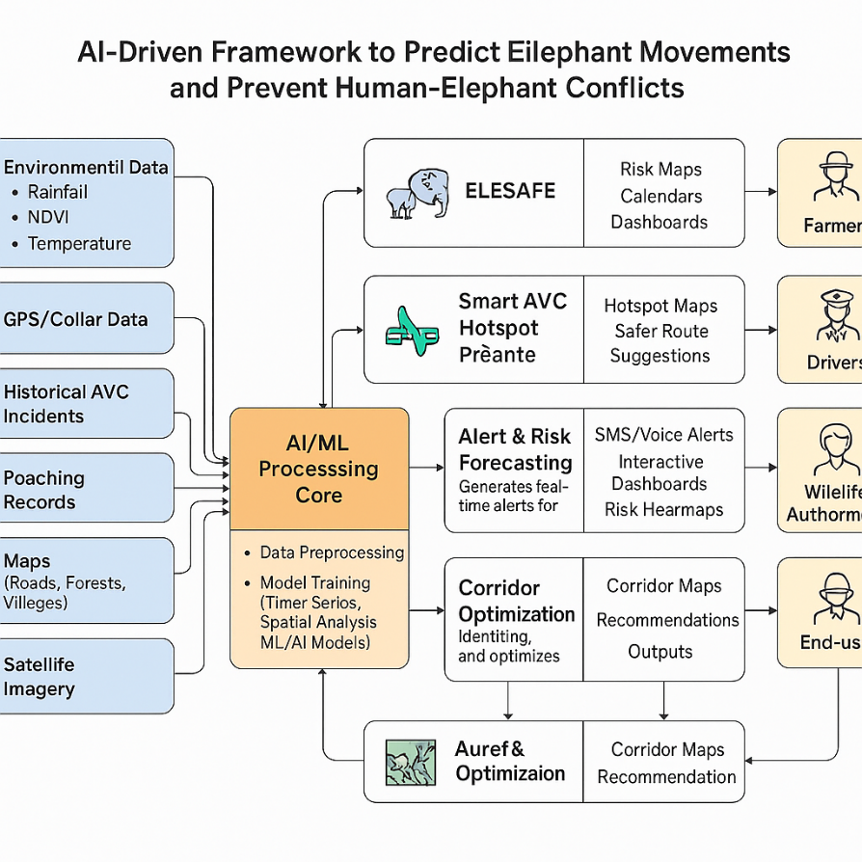

3.2 COMPONENT OVERVIEW DIAGRAM
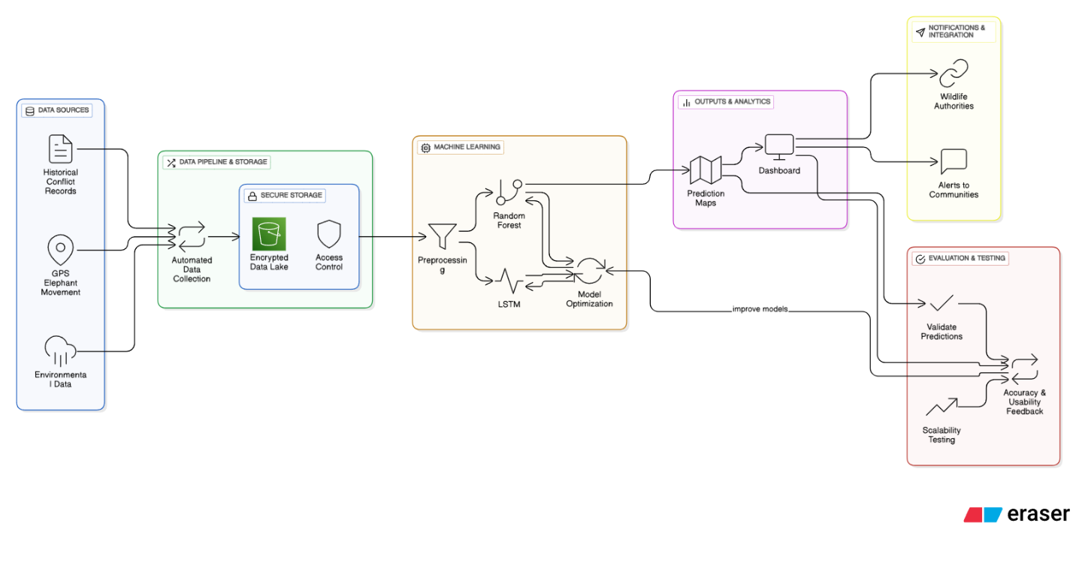

• Inputs:
- Historical Elephant Movement Data: Past records of elephant sightings, migration patterns, and human–elephant conflict incidents are used to identify high-usage areas.
- Environmental Data: Factors such as rainfall, temperature, vegetation indices (NDVI), and seasonal changes that influence elephant movement are continuously monitored.
- Geospatial Features: Terrain, water sources, agricultural lands, and known wildlife corridors are mapped to understand likely movement paths.
- Human Activity Data: Settlement boundaries, farmland distribution, and road networks are considered, since these increase conflict likelihood.

• Processing Core:
- At the center is the Corridor Prediction & Risk Assessment Module, which applies AI/ML models to:
  - Detect patterns in elephant movement across landscapes.
  - Predict daily corridor usage probabilities.
  - Classify conflict risk levels (low, medium, high) for nearby human settlements.
  - Represent uncertainty/confidence scores for better decision-making.

• Outputs:
- Corridor Risk Maps: Color-coded maps highlight predicted elephant movement corridors and conflict-prone zones.
- Community Risk Alerts: Notifications sent to farmers and local residents about potential elephant approaches.
- Patrol & Resource Guidance: Recommendations for wildlife authorities to prioritize monitoring and deploy preventive measures in high-risk areas.

• Overall Purpose:
- The diagram illustrates how multiple data streams (ecological, environmental, and human) are transformed into predictive insights.
- By combining historical movement, environmental conditions, and human activity, the system provides proactive risk management instead of reactive conflict response.
- This reduces crop damage, safeguards human lives, and promotes safer human–elephant coexistence while respecting natural elephant corridors.

4. Gantt Chart
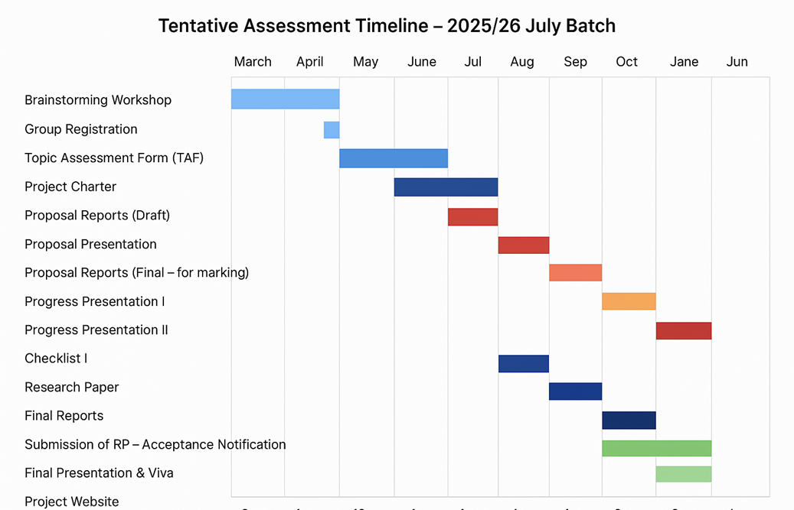

REFERENCE LIST

[References
- [1] Thomas, G., "How to do your research Project: A Guide for students", Sage Publication, 3rd Ed., 2017, ISBN: 9781473948877.
- [2] Pastorini, P., et al., "Human–elephant conflict and land cover change in Sri Lanka", Applied Geography, vol. 143, Jun. 2022.
- [3] Shaffer, M., et al., "Human-Elephant Conflict: A Review of Current Management Strategies", Frontiers in Ecology and Evolution, Jan. 2019.
- [4] Li, Y., et al., "Assessing Habitat Quality Using the InVEST Model", Diversity, Dec. 2024.
- [5] Taylor, L., et al., "Elephants and Algorithms: A Review of the Current and Future Role of AI in Elephant Monitoring", arXiv, Dec. 2023.
- [6] Wang, Q., et al., "Habitat Suitability Evaluation and Ecological Corridor Construction for Asian Elephants", Forests, Jul. 2024.
- [7] Suwannarong, S., et al., "Effect of human–elephant conflict on local attitudes", Human Dimensions of Wildlife, Oct. 2022.
- [8] "Handbook to Mitigate the Impacts of Roads and Railways on Asian Elephants", WWF, Mar. 2024.
- [9] "Human-Elephant Conflict in the Wildlife Corridors of Northern Tanzania", CHMSIB, undated.
- [10] Jacobson, S. K., et al., "Effects of climate, land use, and human population change on human–wildlife conflict", Proceedings of the National Academy of Sciences, Jan. 2024.
.

