# Flask + MongoDB Project Submission

## 1. Project Setup

• Created a Flask project in VS Code.  
• Installed dependencies using: pip install flask pymongo.  
• Set up MongoDB Atlas cluster.

Screenshot :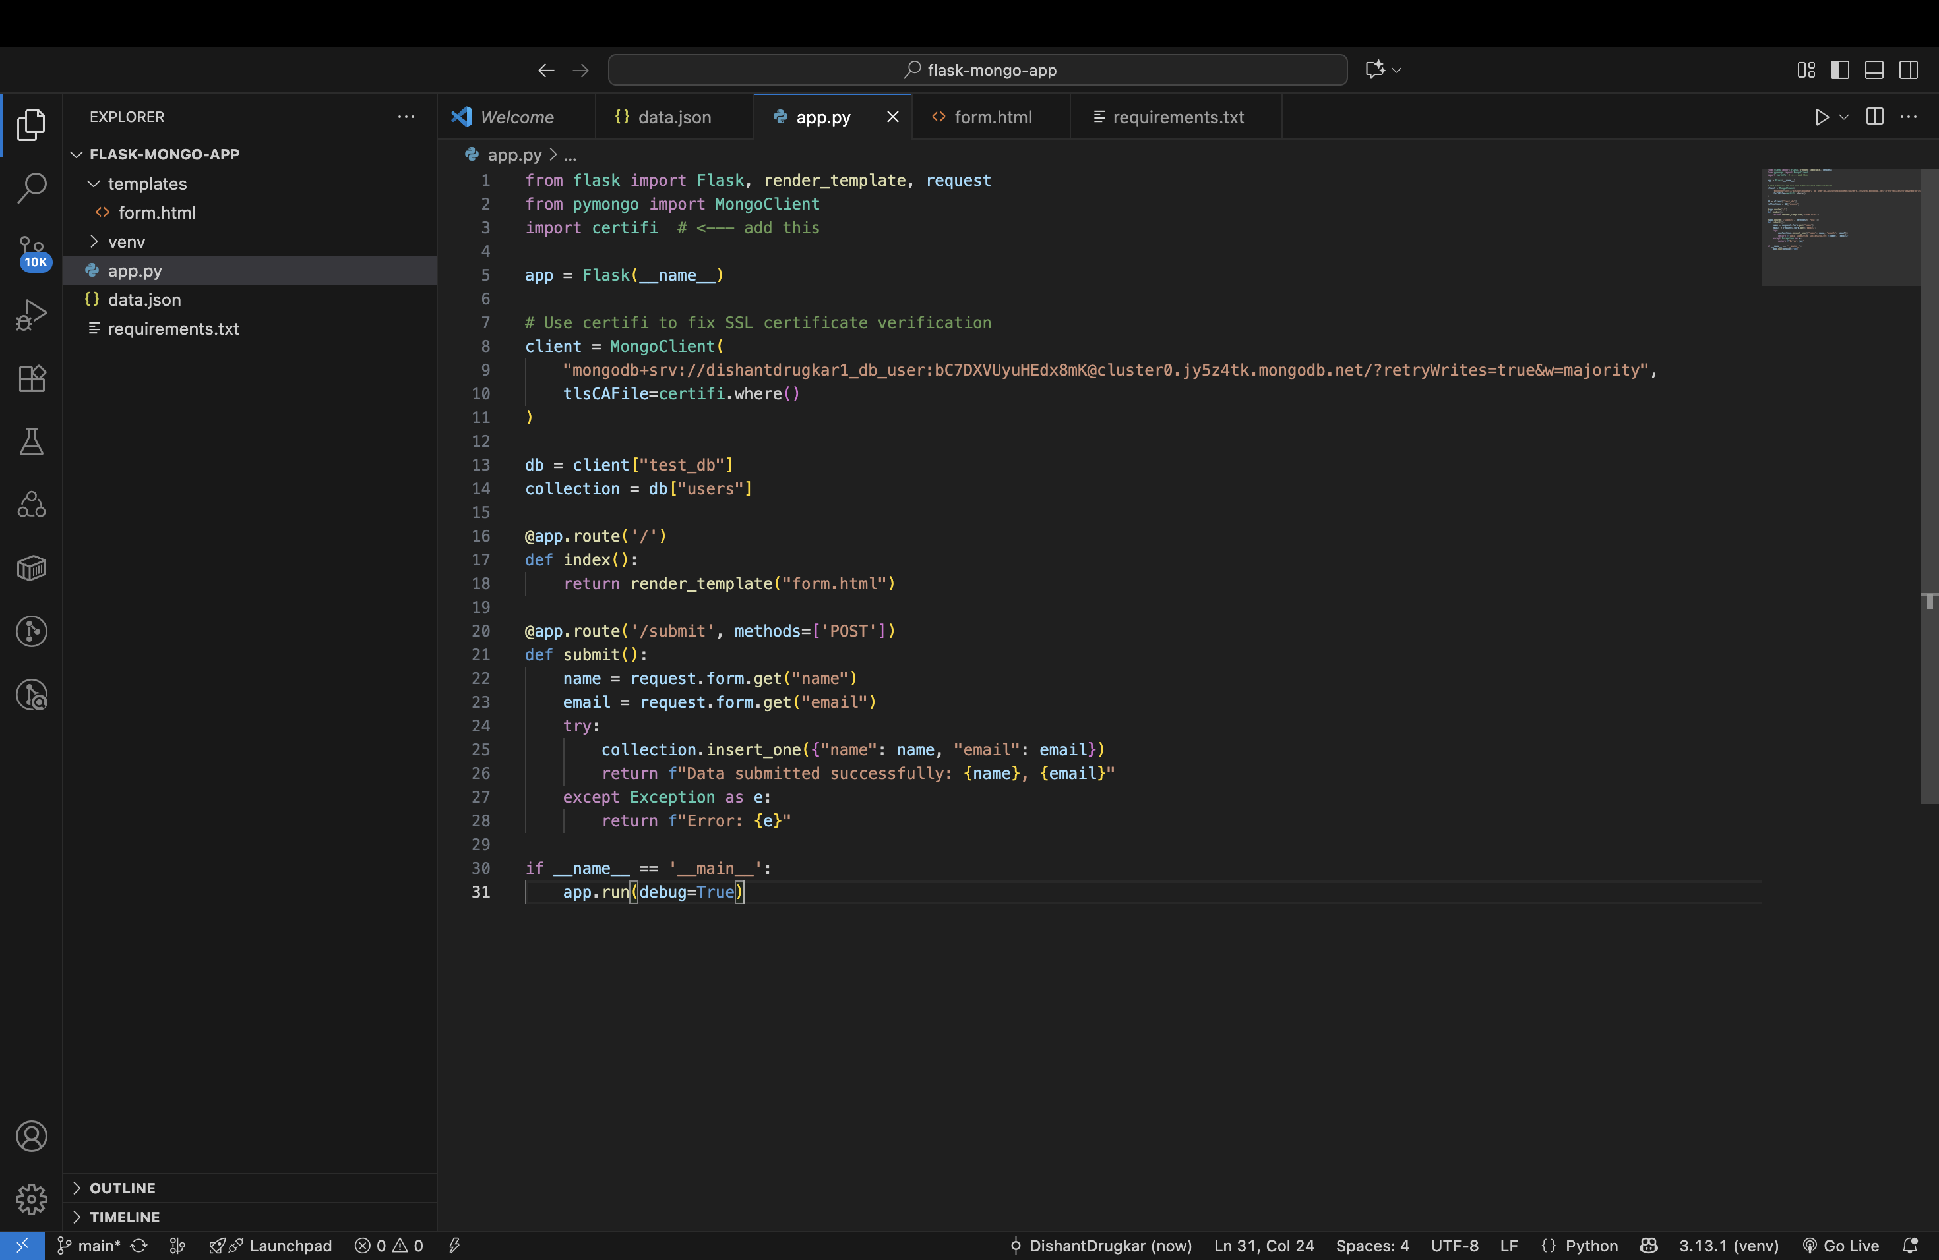

## 2. Frontend Form

• Created an HTML form (name, email).  
• The form is accessible at: http://127.0.0.1:5000

Screenshot :

## 3. Data Submission

• On submitting the form, data is inserted into Mong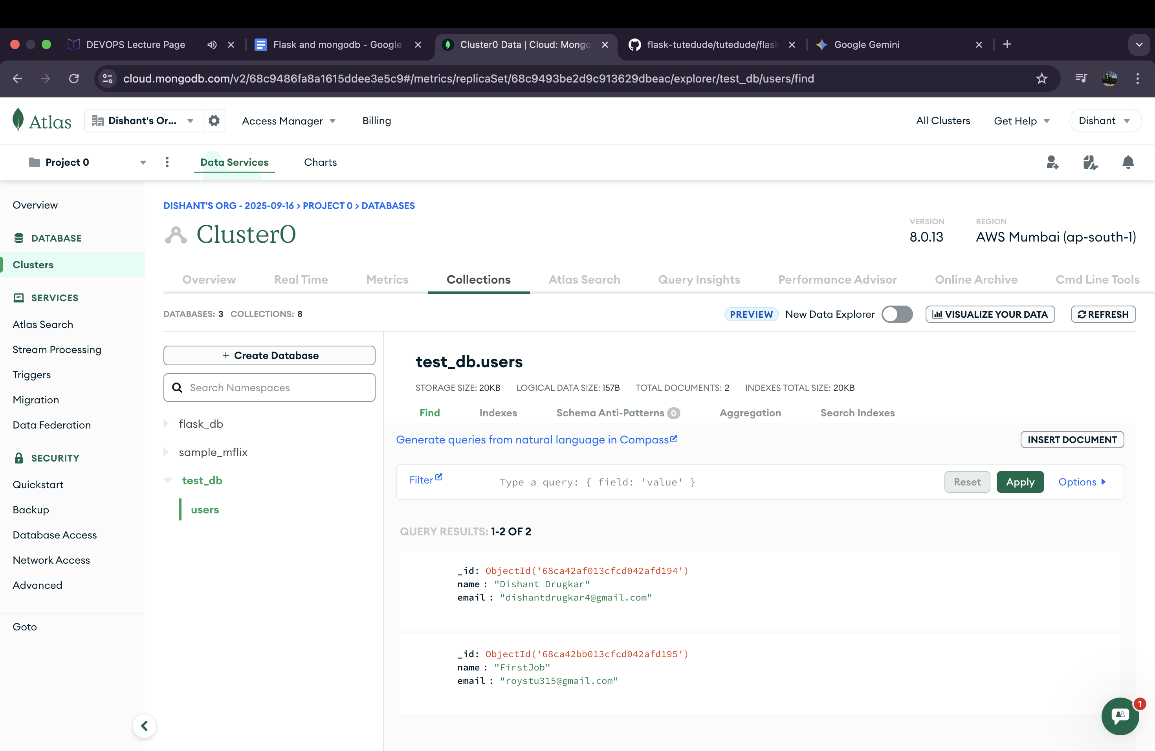oDB Atlas.  
• Verified the document in MongoDB collection.

Screenshot :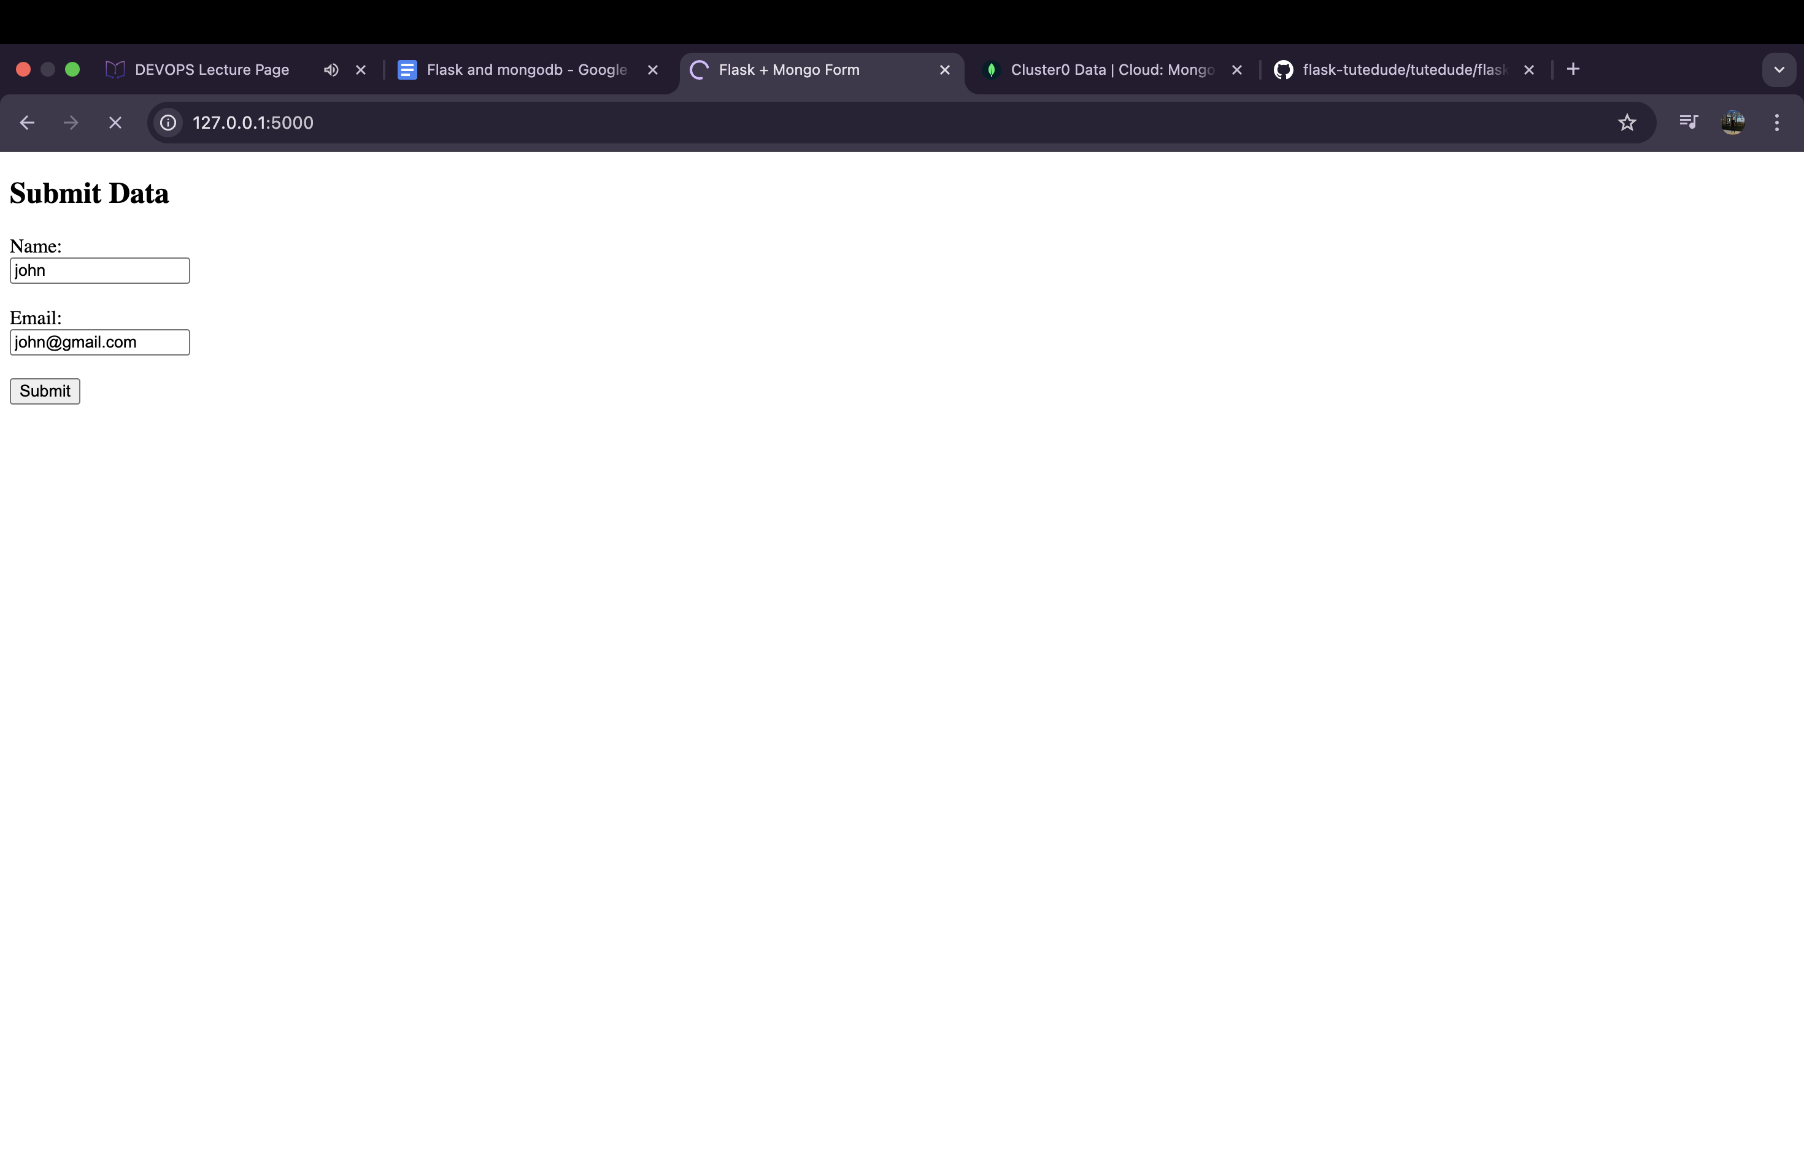

## 4. GitHub Repository

• The complete project is pushed to GitHub.  
• Repo contains app.py, templates/, requirements.txt, etc.

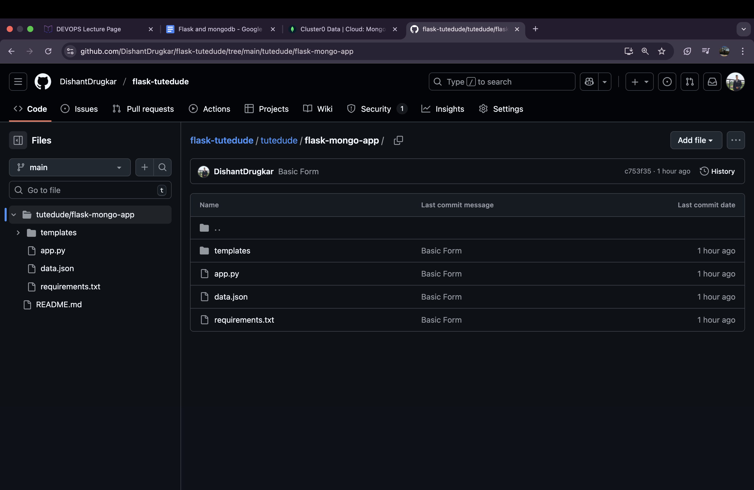GitHub Link: https://github.com/DishantDrugkar/flask-tutedude/tree/main/tutedude/flask-mongo-app