

**Department of Electronics and Computer engineering**

**Master of Engineering in Computer and Communication Systems**

**Project Title: Smart Bicycle**

**Student Name: Vikram Tokala, ID:17103592**

**Supervisor: Dr. Ciaran MacNamee**

**March 2018**

**Table of Contents:**

**Introduction 3**

Project Aim..............................................................................................................................................3Project Objectives....................................................................................................................................3

Report Outline..........................................................................................................................................4

**Literature Survey 5**

**Background theory 7**

Cadence......................................................................................................................................7

Bluetooth Module…………………………………………………………………………...…8

Global Positioning System……………………………………………………………….…..10

Radio Frequency Identification................................................................................................11

**Design of the system 12**

Architecture diagram................................................................................................................12

**Project Plan**

Progress to Date........................................................................................................................14

Challenges............ ……………………………………………………………………...……14

Risks………………………………………………………………………………………….14

**References 15**

**Introduction:**

Your happiness is Reflection of your Health. Technology has been one of the greatest development mankind has ever seen. The fruits of the technology have been delivering some sweet results for wellbeing of human health. To be physically active you must be fit and healthy. Regular Body Exercise can help protect you from serious diseases such as obesity, heart disease, cancer, mental illness, diabetes and arthritis. Riding your bicycle regularly is one of the best ways to reduce your risk of health problems associated with a sedentary lifestyle

This report is an interim “Spring Project Report”of the “Smart Bicycle” Project. Generally, this project is interfacing various sensors with Arduino 101 which will be mounted on a bicycle so as to measure real time assessment of the performance of the rider, Increase the ease in operation of bicycle during the ride thereby avoiding the chance of accidents, implant measures to protect the bicycle from thieves and also track the bicycle using the GPS.

**Project Aim:** The aim of the project is to develop a smart Bicycle

**Project Objectives**: the main objectives of the project have been updated from the autumn report. They are: -

1.Identify and setup appropriate sensors to measure and display the cadence, as recent studies show high cadence cycling and high intensity treadmill training improves motor function in Parkinson’s disease patients.

1. Ultrasonic Ranging Sensor to indicate vehicles behind the bicycle.
2. Temperature and Humidity sensor to measure real time weather.

4.GPS tracker on the bike to track whereabouts of the bicycle.

5.Heart Rate Monitoring sensor to indicate heartbeat of rider.

6. Possibility of battery charging using the bicycle motion.

**Report Outline:**

This report is written as an update from the previous ‘Autumn interim report’ for the same project. The first section of the report describes the overall project and its Aims and objectives. Following it we have described the material summary from various researched sources and its relevance to specific project. In the theory section is discussion of the technical theory of the equipment used in the project. Then it gets into design of the system detailing about the architecture of the project. In the discussion section it points out the progress to date and relates this to expected performance in the project plan.

**Literature Survey:** (Mohammadi-Abdar, 2016)

This project “the Smart Bike” is designed taking into account reference from certain research and published papers regarding the use of measuring of the cadence which in turn benefits the person who are suffering from Parkinson’s disease ,studying the installation of the RFID tags on the parts of the bicycle to increase the security of the bicycle, decreasing the usage of mobile phone while driving using to reduce the chance of accidents ,installing the GPS device on the bicycle to track the movement of the bicycle, Monitoring heart rate of the rider, to provide real time weather conditions ,Ultrasonic Ranging sensor to indicate vehicles behind the bicycle and checking the possibility of the battery charging using the motion of the bicycle. Assembling of all this parts on the bicycle so as to produce the smart bike which increases the ease of the commuter and decreases the risks associated with it.

They are

Mohammadi-Abdar, H., Ridgel, A.L., Discenzo, F.M. and Loparo, K.A., 2016. Design and development of a smart exercise bike for motor rehabilitation in individuals with Parkinson's disease. IEEE/ASME Transactions on Mechatronics, 21(3), pp.1650-1658

Recent studies in rehabilitation of Parkinson’s disease (PD) have shown cycling on a tandem bicycle on an regular speed will result in significant improvement in motor symptoms as measured with Unified Parkinson’s Disease Rating Scale (UPDRS) Motor .The approach used with the help of an abled –bodied cyclist to assist individuals with PD to pedal at a cadence between 80 and 90 r/min, which is about 30% faster than the effected can pedal on their own.

The Research results indicate the individuals affected may realize significant improvements in motor skills by riding the bike under specified conditions of speed and load dynamics this important research area. This innovative design incorporates high performance drives and controls and a low-inertia power-dense servomotor which forms a adaptive platform for clinical research for the improvement of the individuals suffering with PD.

Research results in the field of rehabilitation for people diagnosed with PD indicate that a person may realize significant improvements in motor skills by pedalling a bike under unique conditions of speed and load dynamics this important research area, a novel exercise bike has been designed and fabricated-based the operating paradigm of a tandem bike. The framework for the Smart single-rider exercise bike is a commercial bike chassis and commercially available motor and control equipment. This innovative design incorporates high performance drives and controls and a low-inertia power-dense servomotor to form a flexible and adaptive platform to support clinical research studies of exercise for people with PD.

Jolting down from the above thesis the measurement of the RPM and displaying it on the screen gives the required desired output for our project.

2. An ‘Almost Everything’ Tool (Zalud, 2016)

From Security Magazine.com

Technologies like smart phones, smart watches from Apple and RFID cards is a step towards the evolution. However, such a step forward can create security problems like privacy theft and more. Open Standard for Public Transport (OSPT) Alliance and its Cipurse open provides an advanced foundation for developing highly secure, interoperable and flexible transit fare collection solutions. According to Laurent Cremer director of the alliance with headquarters in Munich, many public transit systems currently collect fares using closed-loop applications and contactless smart cards. It relies on legacy technology that provides only a basic level of security and can cost more to license, acquire, deploy and maintain. With newer payment technologies, multi-application cards and near field communication, there is an intense need for a more secure fare collection such as Cipurse. The alliance brings together an assortment of vendors that translates into more product choices and capabilities than with proprietary systems. It includes a unique cryptographic protocol against counterfeiting, eavesdropping, man-in-the-middle attacks and other security threats.

We can use this RFID tags as a technology to track tyres of bicycle and important hardware equipment on the bicycle preventing them from being vulnerable to thieves

**Background Theory:**

**Genuino 101 :** (arduino, n.d.)

Genuino 101 is a learning and development board that delivers performance and low power consumption with the simplicity of Arduino .The robust form factor and peripheral list are same as Arduino UNO with the addition of onboard Bluetooth LE capabilities a 6-axis accelerometer/gyro meter.

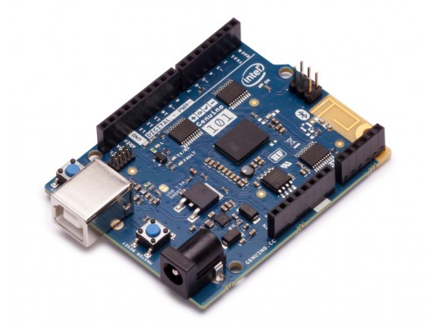

The boards I/O and operating voltage is 3.3V besides all pins are protected against 5V overvoltage. It comes with :

1. 14 digital input/output pins out of which 4 can be used as PWN outputs
2. 6 analog inputs
3. USB connector for serial communication and sketch upload
4. A Power Jack
5. An ICSP header with SPI signals and I2C dedicated pins

We are using Genuino101 to interface the sensors and also the Bluetooth module present on the 101 as part of our project.

**Cadence** (Cadence Bicycle Computers: Features to Expect, 2016)

* **Cadence Measurement:**  The rotations of the cranks per minute are defined as the measurement of Cadence. This is important to measure because how fast you are travelling and how fast your legs are working isn’t directly correlated.
* **Odometer:** The measurement of the distance covered.

We are using Cycplus C2 sensor which comes with Bluetooth ANT+ and a Multi-protocol sensor which is used to measure the measure the cadence of the bicycle and supply the data to arduino which transmits the signal to the LCD display to notify the commuters of the cadence.

**CYCPLUS C2 SENSOR** (CYCPLUS C2, n.d.)

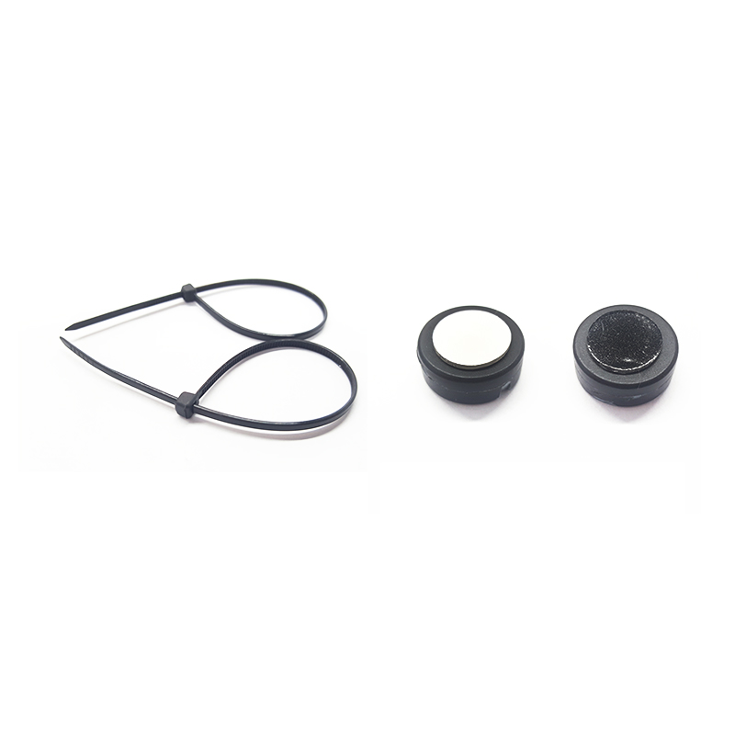The Cycplus C2 comes with Bluetooth and ANT+ Multi-Protocol withdimensions 4g/8mm thick and they are magnet less which comes with IPX7 waterproof and provide High precision results.

**Global Positioning System** (global positioning system, n.d.)

GPS, which stands for Global Positioning System, is the system that will to show you your exact position on the Earth anytime, in any weather, anywhere.

The three parts of GPS are:

* + Satellites
  + Receivers
  + Software

**Receivers and Satellites**

GPS units are made to communicate with GPS satellites (which have a much better view of the Earth) to find out exactly where they are on the global scale of things.The GPS receiver compares the time a signal which was transmitted by a satellite with the time it was received. The time difference tells the GPS receiver how far away the satellite is.

**Calculating Distance**

Velocity x Time = Distance

Radio waves travel at the speed of light, roughly 186,000 miles per second (mps)

**Determining GPS Position**

1. Position is calculated using triangulation
2. Distance is measured by how long a signal takes to reach your position

**Factors effecting the accuracy**

1. Timing of the signal
2. Position Dilution of the Precision

**Adafruit Ultimate GPS Logger Shield** (adafruit gps logger shield, 2013)

We are using Adafruit ultimate GPS logger shield sensor which comes with an SD card holder which enables us to store collected data in it.

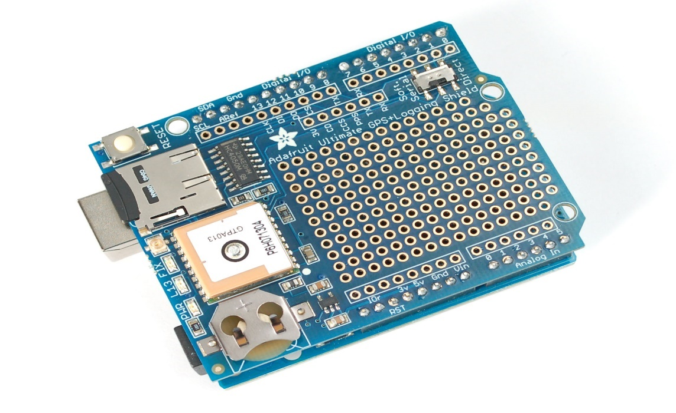The Adafruit GPS logger shield comes along with various features and they are:

* -165 dBm sensitivity, 10 Hz updates, 66 channels
* Low power module - only 20mA current draw, half of most GPS's
* Assembled & tested shield for Arduino Uno/Duemilanove/Diecimila/Leonardo
* MicroSD card slot for datalogging onto a removable card
* RTC battery included, for up to 7 years backup
* Built-in datalogging to flash
* PPS output on fix
* Internal patch antenna + u.FL connector for external active antenna
* Power, Pin #13 and Fix status LED
* Big prototyping area

**Radio Frequency Identification** (Armstrong, 2011)

Radio Frequency Identification or fondly known as RFID is a technology which allows user to store the information on microchip which can be read remotely, with the help of RF spectrum without any physical presence.

It consists of a reader which emits an RF signal through an antenna which is received at Microchip with the help of antenna and varies the electro- magnetic response in such a way that information can be transferred to reader.

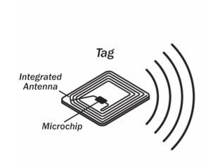

**Figure 2 RFID tag**

We are planning to use RFID stickers to provide necessary security for the mounted hardware along with the bicycle. These RFID stickers are pasted on several parts of the Bicycle and on the mounted hardware box to prevent them from happening theft.

**Temperature and Weather sensor** (adafruit DHT22 Sensor, 2017)

We are using DHT22 Digital temperature and humidity sensor. It consists of Capacitive

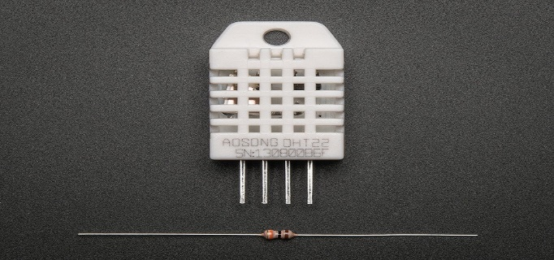

DHT22 Temperature and Humidity Sensor

humidity sensor and a thermistor that measure the surrounding air, and vents out a digital signal on data pin which will be read by Arduino 101.

**Ultrasonic Ranging** (Elec freaks, n.d.)

Ultrasound is used in many real time applications, they operate with frequencies from 20kHz up to several gigahertz. Ultrasonic devices are used to detect and measure objects.

HC-SR04 is an Ultrasonic ranging module which provides 2cm to 400cm non-contact measurement function, the ranging accuracy can reach up to 3mm.This sensor includes ultrasonic transmitters, receiver and control circuit.

The HC-SR04 is an optimum solution to enlighten the rider about the obstacles such as vehicles at the rear of the bicycle .

The working of the HC-SR04 is as follows:

1. Using IO trigger for at least 10us high level signal,

2. The Module automatically sends eight 40 kHz and detect whether there is a pulse signal back.

3. IF the signal back, through high level , time of high output IO duration is the time from sending ultrasonic to returning.

4.Test distance = (high level time×velocity of sound (340M/S) / 2.

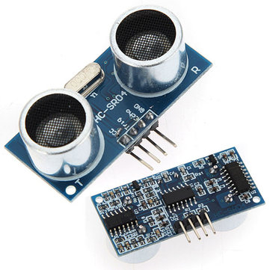

HC-SR04 Ultra Sonic Ranging Sensor

**Design of the system:**

The Smart Bicycle which includes a number of sensors which are being investigated so as to find the sensors which meet the needs of the project. The design shows the overall concept of the smart design which will explain in particular once the requirement design is met. **Architecture diagram**

**Bicycle**

Handle

Front tyre

Back Tyre

Pedal

Arudino

RPM Meter

RFID tags

GPS

Diagram: Description and outline of the project

The above outline depicts the Arduino which is mounted on the handle of the bicycle which has collection of the sensors that are to be mounted on different parts of the bicycle .

**Project Plan**

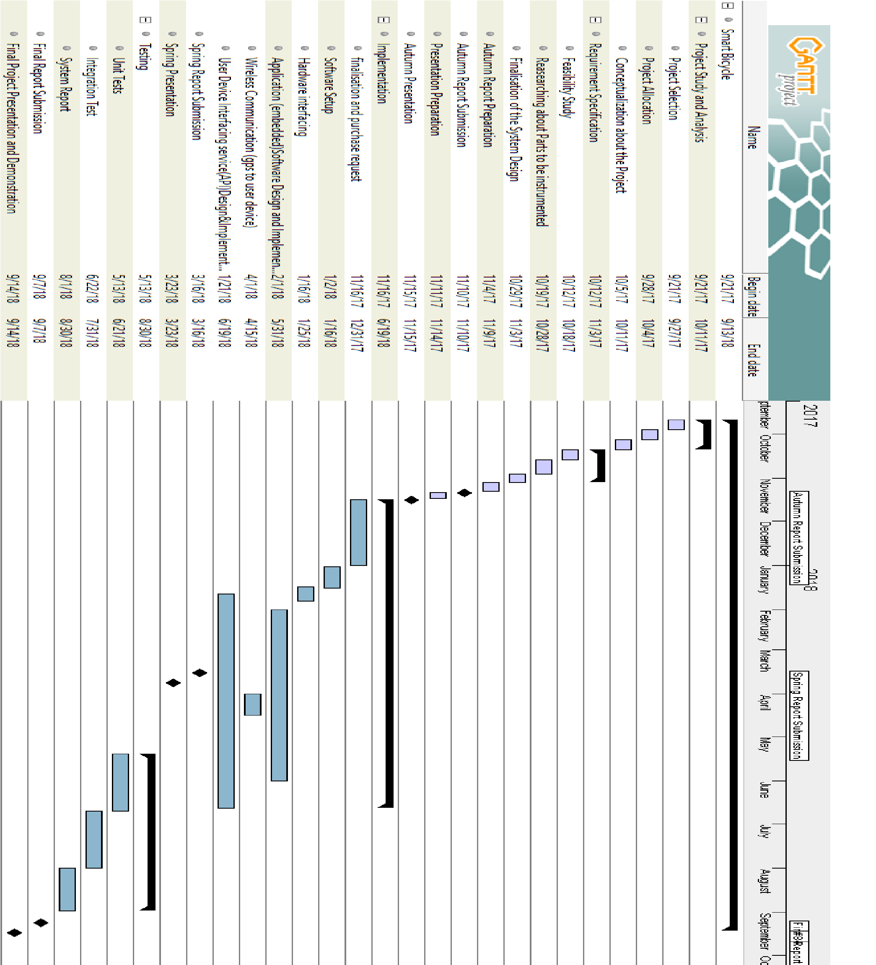

**Progress to Date:**

At this stage, it is thought that the project is in good progress, continuing from the ‘Autumn Project Report’ we have been keeping up with all the project plans. Things carried out to date are summarized in brief below:

1. According to the design which was finalised, Arduino 101 has been chosen as the most feasible to the project.
2. Required components i.e., Arduino 101, sensors and other components are received and are in the testing stage which is a sign of progress and has completed within the scheduled time (31.12.2017).
3. Software required for all the sensors is being tested along with the hardware interface of the individual sensors and it has been worked out to fit into schedule i.e., (1/2/2018-5/31/2018).
4. Hardware interface of the sensors and Arduino has been tested individually accordingly creating the required output for the project.

**Challenges**:

The following design issues have been identified:

1. Use of Bluetooth to interface multiple sensors and devices.
2. Mounting the Arduino 101 along with interfaced sensors on to the bike.
3. To identify the appropriate power source.

**Risks:**

Potential risks in this project are those that their failure may stop or delay planned progress of the project. These may include

1. Failure to find the appropriate power source that can be mounted on the bicycle which may lead to delay in the purchasing process and project progress .
2. Mounting of the sensors on the bicycle as the heavy movement on the bicycle may increase the chances of missing or dropping the sensors while riding so the place of the installation should zeroed down to no movement area.

# Bibliography

adafruit DHT22 Sensor, 2017. *adafruit.com.* [Online]   
Available at: https://www.adafruit.com/product/385  
[Accessed 24 january 2018].

adafruit gps logger shield, 2013. *adafruit.com.* [Online]   
Available at: https://learn.adafruit.com/adafruit-ultimate-gps-logger-shield/overview  
[Accessed 26 febrauary 2018].

arduino, n.d. *store.arduino.cc.* [Online]   
Available at: https://store.arduino.cc/genuino-101  
[Accessed 15 01 2018].

Armstrong, s., 2011. *RFID Basics:how RFID tags work.* [Online]   
Available at: https://blog.atlasrfidstore.com/rfid-tag-basics   
[Accessed 05 november 2017].

Cadence Bicycle Computers: Features to Expect, 2016. *skyaboveus.* [Online]   
Available at: https://skyaboveus.com/cycling/5-Best-Bicycle-Computers-With-Cadence-Reviews  
[Accessed 08 november 2017].

CYCPLUS C2, n.d. *banggood.com.* [Online]   
Available at: https://www.banggood.com/CYCPLUS-C2-Bluetooth-ANT-Multi-protocol-Cadence-Sensor-Magnetless-4g-Ultralight-IPX7-300-Days-Stand-p-1173010.html?cur_warehouse=CN  
[Accessed 18 january 2018].

Elec freaks, n.d. *elecfreaks.com.* [Online]   
Available at: http://www.micropik.com/PDF/HCSR04.pdf  
[Accessed 16 febrauary 2018].

global positioning system, n.d. *wiki/Global_Positioning_System.* [Online]   
Available at: https://en.wikipedia.org/wiki/Global_Positioning_System  
[Accessed 08 november 2017].

Mohammadi-Abdar, H. R. A. D. F. a. L. K., 2016. Design and development of a smart exercise bike for motor rehabilitation in individuals with Parkinson's disease. *IEEE/ASME Transactions on Mechatronics,* pp. 1650-1658.

Zalud, B., 2016. *RFID: The 'Almost Everything' Tool.* [Online]   
Available at: https://www.securitymagazine.com/articles/86954-rfid-the-almost-everything-tool

Zalud, B., 2016. *RFID: The 'Almost Everything' Tool.* [Online]   
Available at: https://www.securitymagazine.com/articles/86954-rfid-the-almost-everything-tool