Name: Dishant Naik

CWID: 10454341

**HW 4**

**Three general principle in Data Visualizations:**

1. **Design and Layout matters:**
   * Design, layout and selection of chart is very important when it comes to visualizing any kind of data using graph or chart. For example, axis should be labeled clearly and lagend should be close enough to the display to facilitate ease comparisons.
2. **Avoid clutter:**
   * In simpler words this rule implies that one should avoid things that does not add any information. For example, use of images in graph.
3. **Use color purposely and effectively:**
   * Color might make visualization seem “prettier”, but it can also be a distraction to the audience and may hinder our message. We should use color to draw attention to important part of the charts. For example, use different color to distinguish between categories.

**Three examples of bad visualizations:**

**1) Line chart used by Apple at the launch of MacBook Pro 2020**

This chart violets the first rule of “**Three general principle in Data Visualizations**”. No axis scale information is provided. Also chart designer shows that new MBP is 2x faster then Latest PC but dose not provide information about with which laptop chip they are comparing M1 to.

Using first rule we can add values on X and Y axis to show better comparison. Also, instead to writing “Latest PC laptop chip” we can be more specific by writing actual name of the chip.

**2) Chart used by Bloomberg Markets in 2012 to show imports from different countries.**

This chart violets the second rule of **“Three general principle in Data Visualizations”.** There is a lot going on with this chart. It’s too cluttered. At first glance it hard to understand what those numbers by the images represents. Also, some images do not have percentage next to it which indicates that it is not being imported but it is hard to understand.

Here choice of chart is wrong. Instead of using this kind of chart we can use bar graph to show this information with amount of import on Y axis and category and countries on X axis. These changes will make this graph more cleaner and easy to understand.

**3) Chart used by Gallup to showcase their poll finding:**

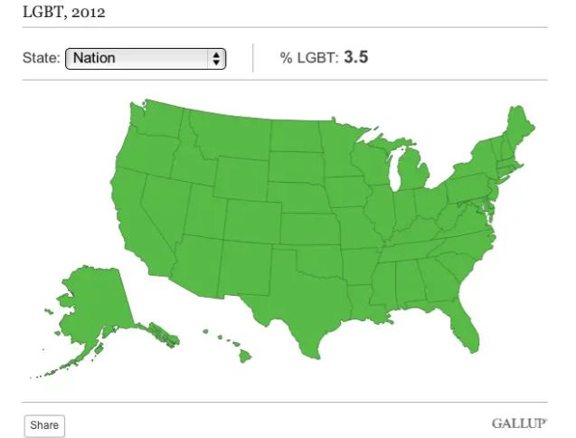

Gallup polled to find out % of LGBT individual in east state. Usurpingly all of the states were rather close. From 1.7% in North Dakota to 5.1% in Hawaii. But due to bad choise to showcase range of % in different color the whole map ended up being green. Hence it is clear that this chart violets the third rule of **“Three general principle in Data Visualizations”.**

Here we can smaller the range of one color. For example, if whole data set has maximum of 5.1% and minimum of 1.7%. And we are using Red, Orange and Green color to show case Low, Medium and High percentage then we can assign range of 1.7% to 2.7% to Red, 2.8% to 4.0% to Orange and Green to 4.1% and above.