LESSON 1

Web Reconnaissance & Lab Evidence Report
Target observed in supplied evidence: 10.129.63.235:3000
Prepared from the screenshots and terminal output supplied during Lesson 1.

1. Lesson objective
The lesson documents a hands-on web-security lab workflow: identify the web technology, inspect HTTP responses and application behavior, research the observed stack, and preserve evidence from controlled testing. The supplied terminal output identifies a ReactorWatch web application served on TCP port 3000.

2. Initial web reconnaissance
The supplied WhatWeb output returned HTTP 200 and identified the page title as 'ReactorWatch | Core Monitoring System'. It also exposed Next.js-related response headers, including X-Powered-By: Next.js and x-nextjs-* cache/prerender headers.
A HEAD request confirmed an HTML response and long-lived shared-cache behavior. A direct GET request returned the rendered ReactorWatch dashboard, including reactor metrics, system logs, personnel entries, and Next.js static chunk references.

3. Technology identification
Browser and command-line evidence was used together to identify the application stack and investigate the framework/version context. The accompanying Wappalyzer CSV and browser screenshots are preserved in the ZIP so the original observations remain available alongside the report.

4. Controlled lab testing evidence
The later screenshots show controlled testing performed against the lab target, including terminal-based request handling, local listener setup, and validation of application behavior. These images are retained as evidence rather than rewritten into a generalized exploit recipe.

5. Key takeaways
- Start with basic HTTP fingerprinting before attempting deeper testing.
- Response headers can reveal frameworks, caching behavior, and deployment characteristics.
- HTML and JavaScript asset references provide useful clues about application architecture.
- Browser observations should be correlated with terminal output rather than treated in isolation.
- Keep screenshots and raw command output so findings can be reproduced and reported accurately.

6. Screenshot evidence

Figure 1
ReactorWatch application viewed in the browser with developer tooling.
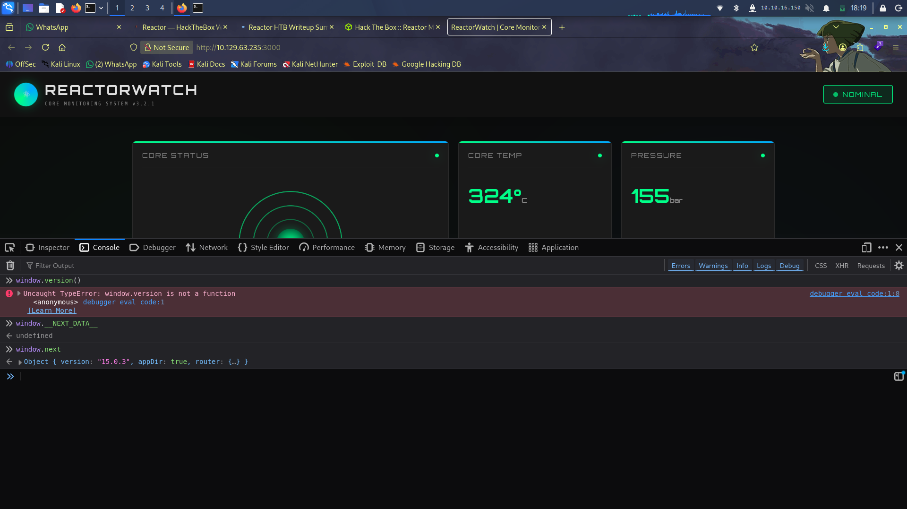

Figure 2
Web research related to the observed application/framework.
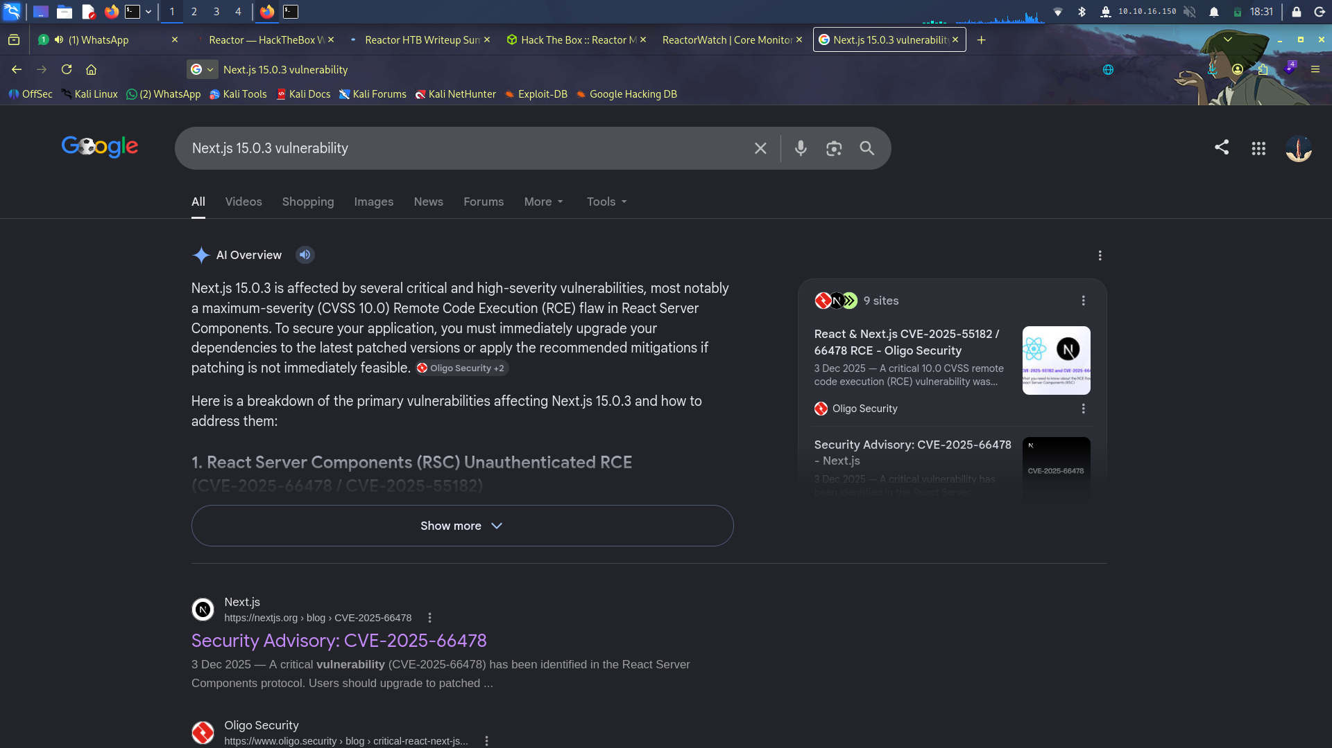

Figure 3
Additional framework/version research.
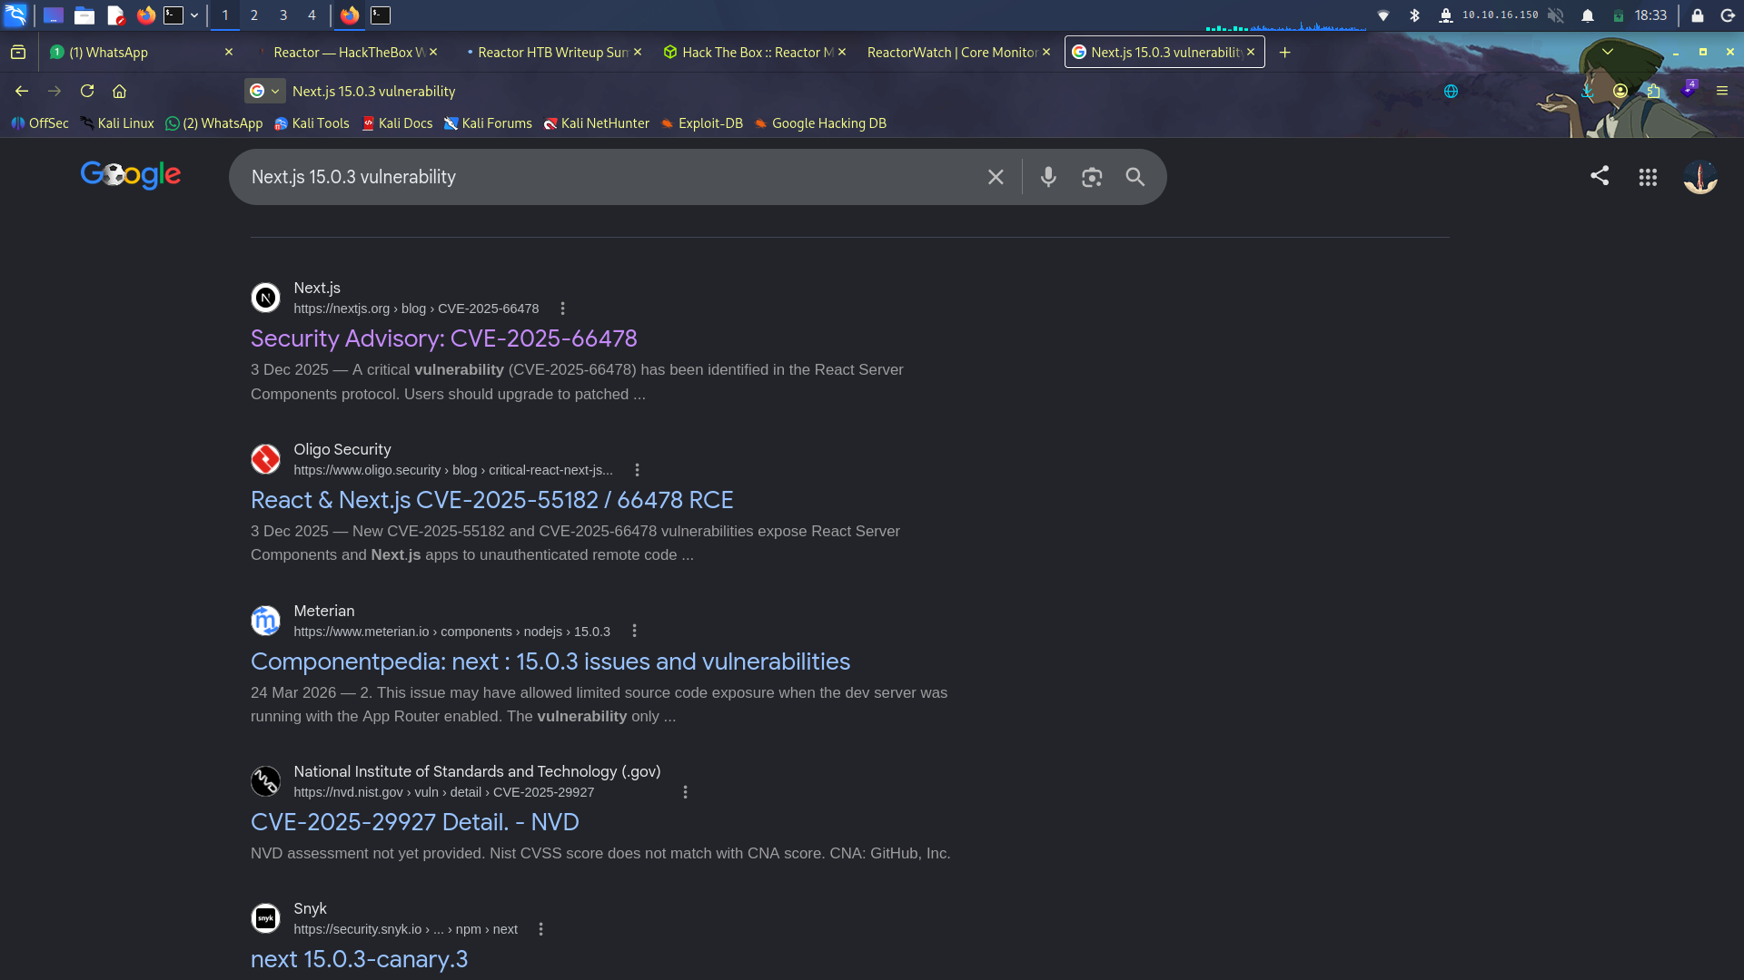

Figure 4
Additional vulnerability/framework research.
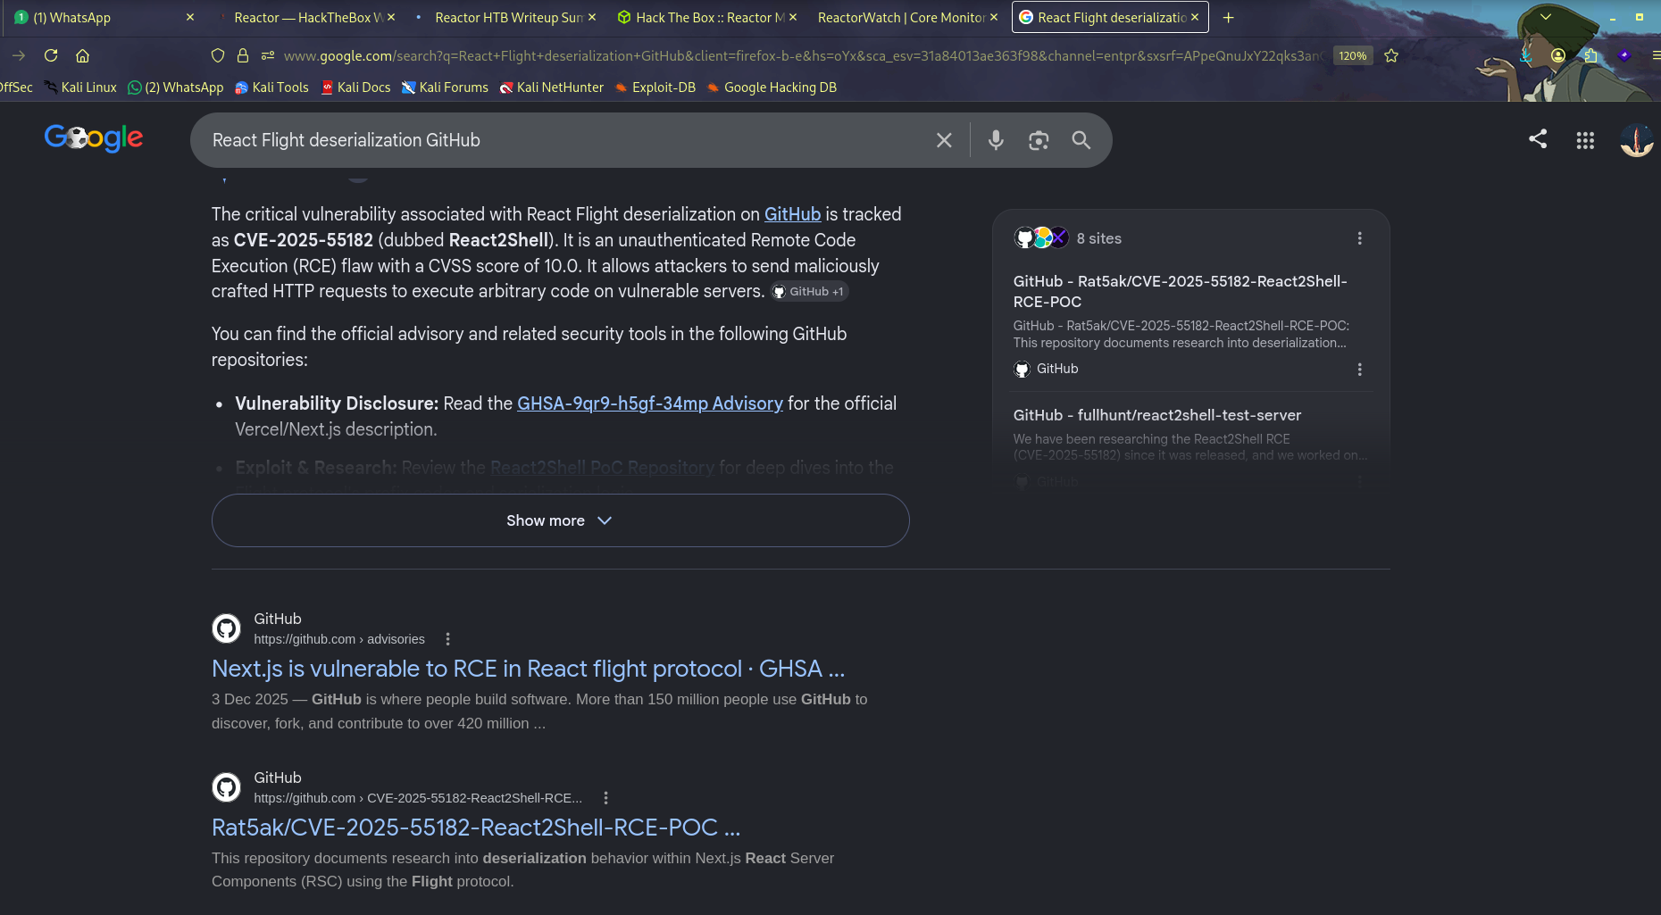

Figure 5
VPN/lab network address evidence.


Figure 6
Terminal evidence from controlled lab testing.
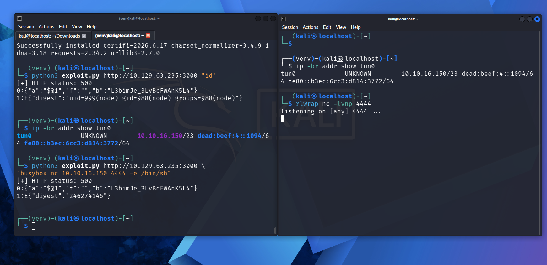

Figure 7
Terminal evidence from controlled lab testing.
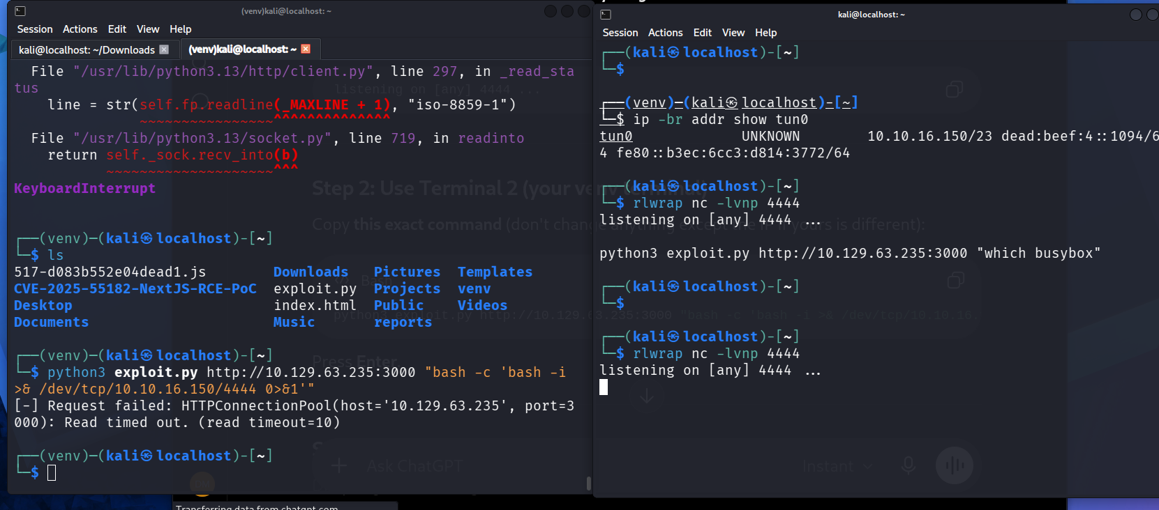

Figure 8
Terminal evidence from controlled lab testing.
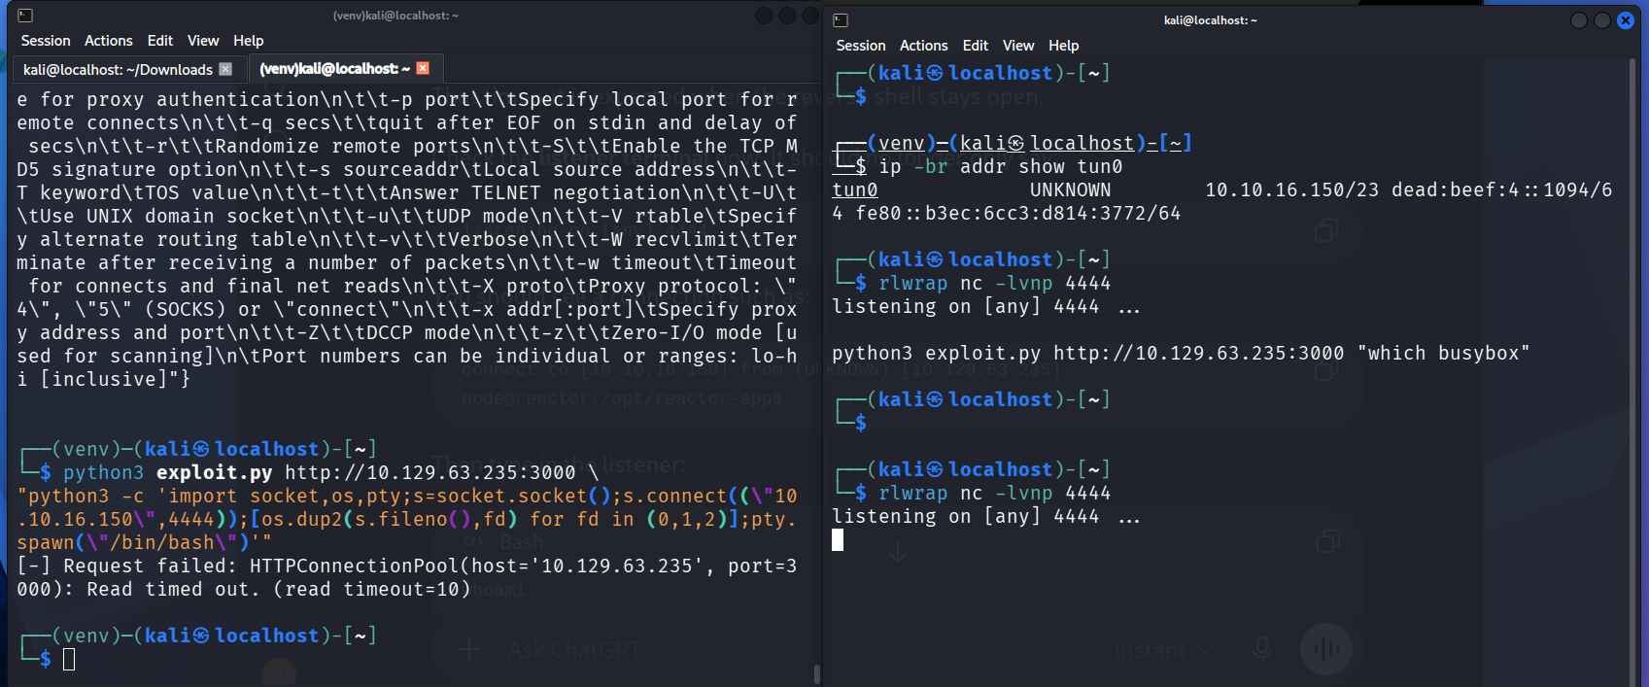

Figure 9
Listener/testing output captured during the lab.
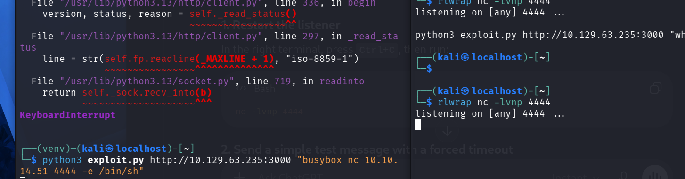

Figure 10
Listener/testing output captured during the lab.
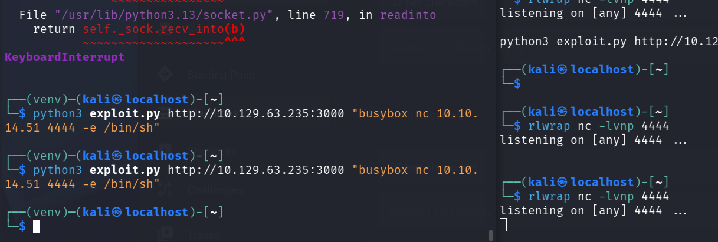

Figure 11
Listener/testing output captured during the lab.
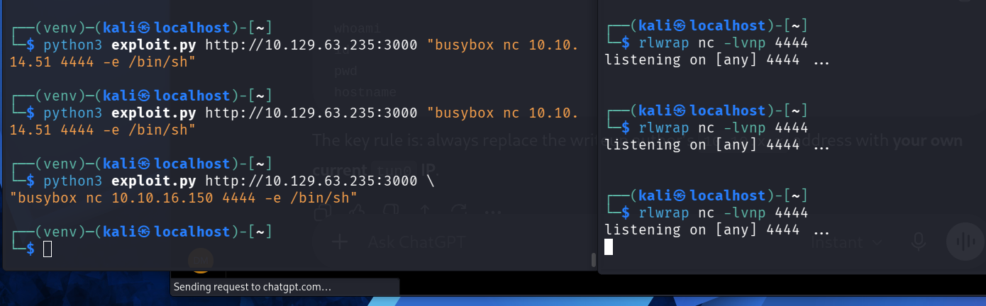

Figure 12
Listener/testing output captured during the lab.
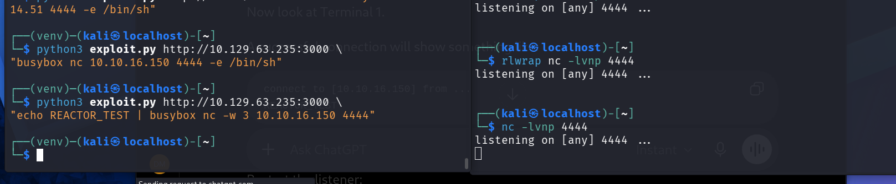

Figure 13
Combined terminal evidence from the lab workflow.
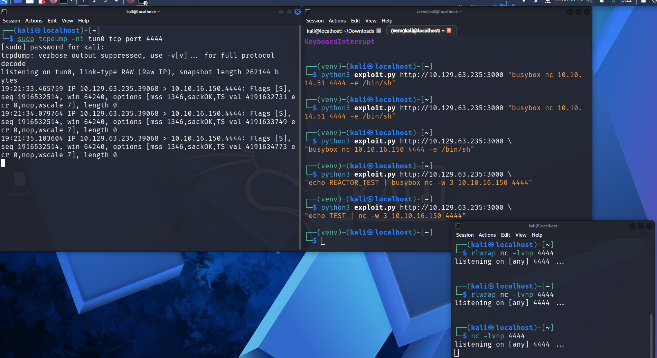

Figure 14
Local listener/network validation evidence.
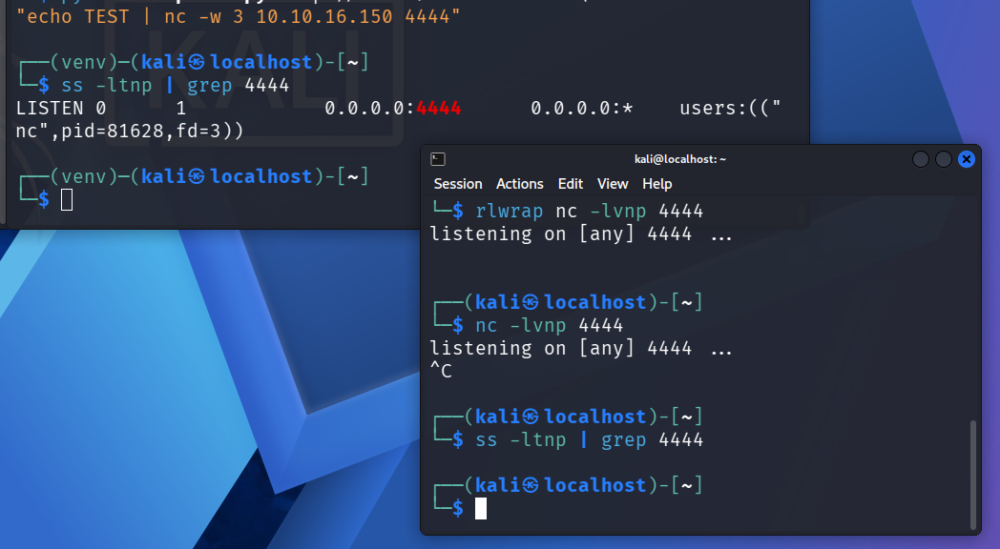

7. Included source material
The ZIP also contains the raw Lesson 1 terminal capture and Wappalyzer CSV used during the exercise, plus the original screenshots in a dedicated screenshots folder.

