**TravelDesk**

**Software Requirement Specifications Document**

# Abstract01

|  |  |
| --- | --- |
| **Document Title:** | TravelDesk__SRS_V1.0 |
| **Project:** | TravelDesk_ |
| **Author** | Anamika Sawhney |
| **Reviewer** |  |
| **Filename:** | TravelDesk__SRS_V1.0 |
| **Version:** | 1.0 |
| **Status:** | Initial Draft |
| **Date:** | 04 June 2024 |

# Version History

|  |  |  |  |  |  |
| --- | --- | --- | --- | --- | --- |
| **Version** | **Date** | **Notes** | **Author** | **Reviewed by** | **Approved By** |
| 1.0 | 04th June2024 | Initial Draft | Anamika Sawhney |  |  |

Contents

1. Abstract01 2

2. Version History 3

3. Abbreviations 4

4. Project Detail & Description 4

4.1 Introduction 4

4.2 Purpose 4

4.3 Scope of Work 4

4.4 Technology Stack Merchant Enrollment Portal 4

4.5 Deliverable 4

5. Workflow Diagram 4

6. User Roles & Characteristics 4

7. Functional Requirements 5

Use Case 1: Logging in to Travel Desk 5

Use Case 2: Admin Rights 6

Use Case 3: Employee Rights 7

Use Case 4: Manager Rights 8

Use Case 5: Travel Admin Right 9

8. Non-Functional Requirements 9

10.2 Usability / Supportability 10

10.4 Accessibility 10

10.5 Design Consideration 10

10.6 Integration 10

9. Other Business Rules 11

Table of Figures

**No table of figures entries found.**

# Abbreviations

|  |  |  |
| --- | --- | --- |
| S. NO. | TERM | MEANING |
| 1 | SRS | Software Requirements Specification |

# Project Detail & Description

## 4.1 Introduction

ABC is a Global Information Technology (IT) services provider that delivers value and competitive advantage to its customers by improving their access to critical information, automating their business processes, and helping their personnel collaborate effectively.

ABC has decided to build a web-based Travel Desk platform for its employees internally.

## 4.2 Purpose

The main purpose of the document is to capture the requirements that is needed to create the web-based portal for Employees. This application will help employees to track their active travel status which was previously done manually over emails.

## 4.3 Scope of Work

This document shall contain detailed use cases that are defined based on the To-Be processes.

## 4.4 Technology Stack

* Frontend : React
* Backend : .Net Core Web API
* Database : MS SQL

## 4.5 Deliverable

Following are the deliverables for this package: -

1. Software requirement specification (SRS)

# Workflow Diagram

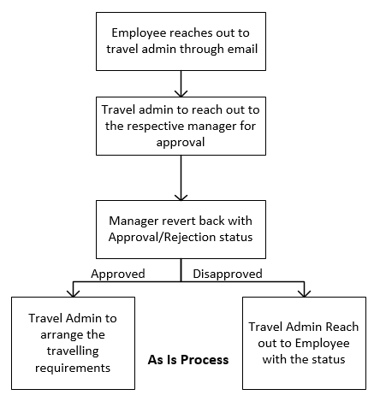

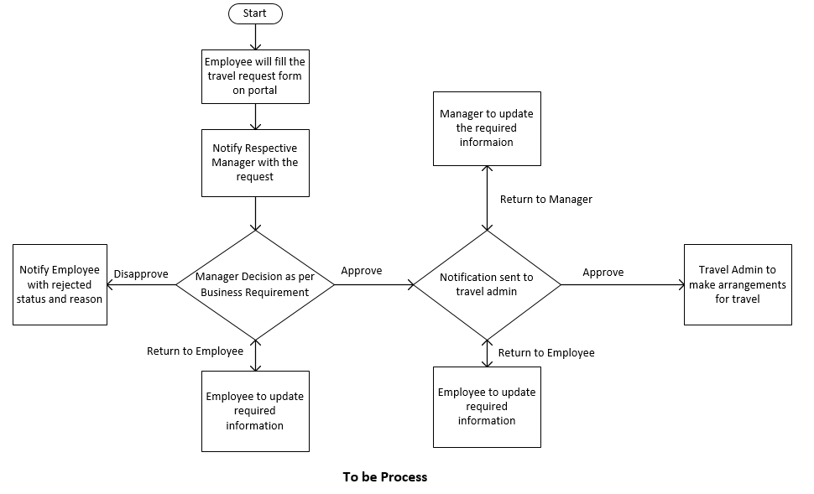

# User Roles & Characteristics

|  |  |
| --- | --- |
| **Actors** | **Description** |
| Admin | Users with admin access to all the features of the application. |
| HR Travel Admin | Users from the Travel Admin Team |
| Employees | All employees of the organization. |
| Manager | Employee managers to approve/reject the travel request |

# Functional Requirements

## Use Case 1: Login on the travel desk portal

This use case provides the details on the necessary steps required to log in into the system.

**1. Actor**

* + Admin
  + Hr Travel Admin
  + Employees
  + Managers

**2. Flow of Events**

2.1 Basic Flow

1. Actor enters the portal URL in a browser link
2. System presents/displays below options to the actor

* Login form

1. Actors fill in their valid Login credentials:
   * Email
   * Password
2. Actor clicks on the ‘Log In’ button
3. System validates Login credentials
4. System redirects the user to the portal landing page

2.2.1 Exception Flow

1. Actors fill in their invalid Login credentials:

* Email
* Password

2. Actor clicks on the ‘Log In’ button

3. System validates Login credentials

4. System identifies wrong Login credentials

5. System displays the following message “Please enter the correct Email & Password”

3. Pre – Conditions

|  |  |
| --- | --- |
| **PRC ID** | **Description** |
|  | The user is authorized to access the travel desk portal. |

4. Post–Conditions

|  |  |
| --- | --- |
| **POC ID** | **Description** |
|  | The system navigates actors to the home page on successful login as per the role. |

5. Business Rules

|  |  |
| --- | --- |
| **BR ID** | **Description** |
|  | An existing user should be authenticated by their login credentials |
|  | An existing user will be authenticated based on their roles and responsibilities. |

## Use Case 2: Admin Rights

1. Actor

* Admin

**2**. Task of Events

2.1 Tasks

1. System will display the ‘Admin Home’ page.
2. System will display below options

* Add User
* User Grid
* Employee First Name
* Employee Last Name
* Employee ID
* Employee Department
* Role
* Manager Name
* Edit User
* Delete User
* Assign Role
* Total user

1. Actor should be able to edit/update the above options.

**3. Pre – Conditions**

|  |  |
| --- | --- |
| **PRC ID** | **Description** |
|  | The actor can access the Admin Portal |

**4. Post–Conditions**

|  |  |
| --- | --- |
| **POC ID** | **Description** |
|  | The system saves the information provided by the users |

**5. Business Rules**

|  |  |
| --- | --- |
| **BR ID** | **Description** |
|  | A user should be authenticated by their login credentials |
|  | Users will be authenticated based on their roles and responsibilities |

## Use Case 3: Employee Rights

**1. Actor**

* Employee

**2. Task of Events**

2.1 Tasks

* + 1. Once the Actor login he should be on User Dashboard
    2. User Dashboard must have History Details and button to create new travel request form.
    3. Actor can create the new Request or view the past Request.
    4. An Actor can use the Request form
* Actor can fill and submit the request form
* Actor can delete the request form
* Once Actor submit the Request Form, a unique request number need to be generated in reference with that.
* The automatic email should be sent to the Employee’s manager Email ID.
  + 1. An Actor Request for Travel

The following option should be present on Request form-

* Employee ID
* Employee Name
* Project Name
* Department Name
* Reason for Travelling
* Type of Booking
* For Booking Air ticket only
* Domestic Flight - Aadhar card, Date
* International Flight – Passport number, Upload Passport file, upload visa file, Date, Aadhar card
* For booking Hotel only
* Date
* Days of stay
* Meal Required – Lunch, Dinner or Both
* Meal preference – Veg/ Non-Veg
* Booking can be Air Ticket + Hotel Both
* Domestic Flight - Aadhar card, Date
* International Flight – Passport number, Upload Passport file, upload visa file, Date, Aadhar card
* Days of stay
* Meal Required – Lunch, Dinner or Both
* Meal preference – Veg/ Non-Veg

* + 1. Actor can upload the required documents in to the portal.
    2. Actor can submit the request form.
    3. Actor can send it to manager for approval.
    4. Form once submitted cannot be edited again until return to employee by Manager/Travel Admin
    5. Actor can see the form in his queue after submission as read only.
    6. Actor can edit the form once return to his queue by Travel Admin/Manger.
    7. The Request ID needs to be visible as Read only once its closed in history tab.
    8. All the comments should be visible under the Request ID in Employee Dashboard.

**3. Pre – Conditions**

|  |  |
| --- | --- |
| **PRC ID** | **Description** |
|  | The user must be logged in to Portal as per actor role |

**4. Post–Conditions**

|  |  |
| --- | --- |
| **POC ID** | **Description** |
|  | Unique Request ID need to be generated on the form submission |
|  |  |

**5. Business Rules**

|  |  |
| --- | --- |
| **BR ID** | **Description** |
|  | All the Questions are mandatory to fill by the user |
|  | There should be ‘+ Add’ and ‘- Remove’ options to add/remove multiple documents |
|  | There should be a ‘Preview’ and ‘Delete’ option on the upload documents page |

## Use Case 4: Manager Rights

**1. Actor**

* Manager

**2. Flow of Events**

2.1 Basic Flow

* + 1. System will navigate the actor to the home page.
    2. Actor should see User dashboard as per actor role.
    3. Actor should see assigned Request ID into his dashboard.
    4. Actor can select the Request id and perform three actions
* Approve – need to put comments
* Disapprove – need to put comments
* Return to Employee – need to put comments.
  + 1. Once approved the notification need to be sent to HR travel admin.
    2. Actor can update the comments if Request ID is reassigned to actor from Travel Admin
* The notification needs to be sent to HR Travel Admin again
  + 1. The status of form needs to be visible to both Manager and Employee.
    2. Once the request is completed the Request ID need to be visible in Manager Dashboard.

**3. Pre – Conditions**

|  |  |
| --- | --- |
| **PRC ID** | **Description** |
|  | The user must be logged in to Portal as per actor role |
|  |  |

**4. Post–Conditions**

|  |  |
| --- | --- |
| **POC ID** | **Description** |
|  | The system displays the status to the actor and employee |
|  | The notification needs to be sent to employee and manger whenever the comments and status changes for Travel Request ID. |

**5. Business Rules**

|  |  |
| --- | --- |
| **BR ID** | **Description** |
|  | The comments section cannot be left blank. |

## Use Case 5: Travel Admin Right

**1. Actor**

* HR Travel Admin

**2. Flow of Events**

2.1 Basic Flow

* + 1. Once the Actor login using his credentials
    2. System will navigate the actor to the HR Travel Admin Screen.
    3. Actor should be able to view User Dashboard as per his role.
    4. The Dashboard must have History for all Request ID’s.
    5. Actor will select the Travel Request ID
    6. Actor can perform below three tasks on Request ID –
* Book a ticket/ travel arrangement- upload tickets, other required documents and mention comments.
* Return to manager- reassign ticket to manager
* Return to employee-- reassign ticket to employee
  + 1. Actor need to put comments with each action.
    2. Actor need to perform step 5 action again once the ticket is reassigned to him in case of Return to Manger/Return to Employee.
    3. Actor can closed the Request ID with Complete status and comments.

**3. Pre – Conditions**

|  |  |
| --- | --- |
| **PRC ID** | **Description** |
|  | The user must be logged in to Portal |
|  | The user is able to view the request ID assigned to him |
|  | There should be an ‘Upload Documents’ option in the portal |

**4. Post–Conditions**

|  |  |
| --- | --- |
| **POC ID** | **Description** |
|  | The notification needs to be sent to employee and manger whenever the comments and status changes for a Request ID. |

**5. Business Rules**

|  |  |
| --- | --- |
| **BR ID** | **Description** |
|  | The comments section cannot be left blank. |

# Non-Functional Requirements

Performance is the rate, volume, or number of transactions or units of work a system/application is capable of, measured over time. An understanding of the immediate and projected performance needs for a business process flow is critical to ensure that they are taken into consideration in the design. Listed below are the NFRs which will be taken into consideration while designing the To-Be system.

|  |  |  |
| --- | --- | --- |
| NFR No. | Function Area | Information |
| NFR 1 | Page Response Time | 3 to 10 Seconds |

8.1 Usability / Supportability

|  |  |  |
| --- | --- | --- |
| NFR No. | Function Area | Information |
| NFR 2 | Web Browser | Application will support latest version of the following.  **Primary Browsers**   1. Google Chrome 2. Safari   **Secondary Browser**   1. Microsoft edge |
| NFR 3 | 10, 20, 50 | Minimum items at a time on a screen would be 20, with option to change size in the grid (20, 50, 100) (wherever its required). |
| NFR 4 |  | Appropriate error message will be displayed when the application is not functioning. |
| NFR 5 | Date Format | Application will present in the format   * MM/DD/YYYY |
| NFR 6 | Time Format | Application will present time in the format   * 24 Hours |

8.2 Accessibility

|  |  |  |
| --- | --- | --- |
| NFR No. | Functional Area | Information |
| NFR 7 | Usability Requirements | Grids will have search, filter option (wherever it will be required) |
|  |  |  |
|  |  |  |

8.3 Design Consideration

|  |  |  |
| --- | --- | --- |
| NFR No. | Functional Area | Information |
| NFR 8 | Notifications |  |

8.4 Integration

|  |  |  |
| --- | --- | --- |
| NFR No. | Functional Area | Information |
| NFR 9 | Email/SMS | If any email notifications in the system, will be sent using ……….. |
| NFR 10 |  | Frontend application will interact …………….. |

# Other Business Rules

|  |  |  |
| --- | --- | --- |
| **Business Rules** | **Module** | **Description** |
| BR 1. | **Email Notification** | Email Mechanism is not required in training phase, it can be done later in live environment. |
|  |  |  |
|  |  |  |
|  |  |  |
|  |  |  |