**Information security (3170720)**



**VVP**

**Engineering**

**College**

Submitted by: **DISHEN MAKWANA**

**180470107035**

**G2**

 **V. V. P. Engineering College, Rajkot**

**Department of Computer Engineering**

**Vision of the Institute**

* To be an exemplary institute, transforming students into competent

professionals with human values.

**Mission of the Institute**

* To provide a conducive academic environment for strengthening technical capabilities of the students.
* To strengthen linkage with industries, alumni and professional bodies.
* To organize various co-curricular and extra-curricular activities for overall development of the students.
* To practice good governance and conduct value- based activities for making students responsible citizens.

**Vision of the Department**

* Transforming students into globally efficient professionals with moral values.

**Mission of the Department**

* To provide a strong foundation of computer engineering through effective teaching learning process.
* To enhance industry linkage & alumni network for better placement and real-world exposure.
* To provide various opportunities & platforms for all round development of students & encourage them for value-based practices.

**Program Educational Objectives (PEOs)**

Graduates will be able to

* Apply computer engineering theories, principles and skills to meet the challenges of the society.
* Communicate effectively, work collaboratively and manifest professionalism with ethics.
* Exhibit life-long learning attitude and adapt to rapid technological changes in industry.
* Advance their career in industry, pursue higher education or become an entrepreneur.

## V.V.P. ENGINEERING COLLEGE

**RAJKOT**

**Certificate**

This is to certify that

Mr. DISHEN MAKWANA, Enrollment No: 180470107035, Branch: Computer Engineering, Semester: 7 has satisfactorily completed the course in the subject: **INFORMATION SECURITY (3170720)** within the four walls of V.V.P. Engineering College, Rajkot.

Date of Submission:

**Prof. Komil Vora**, Head of Department,

Staff In-Charge Department of Computer Engineering,

V.V.P. Engineering College

**V. V. P. Engineering College**

**Department of Computer Engineering**

**Course Outcomes**

Semester: 7th

Subject: Information Security

Subject Code: 3170720

After learning the course, the students will be able to:

|  |  |  |
| --- | --- | --- |
| **CO**  **Number** | **Course Outcomes** | **CL** |
| C3170720.1 | Explain the different attacks possible during data transmission and need of cryptography. | U |
| C3170720.2 | Apply various symmetric and asymmetric algorithms. | Ap |
| C3170720.3 | Assess the performance of Hash function, MAC function and Digital signature. | E |
| C3170720.4 | Classify the different techniques of key distribution. | U |
| C3170720.5 | Compare remote user authentication techniques and security protocols. | A |

**Index**

|  |  |  |  |
| --- | --- | --- | --- |
| **EXP NO.** | **EXPERIMENT** | **LAB** | **Sign** |
| 1 | Breaking the shift cipher | 1 |  |
| 2 | Breaking the monoalphabetic cipher | 2 |  |
| 3 | Vernam Cipher and perfect secrecy | 3 |  |
| 4 | Playfair Cipher | 4 |  |
| 5 | Hill Cipher | 5 |  |

**LAB 1**

* **Shift Cipher**

1. **Encrypt the following plaintext using key = 7:**

Lord Rama was a good king.

ABCDEFGHIJ KLMNOPQRST UVWXYZ

0123456789 0123456789 012345

L=11 O=14 R=17 D=3 R=17 A=0 M=12 A=0 W=22 A=0 S=18 A=0 G=6 O=14 O=14 D=3 K=10 I=8 N=13 G=6

11 14 17 3 17 0 12 0 22 0 18 0 6 14 14 3 10 8 13 6

Ans: +7

18 21 24 10 24 7 19 7 29/4 7 25 7 13 21 21 10 17 15 20 13

Ans: Svyk yhth dhz h nvvk rpun

1. **Given the plain text.**

Plaintext: plain text and its corresponding cipher text, find out the key used for the encryption of abcdefghijklmnopqrstuvwxyz

Ciphertext: TDNUCBZROHLGYVFPWIXSEKAMQJ

Ans: Error

1. **How many different keys are possible with an n-letter alphabet?**

Ans: 25

1. **Given a ciphertext, find out the corresponding plain text using brute force attack:**

Ciphertext: HAAHJR HA KHDU

Ans: 19 Attack at dawn

**Code :**

#include <iostream>

using namespace std;

string encrypt(string text, int s)

{

string result = "";

for (int i=0;i<text.length();i++)

{

if (isupper(text[i]))

result += char(int(text[i]+s-65)%26 +65);

else

result += char(int(text[i]+s-97)%26 +97);

}

return result;

}

int main()

{

string text="ATTACKATONCE";

int s = 4;

cout << "Text : " << text;

cout << "\nShift: " << s;

cout << "\nCipher: " << encrypt(text, s);

return 0;

}

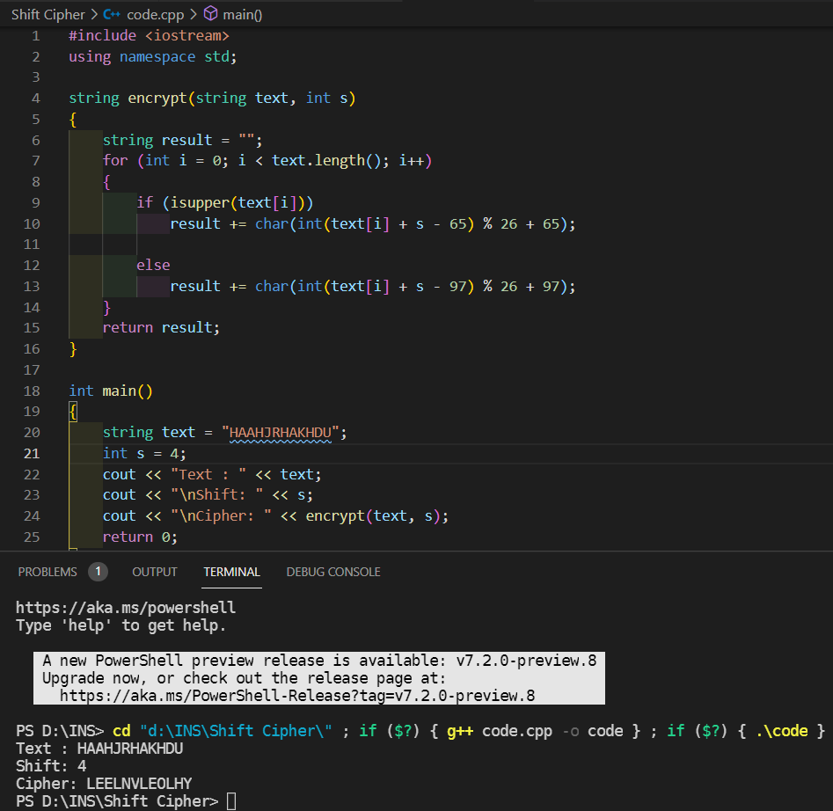

**LAB 2**

* **Monoalphabetic Cipher**

Key:

Plain: a b c d e f g h Ijklmnopq r s t u v w x y z

Cipher: DKVQFIBJWPESCXHTMYAUOLRGZN

Plaintext: if we wish to replace letters

Ciphertext: WI RF RWAJ UH YFTSDVF SFUUFYA

**Quiz:**

**1) Explain Monoalphabetic cipher.**

Monoalphabetic cipher is an improvement over caesar cipher. In this cipher each letter has

a defined alphabet and it is assigned to it in every occurrence. Like

QWERTYUIOPASDFGHJKLZXCVBNM key is assigned to

ABCDEFGHIJKLMNOPQRSTUVWXYZ

So Hello world becomes URAAF VFKAE

**2) Justify why the Monoalphabetic cipher is more secure than the Caesar cipher.**

In a Caesar cipher the possible number of guessing the key is only 25 but in a monoalphabetic cipher, It’s 26!. So to avoid brute force attack, a monoalphabetic cipher is more secure than a caesar cipher.

**3) Create your key and convert following sentence in to cipher text**

|  |  |  |  |
| --- | --- | --- | --- |
| A | Q | I | Z |
| B | A | W | C |
| C | Z | D | B |
| D | W | J | M |
| E | S | Q | N |
| F | X | P | V |
| G | E | E | X |
| H | D | U | A |
| I | C | F | D |
| J | R | H | G |
| K | F | R | J |
| L | V | Y | L |
| M | T | T | K |
| N | G | A | H |
| O | B | L | F |
| P | Y | Z | S |
| Q | H | C | Q |
| R | N | X | E |
| S | U | S | T |
| T | J | K | U |
| U | M | M | O |
| V | I | B | P |
| W | K | N | I |
| X | O | V | Y |
| Y | L | P | R |
| Z | P | F | W |

a. A quick brown fox jump over the lazy dog

ANS: Q HMCZF ANBKG XBO RMTY BISN JDS VQPL WBE

b. I am student of vvp engg college

ANS: F IT SKMJQAK LP BBZ QAEE DLYYQEQ

c. Gandhinagar is capital of gujarat

ANS: XZHMADHZXZE DT BZSDUZL FV XOGZEZU

**Code:**

#include <bits/stdc++.h>

using namespace std;

unordered_map<char,char> hashMap;

string encrypt(string msg)

{

string ciphertext;

for(int i=0; i<msg.size(); i++)

{

ciphertext.push_back(hashMap[msg[i]]);

}

return ciphertext;

}

string decrypt(string msg)

{

string plaintext;

for(int i=0; i<msg.size(); i++)

{

plaintext.push_back(hashMap[msg[i]]);

}

return plaintext;

}

void hashFn(string a, string b)

{

hashMap.clear();

for(int i=0; i<a.size(); i++)

{

hashMap.insert(make_pair(a[i],b[i]));

}

}

int main()

{

string alphabet = "abcdefghijklmnopqrstuvwxyz";

string substitution = "qwertyuiopasdfghjklzxcvbnm";

string msg = "absdhj";

hashFn(alphabet, substitution);

string cipher = encrypt(msg);

cout<<"Encrypted Cipher Text: "<<cipher<<endl;

hashFn(substitution, alphabet);

string plain = decrypt(cipher);

cout<<"Decrypted Plain Text: "<<plain<<endl;

}

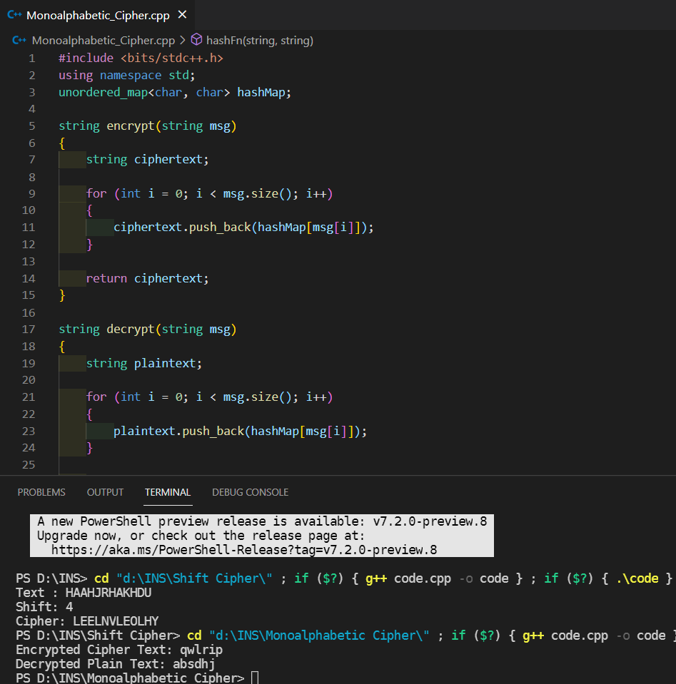

**LAB 3**

* **Vernam Cipher**

**1) Execute below vernam cipher**

**Code:**

#include<bits/stdc++.h>

using namespace std;

int main(){

int t,n,i,j,k,sum=0;

string m;

cout<<"Enter the message"<<'\n';

cin>>m;

string key;

cout<<"Enter the key"<<'\n';

cin>>key;

int mod = key.size();

j=0;

for(i=key.size();i<m.size();i++){

key+=key[j%mod];

j++;

}

string ans="";

for(i=0;i<m.size();i++){

ans += (key[i]-'A'+m[i]-'A')%26+'A';

}

cout<<"Encrypted message: "<<ans<<'\n';

return 0;

}

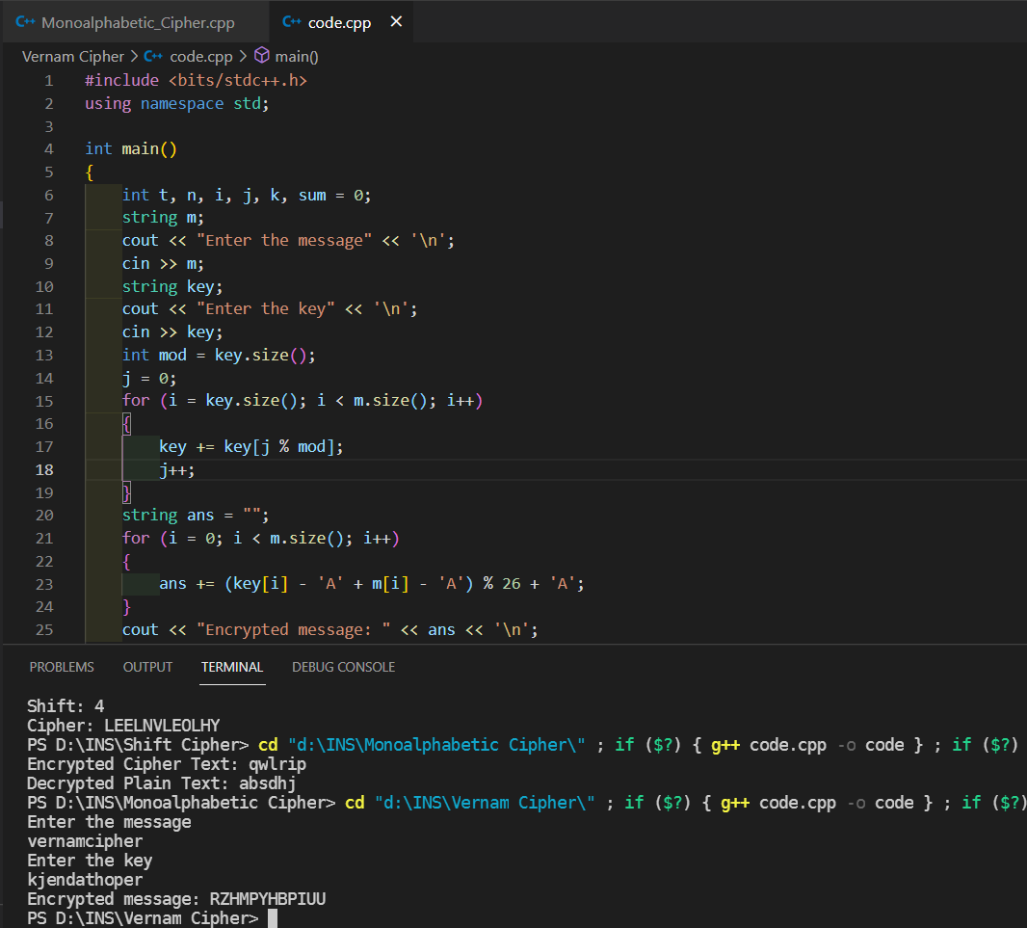

**EX:**

Plain Text : vernamcipher

Key : kjendathoper

Ans : RZHMPYHBPIUU

**2) Decrypt below vernam cipher**

**Code:**

#include<bits/stdc++.h>

using namespace std;

int main(){

int t,n,i,j,k,sum=0;

string m;

cout<<"Enter the message"<<'\n';

cin>>m;

string key;

cout<<"Enter the key"<<'\n';

cin>>key;

int mod = key.size();

j=0;

for(i=key.size();i<m.size();i++){

key+=key[j%mod];

j++;

}

string ans="";

for(i=0;i<m.size();i++){

ans += (m[i]-key[i]+26)%26+'A';

}

cout<<"Decrypted message: "<<ans<<'\n';

return 0;

}

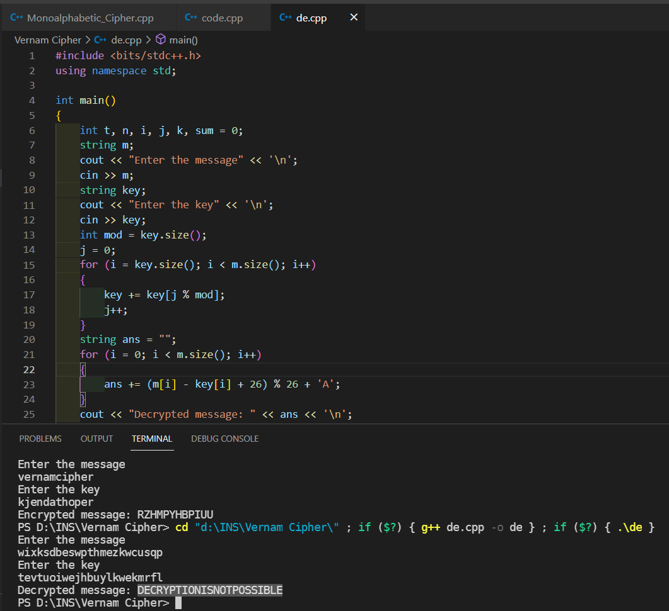

**EX:**

Cipher Text : wixksdbeswpthmezkwcusqp

Key : tevtuoiwejhbuylkwekmrfl

Ans : DECRYPTIONISNOTPOSSIBLE

**LAB 4**

* **Playfair Cipher**

Plain Text : jazz

Key : monarchy

I/J ARE TOGETHER

|  |  |  |  |  |
| --- | --- | --- | --- | --- |
| M | O | N | A | R |
| C | H | Y | B | D |
| E | F | G | I/J | K |
| L | P | Q | S | T |
| U | V | W | X | Z |

Divide plain texts to two pairs:

jazz => ja zx zx

greet => gr ex et

off => of fx

ja => sb

In one column then immediate bottom

|  |  |  |  |  |
| --- | --- | --- | --- | --- |
| M | O | N | A | R |
| C | H | Y | B | D |
| E | F | G | I/J | K |
| L | P | Q | S | T |
| U | V | W | X | Z |

xz => zu

In case of one row thake immediate right

All rows and columns are roundly connected.

|  |  |  |  |  |
| --- | --- | --- | --- | --- |
| M | O | N | A | R |
| C | H | Y | B | D |
| E | F | G | I/J | K |
| L | P | Q | S | T |
| U | V | W | X | Z |

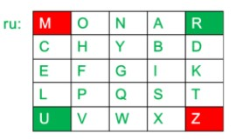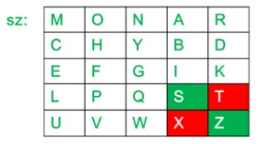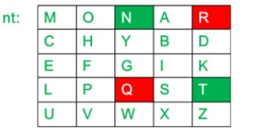

1) Encrypt following:

**Code:**

#include<iostream>

#include<string>

#include<vector>

#include<map>

using namespace std;

int main(){

int i,j,k,n;

cout<<"Enter the message"<<endl;

string s,origin;

getline(cin,origin);

cout<<"Enter the key"<<endl;

string key;

cin>>key;

for(i=0;i<origin.size();i++){

if(origin[i]!=' ')

s+= origin[i];

}

vector<vector<char> > a(5,vector<char>(5,' '));

n=5;

map<char,int> mp;

k=0;

int pi,pj;

for(i=0;i<n;i++){

for(j=0;j<n;j++){

while(mp[key[k]]>0&&k<key.size()){

k++;

}

if(k<key.size()){

a[i][j]=key[k];

mp[key[k]]++;

pi=i;

pj=j;

}

if(k==key.size())

break;

}

if(k==key.size())

break;

}

k=0;

for(;i<n;i++){

for(;j<n;j++){

while(mp[char(k+'a')]>0&&k<26){

k++;

}

if(char(k+'a')=='j'){

j--;

k++;

continue;

}

if(k<26){

a[i][j]=char(k+'a');

mp[char(k+'a')]++;

}

}

j=0;

}

string ans;

if(s.size()%2==1)

s+="x";

for(i=0;i<s.size()-1;i++){

if(s[i]==s[i+1])

s[i+1]='x';

}

map<char,pair<int,int> > mp2;

for(i=0;i<n;i++){

for(j=0;j<n;j++){

mp2[a[i][j]] = make_pair(i,j);

}

}

for(i=0;i<s.size()-1;i+=2){

int y1 = mp2[s[i]].first;

int x1 = mp2[s[i]].second;

int y2 = mp2[s[i+1]].first;

int x2 = mp2[s[i+1]].second;

if(y1==y2){

ans+=a[y1][(x1+1)%5];

ans+=a[y1][(x2+1)%5];

}

else if(x1==x2){

ans+=a[(y1+1)%5][x1];

ans+=a[(y2+1)%5][x2];

}

else {

ans+=a[y1][x2];

ans+=a[y2][x1];

}

}

cout<<ans<<'\n';

return 0;

}

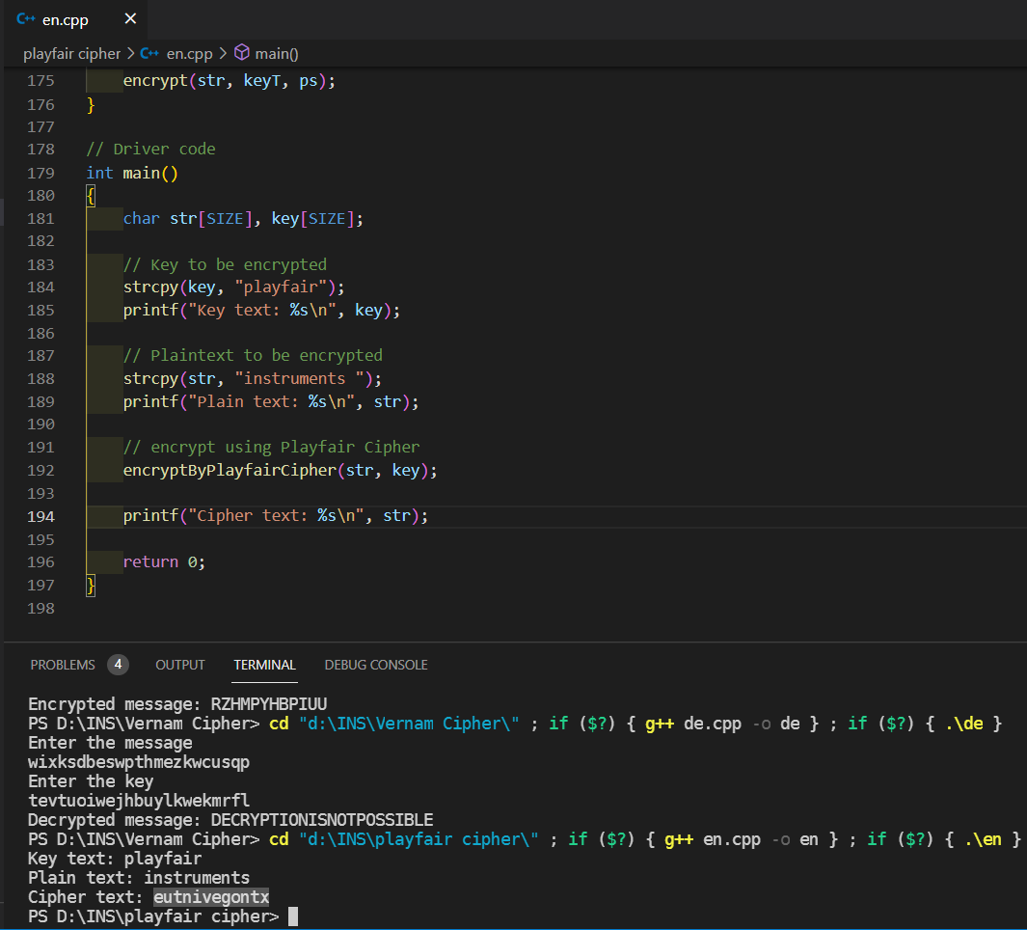

Message : instruments

Key : playfair

Ans : eutnivegontx

2. Decrypt following:

**Code:**

#include<iostream>

#include<string>

#include<vector>

#include<map>

using namespace std;

int main(){

int i,j,k,n;

cout<<"Enter the encrypted message\n";

string s;

cin>>s;

cout<<"Enter the key\n";

string key;

cin>>key;

vector<vector<char> > a(5,vector<char>(5,' '));

n=5;

map<char,int> mp;

k=0;

int pi,pj;

for(i=0;i<n;i++){

for(j=0;j<n;j++){

while(mp[key[k]]>0&&k<key.size()){

k++;

}

if(k<key.size()){

a[i][j]=key[k];

mp[key[k]]++;

pi=i;

pj=j;

}

if(k==key.size())

break;

}

if(k==key.size())

break;

}

k=0;

for(;i<n;i++){

for(;j<n;j++){

while(mp[char(k+'a')]>0&&k<26){

k++;

}

if(char(k+'a')=='j'){

j--;

k++;

continue;

}

if(k<26){

a[i][j]=char(k+'a');

mp[char(k+'a')]++;

}

}

j=0;

}

string ans;

map<char,pair<int,int> > mp2;

for(i=0;i<n;i++){

for(j=0;j<n;j++){

mp2[a[i][j]] = make_pair(i,j);

}

}

for(i=0;i<s.size()-1;i+=2){

int y1 = mp2[s[i]].first;

int x1 = mp2[s[i]].second;

int y2 = mp2[s[i+1]].first;

int x2 = mp2[s[i+1]].second;

if(y1==y2){

ans+=a[y1][(x1-1)%5];

ans+=a[y1][(x2-1)%5];

}

else if(x1==x2){

ans+=a[(y1-1)%5][x1];

ans+=a[(y2-1)%5][x2];

}

else {

ans+=a[y1][x2];

ans+=a[y2][x1];

}

}

if(ans[ans.size()-1]=='x')

ans[ans.size()-1]='\0';

for(i=1;i<ans.size();i++){

if(ans[i]=='x')

ans[i]=ans[i-1];

}

cout<<ans<<'\n';

return 0;

}

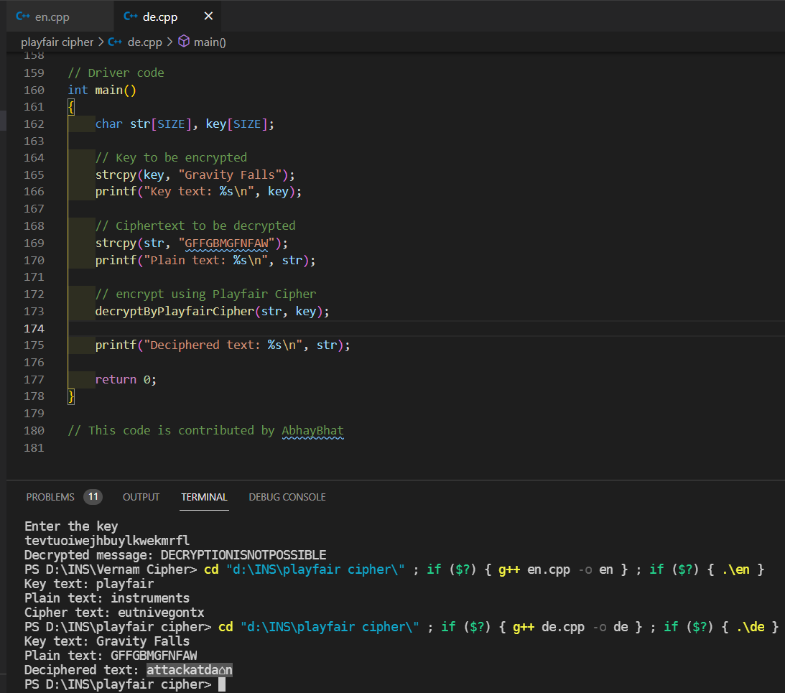

**EX:**

Cipher Text : GFFGBMGFNFAW

Key : Gravity Falls

Ans : attackatdawn

**LAB 5**

* **Hill Cipher**

1.Encrypt Following using Hill Cipher

**Code:**

#include<iostream>

#include<vector>

using namespace std;

int main(){

int x,y,i,j,k,n;

cout<<"Enter the size of key matrix\n";

cin>>n;

cout<<"Enter the key matrix\n";

int a[n][n];

for(i=0;i<n;i++){

for(j=0;j<n;j++){

cin>>a[i][j];

}

}

cout<<"Enter the message to encrypt\n";

string s;

cin>>s;

int temp = (n-s.size()%n)%n;

for(i=0;i<temp;i++){

s+='x';

}

k=0;

string ans="";

while(k<s.size()){

for(i=0;i<n;i++){

int sum = 0;

int temp = k;

for(j=0;j<n;j++){

sum += (a[i][j]%26*(s[temp++]-'a')%26)%26;

sum = sum%26;

}

ans+=(sum+'a');

}

k+=n;

}

cout<<ans<<'\n';

return 0;

}

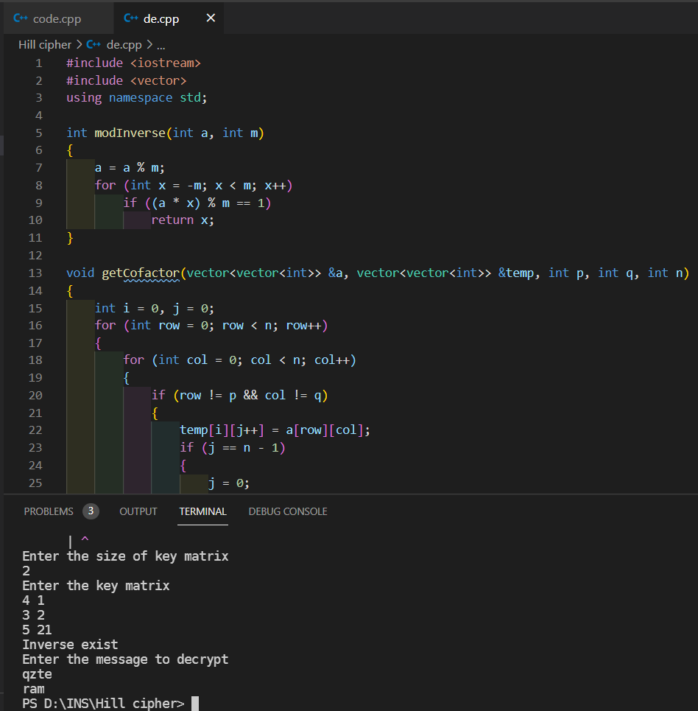

**EX:**

Plain Text : ram

Key : gybnqkcri

Ans : qzte

2. Decrypt following using Hill Cipher

**Code:**

#include<iostream>

#include<vector>

using namespace std;

int modInverse(int a, int m){

a=a%m;

for(int x=-m;x<m;x++)

if((a*x)%m==1)

return x;

}

void getCofactor(vector<vector<int> > &a, vector<vector<int> > &temp, int p, int q, int n){

int i=0,j=0;

for(int row=0;row<n;row++){

for(int col=0;col<n;col++){

if(row!=p&&col!=q){

temp[i][j++] = a[row][col];

if (j==n-1){

j=0;

i++;

}

}

}

}

}

int determinant(vector<vector<int> > &a, int n, int N){

int D = 0;

if(n==1)

return a[0][0];

vector<vector<int> > temp(N, vector<int>(N));

int sign = 1;

for(int f=0;f<n;f++){

getCofactor(a, temp, 0, f, n);

D += sign * a[0][f] * determinant(temp, n - 1, N);

sign = -sign;

}

return D;

}

void adjoint(vector<vector<int> > &a,vector<vector<int> > &adj,int N){

if(N == 1){

adj[0][0] = 1;

return;

}

int sign = 1;

vector<vector<int> > temp(N, vector<int>(N));

for(int i=0;i<N;i++){

for(int j=0;j<N;j++){

getCofactor(a, temp, i, j, N);

sign = ((i+j)%2==0)? 1: -1;

adj[j][i] = (sign)*(determinant(temp, N-1 , N));

}

}

}

bool inverse(vector<vector<int> > &a, vector<vector<int> > &inv, int N){

int det = determinant(a, N, N);

if(det == 0){

cout << "Inverse does not exist";

return false;

}

int invDet = modInverse(det,26);

cout<<det%26<<' '<<invDet<<'\n';

vector<vector<int> > adj(N, vector<int>(N));

adjoint(a, adj, N);

for(int i=0;i<N;i++)

for(int j=0;j<N;j++)

inv[i][j] = (adj[i][j]*invDet)%26;

return true;

}

int main(){

int x,y,i,j,k,n;

cout<<"Enter the size of key matrix\n";

cin>>n;

cout<<"Enter the key matrix\n";

vector<vector<int> > a(n, vector<int>(n));

vector<vector<int> > adj(n, vector<int>(n));

vector<vector<int> > inv(n, vector<int>(n));

for(i=0;i<n;i++){

for(j=0;j<n;j++){

cin>>a[i][j];

}

}

if(inverse(a,inv,n)){

cout<<"Inverse exist\n";

}

cout<<"Enter the message to decrypt\n";

string s;

cin>>s;

k=0;

string ans;

while(k<s.size()){

for(i=0;i<n;i++){

int sum = 0;

int temp = k;

for(j=0;j<n;j++){

sum += ((inv[i][j] + 26)%26*(s[temp++]-'a')%26)%26;

sum = sum%26;

}

ans+=(sum+'a');

}

k+=n;

}

//ans+='\0';

int f=ans.size()-1;

while(ans[f]=='x'){

f--;

}

for(i=0;i<=f;i++){

cout<<ans[i];

}

cout<<'\n';

return 0;

}

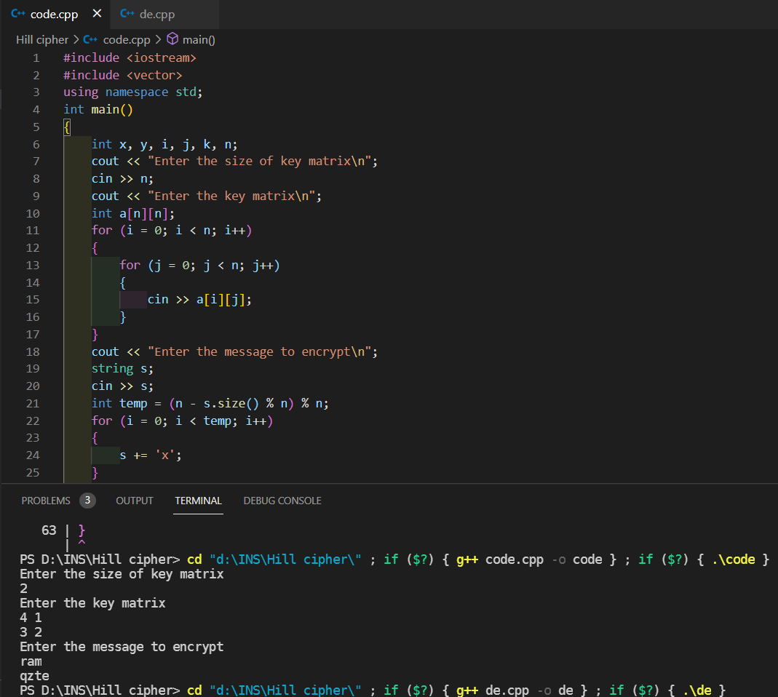

**EX:**

Cipher Text : sok

Key : cabgxrthn

Ans : qzte