LAB MANUAL

SUB: INFORMATION SECURITY

CODE: 3170720

Vision of the Institute
To be an exemplary institute, transforming students into competent professionals with human values.

Mission of the Institute
- To provide a conducive academic environment for strengthening technical capabilities of the students.
- To strengthen linkage with industries, alumni and professional bodies.
- To organize various co-curricular and extra-curricular activities for overall development of the students.
- To practice good governance and conduct value- based activities for making students responsible citizens.

Vision of the Department
Transforming students into globally efficient professionals with moral values.

Mission of the Department
- To provide a strong foundation of computer engineering through effective teaching learning process.
- To enhance industry linkage & alumni network for better placement and real-world exposure.
- To provide various opportunities & platforms for all round development of students & encourage them for value-based practices.

Program Educational Objectives (PEOs)
Graduates will be able to
- Apply computer engineering theories, principles and skills to meet the challenges of the society.
- Communicate effectively, work collaboratively and manifest professionalism with ethics.
- Exhibit life-long learning attitude and adapt to rapid technological changes in industry.
- Advance their career in industry, pursue higher education or become an entrepreneur.

Program Specific Outcomes (PSOs)
Graduates will be able to
- PSO1: Apply fundamental knowledge of hardware and software aspects of computer systems.
- PSO2: Analyze, model and develop computer applications by adapting emerging technologies and standard practices of software project development to meet the requirements of industry and society.
- PSO3: Use different programming languages and open-source platforms.

After learning the course, the students will be able to:

CO NO. | Course Outcomes | CL
C3170720.1 | Explain the different attacks possible during data transmission and need of cryptography. | U
C3170720.2 | Apply various symmetric and asymmetric algorithms. | Ap
C3170720.3 | Assess the performance of Hash function, MAC function and Digital signature. | E
C3170720.4 | Classify the different techniques of key distribution. | U
C3170720.5 | Compare remote user authentication techniques and security protocols. | A

Ex. No. | Experiment | Sign | Grades
1 | BREAKING THE SHIFT CIPHER
2 | BREAKING THE MONOALPHABETIC CIPHER
3 | Vernam Cipher in Cryptography
4 | The Playfair Cipher
5 | Hill Cipher
6 | Transposition Cipher Techniques  1) Rail Fence 2) Columnar Cipher
7 | RSA Algorithm
8 | Diffie-Hellman key exchange Algorithm
9 | Introduction to Cryptool
10 | Introduction to Wireshark

Index

Practical 1
BREAKING THE SHIFT CIPHER
To understand that secure encryption is not possible with small key space. This is more popularly known as the principle of large key space.
STEP 1 :
•For the given ciphertext in the PART I of the simulation page, the first step is to decrypt it using each of the twenty-six different keys, k=0,1,...,25 and obtain the corresponding plaintexts.
•After each decryption, list the plaintext for each iteration.
STEP 2 :
•Finally, we observe the plaintext iterations and choose the most meaningful text as our answer.
STEP 3 [OPTIONAL] :
•To verify that our answer is correct, we encrypt our plaintext with the answer key, if our ciphertext matches the given ciphertext, it is correct.
Example:
Cipher Text: HAAHJR HA KHDU
STEP 1: Trying all the possible combinations until we find a meaningful plaintext. Key 1 : Plaintext: GZZGIQ GZ JGCT
Key 2 : Plaintext: FYYFHP FY IFBS
Key 3 : Plaintext: EXXEGO EX HEAR
Key 4 : Plaintext: DWWDFN DW GDZQ Key 5 : Plaintext: CVVCEM CV FCYP
Key 6 : Plaintext: BUUBDL BU EBXO Key 7 : Plaintext: ATTACK AT DAWN
STEP II: For key = 7, we found a meaningful plaintext, hence, we stop iterating.
STEP III: Encrypt our plaintext, and compare with the ciphertext.
Encrypted plaintext with key = 7: HAAHJR HA KHDU
Here, we can see that our ciphertext matches with the given ciphertext, hence, our process was correct.
CODE: -
alphabet = ['a', 'b', 'c', 'd', 'e', 'f', 'g', 'h', 'i', 'j', 'k', 'l',
'm', 'n', 'o', 'p', 'q', 'r', 's', 't', 'u', 'v', 'w', 'x', 'y', 'z']
def shift(offset):
message = input("Input Message You Would Like Encrypted:\n") new_message = ''
for letter in message:
letter = letter.lower() # doesn't handle upper-case yet
if letter.isalpha():
shift_pos = alphabet.index(letter) + offset
new_pos = alphabet[shift_pos]
new_message += new_pos

# these will not be shifted
elif ' ' or '/t' or '/n' in letter:
new_message += letter
elif letter.isnumeric():
new_message += letter
else:
print("An error took place in recording the message. Check input.\n")
print(new_message)
shift(-1)
QUIZZES
1. Encrypt the following plaintext using key = 7: Lord Rama was a good king.
Ciphertext: Svyk Yhth dhz h nvvk rpun.
2. Given a plain text and its corresponding cipher text, find out the key used for the encryption of the plain text.
Plaintext: abcdefghijklmnopqrstuvwxyz
Ciphertext: TDNUCBZROHLGYVFPWIXSEKAMQJ
3. How many different keys are possible with an n-letter alphabet?
Answer: n-1 different keys
4. Given a ciphertext, find out the corresponding plain text using brute force attack:
Ciphertext: HAAHJR HA KHDU
Answer: Plaintext: ATTACK AT DAWN

Practical 2
BREAKING THE MONOALPHABETIC CIPHER

•To understand that just having a large keyspace is not enough to achieve secure encryption.

EXPERIMENT
STEP 1 :
•For the given ciphertext in the PART I of the experiment page, the first step is to generate ciphertext.

STEP 2 :
•Calculate frequencies of generated ciphertext.

STEP 3 :
•Compare the frequencies with English Alphabet Frequencies.

STEP 4 :
•Based on similarities of frequencies, e.g.: the highest frequencies of English Alphabet, matching with the highest frequencies of cipher text, replace one character at a time.
•After replacing characters with higher frequencies, analyze the resulting text, look for commonly used words i.e.: The, A, An.
•Keep replacing characters until you find a meaningful word. This step certainly involves some English Grammar and Human Intelligence to decrypt (although, it is surely possible to decrypt by using only a computer).
English language freq. distribution
Two latter words : th
Three latter words : the
Four latter words : that
Example: Here's the ciphertext for a message encrypted.

Cihper Text : O eumc uy Duulv Bjoxgl axv xjvod.
Plain Text : A bowl of Moose Tracks ice cream.

Quiz

Example 1:
Cipher Text: dkxyvrh 1 - qegt vkr hxccwv keur: xuwdr wn cehrq nwvvwtp et vkr hwsrhcxto gwvk krh nwnvrh, gkrt nkr tevwdrn x vxuowtp, duevkrq gkwvr hxccwv gwvk x yedorv gxvdk hit yxnv. nkr leuuegn wv qegt x hxccwv keur gkrt niqqrtub nkr lxuun x uetp gxb ve x dihwein kxuu gwvk fxtb uedorq qeehn el xuu nwmrn. nkr lwtqn x nfxuu orb ve x qeeh vee nfxuu leh krh ve lwv, civ vkheipk gkwdk nkr nrrn xt xvvhxdvwsr pxhqrt. nkr vkrt qwndesrhn x cevvur uxcruurq 'qhwto fr', vkr detvrtvn el gkwdk dxinr krh ve nkhwto vee nfxuu ve hrxdk vkr orb. x dxor gwvk 'rxv fr' et wv dxinrn krh ve pheg ve nidk x vhrfrtqein nwmr krh krxq kwvn vkr drwuwtp.
Plain Text: CHAPTER 1 - DOWN THE RABBIT HOLE: ALICE IS BORED SITTING ON THE RIVERBANK WITH HER SISTER, WHEN SHE NOTICES A TALKING, CLOTHED WHITE RABBIT WITH A POCKET WATCH RUN PAST. SHE FOLLOWS IT DOWN A RABBIT HOLE WHEN SUDDENLY SHE FALLS A LONG WAY TO A CURIOUS HALL WITH MANY LOCKED DOORS OF ALL SIZES. SHE FINDS A SMALL KEY TO A DOOR TOO SMALL FOR HER TO FIT, BUT THROUGH WHICH SHE SEES AN ATTRACTIVE GARDEN. SHE THEN DISCOVERS A BOTTLE LABELLED 'DRINK ME', THE CONTENTS OF WHICH CAUSE HER TO SHRINK TOO SMALL TO REACH THE KEY. A CAKE WITH 'EAT ME' ON IT CAUSES HER TO GROW TO SUCH A TREMENDOUS SIZE HER HEAD HITS THE CEILING.

Below is the frequency distribution of plaintext and ciphertext alphabets:

Plain Cipher
e 12.702 r 11.618
t 9.056 v 9.959
a 8.167 k 8.506
o 7.507 e 8.091
i 6.966 x 7.884
n 6.749 n 7.469
s 6.327 w 6.639
h 6.094 h 5.602
r 5.987 u 5.602
d 4.253 t 4.979
l 4.025 d 3.942
c 2.782 q 3.32
u 2.758 g 3.112
m 2.406 c 2.282
w 2.36 i 2.075
f 2.228 o 1.867
g 2.015 f 1.452
y 1.974 l 1.452
p 1.929 p 1.452
b 1.49 b 1.037
v 0.978 s 0.622
k 0.772 y 0.622
j 0.153 m 0.415
x 0.15 a 0
q 0.095 j 0
z 0.074 z 0

Example 2:
Cipher Text: awbix ildxz kolf a dkzeplld afu zbjjbfm lf bj bz a rwkx iajxpobwwap zdlgbfm a ellgae. jex iajxpobwwap ykxzjblfz awbix afu zex audbjz jl exp ikppxfj buxfjbjt ipbzbz, ildolkfuxu rt exp bfarbwbjt jl pxdxdrxp a olxd. rxnlpx ipahwbfm ahat, jex iajxpobwwap jxwwz awbix jeaj lfx zbux ln jex dkzeplld hbww dagx exp jawwxp afu jex ljexp zbux hbww dagx exp zelpjxp. zex rpxagz lnn jhl obxixz npld jex dkzeplld. lfx zbux dagxz exp zepbfg zdawwxp jeaf xcxp, hebwx afljexp iakzxz exp fxig jl mplh ebme bfjl jex jpxxz, hexpx a obmxlf dbzjagxz exp nlp a zxpoxfj. hbje zldx xnnlpj, awbix rpbfmz expzxwn raig jl exp kzkaw exbmej. zex zjkdrwxz kolf a zdaww xzjajx afu kzxz jex dkzeplld jl pxaie a dlpx aooplopbajx exbmej.
Plain Text: ALICE COMES UPON A MUSHROOM AND SITTING ON IT IS A BLUE CATERPILLAR SMOKING A HOOKAH. THE CATERPILLAR QUESTIONS ALICE AND SHE ADMITS TO HER CURRENT IDENTITY CRISIS, COMPOUNDED BY HER INABILITY TO REMEMBER A POEM. BEFORE CRAWLING AWAY, THE CATERPILLAR TELLS ALICE THAT ONE SIDE OF THE MUSHROOM WILL MAKE HER TALLER AND THE OTHER SIDE WILL MAKE HER SHORTER. SHE BREAKS OFF TWO PIECES FROM THE MUSHROOM. ONE SIDE MAKES HER SHRINK SMALLER THAN EVER, WHILE ANOTHER CAUSES HER NECK TO GROW HIGH INTO THE TREES, WHERE A PIGEON MISTAKES HER FOR A SERPENT. WITH SOME EFFORT, ALICE BRINGS HERSELF BACK TO HER USUAL HEIGHT. SHE STUMBLES UPON A SMALL ESTATE AND USES THE MUSHROOM TO REACH A MORE APPROPRIATE HEIGHT.

Below is the frequency distribution of plaintext and ciphertext alphabets:

Plain Cipher
X 14.06 E 12.702
P 8.26 T 9.056
A 8.084 A 8.167
J 7.909 O 7.507
L 7.381 I 6.966
Z 7.381 N 6.749
E 7.206 S 6.327
B 6.854 H 6.094
W 5.097 R 5.987
D 4.394 D 4.253
F 4.394 L 4.025
I 2.988 C 2.782
K 2.636 U 2.758
O 2.285 M 2.406
U 1.933 W 2.36
G 1.757 F 2.228
H 1.582 G 2.015
m 1.582 Y 1.974
N 1.582 P 1.929
R 1.582 B 1.49
T 0.703 V 0.978
C 0.176 K 0.772
Y 0.176 J 0.153
Q 0 X 0.15
S 0 Q 0.095
V 0 Z 0.074

CODE:-
public class Mono {
public static void main(String[] args) {
String c = "ABCDEFGHIJKLMNOPQRSTUVWXYZ ";
String monoAlphabeticCipher1 = "QAZWSXEDCRFVTGBYHNUJMIKOLP ";
String monoAlphabeticCipher2 = "IWDJQPEUFHRYTALZCXSKMBNVPF ";
String monoAlphabeticCipher3 = "ZCBMNVXADGJLKHFSQETUOPIYRW ";
String str1 = "A quick brown fox jump over the lazy dog".toUpperCase();
String str2 = "I am student of vvp engg college".toUpperCase();
String str3 = "Gandhinagar is capital of gujarat".toUpperCase();

System.out.print("First String : \t\t\t" + str1 + "\n");
System.out.print("Monoalphabetic Cipher is : \t");
for (int i = 0; i < str1.length(); i++)
System.out.print(monoAlphabeticCipher1.charAt(c.indexOf(str1.charAt(i))));

System.out.print("\n\n\n");
System.out.print("Second String : \t\t" + str2 + "\n");
System.out.print("Monoalphabetic Cipher is : \t");
for (int i = 0; i < str2.length(); i++)
System.out.print(monoAlphabeticCipher2.charAt(c.indexOf(str2.charAt(i))));

System.out.print("\n\n\n");
System.out.print("Third String : \t\t\t" + str3 + "\n");
System.out.print("Monoalphabetic Cipher is : \t");

for (int i = 0; i < str3.length(); i++)
System.out.print(monoAlphabeticCipher3.charAt(c.indexOf(str3.charAt(i))));
}
}
Practical – 3
Vernam Cipher in Cryptography

Vernam Cipher is a method of encrypting alphabetic text. It is one of the Transposition techniques for converting a plain text into a cipher text. In this mechanism we assign a number to each character of the Plain-Text, like (a = 0, b = 1, c = 2, … z = 25).

Method to take key:
In Vernam cipher algorithm, we take a key to encrypt the plain text which length should be equal to the length of the plain text.

Encryption Algorithm:

1.Assign a number to each character of the plain-text and the key according to alphabetical order.

2.Add both the number (Corresponding plain-text character number and Key character number).

3.Subtract the number from 26 if the added number is greater than 26, if it isn’t then leave it.

Example:
Plain-Text: RAMSWARUPK
Key: RANCHOBABA

Now according to our encryption algorithm we assign a number to each character of our plain-text and key.
PT: R A M S W A R U P K
NO: 17 0 12 18 22 0 17 20 15 10

KEY: R A N C H O B A B A
NO: 17 0 13 2 7 14 1 0 1 0

Now add the number of Plain-Text and Key and after doing the addition and subtraction operation (if required), we will get the corresponding Cipher-Text character number.
CT-NO: 34 0 25 20 29 14 18 20 16 10

In this case, there are two numbers which are greater than the 26 so we have to subtract 26 from them and after applying the subtraction operation the new Cipher text character numbers are as follow:
CT-NO: 8 0 25 20 3 14 18 20 16 10

New Cipher-Text is after getting the corresponding character from the number.
CIPHER-TEXT: I A Z U D O S U Q K
Note:
For the Decryption apply the just reverse process of encryption.
CODE:-
public class VernamCipher{
public static void main(String []args){
String alphabets = "ABCDEFGHIJKLMNOPQRSTUVWXYZ ";
String str = "vernamcipher".toUpperCase();
String key = "kjendathoper".toUpperCase();

System.out.println("The message is "+str);
System.out.println("The key is "+key);
System.out.println("The vernam cipher is \n");

for(int i=0; i<str.length(); i++) {
int a = alphabets.indexOf(str.charAt(i));
int b = alphabets.indexOf(key.charAt(i));
int c = a+b;
if(c>25)
c-=26;
System.out.print(alphabets.charAt(c));
}

}
}
Quiz:
1) Execute below vernam cipher
Plain Text : vernamcipher
Key : kjendathoper
Ans : fnvadmvpdwii

2) Decrypt below vernam cipher
Cipher Text : wixksdbeswpthmezkwcusqp
Key : tevtuoiwejhbuylkwekmrfl
Ans : decryptionisnotpossible

Practical – 4
The Playfair Cipher

The Playfair cipher was the first practical digraph substitution cipher. The scheme was invented in 1854 by Charles Wheatstone but was named after Lord Playfair who promoted the use of the cipher. In playfair cipher unlike traditional cipher we encrypt a pair of alphabets (digraphs) instead of a single alphabet.
It was used for tactical purposes by British forces in the Second Boer War and in World War I and for the same purpose by the Australians during World War II. This was because Playfair is reasonably fast to use and requires no special equipment.
The Playfair cipher, invented by Charles Wheatstone, is a polyalphabetic substitution cipher, meaning that one letter can be denoted by different letters in its encryption, depending on the keyword used, which is given to both parties. For example, let us assume that the keyword is ‘Charles’. A 5x5 matrix is drawn, and letters are filled in each cell, starting with the keyword, followed by the letters in the alphabet. I/J are filled in the same cell. All repeating letters are removed, giving us this matrix -
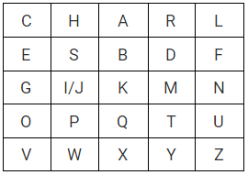
Image by author -Playfair matrix for the keyword ‘Charles’

Given a plaintext sentence, it is split into digrams, removing all spaces, and padding with the letter x in case of an odd number of letters. Repeating plaintext letters are separated with a filler letter such as x. Given the sentence ‘Meet me at the bridge’, the digrams would be -
me et me at th eb ri dg ex

Rules for Encryption
1. Two plaintext letters in the same row of the matrix are each replaced by the letter to the right, with the first element of the row circularly following the last.
eb would be replaced by sd
ng would be replaced by gi/gj
2. Two plaintext letters that fall in the same column of the matrix are replaced by the letters beneath, with the top element of the column circularly following the bottom.
dt would be replaced by my
ty would be replaced by yr
3. Otherwise, each plaintext letter in a pair is replaced by the letter that lies in its own row and the column occupied by the other plaintext letter.
me would be replaced by gd
et would be replaced by do
Following these rules, the ciphertext becomes ‘gd do gd rq pr sd hm em bv’.
This cipher is more secure than simple substitution, but is still susceptible to ciphertext-only attacks by doing statistical frequency counts of pairs of letters, since each pair of letters always gets encrypted in the same fashion. Moreover, short keywords make the Playfair cipher even easier to crack.

CODE:-
public class PlayFairCipher{
static char[][] c = new char[5][5];
static String alphabets = "ABCDEFGHIJKLMNOPQRSTUVWXYZ";
static void putCharacters(String key) {
int n = 0;
StringBuilder sb = new StringBuilder();
sb.append(""+alphabets);
for(int i=0; i<5; i++) {
for(int j=0; j<5; j++) {
if(n<key.length()) {
int temp = sb.indexOf(Character.toString(key.charAt(n)));
if(temp!=-1) {
c[i][j] = key.charAt(n);
sb.deleteCharAt(temp);
}
else {
j--;
}
n++;

}
else {
if(sb.charAt(0) == 'J')
sb.deleteCharAt(0);
c[i][j] = sb.charAt(0);
sb.deleteCharAt(0);
}
}
}
}

static String makePair(String str) {
StringBuilder sb = new StringBuilder();
for(int i=0; i<str.length(); i+=2) {
char a = str.charAt(i);
if(i+1<str.length()) {
char b = str.charAt(i+1);
if(a==b && i!=0 && i+1==str.length()) {
sb.append(a);
sb.append("X");
//sb.append(" ");
sb.append(b);
sb.append("X");
//sb.append(" ");
}
else if(a==b && i!=0 && i+1!=str.length()) {
sb.append(a);
sb.append("X");
//sb.append(" ");
i--;
}
else {
sb.append(a);
sb.append(b);
//sb.append(" ");
}
}
else {
sb.append(a);
sb.append("X");
}

}
return sb.toString();
}

static void cipher(String pairs) {
StringBuilder ans = new StringBuilder();
char pair[] = pairs.toCharArray();
for(int i=0; i<pair.length; i+=2) {
int a1=0,a2=0,b1=0,b2=0;
for(int a=0; a<5; a++) {
for(int b=0; b<5; b++) {
if(pair[i]==c[a][b]) {
a1 = a;
a2 = b;
}
if(pair[i+1]==c[a][b]) {
b1 = a;
b2 = b;
}
}
}
if(a2==b2) {
a1++;
b1++;
if(a1==5)
a1=0;
if(b1==5)
b1=0;
System.out.print(c[a1][a2]+""+c[b1][b2]);
}
else if(a1==b1) {
a2++;
b2++;
if(a2==5)
a2=0;
if(b2==5)
b2=0;
System.out.print(c[a1][a2]+""+c[b1][b2]);
}
else {
int temp = b2;
b2 = a2;
a2 = temp;
System.out.print(c[a1][a2]+""+c[b1][b2]);
}
}
}

public static void main(String []args){

String str = "instruments".toUpperCase();
String key = "playfair".toUpperCase();

System.out.println("The message is "+str);
System.out.println("The key is "+key);
System.out.println("The playfair cipher is \n");

putCharacters(key);

String pairs = makePair(str);

cipher(pairs);
}
}
Quiz
1) Encrypt following:
Message : instruments
Key :monarchy
ANS : gatlmzclrqtx

2) Decrypt following:
Cipher Text : GFFGBMGFNFAW
Key : Gravity Falls
ANS : ATTACKATDAWN

Practical – 5
Hill Cipher

Hill cipher is a polygraphic substitution cipher based on linear algebra. Each letter is represented by a number modulo 26. Often the simple scheme A = 0, B = 1, …, Z = 25 is used, but this is not an essential feature of the cipher. To encrypt a message, each block of n letters (considered as an n-component vector) is multiplied by an invertible n × n matrix, against modulus 26. To decrypt the message, each block is multiplied by the inverse of the matrix used for encryption.
The matrix used for encryption is the cipher key, and it should be chosen randomly from the set of invertible n × n matrices (modulo 26).
Examples:

Input : Plaintext: ACT
Key: GYBNQKURP
Output : Ciphertext: POH

Input : Plaintext: GFG
Key: HILLMAGIC
Output : Ciphertext: SWK

Encryption
We have to encrypt the message ‘ACT’ (n=3).The key is ‘GYBNQKURP’ which can be written as the nxn matrix:
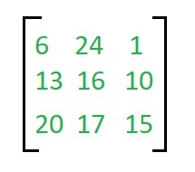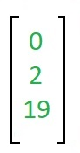
Key written in matrix format. The message ‘ACT’ is written as vector

The enciphered vector is given as:
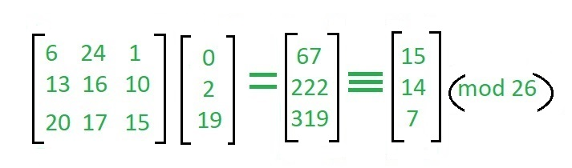
Which corresponds to ciphertext of ‘POH’

Decryption
To decrypt the message, we turn the ciphertext back into a vector, then simply multiply by the inverse matrix of the key matrix (IFKVIVVMI in letters).The inverse of the matrix used in the previous example is:
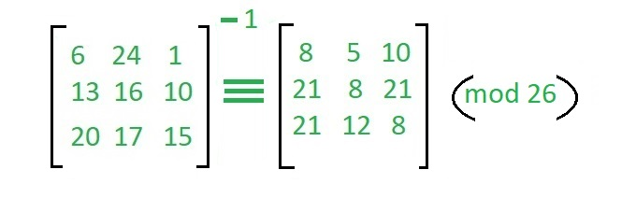
For the previous Ciphertext ‘POH’:

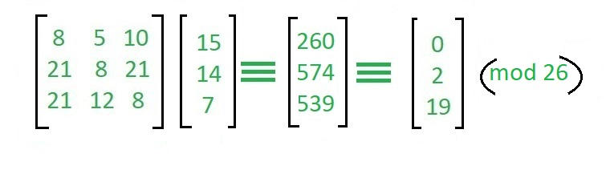
Which gives us back ‘ACT’.
Assume that all the alphabets are in upper case.
Below is the implementation of the above idea for n=3.
Output:
Ciphertext: POH

CODE:-
public class HillCipher{
static String message = "ram".toUpperCase();
static String key = "gybnqkcri".toUpperCase();
static int[][] matrix = new int[3][3];
static int[][] mesmat = new int[3][1];
static int ans[][] = new int[3][1];

static void toMatrix(String key) {
int n=0;
for(int i=0; i<3; i++) {
for(int j=0; j<3; j++) {
matrix[i][j] = (key.charAt(n))%65;
/*this statement will convert text into its ascii and then into alphabet order.
a->1 , b->2, ...*/
n++;
}
}
}

static void toMessageMatrix(String message) {
int n=0;
for(int i=0; i<3; i++) {
mesmat[i][0] = (message.charAt(n))%65;
n++;
}
}

static void matricsMultiplication(int matrix[][], int mesmat[][]) {
for(int i=0; i<3; i++) {
ans[i][0] = mesmat[0][0]*matrix[i][0] + mesmat[1][0]*matrix[i][1] + mesmat[2][0]*matrix[i][2];
ans[i][0] = ans[i][0]%26;
}
}
static void toString(int ans[][]) {
for(int i=0; i<3; i++) {
System.out.print((char)(ans[i][0] + 65));
}
}
public static void main(String[] args){
System.out.println("The message is: "+message);
System.out.println("The key is: "+key);
System.out.print("\nThe hill cipher is: ");
toMatrix(key);
toMessageMatrix(message);
matricsMultiplication(matrix, mesmat);
toString(ans);
}
}
Quiz

1) Encrypt Following using Hill Cipher
Plain Text : ram
Key : gybnqkcri
output : kda

2) Decrypt following using Hill Cipher
Cipher Text : sok
Key : cabgxrthn
output : key
Practical – 6
Transposition Cipher Techniques
Rail Fence Cipher
Given a plain-text message and a numeric key, cipher/de-cipher the given text using Rail Fence algorithm.
The rail fence cipher (also called a zigzag cipher) is a form of transposition cipher. It derives its name from the way in which it is encoded.

Encryption
In a transposition cipher, the order of the alphabets is re-arranged to obtain the cipher-text.
In the rail fence cipher, the plain-text is written downwards and diagonally on successive rails of an imaginary fence.
When we reach the bottom rail, we traverse upwards moving diagonally, after reaching the top rail, the direction is changed again. Thus the alphabets of the message are written in a zig-zag manner.
After each alphabet has been written, the individual rows are combined to obtain the cipher-text.

Decryption
As we’ve seen earlier, the number of columns in rail fence cipher remains equal to the length of plain-text message. And the key corresponds to the number of rails.
Hence, rail matrix can be constructed accordingly. Once we’ve got the matrix we can figure-out the spots where texts should be placed (using the same way of moving diagonally up and down alternatively).
Then, we fill the cipher-text row wise. After filling it, we traverse the matrix in zig-zag manner to obtain the original text.
CODE:-
def encryptRailFence(text, key): rail = [['\n' for i in range(len(text))] for j in range(key)]

dir_down = False
row, col = 0, 0

for i in range(len(text)): if
(row == 0) or (row == key - 1): dir_down = not dir_down

rail[row][col] = text[i]
col += 1
if dir_down:
row += 1 else: row -= 1
result = []
for i in range(key):
for j in range(len(text)):
if rail[i][j] != '\n': result.append(rail[i][j])
return ("".join(result))

def decryptRailFence(cipher, key):
rail = [['\n' for i in range(len(cipher))]
for j in range(key)]

dir_down = None
row, col = 0, 0
for i in range(len(cipher)): if
row == 0: dir_down = True
if row == key - 1: dir_down = False
rail[row][col] = '*'
col += 1
if dir_down:
row += 1 else: row -= 1
index = 0
for i in range(key): for
j in range(len(cipher)):
if ((rail[i][j] == '*') and (index < len(cipher))): rail[i][j] = cipher[index]
index += 1
result = []
row, col = 0, 0
for i in range(len(cipher)): if
row == 0:
dir_down = True
if row == key - 1: dir_down = False
if (rail[row][col] != '*'): result.append(rail[row][col])
col += 1
if dir_down:
row += 1
else:
row -= 1
return ("".join(result))
if name == "main":
print(encryptRailFence("attack at once", 2))
print(encryptRailFence("hello world ", 3))
print(encryptRailFence("defend the east wall", 3))
print(decryptRailFence("atc toctaka ne", 2))
print(decryptRailFence("wdlor olleh", 3))
print(decryptRailFence("dnhaweedtees alf tl", 3))
Quiz:
Encryption
Input : "defend the east wall"
Key = 3
Output : dnhaweedtees alf tl

Decryption
Input : "atc toctaka ne"
Key = 2
Output : attack at once

Columnar Cipher
Introduction
The columnar transposition cipher is a fairly simple, easy to implement cipher. It is a transposition cipher that follows a simple rule for mixing up the characters in the plaintext to form the ciphertext.
Although weak on its own, it can be combined with other ciphers, such as a substitution cipher, the combination of which can be more difficult to break than either cipher on it's own. The ADFGVX cipher uses a columnar transposition to greatly improve its security.

Encryption
The key for the columnar transposition cipher is a keyword e.g. GERMAN. The row length that is used is the same as the length of the keyword. To encrypt a piece of text, e.g.

defend the east wall of the castle
we write it out in a special way in a number of rows (the keyword here is GERMAN):

G E R M A N
d e f e n d
t h e e a s
t w a l l o
f t h e c a
s t l e x x

In the above example, the plaintext has been padded so that it neatly fits in a rectangle. This is known as a regular columnar transposition. An irregular columnar transposition leaves these characters blank, though this makes decryption slightly more difficult. The columns are now reordered such that the letters in the key word are ordered alphabetically.

A E G M N R
n e d e d f
a h t e s e
l w t l o a
c t f e a h
x t s e x l

The ciphertext is read off along the columns:
nalcxehwttdttfseeleedsoaxfeahl
Decryption
To decipher it, the recipient has to work out the column lengths by dividing the message length by the key length.
Then, write the message out in columns again, then re-order the columns by reforming the key word.
CODE:-
def columnar_encrypt(text, key):
m = {i: [] for i in key}
cols = [list(text[j:j + len(key)]) for j in range(0, len(text), len(key))]
if len(cols[-1]) < len(key): while
len(cols[-1]) != len(key): cols[-1].append(' ')
i = 0
for k in m.keys(): if
i < len(key):
for j in cols: m[k] += j[i]
i += 1
s = {k: m[k] for k in sorted(m)}
cipher = ''
for i in s.keys(): for
x in s[i]: cipher += x
print(m)
return cipher

def columnar_decrypt(cipher, key): if

len(cipher) < len(key): key = key[:len(cipher)]
n = len(cipher) // len(key)
s = {k: [] for k in sorted(key)}
cols = [cipher[j:j + n] for j in range(0, len(cipher), n)]
i = 0
for k in s.keys():
if i < len(key):
s[k] = list(cols[i])
i += 1
m = {}
for k in key: m[k] = s[k]
o = m
plain = ''
import pandas as pd

m = pd.DataFrame(m)
for i in m.itertuples(): for
j in i[1:]: plain += j
print(s, '\n')

return plain.strip()
Quiz
Encryption:
Plain Text: The nose is pointing down and the houses are getting bigger.
Key: 1423756
Ans: TIIAOEGEPGDSEINODTETGHSNNUGBSNWEAIEETNHRNROIOHSTG
Decryption:
Cipher Text: TSUTPI ILRST SOANI HAMROO ICNASN.
Key: 15423
Ans: T H I S I S A C O LU M N A RT R A N SP O S I TI O N
Practical – 7
RSA Algorithm
The RSA algorithm is the basis of a cryptosystem -- a suite of cryptographic algorithms that are used for specific security services or purposes -- which enables public key encryption and is widely used to secure sensitive data, particularly when it is being sent over an insecure network such as the internet.
RSA was first publicly described in 1977 by Ron Rivest, Adi Shamir and Leonard Adleman of the Massachusetts Institute of Technology, though the 1973 creation of a public key algorithm by British mathematician Clifford Cocks was kept classified by the U.K.'s GCHQ until 1997.
Public key cryptography, also known as asymmetric cryptography, uses two different but mathematically linked keys -- one public and one private. The public key can be shared with everyone, whereas the private key must be kept secret.
In RSA cryptography, both the public and the private keys can encrypt a message; the opposite key from the one used to encrypt a message is used to decrypt it. This attribute is one reason why RSA has become the most widely used asymmetric algorithm: It provides a method to assure the confidentiality, integrity, authenticity, and non-repudiation of electronic communications and data storage.
Many protocols like secure shell, OpenPGP, S/MIME, and SSL/TLS rely on RSA for encryption and digital signature functions. It is also used in software programs -- browsers are an obvious example, as they need to establish a secure connection over an insecure network, like the internet, or validate a digital signature. RSA signature verification is one of the most commonly performed operations in network-connected systems.
Why the RSA algorithm is used
RSA derives its security from the difficulty of factoring large integers that are the product of two large prime numbers. Multiplying these two numbers is easy, but determining the original prime numbers from the total -- or factoring -- is considered infeasible due to the time it would take using even today's supercomputers.
The public and private key generation algorithm is the most complex part of RSA cryptography. Two large prime numbers, p and q, are generated using the Rabin-Miller primality test algorithm. A modulus, n, is calculated by multiplying p and q. This number is used by both the public and private keys and provides the link between them. Its length, usually expressed in bits, is called the key length.
The public key consists of the modulus n and a public exponent, e, which is normally set at 65537, as it's a prime number that is not too large. The e figure doesn't have to be a secretly selected prime number, as the public key is shared with everyone.
The private key consists of the modulus n and the private exponent d, which is calculated using the Extended Euclidean algorithm to find the multiplicative inverse with respect to the totient of n.
Read on or watch the video below for a more detailed explanation of how the RSA algorithm works.
How does the RSA algorithm work?
Alice generates her RSA keys by selecting two primes: p=11 and q=13. The modulus is n=p×q=143. The totient is n ϕ(n)=(p−1)x(q−1)=120. She chooses 7 for her RSA public key e and calculates her RSA private key using the Extended Euclidean algorithm, which gives her 103.
Bob wants to send Alice an encrypted message, M, so he obtains her RSA public key (n, e) which, in this example, is (143, 7). His plaintext message is just the number 9 and is encrypted into ciphertext, C, as follows:
Me mod n = 97 mod 143 = 48 = C
When Alice receives Bob's message, she decrypts it by using her RSA private key (d, n) as follows:
Cd mod n = 48103 mod 143 = 9 = M
To use RSA keys to digitally sign a message, Alice would need to create a hash -- a message digest of her message to Bob -- encrypt the hash value with her RSA private key, and add the key to the message. Bob can then verify that the message has been sent by Alice and has not been altered by decrypting the hash value with her public key. If this value matches the hash of the original message, then only Alice could have sent it -- authentication and non-repudiation -- and the message is exactly as she wrote it -- integrity.
Alice could, of course, encrypt her message with Bob's RSA public key -- confidentiality -- before sending it to Bob. A digital certificate contains information that identifies the certificate's owner and also contains the owner's public key. Certificates are signed by the certificate authority that issues them, and they can simplify the process of obtaining public keys and verifying the owner.
RSA security
RSA security relies on the computational difficulty of factoring large integers. As computing power increases and more efficient factoring algorithms are discovered, the ability to factor larger and larger numbers also increases.
Encryption strength is directly tied to key size, and doubling key length can deliver an exponential increase in strength, although it does impair performance. RSA keys are typically 1024- or 2048-bits long, but experts believe that 1024-bit keys are no longer fully secure against all attacks. This is why the government and some industries are moving to a minimum key length of 2048-bits.
Barring an unforeseen breakthrough in quantum computing, it will be many years before longer keys are required, but elliptic curve cryptography (ECC) is gaining favor with many security experts as an alternative to RSA to implement public key cryptography. It can create faster, smaller and more efficient cryptographic keys.
Modern hardware and software are ECC-ready, and its popularity is likely to grow, as it can deliver equivalent security with lower computing power and battery resource usage, making it more suitable for mobile apps than RSA. Finally, a team of researchers, which included Adi Shamir, a co-inventor of RSA, has successfully created a 4096-bit RSA key using acoustic cryptanalysis; however, any encryption algorithm is vulnerable to attack.
CODE:-
import time
import rsa

poolsize = 8
accurate = True
def run_speed_test(bitsize):
iterations = 0
start = end = time.time()

# At least a number of iterations, and at least 2 seconds
while iterations < 10 or end - start < 2:
iterations += 1
rsa.newkeys(bitsize, accurate=accurate, poolsize=poolsize)
end = time.time()

duration = end - start
dur_per_call = duration / iterations

print('%5i bit: %9.3f sec. (%i iterations over %.1f seconds)' %
(bitsize, dur_per_call, iterations, duration))

if name == 'main':
for bitsize in (128, 256, 384, 512, 1024, 2048, 3072, 4096):
run_speed_test(bitsize)
Quiz
Perform encryption and decryption using RSA algorithm for following values
1) p = 3; q = 11, e = 7; M = 5
2) p = 5; q = 11, e = 3; M = 9
3) p = 7; q = 11, e = 17; M = 8
Practical – 8
Diffie-Hellman key exchange Algorithm
Diffie-Hellman key exchange, also called exponential key exchange, is a method of digital encryption that uses numbers raised to specific powers to produce decryption keys on the basis of components that are never directly transmitted, making the task of a would-be code breaker mathematically overwhelming.
To implement Diffie-Hellman, the two end users Alice and Bob, while communicating over a channel they know to be private, mutually agree on positive whole numbers p and q, such that p is a prime number and q is a generator of p. The generator q is a number that, when raised to positive whole-number powers less than p, never produces the same result for any two such whole numbers. The value of p may be large but the value of q is usually small.
Once Alice and Bob have agreed on p and q in private, they choose positive whole-number personal keys a and b, both less than the prime-number modulus p. Neither user divulges their personal key to anyone; ideally they memorize these numbers and do not write them down or store them anywhere. Next, Alice and Bob compute public keys a* and b* based on their personal keys according to the formulas
a* = qa mod p
and
b* = qb mod p
The two users can share their public keys a* and b* over a communications medium assumed to be insecure, such as the Internet or a corporate wide area network (WAN). From these public keys, a number x can be generated by either user on the basis of their own personal keys. Alice computes x using the formula
x = (b*)a mod p
Bob computes x using the formula
x = (a*)b mod p
The value of x turns out to be the same according to either of the above two formulas. However, the personal keys a and b, which are critical in the calculation of x, have not been transmitted over a public medium. Because it is a large and apparently random number, a potential hacker has almost no chance of correctly guessing x, even with the help of a powerful computer to conduct millions of trials. The two users can therefore, in theory, communicate privately over a public medium with an encryption method of their choice using the decryption key x.
Example:
Step 1: Alice and Bob get public numbers P = 23, G = 9
Step 2: Alice selected a private key a = 4 and
Bob selected a private key b = 3
Step 3: Alice and Bob compute public values
Alice: x =(9^4 mod 23) = (6561 mod 23) = 6
Bob: y = (9^3 mod 23) = (729 mod 23) = 16
Step 4: Alice and Bob exchange public numbers
Step 5: Alice receives public key y =16 and
Bob receives public key x = 6
Step 6: Alice and Bob compute symmetric keys
Alice: ka = y^a mod p = 65536 mod 23 = 9
Bob: kb = x^b mod p = 216 mod 23 = 9
Step 7: 9 is the shared secret.

CODE:-
# use Python 3 print function
# this allows this code to run on python 2.x and 3.x from _future_ import print_function

# Variables Used sharedPrime = 23 # p
sharedBase = 5 # g

aliceSecret = 6 # a
bobSecret = 15 # b

# Begin
print( "Publicly Shared Variables:") print( " Publicly Shared Prime: " , sharedPrime )
print( " Publicly Shared Base: " , sharedBase )

# Alice Sends Bob A = g^a mod p
A = (sharedBase**aliceSecret) % sharedPrime
print( "\n Alice Sends Over Public Chanel: " , A )

# Bob Sends Alice B = g^b mod p
B = (sharedBase ** bobSecret) % sharedPrime
print( &amp;amp;amp;amp;amp;amp;quot; Bob Sends Over Public Chanel: ", B )

print( "\n------------\n" ) print( "Privately Calculated Shared Secret:" ) # Alice Computes Shared Secret: s = B^a mod p aliceSharedSecret = (B ** aliceSecret) % sharedPrime print( " Alice Shared Secret: ", aliceSharedSecret )

# Bob Computes Shared Secret: s = A^b mod p bobSharedSecret = (A**bobSecret) % sharedPrime print( " Bob Shared Secret: ", bobSharedSecret )

Quiz
- Alice and Bob are using the Diffie-Hellman key exchange protocol with (p, α) = (19, 13) to agree on a key for a shift cipher. Bob’s secret exponent is 5, and he receives the message (11, SVVRVBA). What message did Alice send to him?
ANS : Lookout

- Consider above facts: What information did Bob exchange with Alice to notify her of the key they would be using?
ANS : Bob would exchange 135 ≡ 14 with Alice to let her know what key they were agreeing to.

Practical – 9
Introduction to Cryptool
In this practical Cryptool tutorial, we will create a simple cipher using the RC4 brute force tool. We will then attempt to decrypt it using brute-force attack. For this exercise, let us assume that we know the encryption secret key is 24 bits. We will use this information to break the cipher.

Creating the RC4 stream cipher
Step 1) Download and intallCryptTool
We will use CrypTool 1 as our cryptology tool. CrypTool 1 is an open source educational tool for crypto logical studies. You can download it from https://www.cryptool.org/en/ct1/
Step 2) Open CryptTool and replace the text (For ref. only)
We will encrypt the following phrase
Never underestimate the determination of a kid who is time-rich and cash-poor
We will use 00 00 00 as the encryption key.
- Open CrypTool 1
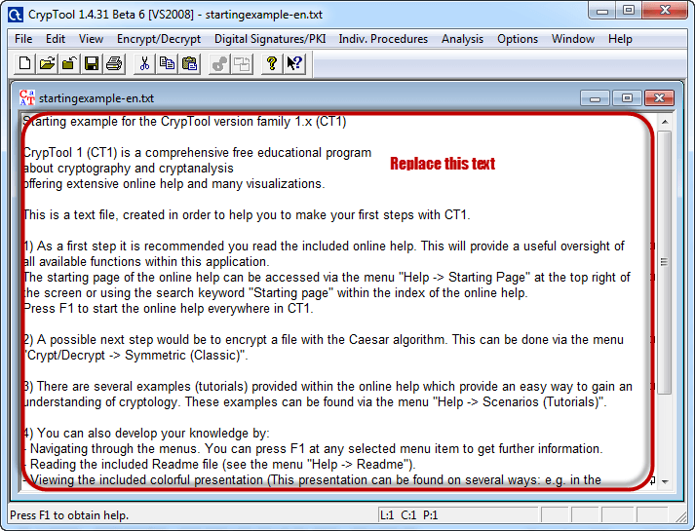
- Replace the text with Never underestimate the determination of a kid who is time-rich and cash-poor
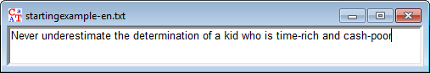
Step 3) Encrypt the text
- Click on Encrypt/Decrypt menu
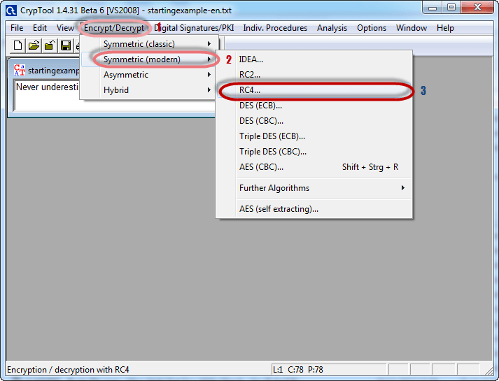
- Point to Symmetric (modern) then select RC4 as shown above
- The following window will appear
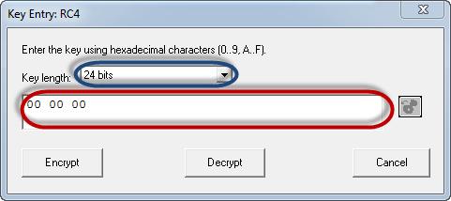
Step 4) Select encryption key
- Select 24 bits as the encryption key
- Set the value to 00 00 00
- Click on Encrypt button
- You will get the following stream cipher
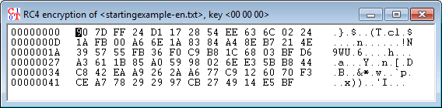

Attacking the stream cipher
Step 5) Start Analysis
- Click on Analysis menu
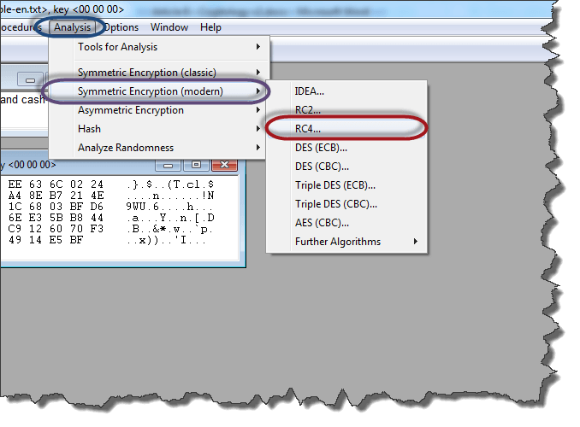
- Point to Symmetric Encryption (modern) then select RC4 as shown above
- You will get the following window
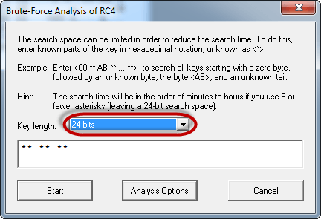
- Remember the assumption made is the secret key is 24 bits. So make sure you select 24 bits as the key length.
- Click on the Start button. You will get the following window
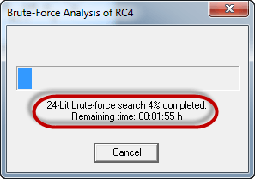
- Note: the time taken to complete the Brute-Force Analysis attack depends on the processing capacity of the machine been used and the key length. The longer the key length, the longer it takes to complete the attack.
Step 6) Analyse the results
- When the analysis is complete, you will get the following results.
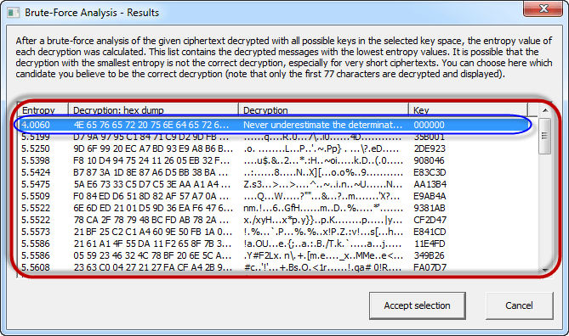
- Note: a lower Entropy number means it is the most likely correct result. It is possible a higher than the lowest found Entropy value could be the correct result.
- Select the line that makes the most sense then click on Accept selection button when done

Summary
- Cryptography is the science of ciphering and deciphering messages.
- A cipher is a message that has been transformed into a nonhuman readable format.
- Deciphering is reversing a cipher into the original text.
- Cryptanalysis is the art of deciphering ciphers without the knowledge of the key used to cipher them.
- Cryptology combines the techniques of both cryptography and cryptanalyst.
- RC4 brute force online algorithm is used to create stream ciphers. It is mostly used in protocols such as Secure Socket Layer (SSL) to encrypt internet communication and Wired Equivalent Privacy (WEP) to secure wireless networks.

Quiz
- Download and install cryptool 1.4
- Using cryptool try each encryption and
decryption technique one by one.
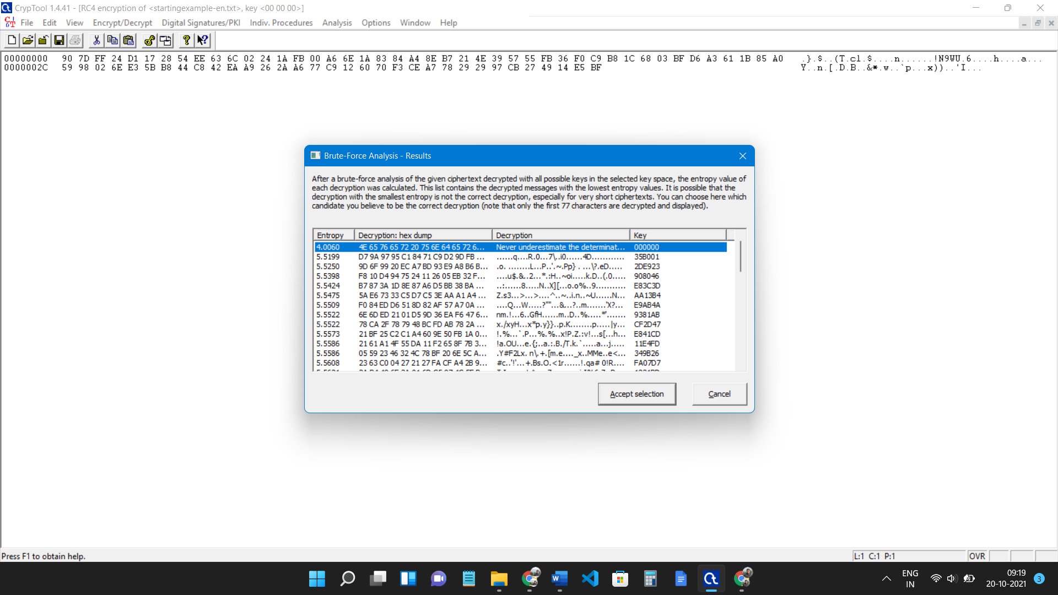

Practical – 10
Introduction to Wireshark
Network Traffic Trace
A recording of the network packets both received by and transmitted from a network interface.
What is a pcap file?
- pcap = Packet Capture
- File format originally designed for tcpdump/libpcap.
- Most widely used packet capture format.

What is Wireshark?
- A graphical network packet analyser.
- Found at http://www.wireshark.org
- The complete manual is located here.
What some are it's uses?
- Troubleshoot network problems.
- Learn network protocol internals.
- Debug protocol/program implementation.
- Examine network-related security issues.

Wireshark is an open source software project, and is released under the GNU General Public License (GPL). You can freely use Wireshark on any number of computers you like, without worrying about license keys or fees or such. In addition, all source code is freely available under the GPL. Because of that, it is very easy for people to add new protocols to Wireshark, either as plugins, or built into the source, and they often do!
Basic UI

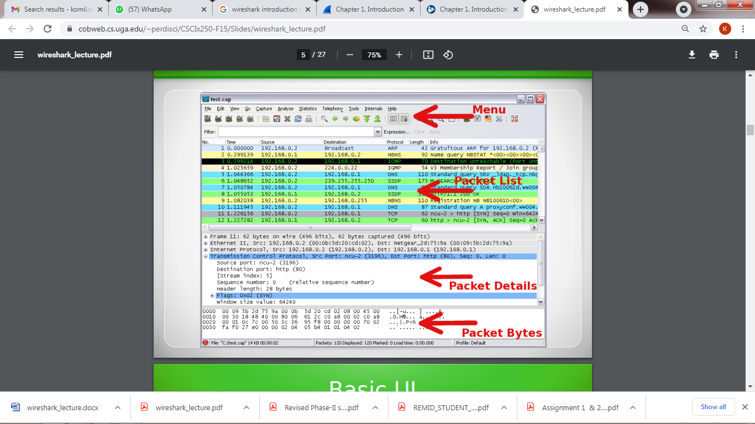

Quiz
Basic HTTP GET/ Response messages:
1. Empty your browser’s cache.
2. Open the Wireshark tool and start capturing the packets.
3. Open the browser and type http://gaia.cs.umass.edu/wireshark-labs/HTTP-wireshark-file2.html
4. Stop capturing the packets and type http in the Wireshark filter text box. Close your browser but do not close the Wireshark tool.
5. Answer the following questions:
a. What HTTP version is your browser and the gaia.cs.umass.edu server running? Ans: HTTP 1.1
b. What language your browser can accept from the server? Ans: En-us
c. What is the status code the server has returned to your browser? Ans: 200 OK
d. What is the size of the content in terms of bytes? Ans: 331
6. Give the screenshot of the captured packets in Wireshark.
