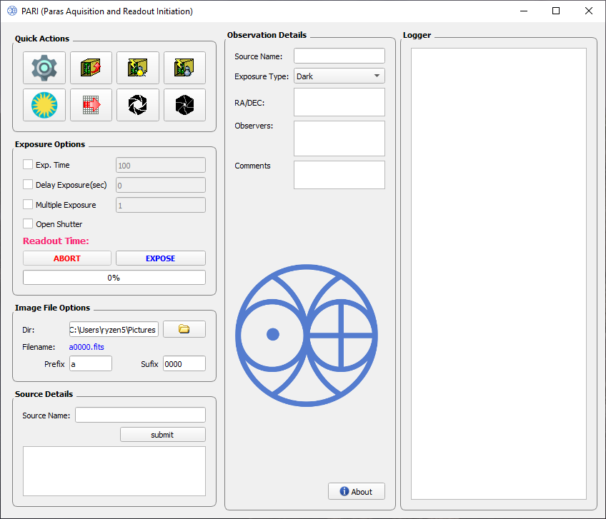**PARAS2 Aquisition and Readout Initiation (PARI)**

**Manual V1.0**

**Index**

|  |  |  |
| --- | --- | --- |
| S.No. | Item | Page No. |
|  | GUI Anatomy | 3 |
|  | Quick Action Panel | 4 |
|  | Exposure Options Panel | 6 |
|  | Image File Options Panel | 7 |
|  | Source Details Panel | 8 |
|  | Observation Details Panel | 9 |
|  | Logger Panel | 10 |
|  | Exposure cycle diagram | 11 |

1. **GUI Anatomy**

Exposure options like exposure time, delay, shutter etc. can be configured through this panel.

To start/ abort exposure two buttons are available here.

In this panel you can set filename name and directory where the fits file will be saved.

RA/DEC of target can be fetch from internet using its TOI name in this panel.

This window shows vaious updates and messages during th run cycle of the software.

Details filled here goes into the header of fits file.

Quick Actions panel contains fcuntion CCD controller related functions like power-on, power-off, setup-controller etc.

1. **Quick Action Panel**

class PARI has the following functions to support functionality for the Quick Action Panel.

|  |  |
| --- | --- |
| **function** | **description** |
| setup_dialog() | loads the tim.lod file to the controller and configures parameters as shown in image below. |
| reset_controller() | resets the controller. |
| power_on_controller() | Powers the controller on. |
| power_off_controller() | Powers the controller off |
| ds9_process() | Opens DS9 fits viewer. |
| btn_clr_array() | Clears camera array. |
| open_shutter() | Opens the CCD shutter. |
| close_shutter() | Closes the CCD shutter. |

All above functions uses the Wrapper class ArcWrapper as interface between GUI and ARCAPI.

Table below shows which function of ArcWrapper is called respectively.

|  |  |
| --- | --- |
| **function** | **Function called in** ArcWrapper |
| setup_dialog() | ArcWrapper:: apply_setup() |
| reset_controller() | ArcWrapper:: reset_controller() |
| power_on_controller() | ArcWrapper:: poweron() |
| power_off_controller() | ArcWrapper:: poweroff() |
| btn_clr_array() | ArcWrapper:: clear_camera_array() |
| open_shutter() | ArcWrapper:: open_shutter() |
| close_shutter() | ArcWrapper:: close_shutter() |

1. **Exposure Options Panel**

calls

abort_expose()

**ABORT**

calls

ArcThread::initiate() via self.new_expose_thread object

**EXPOSE**

**ABORT** and **EXPOSE** buttons calls function as shown in illustraion above.

|  |  |
| --- | --- |
| **function** | **description** |
| abort_expose() | Creates a file named exposure.dat. This file is constantly checked ARCAPI thread, whenever during an exposure this file is found the ARCAPI thread aborts the exposure.  Before starting exposure this file gets remove by start_expose(). |
| ArcThread::initiate() | Start the ARCAPI exposure thread with passed parameters. |

1. **Image File Options Panel**

You can select the output directory and filename in this panel.

img_file_options()

()

calls



|  |  |
| --- | --- |
| **function** | **description** |
| img_file_options() | Sets the output directory for saving the fits file. Uses QfileDialog(). |

Input Fields prefix and suffix are validates using QregExpValidator and QintValidator as shown below

self.input_img_prefix.setValidator(QRegExpValidator(QRegExp("\w*")))

self.input_img_suffix.setValidator(QIntValidator())

1. **Source Details Panel**

You can search RA/DEC of target using this panel. Just enter TOI ID and click submit as show in image below:

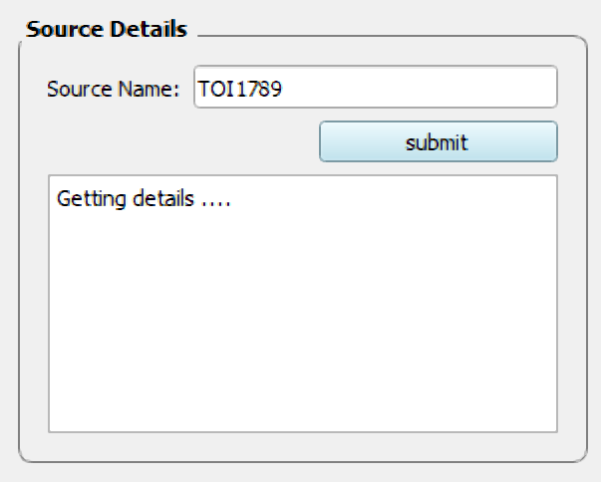

spawn_thread()

calls

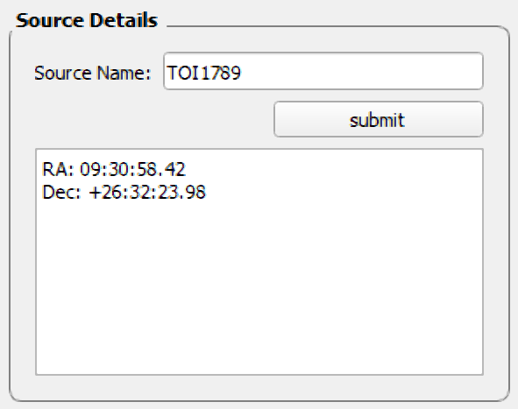

submit

When is clicked it calls the spawn_thread() as shown below:

self.spawn_thread(self.get_src_info, None, self.set_src_info))

|  |  |
| --- | --- |
| **function** | **description** |
| spawn_thread() | Takes 3 arguments   1. fn_name : a function which will be run in thread 2. fn_progress : a function that will perform UI updates during execution of thread 3. fn_result_handler : a functions which will run after thread completion. |
| get_src_info() | Calls tess_api.get_planet_data() from modules/tess_api.py. |
| set_src_info() | sets the view field with the output. |

1. **Observation Details Panel**

Following input fields will be added to the fits image.

|  |  |
| --- | --- |
| **Input Field** | **Description** |
| Source Name | Source name or target object name eg. TOI1789 |
| Exposure Type | Type of the exposure from the following values: Dark  Dark+Tung  Tung+Dark  UAr+UAr  UAr+Dark  Dark+UAr  ThAr+ThAr  Dark+ThAr  Star+UAr  Star+ThAr  Star+Dark |
| RA/DEC | RA (right ascension) and Dec (declination) of the target object. |
| Observers | Name of the observers who took the observations. |
| Comment | Any comments. |



about_dialog()

calls

|  |  |
| --- | --- |
| **function** | **description** |
| about_dialog() | Opens a QmessageBox() with a message. |

1. **Logger Panel**

Displays various messages and info during the run life-cycle of the software. It uses the log() of the PARI class.

|  |  |
| --- | --- |
| **function** | **description** |
| log() | Updates the logger windows using functions call  self.txt_logger.textCursor().insertHtml() |

1. **Exposure cycle diagram**

