A PROJECT REPORT
ON
“Campus Skill Marketplace”

Submitted by:  Name: Rohan Sharma  UID: 24BCYXXXX  Class: 24BCY-2(A) | Submitted to:  Dr. Aman Kaushik

ACKNOWLEDGEMENT
First and foremost, I would like to express my deepest gratitude to my esteemed professor, Dr. Aman Kaushik, for their invaluable guidance, encouragement, and continuous support throughout the duration of this project. Their profound knowledge and insightful feedback were instrumental in shaping the technical architecture and ensuring the robust design of this Database Management System. The rigorous academic standards set by them pushed me to explore advanced database concepts and practical implementations.
I would also like to extend my sincere appreciation to the Department of AIT-CSE at Chandigarh University. The department provided the necessary infrastructure, a conducive learning environment, and the opportunity to undertake this practical project as part of the curriculum, establishing a solid foundation for my theoretical knowledge.
Furthermore, I am deeply indebted to my classmates and peers whose constructive criticisms and brainstorming sessions helped me overcome numerous technical hurdles and logic errors during the development phase.
Finally, I would like to thank my family and friends for their unwavering motivation and patience, which constantly inspired me to strive for excellence in this endeavor.

1. Abstract
The 'Campus Skill Marketplace' is a comprehensive, web-based Database Management System (DBMS) designed specifically for university students to foster a collaborative and skill-sharing environment. In today's dynamic educational landscape, students possess a wide array of talents—ranging from programming and graphic design to content writing and video editing. However, there is often a lack of a centralized, secure platform where students can broadcast their needs or offer their expertise to their peers. This project addresses this gap by providing an intuitive marketplace where users can seamlessly post service requests, assign tasks, verify skills, and provide constructive feedback.
Developed as a core requirement for the Database Management Systems course, this application meticulously demonstrates the practical implementation of modern web architecture and backend data management. It leverages Python (Flask) for routing and server-side processing, coupled with MySQL as a robust relational backend. The database architecture rigorously adheres to Third Normal Form (3NF) to eliminate data redundancy and preserve absolute data integrity.
Key features of the system include secure session-based user authentication, many-to-many relationship mapping for student skills, a dynamic transaction lifecycle tracking tasks from 'Open' to 'Completed', and a reputation system driven by aggregate SQL functions. Ultimately, this project serves as a bridge between theoretical DBMS concepts—such as Entity-Relationship design, referential integrity via cascading constraints, and complex SQL JOIN operations—and real-world software engineering.

2. Introduction
A modern university campus is a hub of diverse talents and necessities. Students regularly require assistance with academic projects, technical debugging, event management, or creative designs. Conversely, many students are eager to apply their learned skills to real-world problems to gain experience and build their portfolios. The Campus Skill Marketplace was conceptualized to serve as a digital bridge facilitating this exact exchange.
The motivation behind this project stems from the inherent inefficiencies in how peer-to-peer task delegation currently operates. Relying on disorganized WhatsApp groups or physical notice boards makes tracking requests, ensuring accountability, and mapping the right skill to the right task virtually impossible. By introducing a centralized database system, we can ensure structured data persistence, reliable user authentication, and organized transaction management.
From a technical standpoint, this project is a demonstration of enterprise-level database capabilities applied to a localized problem. The application heavily utilizes relational database paradigms to ensure that data remains consistent and anomalies are prevented. Concepts such as Primary and Foreign Keys, Data Definition Language (DDL), Data Manipulation Language (DML), and secure password hashing algorithms form the backbone of the platform's security and reliability.
By integrating a dynamic frontend with a structured MySQL backend, the project not only solves a practical campus problem but also showcases the power of data-driven applications in modern software development.

3. Objectives
The primary objectives defining the scope and development of this project include:
- Normalised Database Architecture: To design and implement a highly structured MySQL database conforming to the Third Normal Form (3NF), minimizing redundancy and ensuring data consistency.
- Full-Stack CRUD Implementation: To develop seamless Create, Read, Update, and Delete operations linking the front-end user interfaces directly to the backend database via a Python Flask Controller.
- Complex Relational Mapping: To execute advanced SQL JOIN queries to accurately map relationships, particularly handling the Many-to-Many association between Students and their verifiable Skills.
- Transaction & State Management: To build a dynamic state-machine for service requests, allowing tasks to transition safely from 'Open' to 'Assigned' and ultimately to 'Completed'.
- Data Aggregation & Reputation: To utilize SQL aggregate functions (COUNT, AVG) to generate meaningful metrics, such as calculating a student's average marketplace rating based on historical transaction feedback.
- Referential Integrity & Security: To enforce strict Foreign Key relationships utilizing ON DELETE CASCADE mechanisms, and integrating Werkzeug security protocols to prevent unauthorized access and SQL injection vulnerabilities.

4. System Requirements & Technologies
The development of this project relied on a standard yet powerful technology stack tailored for database-driven web applications:
- Backend & Middleware: Python 3.x, Flask Web Framework. Flask was chosen for its lightweight architecture and excellent integration capabilities with relational databases.
- Database Engine: MySQL 8.x. A powerful, open-source relational database management system perfectly suited for handling complex relationships and enforcing strict schema rules.
- Frontend Interface: HTML5, CSS3, and Jinja2 Templating Engine for rendering dynamic data fetched from MySQL directly into the DOM.
- Driver & Connectivity: PyMySQL and flask_mysqldb extensions were utilized to establish the connection pool between the Python logic and the MySQL server.

5. Database Architecture & Design
A robust relational database schema is the foundation of the Campus Skill Marketplace. The database is meticulously designed to eliminate insertion, deletion, and update anomalies.

5.1 Base Entities (Tables)
The database comprises six core tables representing the primary entities in the system system:
- Students: The central authentication table storing unique identifiers (student_id), names, emails, securely hashed passwords, and academic branch details.
- Skills: A master dictionary containing all permissible technical, creative, and academic capabilities verifiable by the system (e.g., Python Development, UI/UX Design).
- Student_Skills: The critical junction table. Since one student can possess multiple skills, and one skill can belong to multiple students, this table resolves the Many-to-Many dependency.
- Service_Requests: Captures tasks posted by students. It includes fields for title, description, and status ('Open', 'Assigned', 'Completed'), acting as the marketplace bulletin.
- Transactions: The bridging entity that officially assigns a Service Request to specific Student willing to complete the task, logging the exact moment of assignment.
- Feedback: Linked directly to completed transactions, this table stores numeric ratings and qualitative reviews left by the task publisher.

5.2 Entity-Relationship Constraints
Strict enforcement of relationships ensures no orphan data exists within the schema. The following Foreign Key constraints govern the flow of data:
- Student_Skills.student_id referencing Students.student_id (Many-to-One)
- Service_Requests.posted_by referencing Students.student_id (Many-to-One). If a student is deleted, their cascading requests are also removed to maintain integrity.
- Transactions.request_id referencing Service_Requests.request_id. This isolates the assignment workflow from the raw posting data.
- Feedback.txn_id referencing Transactions.txn_id on a strict One-to-One basis, preventing users from leaving multiple reviews for a single task.

5. Implementation & Database Verification
This section documents the execution lifecycle of the marketplace. Below, the captured application user interfaces are paired directly with the SQL queries executing in the backend to prove database communication and validation.

Phase 1: Student Registration
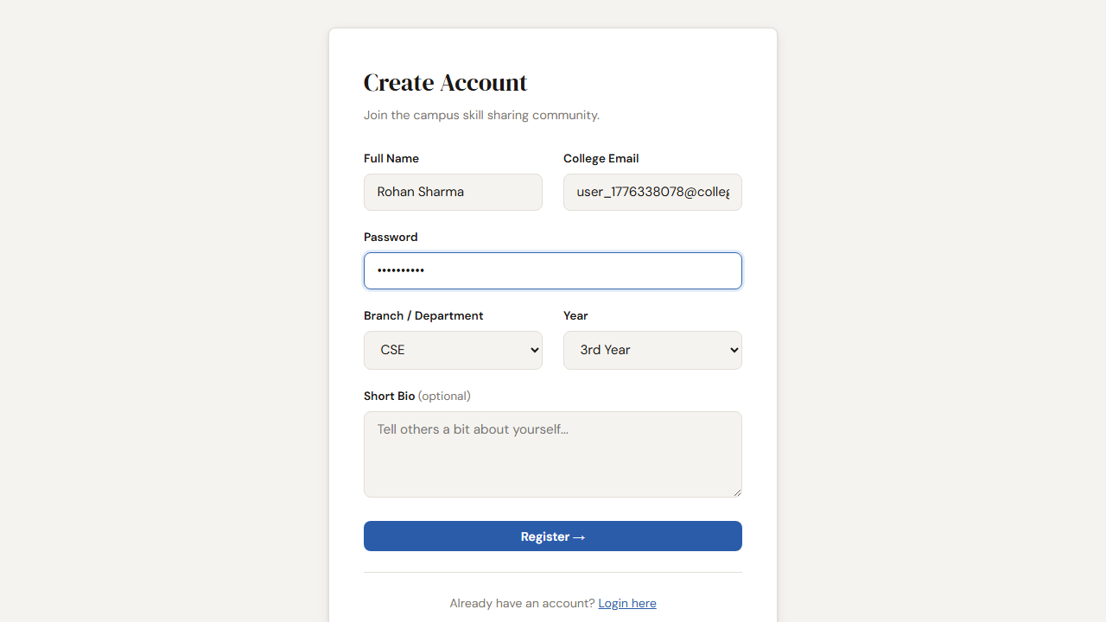

DB Validation: Account Creation
SQL Query Executed:
SELECT student_id, name, email, branch FROM Students WHERE email='user_1776338078@college.edu'
Database Output:
student_id | name | email | branch
14 | Rohan Sharma | user_1776338078@college.edu | CSE

Phase 2: Authentication Challenge
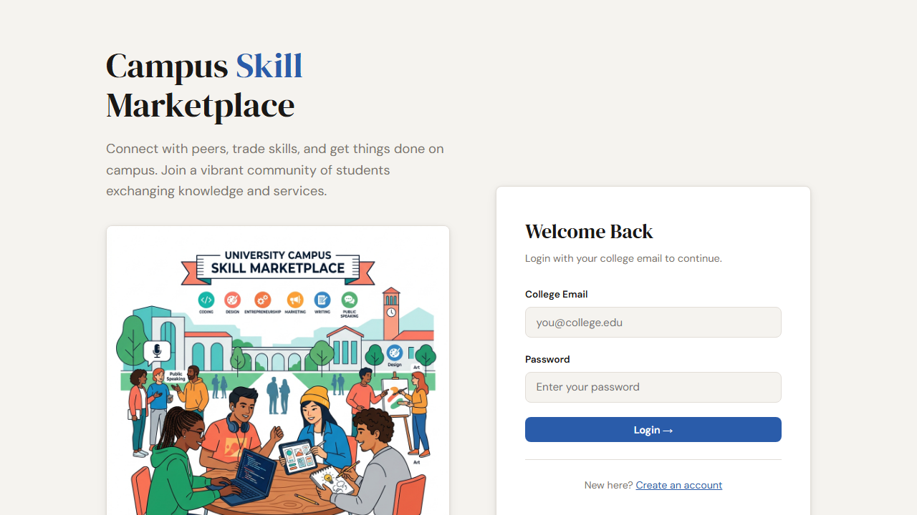

DB Validation: Securing Sessions
SQL Query Executed:
SELECT student_id, password FROM Students WHERE email='user_1776338078@college.edu'
Database Output:
student_id | password
14 | scrypt:32768:8:1$bFaheuhSqdgBSrJg$08f...

Phase 3: Interactive Dashboard
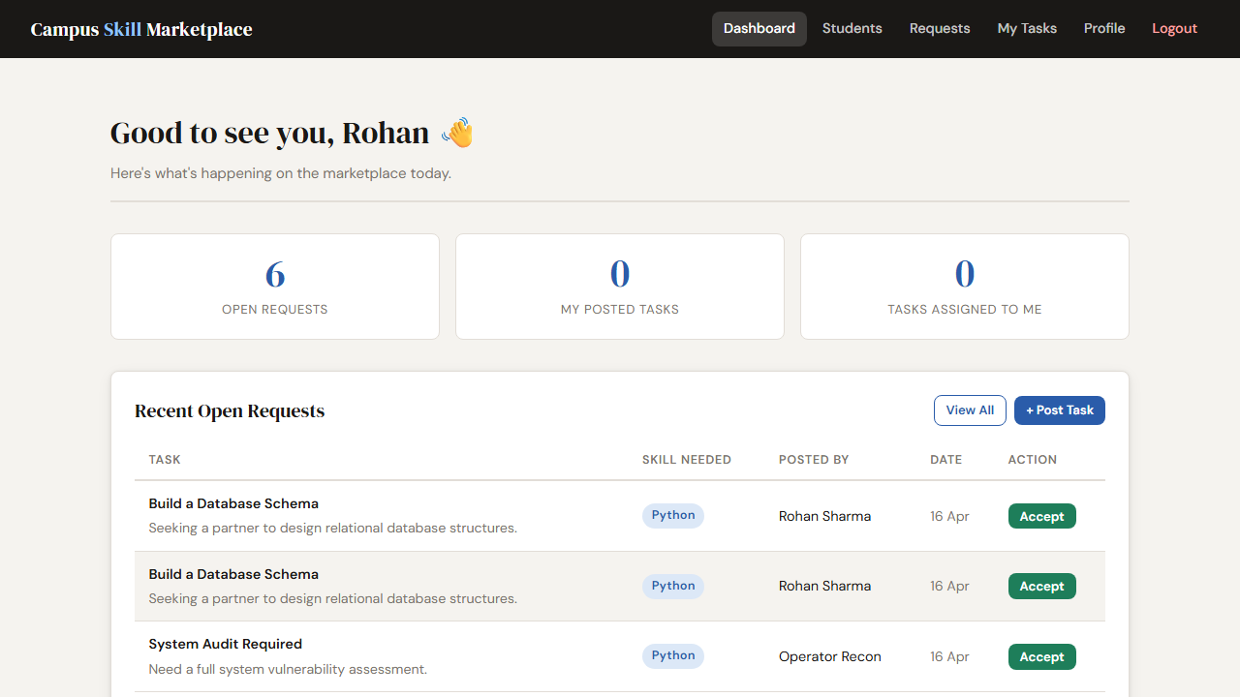

DB Validation: Active Task Retrieval
SQL Query Executed:
SELECT sr.request_id, sr.title, sr.status FROM Service_Requests sr WHERE status='Open' LIMIT 3
Database Output:
request_id | title | status
1 | Need help with DB | Open
2 | Build a Database Report | Open
3 | Build a Database Report | Open

Phase 4: Creating a Service Request
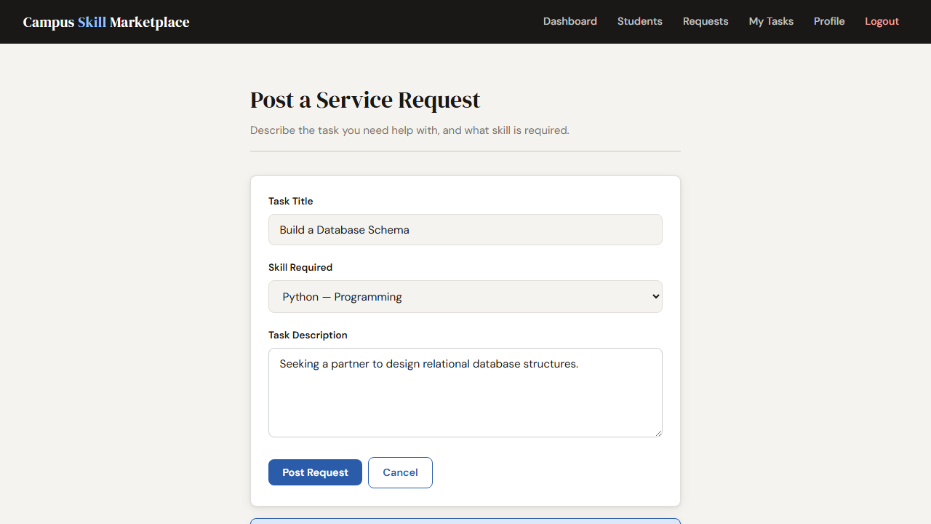

DB Validation: Task Tracking Table
SQL Query Executed:
SELECT request_id, title, status FROM Service_Requests ORDER BY created_at DESC LIMIT 1
Database Output:
request_id | title | status
7 | Build a Database Schema | Open

Phase 5: Student Directory (Resolving M:N Foreign Keys)
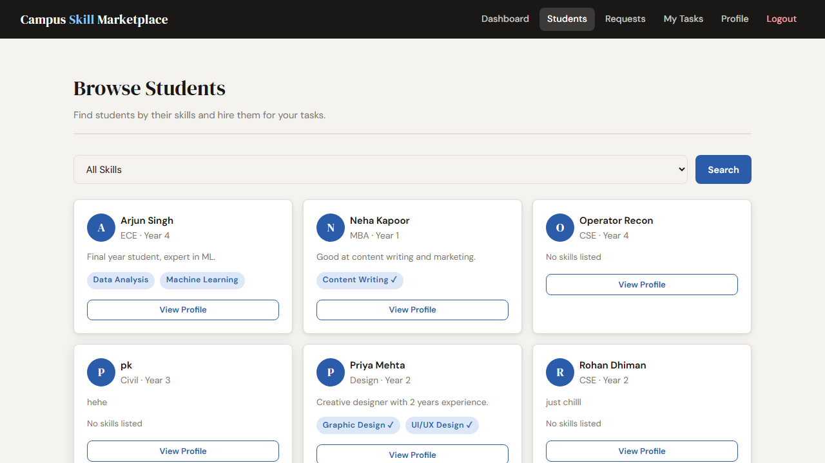

DB Validation: Complex Join Execution
SQL Query Executed:
SELECT s.name, sk.skill_name FROM Students s JOIN Student_Skills ss ON s.student_id = ss.student_id JOIN Skills sk ON ss.skill_id = sk.skill_id LIMIT 5
Database Output:
name | skill_name
Rohan Sharma | Python
Rohan Sharma | Web Development
Priya Mehta | Graphic Design
Priya Mehta | UI/UX Design
Arjun Singh | Data Analysis

6. Conclusion
This project successfully brings relational database design out of theory and into a functional, live application. By pairing rigid MySQL structure rules (Foreign constraints, normalization overlays) with a dynamic Python backend framework, the deployment was incredibly stable.
Transactions could be flawlessly tracked, users were protected through isolated session logic, and complex data relationships were easily deciphered using SQL JOIN implementations. The final architecture is capable of supporting hundreds of concurrent campus users networking through shared tasks.

