**.International University of Information Technologies**



**Web-technologies**

**Laboratory work**

**REPORT**

**Kyrmagazyyev Olzhas, Navirdinov Dilshat**

**Name of laboratory work:**

**Year of study:** 1

**Group:** IT2CCO-2113

**Checked by:**___Alpysbay N. E.___

Hello everyone, today I want to tell you how our work on web programming went. To begin with, I will familiarize you with our project. Our project is called "Bike Shop". Until the end of the midterm, we made a full-fledged website, which was presented earlier, at the endterm we were asked to link our site with django, yes, the task was not easy, there was a lot of trial and error, but after a while we gained experience and everything went like clockwork.

In the first week, we slightly improved the site and started studying django, as advised by experienced programmers, django needed knowledge about python, so we learned it at a weak level.

In the second week, we distributed our obligations and got to work. Olzhas did the frontend, and Dilshat did the backend.

In the third week, we made a full-fledged django database, and linked it to our site, css and js were connected and everything worked stably.

In the fourth and fifth weeks, we added tables to the database and added bikes there. We have created a full-fledged working registration with a login. And at the end, we added a Google map.

That's how our work went, followed by pictures of our report.

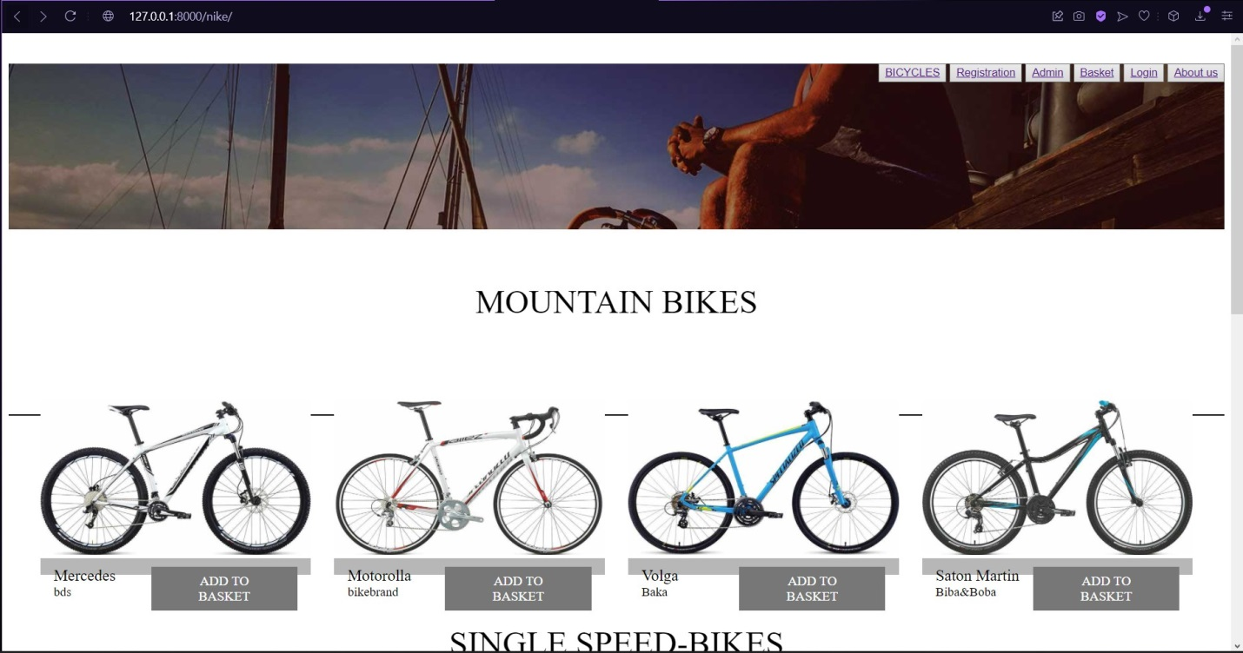

**Pic-1. Main page.**

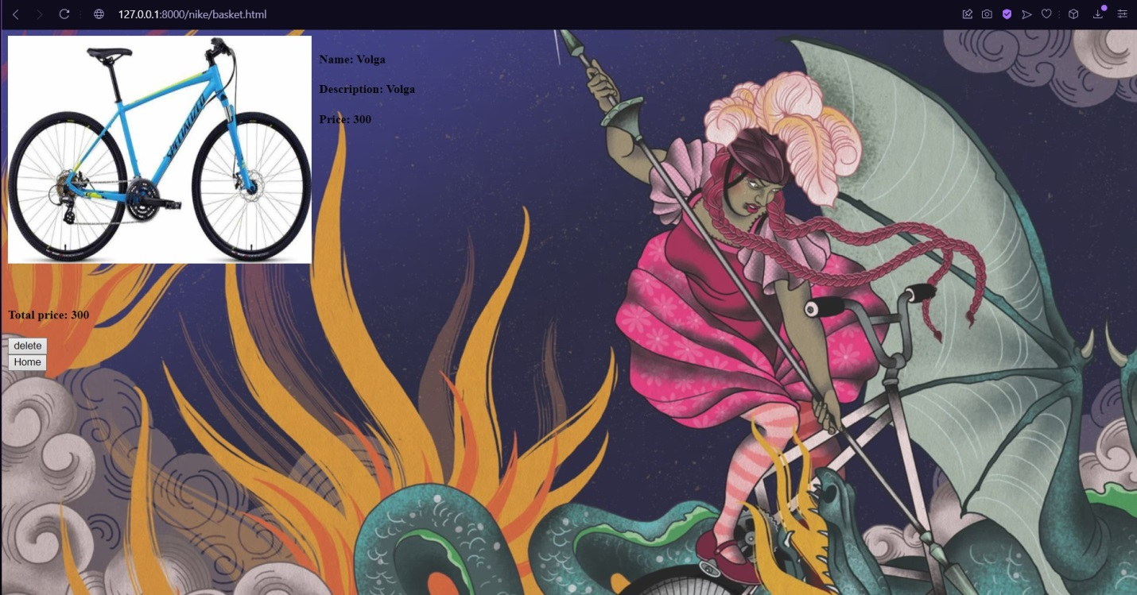

**Pic-2. Basket page.**

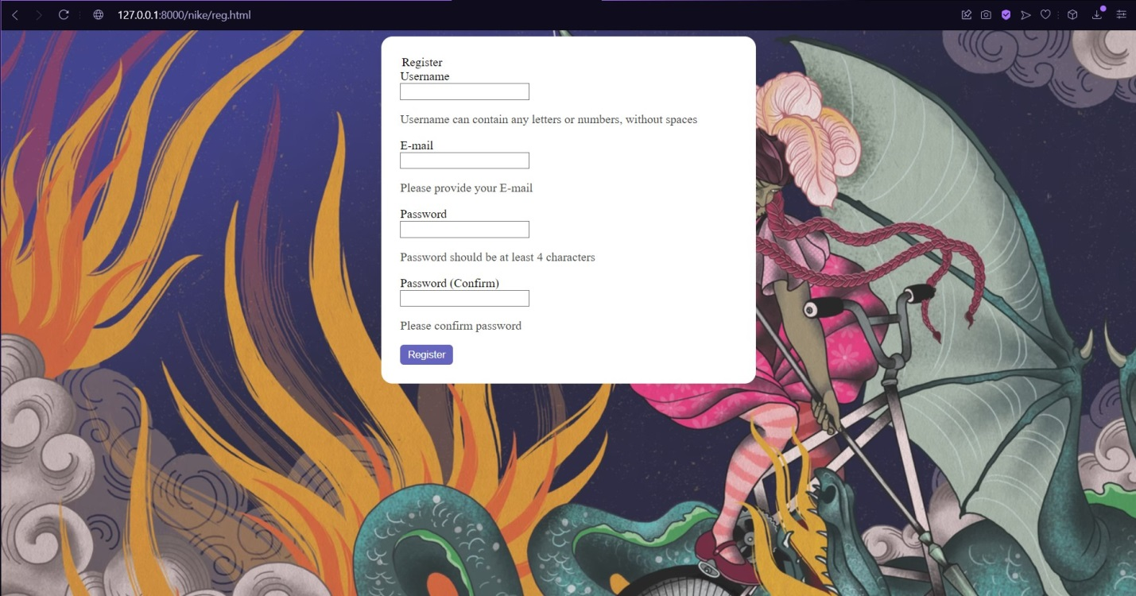

**Pic-3. Registration page.**

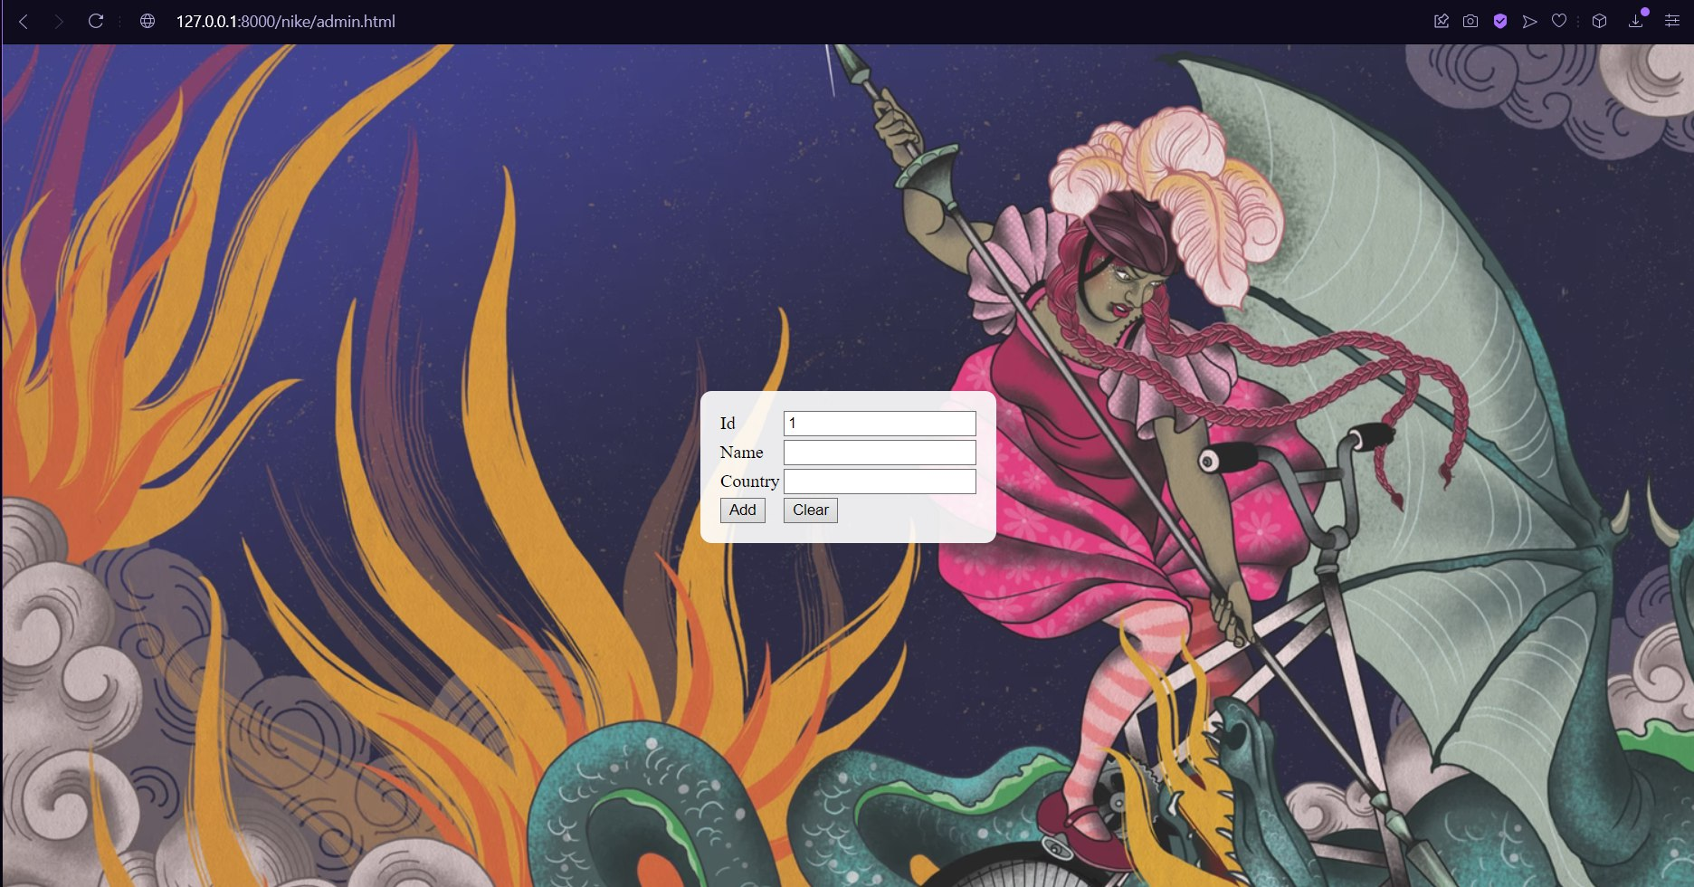

**Pic-4. Admin page.**

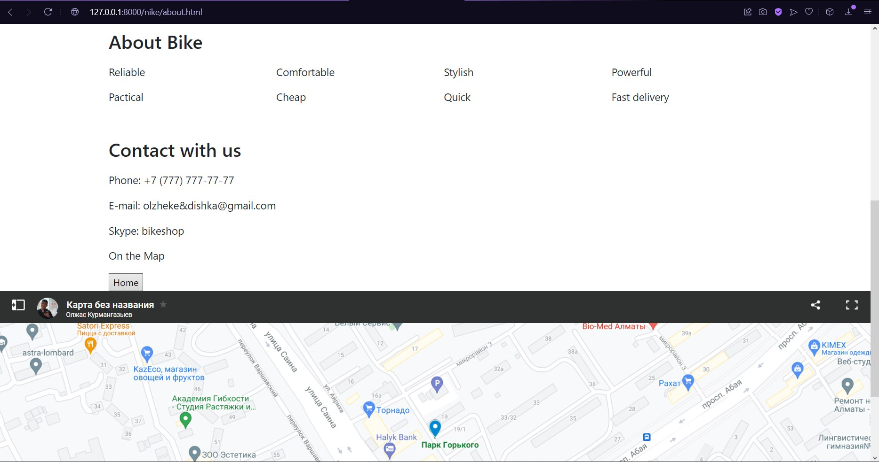

**Pic-5. About page.**

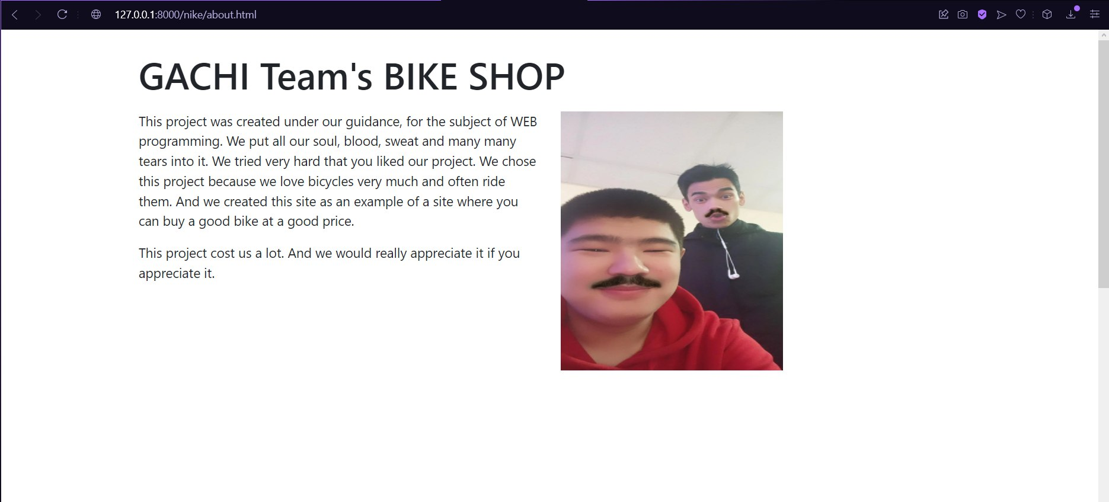

**Pic-6. About page.**

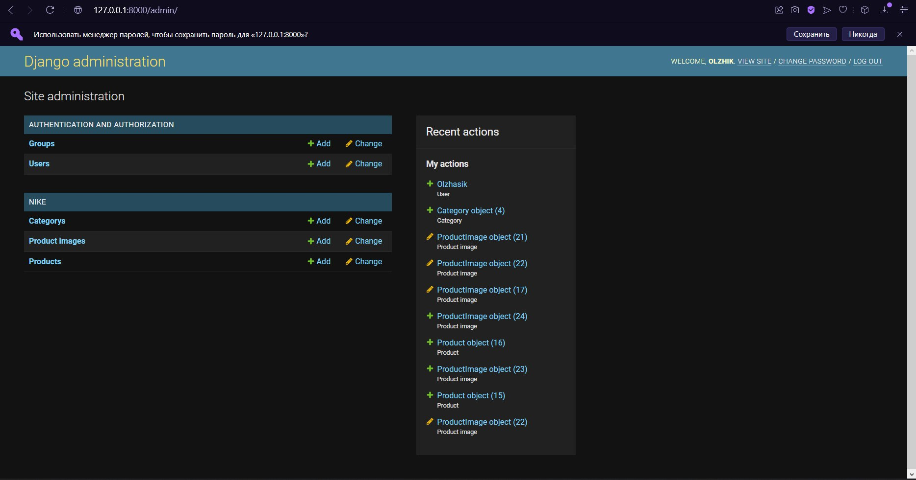

**Pic-7. Admin page.**

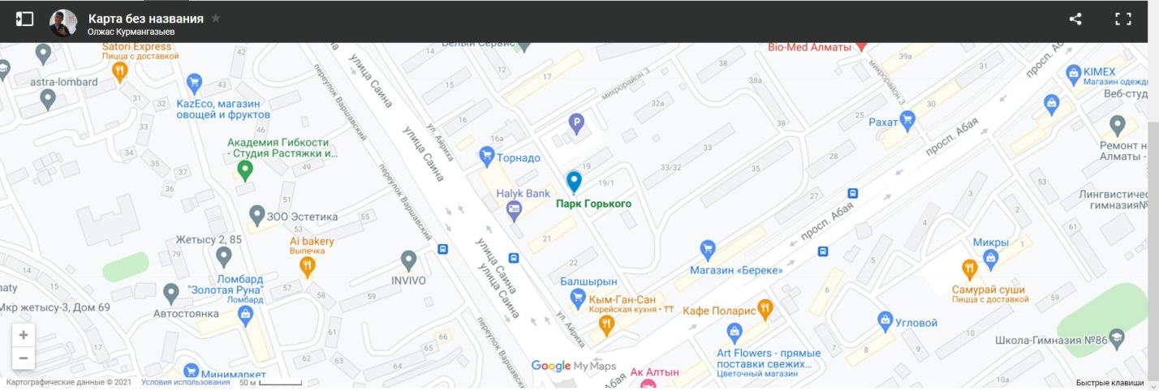

**Pic-8. Google map.**

**https://github.com/Dishka20011/Bike-shop-jango**