**JADE day01**

First install the software and make the folder structure   
then according to the tutorial guide we have to go to the jade directory and start the JADE GUI

Code we have to run to start JADE GUI  
java -cp lib\jade.jar jade.Boot -gui

Some time we have to mention where is our class files are locatingjava -cp lib\jade.jar;classes jade.Boot -gui

Then when its run we get the GUI like this

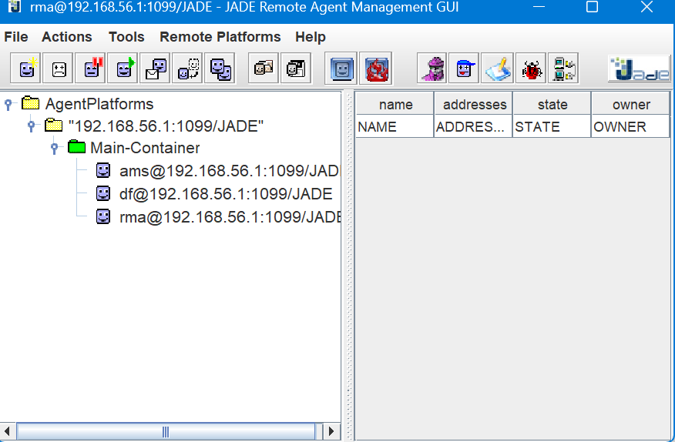



In this GUI you can see we get default 3 agents

ams , df , rma these are default agent coming with our system

------------------------------------------------------------------------------------------------------------------what are these default agents

1. AMS (Agent Management System)

This is supervise agent for whole system ,that manage all agent identities and address like a phone book

1. DF (Directory Facilitator)

This is called as yellow agents in the system

They are providing their services , hi I am agent 1 , I am selling vanilla ice-cream

1. RMA (Remote Monitoring Agent)

This is Your GUI, that provide interface to manage the agents

------------------------------------------------------------------------------------------------------------------creat a new agent

If you want to create a new agent you have to compile the agent first , after that you can create the agent   
so in first how to compile  
  
You have to stay in your same Jade directry and type  
javac -classpath lib\jade.jar -d classes src\examples\PingAgent\*.java

This PingAgent is example agent class file that come with jade platform to test some message passing, this Ping-Agent class file is defined how should our agent must behave

Using this class we are creating agents , so these agents have behave of Pingagent class file , if you want any changes of the your agent behave , you have to change your class file code

So before that we are going with PingAgent example to familiar with this framework

After compiling we can load the agent in two different way , by using CMD or JADE GUI, in cmd we have to type<java -cp lib/jade.jar;classes jade.Boot -gui -agents ping1:examples.PingAgent.PingAgent> But is good way to start with GUI,

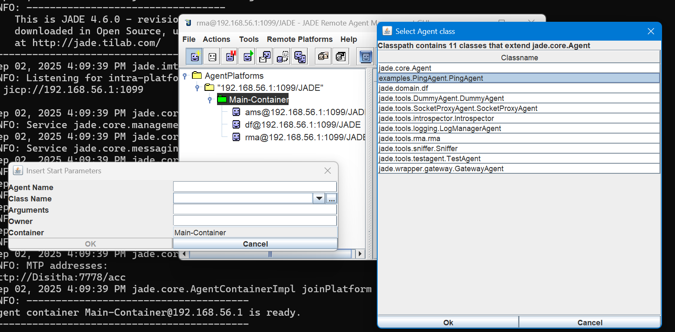



Give the agent name as ping2 and , Now you ping2, agent is created

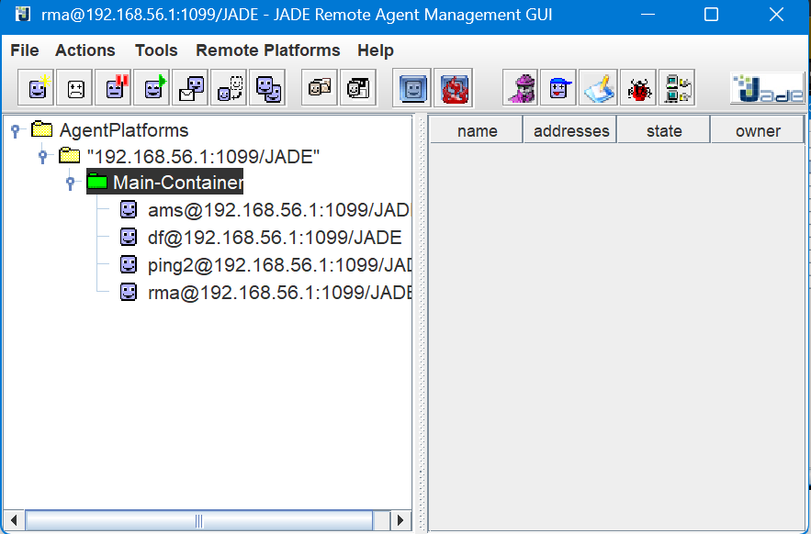



Now create two agents

