Employee Spreadsheet Import
Six Phase Project Documentation
  - Import Data using Transform Maps Spreadsheet
Team lead Disney Antro J
Team members Praveen N and Sibin P
Team ID Not assigned
ServiceNow Zurich | dev230529
Implementation evidence 29 September 2026
Read only recheck 30 September 2026
This master document brings the six project phases into one submission: ideation, requirements, design, planning, development and testing, and the final project report. It describes a verified employee import workflow with 17 final records, five field mappings and three saved reports on one dashboard.
The original CSV tests passed: 15 baseline inserts, then two inserts and two updates, then zero duplicate inserts. Actual Excel uploads were also verified on 3 October 2026 against the existing 17 records. All six transformations completed with zero errors. The narrated demo is complete; formal human and reviewer acceptance remain pending.

How to use this document
Phase 1 Ideation Phase — problem statements, empathy map and idea prioritization
Phase 2 Requirement Analysis — journey, requirements, data flow, user stories and technology
Phase 3 Project Design Phase — problem solution fit, proposed solution and architecture
Phase 4 Project Planning Phase — backlog, sprint estimates, tracker, velocity and planned burndown
Phase 5 Project Development Phase — implementation summary, functional tests, performance observations and UAT
Phase 6 Project Documentation — final report, actual results, screenshots, limitations and submission appendix
Research personas and journeys are design assumptions. Planned dates, actual velocity, signatures and approvals are not invented. The source template examples for other technology tracks are not treated as implemented project features.

Phase 1 Ideation Phase
The following persona and problem statements are design assumptions for this employee import exercise. They do not represent interviews or external research findings.

1 Define the Problem Statements
Problem | I am | I am trying to | But | Because | Which makes me feel
PS1 | A ServiceNow administrator | Maintain current employee records | Repeated files can create duplicates | Rows are inserted without a stable matching key | Uncertain about data quality
PS2 | A staff member preparing employee data | Provide usable employee updates | Names and fields can be mapped incorrectly | Spreadsheet and target labels differ | Concerned that a correction will affect the wrong record

2 Empathy Map Canvas
Area | Design persona observations
Think and feel | Wants a predictable update process and confidence in each employee's identity.
Hear | Requests to add employees, change contact details and provide department summaries.
See | Multiple spreadsheet versions, varied column labels and import status messages.
Say and do | Checks source IDs, uploads files, reviews mappings and inspects target records.
Pain | Duplicate records, overlooked field mappings and manual comparison of revisions.
Gain | Reusable configuration, visible import results and counts that reconcile with the employee list.

3 Brainstorm and Idea Prioritization

Step 1 Team Gathering and Problem Selection
The selected problem is maintaining one current employee record per Employee ID when data arrives in successive spreadsheets. Team responsibilities follow the task board: Praveen N prepares the data and tables, Disney Antro J configures and validates transformation, and Sibin P handles update data and reporting.

Step 2 Idea Listing and Grouping
Idea | Group | Benefit | Limitation
Enter every employee using forms | Manual entry | Straightforward for a few changes | Repeated typing and comparison
Insert every spreadsheet row | Bulk loading | Quick first load | Duplicate records on repeated import
Stage, map and coalesce on Employee ID | Reusable import | Supports inspection, updates and additions | Requires clean stable IDs and correct mappings
Show saved reports on a dashboard | Data review | Makes totals and employee details accessible | Accurate only when source and target data are correct

Step 3 Idea Prioritization
Selected idea | Importance | Feasibility | Decision
Clean source schema and stable IDs | High | High | Essential before any load
Five explicit field mappings | High | High | Essential for correct target values
Employee ID coalesce | High | High | Essential for update and repeat tests
Department and location summaries | Medium | High | Required presentation stage
Scheduled integration and custom validation scripts | Future | To assess | Outside the current manual-import scope

Phase 2 Requirement Analysis
Requirements follow the five employee fields, the 15 row baseline and four row update, Employee ID matching, validation, reporting and dashboard tasks.

4 Customer Journey Map
Stage | Steps and interactions | Goal | Positive moment | Pain point | Opportunity
Entice | Receive an employee update spreadsheet | Understand the changes needed | A familiar spreadsheet source | Different file versions | Keep distinct baseline and update files
Enter | Validate headers, IDs and row count | Supply usable input | Clear five-column contract | Missing or repeated IDs | Check the source before loading
Engage | Load staging, inspect rows and configure the map | Transfer correct values | Source rows can be checked first | Name differs from Employee Name | Save the explicit mapping
Exit | Transform and compare target records | Confirm inserts and updates | Run counts and target values agree | A completion banner can hide row errors | Inspect both history and records
Extend | Repeat the update file and view reports | Maintain confidence across future files | No unintended new records | Counts drift if filters differ | Reuse the same map and consistent report data

5 Solution Requirements

Functional Requirements
FR No | Functional requirement | Sub requirement and acceptance criterion
FR1 | Spreadsheet preparation | Employee ID, Name, Email, Department, Location; 15 baseline rows and 4 update rows; no blank or duplicate source IDs.
FR2 | Table structure | Employee Test (u_employee_test) with Employee ID, Employee Name, Email, Department and Location, all String.
FR3 | Import staging | Employee Import (u_employee_import) receives rows from the spreadsheet or equivalent CSV; preserve headers and inspect all loaded rows.
FR4 | Transformation | Sample Spreadsheet Import maps all five source fields; Name maps to Employee Name.
FR5 | Stable updates | Coalesce only on Employee ID; existing IDs retain target identity after updates.
FR6 | Duplicate prevention demonstration | Repeat the equivalent update data; zero new inserts and 17 unique project IDs.
FR7 | Reporting | Employees by Department pie grouped by Department and Count; Employees by Location bar grouped by Location and Count; Employee List Report with all five fields.
FR8 | Dashboard | Employee Analytics Dashboards contains all three reports and preserves the layout after reload.

Non Functional Requirements
ID | Category | Requirement
NFR1 | Usability | Use clear table, field, map and report labels; show all five employee fields in the review list.
NFR2 | Security | Use authorized instance access; keep credentials out of reports, sample data and repository files.
NFR3 | Reliability | Reconcile values and counts after each transform, and preserve record identity for matched employees.
NFR4 | Performance | Capture elapsed duration and row throughput for the provided files; no unmeasured response-time guarantee.
NFR5 | Availability | Confirm the development instance is accessible during import and demonstration; no production uptime claim.
NFR6 | Scalability | Reuse the map for additional rows with the same schema; validate larger volumes before making scale claims.

6 Data Flow Diagram and User Stories
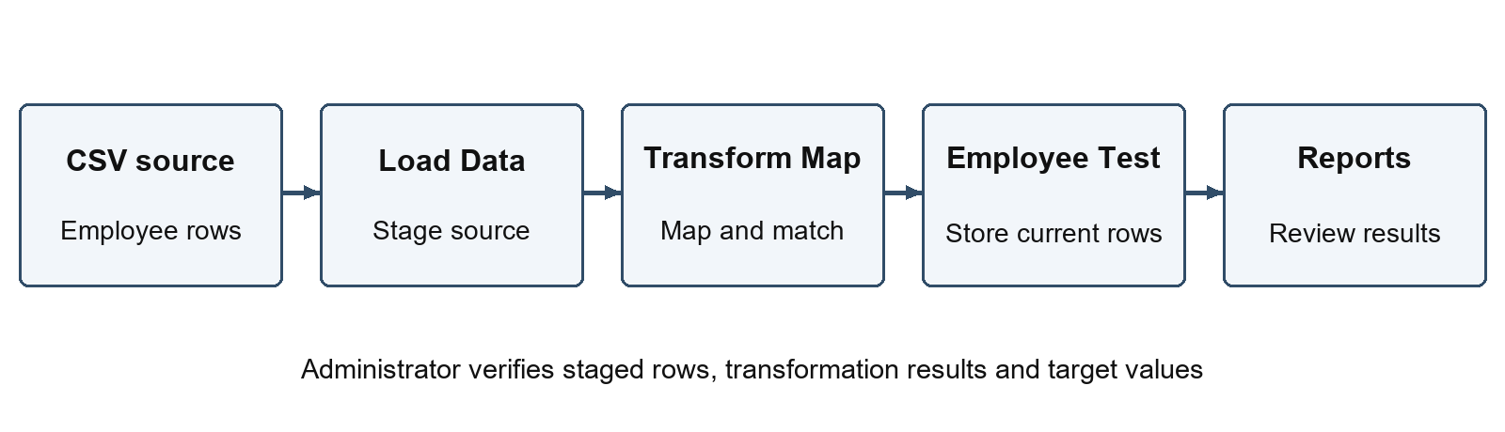
Data flow from spreadsheet to dashboard
User type | Epic | Story | User story or task | Acceptance criteria | Priority | Release
Data preparer | Source data | US1 | Prepare the employee spreadsheet | Five headers, 15 valid baseline rows | High | Sprint 1
Administrator | Configuration | US2 | Create target and import tables | Required table and field definitions inspected | High | Sprint 1
Administrator | Transformation | US3 | Save all five mappings | Name maps to Employee Name; correct source and target | High | Sprint 1
Administrator | Validation | US4 | Transform the baseline | 15 correct target records from an empty target; no row errors | High | Sprint 2
Administrator | Coalesce | US5 | Update matching employees and add new employees | Two updates, two inserts, 17 unique IDs; original sys_id retained for updates | High | Sprint 2
Administrator | Coalesce | US6 | Repeat the update file | No new inserts; final records and values unchanged | High | Sprint 2
Reviewer | Reporting | US7 | Inspect employee summaries and details | Saved department, location and list reports reconcile with target | High | Sprint 3
Reviewer | Dashboard | US8 | Open the saved dashboard | All three reports available after reload | High | Sprint 3

7 Technology Stack

Components and Technologies
Component | Description | Technology
User interface | Authorized administrator performs the workflow | ServiceNow browser interface
Source files | Five columns with synthetic employee records | XLSX and equivalent comma-delimited CSV
Application logic | Load staging rows, map fields and match employee keys | Import Sets and Transform Map
Data storage | Staged source rows and final employee records | u_employee_import and u_employee_test
File storage | Local workbooks and approved public synthetic CSV inputs | Workspace and GitHub repository
Reporting | Count by department/location and show employee details | ServiceNow reports and dashboard
Infrastructure | Instance hosts processing and data; local client supplies files | ServiceNow development instance and browser

Application Characteristics
Characteristic | Project treatment | Technology
Open source frameworks | No custom application framework required | Native ServiceNow configuration
Security implementations | Use existing authorized access; verify any table-access issue specifically | Instance roles and access controls
Scalable architecture | Reuse the same mapping for a consistent input schema; larger volumes need further tests | Import staging and transformation
Availability | Development instance must be awake and accessible | ServiceNow development hosting
Performance | Measure actual runs; inspect errors and target values | Transform History and row results

Phase 3 Project Design Phase

1 Problem Solution Fit
Purpose and vision: make employee spreadsheet imports repeatable, inspectable and useful for reporting.
Canvas section | Project response
1 Customer segments | ServiceNow administrators and staff preparing employee spreadsheets.
2 Jobs to be done and problems | Add employees, correct details and review totals without unintended duplicates.
3 Triggers | A new employee joins or an existing employee's details change.
4 Emotions before and after | Before: uncertainty about repeated imports. Desired after: confidence from verified mapping and results.
5 Available solutions | Manual record entry, unconditional bulk insertion, or staged import with matching.
6 Customer constraints | Browser/instance access, agreed spreadsheet schema and clean employee identifiers.
7 Behaviour | Prepare a file, upload it, inspect rows, run the map and compare records.
8 Channels of behaviour | Online: ServiceNow instance and project repository. Offline/local: workbook preparation and review.
9 Problem root cause | Repeated files do not inherently identify which rows should update existing target records.
10 Your solution | Stage rows and use Employee ID coalesce with five explicit field mappings.

2 Proposed Solution
Parameter | Description
Problem statement | Maintain correct employee data when successive spreadsheets contain both existing and new employees.
Idea and solution | Load each file into Employee Import, transform through Sample Spreadsheet Import, validate Employee Test, then report the results.
Novelty and uniqueness | The project applies an explicit input contract and key-based update demonstration to this employee dataset; it does not claim a new platform capability.
Social impact and customer satisfaction | Less repeated administration and a clearer way to review employee information. Benefits are qualitative until measured.
Business model | Internal operational value; no revenue-generating feature is required.
Scalability | Reuse the schema and map for additional employees; further volume testing is required for production use.

3 Solution Architecture
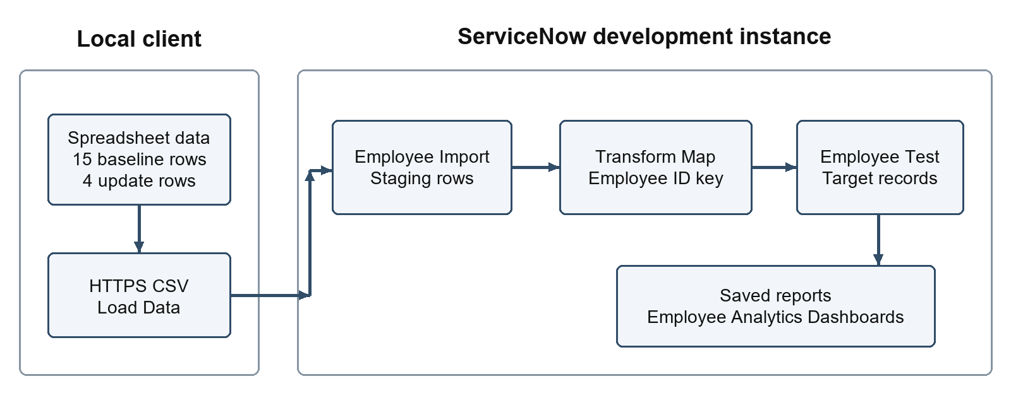
Architecture of the original CSV demonstration
The baseline and update XLSX workbooks are uploaded using ServiceNow Load Data, File, Sheet 1 and header row 1. Employee Import stages the source rows. Sample Spreadsheet Import maps all five fields into Employee Test, using Employee ID to match existing records. Three saved reports present the final target. Original CSV-over-HTTPS runs remain recorded as the initial insert demonstration.
The Zurich implementation uses Platform Analytics data visualizations for the required reports. Access the visualization library through Platform Analytics, create each table-based visualization, then add the saved visualizations to an inline dashboard. This preserves the project's required report names, chart types and employee data while using the supported instance interface.
Object | Verified identifier or label | Responsibility
Target table | Employee Test, u_employee_test | Store the current employee records
Staging table | Employee Import, u_employee_import | Hold source rows for inspection and transformation
Transform Map | Sample Spreadsheet Import | Apply mappings and Employee ID coalesce
Department report | Employees by Department | Pie chart; Department group; Count aggregation
Location report | Employees by Location | Bar chart; Location group; Count aggregation
List report | Employee List Report | Show the five employee fields
Dashboard | Employee Analytics Dashboards | Present all three reports together

Field Mapping Contract
Source header | Target label | Verified internal target name | Type | Coalesce
Employee ID | Employee ID | u_employee_id | String 40 | Yes
Name | Employee Name | u_employee_name | String 100 | No
Email | Email | u_email | String 100 | No
Department | Department | u_department | String 100 | No
Location | Location | u_location | String 100 | No

The five internal field names and lengths in this table have been verified in the instance. The saved map explicitly maps u_name to u_employee_name. Employee ID alone is marked coalesce. Department and Location are Strings for this exercise.

Record Matching and Validation
A staged row whose Employee ID matches an existing target updates that record. A new Employee ID inserts a new target. No other field participates in coalesce; otherwise a name or email change could prevent the intended match. Coalesce does not remove historical duplicates or validate every source field.
Validate required values, unique IDs and the five-column schema before upload. Check transform history, row errors and all final values. The 3 October Excel replay retained all 17 target sys_id values. Use the same map for the update and repeat files.

Test Dataset Design
File | Rows | Intended effect from an empty baseline target
Sample Spreadsheet.xlsx | 15 | Insert SB-0001 through SB-0015
Updated Sample Spreadsheet.xlsx | 4 | Update SB-0004 and SB-0010; insert SB-0016 and SB-0017
Same update file loaded again | 4 | Match four existing IDs; insert no new records
Expected Final Target.csv | 17 | Comparison fixture only; not a source of measured results

The verified final target has ServiceNow 9 and Salesforce 8. All 17 captured target rows match the expected comparison fixture. All sample records are synthetic and use example.com email addresses.

Boundaries and Future Changes
The implementation uses native Import Sets and Transform Maps. Actual XLSX uploads were verified on 3 October 2026; equivalent CSV sources preserve the original demonstration. No custom transform script is required. Later changes must preserve the employee key and pass the same data checks.

Phase 4 Project Planning Phase
The backlog totals 23 estimated points across three planned sprints. SkillWallet remains at the last observed 90 percent with nine stories in Review. Actual sprint dates and accepted points must come from team records; reviewer acceptance is separate from the technical evidence.

1 Product Backlog and Sprint Schedule
Sprint | Functional requirement or epic | Story | User story or task | Points | Priority | Team member
1 | Source data | US1 | Creation Of Spreadsheet | 2 | High | Praveen N
1 | Target structure | US2 | Creation of Tables | 3 | High | Praveen N
1 | Import staging | US3 | Create Importset Table | 2 | High | Praveen N
1 | Field mapping | US4 | Create Transform Map | 3 | High | Disney Antro J
2 | Import validation | US5 | Transform Data & Validate | 3 | High | Disney Antro J
2 | Record matching | US6 | Enable Coalesce to Avoid Duplicate Records | 3 | High | Disney Antro J
2 | Updated dataset | US7 | Inserting New Data In Excel Format | 2 | High | Sibin P
3 | Reports | US8 | Report 1 | 3 | High | Sibin P
3 | Dashboard | US9 | Adding Reports to Dashboard | 2 | High | Sibin P

Total estimate: 23 story points. Sprint 1 plans 10 points, Sprint 2 plans 8 and Sprint 3 plans 5. These planning story identifiers follow the nine task-board items; the requirements document groups related acceptance stories separately.

2 Dependencies and Completion Criteria
Sprint 1 plans source files, fields, staging and mappings. Sprint 2 covers baseline, update and repeat tests. Sprint 3 covers the three reports and saved dashboard. The original execution loaded the baseline before enabling Employee ID coalesce; the later Excel replay used the saved coalesce map throughout.
An item is complete only when its saved output exists, the acceptance check has been performed, and the supporting evidence is recorded. Updating a task-board status alone is not a completion check.

3 Project Tracker
Sprint | Total points | Duration | Start date | Planned end | Points completed by planned end | Actual release date
1 | 10 | Not recorded | Not recorded | Not recorded | Not recorded | Not recorded
2 | 8 | Not recorded | Not recorded | Not recorded | Not recorded | Not recorded
3 | 5 | Not recorded | Not recorded | Not recorded | Not recorded | Not recorded

4 Velocity
Average sprint velocity = total completed story points / number of completed sprints. Compute it only when completed-sprint data is available. If measuring daily throughput, use completed points / elapsed working days and state the units separately. Planned points are not actual velocity.
Actual sprint dates, accepted completed points and completed-sprint count: Not recorded. Actual velocity cannot be calculated until the team lead supplies those records.

5 Burndown Chart
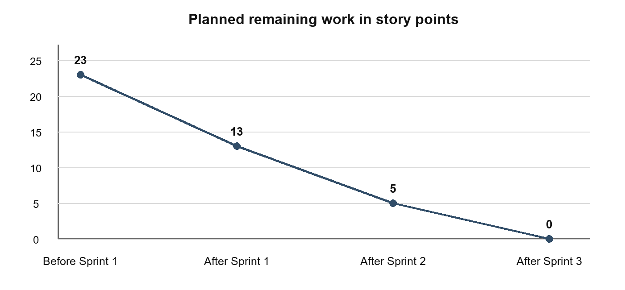
Planned remaining story points by sprint boundary
This is a planned trajectory: 23 points before Sprint 1, 13 after Sprint 1, 5 after Sprint 2 and 0 after Sprint 3. No actual-progress line is drawn. Add actual remaining work only from dated completion records.

6 Delivery Checklist
- Five String field definitions and all five mappings verified.
- Baseline, update and repeat runs recorded: 15 inserts; 2 inserts and 2 updates; then 4 ignored and zero inserts. All runs have zero errors.
- Excel replay: all 17 target record IDs preserved; retain the before/after evidence.
- Reconcile all three reports with the final target data and reload the saved dashboard.
- Add real evidence, dates, links and tester sign-off to the report.
- Verify SkillWallet upload requirements and record the submission acknowledgement.

Phase 5 Project Development Phase

Implementation summary
Employee Test stores five String fields: Employee ID, Employee Name, Email, Department and Location. Actual baseline and update XLSX files were uploaded into Employee Import on 3 October 2026. Sample Spreadsheet Import maps all five fields; Employee ID is the only coalesce key. Original CSV histories retain the initial insert evidence.
The baseline, update and repeated update were executed on 29 September 2026. A read only recheck on 30 September found the same three Complete history rows with zero errors. It also confirmed the active map and its five mappings, and the saved dashboard showing 17 employee rows. No import was rerun during that recheck.
The map displays an optional warning that its coalesce field is not indexed. No index was created during the recheck. Indexing and larger volume performance testing remain possible future improvements; the warning does not mean the recorded transformations failed.

Original CSV transform history evidence
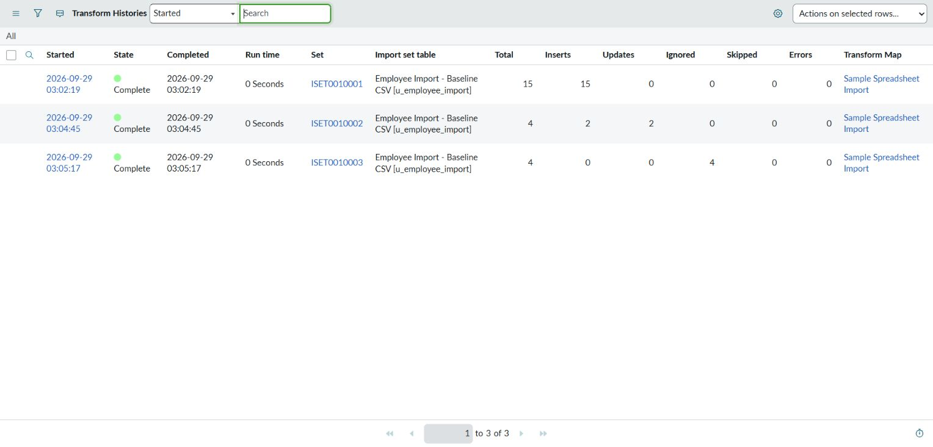

1 Project Overview
The project imports synthetic employee spreadsheet records through a ServiceNow staging table and Transform Map, then presents the employee target in three reports and a dashboard. The main acceptance condition is correct insertion and update behavior with Employee ID coalescing, including no new records when the update file is repeated.
Project version: 1.1 configuration exercise. Initial verification: 29 September 2026. Excel attachment and source-check verification: 3 October 2026. Formal reviewer acceptance remains pending.

2 Testing Scope and Environment
Scope includes the five String fields, source loading, all five field mappings, baseline transformation, existing-record updates, new-record inserts, repeat-import behavior, reports and dashboard persistence. Source-preparation negative checks are separate from live platform validation tests.
Environment item | Value
Instance URL and release | https://dev230529.service-now.com; Zurich
Target table | Employee Test, u_employee_test, Global scope
Table definition record | a88a703ec3a78b54c34b78cc050131bf
Target fields | u_employee_id String(40); u_employee_name, u_email, u_department, u_location String(100)
Staging and map | Employee Import u_employee_import; Sample Spreadsheet Import 16feadfec36f8b54c34b78cc050131a3
Reporting interface | Platform Analytics data visualizations and inline dashboard on Zurich
Source data | Baseline XLSX 15 rows; update XLSX 4 rows; expected final comparison CSV 17 rows
Access | Authorized administrator session; no password is recorded in this document

The target schema has been observed in the instance. Its form screenshot is evidence E02. The three transforms and complete target-data comparison passed. Saved report data and the populated dashboard also passed visual verification.

3 Test Cases
ID | Test scenario | Test steps | Expected result | Actual result | Status
FT01 | Target field structure | Inspect target Dictionary and form. | Five required String fields; Employee ID length 40, other four lengths 100. | Fields verified; E02 supplied. | Pass
FT02 | Baseline staging | Load the approved equivalent CSV through its HTTPS source; inspect staged rows. | 15 rows; five correct fields; header not a data row. | ISET0010001: 15 staged rows; evidence 08. | Pass
FT03 | Field mappings and key | Inspect saved Field Maps after enabling the key. | Five mappings; Name to Employee Name; only Employee ID coalesces. | Saved u_name to u_employee_name; only u_employee_id coalesces; evidence 10. | Pass
FT04 | Original CSV baseline transform | Transform the baseline into an empty target; inspect history. | 15 inserted rows and no errors. | TH0001001: 15 total, 15 inserts, 0 updates, 0 errors; evidence 09. | Pass
FT05 | Delta update and insert | Transform the update CSV; inspect history and final values. | Two updates, two inserts; correct changed values; 17 unique IDs. | TH0001002: 2 inserts, 2 updates, 0 errors. All 17 target rows match expected; evidence 11 and 16. | Pass
FT06 | Repeat delta | Reload the same four-row CSV with the same map; compare count and values. | Zero new inserts; 17 unique IDs; unchanged values; no errors. | TH0001003: 0 inserts, 0 updates, 4 ignored, 0 errors; full final comparison passed; evidence 12 and 16. | Pass
FT07 | Department report | Save pie report grouped by Department, aggregation Count; inspect chart totals. | Employees by Department: ServiceNow 9, Salesforce 8; total 17 after imports pass. | Saved and populated; counts reconcile to 17; evidence 14. | Pass
FT08 | Location report | Save bar report grouped by Location, aggregation Count; compare to target values. | Employees by Location category counts match target and total 17. | Saved and populated; counts reconcile to 17; evidence 14. | Pass
FT09 | Employee list report | Save list with Employee ID, Employee Name, Email, Department, Location. | Employee List Report shows all five fields and the 17 final project records. | Saved and populated; counts reconcile to 17; evidence 14. | Pass
FT10 | Dashboard persistence | Add all three saved reports to Employee Analytics Dashboards; save and reload. | All three reports remain present with the expected data and readable titles. | Saved view shows all three reports; evidence 14. | Pass
PT01 | Import duration | Record start/end and row count for baseline, delta and repeat runs; divide processed rows by nonzero elapsed seconds. | Record elapsed seconds and rows/second alongside data checks; if duration rounds to zero, report throughput as unavailable. | All three history rows display 0 Seconds; throughput unavailable at this resolution. | Pass

FT01–FT10 and PT01 record the original implementation checks. FT02, FT04, FT05 and FT06 used CSV sources. FT05 changed SB-0004 from Ajay Kumar to Ajay and SB-0010 email to test18@example.com, and inserted SB-0016 and SB-0017. The later Excel replay independently retained all 17 target sys_id values. The new XF checks below supplement the original insert demonstration.

Excel Attachment Verification — 3 October 2026
These checks replayed the actual XLSX files against 17 existing employees. The original empty-target inserts remain documented in TH0001001 and TH0001002. Sheet number and header row were both 1.
XF01 — Pass. Baseline file: 15 staged rows. ISET0010004 / TH0001004: 0 inserts, 2 updates, 13 ignored, 0 errors. The two prior changes returned to their baseline values.
XF02 — Pass. Update file: 4 staged rows. ISET0010005 / TH0001005: 0 inserts, 2 updates, 2 ignored, 0 errors. Final Ajay and test18@example.com values were restored.
XF03 — Pass. Repeated update file: 4 staged rows. ISET0010006 / TH0001006: 0 inserts, 0 updates, 4 ignored, 0 errors. No duplicates were added.
XF04 — Pass. Final reconciliation: 17 records, 17 unique Employee IDs, 85/85 field values matching and 17/17 sys_id values unchanged. Evidence: xlsx-verification.json, three UI snapshots and screenshots 23–33 in the package.

Source Preparation Negative Checks
The negative cases used disposable in-memory copies and preserved both original workbooks. These checks verify local preparation; invalid records were not submitted to ServiceNow.
ID | Scenario | Steps | Expected result | Actual result | Status
NC01 | Blank Employee ID | Clear the first ID in an in-memory source copy; run the local validator. | Preparation check identifies the row and stops that copy from being loaded. | REQUIRED_VALUE detected at row 2, Employee ID; invalid copy not uploaded. | Pass
NC02 | Repeated source ID | Copy the first ID to row 3 in memory; run the local validator. | Duplicate rows are flagged and resolved before upload. | DUPLICATE_ID detected at row 3 for SB-0001; invalid copy not uploaded. | Pass
NC03 | Missing or wrong header | Rename Name to Full Name in an in-memory header; validate the schema. | Schema mismatch is identified before mapping/transformation. | HEADERS mismatch detected; invalid copy not uploaded. | Pass
NC04 | Missing Name mapping | Remove Name from an in-memory mapping contract; validate all five mappings. | Review flags an omitted Name to Employee Name map before a transform. | FIELD_MAPPING detected for Name to u_employee_name; the live map was unchanged. | Pass

4 Defect Register
Bug ID | Description | Reproduction steps | Severity | Status | Feedback or evidence
ENV01 | Browser file chooser blocked automated direct upload | Select the local workbook in Load Data; the file selector did not attach the file. | Environment blocker | Resolved 3 Oct 2026 | Original CSV workaround succeeded. Direct XLSX file upload also succeeded on 3 October; see XF01–XF04.

5 Defect Analysis
No product defects were observed in the executed cases. The resolved file-upload issue was an environment blocker and is listed separately as ENV01.
Resolution | Severity 1 | Severity 2 | Severity 3 | Severity 4 | Subtotal
No product defects recorded in executed cases | 0 | 0 | 0 | 0 | 0

6 Test Case Analysis
Section | Total cases | Not tested | Fail | Pass
Functional FT01–FT10 and Excel XF01–XF04 | 14 | 0 | 0 | 14
Performance PT01 | 1 | 0 | 0 | 1
Source preparation NC01 to NC04 | 4 | 0 | 0 | 4
Total | 19 | 0 | 0 | 19

All 19 recorded cases passed: ten original functional checks, one duration observation, four Excel replay checks and four local source-preparation checks. The negative cases used disposable in-memory copies and do not establish ServiceNow rejection rules. PT01 records displayed duration; precise throughput remains unavailable. Human UAT signatures and reviewer approval are separate.

7 Evidence Register
ID | Evidence required | Current reference
E02 | Employee form and field verification | 01-employee-form.png; five field types and lengths verified by instance inspection
E03 | Baseline staging | 08-baseline-staging-load.png; ISET0010001
E04 and E05 | Map, field maps and coalesce | 10-transform-map-coalesce.png
E06 | Baseline, delta and repeat history | 09, 11, 12 screenshots; TH0001001 to TH0001003. Run time displays 0 Seconds in each history row; precise throughput is unavailable.
E07 | Target records and values | 16-final-ordered-employee-list.png; final-target-ui-data.json; final-data-reconciliation.json
E08 | Three saved reports | 03, 04 and 05 configuration screenshots
E09 | Saved dashboard after reload | 14-populated-dashboard.png; saved dashboard 549ca1bac36f8b54c34b78cc05013131

8 Sign off
Evidence prepared for team lead Disney Antro J. Latest technical verification: 3 October 2026. Human tester name, verification date and signature: Awaiting the tester’s own review.
Team lead acceptance and date: Awaiting human review. Faculty or reviewer acceptance and date: Awaiting reviewer approval. Each person must enter their own approval after checking results and open issues; no signature is inferred from this report.

Phase 6 Project Documentation
This final report follows the supplied Project Documentation outline and summarizes the implementation, results and supporting evidence. Detailed phase artifacts appear earlier in this same document.

1 Introduction
Project overview and purpose: the workflow loads synthetic employee spreadsheets into ServiceNow, matches Employee ID for updates and presents the verified target in reports. It reduces repeated entry and makes each import result traceable. The verified final state contains 17 unique employees.

2 Ideation Phase
Phase 1 contains the problem statements, empathy canvas and brainstorm. The selected approach stages data and uses a reusable map because direct insertion of every incoming row would not provide update matching. Persona statements are design assumptions.

3 Requirement Analysis
Phase 2 contains the customer journey, functional and non functional requirements, data flow, user stories and technology stack. The source contract is five employee columns, a 15 row baseline and a four row update. Acceptance checks cover data values, record counts, repeat imports, reports and the saved dashboard.

4 Project Design
Phase 3 records the problem solution fit, proposed solution and architecture. Employee Import stages the data; Sample Spreadsheet Import maps all five fields to Employee Test. Employee ID alone is the coalesce key. Native Platform Analytics provides the three required reports and dashboard.

5 Project Planning and Scheduling
Phase 4 contains the backlog, three planned sprints, 23 estimated points, ownership, tracker, velocity definition and planned burndown. Historical sprint dates and accepted points are not recorded; the team lead must provide them from real records. SkillWallet acceptance remains under review.

6 Functional and Performance Testing
Phase 5 records 19 passed technical cases. Original CSV histories prove the initial 15 inserts, two updates plus two inserts, and zero duplicate inserts on repeat. Actual Excel uploads later passed against the existing 17 employees, retaining all sys_id values and matching 85/85 expected field values. Four local negative preparation checks passed. Human signatures and reviewer acceptance remain outstanding.

7 RESULTS

7 1 Output Screenshots
Evidence ID | Required output | Verified evidence
E01 | Source workbook and equivalent CSV | Local workbooks verified; 07-published-baseline-csv.png
E02 | Target table and five String field definitions | Verified; 01-employee-form.png and field inspection
E03 | Baseline import set with 15 staged rows | 08-baseline-staging-load.png; ISET0010001
E04 | Saved Transform Map and five field mappings | 10-transform-map-coalesce.png; Sample Spreadsheet Import
E05 | Employee ID coalesce configuration | 10-transform-map-coalesce.png; Employee ID only
E06 | Baseline, update and repeat history | 09, 11 and 12 screenshots; TH0001001 to TH0001003
E07 | Final values and 17 unique Employee IDs | 16-final-ordered-employee-list.png; full JSON comparison passed
E08 | Three saved report configurations | 03, 04 and 05 report configuration screenshots
E09 | Employee Analytics Dashboards | 14-populated-dashboard.png; saved dashboard 549ca1bac36f8b54c34b78cc05013131

The verified target table is Employee Test (u_employee_test) in Global scope. Its table-definition record ID is a88a703ec3a78b54c34b78cc050131bf. Employee ID is u_employee_id, String length 40. Employee Name, Email, Department and Location are u_employee_name, u_email, u_department and u_location, each String length 100. The following image is the actual employee form. The following figures are genuine captures from the implementation. Earlier no-data report configuration screenshots are retained in the evidence folder; they are not presented as populated final charts.
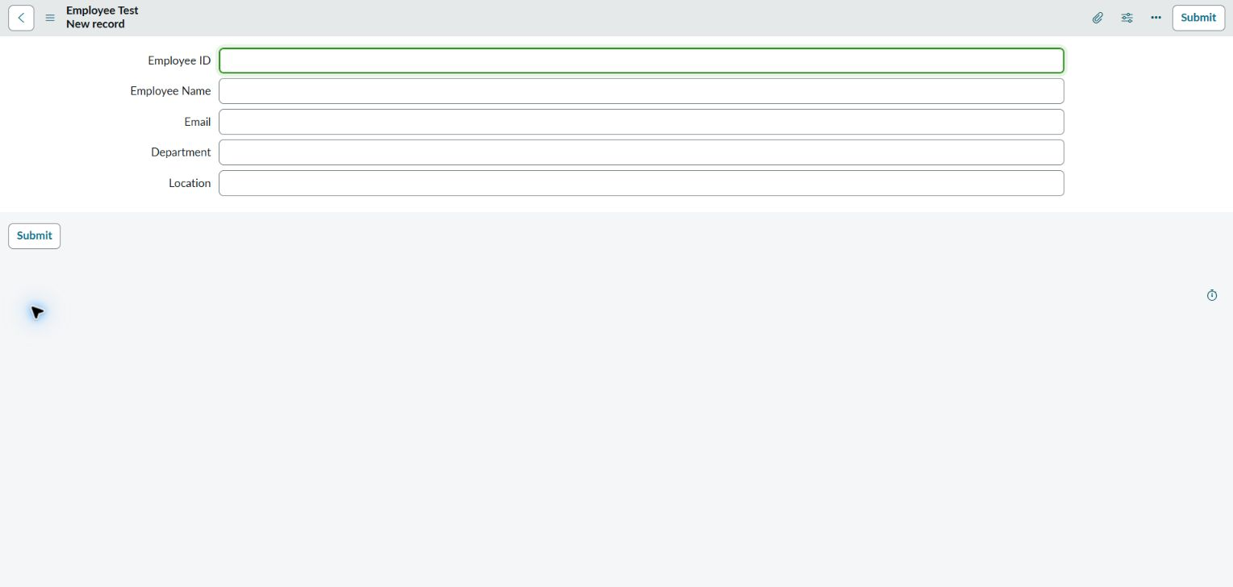
E02 Employee Test form showing the five required fields
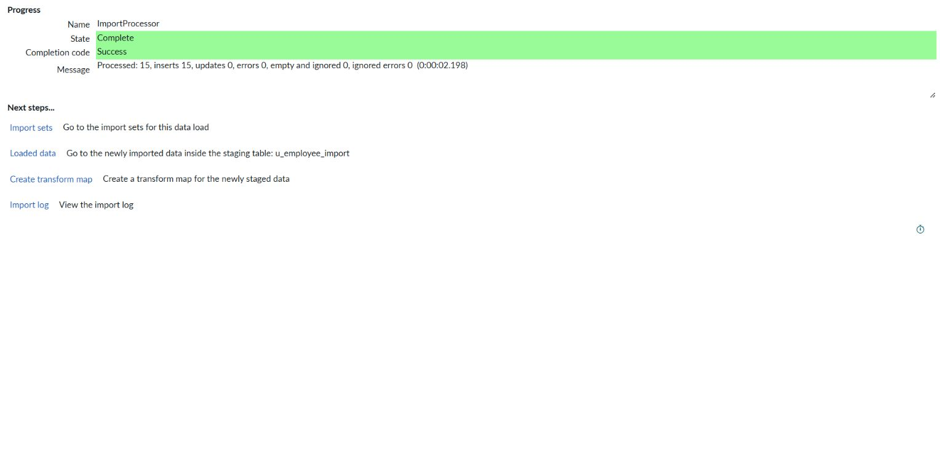
E03 Baseline source loaded into Employee Import
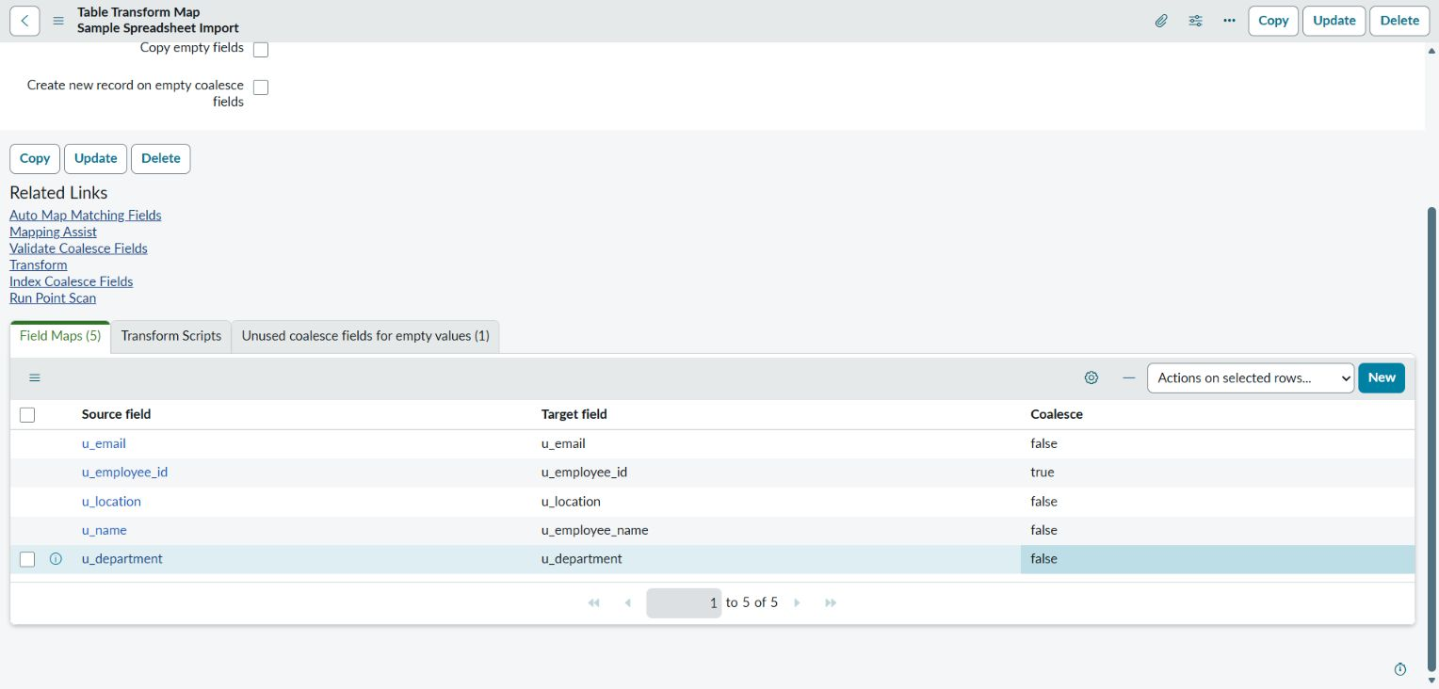
E04 and E05 Saved mappings with Employee ID coalesce
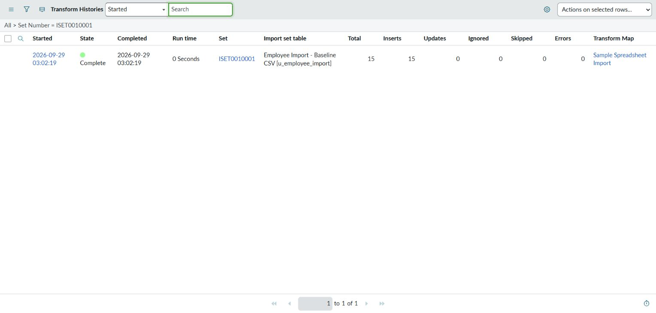
E06 Baseline transformation with 15 inserted rows
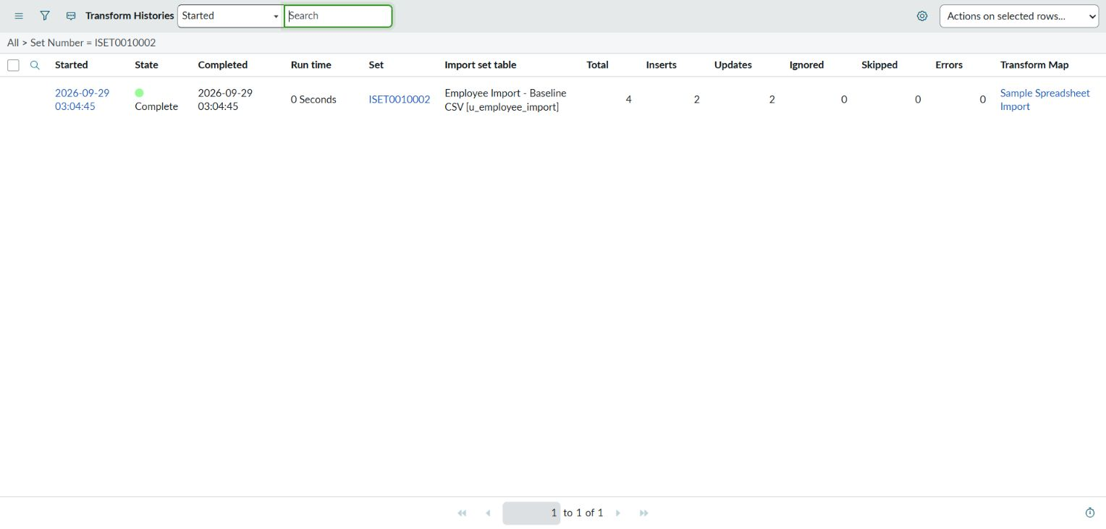
E06 Update transformation with two inserts and two updates
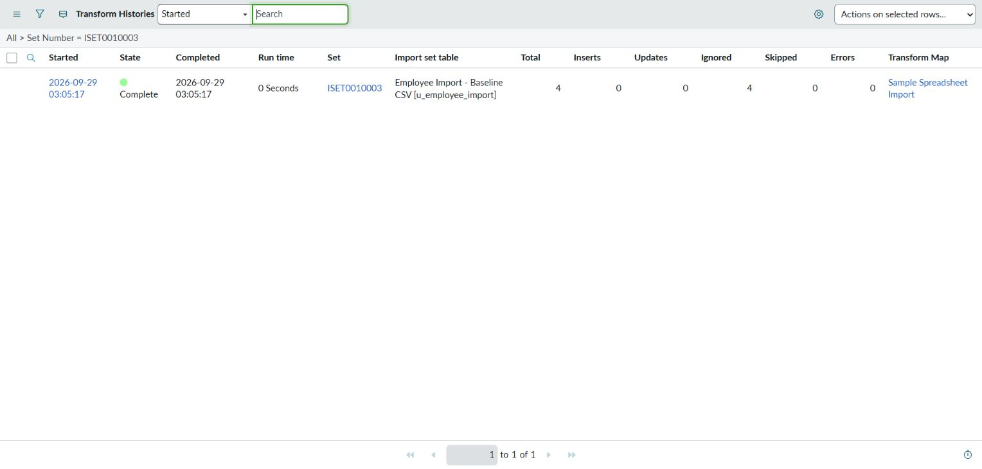
E06 Repeat transformation with zero inserts and four ignored rows
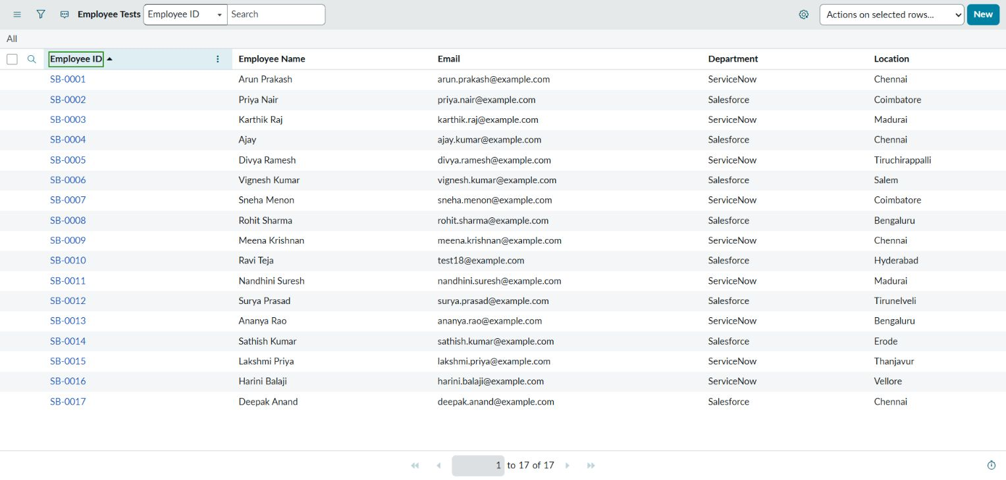
E07 Final Employee Test records
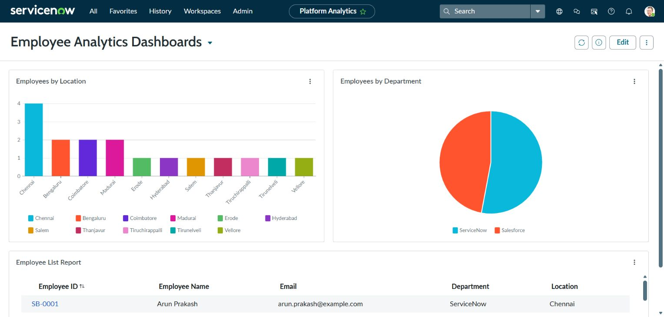
E08 and E09 Populated Employee Analytics Dashboards
Department totals are ServiceNow 9 and Salesforce 8. Location totals are Chennai 4; Bengaluru, Coimbatore and Madurai 2 each; Erode, Hyderabad, Salem, Thanjavur, Tiruchirappalli, Tirunelveli and Vellore 1 each. Both charts reconcile to 17 employees. The saved list uses Employee ID, Employee Name, Email, Department and Location.
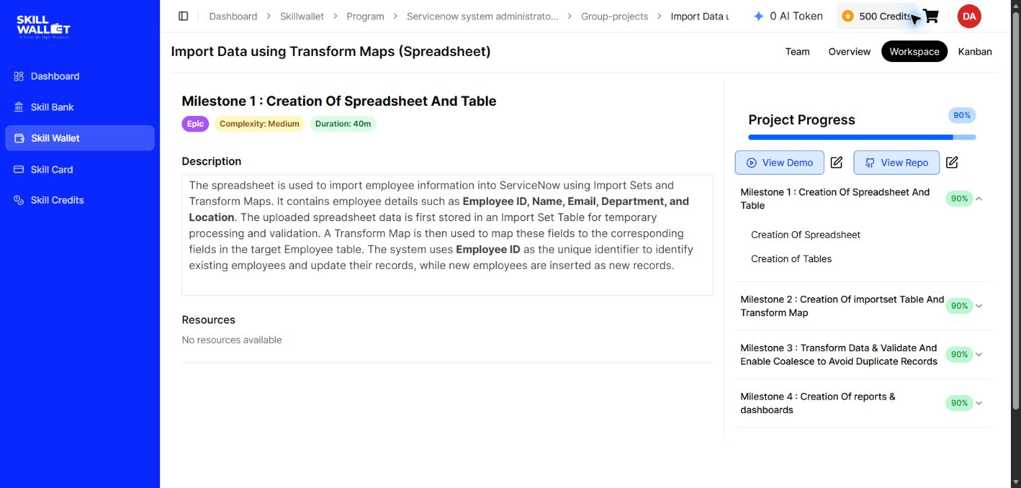
SkillWallet milestones at 90 percent with repository and demo links
All nine stories remain in Review. The final observed portal state is 90 percent; reviewer acceptance is still required.

8 ADVANTAGES AND DISADVANTAGES
Advantages include reusable mappings, explicit update matching, a staging checkpoint, recorded transformation outcomes and reports built on the same target dataset. Limitations include dependence on a stable Employee ID, the need to validate source data, and the fact that all five fields are Strings rather than structured reference or choice fields. The sample dataset demonstrates the workflow at small scale and does not establish production-scale performance.

9 CONCLUSION
The implemented workflow imports employee records, updates matching Employee IDs and avoids duplicates on a repeated update file. All 17 target rows match the expected data. The reports and dashboard are saved. The history displays each transform duration as 0 Seconds, which does not support a precise throughput calculation. Formal reviewer sign-off and final SkillWallet acceptance remain pending.

10 FUTURE SCOPE
Possible later improvements include formal input validation, controlled department/location values, scheduled imports, a documented employee key policy, and larger-volume performance tests. These are future options rather than features claimed in the current implementation.

11 APPENDIX
Source code: the current design uses direct Transform Map configuration. Add configuration exports or scripts only if actually created and required for submission. The companion project-runbook.md records the implementation and demonstration procedure.
Dataset files: Sample Spreadsheet.xlsx (15 rows), Updated Sample Spreadsheet.xlsx (4 rows) and Expected Final Target.csv (17 expected records). The repository provides both required XLSX workbooks and equivalent CSVs. All employee records are synthetic.
GitHub project: https://github.com/DisneyAntroJ/skillwallet. Baseline CSV commit: 9a24c7f0acde456ffacf28d5bcdcd916f5a71a16. Update CSV commit prefix: a92bf12.
Project demo video: https://drive.google.com/file/d/1gonx-uMMW-M-BO6GmONjhmYsgV-luIr7/view. This 2 minute 20 second narrated walkthrough is available to anyone with the link. SkillWallet uses this video as the project demo. Team ID: Not assigned.
Live ServiceNow dashboard: https://dev230529.service-now.com/now/platform-analytics-workspace/dashboards/params/edit/false/sys-id/549ca1bac36f8b54c34b78cc05013131. Opening the live dashboard requires an authorized instance session.
Import trace: ISET0010001 / TH0001001 at UI time 2026-09-29 03:02:19; ISET0010002 / TH0001002 at 03:04:45; ISET0010003 / TH0001003 at 03:05:17. The history Run time column displays 0 Seconds for each run. This rounded display cannot establish a precise elapsed duration or rows per second.
References: supplied Final Report Template and phase templates; the following official ServiceNow documentation explains the platform behavior used in this design.
- Transform Map settings: https://www.servicenow.com/docs/r/integrate-applications/system-import-sets/t_CreateATransformMap.html
- Field Map settings: https://www.servicenow.com/docs/r/integrate-applications/system-import-sets/t_CreatingAFieldMap.html
- Coalesce behavior: https://www.servicenow.com/docs/r/xanadu/integrate-applications/system-import-sets/c_ImportSetCoalesce.html
- Zurich reporting and Data Visualizations: https://www.servicenow.com/docs/r/zurich/now-intelligence/reporting/t_CreateYourOwnReport.html
- Platform Analytics dashboards: https://www.servicenow.com/docs/r/zurich/now-intelligence/create-db-in-ac.html

Submission and demonstration status

Prepared deliverables
This six-phase report is supplied as editable DOCX, PDF and an owner Google Doc. The package includes both XLSX workbooks, equivalent CSVs, original results, actual Excel replay evidence, the local source validator, the setup guide and the completed narrated demo.

Project demonstration
Transform_Maps_Project_Demo.mp4 is the completed 2 minute 20 second walkthrough with English captions and the team lead’s narration. It uses project screenshots to explain the original CSV import, coalesce results and dashboard. The 3 October Excel attachment verification is documented separately in this report and xlsx-verification.md. The repository includes a 1080p MP4 copy.

Submission links
Repository: https://github.com/DisneyAntroJ/skillwallet. The repository includes the six-phase PDF and DOCX, source workbooks, validation evidence, setup guide and narrated demo. Editable Google Doc: https://docs.google.com/document/d/1LFzab42jFeOn9L5nKm1muUL8pDDFKQp9AvjMeIc7vPs/edit. The Google Doc requires Drive permission; the public repository PDF and DOCX are available to reviewers.

Acceptance status
The last observed SkillWallet state is 90 percent, with all nine stories in Review. Disney Antro J is team lead, with Praveen N and Sibin P as members. The narrated demo, actual Excel imports and 19 recorded technical checks are complete. Human signatures, actual sprint records and formal reviewer acceptance remain to be supplied by the responsible people.

Fresh evidence captured on 30 September
The current evidence folder contains the populated dashboard, transform settings, all five field mappings with Employee ID coalesce, and the three completed transform histories. These captures supplement the implementation evidence dated 29 September and preserve the actual interface without visual alteration.

Final Human Verification
1. In Employee Test, confirm 17 records, SB-0004 name Ajay and SB-0010 email test18@example.com. Open Employee Analytics Dashboards and inspect all three reports.
2. Play the submitted narrated video and open the repository PDF and both Excel workbooks. Read the original CSV results together with the later Excel replay evidence.
3. Enter the actual tester name, verification date and signature in Phase 5. The team lead records their own acceptance after review; the faculty or reviewer records their separate approval.
4. Fill the Phase 4 sprint tracker from genuine team records. If dates or accepted points were not recorded, retain Not recorded and ask the faculty how to complete the planning record. Calculate velocity only from confirmed completed sprints.
5. Request review of the nine SkillWallet items already in Review. Confirm that the demo and repository links open correctly. Final platform completion is established by the reviewer’s recorded acceptance.

