概念模型设计

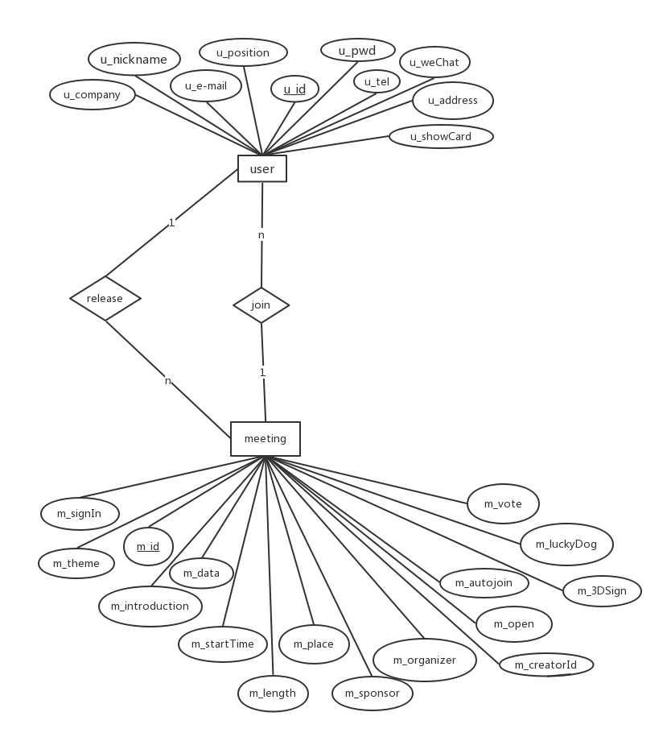

逻辑结构设计及物理结构设计

user(u_id,u_pwd,u_nickname,u_position,u_company,u_email,u_tel,u_qq,u_weChat,u_address,u_showCard)

meeting(m_id,m_theme,m_introduction,m_dataTime,m_length,m_place,m_sponsor,m_organizer,m_createrId,m_open,m_autoJoin,m_signIn,m_3DSign,m_luckyDog,m_vote,m_num,m_3DSignM)

meeting_ participants (u_id,m_id,signIn,luckyDog)

meeting_manager(u_id,m_id)

meeting_vote(m_id,u_id,voteNum)

sys_token(token_id,token,time_out,u_id)

创建数据库，三类模式结构及基础数据导入得MYSQL语句