แบบทดสอบทางการศึกษาระดับชาติขั้นพื้นฐาน (O-NET)
กลุ่มสาระการเรียนรู้ภาษาต่างประเทศ (ภาษาอังกฤษ) ชั้นมัธยมศึกษาปีที่ 3
ปีการศึกษา 2568 | สถาบันทดสอบทางการศึกษาแห่งชาติ (องค์การมหาชน)
คะแนนเต็ม 100 คะแนน | จำนวน 32 ข้อ (ข้อละ 3.125 คะแนน) | เวลา 90 นาที
――――――――――――――――――――――――――――――――――――――――――――――――――――――――――――
Part 1: Listening and Speaking (Items 1 – 9)
Directions: Choose the BEST answer for each situation.
Conversation 1: Items 1 – 3
Situation: Class friends are talking about exclamatory words in English.
Conrad: Oops! ____(1)____. I forgot to bring you your notebook. Forgive me.
Julian: ____(2)____. Just go back to the dorm and give it back to me in the English class.
Nina: You sound like a native speaker, using 'Oops!' followed by saying ____(3)____ for the mistake you made.
1. What should Conrad say in blank (1)?
(1) I did it again
(2) I smiled too much
(3) I learned it before
(4) I got away easily
2. What should Julian say in blank (2)?
(1) It ends
(2) It stops
(3) It matters
(4) It happens
3. What should Nina say in blank (3)?
(1) you're sorry
(2) you're ready
(3) you're sincere
(4) you're pleasant
Conversation 2: Items 4 – 6
Situation: Bonnie and Ava are discussing 'The Glory', a renowned Korean series.
Bonnie: Why don't you want to watch The Glory?
Ava: I don't like Korean series.
Bonnie: ____(4)____. It gets millions of views on Netflix. Actually, I read a review about it. It said it's brutal and violent. Anyway, it's ____(5)____.
Ava: I'm just not interested.
Bonnie: Okay. We can find ____(6)____.
4. What should Bonnie say in blank (4)?
(1) Go and get it
(2) It's a must-see
(3) You should leave it now
(4) Enjoy it for once
5. What should Bonnie say in blank (5)?
(1) not that bad
(2) all of things
(3) a failure
(4) unpopular
6. What should Bonnie say in blank (6)?
(1) the other
(2) something else
(3) a Korean series
(4) a popular show
Conversation 3: Items 7 – 9
Situation: Two friends are talking about sarcasm in speaking.
Elijah: The teacher said to you, "You have been working very hard!"
James: ____(7)____? I was playing on my phone all through class.
Elijah: Don't you know that he was being sarcastic?
James: What do you mean by that?
Elijah: He clearly meant ____(8)____. You handed in almost an empty page of the unit summary. Didn't you see his facial expression or hear his tone of voice?
James: I didn't know that he was irritated. I thought he was being ____(9)____.
7. What should James say in blank (7)?
(1) Isn't it what I wrote
(2) Why did he say that
(3) Could you repeat that
(4) Have you worked hard before
8. What did the teacher mean in blank (8)?
(1) the truth
(2) the same
(3) the opposite
(4) the difference
9. What should James say in blank (9)?
(1) lazy
(2) angry
(3) caring
(4) worried
Part 2: Reading (Items 10 – 23)
Reading 1: Instructions (Item 10)
Directions: Look at the pictures (1) – (6) and read the instruction sentences A – F. Rearrange the sentences according to the correct order of the pictures.
10. What is the correct order of making a beef burger?
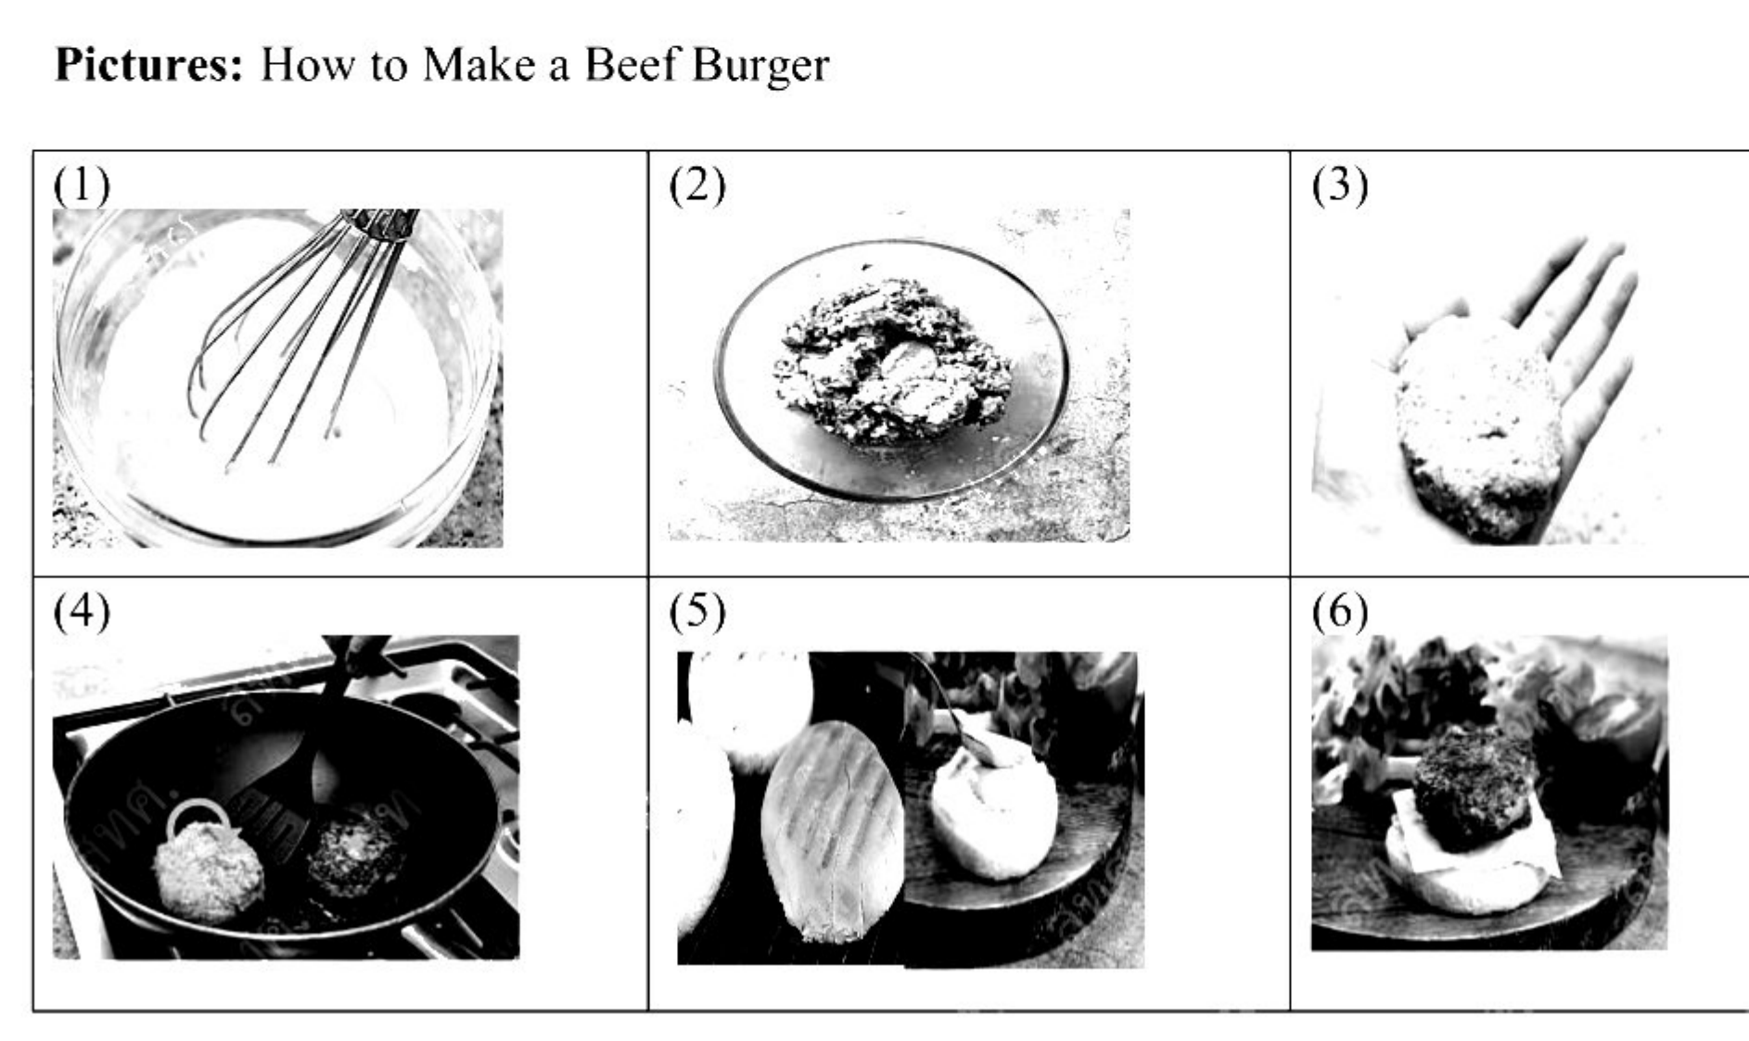
(1) D – A – B – C – F – E
(2) A – B – D – C – F – E
(3) D – B – A – C – F – E
(4) A – D – B – C – F – E
Instructions A – F for Item 10:
A. Prepare the burgers, by mixing the beef mince with salt, pepper, onion and eggs.
B. Use hands or a burger mold to shape the meat mixture into flat burger patties.
C. Fry the burgers for 5-6 minutes on each side.
D. Make the burger sauce, by whisking together mayonnaise, ketchup, mustard and vinegar in a bowl.
E. Fill the buns with the burger, lettuce, cheese and tomato slices.
F. Toast the hamburger buns and spread burger sauce on the bottom.
Reading 2: A Description (Item 11)
Directions: Read the description of a famous tower and choose the picture it describes.
"This beautiful tower is made of a special kind of iron which can be bent into an attractive shape. The tower's base is supported by four massive, slightly curved legs that narrow towards the top, creating a distinctive cone-like shape. The legs are connected by a network of metal framework and arches."
11. Which of the following pictures is described above?
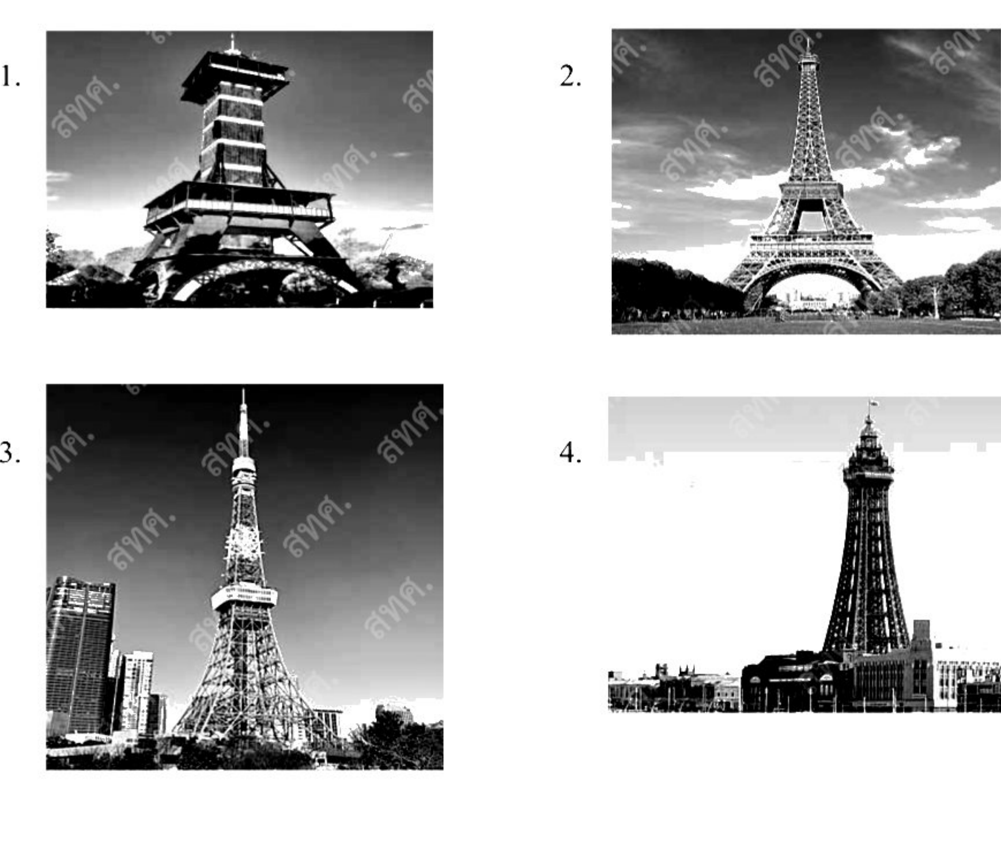
Reading 3: A Story (Items 12 – 15)
Directions: Read the story and choose the BEST answers to the questions.
Once, there was a young boy. This boy had problems controlling his anger. When he got angry, he would say the first thing that came to mind, even if it hurt people.
One day, his father gifted him a hammer and a bundle of nails, then said, "Whenever you get mad, hammer a nail into the backyard fence."
The boy used up half of his nails in the first few days. Over the following weeks, he used up fewer nails until his temper was under control. The father then asked the young boy to remove a nail for each day he didn't lose his temper.
On the day when the boy had removed his last nail, his father told him, "You have done good, boy. But can you see the holes in the wall? The fence is never going to be the same. Likewise, when you say mean things in anger, you'll leave a scar."
12. What did we learn about the boy in the first paragraph?
(1) He could not control his speaking when angry.
(2) His anger usually led to devastating violence.
(3) He wasn't able to speak when he was angry.
(4) He normally impressed others with words when angry.
13. Which of the following is TRUE about the boy?
(1) Removing the nails from the fence, he lost his temper.
(2) Receiving gifts from his father, he never lost his temper.
(3) He got angry so often that he used up all the nails he had.
(4) He got angry less often because of the use of hammer and nails.
14. What is the father's purpose for telling the boy to take out the nails?
(1) To suggest he reuse the nails for economic reasons.
(2) To warn him that bad words, once said, are never forgotten.
(3) To help him find ways to repair the holes in the wood fence.
(4) To teach him to repair relationships with friends by apologizing.
15. What is the best title for the story?
(1) Useful Tools
(2) Father Knows Best
(3) Anger Turns into Tears
(4) Words Heal All Wounds
Reading 4: A News Report and a Fact Sheet (Items 16 – 19)
Directions: Choose the BEST answers using the information from the News Report and the Fact Sheet.
News Report:
SANTA BARBARA, Calif. (AP) — Sea lions are stranding themselves on a long stretch of the California coast and showing signs that they may have been poisoned by a bloom of harmful algae, experts said Thursday.
The Channel Islands Marine & Wildlife Institute said that since July 26, there have been reports of sick sea lions along 155 miles (249 kilometers) of shoreline in Santa Barbara and Ventura counties, northwest of Los Angeles. The nonprofit said it had rescued 23 animals so far.
The marine mammals are suffering from domoic acid, a neurotoxin that affects the brain and heart, the institute said in a statement. The poisoning event is largely affecting adult female California sea lions, it said.
An outbreak last year was particularly severe, with hundreds of sea lions and dozens of dolphins dying in the first weeks of June.
The poison is produced by microscopic algae that are consumed by shellfish and small fish that are then eaten by sea lions, dolphins and birds. Symptoms in affected sea lions may include confusion, foaming at the mouth and seizures. People can also get sickened.
Fact Sheet for Items 16 – 19:
16. What is the News Report mainly about?
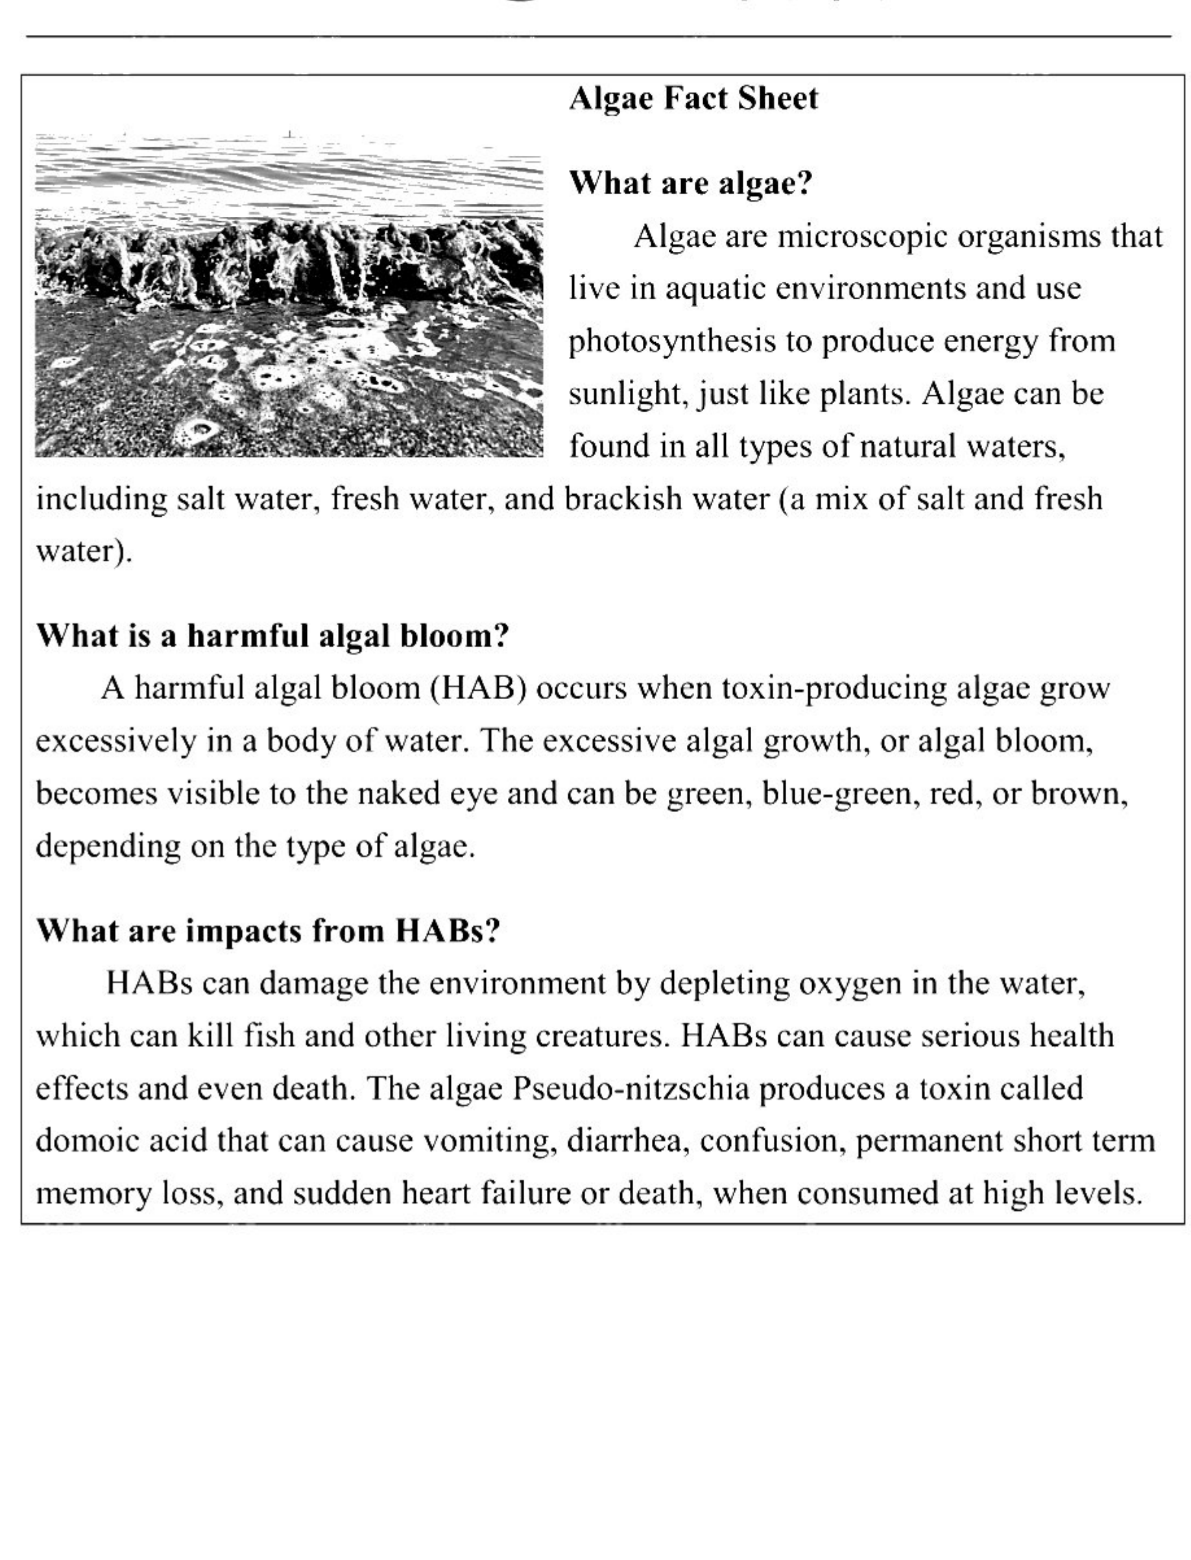
(1) The causes of a harmful algal bloom on the California coast
(2) The spread of a toxic algal bloom along the California coast
(3) The effect of a harmful algal bloom on California sea lions
(4) The symptoms of domoic acid poisoning in California sea lions
17. How does the Fact Sheet help readers understand the news more clearly?
(1) By explaining how algal blooms are formed
(2) By giving reasons why algal blooms spread very quickly
(3) By describing the different colors of algal blooms in the sea
(4) By providing information about the dangers of toxic algal blooms
18. Which of the following is TRUE about California sea lions?
(1) Only adult female sea lions have been affected by harmful algae.
(2) They eat small fish and shellfish that consume bad algae.
(3) All of them have been reported dying on the California coast since July 26.
(4) The affected sea lions do not have any symptoms if they do not eat toxic algae directly.
19. What can be inferred from the last paragraph of the News Report?
(1) Sea lions are primary consumers in the marine food chain.
(2) Marine mammals die when they directly touch domoic acid.
(3) Eating fish and shellfish during algal blooms can become a risk to people.
(4) The symptoms of domoic acid poisoning in sea lions include vomiting and diarrhea.
Reading 5: A Feature Story (Items 20 – 23)
Directions: Read the feature story and choose the BEST answers.
Red Nose Day (RND) is a well-known event in the UK. It is called Red Nose Day because on this day many people buy a plastic red nose to wear. The money made from selling these red noses goes to charity.
Back in 1985, Comic Relief started as a charity with the desire to respond to the severe famine in Ethiopia at the time. The desire was to get comedians together to help people laugh while raising support to help people around the world.
The following year, the notion of Red Nose Day was established and was then held every other year, broadcast on British Television (BBC). Although the charity focuses have changed throughout the years, the organization continues to raise funds for those in need.
By 2015, Red Nose Day had made its way to the United States and it had a great amount of success there. Since 2021, Red Nose Day in the UK and in the US has been held annually.
20. What is this passage mainly about?
(1) Red Nose Day events
(2) A well-known event in the UK
(3) A charity called Comic Relief
(4) The evolution of Red Nose Day
21. What is the purpose of selling plastic red noses?
(1) To celebrate Red Nose Day
(2) To raise funds for the needy
(3) To respond to famine in Ethiopia
(4) To get comedians to entertain people
22. According to the passage, what is TRUE about Red Nose Day?
(1) Its name was created in 2015.
(2) It was established before Comic Relief.
(3) It's the day when comedians tell jokes.
(4) It was adopted by the US and had great success there.
23. Which question can be answered from the passage?
(1) How did Red Nose Day come to the US?
(2) How long did the famine in Ethiopia last?
(3) How often is Red Nose Day held in the UK and the US?
(4) What events can people participate in on Red Nose Day?
Part 3: Writing (Items 24 – 32)
Writing 1: Cloze Passage with Chart (Items 24 – 27)
Directions: Choose the best word/words to complete the text below.
The chart illustrates the percentage of the population who owned a smartphone from 2011 to 2016.
Overall, smartphone ownership ____(24)____ during the six-year period. In general, the younger people were, ____(25)____ to own a smartphone. ____(26)____, the most significant increases in smartphone ownership in 2016 ____(27)____ people aged 45 to 54, from 46% to 84%; from those in the 55 to 64 categories, from 9% to 59%; and from those aged 65 to 74, from 5% to 50%.
24. Choose the best answer for (24):
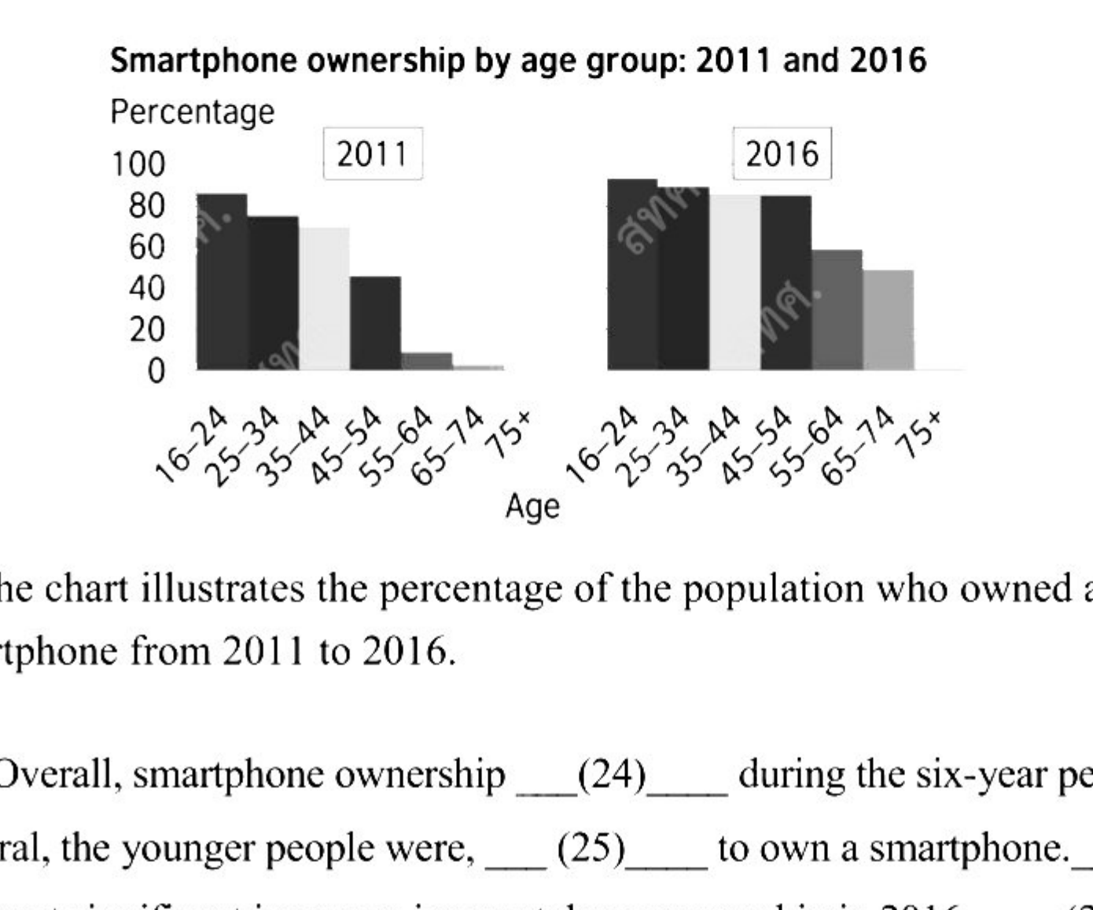
(1) increase
(2) will increase
(3) increased
(4) increasing
25. Choose the best answer for (25):
(1) the more they likely were
(2) the more likely they were
(3) they were the more likely
(4) likely the more they were
26. Choose the best answer for (26):
(1) Since
(2) Unless
(3) However
(4) Although
27. Choose the best answer for (27):
(1) come to
(2) come over
(3) came by
(4) came from
Writing 2: A Movie Review (Items 28 – 32)
Directions: Choose the best word/words to complete the movie review below.
"Mission Impossible: Dead Reckoning" is an incredible movie that left me thoroughly impressed. In the movie, Tom Cruise, ____(28)____ plays Ethan Hunt, is on another mission—this time against AI. He is ____(29)____ as always. I couldn't believe that he is 61 years old ____(30)____ he runs and jumps like a much younger man. This movie features ____(31)____ to stunning frantic music. Action movie fans will find this to be an amazing experience. This is the best movie ____(32)____ in 2023.
28. Choose the best answer for (28):
(1) who
(2) when
(3) whose
(4) which
29. Choose the best answer for (29):
(1) fearful
(2) fantastic
(3) faithless
(4) fortunate
30. Choose the best answer for (30):
(1) so
(2) before
(3) because
(4) although
31. Choose the best answer for (31):
(1) action scenes tense
(2) action tense scenes
(3) scenes tense action
(4) tense action scenes
32. Choose the best answer for (32):
(1) release
(2) released
(3) releasing
(4) to release

เฉลยคำตอบ (Answer Key)
O-NET ภาษาอังกฤษ ม.3 (ปีการศึกษา 2568) | คะแนนเต็ม 100 คะแนน (ข้อละ 3.125 คะแนน)
ข้อที่ | ตัวเลือก | คะแนน | คำตอบ / เฉลย
ข้อ 1 | ข้อ A | 3.125 | (1) I did it again
ข้อ 2 | ข้อ D | 3.125 | (4) It happens
ข้อ 3 | ข้อ A | 3.125 | (1) you're sorry
ข้อ 4 | ข้อ B | 3.125 | (2) It's a must-see
ข้อ 5 | ข้อ A | 3.125 | (1) not that bad
ข้อ 6 | ข้อ B | 3.125 | (2) something else
ข้อ 7 | ข้อ B | 3.125 | (2) Why did he say that
ข้อ 8 | ข้อ C | 3.125 | (3) the opposite
ข้อ 9 | ข้อ C | 3.125 | (3) caring
ข้อ 10 | ข้อ A | 3.125 | (1) D – A – B – C – F – E
ข้อ 11 | ข้อ B | 3.125 | (2) Eiffel Tower
ข้อ 12 | ข้อ A | 3.125 | (1) He could not control his speaking when angry.
ข้อ 13 | ข้อ D | 3.125 | (4) He got angry less often because of the use of hammer and nails.
ข้อ 14 | ข้อ B | 3.125 | (2) To warn him that bad words, once said, are never forgotten.
ข้อ 15 | ข้อ B | 3.125 | (2) Father Knows Best
ข้อ 16 | ข้อ C | 3.125 | (3) The effect of a harmful algal bloom on California sea lions
ข้อ 17 | ข้อ D | 3.125 | (4) By providing information about the dangers of toxic algal blooms
ข้อ 18 | ข้อ B | 3.125 | (2) They eat small fish and shellfish that consume bad algae.
ข้อ 19 | ข้อ C | 3.125 | (3) Eating fish and shellfish during algal blooms can become a risk to people.
ข้อ 20 | ข้อ D | 3.125 | (4) The evolution of Red Nose Day
ข้อ 21 | ข้อ B | 3.125 | (2) To raise funds for the needy
ข้อ 22 | ข้อ D | 3.125 | (4) It was adopted by the US and had great success there.
ข้อ 23 | ข้อ C | 3.125 | (3) How often is Red Nose Day held in the UK and the US?
ข้อ 24 | ข้อ C | 3.125 | (3) increased
ข้อ 25 | ข้อ B | 3.125 | (2) the more likely they were
ข้อ 26 | ข้อ C | 3.125 | (3) However
ข้อ 27 | ข้อ D | 3.125 | (4) came from
ข้อ 28 | ข้อ A | 3.125 | (1) who
ข้อ 29 | ข้อ B | 3.125 | (2) fantastic
ข้อ 30 | ข้อ D | 3.125 | (4) although
ข้อ 31 | ข้อ D | 3.125 | (4) tense action scenes
ข้อ 32 | ข้อ B | 3.125 | (2) released

