Hotel Management System
Software Requirements Specification
Prepared in accordance with IEEE Std 830-1998 guidelines

Prepared for: [Client / Hotel Group Name]
Prepared by: Disura
Date: July 2026
Version: 1.0
Status: Draft for client review

Revision History
Version | Date | Author | Description
0.1 | 18 Jun 2026 | Disura | Initial draft of functional requirements
1.0 | 01 Jul 2026 | Disura | Complete SRS issued for review

Table of Contents

1. Introduction

1.1 Purpose
This Software Requirements Specification (SRS) describes the functional and non-functional requirements of the Hotel Management System (HMS). It is intended for the client/product owner, the development team, and any future maintainers of the system, and follows the general structure recommended by IEEE Std 830-1998 for software requirements documents.

1.2 Scope
The HMS is a web-based platform that enables hotel staff to manage room inventory, reservations, guest profiles, billing, housekeeping, and reporting across one or more properties. It also exposes a guest-facing booking widget for direct reservations. The system is designed to be cost-effective to host, straightforward to maintain, and secure enough for production use, including handling of guest payment data via a third-party payment gateway.

1.3 Definitions, Acronyms and Abbreviations
Term | Definition
HMS | Hotel Management System – the system described in this document
PMS | Property Management System – industry term for hotel operations software
Folio | A guest's running account of charges and payments during a stay
RBAC | Role-Based Access Control
OTA | Online Travel Agency (e.g., Booking.com, Agoda, Expedia)
ADR | Average Daily Rate – average revenue earned per occupied room per day
RevPAR | Revenue Per Available Room
Night audit | End-of-day process that closes out the day's transactions and rolls the system date forward

1.4 References
- IEEE Std 830-1998, IEEE Recommended Practice for Software Requirements Specifications.
- Project Proposal – Hotel Management System, v1.0.
- Software Design Document – Hotel Management System, v1.0.
- Database Design Document – Hotel Management System, v1.0.
- PCI DSS v4.0 – Payment Card Industry Data Security Standard (referenced for payment-handling requirements).

1.5 Overview
Section 2 gives an overall description of the product, its users and constraints. Section 3 lists specific functional and non-functional requirements, organised by module. Section 4 describes external interface requirements. Section 5 lists use cases in detail.

2. Overall Description

2.1 Product Perspective
The HMS is a new, self-contained product. It is not a replacement module within an existing legacy system, though it is designed to allow future integration with OTAs and accounting software via its API layer. It follows a client-server architecture: browser and mobile clients communicate with a backend API over HTTPS, which in turn communicates with a relational database and third-party services (payment gateway, email/SMS provider).

2.2 Product Functions (Summary)
- Room and rate management (room types, individual rooms, seasonal rates).
- Reservation management (search availability, create/modify/cancel bookings).
- Guest profile management (contact details, ID/passport, stay history).
- Check-in / check-out workflow.
- Folio and billing management with integrated payment processing.
- Housekeeping status tracking.
- Role-based staff accounts and permissions.
- Operational and financial reporting.
- Multi-property support for hotel groups.

2.3 User Classes and Characteristics
User Class | Description | Technical Expertise
Owner / General Manager | Full access across all properties; views financial reports, manages staff and rates | Low to moderate
Branch Manager | Full operational access for their assigned property/properties | Low to moderate
Front Desk / Cashier | Creates and manages reservations, checks guests in/out, records payments | Low
Housekeeping Staff | Updates room cleaning/maintenance status only | Low
Accountant | Views billing, payments and financial reports; no reservation editing | Low to moderate
Guest (public) | Uses the public booking widget to search and reserve rooms | None assumed

2.4 Operating Environment
- Server-side: Linux-based cloud environment (containerised), Node.js runtime, PostgreSQL database.
- Client-side (staff): modern desktop browser (Chrome, Edge, Firefox, Safari, latest two major versions).
- Client-side (guest booking widget): modern desktop and mobile browsers.
- Optional: Electron-based front-desk terminal application for offline-tolerant kiosk use.

2.5 Design and Implementation Constraints
- The system must isolate data by property to support multi-branch clients from day one.
- All card payment data must be handled exclusively via a PCI-DSS-compliant third-party gateway; the system must never store raw card numbers.
- The system must remain operable on cost-effective infrastructure suitable for a small-to-mid-sized hotel budget.
- Time-sensitive operations (night audit, checkout timing) must correctly account for the property's local time zone.

2.6 Assumptions and Dependencies
- The client will provide a merchant account with the selected payment gateway (Stripe or a local aggregator such as PayHere).
- The client will provide branding assets (logo, color scheme) for the guest-facing booking widget.
- Reliable internet connectivity is available at each property for staff to access the system.
- OTA channel synchronisation is treated as a future phase and is not a dependency of the Phase 1 release.

3. Specific Requirements

3.1 Functional Requirements

3.1.1 Authentication and Access Control
ID | Requirement | Priority
FR-1.1 | The system shall allow staff to log in using an email/username and password. | High
FR-1.2 | The system shall enforce role-based access control, restricting each API endpoint and UI view according to the logged-in user's role. | High
FR-1.3 | The system shall support optional two-factor authentication (TOTP) for Owner and Manager roles. | Medium
FR-1.4 | The system shall lock an account after 5 consecutive failed login attempts for 15 minutes. | Medium
FR-1.5 | The system shall allow an Owner/Manager to create, edit, deactivate, and assign roles to staff accounts. | High

3.1.2 Room and Rate Management
ID | Requirement | Priority
FR-2.1 | The system shall allow authorised staff to define room types (e.g., Standard, Deluxe, Suite) with a base rate and maximum occupancy. | High
FR-2.2 | The system shall allow authorised staff to add, edit, and deactivate individual rooms under a room type. | High
FR-2.3 | The system shall allow authorised staff to define rate plans (e.g., seasonal rate, non-refundable rate) per room type. | High
FR-2.4 | The system shall prevent two confirmed reservations from overlapping on the same physical room, enforced at the database level. | High

3.1.3 Reservation Management
ID | Requirement | Priority
FR-3.1 | The system shall allow searching room availability by property, date range, and guest count. | High
FR-3.2 | The system shall allow staff to create a reservation on behalf of a guest, including walk-ins. | High
FR-3.3 | The system shall allow guests to create a reservation through the public booking widget. | High
FR-3.4 | The system shall allow staff to modify or cancel an existing reservation, subject to the applicable cancellation policy. | High
FR-3.5 | The system shall send a booking confirmation email to the guest upon successful reservation. | Medium
FR-3.6 | The system shall display a real-time occupancy/availability calendar to front-desk staff. | High

3.1.4 Check-in / Check-out
ID | Requirement | Priority
FR-4.1 | The system shall allow front-desk staff to check in a guest against an existing reservation, capturing ID/passport details. | High
FR-4.2 | The system shall automatically update room status to “Occupied” upon check-in and “Dirty” upon checkout. | High
FR-4.3 | The system shall allow staff to check out a guest only once the folio balance is zero or a payment method is confirmed. | High

3.1.5 Billing and Payments
ID | Requirement | Priority
FR-5.1 | The system shall maintain a folio per reservation, itemising all charges (room, services, taxes). | High
FR-5.2 | The system shall allow staff to post ad-hoc charges (e.g., minibar, laundry) to a guest's folio. | High
FR-5.3 | The system shall integrate with a third-party payment gateway to process card payments. | High
FR-5.4 | The system shall record all payments and refunds against the relevant folio with a timestamp and staff identifier. | High
FR-5.5 | The system shall generate a printable/emailable invoice upon checkout. | Medium

3.1.6 Housekeeping
ID | Requirement | Priority
FR-6.1 | The system shall allow housekeeping staff to update a room's status (clean, dirty, inspected, out-of-order). | High
FR-6.2 | The system shall prevent a room marked “out-of-order” from appearing in availability search results. | High

3.1.7 Reporting
ID | Requirement | Priority
FR-7.1 | The system shall generate an occupancy report for a selected date range and property. | High
FR-7.2 | The system shall generate a daily revenue and night-audit summary report. | High
FR-7.3 | The system shall calculate and display ADR and RevPAR for a selected period. | Medium
FR-7.4 | The system shall allow exporting reports to CSV/PDF. | Medium

3.1.8 Multi-Property Support
ID | Requirement | Priority
FR-8.1 | The system shall allow an Owner to manage multiple properties under a single account. | High
FR-8.2 | The system shall scope all reservation, room, and billing data strictly to its owning property. | High
FR-8.3 | The system shall allow an Owner/Manager to view consolidated reports across all properties. | Medium

3.2 Non-Functional Requirements
ID | Category | Requirement
NFR-1 | Performance | 95% of API requests shall complete within 500ms under normal load (excluding third-party payment calls).
NFR-2 | Availability | The production system shall maintain 99.5% uptime outside scheduled maintenance windows.
NFR-3 | Security | All traffic shall be encrypted via HTTPS/TLS 1.2 or higher.
NFR-4 | Security | Passwords shall be hashed using bcrypt or argon2; plaintext passwords shall never be stored or logged.
NFR-5 | Security | Raw payment card data shall never be stored on HMS servers; tokenisation via the payment gateway shall be used exclusively.
NFR-6 | Auditability | All rate overrides, refunds, cancellations, and role changes shall be recorded in an audit log with user, timestamp, and action.
NFR-7 | Usability | A new front-desk staff member shall be able to complete a check-in without developer assistance after a 1-hour training session.
NFR-8 | Scalability | The system shall support horizontal scaling of the application layer without code changes.
NFR-9 | Maintainability | The codebase shall use a single primary language (TypeScript) across frontend and backend to reduce long-term maintenance overhead.
NFR-10 | Localisation | The system shall correctly handle date/time calculations in the property's local time zone (e.g., Sri Lanka, UTC+5:30), including across daylight-saving boundaries where applicable.
NFR-11 | Backup & Recovery | The production database shall be backed up at least daily, with point-in-time recovery available for at least 7 days.
NFR-12 | Compatibility | The staff dashboard shall function correctly on the latest two major versions of Chrome, Edge, Firefox, and Safari.

4. External Interface Requirements

4.1 User Interfaces
The system provides a staff web dashboard (desktop-first, responsive to tablet) and a guest-facing booking widget (desktop and mobile responsive). Detailed wireframes and interaction flows are provided in the UI/UX Design Document.

4.2 Hardware Interfaces
No specialised hardware is required. The system is designed to run on standard desktop/laptop computers and tablets with a modern web browser. Optional receipt printers may be integrated via standard OS print drivers.

4.3 Software Interfaces
Interface | Purpose
Payment gateway API (Stripe / PayHere) | Processing card payments and refunds
Email/SMS provider API | Sending booking confirmations and notifications
PostgreSQL | Primary data store
Redis | Caching, session storage, background job queue

4.4 Communications Interfaces
All client-server communication occurs over HTTPS using a RESTful JSON API. Real-time availability updates on the booking calendar are delivered via a WebSocket channel.

5. Use Case Model
The diagram below summarises the primary actors and use cases of the system.
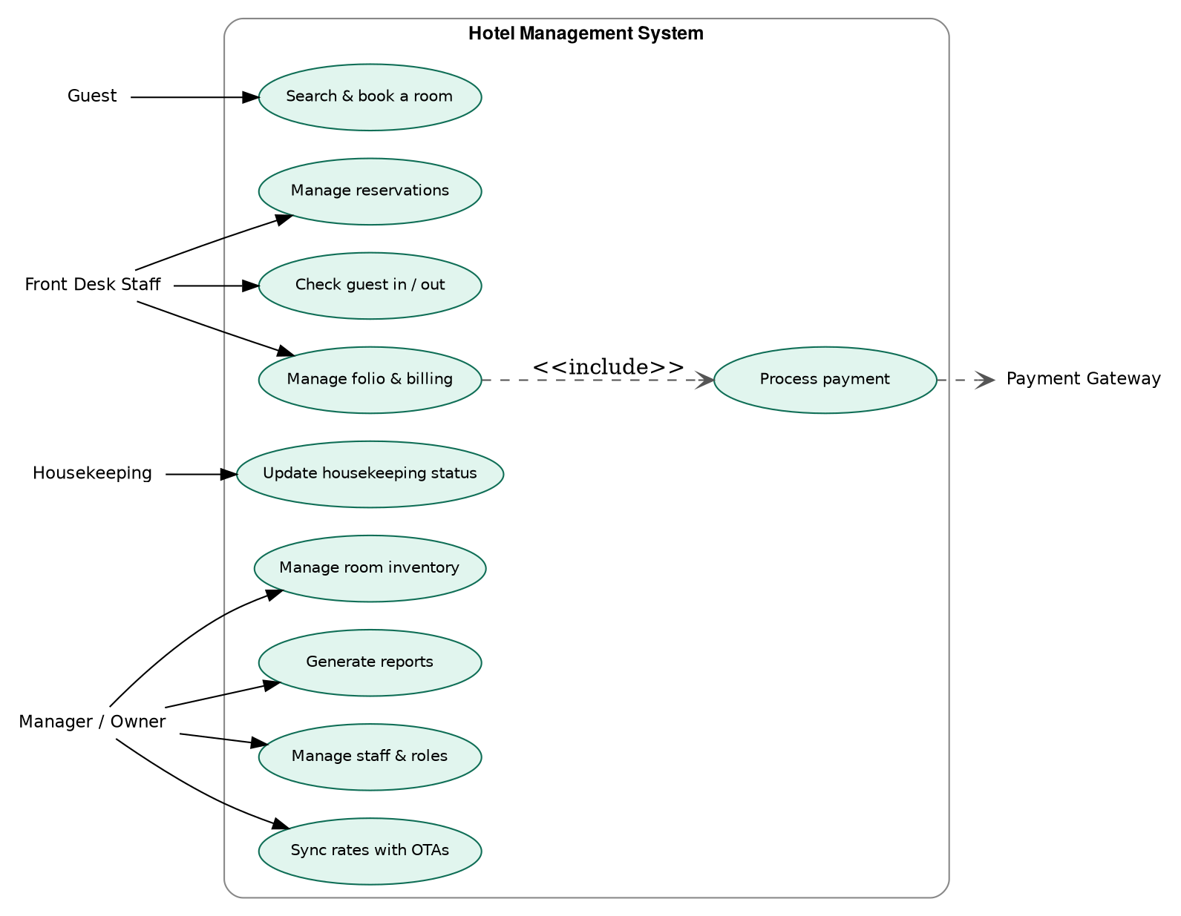
Figure 1: Use case diagram – Hotel Management System

5.1 Use Case: Book a Room (Guest, via booking widget)
Field | Description
Actor | Guest
Precondition | Guest has selected valid check-in/check-out dates
Main flow | 1. Guest searches availability. 2. System returns available room types and rates. 3. Guest selects a room and enters details. 4. Guest completes payment via the payment gateway. 5. System confirms the reservation and sends a confirmation email.
Alternate flow | If no rooms are available for the selected dates, the system displays alternative dates or room types.
Postcondition | A confirmed reservation exists; the room is no longer available for the booked dates.

5.2 Use Case: Check-in a Guest (Front Desk)
Field | Description
Actor | Front Desk Staff
Precondition | A confirmed reservation exists for the current date
Main flow | 1. Staff searches for the reservation. 2. Staff verifies guest identity and captures ID details. 3. Staff assigns a specific room if not already assigned. 4. System updates room status to Occupied and opens the guest folio.
Postcondition | Guest is checked in; room status is Occupied.

5.3 Use Case: Process Checkout Payment (Front Desk)
Field | Description
Actor | Front Desk Staff, Payment Gateway
Precondition | Guest folio has an outstanding balance
Main flow | 1. Staff opens the guest folio. 2. Staff selects payment method. 3. System sends a payment request to the gateway. 4. Gateway confirms payment via webhook. 5. System updates the folio balance and marks the reservation as checked out.
Exception flow | If the payment is declined, the system displays an error and the folio balance remains unpaid.
Postcondition | Folio balance is zero; room status is Dirty (pending housekeeping).

Appendix A: Requirements Traceability
Each functional requirement above is designed to map directly to a corresponding module in the Software Design Document and a set of test cases to be defined during the testing phase, ensuring every requirement is both implemented and verified before go-live.

