Hotel Management System
Database Design Document
Entity-relationship model, schema definitions, and data integrity rules

Prepared for: [Client / Hotel Group Name]
Prepared by: Disura
Date: July 2026
Version: 1.0
Status: Draft for client review

Revision History
Version | Date | Author | Description
0.1 | 22 Jun 2026 | Disura | Initial schema draft
1.0 | 01 Jul 2026 | Disura | Complete database design issued for review

Table of Contents

1. Introduction

1.1 Purpose
This document describes the database design for the Hotel Management System: the entity-relationship model, table definitions, keys, constraints, and indexing strategy. It is intended to guide implementation and to serve as a reference for future maintenance.

1.2 Database Management System
PostgreSQL is used as the primary relational database. It was selected over alternatives such as MySQL or MongoDB primarily because of its native support for range types and exclusion constraints, which allow the system to guarantee – at the database level – that no two reservations can ever overlap for the same room, and its strong general-purpose transactional integrity, which matters when a single action (e.g., checkout) must atomically update room status, folio balance, and payment records together.

2. Entity-Relationship Diagram
The diagram below shows the core entities of the system and their relationships. Supporting/lookup tables (roles, permissions, audit log) are described in the table definitions but omitted from the diagram for clarity.
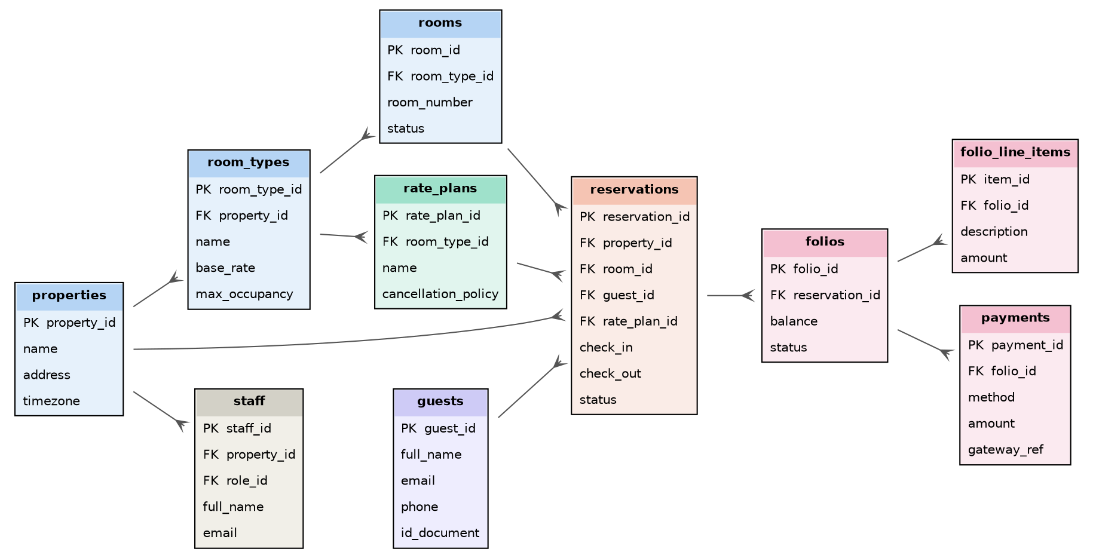
Figure 1: Entity-relationship diagram – core hotel management entities

3. Table Definitions

3.1 properties
Represents a single hotel/branch. All operational data is scoped to a property.
Column | Type | Constraints | Description
property_id | UUID | PK | Unique identifier
name | VARCHAR(150) | NOT NULL | Property/branch name
address | TEXT | NOT NULL | Physical address
timezone | VARCHAR(50) | NOT NULL, default 'Asia/Colombo' | IANA timezone used for all date/time calculations at this property
currency | CHAR(3) | NOT NULL | ISO 4217 currency code, e.g. LKR, USD
created_at | TIMESTAMPTZ | NOT NULL, default now() | Record creation time

3.2 room_types
Column | Type | Constraints | Description
room_type_id | UUID | PK | Unique identifier
property_id | UUID | FK → properties.property_id, NOT NULL | Owning property
name | VARCHAR(100) | NOT NULL | e.g. Deluxe Double, Family Suite
base_rate | NUMERIC(10,2) | NOT NULL, CHECK (base_rate >= 0) | Default nightly rate before rate-plan overrides
max_occupancy | SMALLINT | NOT NULL, CHECK (max_occupancy > 0) | Maximum guests permitted

3.3 rooms
Column | Type | Constraints | Description
room_id | UUID | PK | Unique identifier
room_type_id | UUID | FK → room_types.room_type_id, NOT NULL | Room type this room belongs to
room_number | VARCHAR(20) | NOT NULL | Displayed room number/name
status | room_status_enum | NOT NULL, default 'available' | available | occupied | dirty | inspected | out_of_order
 |  | UNIQUE (room_type_id, room_number) | Prevents duplicate room numbers within the same room type

3.4 rate_plans
Column | Type | Constraints | Description
rate_plan_id | UUID | PK | Unique identifier
room_type_id | UUID | FK → room_types.room_type_id, NOT NULL | Applicable room type
name | VARCHAR(100) | NOT NULL | e.g. Non-refundable, Seasonal 2026
rate_multiplier | NUMERIC(4,2) | NOT NULL, default 1.00 | Multiplier applied to base_rate
cancellation_policy | TEXT | NULL | Free-text cancellation terms
valid_from | DATE | NULL | Optional seasonal start date
valid_to | DATE | NULL | Optional seasonal end date

3.5 guests
Column | Type | Constraints | Description
guest_id | UUID | PK | Unique identifier
full_name | VARCHAR(150) | NOT NULL | Guest's full name
email | VARCHAR(150) | NULL | Contact email
phone | VARCHAR(30) | NULL | Contact phone
id_document_type | VARCHAR(30) | NULL | e.g. Passport, National ID
id_document_number | VARCHAR(60) | NULL, encrypted at rest | Identity document reference
created_at | TIMESTAMPTZ | NOT NULL, default now() | Record creation time

3.6 reservations
The central table of the system. A PostgreSQL exclusion constraint guarantees at the database level that no two reservations for the same room can have overlapping date ranges (see Section 4.1).
Column | Type | Constraints | Description
reservation_id | UUID | PK | Unique identifier
property_id | UUID | FK → properties.property_id, NOT NULL | Owning property
room_id | UUID | FK → rooms.room_id, NOT NULL | Assigned room
guest_id | UUID | FK → guests.guest_id, NOT NULL | Guest for this reservation
rate_plan_id | UUID | FK → rate_plans.rate_plan_id, NULL | Applied rate plan, if any
stay_range | TSTZRANGE | NOT NULL | Check-in/check-out as a single range value, used by the exclusion constraint
status | reservation_status_enum | NOT NULL, default 'confirmed' | pending | confirmed | checked_in | checked_out | cancelled | no_show
created_by | UUID | FK → staff.staff_id, NULL | Staff member who created the booking (NULL for guest self-booking)
created_at | TIMESTAMPTZ | NOT NULL, default now() | Record creation time

3.7 folios
Column | Type | Constraints | Description
folio_id | UUID | PK | Unique identifier
reservation_id | UUID | FK → reservations.reservation_id, NOT NULL, UNIQUE | One folio per reservation
balance | NUMERIC(12,2) | NOT NULL, default 0 | Current outstanding balance
status | folio_status_enum | NOT NULL, default 'open' | open | closed

3.8 folio_line_items
Column | Type | Constraints | Description
item_id | UUID | PK | Unique identifier
folio_id | UUID | FK → folios.folio_id, NOT NULL | Owning folio
description | VARCHAR(200) | NOT NULL | e.g. Room charge, Minibar, Laundry
amount | NUMERIC(10,2) | NOT NULL | Charge amount (positive) or adjustment (negative)
posted_by | UUID | FK → staff.staff_id, NULL | Staff member who posted the charge
posted_at | TIMESTAMPTZ | NOT NULL, default now() | Timestamp of the charge

3.9 payments
Column | Type | Constraints | Description
payment_id | UUID | PK | Unique identifier
folio_id | UUID | FK → folios.folio_id, NOT NULL | Folio being paid
method | payment_method_enum | NOT NULL | card | cash | bank_transfer
amount | NUMERIC(10,2) | NOT NULL, CHECK (amount > 0) | Payment amount
gateway_reference | VARCHAR(100) | NULL | Transaction ID returned by the payment gateway
status | payment_status_enum | NOT NULL, default 'pending' | pending | succeeded | failed | refunded
created_at | TIMESTAMPTZ | NOT NULL, default now() | Record creation time

3.10 staff
Column | Type | Constraints | Description
staff_id | UUID | PK | Unique identifier
property_id | UUID | FK → properties.property_id, NULL | NULL for an Owner with cross-property access
role_id | SMALLINT | FK → roles.role_id, NOT NULL | Assigned role
full_name | VARCHAR(150) | NOT NULL | Staff member's name
email | VARCHAR(150) | NOT NULL, UNIQUE | Login email
password_hash | VARCHAR(255) | NOT NULL | bcrypt/argon2 hash – never plaintext
is_active | BOOLEAN | NOT NULL, default true | Deactivated staff cannot log in

3.11 roles and permissions
A standard role/permission lookup pair supports fine-grained RBAC without hardcoding role checks throughout the codebase.
Column | Type | Constraints | Description
roles.role_id | SMALLINT | PK | e.g. 1=Owner, 2=Manager, 3=Front Desk, 4=Housekeeping, 5=Accountant
roles.name | VARCHAR(50) | NOT NULL, UNIQUE | Role display name
permissions.permission_id | SMALLINT | PK | e.g. reservations.create, folios.refund
role_permissions.role_id / permission_id | SMALLINT, SMALLINT | Composite PK, FKs | Many-to-many mapping of roles to permissions

3.12 audit_log
Column | Type | Constraints | Description
audit_id | UUID | PK | Unique identifier
staff_id | UUID | FK → staff.staff_id, NULL | Actor (NULL for system-initiated actions)
property_id | UUID | FK → properties.property_id, NULL | Related property
action | VARCHAR(100) | NOT NULL | e.g. reservation.cancel, folio.refund, staff.role_change
entity_type | VARCHAR(50) | NOT NULL | Table/entity affected
entity_id | UUID | NOT NULL | Identifier of the affected record
metadata | JSONB | NULL | Additional context (old/new values, reason)
created_at | TIMESTAMPTZ | NOT NULL, default now() | When the action occurred

4. Data Integrity and Constraints

4.1 Preventing Double-Booking
The reservations table uses the btree_gist PostgreSQL extension together with an EXCLUDE constraint on (room_id, stay_range), configured so that overlapping ranges are only rejected between reservations in an active status (confirmed, checked_in). This means the database itself will refuse to insert or update a reservation that would overlap an existing active reservation for the same room – this protection holds even under concurrent requests, which an application-level “check then insert” pattern cannot reliably guarantee.
Representative constraint (illustrative SQL):
CREATE EXTENSION IF NOT EXISTS btree_gist;
ALTER TABLE reservations ADD CONSTRAINT no_overlapping_bookings
EXCLUDE USING gist (room_id WITH =, stay_range WITH &&)
WHERE (status IN ('confirmed','checked_in'));

4.2 Referential Integrity
- All foreign keys use ON DELETE RESTRICT by default to prevent accidental loss of historical booking/financial data.
- Soft-deletion (an is_active or deleted_at flag) is used for rooms, room types, and staff instead of hard deletes, preserving historical reservation and folio references.
- folios.balance is maintained via a database trigger that recalculates the balance whenever a folio_line_items or payments row is inserted, updated, or deleted, keeping it consistent without relying on application code to remember to update it.

4.3 Multi-Property Data Isolation
Every operationally significant table (rooms, reservations, folios, staff) carries a direct or indirect property_id. All API queries are automatically scoped by the authenticated user's assigned property/properties at the data-access layer, so it is not possible for a query to accidentally return another property's data even if application code has a bug elsewhere.

4.4 Indexing Strategy
Table | Index | Purpose
reservations | GIST (room_id, stay_range) | Supports the exclusion constraint and fast availability lookups
reservations | BTREE (property_id, status) | Fast filtering for dashboards and reports
folio_line_items | BTREE (folio_id) | Fast folio detail retrieval
payments | BTREE (folio_id, status) | Fast payment reconciliation
staff | UNIQUE BTREE (email) | Fast login lookups and uniqueness enforcement
audit_log | BTREE (property_id, created_at) | Efficient audit trail queries by date range

5. Backup and Recovery Strategy
- Automated daily full backups of the production database via the managed cloud provider.
- Point-in-time recovery enabled, allowing restoration to any point within the retention window (minimum 7 days).
- Backups stored in a separate region/availability zone from the primary database.
- Quarterly restore drills to verify backup integrity.

6. Migration Strategy
Schema changes are managed through versioned migration files (e.g., via Prisma Migrate), applied in a fixed order and tracked in a migrations history table. Migrations are reviewed and tested in the staging environment before being applied to production as an explicit, logged deployment step – never generated or applied automatically against production data.

