Hotel Management System
UI/UX Design Document
Design principles, information architecture, wireframes, and interaction flows

Prepared for: [Client / Hotel Group Name]
Prepared by: Disura
Date: July 2026
Version: 1.0
Status: Draft for client review

Revision History
Version | Date | Author | Description
0.1 | 24 Jun 2026 | Disura | Initial wireframes
1.0 | 01 Jul 2026 | Disura | Complete UI/UX design issued for review

Table of Contents

1. Introduction

1.1 Purpose
This document describes the user interface design and user experience principles for the Hotel Management System, covering both the internal staff dashboard and the public-facing guest booking widget. It includes low-fidelity wireframes for key screens and the reasoning behind major interaction decisions.

1.2 Design Principles
- Clarity over density: front-desk staff often work under time pressure with a guest waiting; every screen prioritises the 2–3 actions relevant to that moment over exhaustive options.
- Error prevention over error messages: where possible, the interface prevents invalid actions (e.g., greying out unavailable rooms) rather than allowing an action and then showing an error.
- Consistency: the same components (date pickers, status badges, action buttons) are reused across every module so staff only have to learn them once.
- Progressive disclosure: advanced settings (rate rules, role permissions) are tucked into dedicated settings screens, kept out of daily workflows.
- Role-appropriate views: a Housekeeping user should never see billing information; a Front Desk user should never see system-wide financial reports.

1.3 Target Devices
Application | Primary Device | Secondary Support
Staff dashboard | Desktop (1366px+) | Tablet (landscape), for mobile front-desk use
Guest booking widget | Mobile phone (portrait) | Desktop browser, embedded on the hotel's website

2. Information Architecture
The staff dashboard is organised around a persistent left-hand navigation with the following top-level sections, matching the module breakdown in the Software Design Document:
- Dashboard – today's arrivals/departures, occupancy snapshot, quick actions.
- Reservations – calendar view, search, create/modify booking.
- Guests – guest profile directory and stay history.
- Housekeeping – room status board.
- Billing – folios, payments, invoices.
- Reports – occupancy, revenue, ADR/RevPAR.
- Settings – rooms, rate plans, staff and roles, property details.
Navigation items shown to a given user are filtered by their role: for example, a Housekeeping account sees only Dashboard and Housekeeping.

3. Key Screen: Staff Dashboard / Booking Calendar
This is the default landing screen for Front Desk and Manager roles. It surfaces the day's operational picture (occupancy, arrivals, departures) alongside a room-by-day availability grid, colour-coded by status.
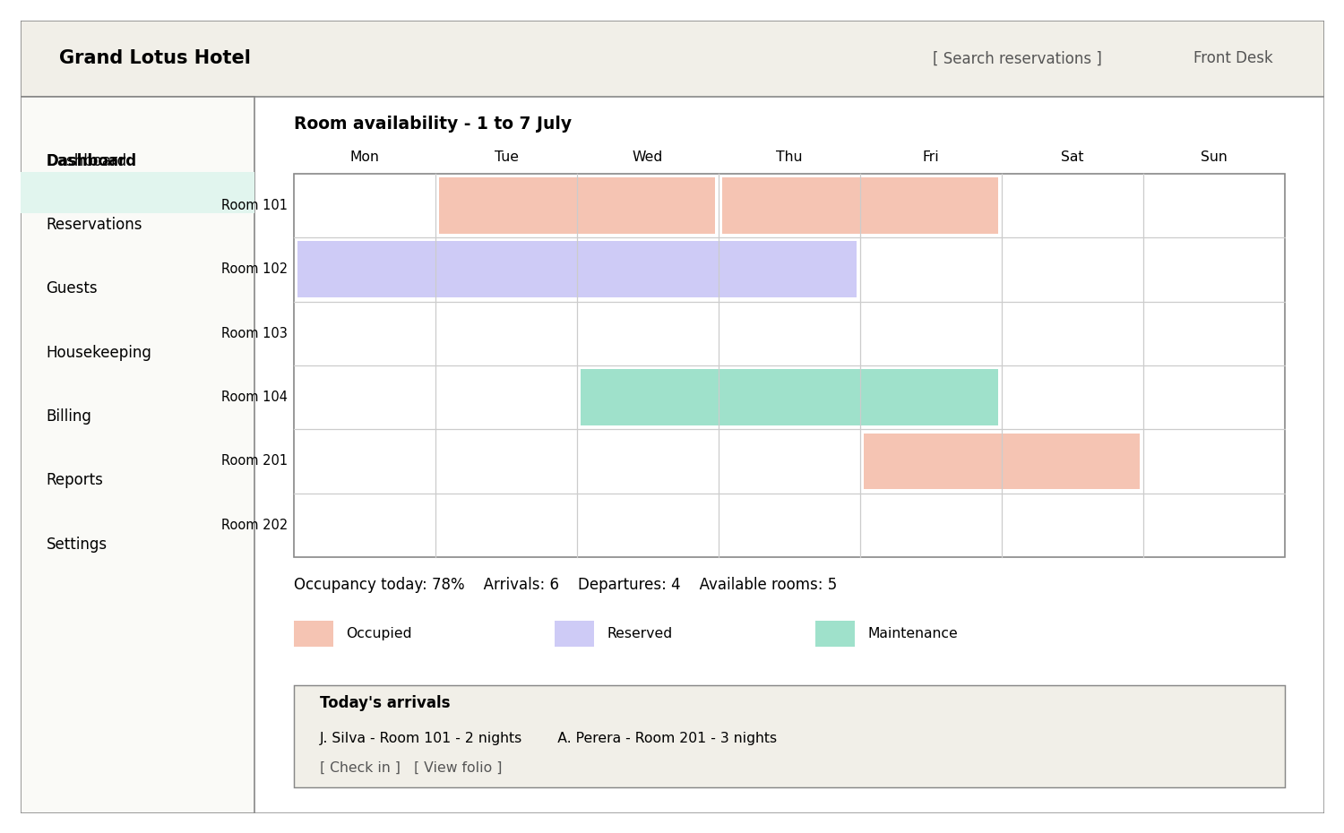
Figure 1: Wireframe – staff dashboard and booking calendar

3.1 Key Interactions
- Clicking an empty cell on the calendar opens a new-booking form pre-filled with that room and date.
- Clicking an occupied/reserved cell opens that reservation's detail and folio.
- Colour coding (occupied, reserved, maintenance) is paired with a text legend to remain usable for colour-blind users.
- Today's arrivals list provides one-click access to “Check in” and “View folio” without navigating away from the dashboard.

4. Key Screen: Guest Booking Widget
The public booking widget is optimised for a guest on a mobile device, arriving from the hotel's website or a marketing link. The flow is intentionally short: search, select, pay.
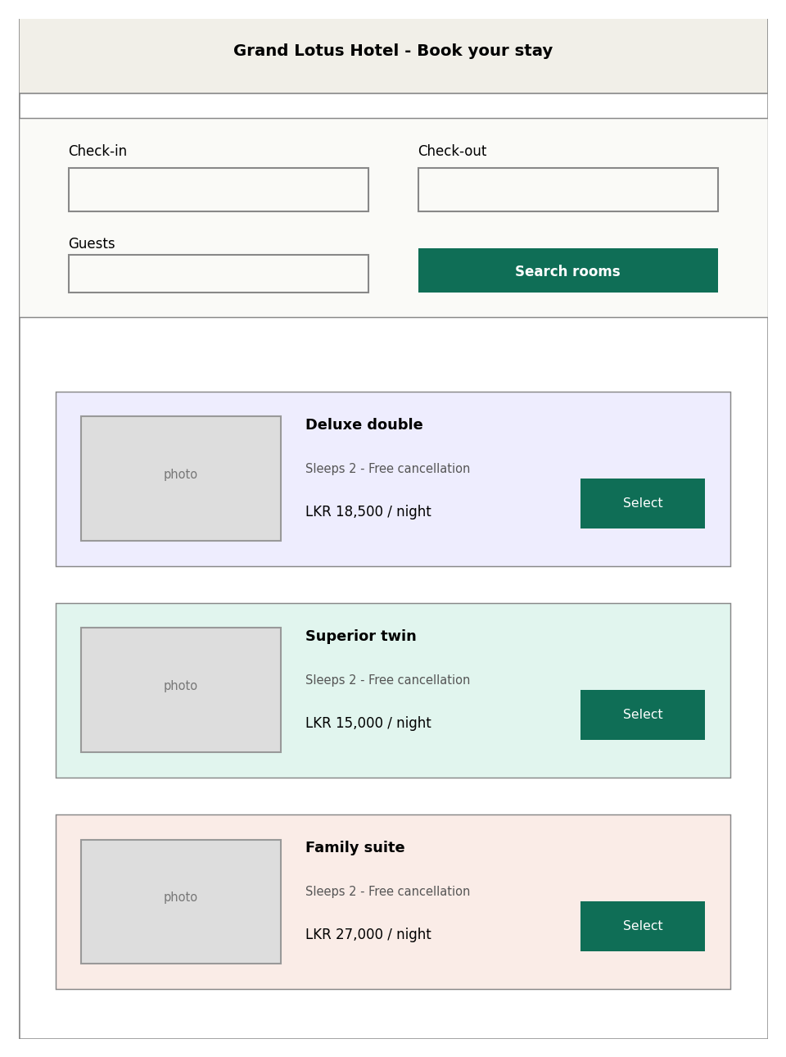
Figure 2: Wireframe – guest-facing booking widget

4.1 Key Interactions
- Date and guest-count fields use native mobile pickers to minimise typing.
- Room results show photo, capacity, cancellation policy, and price up front – the four things a guest needs to decide, with no hidden fees revealed later in the flow.
- “Select” leads directly into a single-page checkout (guest details + payment), avoiding a long multi-step wizard that increases drop-off.
- A confirmation screen and email are shown immediately after successful payment, including a cancellation policy summary.

5. Key Screen: Reservation Folio / Checkout
Used by Front Desk staff throughout a guest's stay to post charges, and at checkout to settle the balance.
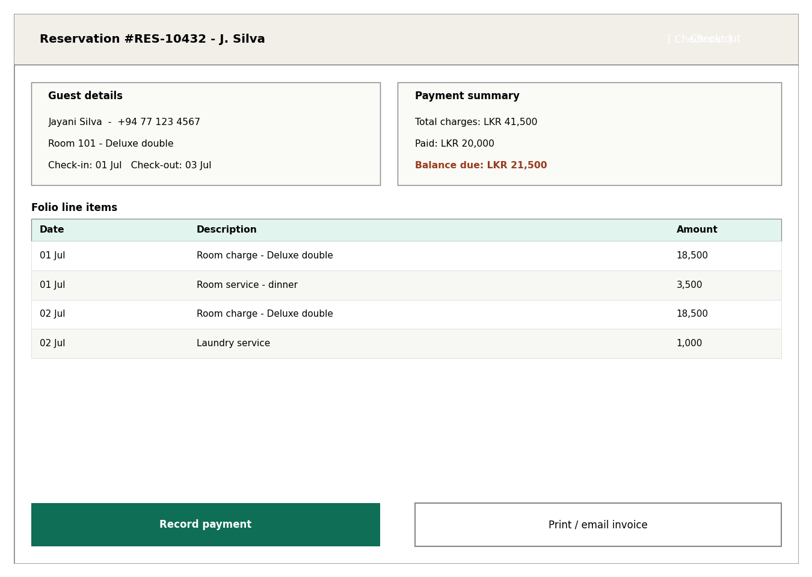
Figure 3: Wireframe – reservation folio and checkout

5.1 Key Interactions
- The outstanding balance is shown prominently in a warning colour whenever it is greater than zero.
- “Check out” is disabled (greyed out) until the balance reaches zero or an authorised override is applied by a Manager, preventing accidental unpaid checkouts.
- “Record payment” opens the payment gateway's hosted payment form as an embedded step, never a custom card-number input field, so card data never touches the HMS UI directly.
- Every folio line item shows which staff member posted it and when, supporting the audit trail requirement.

6. Interaction Flow: End-to-End Guest Stay
- Guest searches and books a room via the booking widget, or a Front Desk agent creates the booking on their behalf.
- On arrival, Front Desk checks the guest in from the Reservations screen; room status updates automatically on the dashboard.
- Charges (room, services) accumulate on the guest's folio throughout the stay, visible in real time to any authorised staff member.
- At departure, Front Desk opens the folio, settles any outstanding balance, and completes checkout.
- Room status automatically flips to “Dirty”, appearing on the Housekeeping board for cleaning.
- Once Housekeeping marks the room “Clean”/“Inspected”, it becomes available again on the booking calendar.

7. Accessibility Considerations
- Minimum 4.5:1 colour contrast for all text, verified against the palette used for status badges.
- All interactive elements reachable and operable via keyboard alone (tab order, visible focus states).
- Status information (room/booking state) conveyed through text labels in addition to colour.
- Form fields include explicit labels (not placeholder-only text) to support screen readers.
- Minimum 44x44px touch targets on the mobile booking widget.

8. Visual Design Guidelines
Element | Guideline
Typography | One primary sans-serif typeface across the product; a maximum of three font sizes per screen
Colour usage | Colour reserved for status/meaning (occupied, available, warning); neutral greys for structure
Spacing | Consistent 8px spacing scale to keep dense data screens (like the calendar) visually organised
Iconography | A single consistent icon set throughout, used to reinforce – never replace – text labels
Branding | Hotel logo and primary brand colour applied to the guest-facing booking widget; the internal staff dashboard uses a neutral, low-distraction theme

9. Usability Testing Plan
Before go-live, the following light-weight usability validation is recommended:
- Walk a Front Desk staff member through a full check-in/checkout cycle using the staging environment, without prior explanation, and observe where they hesitate.
- Time a Housekeeping user updating five room statuses in sequence to confirm the workflow is fast enough for real shift use.
- Complete a full guest booking on a mobile device from start to payment confirmation, checking for any confusing step.
- Collect feedback from the hotel's operations lead on whether the dashboard surfaces the information they actually check first each morning.

