**Report**

2145217

Scientific Programming

1st Semester Academic Year 2019

Topic

Initial aircraft sizing tool

Presents

Asst. Prof. Niphon Wansophark, Ph.D.

By

Mr. Dit Dejphachon

Student ID: 6131765321

**Introduction**

Aircraft design is very complex and convoluted process involved a branch of physics dealing with aerodynamics, performance, and stability and control analysis. This program developed in MATLAB2019b is intended to provide user easy solution for aircraft design process with Constraint Diagram, BHP Requirement Diagram, and BHP Requirement-Normalized to S-L Diagram by simply fill in data.

**Variables**

AR = Aspect ratio

CDTO = Drag coefficient during T-O run

CDmin = Minimum drag coefficient

CLTO = Lift coefficient during T-O run

CLmax = Maximum lift coefficient

e = Oswald efficiency

g = Acceleration due to gravity [ft/s^2]

H = Cruise altitude [ft]

k = Coefficient for lift-induced drag

KCAS = Knots calibrated airspeed [knots]

KTAS = Knots true airspeed [knots]

n = Load factor

PBHP = Power of a piston engine [BHP]

q = Dynamic pressure [lbf/ft^2]

qstall = Dynamic pressure @ stall condition [lbf/ft2]

ROC = Rate of climb [ft/min]

S = Surface area [ft^2]

SG = Ground run [ft]

T = Thrust [lbf]

TtoW = Thrust-to-weight ratio

V = Airspeed [ft/s]

VC = Cruise speed [ft/s]

VLOF = Liftoff speed [ft/s]

Vs = Stall speed [ft/s]

VV = Vertical speed [ft/s]

W = Weight [lbf]

WtoS = Wing loading [lbf/ft^2]

mu = Ground friction constant

eta = Propeller efficiency factor

rho = Density [slugs/ft^3]

**Equations and theories**

**T/W for a Level Constant-velocity Turn**

The following expression is used to determine the T/W ratio required to maintain a speciﬁc banking load factor (n) at a speciﬁc airspeed and altitude, without losing altitude. The expression would be used to determine the required T/W as a function of W/S.

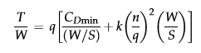

where

CDmin = minimum drag coefﬁcient

k = lift-induced drag constant

q = dynamic pressure at the selected airspeed and altitude (lbf/ft2 or N/m2)

S = wing area (ft2 or m2)

T = thrust (lbf or N)

W = weight (lbf or N)

n = load factor = 1/cos(bank angle)

**T/W for a Desired Rate of Climb**

The following expression is used to determine the T/W required to achieve a given rate of climb. The expression would be used to determine the required T/W as a function of W/S.



where

q = dynamic pressure at the selected airspeed and altitude

V = airspeed

VV = vertical speed

**T/W for a Desired T-O Distance**

The following expression is used to determine the T/W required to achieve a given ground run distance during T-O. The expression would be used to determine the required T/W as a function of W/S.

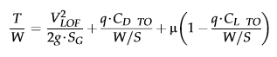

where

CL TO = lift coefﬁcient during T-O run

CD TO = drag coefﬁcient during T-O run

q = dynamic pressure at VLOF/(2)^(1/2) and selected altitude

SG = ground run

VLOF = liftoff speed

m = ground friction constant

g = acceleration due to gravity

**T/W for a Desired Cruise Airspeed**

The following expression is used to determine the T/W required to achieve a given cruising speed at a desired altitude. The expression would be used to determine the required T/W as a function of W/S.



where

q = dynamic pressure at the selected airspeed and altitude

S = wing area

**T/W for a Service Ceiling**

The following expression is used to determine the T/W required to achieve a given service ceiling, assuming it is where the best rate-of-climb of the airplane has dropped to 100 fpm. The expression would be used to determine the required T/W as a function of W/S.

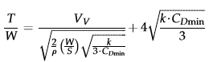

where

rho = air density at the desired altitude.

VV = rate-of-climb = 1.667 ft/s if using the UK-system and 0.508 m/s if using the SI-system

**CLmax for a Desired Stalling Speed**

For this purpose, the maximum lift coefﬁcient can be considered a function of the wing loading, W/S, for a constant dynamic pressure, qstall, using the expression below:



where

q = dynamic pressure at the selected stall speed and altitude

**Additional Notes**

1. Note that when constructing constraint diagrams for propeller aircraft, the analysis is complicated by having to convert the thrust-to-weight ratio to P/W. Such diagrams are far more convenient for propeller-powered aircraft because conventional piston and turboprop engines are rated in terms of horsepower. 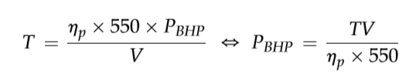
2. **Normalization of thrust and power** Since engine thrust or power depends on altitude, a proper comparison requires a transfer of all altitude characteristics to S-L by following equation

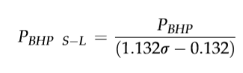

**Program Manual**

**Process Calculator**

1. Open user interface

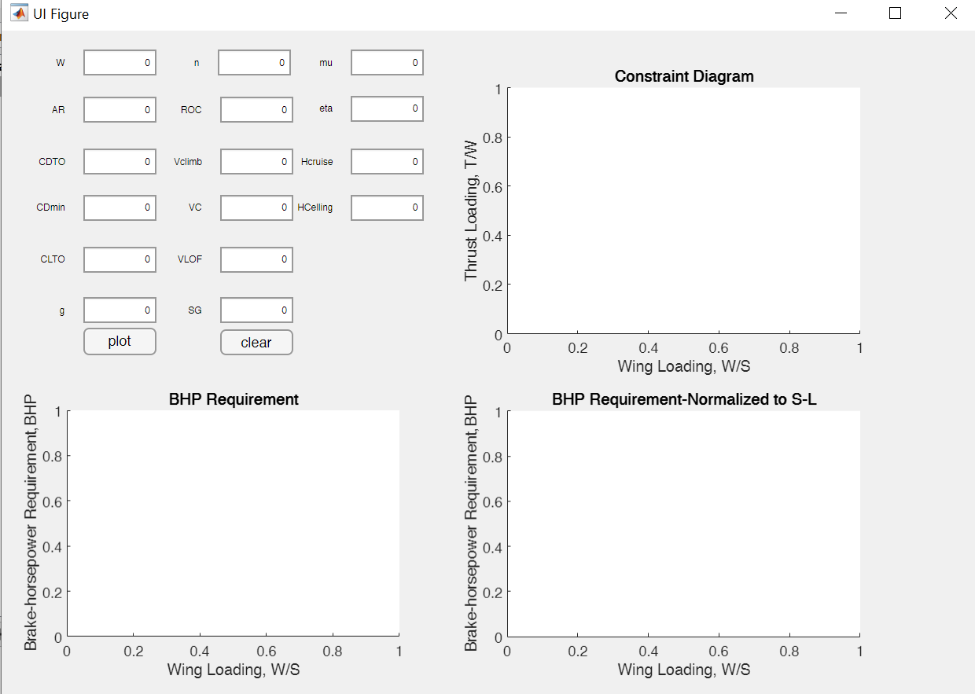

1. Input data

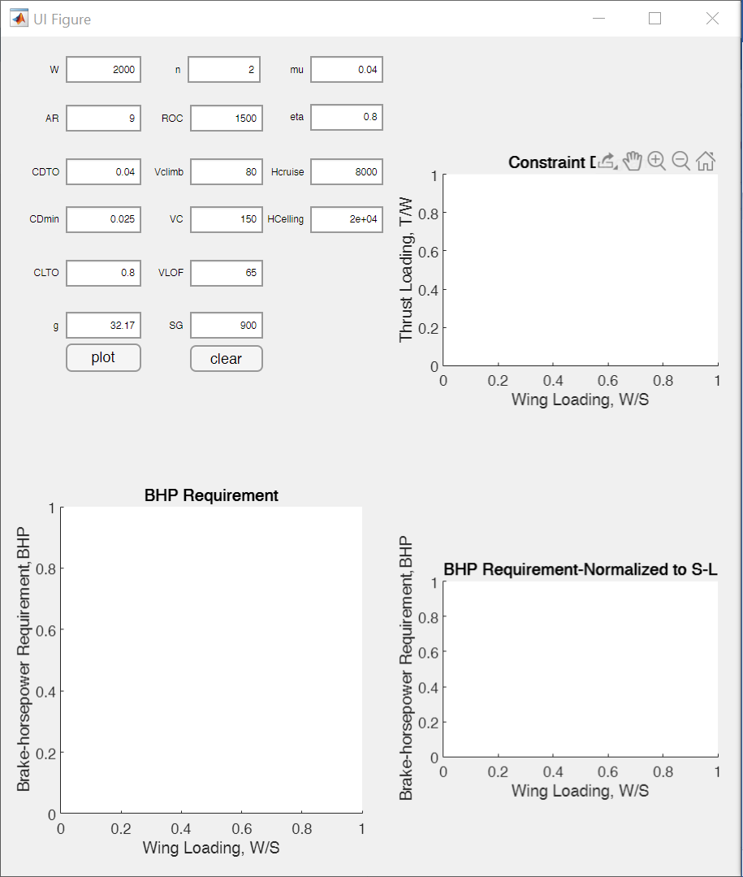

1. Press “plot” button

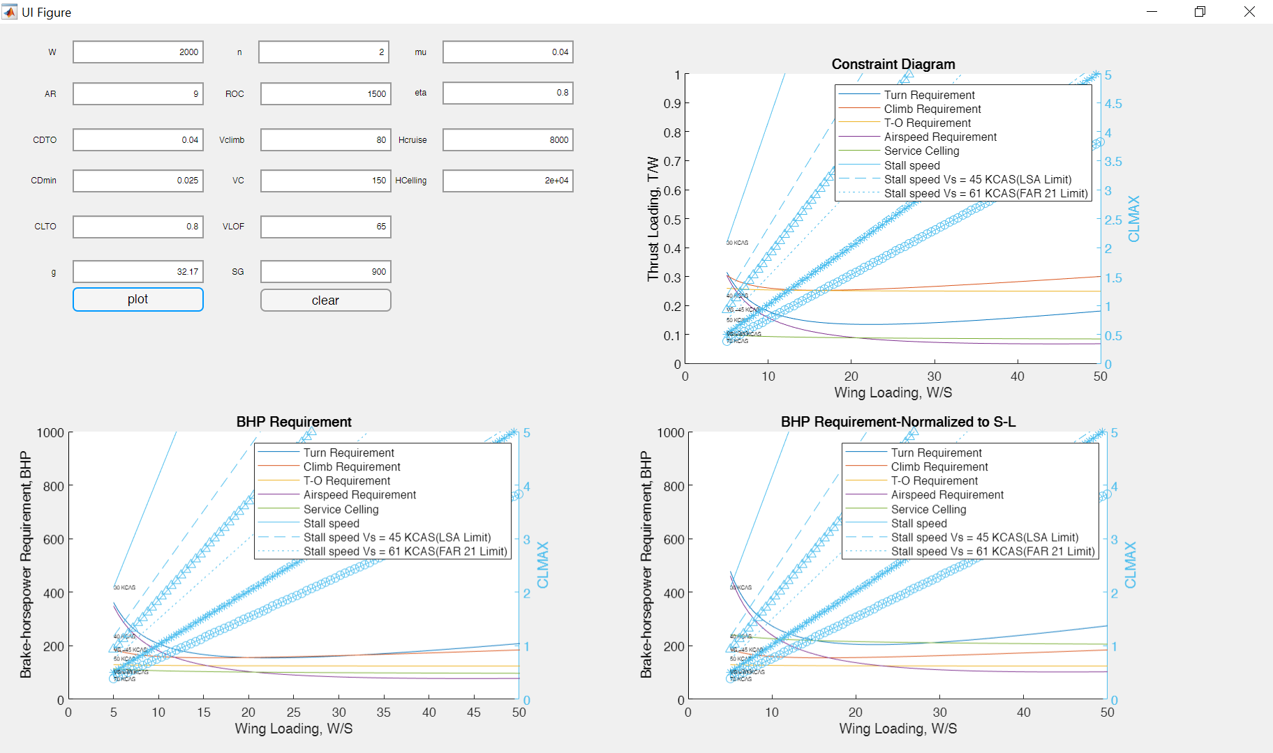

1. clear the data for next input

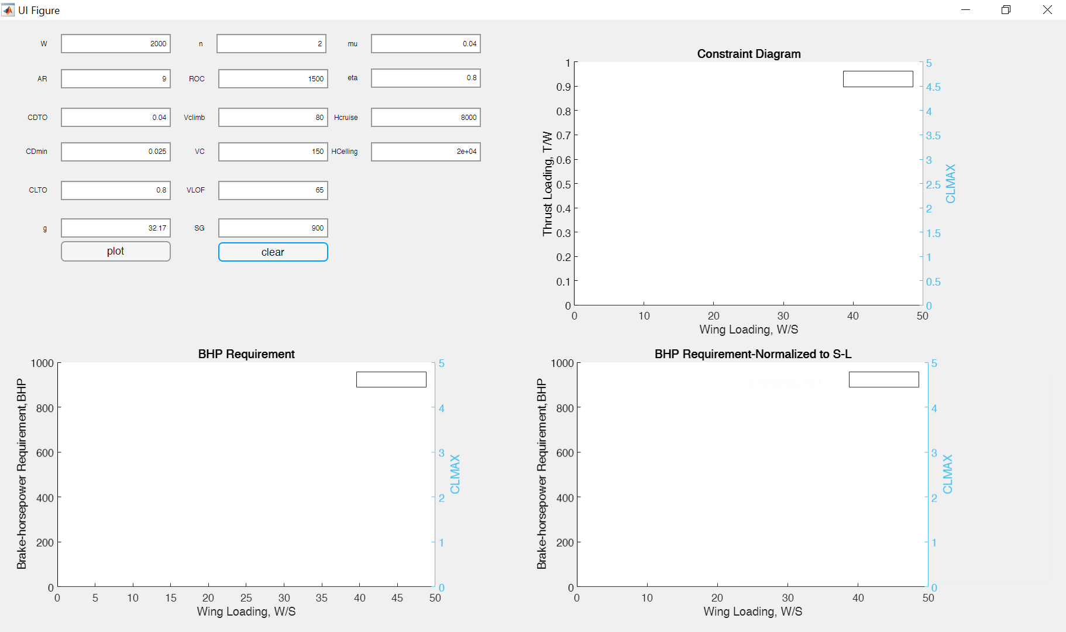

**Original Code**

Variables 1

input data 2

T/W for a Level Constant-velocity Turn 2

T/W for a Desired Rate of Climb 3

T/W for a Desired T-O Distance 4

T/W for a Desired Cruise Airspeed 5

T/W for a Service Ceiling 6

CLmax for a Desired Stalling Speed 7

BHP Requirement 14

BHP Requirement-Normalized to S-L 15

## Variables

%{  
 AR = Aspect ratio  
 CDTO = Drag coefficient during T-O run  
 CDmin = Minimum drag coefficient  
 CLTO = Lift coefficient during T-O run  
 CLmax = Maximum lift coefficient  
 e = Oswald efficiency  
 g = Acceleration due to gravity [ft/s^2]  
 Hcruise = Cruise altitude [ft]  
 HCelling = Celling altitude [ft]  
 k = Coefficient for lift-induced drag  
 KCAS = Knots calibrated airspeed [knots]  
 KTAS = Knots true airspeed [knots]  
 n = Load factor  
 q = Dynamic pressure [lbf/ft^2]  
 qstall = Dynamic pressure @ stall condition [lbf/ft2]  
 ROC = Rate of climb [ft/min]  
 S = Surface area [ft^2]  
 SFC = Specific fuel consumption [lbf/(hr*BHP)]  
 SG = Ground run [ft]  
 T = Thrust [lbf]  
 TtoW = Thrust-to-weight ratio  
 V = Airspeed [ft/s]  
 VC = Cruise speed [ft/s]  
 VLOF = Liftoff speed [ft/s]  
 Vs = Stall speed [ft/s]  
 VV = Vertical speed [ft/s]  
 W = Weight [lbf]  
 WtoS = Wing loading [lbf/ft^2]  
 mu = Ground friction constant  
 eta = Propeller efficiency factor  
 rho = Density [slugs/ft^3]  
%}

## input data

W = 2000; %(lbf)  
 WtoS = linspace(5,58);%(lbf/ft^2)  
 AR = 9;  
 CDTO = 0.04;  
 CDmin = 0.025;  
 CLTO = 0.8;  
 e = 1.78*(1-(0.045*(AR)^0.68))-0.64;  
 g = 32.174; %(ft/s^2)  
 Hcruise = 8000;%(ft)  
 HCelling = 20000;%(ft)  
 k = 1/(pi*AR*e);  
 n = 2; % n=(1/cos(bank angle))  
 ROC = 1500; %(ft/min)  
 Vclimb = 80;%(KCAS)  
 VC = 150;%(KTAS)  
 VLOF = 65;%(KCAS)  
 Vs = 0.3*VC;%(ft/s)  
 VV = ROC/60;%(ft/s)  
 rhoTO = 0.002378; %international standard atmosphere (slugs/ft^3)  
 qcruise = 0.5*rhocal(Hcruise)*(1.688*VC)^2;%(lbf/ft^2)  
 qTO = 0.5*rhoTO*((1.688*VLOF)/(2)^(1/2))^2;%(lbf/ft^2)  
 qclimb = 0.5*rhoTO*(1.688*Vclimb)^2;%(lbf/ft^2)  
 qstall = 0.5*rhocal(Hcruise)*(1.688*Vs)^2;%(lbf/ft^2)  
 SG = 900;%(ft)  
 mu = 0.04;  
 eta = 0.80;  
 CLmax = (1/qstall).*WtoS;

## T/W for a Level Constant-velocity Turn

TtoW = qcruise*((CDmin./WtoS)+(k*(n/qcruise)^2).*(WtoS));  
  
 plot(WtoS,TtoW)  
 title('Constraint Diagram')  
 xlabel('Wing Loading, W/S')  
 ylabel('Thrust Loading, T/W')  
 ylim([0 1])  
 %legend({'Turn Requirement'},'Location','northeast')  
 hold on

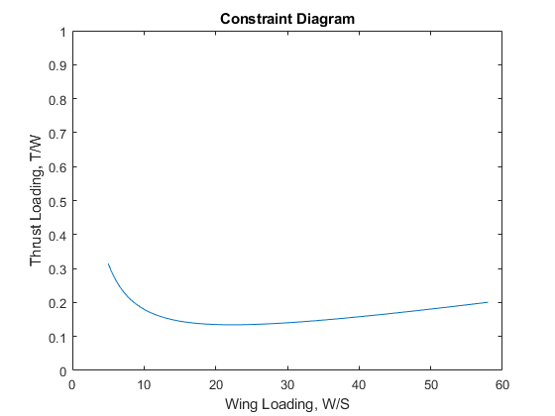

## T/W for a Desired Rate of Climb

TtoW = (VV/(1.688*Vclimb))+((qclimb./WtoS))*CDmin + ((k/qclimb).*WtoS);  
 plot(WtoS,TtoW)  
 %legend({'Turn Requirement','Climb Requirement'},'Location','northeast')  
 hold on

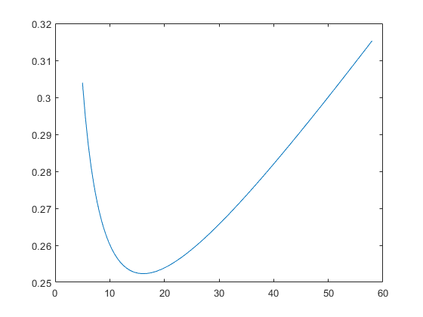

## T/W for a Desired T-O Distance

%disp(qTO)  
 TtoW = (((1.688*VLOF)^2)/(2*g*SG)) + ((qTO*CDTO)./WtoS) + mu.*(1-((qTO*CLTO)./WtoS));  
 plot(WtoS,TtoW)  
 %legend({'Turn Requirement','Climb Requirement','T-O Requirement'},'Location','northeast')  
 hold on

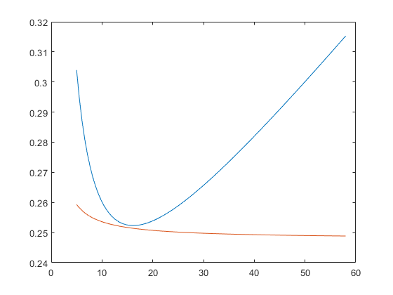

## T/W for a Desired Cruise Airspeed

%disp(qcruise)  
 TtoW = ((qcruise*CDmin)./WtoS) + (k/qcruise).*WtoS;  
 plot(WtoS,TtoW)  
 %legend({'Turn Requirement','Climb Requirement','T-O Requirement','Airspeed Requirement'},'Location','northeast')  
 hold on

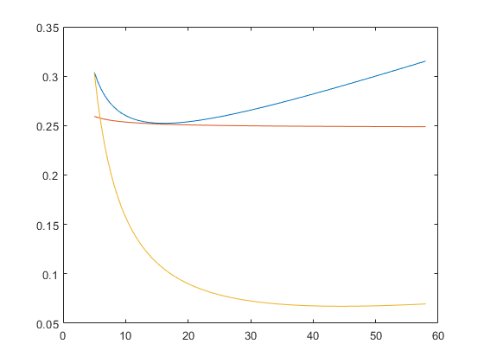

## T/W for a Service Ceiling

%disp(rhocal(HCelling))  
 TtoW = (1.667./((2./rhocal(HCelling)).*WtoS.*(k./(3*CDmin)).^(1/2)).^(1/2)) + 4*((k*CDmin)./3).^(1/2);  
 plot(WtoS,TtoW)  
 %legend({'Turn Requirement','Climb Requirement','T-O Requirement','Airspeed Requirement','Service Celling'},'Location','northeast')  
 hold on  
 %disp(TtoW)

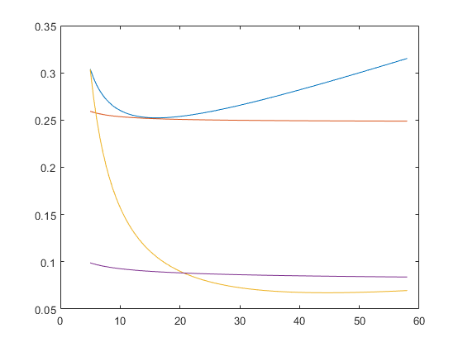

## CLmax for a Desired Stalling Speed

%disp(CLmax)  
 yyaxis right  
 ylim([0 5])  
 for i = 30:10:70  
 qstall = 0.5*rhocal(Hcruise)*(1.688*i)^2;  
 CLmax = (1/qstall).*WtoS;  
 %disp(CLmax)  
 plot(WtoS,CLmax)  
 SlopeBetweenPoints = diff(CLmax)./diff(WtoS);  
 disp(SlopeBetweenPoints)  
 disp(5.*SlopeBetweenPoints(1))  
 %text(1,1,'h');%strcat(int2str(i),' KCAS')  
 text(double(5),double((5.*SlopeBetweenPoints(1))),strcat(int2str(i),' KCAS'),'FontSize', 5)  
 hold on  
 end  
 ylabel('Required CLMAX')  
  
 legend({'Turn Requirement','Climb Requirement','T-O Requirement','Airspeed Requirement','Service Celling','Stall speed'},'Location','northeast')  
 qstall = 0.5*rhocal(Hcruise)*(1.688*Vs)^2;  
 CLmax = (1/qstall).*WtoS;  
 plot(WtoS,CLmax)  
 SlopeBetweenPoints = diff(CLmax)./diff(WtoS);  
 %disp(SlopeBetweenPoints)  
 VsText = strcat('VS = ',mat2str(Vs));  
 text(5,(5.*SlopeBetweenPoints(1)),strcat(VsText,' KCAS'),'FontSize', 5)  
 hold on  
  
 qstall = 0.5*rhocal(Hcruise)*(1.688*61)^2;  
 CLmax = (1/qstall).*WtoS;  
 plot(WtoS,CLmax)  
 SlopeBetweenPoints = diff(CLmax)./diff(WtoS);  
 %disp(SlopeBetweenPoints)  
 text(5,(5.*SlopeBetweenPoints(1)),'VS = 61 KCAS','FontSize',5) %FAR 23 limit  
 hold on  
 legend({'Turn Requirement','Climb Requirement','T-O Requirement','Airspeed Requirement','Service Celling','Stall speed','Stall speed Vs = 45 KCAS(LSA Limit)','Stall speed Vs = 61 KCAS(FAR 21 Limit)'},'Location','northeast')  
 hold off  
 figure

## BHP Requirement

TtoW = qcruise*((CDmin./WtoS)+(k*(n/qcruise)^2).*(WtoS));  
 PBHP = (TtoW.*W.*1.688*VC)./(eta.*550);  
 disp(PBHP)  
 plot(WtoS,PBHP)  
 title('BHP Requirement')  
 xlabel('Wing Loading, W/S')  
 ylabel('Brake-horsepower Requirement,BHP')  
 ylim([0 400])  
 %legend({'Turn Requirement'},'Location','northeast')  
 hold on  
  
 TtoW = (VV/(1.688*Vclimb))+((qclimb./WtoS))*CDmin + ((k/qclimb).*WtoS);  
 PBHP = (TtoW.*W.*1.688*Vclimb)./(eta.*550);  
 plot(WtoS,PBHP)  
 %legend({'Turn Requirement','Climb Requirement'},'Location','northeast')  
 hold on  
  
 TtoW = (((1.688*VLOF)^2)/(2*g*SG)) + ((qTO*CDTO)./WtoS) + mu.*(1-((qTO*CLTO)./WtoS));  
 PBHP = (TtoW.*W.*1.688*VLOF)./(eta.*550);  
 plot(WtoS,PBHP)  
 %legend({'Turn Requirement','Climb Requirement','T-O Requirement'},'Location','northeast')  
 hold on  
  
 TtoW = ((qcruise*CDmin)./WtoS) + (k/qcruise).*WtoS;  
 PBHP = (TtoW.*W.*1.688*VC)./(eta.*550);  
 plot(WtoS,PBHP)  
 %legend({'Turn Requirement','Climb Requirement','T-O Requirement','Airspeed Requirement'},'Location','northeast')  
 hold on  
  
 TtoW = (1.667./((2./rhocal(HCelling)).*WtoS.*(k./(3*CDmin)).^(1/2)).^(1/2)) + 4*((k*CDmin)./3).^(1/2);  
 PBHP = (TtoW.*W.*1.688*VC)./(eta.*550);  
 plot(WtoS,PBHP)  
 %legend({'Turn Requirement','Climb Requirement','T-O Requirement','Airspeed Requirement','Service Celling'},'Location','northeast')  
 hold on  
  
 yyaxis right  
 ylim([0 5])  
 for i = 30:10:70  
 qstall = 0.5*rhocal(Hcruise)*(1.688*i)^2;  
 CLmax = (1/qstall).*WtoS;  
 plot(WtoS,CLmax)  
 SlopeBetweenPoints = diff(CLmax)./diff(WtoS);  
 disp(SlopeBetweenPoints)  
 text(5,(5.*SlopeBetweenPoints(1)),strcat(int2str(i),' KCAS'),'FontSize', 5)  
 hold on  
 end  
 ylabel('Required CLMAX')  
  
 legend({'Turn Requirement','Climb Requirement','T-O Requirement','Airspeed Requirement','Service Celling','Stall speed'},'Location','northeast')  
  
 qstall = 0.5*rhocal(Hcruise)*(1.688*Vs)^2;  
 CLmax = (1/qstall).*WtoS;  
 plot(WtoS,CLmax)  
 SlopeBetweenPoints = diff(CLmax)./diff(WtoS);  
 disp(SlopeBetweenPoints)  
  
 VsText = strcat('VS = ',mat2str(Vs));  
 text(5,(5.*SlopeBetweenPoints(1)),strcat(VsText,' KCAS'),'FontSize', 5)  
  
 hold on  
  
 qstall = 0.5*rhocal(Hcruise)*(1.688*61)^2;  
 CLmax = (1/qstall).*WtoS;  
 plot(WtoS,CLmax)  
 SlopeBetweenPoints = diff(CLmax)./diff(WtoS);  
 %disp(SlopeBetweenPoints)  
 text(5,(5.*SlopeBetweenPoints(1)),'VS = 61 KCAS','FontSize',5) %FAR 23 limit  
 hold on  
 legend({'Turn Requirement','Climb Requirement','T-O Requirement','Airspeed Requirement','Service Celling','Stall speed','Stall speed Vs = 45 KCAS(LSA Limit)','Stall speed Vs = 61 KCAS(FAR 21 Limit)'},'Location','northeast')  
 hold off  
 figure

## BHP Requirement-Normalized to S-L

TtoW = qcruise*((CDmin./WtoS)+(k*(n/qcruise)^2).*(WtoS));  
 PBHP = (TtoW.*W.*1.688*VC)./(eta.*550);  
 PBHPSL = PBHP/(1.132*(rhocal(Hcruise)/rhoTO)-0.132);  
 fprintf('PBHPSL is %f',PBHPSL)  
  
 plot(WtoS,PBHPSL)  
 title('BHP Requirement-Normalized to S-L')  
 xlabel('Wing Loading, W/S')  
 ylabel('Brake-horsepower Requirement,BHP')  
 ylim([0 400])  
 %legend({'Turn Requirement'},'Location','northeast')  
 hold on  
  
 TtoW = (VV/(1.688*Vclimb))+((qclimb./WtoS))*CDmin + ((k/qclimb).*WtoS);  
 PBHP = (TtoW.*W.*1.688*Vclimb)./(eta.*550);  
 PBHPSL = PBHP/(1.132*(rhoTO/rhoTO)-0.132);  
 plot(WtoS,PBHPSL)  
 %legend({'Turn Requirement','Climb Requirement'},'Location','northeast')  
 hold on  
  
 TtoW = (((1.688*VLOF)^2)/(2*g*SG)) + ((qTO*CDTO)./WtoS) + mu.*(1-((qTO*CLTO)./WtoS));  
 PBHP = (TtoW.*W.*1.688*VLOF)./(eta.*550);  
 PBHPSL = PBHP/(1.132*(rhoTO/rhoTO)-0.132);  
 plot(WtoS,PBHPSL)  
 %legend({'Turn Requirement','Climb Requirement','T-O Requirement'},'Location','northeast')  
 hold on  
  
 TtoW = ((qcruise*CDmin)./WtoS) + (k/qcruise).*WtoS;  
 PBHP = (TtoW.*W.*1.688*VC)./(eta.*550);  
 PBHPSL = PBHP/(1.132*(rhocal(Hcruise)/rhoTO)-0.132);  
 plot(WtoS,PBHPSL)  
 %legend({'Turn Requirement','Climb Requirement','T-O Requirement','Airspeed Requirement'},'Location','northeast')  
 hold on  
  
 TtoW = (1.667./((2./rhocal(HCelling)).*WtoS.*(k./(3*CDmin)).^(1/2)).^(1/2)) + 4*((k*CDmin)./3).^(1/2);  
 PBHP = (TtoW.*W.*1.688*VC)./(eta.*550);  
 PBHPSL = PBHP/(1.132*(rhocal(HCelling)/rhoTO)-0.132);  
 plot(WtoS,PBHPSL)  
 %legend({'Turn Requirement','Climb Requirement','T-O Requirement','Airspeed Requirement','Service Celling'},'Location','northeast')  
 hold on  
  
 yyaxis right  
 ylim([0 5])  
 for i = 30:10:70  
 qstall = 0.5*rhocal(Hcruise)*(1.688*i)^2;  
 CLmax = (1/qstall).*WtoS;  
 plot(WtoS,CLmax)  
 SlopeBetweenPoints = diff(CLmax)./diff(WtoS);  
 disp(SlopeBetweenPoints)  
 text(5,(5.*SlopeBetweenPoints(1)),strcat(int2str(i),' KCAS'),'FontSize', 5)  
 hold on  
 end  
 ylabel('Required CLMAX')  
  
 legend({'Turn Requirement','Climb Requirement','T-O Requirement','Airspeed Requirement','Service Celling','Stall speed'},'Location','northeast')  
  
 qstall = 0.5*rhocal(Hcruise)*(1.688*Vs)^2;  
 CLmax = (1/qstall).*WtoS;  
 plot(WtoS,CLmax)  
 SlopeBetweenPoints = diff(CLmax)./diff(WtoS);  
 disp(SlopeBetweenPoints)  
  
 VsText = strcat('VS = ',mat2str(Vs));  
 text(5,(5.*SlopeBetweenPoints(1)),strcat(VsText,' KCAS'),'FontSize', 5)  
  
 hold on  
  
 legend({'Turn Requirement','Climb Requirement','T-O Requirement','Airspeed Requirement','Service Celling','Stall speed','Stall speed Vs = 45 KCAS(LSA Limit)'},'Location','northeast')  
  
 qstall = 0.5*rhocal(Hcruise)*(1.688*61)^2;  
 CLmax = (1/qstall).*WtoS;  
 plot(WtoS,CLmax)  
 SlopeBetweenPoints = diff(CLmax)./diff(WtoS);  
 %disp(SlopeBetweenPoints)  
 text(5,(5.*SlopeBetweenPoints(1)),'VS = 61 KCAS','FontSize',5) %FAR 23 limit  
 hold on  
 legend({'Turn Requirement','Climb Requirement','T-O Requirement','Airspeed Requirement','Service Celling','Stall speed','Stall speed Vs = 45 KCAS(LSA Limit)','Stall speed Vs = 61 KCAS(FAR 21 Limit)'},'Location','northeast')  
 hold off

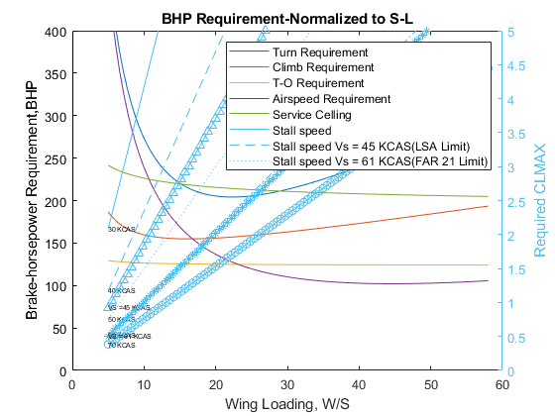

[*Published with MATLAB® R2019b*](https://www.mathworks.com/products/matlab)