**GSWC 2014**

Proceedings of

The 9th Annual Graduate Student Workshop on Computing

October 10th 2014

Santa Barbara, California

http://gswc.cs.ucsb.edu



Department of Computer Science

University of California, Santa Barbara

**Organized By**

Alexander Pucher, Chair

Vaibhav Arora, Vice-chair

Nevena Golubović, Industry Liaison

Xiaofei Du, Industry Liaison

Cetin Sahin, Financial Coordinator

Hiranya Jayathilaka, Proceedings Coordinator

Stratos Dimopoulos, Website Coordinator

Program Committee

Kevin Borgolte

Victor Fragoso

Yanick Fratantonio

Madhukar Kedlaya

Ana Nika

Divya Sambasivan

Saiph Savage

Paul Schmitt

Morgan Vigil

**Platinum Partners**





**Silver Partners**



**Bronze Partners**



**Keynote Speech**

**Title**

Google Cloud Platform, IoT, and Beyond

**Abstract**

Ok, so you've got a few billion sensors, a few trillion rows, and no matter how you try, it just doesn't seem to fit in your spreadsheet. Google is doing this today. Join us to take a look under the hood at the new tools, methods, and results for folks pushing the state of the art in IoT in the cloud.

**About the Speaker**

**Miles Ward** is a three-time technology startup entrepreneur with a decade of experience building cloud infrastructures. Miles is Global Head of Solutions for the Google Cloud Platform; focused on delivering next-generation solutions to challenges in big data and analytics, multi-tiered storage, high-availability, and cost optimization.  He worked as a core part of the Obama for America 2012 “tech” team, crashed Twitter a few times, helped NASA stream the Curiosity Mars Rover landing, and plays electric sousaphone in a funk band.

**Panel Discussion**

**Title**

Building an Internet of Things for Humans

**Abstract**

The Internet of Things (IoT) is expected to connect 50 billion devices to the Internet by 2020! Sensors and actuators will be everywhere including streets, farmlands, enterprises, households, cars, and even on our bodies. In this panel discussion we will try to understand what IoT is, how it affects the software industry, and the skillset that new computer science graduates should possess to cope with it. We will also discuss the challenges, opportunities and risks IoT introduces, along with the new areas of research that it opens up.

**Panelists**

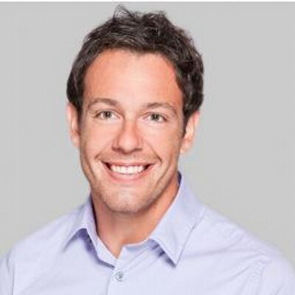**Luca Foschini** is a co-founder and data scientist at The Activity Exchange, a platform that uses data analytics on people's activities to incentivize healthy behavior. Luca earned a Ph.D. in Computer Science from UC Santa Barbara where he developed efficient algorithms for routing in road networks under heavy traffic conditions. He also holds a Master in Engineering from the University of Pisa, and is an alumnus of the Sant'Anna School of Advanced Studies. In a previous life, Luca accumulated 5 years of industry experience at Ask.com, Google, and the CERN, and was a coach of the Italian national team participating in the International Olympiad in Informatics (IOI).

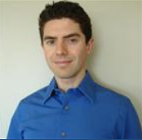**Hagen Green** is a Program Manager Lead at Microsoft on the Windows Shell Experiences team. Previously, he was a Test Lead in Office on SharePoint. Hagen holds several patents, written several technical articles, contributed to a book, and authored a book. In his spare time, Hagen enjoys the great Northwest by cycling, running, skiing, and backpacking. When he’s not outside, he’s reading, tinkering with technology, or spending time with his wife Jaime and their 15 month old son Nolan. Hagen holds a B.S. in Computer Science from UC Santa Barbara.

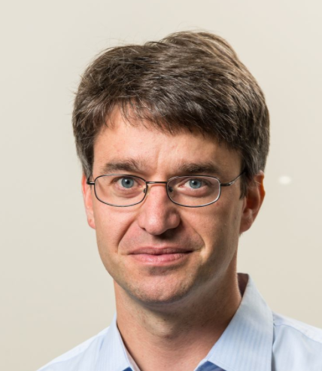**Christopher Kruegel** is the co-founder of Lastline, Inc., where he currently serves as the Chief Scientist. He is also a Professor in the Computer Science Department at the UC Santa Barbara. His research interests are computer and communications security, with an emphasis on malware analysis and detection, web security, and intrusion detection. Christopher enjoys to build systems and to make security tools available to the public. He has published more than 100 conference and journal papers. Christopher is a recent recipient of the NSF CAREER Award, the MIT Technology Review TR35 Award for young innovators, an IBM Faculty Award and several best paper awards. Moreover, he served as an associate editor for several journals and on program committees of leading computer security conferences.

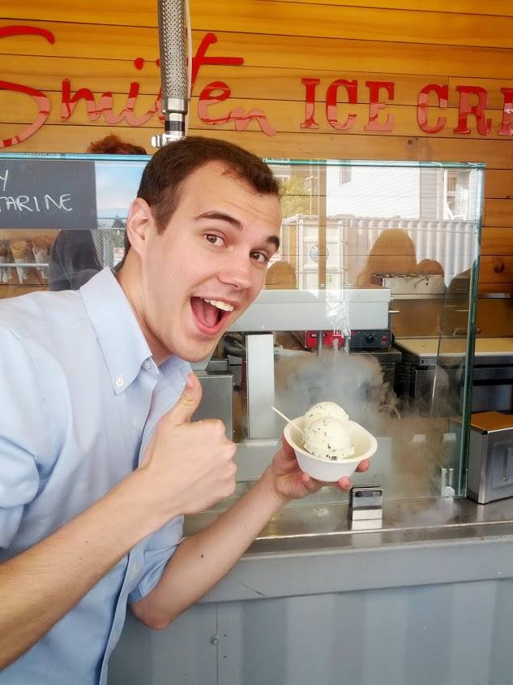**Charles Munger** is an alumnus of UCSB, having completed the 5 year BS/MS program in 2013. He is currently a software engineer for Google, working on frameworks and analysis/build tools for first party android apps.

**Andrew Mutz** is Chief Scientist at Appfolio, a Santa Barbara company focused on creating easy-to-use, web-based software that helps small and mid-sized businesses more effectively market, manage and grow their business.  Before joining Appfolio, Andrew completed his PhD in Computer Science at UC Santa Barbara.  Prior to his PhD, Andrew worked as a Software Engineer at Expertcity (now Citrix Online).

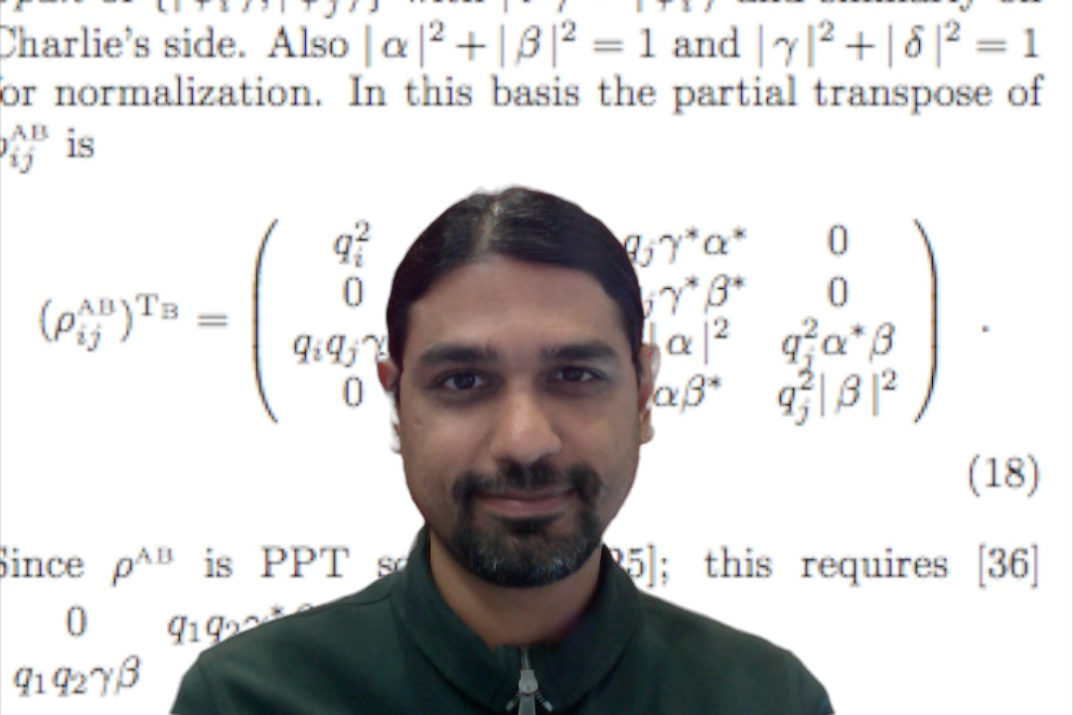

**Ashish Thapliyal** is a Principal Research Engineer at Citrix.  He is interested in applying Summarization, Text Analytics and Machine learning to the real world.  Previously, he was VP of Engineering at Lastline, and he has almost a decade of experience designing security for key Citrix Collaboration products. Before that he was a Postdoctoral Researcher at the Computer Science Department at UC Berkeley, and a Student Researcher at IBM T.J. Watson Research Center. His academic research in Quantum Entanglement and Information Theory produced more than 10 peer-reviewed publications. He has two patents and 10+ applications pending. Ashish has an MS in Computer Science, and a PhD in Physics from UCSB.

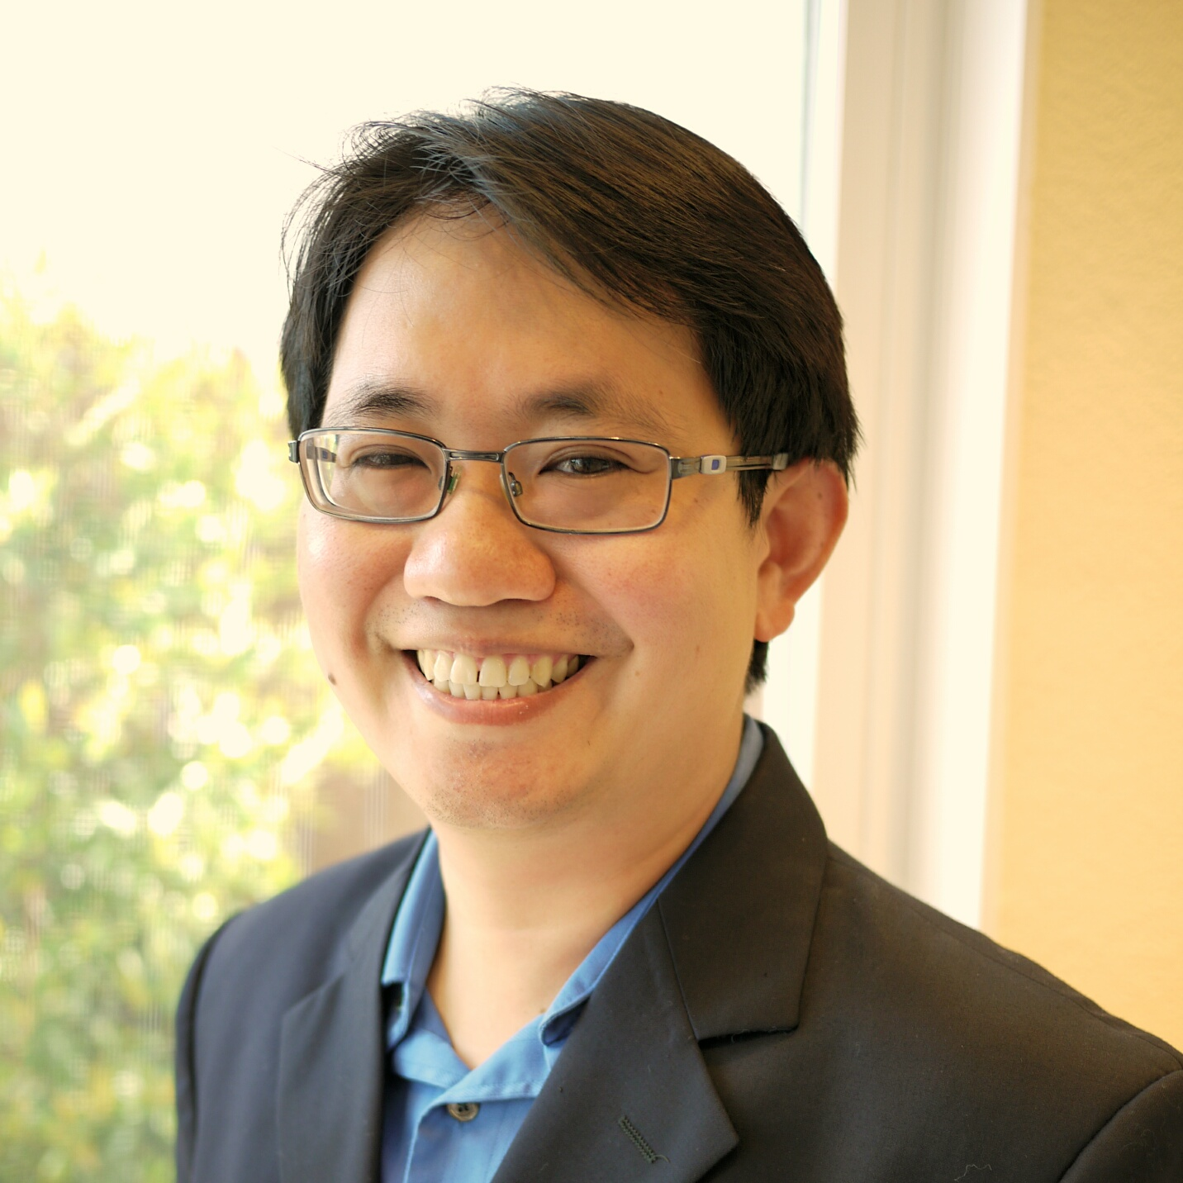**Peerapol Tinnakornsrisuphap** is the systems engineering lead for Connected Home R&D in Qualcomm Research. His team has addressed many critical issues facing Internet of Things including low power protocol optimization, security and provisioning, multi-hop and mesh networking, proximal services discovery, and smart energy management. He received Ph.D. in Electrical Engineering from University of Maryland and holds 34 US Patents.

**Table of Contents**

Session 1: Above the Clouds

GNSS Positioning Improvement and 3D Mapping Using Crowdsources Satellite SNR Measurements - A. Irish, D. Iland, J. Isaacs, E. Belding, J. Hespanha, U. Madhow 8

A Shared Log Storage for Applications Running on the Cloud - F. Nawab, V. Arora, D. Agrawal, A. Abbadi 10

EAGER: API Governance for Modern PaaS Clouds - H. Jayathilaka, C. Krintz, R. Wolski 12

Efficient Sparse Matrix-Matrix Multiplication on Multicore Architectures - A. Lugowski, J. Gilbert 14

Session 2: Automated Testing and Verification

Fuzz Testing using Constraint Logic Programming - K. Dewey, J. Roesch, B. Hardekopf 16

Automated Test Generation from Vulnerability Signatures - A. Aydin, M. Alkhalaf, T. Bultan 18

Coexecutability: How to Automatically Verify Loops - I. Bocić, T. Bultan 20

Code-specific, Sensitive, and Configurable Plagiarism Detection - K. Dewey, B. Hardekopf 22

Session 3: Social Networking and Graph Mining

Analyzing Expert Behaviors in Collaborative Networks - H. Sun, M. Srivatsa, S. Tan, Y. Li, L. Kaplan, S. Tao, X. Yan 24

SLQ: A User-friendly Graph Queuing System - S. Yang, Y. Wu, H. Sun, X. Yan 26

Advocacy Citizen Journalism and their Participatory Audience - S. Savage, A. Monroy-Hernandez 28

Posters

Collaborative Interfaces for Designing Optical Fiber Networks - H. Leon, J. Cruz, S. Savage, N. Chavez, T. Hollerer 30

Comparing Different Cycle Bases for a Laplacian Solver - E. Boman, K. Deweese, J. Gilbert 32

Assailed: A Story Illustration Algorithm to Generate a Data Structure Connecting Content,

Art and Object - C. Segal, J. McMahan 34

Towards Real-time Spectrum Monitoring - A. Nika, Z. Zhang, X. Zhou, B. Zhao, H. Zheng 36