Feasibility Evidence Description (FED)

SnapValet

Team 03

Team members

Brain Vanover: Project Manager, Feasibility Analyst
Abhinandan Patni: Operations Concept Engineer, Prototyper
Xiaoting Bi: Feasibility Analyst, Prototyper
Ditong Ding: System Architect, UML Modeler
Ridhima Manjrekar: Requirements Engineer, Prototyper
Saikarthik Desiraju: Life Cycle Planner, Prototyper
Molly Karcher: IIV&V, Quality Focal Point

10/11/14

Version History
Date | Author | Version | Changes made | Rationale
09/28/14 | Xiaoting Bi | 1.0 | - Original template v1.0 | - Initial draft of Feasibility Evidence Description (FED)
10/11/14 | Xiaoting Bi | 2.0 | - Draft FC Package | - All sections till section 5 are updated.

Table of Contents
Feasibility Evidence Description (FED) i
Version History ii
Table of Contents iii
Table of Tables iv
Table of Figures v
1. Introduction 1
1.1 Purpose of the FED Document 1
1.2 Status of the FED Document 1
2. Business Case Analysis 2
2.1 Cost Analysis 3
2.2 Benefit Analysis 3
2.3 ROI Analysis 4
3. Architecture Feasibility 5
3.1 Level of Service Feasibility 5
3.2 Capability Feasibility 5
3.3 Evolutionary Feasibility 6
4. Process Feasibility 7
5. Risk Assessment 8
6. NDI/NCS Interoperability Analysis 9
6.1 Introduction 9
6.2 Evaluation Summary 9

Table of Tables
Table 1: Personnel Costs 3
Table 2: Hardware and Software Costs 3
Table 3: Benefits of xxx System 3
Table 4: ROI Analysis 4
Table 5: Level of Service Feasibility 5
Table 6: Capability Requirements and Their Feasibility Evidence 5
Table 7: Evolutionary Requirements and Their Feasibility Evidence 6
Table 8: Rationales for Selecting Architected Agile Model 7
Table 9: Risk Assessment 8
Table 10: NDI Products Listing 9
Table 11: NDI Evaluation 9

Table of Figures
Figure 1: ROI Analysis Graph 4

Introduction

Purpose of the FED Document
The document provides necessary feasibility analysis for the SnapValet project. It reports the evidence of project feasibility in term of business case analysis and risk assessment.

Status of the FED Document
- This version corresponds to the Draft FC Package.
- The propose and status of FED have been added.
- Cost analysis, benefits analysis and Return-on-Investment analysis are performed and added.

Business Case Analysis

Assumptions
- Users/Drivers prefer using mobile payment over a cash transaction.
- People trust mobile payment systems.
- Valet companies prefer mobile payments over cash transactions.
- There isn’t already a similar competitive functionality in other existing applications.
- SnapValet indeed speeds up facilitation of valet service.
- A noteworthy amount of customers often do not carry cash for valet.
- Our users would rather prefer using an android phone over other platforms.
Stakeholders | Initiatives | Value Propositions | Beneficiaries
- SnapValet  - Developers | - Develop system  - Direct sales  - Network  Conference / trade shows  - Market campaign  End user: social media | - To speed up the process of valet  - Improve cashless valet experience for customers.  - Expand potential customer base for valet.  - Better valet account / transaction management.  - Enable direct advertising.  - Increase revenue / profits. | - Drivers / users  - SnapValet clients  - Valet companies  Restaurants  Hotels  - Sponsors/investors
Cost  - Time.  - Marketing Costs.  - Maintenance Costs.  - Team building.  - Infrastructure:  Web server,  Third party transaction management. |  | Benefits  - A faster, more convenient way to valet park.  - Increase market share to include non cash-carrying customers.  - 3% revenue / transaction.  - Prestige for developing a successful, popular mobile app.  - A reputable grade in CSCI 577a.  - Experience developing mobile apps.  - Experience working with a highly diverse, interdisciplinary team.

Cost Analysis

Personnel Costs
Table 1: Personnel Costs
Activities | Time Spent (Hours)
Development Period (12 weeks)
Valuation and Foundations Phases: Time Invested (6 weeks)
Client: Meeting via email, phone, and other channels [2 hrs/week * 6 weeks * 2 people] | 24
Group: Meeting via email, phone, and other channels [3 hrs/week *6 weeks * 7 people] | 126
Architecture Review Boards [1.5 hrs * 2 times * 2 people] | 6
Development and Operation Phases: Time Invested (6 weeks)
Client: Meeting via email, phone, and other channels [2 hrs/week * 6 weeks * 2 people] | 24
Maintainer: Meeting via email, phone, and other channels [3 hrs/week * 6 weeks * 2 people] | 36
Architecture Review Boards and Core Capability Drive-through session [1.5 hrs * 6 weeks * 2 people] | 6
Group: Meeting via email, phone, and other channels [3 hrs/week *6 weeks * 7 people] | 126
Deployment of system in operation phase and training  - Installation & Deployment [1 hrs * 1 times * 2 people]  - Training & Support [1 hrs * 2 times * 2 people] | 6
Total | 354
Maintenance Period (1 year)
Maintenance [2 hr/week * 52 weeks * 1 people] | 104

Hardware and Software Costs
Table 2: Hardware and Software Costs
Type | Cost | Rationale
Hardware – Server | $3,000 | A new machine is needed to act as a web server for the system.

Benefit Analysis
Table 3: Benefits of xxx System
Current activities & resources used | % Reduce | Time Saved (Hours/Year)
Giving a car to a valet operator
Driver (60 times * 30 mins/time = 1800mins) | 83.3 | 25
Picking a car
Driver (60 times * 20 mins/time = 1200mins) | 75 | 15
Payment
Valet operator (3 mins/time * 5000 times = 15000 mins) | 66.7 | 200
Driver (3 mins/time * 60 times = 300 mins) | 66.7 | 3
Total |  | 243

ROI Analysis
Table 4: ROI Analysis
Year | Cost | Benefit  (Effort Saved) | Cumulative Cost | Cumulative Benefit | ROI
2014 | 354 | 0 | 354 | 0 | -1
2015 | 104 | 243 | 458 | 243 | -0.47
2016 | 114 | 243 | 572 | 486 | -0.15
2017 | 126 | 243 | 698 | 729 | 0.04
2018 | 139 | 243 | 837 | 972 | 0.16
Figure 1: ROI Analysis Graph
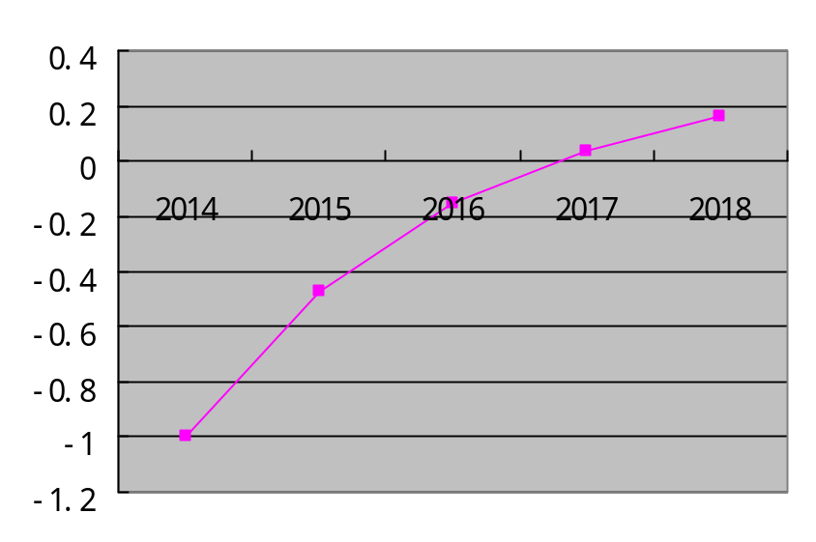

Architecture Feasibility

Level of Service Feasibility
Table 5: Level of Service Feasibility
Level of Service Requirement | Product Satisfaction
LOS-1: Usability | Product Strategies: Develop a simple user interface.
LOS-1: Usability | Process Strategies: Test the usability by prototyping and user involvement.
LOS-1: Usability | Analysis: By prototyping and user involvement, we can make sure the interface is simple and easy to use for drivers.
LOS-2: Payment Security | Product Strategies: Usage of third party online money transaction system — Stripe.
LOS-2: Payment Security | Process Strategies: Thorough testing of all use cases through the usage of Stripe.
LOS-2: Payment Security | Analysis: Stripe provides a set of APIs and tools that enables businesses to accept and manage online payments.

Capability Feasibility
Table 6: Capability Requirements and Their Feasibility Evidence
Capability Requirement | Product Satisfaction
CR-1: Check in location | Software/Technology used: Google Map API
CR-1: Check in location | Feasibility Evidence: Location check-in is prototyped. User is able to choose a location and check in on Google Map
CR-1: Check in location | Referred use case diagram: UC-2: Valet Process
CR-2: Request a car | Software/Technology used: MySQL
CR-2: Request a car | Feasibility Evidence: Requesting is prototyped. There is a car retrieval queue and when a driver requests a car, this request will be added to the request queue.
CR-2: Request a car | Referred use case diagram: UC-2: Valet Process
CR-3: Payment via mobile phone | Software/Technology used: Stripe API, MySQL
 | Feasibility Evidence: The transaction will be implemented via Stripe API and all the transaction details will be stored in the MySQL database.
 | Referred use case diagram: UC-2: Valet Process
CR-4: Register | Software/Technology used: MySQL
CR-4: Register | Feasibility Evidence: Register is prototyped.
CR-4: Register | Referred use case diagram: UC-4: Register
CR-5: Login | Software/Technology used: MySQL
CR-5: Login | Feasibility Evidence: Login is prototyped.
CR-5: Login | Referred use case diagram: UC-3: Log in

Evolutionary Feasibility
Table 7: Evolutionary Requirements and Their Feasibility Evidence
Evolutionary Requirement | Product Satisfaction
ER-1: Valet operator check-in | Software/Technology used: Google Map API, MySQL
ER-1: Valet operator check-in | Feasibility Evidence: Valet operator check-in is prototyped. The first valet operator is able to choose a location and check in on Google Map. And other operators can be added to this location.
ER-1: Valet operator check-in | Referred use case diagram: UC-1: Valet operator check in

Process Feasibility
Table 8: Rationales for Selecting Architected Agile Model
Criteria | Importance | Project Status | Rationales
30 % of NDI/NCS features | 3 | 4 | Using Stripe API and Google Map API which is an important part of the whole project.
Single NDI/NCS | 1 | 0 | There is no single NDI/NCS solution that satisfies a complete solution.
Unique/ inflexible business process | 2 | 2 | The business process is not very unique.
Need control over upgrade / maintenance | 3 | 4 | The project may need to add new functions in the future.
Rapid deployment | 3 | 3 | The valet parking industry is a great opportunity to the first movers.
Critical on compatibility | 3 | 3 | Our project should be compatible with Google Map and Stripe.
Internet connection independence | 3 | 3 | Our project is web based.
Need high level of services / performance | 1 | 1 | Our system does not need high performance.
Need high security | 3 | 4 | High security is required in the system while making transactions.
Asynchronous communication | 2 | 2 | System asynchronous communication does have nominal value
Be accessed from anywhere | 1 | 2 | This system is needed to be accessed from mobile phone.
Critical on mass schedule constraints | 2 | 2 | The system is developed according to ICSM schedule
Lack of personnel capability | 1 | 1 | Most team members do not have experience in android development.
Require little upfront costs | 2 | 2 | The major cost is the cost of server.
Require low total cost of ownership | 1 | 1 | This feature does not affect the system
Not-so-powerful local machines | 1 | 1 | System does not need high performance computers

Risk Assessment
Table 9: Risk Assessment
Risks | Risk Exposure |  |  | Risk Mitigations
Risks | Potential Magnitude | Probability Loss | Risk Exposure | Risk Mitigations
Inexperience with mobile development may hinder system development (Personnel Shortfalls) | 10 | 1 | 10 | Each developer will complete the Android tutorials at http://www.developer.android.com/training/index.html
Developers schedules may prevent developers from completing Android training in a reasonable time (Inflated Expectations) | 10 | 1 | 10 | The team will take advantage of group development sessions such as team meetings and hack nights to complete the android tutorials
Geolocation APIs may charge for their services which may cause the budget to be exceeded and/or disrupt the program model (NDI Conflict) | 3 | 2 | 6 | The team will thoroughly investigate various geolocation APIs to determine their pricing models.
Chosen APIs may not be compatible with development platform (NDI Conflict) | 5 | 1 | 5 | The team will focus on well documented geolocation APIs such as Google Places and Yelp. The team will additionally prototype a chosen API in the Android development environment
The new workflow may be too complex such that the valet companies do not want to use the system (Underdefined Plans and Requirements) | 8 | 5 | 40 | The client and project manager will conduct user interviews of valet companies and operators. The team will develop various workflow solutions and discuss these with the users.
Uncertainties surrounding profile management may cause the interface to be too complex/confusing (Human-System Integration Shortfalls) | 7 | 5 | 35 | Information gathered from user interviews will be used in conjunction with interface and profile architecture prototyping
Client uncertainties and changes regarding system workflow requirements i.e. admin console and/or web application may cause  the project to expand out of scope (Underdefined Plans and Requirements) | 4 | 4 | 16 | The team will conduct multiple rounds of win negotiations to ensure that both clients and developers are satisfied with the agreed deliverables and system requirements
There is uncertainty surrounding the selection of a transaction management NDI/COTS which may lead to selection of an improper or mobile incompatible product (NDI Conflicts) | 5 | 2 | 10 | The team will evaluate various mobile transaction management NDIs and choose two that will be prototyped in parallel in a mobile development environment.
Mobile transactions may create an insecure environment and foster the breach of sensitive data (Value Conflict) | 6 | 2 | 12 | The team will learn and apply best practices for securing the application.
Unclear full understandings of the current process model for valet parking may cause developers and acquirers to fall out of sync with user win conditions (SCS Lack of Involvement) | 8 | 6 | 48 | The client and project manager will conduct user interviews of valet companies and operators. The team will develop various workflow solutions and discuss these with the users.
Valet operations at unofficial events/venues such as concerts/football games or large house parties may not be locatable by geolocation APIs (NDI Conflict) | 1 | 9 | 9 | The team will apply risk avoidance pending client approval.
Current valet business process regarding transaction management may be incompatible with proposed SnapValet transaction management solutions (SCS Lack of Involvement / Value Conflict) | 8 | 5 | 40 | The client and project manager will discuss current transaction management practices with two large, Los Angeles-based valet companies.

NDI/NCS Interoperability Analysis

Introduction
<< Identify the Non-Developmental Item (NDI) and Net-Centric Services (NCS) including open source software or libraries that you are using/ plan to use in your project and analyze their interoperability. >>

COTS / GOTS / ROTS / Open Source / NCS
<< Identify all candidate commercial off-the-shelf, government-off-the-shelf, research-off-the-shelf, open source software, libraries, and net-centric services component that you are using/ plan to use. Also identify the purpose of each component. >>
Table 10: NDI Products Listing
NDI/NCS Products | Purposes

Connectors
<< Identify the connector, for example
- “In this project, we use PHP/MySQL Connector to enable the PHP web application to retrieve and query data from the database”. >>

Legacy System
<< Identify the connector, for example
- “In this project, the development system has to be able to interoperate and works well with “BusinessWorks” version 5.2, which is a software system that the client is currently using.” >>

Evaluation Summary
<< Summarize the final selection of your interoperable NDI/NCS, its usage and its comment. Example can be found in ICSM EPG> Task: Analyze NDI Interoperability for NDI / NCS project. >>
Table 11: NDI Evaluation
NDI | Usages | Comments

