System and Software Architecture Description (SSAD)

SnapValet

Team 03

Name | Role
Brian Vanover | Project Manager, Feasibility Analyst, Life Cycle Planner.
Abhinandan Patni | Operations Concept Engineer, Prototyper/Builder.
Xiaoting Bi | Feasibility Analyst, Prototyper/Builder.
Molly Karcher | IIV & V, Quality Focal Point, Prototyper/Builder.
Ditong Dong | System Architect, Prototyper/Builder.
Ridhima Manjrekar | Requirements Engineer, Prototyper/Builder.
Saikarthik Desiraju | Life Cycle Planner, Prototyper/Builder.

10/11/2014

Version History
Date | Author | Version | Changes made | Rationale
10/11/2014 | Ditong Ding | 1.0 | - Original for CSCI577 project SnapValet | - Initial draft for use with SnapValet v1.0

Table of Contents
System and Software Architecture Description (SSAD) i
Version History ii
Table of Contents iii
Table of Tables iv
Table of Figures vi
1. Introduction 1
1.1 Purpose of the SSAD 1
1.2 Status of the SSAD 1
2. System Analysis 2
2.1 System Analysis Overview 2
2.2 System Analysis Rationale 10
3. Technology-Independent Model 11
3.1 Design Overview 11
3.2 Design Rationale 13
4. Technology-Specific System Design 14
4.1 Design Overview 14
4.2 Design Rationale 15
5. Architectural Styles, Patterns and Frameworks 16

Table of Tables
Table 1: Actors Summary 2
Table 2: Artifacts and Information Summary 3
Table 3: Process Description (Valet Operator Check in) 4
Table 4: Typical Course of Action (Valet Operator Check in) 4
Table 5: Alternate Course of Action (Valet Operator Check in) 5
Table 6: Process Description (Valet Process) 5
Table 7: Typical Course of Action (Valet Process) 5
Table 8: Alternate Course of Action (Valet Process) 5
Table 9: Exceptional Course of Action (Valet Process) 6
Table 10: Exceptional Course of Action (Valet Process) 6
Table 11: Exceptional Course of Action (Valet Process) 6
Table 12: Process Description (Log in) 7
Table 13: Typical Course of Action (Log in) 7
Table 14: Exceptional Course of Action (Log in) 7
Table 15: Process Description (Register) 7
Table 16: Typical Course of Action (Register) 8
Table 17: Exceptional Course of Action (Register) 8
Table 18: Process Description (Hire Valet Operator) 8
Table 19: Typical Course of Action (Hire Valet Operator) 8
Table 20: Process Description (Fire Valet Operator) 9
Table 21: Typical Course of Action (Fire Valet Operator) 9
Table 22: Process Description (Return Tip) 9
Table 23: Typical Course of Action (Return Tip) 9
Table 7: Hardware Component Description 11
Table 8: Software Component Description 12
Table 9: Supporting Software Component Description 12
Table 10: Design Class Description 12
Table 11: Hardware Component Description 14
Table 12: Software Component Description 14
Table 13: Supporting Software Component Description 15
Table 14: Design Class Description 15
Table 15: Architectural Styles, Patterns, and Frameworks 16

Table of Figures
Figure 1: System Context Diagram 2
Figure 2: Artifacts and Information Diagram 3
Figure 3: Process Diagram 4
Figure 4: Hardware Component Class Diagram 11
Figure 5: Software Component Class Diagram 11
Figure 6: Deployment Diagram 11
Figure 7: Supporting Software Component Class Diagram 11
Figure 8: Design Class Diagram 12
Figure 9: Process Realization Diagram 13
Figure 10: Hardware Component Class Diagram 14
Figure 11: Software Component Class Diagram 14
Figure 12: Deployment Diagram 14
Figure 13: Supporting Software Component Class Diagram 14
Figure 14: Design Class Diagram 15
Figure 15: Process Realization Diagram 15

Introduction

Purpose of the SSAD
The purpose of the SSAD is to record the results of SnapValet system analysis and design. This document is used by developers as reference to the system architecture, and the development of application must follow the statement in the SSAD. Furthermore, the SSAD is used to help the maintainer and clients to understand the architecture of the system once the application is delivered.

Status of the SSAD
The status of the SSAD is currently at the Foundations phase version number 1.0. This is the first version of this document.

System Analysis

System Analysis Overview
The primary purpose of SnapValet is to improve the experience of valet service. By providing cashless payment, car request feature, SnapValet will highly improve the speed of valet process, give drivers more choice when they want to use valet service. For valet operator and valet company, the system also provides some features in employee management and tip management, for supporting the cashless valet service.

System Context
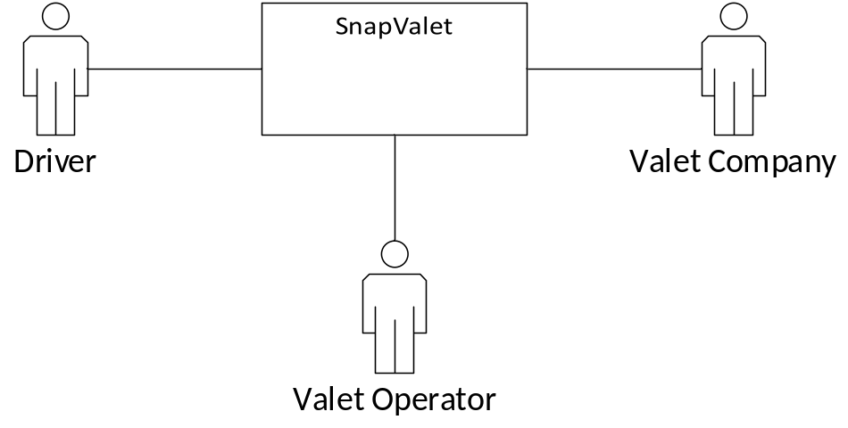
Figure 1: System Context Diagram
Table 1: Actors Summary
Actor | Description | Responsibilities
Driver | People who use valet service and use SnapValet app to notify or pay valet service | - Request for valet service  - Request to retrieve car  - Pay valet service fee and tip
Valet Operator | People who provide valet service | - Provide valet service  - Manage keys and cars  - Charge valet service fee
Valet Company | Entity which in charge of valet operators | - Manage valet service fee and salary  - Manage employee

Artifacts & Information
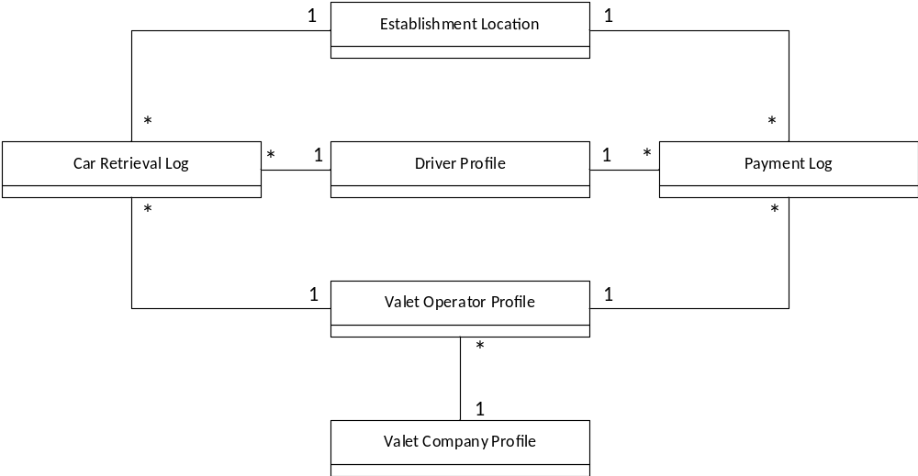
Figure 2: Artifacts and Information Diagram
Table 2: Artifacts and Information Summary
Artifact | Purpose
Valet Company Profile | Contains information of a valet company for cashless valet service.
Valet Operator Profile | Contains information of a valet operator for cashless valet service.
Driver Profile | Contains information of a driver for valet service.
Car Retrieval Log | Contains information of a car retrieval request from driver.
Payment Log | Contains information of a valet service fee and tip
Establishment Location | Contains information of the establishments which provide SnapValet service.

Behavior
Figure 3 illustrates the process diagram of SnapValet. It can be divided into three capabilities: valet service, employee management and account management.
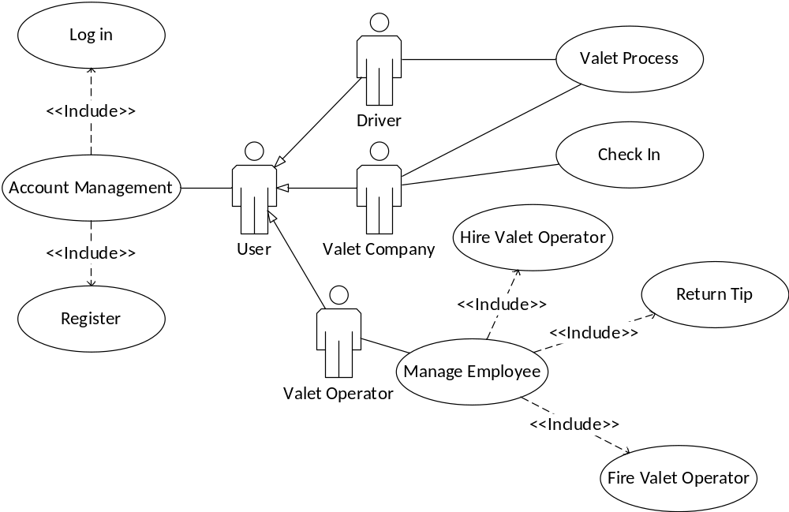s
Figure 3: Process Diagram

Valet Service

Valet Operator Check in
Table 3: Process Description (Valet Operator Check in)
Identifier | UC-1: Valet operator check in
Purpose | For valet operator to log in the public device in the establishment he works for.
Requirements | WC_3392, WC_3390
Development Risks | Account security problem
Pre-conditions | Valet operator has logged in.
Post-conditions | Valet operator checks in location.
Table 4: Typical Course of Action (Valet Operator Check in)
Seq# | Actor’s Action | System’s Response
1 | Valet operator selects the location s/he working for. | Keep session in the public tablet for receiving notification in this establishment.
Table 5: Alternate Course of Action (Valet Operator Check in)
Seq# | Actor’s Action | System’s Response
1 | Valet operator adds himself/herself into the operators list. | Keep session in the public tablet for receiving notification in this establishment.

Valet Process
Table 6: Process Description (Valet Process)
Identifier | UC-2: Valet Process
Purpose | For the whole process of valet service
Requirements | WC_3392, WC_3390
Development Risks | None
Pre-conditions | At least one valet operator has checked in this location via public tablet, driver has logged in.
Post-conditions | Driver get car and leave.
Table 7: Typical Course of Action (Valet Process)
Seq# | Actor’s Action | System’s Response
1 | Driver requests for valet service and gives car and key to valet operator.
2 | Valet operator gives a ticket to driver, parks driver’s car and manage key and car.
3 | Driver checks in location and request car, pays service fee and tip with application. | Send request to the public tablet to notify valet operator to retrieve car.
4 | Valet operator gets notification from public tablet and assigns task to some operator. | Send notification to driver to notify him/her that the car is in retrieval.
5 | Valet operator retrieves car and sends notification to driver. | Send notification to driver to notify him/her that the car is ready.
6 | Driver gets his/her car and leaves
Table 8: Alternate Course of Action (Valet Process)
Seq# | Actor’s Action | System’s Response
1 | Driver requests for valet service and gives car and key to valet operator.
2 | Valet operator gives a ticket to driver, parks driver’s car and manage key and car.
3 | Driver checks in location and requests car without payment. | Send request to the public tablet to notify valet operator to retrieve car.
4 | Valet operator gets notification from public tablet and assigns task to some operator. | Send notification to driver to notify him/her that the car is in retrieval.
5 | Valet operator retrieves car and sends notification to driver. | Send notification to driver to notify him/her that the car is ready.
6 | Driver gets his/her car, pay with cash and leave
Table 9: Exceptional Course of Action (Valet Process)
Seq# | Actor’s Action | System’s Response
1 | Driver requests for valet service but valet operator refuses the request as parking lot has been full.
Table 10: Exceptional Course of Action (Valet Process)
Seq# | Actor’s Action | System’s Response
1 | Driver requests for valet service and gives car and key to valet operator.
2 | Valet operator gives a ticket to driver, parks driver’s car and manage key and car.
3 | Driver checks in wrong location and requests car. | Send request to the public tablet to notify valet operator to retrieve car.
4 | Valet operator finds the mistake and sends notification to driver. | Send notification to driver to notify him/her about the mistake.
Table 11: Exceptional Course of Action (Valet Process)
Seq# | Actor’s Action | System’s Response
1 | Driver requests for valet service and gives car and key to valet operator.
2 | Valet operator gives a ticket to driver, parks driver’s car and manage key and car.
3 | Driver checks in location and requests car with/without payment. | Send request to the public tablet to notify valet operator to retrieve car.
4 | Valet operator gets notification from public tablet and assigns task to some operator. | Send notification to driver to notify him/her that the car is in retrieval.
5 | Valet operator retrieves car and sends notification to driver. | Send notification to driver to notify him/her that the car is ready.
6 | As driver hasn’t come after a period of time, valet operator re-parks car and sends notification to driver | Send notification to driver to notify him/her that the car has been re-parked.

Account Management

Log in
Table 12: Process Description (Log in)
Identifier | UC-3: Log in
Purpose | To check if a user has right to access system
Requirements
Development Risks | Account security problem
Pre-conditions | SnapValet server has successfully started.
Post-conditions | User logs in system.
Table 13: Typical Course of Action (Log in)
Seq# | Actor’s Action | System’s Response
1 | User provide username and password | The username and password is valid
Table 14: Exceptional Course of Action (Log in)
Seq# | Actor’s Action | System’s Response
1 | User provide username and password | The username and password is invalid

Register
Table 15: Process Description (Register)
Identifier | UC-4: Register
Purpose | For users to get access to system.
Requirements
Development Risks | Account security problem
Pre-conditions | SnapValet server has successfully started.
Post-conditions | User gets an account.

Table 16: Typical Course of Action (Register)
Seq# | Actor’s Action | System’s Response
1 | User provides personal information with username and password. | Add user information into system.
Table 17: Exceptional Course of Action (Register)
Seq# | Actor’s Action | System’s Response
1 | User provide information with username and password. | As username duplicate/password does not meet constraint, refuse to add user information.

Employee Management

Hire Valet Operator
Table 18: Process Description (Hire Valet Operator)
Identifier | UC-5: Hire valet operator
Purpose | Add valet operator information linked to valet company
Requirements
Development Risks | Account security problem
Pre-conditions | Valet company has logged in system.
Post-conditions | A new valet operator added into system.

Table 19: Typical Course of Action (Hire Valet Operator)
Seq# | Actor’s Action | System’s Response
1 | Valet company adds a new valet operator into system with employee information. | Return a new generated employee ID.

Fire Valet Operator
Table 20: Process Description (Fire Valet Operator)
Identifier | UC-6: Fire valet operator
Purpose | Delete valet operator information linked to valet company
Requirements
Development Risks | Account security problem
Pre-conditions | Valet company has logged in system.
Post-conditions | A previous valet operator deleted from system.

Table 21: Typical Course of Action (Fire Valet Operator)
Seq# | Actor’s Action | System’s Response
1 | Valet company deletes a previous valet operator from system and confirm operation. | Return successfully delete notification to user.

Return Tip
Table 22: Process Description (Return Tip)
Identifier | UC-7: Return tip
Purpose | Return tip to specific valet operator.
Requirements | WC_3208
Development Risks | Account security problem
Pre-conditions | Valet company has logged in system.
Post-conditions | Valet company get a list of tip amount for employee.

Table 23: Typical Course of Action (Return Tip)
Seq# | Actor’s Action | System’s Response
1 | Valet company queries for tips-valet operator list. | Search payment log and return tips-valet operator list.
2 | Valet company returns tips with information in list.

Modes of Operation
The SnapValet, as we envision implementing it, will operate in only one mode, so nothing further need be said of modes of operation.

System Analysis Rationale
Based on our analysis of how the users interact with the system, we have identified 3 classes of operational stakeholders.

Driver: They are the client of valet service users, and their responsibility for this system is to use request system and cashless payment to improve their valet experience.

Valet operator: They are the performer of valet service. Their responsibility for this system is to perform valet service, and receive salary and tips as return.

Valet Company: They are supervise of valet operator. Their responsibility is to manage the valet operators whether hired or fired, and to pay salary to them.

Technology-Independent Model

Design Overview

System Structure
<< This section should contain
- a UML hardware component class diagram
- a UML software component class diagram
- a UML deployment diagram
- If necessary, a class diagram for the system's supporting software infrastructure
- and descriptions of the hardware components, software components, and, if necessary, the supporting software infrastructure components of the technology/platform-independent system architecture
More information and example can be found in ICM EPG> Task: Define Technology-Independent Architecture >>

<<Hardware Component Class Diagram>>
Figure 4: Hardware Component Class Diagram

<<Software Component Class Diagram>>
Figure 5: Software Component Class Diagram

<<Deployment Diagram>>
Figure 6: Deployment Diagram

<<Optional: Supporting Software Infrastructure Diagram>>
Figure 7: Supporting Software Component Class Diagram

Table 24: Hardware Component Description
Hardware Component | Description

Table 25: Software Component Description
Software Component | Description

Table 26: Supporting Software Component Description
Support Software Component | Description

Design Classes
This section should contain:
- UML class diagrams showing all the boundary, entity, and control classes in the design of the system being developed
- and a description of each class in the diagram
More information and example can be found in ICM EPG> Task: Define Technology-Independent Architecture >>

<Classes n>
<<Design Classes Class Diagram>>
Figure 8: Design Class Diagram

Table 27: Design Class Description
Class | Type | Description

Process Realization
<< This section shows how the proposed architecture can be realized by constructing sequence diagrams. More information and example can be found in ICM EPG> Task: Define Technology-Independent Architecture >>

<<Process Realization Diagram>>
Figure 9: Process Realization Diagram

Design Rationale

<< This section should contain an explanation of how/why the architecture/design described in previous sections was chosen. More information and example can be found in ICM EPG> Task: Define Technology-Independent Architecture >>

Technology-Specific System Design
<< Once you know specific technology that you team is going to use, design the system and software architecture and document them in this section. >>

Design Overview

System Structure
<<Hardware Component Class Diagram>>
Figure 10: Hardware Component Class Diagram

<<Software Component Class Diagram>>
Figure 11: Software Component Class Diagram

<<Deployment Diagram>>
Figure 12: Deployment Diagram

<<Optional: Supporting Software Infrastructure Diagram>>
Figure 13: Supporting Software Component Class Diagram

Table 28: Hardware Component Description
Hardware Component | Description

Table 29: Software Component Description
Software Component | Description

Table 30: Supporting Software Component Description
Support Software Component | Description

Design Classes

<Classes n>
<<Design Classes Class Diagram>>
Figure 14: Design Class Diagram

Table 31: Design Class Description
Class | Type | Description

Process Realization
<<Process Realization Diagram>>
Figure 15: Process Realization Diagram

Design Rationale

Architectural Styles, Patterns and Frameworks
<< Describe any implementation architecture styles (e.g. the Prism style and 3-tier architecture), patterns (e.g. pipe-and-filter and client-server), or frameworks (e.g. Java and CORBA) used to describe the system architecture. >>
Table 32: Architectural Styles, Patterns, and Frameworks
Name | Description | Benefits, Costs, and Limitations

